Anton Imbrea
2125640

Table of Contents

Introduction…………………………………………………………………………………… 3
Written summary - Preparing for Higher Education………………………………………….. 3
Mind Map “Becoming a digital learner”……………………………………………………… 5
Presentation…………………………………………………………………………………… 6
Reflection - Borton reflective tool…………………………………………………………….. 7
Conclusion…………………………………………………………………………………….. 8
Reference list………………………………………………………………………………….. 9

Introduction
The present age is rightly termed the digital era because of the rapid development in technology and the large-scale implementation of the same. Both industrial operations and learning processes have faced disruptive change because of the effective utilisation of different digital tools in education and business (Ovcharuk et al., 2020). The portfolio here will cover the aspects of preparation for higher education in the summary. A mind map regarding digital learning will also be prepared. Along with that, the influence of values, place, and beliefs on personal identity will be discussed in accordance with the team playing. Moreover, a reflection will be covered by using the Bortons reflective tool.

Written summary - Preparing for Higher Education
Higher education in a country plays the role of a cultural and scientific asset. Higher educational activities significantly contribute to personal, societal, economic and overall development. For example, Rokicki et al. (2020) have found that in the European Union countries, higher education plays an important role in achieving the objectives of a circular economy. On the other hand, decisions made based on higher education and advanced analysis are more effective and indicate the right way. In figure 1, the importance of higher education has been depicted. Learning and studying with proper effort indicates success in learning. Academic skills are also improved from higher education.

Figure 1: Higher education
(Source: Learningscientists, 2022)
While preparing for higher education several factors are to be considered. Firstly, the field of education is selected. A wrong selection of the area for higher education may lead to unfavourable impacts. In this context, evaluating all the possible ways to continue higher education is essential. Monteiro and Leite (2021) have found that at present digital literacies in higher education can only be facilitated by appropriate skills, and competencies and to eliminate the obstacles of higher education in the age of digital transformation. Efficient communication skills, time management skills, collaboration skills, and critical thinking skills are some of the specific skills and competencies that are essential for achieving success in higher education.
Developing these skills will be a necessary part of preparing for higher education. As found by Ovcharuk et al. (2020), at present a number of technical tools have revolutionised the systems of learning including higher education. Hence, it can also be perceived that having appropriate technological skills is essential for effectively and quickly cope up with the system of higher education. Schofer et al. (2021) have stated that the impact of higher education is mainly related to social impact. Four key dynamics exist for higher education. a) Modern profession and rationalisation of society are fostered through higher education. b) Higher education leads to shared values and globalisation. c) Higher education, directly and indirectly, contributes to major socio-political change in society. d) Higher education contributes to economic development. Hence, for these reasons, effectively and appropriately preparing for higher education is essential.

Mind Map “Becoming a digital learner”
- Digital learning
The learning process facilitated by new and advanced technologies indicate digital learning. The Digital learning process is dependent on technological tools. Digital learning at present facilitates organisational digital transformation. Artificial intelligence, augmented reality, the internet of things, smartphone applications and others are among the technologies that are utilised in digital learning (Sousa and Rocha, 2019).
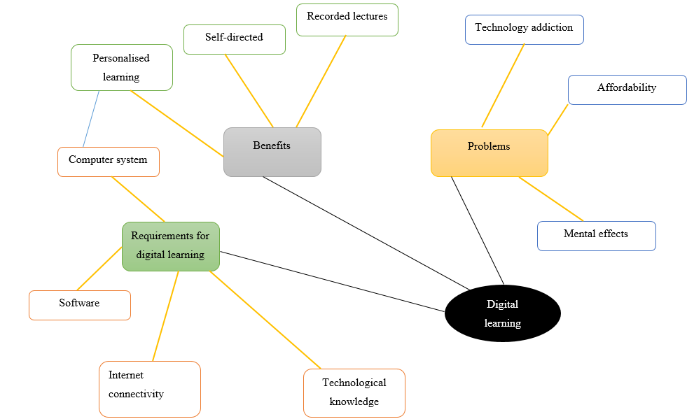
Figure 2: Mind Map
(Source: Created by the learner)
- Requirements for digital learning
In the current scenario, some basic essential requirements can be marked as the threshold for digital learning. Hardware and software are two aspects which are essential for digital learning. Computer facility, stable connection, mic, webcam and others are essential requirements for digital learning. On the other hand, specialised software for the learning platform is also needed to be installed. Apart from the tools and equipment, appropriate knowledge of operating the technology is essential.
- Necessity and benefits of digital learning
- Digital learning is necessary because learners can improve their skills to handle new and complex technologies.
- Digital learners become aware of online mediums and can use the same beneficially.
- The primary benefits of digital learning include personalised learning.
- The learners in the process can control time, place and other factors.
- Learners can refer to the lectures even after the class in recorded format.
- The direction of self-study is facilitated by e-learning.
- Digital learning fosters the development of the technological skills and knowledge necessary for the future workplace.
- Problems of digital learning
- The basic technical requirements that are demanded in digital learning may not be affordable for everyone.
- Lack of classroom ambience in the digital learning process (Reyes-Chua et al., 2020).
- Chances of technology addiction, isolation and others.
- Lesser or no presence of physical activities in digital learning.
- In the chosen discipline, digital learning will help in preparing any essential documents and it will develop ample knowledge about technology hence problems regarding technology handling will be eliminated. It will be beneficial in academics and the future workplace.

Presentation
Personal identity
The characteristics of self are included in the discussion of personal identity. In analysing my personal identity, many characteristics can be identified. The identity of a person is significantly influenced by values, places, beliefs, principles, experiences and others. My personal identity can be described by different skills and competencies. Both strengths and weaknesses of my personal identity can be mentioned. The strengths of my personal identity can be taken as good communication skills, quick learning ability, effective decision-making skills, and others. Some of the weaknesses of my personal identity can be a lack of concentration, time management, and others.
Place, values, beliefs
The sense of place is influenced by the conditions of the surroundings. Taking the right decisions in the right place indicates an improved sense of place. Ideas, values, principles, other senses, and cognitive abilities are associated with the development of a sense of place.
Values and beliefs are the shapers of personal identity (Ignell et al., 2019). My sense of values and beliefs influence my personal identity. It also significantly influences my behavioural traits, the consequences of decisions made and others. Positively developed values and beliefs will foster societal development and vice versa.
Good team player
To achieve any desired target of a team, both the contributions of the leader and the members are important. According to Minett-Smith and Davis (2019), effective teamwork is essential for perfectly balanced shaping and progress in the field of higher education. Moreover, teamwork also fosters innovation and improves the rate of achievement of the desired goal. My sense of place, values and beliefs include effective communication, desire to learn, the mentality for avoiding any kind of problems and complexities and understanding of the need for effective teamwork may have facilitated my good team playing skills and made me a good team player. For the good team working ability, leadership, communication, collaboration, problem-solving and others are essential.
Please follow this link to view my presentation: Evidence of Learning (E-Portfolio) Presentation.mp4

Reflection - Borton reflective tool
Reflection of learning indicates the process of learning by reconsidering an experience. Different models of reflection are Gibb's reflective model, Borton’s tool, Kolb’s model and others. Borton's model of reflection consists of the application of three broad questions: what, so what and now what (Hurst, 2020). The application of the model is as follows.
- What?
The experience here considered will be starting university, getting accustomed to online learning resources and writing the first assignments. I have seen the ambience of studying in a university, and the different procedures and set-up for digital learning. I have completed writing the first university assignment. I was amazed to observe all the many processes that are accomplished as part of the university. I was trying to achieve knowledge about academic writing. I was also trying to build essential knowledge regarding online learning and technology. During the experience of starting university, the thing that went well was the system of studying at the university. The initial few days did not go smoothly because it was necessary for me to cope up with the new systems.
- So what?
In this second stage of the reflective tool, the analysis of the event or experience is accomplished (Grimmer, 2022). From the considered experience, during the starting of the university I felt nervous and the same before operating the online learning tools. After being accustomed to the tools and resources of online earning I feel confident about the same. After writing the first assignment, I feel rich in knowledge about academic writing.
- Now what?
The implications for online learning and writing assignments can be considered to be gained in knowledge and application in the future studies and workplaces. Most importantly I have learned about the actual importance of digital technologies and the rules and regulations of academic writing. I need to improve the different academic skills like critical thinking skills, research skills and others for improving academic performance in future.

Conclusion
The portfolio has covered the different aspects of learning and the strategies for the same. It has been found that efficiently preparing for higher education is significantly necessary. Digital learning can be considered the future. Moreover, the influence of a sense of place, values and beliefs on personal identity has also been explored. Lastly, the Bortons reflective tools have been utilised for analysing learning experiences.

Reference list
Grimmer, A., 2022. The cloverleaf model of cognitive behaviour therapy as experiential learning: implications for case formulation, therapeutic practice and practitioner development. the Cognitive Behaviour Therapist, 15.
Hurst, R.N., 2020. Emerging Characteristics of Median Stage Ego Development: When Does Self-Initiated Reflection Begin? (Doctoral dissertation, Fielding Graduate University).
Ignell, C., Davies, P. and Lundholm, C., 2019. A longitudinal study of upper secondary school students’ values and beliefs regarding policy responses to climate change. Environmental Education Research, 25(5), pp.615-632.
Learningscientists. 2022. THE LEARNING SCIENTISTS. [online] Available at:<https://www.learningscientists.org/blog/2018/3/18/weekly-digest-101> [Accessed on 7th November 2022]
Minett-Smith, C. and Davis, C.L., 2019. Widening the discourse on team-teaching in higher education. Teaching in Higher Education.
Monteiro, A. and Leite, C., 2021. Digital literacies in higher education: Skills, uses, opportunities and obstacles to digital transformation. Revista de Educación a Distancia (RED), 21(65).
Ovcharuk, O., Ivaniuk, I., Soroko, N., Gritsenchuk, O. and Kravchyna, O., 2020. The use of digital learning tools in the teachers’ professional activities to ensure sustainable development and democratization of education in European countries.
Reyes-Chua, E., Sibbaluca, B.G., Miranda, R.D., Palmario, G.B., Moreno, R.P. and Solon, J.P.T., 2020. The status of the implementation of the e-learning classroom in selected higher education institutions in region IV-A amidst the COVID-19 crisis. Journal of Critical Reviews, 7(11), pp.253-258.
Rokicki, T., Perkowska, A., Klepacki, B., Szczepaniuk, H., Szczepaniuk, E.K., Bereziński, S. and Ziółkowska, P., 2020. The importance of higher education in the EU countries in achieving the objectives of the circular economy in the energy sector. Energies, 13(17), p.4407.
Schofer, E., Ramirez, F.O. and Meyer, J.W., 2021. The societal consequences of higher education. Sociology of Education, 94(1), pp.1-19.
Sousa, M.J. and Rocha, Á., 2019. Digital learning: Developing skills for digital transformation of organizations. Future Generation Computer Systems, 91, pp.327-334.

