

Name: Gabriela Arapu
Student ID: 2311889
Module Code: BMHP5014

Module: Changemakers: Creativity and Value Creation

Lecturer: Caroline Salami (module
leader)

Table of Contents
Poster 3
Introduction 4
The Need for Innovation 4
Description of the Innovation 5
Benefits of the Innovation 5
Stakeholder Involvement 6
Ethical Considerations 6
Conclusion 7
References 8

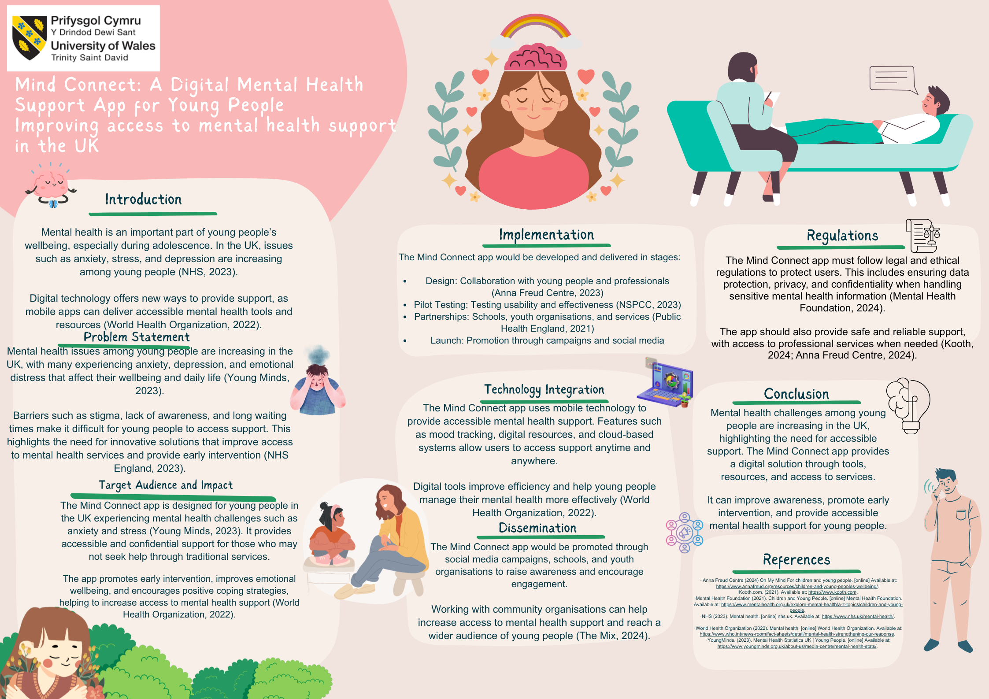
Poster

Mind Connect: A Digital Mental Health Support App for Young People

Introduction
Young people's growth and overall well-being are significantly impacted by their mental health. Due to emotional, psychological, and social changes, many people experience stress, anxiety, and other mental health problems during adolescence. If these difficulties are not adequately supported, they may negatively affect relationships, academic performance, and self-confidence.
The growing demand for mental health services is placing pressure on the UK's established support systems, which often results in long wait times and limited access to care. Digital technology offers an opportunity to improve accessibility and provide timely support. Mobile applications are particularly helpful because young people use digital platforms so regularly. These tools enable resources such as wellness activities, mood monitoring, and professional assistance (Mental Health Foundation, 2024).
The suggested innovation, Mind Connect, is a digital mental health application that helps young people keep an eye on their emotional health, get trustworthy mental health information, and get in touch with the right support services when they need it.

The Need for Innovation

By giving young people, a confidential and convenient means to get mental health treatment, digital tools can encourage help-seeking behaviour and improve overall wellbeing (Anna Freud Centre, 2024). For instance, websites like Kooth offer emotional support and online counselling, enabling youth to seek assistance without in-person contact. This can promote early intervention and lessen stigma. But there are restrictions as well.

Digital exclusion may result from unequal access to digital devices and the internet among young people. Furthermore, some users could rely too much on digital technologies rather than seeking expert assistance when necessary.

To overcome these challenges, digital solutions should be linked with traditional services and made inclusive and accessible. Schools and community organisations can also help young people use these resources. Government guidelines highlight the importance of early intervention and increasing young people's access to mental health services, including the use of digital assistance, as part of a bigger mental health plan (Department for Education, 2023).

Description of the Innovation
A smartphone app called MindConnect was created to encourage early intervention, self-care, and emotional awareness. The app satisfies the needs mentioned in the poster by combining several functions into a single, user-friendly platform. Mood tracking, which enables users to document and track their feelings over time, is a crucial function. This aids youth in identifying trends and stressors that affect their mental well-being.

Additionally, the app offers wellness features that help with stress management and emotional regulation, like breathing techniques, mindfulness exercises, and guided meditation. Additionally, MindConnect provides customers with access to support services by putting them in touch with reputable companies and professional help when they need it. This offers connections to different mental health providers and services, such as Kooth. (Kooth 2024).

To encourage creativity, the app may incorporate AI-driven support features like personalised recommendations and early warning alerts based on user data. This would improve early intervention and provide tailored assistance to every user.

Benefits of the Innovation
Young people, healthcare systems, and society can all benefit from Mind Connect. First, it encourages early intervention, allowing users to recognize and address mental health issues before they get worse. Early assistance can lessen the need for more intense therapy and improve long-term results (Mental Health Foundation, 2024).

Second, by helping via mobile devices at any time and from any location, the software enhances accessibility. This is especially crucial for people who might not feel comfortable asking for help in person.

Thirdly, Mind Connect helps people better understand their mental health and create coping mechanisms by promoting emotional literacy and self-awareness.

Additionally, by offering a different kind of assistance, the app can lessen the strain on NHS services and promote broader healthcare objectives of increasing effectiveness and preventative care.

Stakeholder Involvement
The success of Mind Connect depends on cooperation amongst many parties. Young people should be actively involved in the design and testing process to ensure that the app meets their needs and preferences.

Mental health organizations guarantee that the app offers safe and efficient support by offering knowledge, direction, and reliable resources. Promoting the app and boosting engagement can also be greatly aided by community organizations and youth services (The Mix, 2024).

As part of a more comprehensive care route, healthcare providers—including those working in NHS services—can facilitate integration by directing patients to the app. This cooperative strategy guarantees that the innovation is evidence-based, user-centered, and compatible with the current social and health care systems.

Ethical Considerations
The development of digital mental health treatments is heavily influenced by ethical considerations. Ensuring data security and safeguarding user privacy are crucial, especially when managing sensitive personal data.

To maintain confidentiality and safe data handling, Mind Connect must abide by all applicable rules, including data protection legislation like GDPR. Vulnerable users must also be protected by safeguards.
Additionally, the idea aligns with significant UK goals, like the NHS Long Term Plan, which emphasises the importance of digital transformation and improving access to mental health therapies (NHS England, 2019).
In compliance with the Care Act of 2014, it also encourages early intervention and welfare. Users must also have access to professional help when needed for digital technologies to complement existing services rather than replace them (Anna Freud Centre, 2024).

Conclusion
The growing number of young people in the UK dealing with mental health problems highlights the urgent need for innovative and accessible support networks. Mind Connect offers a digital approach that improves mental health, makes early intervention easier, and makes resources more accessible.
The software offers a comprehensive and user-friendly platform by integrating mood tracking, self-help features, and professional services. Its viability and applicability are increased by its alignment with healthcare policy and integration with current services.

However, to guarantee fair and secure implementation, factors like digital inclusion and data protection must be considered. All things considered, Mind Connect has the potential to improve youth mental health support and lead to better results within the UK health and social care system.

References
Anna Freud Centre (2024) For children and young people. Available at: https://www.annafreud.org/resources/children-and-young-peoples-wellbeing/ (Accessed: 10 April 2026).

Anna Freud Centre (2024) On My Mind - For children and young people. Available at: https://www.annafreud.org/resources/children-and-young-peoples-wellbeing/ (Accessed: 10 April 2026).

Department for Education (2023). Promoting Children and Young People’s Emotional Health and Wellbeing. [online] GOV.UK. Available at: https://www.gov.uk/government/publications/promoting-children-and-young-peoples-emotional-health-and-wellbeing. (Accessed: 21 April 2026)

Kooth.com (2021) Kooth. Available at: https://www.kooth.com (Accessed: 10 April 2026).

Mental Health Foundation (2021) Children and young people. Available at: https://www.mentalhealth.org.uk/explore-mental-health/a-z-topics/children-and-young-peoples. (Accessed 21 April 2026)

Nationalarchives.gov.uk (2025) UK Government Web Archive. Available at: https://webarchive.nationalarchives.gov.uk/ukgwa/20250707103655/https://www.longtermplan.nhs.uk/ (Accessed: 10 April 2026).

The Mix (2024) The Mix - Essential support for under 25s. Available at: https://www.themix.org.uk (Accessed: 10 April 2026).

‌

