
Applied Leadership and Management in the Workplace
Module Assignment Submission
Student Name: | Darcey Marie Richards
Student Number: | 2323405
Module No: | BMSK5013
Module Title: | Knowledge and Information Management Skills

Statement of Confirmation of Authenticity
By the act of making this submission, the student declares that this is the work of the student named above. The work has not, in whole or in part, been knowingly presented elsewhere for assessment, or where assessment has been built on a previous assessment, this has been identified. Where materials have been used from other sources it has been properly acknowledged. If this statement is untrue, the student acknowledges that an assessment offence has been committed.
Attention is drawn to the plagiarism and unfair practice policies of both the University and of ILM.

Table of Contents
Knowledge and Information Management Skills 3
Evaluate the concept and importance of knowledge management in terms of an organization's knowledge, assets and their management. 4
The Relationship between individual and organizational knowledge. 5
Business plan: 12
The business plan and oversight. 12
Storage and implementing knowledge through supervision. 14
Key Performance indicators. 15
Key practice indicator list. 16
Conclusion 17
Reference list 18

Knowledge and Information Management Skills

The aim of this assignment is to enable and encourage adaptations and improvements within a workplace to ensure all knowledge and skills are kept up to date with changing landscapes, standards and policies made by government. The Chartered Institute of Personnel and Development (2025) explains that demanding and evolving times encourages all companies to ensure all colleges, students and apprentices are supported to ensure their practice and knowledge remains up to date and within the best standard. This enables safe and effective standards to be met by all involved with procedures, practices and treatments delivered. (Harvard Business School (2025) also supports this by explaining technology, structured methods and pathways of running a business safely and optimally have changed over the decades and ensuring these are pursued is vital within a company overall outcome. Learning to create a thorough and evidence-based structure for a company will encourage the best outcomes for all involved. Linking this within this Essay, a strategic framework will be created to ensure a developmental plan is made for the workplace which aims to enhance efficiency through up-to-date knowledge and practices.
In order to encourage and prove that these are being achieved and met, the action plan that will involve everyone within the business and will include the importance of knowledge and leadership from the manager to highlight the importance of ‘leading by example’ and the importance of linking knowledge and practice within the business.
Overall, the framework and action plan will create a series of key practice indicators (KPI’s) and therefore allow everyone to understand the link and relationship between data, information and knowledge in relation to applying it to practice and what is expected of them.
The importance of utilizing individuals' knowledge and skills as opposed to just the company's knowledge and ‘policies’ will also be evaluated to highlight that creating a team and ‘one goal approach’ to set standards. Sergeant (2024) explains this approach allows everyone feels valued and satisfied within the team and know what is expected of them, what standards need to be met as well as working towards higher skills and knowledge within a set time frame and structured plan.

Evaluate the concept and importance of knowledge management in terms of an organization's knowledge, assets and their management.

To develop and create a successful business it is vital that management plays a leading role in overall evolvement, expansion and creativity. To achieve this having effective knowledge and professional assets is vital. These skills encourage the significant development of skills through the whole business including colleges. Management is deemed ‘the leader’ when running a business and therefore must lead by example by ensuring their knowledge and skills remain up to date and within the best standard within their work force to share this invaluable within companies. Shared knowledge is explained by Posthuma-Coelh, (2016) a group of individuals can learn from each other's skills and knowledge to allow them to become a common factor within the environment in which is shared, it allows information and understandings to be used and collaborated to solve problems and enhance a business resulting in new and less competent staff can report and compare to higher personable within the company and strive to match and meet these standards. Harvard Business School (2025) backs this by explaining running a business is not an easy role to fulfil, however if done accurately and with professionalism it can be the primary factor of the success of a company. By remaking up to date with changing skills and technology managers can facilitate knowledge management with confidence through connecting staff and promoting value with the team. Working together to share goals, encourage each person and striving for higher standards all enhances outcomes and therefore leads to institution success through efficiency, expertise and ratification. The Chartered Institute of Personnel and Development (2025) backs this by explaining having well skills, dedicated and passionate leaders and managers within a company is the backbone of a successful outcome and everyone can trust, respects and learn from higher levels and utilize this within the own practice.

The process to become this level of trained is one that should be taken seriously throughout a colleges career, promoting and encouraging a junior to do well and strive for best will be the overall reason why staff are retained, skills are developed over time and leaders are created from good role models showing what is expected from all with the team to meet goals, set higher standards and achieve successful outcomes.

Having these skills will always include a person's knowledge, skills and strengths that are used accurately within the right areas of a company. Ruch and Proyer (2015) explains different people will offer different strengths and seeking and using these are vital. Having managers and leaders that could seek these skills is important. Data, information and knowledge all play a contributing factor within a comment, and these come hand in hand with a very strong relationship between all.

The Relationship between individual and organizational knowledge.

As previously discussed, there it's a vital role for mangers to lead by example and show enthusiasm within their workplace to promote higher standard of knowledge however Mosconi and Roy, (2013), explains that there is an important link between individuals' knowledge and the organisation/business knowledge. Individuals' knowledge can be perceived in many formats, say at intellectual knowledge, declarative and experiential. All of which are important to run a successful business, having the knowledge and skills to lead by example often links with confidence and knowledge gained from experience and therefore being able to carry out tasks and roles to a high standard. The domino effect of this type of performed stemmed from said knowledge is how others learn and develop within the company (Glushenkov, 2024). Although there are clear advantages of personal and individual knowledge Glushenkov, (2024) also explains how organizational knowledge is just as important. This is due to allowing a whole organization to use shared knowledge approach. As aforementioned, knowing, respecting and combining everyone's strength and waking allows a holistic approach to developing skills and knowledge while keeping them up to date. Temel and Durst. (2020) adds that although individuals' knowledge is important, relying solely on this leads to a risk of new up and coming techniques/practices and policies being missed. () backs this by expressing the famous quotes of ‘Nothing changes if nothing changes’ and this should be remembered by all especially managers, leaders and role models within a company. Although it's evident that keeping skills and knowledge up to date is vital, using everyone's skills to ensure this is completed is a skill the organization must utilize. Linking this to a hairdressing company for the nature of this essay an action plan and framework are being used to ensure these are achieved.

Frameworks are developed within a setting of choices to provide a structured approach to creating or building something, a set of resources that provide guidance and steps that can be followed to whom they concern. Frameworks can be a powerful tool within a company to give colleagues a clear outline of what is expected of them, often leading to improved confidence and achievements (BasuMallick, 2023). Frameworks can include signposting tools, flow charts and relevant information within its field of practice. Boogaard (2023) supports this by explaining frameworks allow a step-by-step approach to overall goals making them specific, mesurable, achievable realistic and timely also known as SMART.

Frameworks allow companies to choose their audience and how they are going to attract the attention to ensure the company can strive within its field of work, for the nature of this essay the audience that likely to buy into hairdressing and hair styling is going to be the female population between the age of 16-40 (Kabuya, 2023), and therefore frameworks can be used to ensure the correct tools and services are used to reach this audience, through investigation and research is it apparent social media, word of mouth and advertising market is best to utilize when capturing said audience and therefore frameworks can include these approached to enhance the business. Market reach is vital to ensure time and effort is used within the correct sections of the market. This is going to be beneficial to gaining clientele and developing a reputation and portfolio. While creating frameworks allows the company to look at the strengths and weaknesses within the company and identify strengths that can be utilized as well as creating SMART goals to enhance areas of improvement. Overall, these skills can determine tactics to allow the company to thrive and keep developing through changing times as mentioned. Monitoring the success of these and creating them to ensure they can be adapted and changed when needed is vital to ensure all effects are documented, evaluated and analyses.

In addition to Frameworks, companies can also be incorporated Action Plans alongside frameworks and interlink them to promote and encourage development from all within the team, Action plans can be individualized to everyone, made with a holistic approach to personal goals and wired into a plan to achieve set goals.
Overall frameworks are normal a set-in stone practice to follow with clear and set outcomes, as oppose action plans being interchangeable between people however often correlate with the overall goals and achievements wanted within the company

To incorporate these into everyday practice a set of key practice indications will be used. Key practice indications are daily reminders used within a company to remember the team what is expected of them within a timely manner (Hiles, 2024). These indicators are signposting methods to enhance development of those skills that are fundamental. Ruch and Proyer (2015) explain these are gentle but matter of fact tasks that must be adhered to by all. KPIs must be clear, beneficial and always within the best interest of a developing company. Yeboah (2023). supports the use of KPIs, Frameworks and actions plan as they allow goals to be made, stored to development and accessible by every one of which links with utilizing individual and organizational knowledge appropriately.

Using the information and research gained about the importance of keeping skills up to date and how to do this effetely multiple frameworks and SMART goals within hairdressing for knowledge management has been developed. These frameworks include the key aspects of fundamental knowledge needed by all to ensure the company has the best chance of developing and being successful. The frameworks and goals are created under five umbrella goals all of which are aimed to provide guidance to cover all aspects of the company's success.

Goal: Keeping up to date with new hair styles.
Specific goal:
Going to events of new hair extensions and gaining more knowledge on hair types/methods and types of extensions.

Measurable:
All Colleges within the team must have evidence of attending additional events and lessons to practice new up and coming styles and hair extension techniques within a hair of employment.

Achievable:
With the managers understanding the importance of these additional skills the company must support and encourage this to be met within the time frame.

Realistic:
Allowing study time and leave must be due within periods of fewer clients and therefore lower the risk of losing clients through study leave.

Time:
Although styles change seasonally, a yearly training session should be completed by all to keep up to date and allow competence to be updated.

Goal: Utilizing what marketing companies work best within the hair dressing field and employment of colleges with the skills to be able to keep this up to date to get the audience on board and book appointees and extensions within the company.

Measurable: through monitoring and auditing the positive effects of clients booking through the social media accounts and feedback from where they heard of the business. Feedback forms can be used by all new clients to assess the effectiveness of social media.

Achievable: setting up a business page with open access to the targeted audience. Employing staff that are up to date with modern technology and the developing culture of social media.

Realistic: setting a goal of all consenting clients to have before and after photos/videos taken and using their hair styles/color changes and cuts to be uploaded to social media to show the transitions that can be made by all within the team. Highlighting different skills and knowledge from each member of the team to widen the audience attraction and each hairdresser's client base.

Time: these skills and practices are to be updated regularly and remain at the forefront of everyone's daily plan to ensure the advertisement of the company is optimal and gain a following popular enough to attract additional clients and widen the clientele. Overall, this will enhance success and tighten finical benefits.

Goal: advertising, marketing, and teaching

Specific goal: using social media, classroom teaching, allowing time to allow colleges to learn a gain the skills and confidence in both practical hair styles and social media content which leads back to the domino effect of encouragement and leading by example through encouragement and confidence.
Measurable: Each member of the team having a competency time frame to ensure they have been met.

Achievable: allowing the first year of apprentice scheme to include mandatory study days to enhance learning and confidence.

Realistic: a year as a set time frame which allows enough time to settle into the team, build relationships and foundations of the salon to then enhance skills further to wide skills further and develop the team's ability, confidence and ability to offer a larger range of appointments between all within the team.

Timely: within the yearly PDAR meeting, with a midway meeting at six months to ensure these are being worked towards accordingly, if not this will allow managers to investigate reasons why not (i.e. Time of year/business of the business or other contributing factors).

Goal: Pricing and reputation

Specific goal: Using the right tactics such as appropriate prices, feedback and word of mouth through friendships groups, incentives like discount codes and color of the month, often seasonal.

Measurable: to ensure this is measurable it will be audited by senior management about the rate of clients and colours used within the previous month in relation to if there had been a high percentage of clients choosing the colour of the month and this will allow everyone to see if this method of Advertising works. Also asking clients where they had heard of the company to highlight where increasing numbers of clients are coming from to ensure this is maintained as it would be working.

Achievable: These are achievable methods of advertising as they are skills and knowledge that are already known by the team. It just highlights the importance of using theory as practice together to encourage the development of the business. Also achievable to price hair and appointments that ensure the cost of the tools, wages and colors are colored with an addition profit but without charging rates that will prevent clients from booking and therefore losing money over the annual year.

Realistic: ensuring these are completed daily and putting the additional effort into these aspects of running the company may short term take time away from the clients however approaching the company holistically and working on all aspects of improvements will long term help the success of personal and professional goals.

Time: these can be achieved daily, monthly and annual checks on finical benefits.

Goal: Documentation and filing

Specific goal: Keeping a file of each college and client to know and understand where they are and what’s the best development move for them as well as making the client feel like they are respected and valued within the company through knowing their likes and dislikes to allow them to trust you to try new up and coming methods such as tapes, nano extensions and more advanced hair.

Measurable: To measure this supervisore and senior management are to review bookings, order trials and following days plan daily to ensure all appointments are manageable, timely and reasonably catered for daily. And issues to be highlighted with immediate reasons with right personal.

Achievable: protected time for suitable person on shift to audit the books, safety policies and insurance details. Each college takes reasonability off their client's bookings, coloring and plans to ensure the correct hair is ordered, delivered and deposits are taken to confirm the booking and actions needed are taken. This must be clearly documented and available for auditing review daily.

Realistic: through the correct training and planning skills learnt throughout the competencias stated previously this is a realistic and fundamental skill for all within the team. Full and additional audits and safety regulations are in place for senior members of the management and business owners.

Timely: daily changes to documentation, new bookings and ordering are to be carried out with very high care of detail and changes are to be made only within the best interest of clients and standard of appointment to lower the risk of unsatisfied clients.

Business plan:
Along with these frameworks a business case for the collection and distribution of knowledge has also been created to be combined with the frame works.

This short and simple care business case allows a clear and easy to follow table that justifies the needs of the company and overall goals to be achieved, these allows the stakeholders to be engaged within the company, and they can see its true values. These also enable a clear understand go what is to be expected within the salon by clients and employees. The case plan also highlights the importance of risk assessing to minis risks and enhance overall finical gain where needed.

The business plan and oversight.

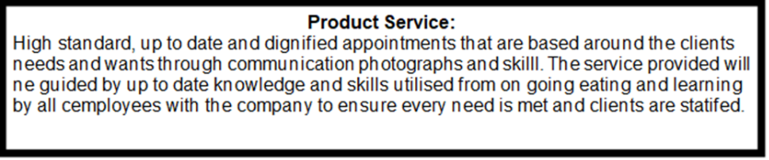
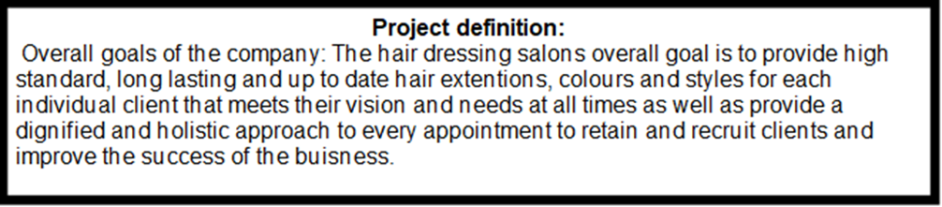
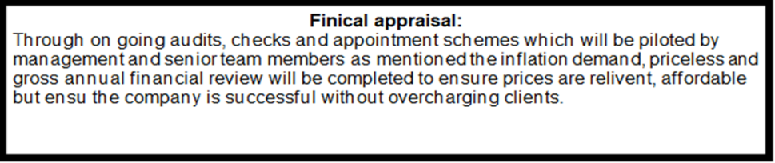

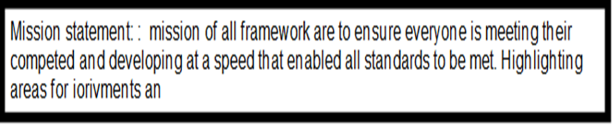

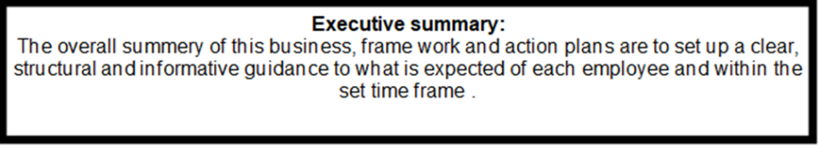

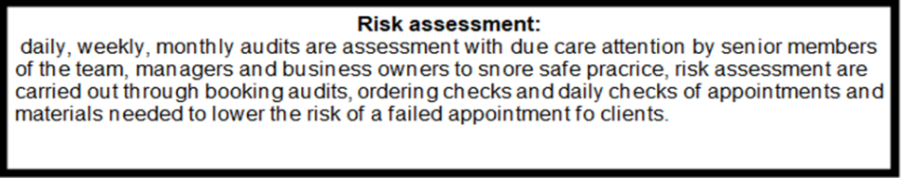

Storage and implementing knowledge through supervision.

Ensuring all knowledge learnt through the career of all employees, the plan, do, check, act (PDCA) method is used within the hairdressers. The approach allows the collection, storage and sharing of any learnt information within the company to promote career goals being achieved, satisfy clients and positive impact on the business’ success throughout. This leads to the employees feeling satisfied, achieving and confident within their practice to perform their skills on clients leading to clients returning and improving the likeliness of gaining clientele over time. To endure this method can be achieved each employee is paired with a more senior member of the team used as a ‘mentor’ of which will have the experience and time to support, review and encourage their team member to achieve the framework and action plans as well as own set goals of what they want within their career and how the company can support this to ensure the support provided PDAR’s are used (Dwyer, 2020). These are mandatory to be annual however if needed more frequent can be done however they are used to ensure all SMART goals are being achieved, competencies from the action plans are being met and any under-developing staff can be supported and guided to minimize the risk of not satisfied clients.

Storing information is a vital aspect of the business which is carried out using modern technology and highlights the importance of being up to date with social media, computers and phones. Each client how their own folder found using their name and Date of Birth created on their first visit of which hold all the necessary information.

Information about their hair type, colors, styles and long-term plans that they wish to work towards such as hair changes and extension plan. This allows the correct materials to be ordered for their appointment and the specific allocation of the hair slyest to be designated to them.

Furthermore, to ensure the safety of the clients and in line with data protection all clients notes are kept locked away on a file protected by a company password that is not accessible to anyone that does not know the password, all flies are closed down and unnecessary information is removed from file immediately. Clients have a consent for the fill in upon first visit or ensure they're happy with the modern technology approached to be used when booking their appointment.

Key Performance indicators.

As mentioned, there are many ways to audit, assess and monitor the successfulness of the company through guidelines, GOALS and education all of which work together to ensure employees are maintaining and improving their skills and qualities in order the provide the best standard of hair dressing. However, in addition to these as a manager there are always other ways to help encourage this and this is through Key Practice Indicators (KPI’s). KPIs are specific and measurable elements within an employee's practice and can be used alongside work to highlight areas of importance and performance against core standards. KPI’s are interchangeable throughout phases and allow all employees to be working towards the same goal. Additionally, KPIs can indicate areas that may require more support, work or follow up by senior team or management. The purpose of these is to attain and improve key areas within the company. These can be reviewed as frequently as hours, daily, weekly, monthly or annually and therefore allocating the time and effort into creating these and ensuring they are up to date allows all employees to think about what is expected of them Gitlow (2008).

Key practice indicator list.

- Keep up to date with bookings and know the next 24-hour plan.
- Check emails regularly throughout the day for updates and changes.
- Book on to e-learning courses.
- Daily check in with the whole team (AM MEETING)
- Order hair, color and extensions for the next 48-hour appointments by 1400pm daily.
- Daily shop cleaning (Deep clean Monday, Wednesday, Friday)
- Update finical books and bank plans (daily) with tracible documents of each clients pay method.
- Ensure PDARs are completed in a timely manner.
- Target of the month: I.e. Improve follow-up messages to clients.
- 10: Update local media account with daily before and after photos.

‘Overall monthly message from business owner Important to remember it's still mind over technology and not to lose the importance of the power of face-to-face communications, emotional intelligence and support.’

Conclusion
Overall and to conclude this essay, using the process of being organised, structural and willing to always deliver a higher standard of hair dressing is vital. The importance of knowing how to run a successful business has been assess and analysed throughout to show the vital steps via a team approach are needed. Highlighting importance facts such as the importance of GOALs, that are realistic and encourages everyone to work towards and also guidance on how these goals can be met without them feeling over whelming and unachievable. It has been taught that goals that feel like they are not achievable often leads employees feeling deflated and underperforming and therefore lacking satisfaction within their job. As a result of learning this the vital role in which a manager and business owner plays to lower this risk is key and striving to lead by example, teaching skills and professionalism and having the time and skills to encourage all employees will lead to better business outcomes and successfulness due to everyone working as a team towards the set clear goals together. Being transparent about what the company is stiving for allows everyone to understand and accept what is required of them to achieve this. Long term this means everyone within the company will feel like they are developing, learning and able to offer their skills towards these goals and therefore result in a developing and successful business. Managers also lead the roll out of these plans and therefore getting the respect and relationship with everyone within the team no matter what size team companies have will effectively benefit team working, commitment and drive and therefore result in better client satisfaction, retention of clients and reputation leading to an expanding audience and clientele.
Finally, the finical benefits of an expanding company will come as a result of the hard work and commitment of everyone and therefore seeing these positive rewards will keep all interested and thriving the achieve goals that will be forever changing to better the company.

Reference list

BasuMallick, C. (2023). What Is a Framework? Definition, Types, Examples, and Importance. Retrieved from https://www.spiceworks.com/tech/tech-general/articles/what-is-framework/
Boogaard, K. (2023). How to write SMART Goals. Retrieved from https://www.atlassian.com/blog/productivity/how-to-write-smart-goals
Dwyer, J. (2020) The Business Communication Handbook. 11th edn. Cengage Learning Australia.
Glushenkov, A. (2024). The Domino Effect: When Habits Build Your Success — or Break It. Retrieved from https://medium.com/@alexglushenkov/the-domino-effect-when-habits-build-your-success-or-break-it-1c0250e62204
Harvard business school. (2025) Business Insights. Retrieved from How to Develop a Business Strategy: 6 Steps | HBS Online
Harverd Business School.(2025). 10 CHARACTERISTICS OF SUCCESSFUL ENTREPRENEURS. Retrieved from https://online.hbs.edu/blog/post/characteristics-of-successful-entrepreneurs
Hiles, A. (2004) Business continuity : best practices : world-class business continuity management. Rothstein Associates.
Kabuya, M. (2023) ‘Necessity Entrepreneurs’ and Stakeholders’ Strategies: Bridging Business Survival in the Hairdressing Salon Industry’, Academic Journal of Interdisciplinary Studies, 12(6), pp. 274–274. Available at: https://doi.org/10.36941/ajis-2023-0169.
Mosconi, E., & Roy, M. C. (2013). Making Links between Knowledge Management and Organizational Performance. International Business Research, 6(9). https://doi.org/10.5539/ibr.v6n9p68 ¹²
Posthuma-Coelh, A. (2016). Personal vs Shared Knowledge. Retrieved from https://medium.com/@amandaposthuma/personal-vs-shared-knowledge-d9633501fc44
Ruch, W. and Proyer, R.T. (2015) ‘Mapping strengths into virtues: the relation of the 24 VIA-strengths to six ubiquitous virtues’, Frontiers in Psychology, 6. Available at: https://doi.org/10.3389/fpsyg.2015.00460.
Sergeant, D (2024). How Fair Process Increases Your Team’s Commitment. Retrieved from How Fair Process Increases Your Team's Commitment - Way We Do
Temel, S. and Durst, S. (2020) ‘Knowledge risk prevention strategies for handling new technological innovations in small businesses’, VINE Journal of Information and Knowledge Management Systems, 51(4), pp. 655–673. Available at: https://doi.org/10.1108/vjikms-10-2019-0155.
The Chartered Institute of Personnel and Development. (2025). Employee engagement and motivation. Retrieved from Employee Engagement & Motivation | Factsheets | CIPD
The Chartered Institute of Personnel and Development. (2025). Role of line managers in supporting skills development. Retrieved from https://www.cipd.org/uk/views-and-insights/thought-leadership/insight/learning-value-role-manager/
Yeboah, A. (2023). Knowledge sharing in organization: A systematic review. Cogent Business & Management, 10(1). https://doi.org/10.1080/23311975.2023.2195027

