
Holistic Dementia Care: Integrating the National Dementia Strategy and Social Models for Improved Patient Outcomes
Student Name: Mst. Shahrin Sultana
Student ID: 2503591
Lecturer: Dr. Muhammed Khan
Module Code: LCHS7003
Assignment Title: Information Booklet on Long-Term Condition Management- Dementia

Table of Contents
1. Introduction 3
2. Understanding Dementia 4
3. Physical, Psychological, and Social Impacts of Dementia 7
4. Evidence-Based Treatments for Dementia 10
5. Theoretical Models for Dementia Management 11
6. Current Local and National Health and Social Care Agendas 15
7. Recommendations for Person-Centered Care Approaches 18
8. Conclusion 21
9. References 22

1. Introduction
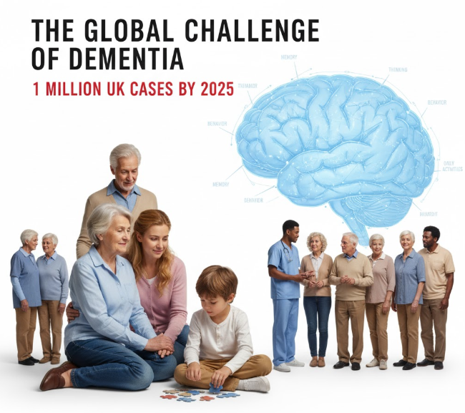
The symptoms of dementia include impairments in memory, thinking, behaviour, and day-to-day activities. Alzheimer's disease is the most common kind of dementia, and it affects millions of individuals all over the world. In the approaching decades, as the population gets older, even more people are likely to be impacted by this ailment. The Alzheimer's Society forecasts that there will be one million instances of dementia in the United Kingdom by the year 2025 (Zhang et al., 2021).
Figure1: Dementia Review

One of the most significant challenges facing public health in the 21st century is Alzheimer's disease. Patients, their families, carers, healthcare institutions, and society as a whole are all impacted by it. In light of the fact that dementia cannot be cured, the primary foci of treatment are quality of life, support for the family, early diagnosis, and management (Akinyemi et al., 2021).
A description of the symptoms, signs, and course of dementia is provided in this booklet. There will be a discussion on both evidence-based and theoretical approaches to treating dementia. The most effective and individualised therapy for dementia patients is provided by person-centred care methods. Affected individuals, carers, family, and healthcare professionals are the intended recipients of the booklet.


2. Understanding Dementia
Definition of Dementia
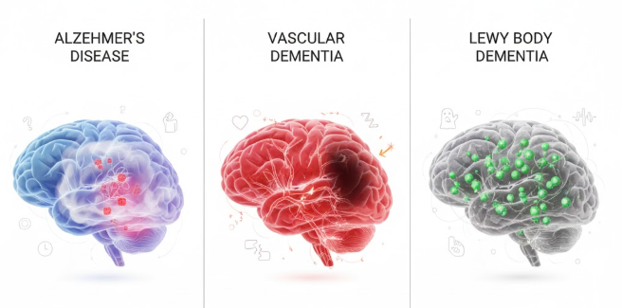
Memory, cognition, judgement, conduct, and personality are all negatively impacted by Alzheimer's disease, which is caused by brain disorders or abnormalities. Cognitive deficiencies make it more difficult to do daily tasks over time. This is an exceptional occurrence, but the chance of dementia increases with age, particularly after the age of 65 (Beard, 2016).
Figure 2: Brain Function and Cognitive Impact

Types of Dementia
- The most prevalent kind of dementia is Alzheimer's disease, which affects sixty to seventy percent of people. Alzheimer's disease causes brain changes that impair memory, thinking, and behaviour. Alzheimer's patients may forget names, conversations, and tasks. Some of the early warning signs include confusion, problems with focus, and a loss of short-term memory. It is possible for it to cause memory loss, disorientation, as well as problems with language and communication (Zhang et al., 2021).
Figure 3: Types of Dementia
- Vascular dementia is when there is a reduction in the amount of blood that flows to the brain as a result of a stroke or another cardiovascular illness. Both sudden and progressive vascular dementia can be brought on by a stroke. Memory, cognition, and judgement are all negatively impacted by vascular dementia. When the blood flow to the brain is restricted, different regions of the brain experience distinct symptoms (van Dyck et al., 2022).
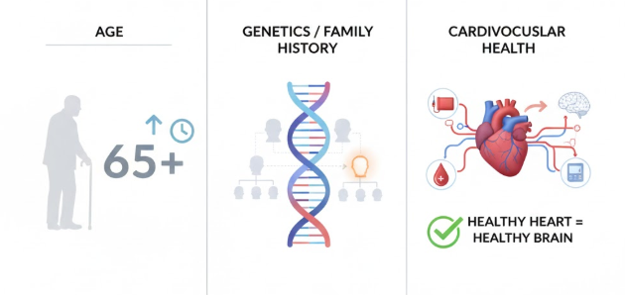
- The Lewy body dementia is caused by anomalies in the proteins found in the brain. Memory impairment, difficulties with mobility, and hallucinations are all symptoms of Alzheimer's disease and Parkinson's disease. Cognitive oscillations and visual hallucinations are associated with Lewy body dementia, which makes it difficult to diagnose (Roche et al., 2025).
Figure 4: Risk Factors for Dementia (Lopez-Lee et al., 2024)
Prevalence of Dementia
When dementia affects elderly people, it results in inability and dependence. By the year 2050, the World Health Organisation (WHO) anticipates that 152 million people will be living with Alzheimer's disease. Dementia affects around 850,000 people in the United Kingdom. By the year 2025, this number will have surpassed one million as a result of an ageing population. Diagnosis and treatment of dementia at an earlier stage can lessen the impact it has on society (Rodriguez et al., 2020).
Risk Factors for Dementia
The risk of dementia is increased by multiple variables. Changes in lifestyle and health are possible, but age and genetics cannot be altered (Vinay and Biller-Andorno, 2023).
- More persons over the age of 65 are diagnosed with dementia (Department of health, 2009).
- There is a correlation between Alzheimer's disease and the history of the patient's family. An early onset of dementia can be caused by rare genetic abnormalities (Lopez-Lee et al., 2024).
- Increased risk of vascular dementia is associated with cardiovascular health conditions such as hypertension, diabetes, and high cholesterol. Preventing dementia by maintaining a healthy heart is important (Pritam et al., 2022).

3. Physical, Psychological, and Social Impacts of Dementia
Physical Impacts
Ageing of the body is a symptom of dementia. Changes of this kind may include:
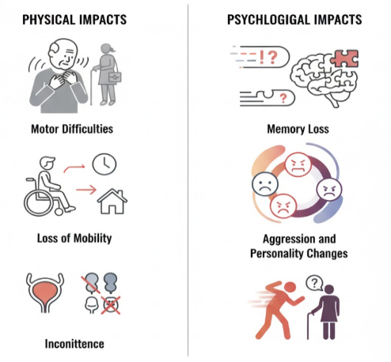
- Motor Difficulties: Movement and coordination might be affected by dementia. Especially in Parkinson's and Lewy body dementia, dementia patients may suffer walking, balance, tremors, and stiffness. It is possible that they have difficulty walking, working, and standing on their own.
- Loss of Mobility: Dementia is a condition that causes people to lose their independence. Concerns over mobility may result in an increased demand for carers and professional care (Frost et al., 2020).
- Incontinence: Because of problems with the bladder and bowels, dementia in its later stages can have a negative impact on a person's capacity to care for themselves and their dignity (Desai et al., 2024).
Psychological Impacts
In persons suffering from dementia, the following psychological impacts can be observed:
- Memory Loss: There are two types of memory loss that are symptoms of dementia: short-term and long-term. Faces, conversations, and appointments could become less clear (Pritam et al., 2022).
Figure 5: Physical Impacts
- Mood Changes: Symptoms of dementia include feelings of depression, worry, and wrath. It's possible that mood swings are made worse by a lack of independence and cognitive awareness (Scottish Government, 2017).
- Aggression and Personality Changes: A person with dementia may experience agitation and roaming. Those who care for the individual may experience distress as a result of these developments (Rossini, Miraglia and Vecchio, 2022).
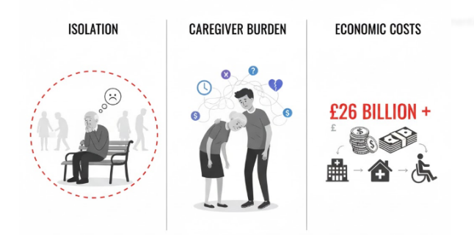
Social and Economic Impacts
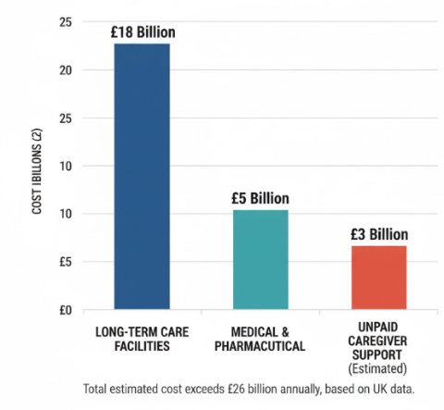
- Isolation: People with dementia may feel cut off from other people and stop doing things with others as the disease gets worse. To help people feel less alone, family and friends should support them and urge them to go to social gatherings. Isolation from others can be detrimental to one's mental and emotional wellbeing (Chouliaras and O’Brien, 2023).
Figure 6: Economic Costs of Dementia (UK) - Conceptual Breakdown of £26 Billion+ Annual Cost (Desai et al., 2024)
Figure 7: Social and Economic Impacts of Dementia
- Caregiver Burden: Carers who are members of the family must contend with a multitude of emotional, physical, and financial challenges. Being a carer may be a high-stress, exhausting, and unhealthy occupation. Carers frequently experience feelings of anxiety and depression (Desai et al., 2024).

- Economic Costs: Costs to the economy: Dementia is one of the diseases that causes the greatest financial burden on both individuals and healthcare systems. In the United Kingdom, families and social services collectively spend more than twenty-six billion pounds on dementia care. It is expensive to pay for medical care, long-term care, and carers (Roche et al., 2025).

4. Evidence-Based Treatments for Dementia
Pharmacological Treatments
- Cholinesterase Inhibitors: Galantamine, rivastigmine, and donepezil are all drugs that can help people with Alzheimer's disease. There are drugs that increase acetylcholine, a neurotransmitter that has been linked to cognitive decline (Desai et al., 2024).
- Memantine: Memantine is prescribed to Alzheimer's patients who are experiencing moderate to severe symptoms. Both memory and cognition can be improved through the control of glutamate (Lee-Cheong, Amanullah and Jardine, 2022).
- Antidepressants and Antipsychotics: Depression, anxiety, and agitation are all symptoms that can be treated with SSRIs and other medications for dementia patients. You should be warned that these medications can have adverse effects (NHS, 2021).
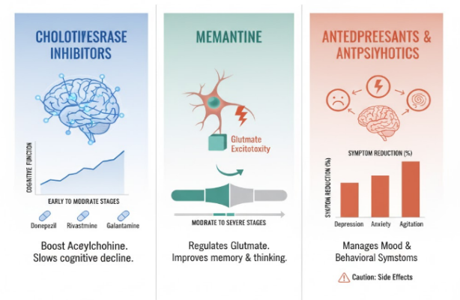
Non-Pharmacological Treatments
Figure 8: Pharmacological Treatments for Dementia

- Cognitive Stimulation Therapy (CST): This involves activities, such as puzzles, memory exercises, and group discussions to stimulate thinking and improve cognitive ability. The leisure activities not only improve the cognitive function but also the quality of life and the level of depression of people with dementia, according to research given in the findings (Lopez-Lee et al., 2024).
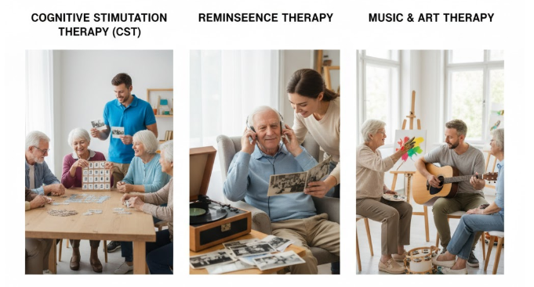
- Reminiscence therapy: Reminiscence therapy can be helpful for dementia patients by having them listen to music or view images that trigger memories of long-term events. With this therapy, you will expand your thinking, your intelligence level, and your comfort zone (NHS, 2022).
Figure 9: Non-Pharmacological Treatments for Dementia
- Music and art therapy: people with dementia could be treated with the help of music and art therapy (Roche et al., 2025).
Care Models and Approaches
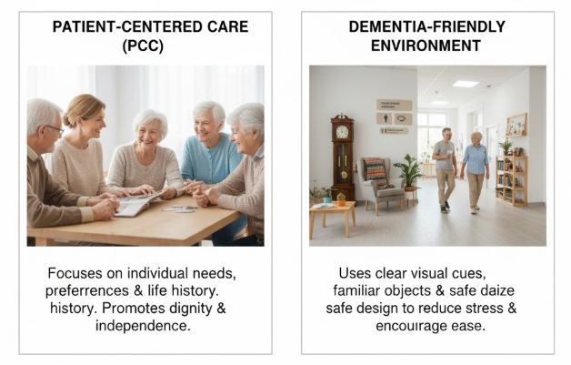
- Patient-centred care (PCC): In this approach to patient-centred treatment, the needs, preferences, and life history of the patient are primary. Great importance is given on the need to respect the dignity, interests, and self-determination of dementia patients. Person-Centred Care (PCC) can assist patients who have dementia in improving their quality of life by removing the practices that are causing them distress (Chen, 2022).
Figure 10: Care Models and Approaches

- Environment: Dementia-friendly environments help the cognitively impaired. These require visual cues, familiar objects, clear signage for people to make feel at ease in these places. Providing a safe environment that is relaxed, inviting, and comfortable reduces stress and allows for independence (Chen, 2022).

5. Theoretical Models for Dementia Management
The National Dementia Strategy: UK Model
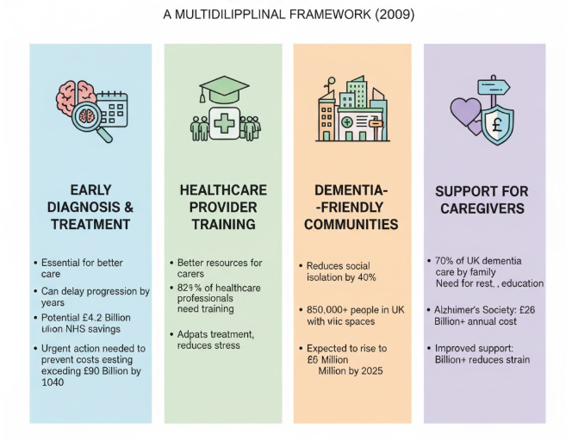
Early diagnosis, high-quality treatment, and support for both patients and carers are all encouraged by the England National Dementia Strategy, which was implemented in 2009 (Department of health, 2009).
Figure 11: The National Dementia Strategy: UK Model - A Multidisciplinary Framework (2009)

Early Diagnosis and Treatment: The early diagnosis and treatment of dementia is essential to providing better care. A two-year delay in the course of symptoms can be achieved via early therapy, which gives patients and their families additional time to adjust. Using early dementia therapy could save the United Kingdom's healthcare system £42 billion. It is possible that spending will surpass 90 billion pounds in 2040 if quick action is not taken (Frost et al., 2020).

Healthcare Provider Training: Carers for dementia patients have better resources. There is a need for dementia training among more than 82% of healthcare professionals. The ability of doctors to adapt treatment reduces stress for both patients and carers (Tan, Lo and Ho, 2024).
Dementia-Friendly Communities: In order to lessen the effects of social isolation, the strategy fosters dementia-friendly environments. More than 850,000 people in the United Kingdom have dementia, and by 2025, that number will rise to one million. Public areas and signage that are dementia-friendly reduce feelings of isolation by forty percent and make life better (Sleeman et al., 2021).
Support for Caregivers: Seventy percent of dementia care in the United Kingdom is supplied by informal carers, who are typically family members. Rest, financial assistance, and education for carers are all required. It is estimated by the Alzheimer's Society that households in the United Kingdom spend more than £26 billion on dementia care; hence, there is a need for improved carer assistance in order to reduce the emotional and financial strain (Wiggins, McEwen and Sexton, 2022).
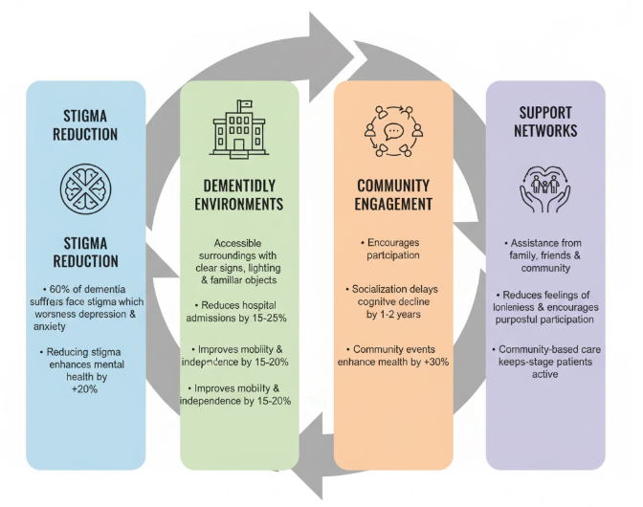
The Social Model of Dementia: Global Model
The Social Model of Dementia places an emphasis on society and the environment as a means of reducing stigma and of welcoming communities that are affected by dementia (NHS, 2021).
Stigma Reduction: The stigma associated with dementia must be reduced. Sixty percent of dementia sufferers are stigmatised, which makes issues of sadness and anxiety even worse. Research has shown that reducing stigma can enhance mental health by twenty percent (Tokovska et al., 2021).
Figure 12: The Social Model of Dementia

Creating Dementia-Friendly Environments: It is easier for dementia sufferers to avoid confusion and agitation when they are in accessible surroundings. Facilities that are dementia-friendly minimise hospital admissions by twenty-five percent and improve mobility and independence by fifteen to twenty percent. These facilities feature clear signs, lighting, and familiar surroundings (Lopez-Lee et al., 2024).
Community Engagement: Participation in the community is encouraged in accordance with the Social Model. Cognitive decline can be delayed by one to two years through socialisation. Dementia patients who maintain their independence through socialisation see improvements in both their mental health and their quality of life. According to research, attending community events enhances one's mental health by thirty percent (Hampel et al., 2022).
Support Networks: Assistance from family, friends, and the community is encouraged by the Social Model. The networks reduce the feelings of loneliness that dementia patients experience and encourage purposeful participation. Early-stage dementia patients are kept active through the provision of community-based care (Lopez-Lee et al., 2024).
The comparison of models:
A complementary relationship exists between the Social Model and the National Dementia Strategy. In contrast to the Social Model, which places an emphasis on community engagement, stigma reduction, and support networks, the National Dementia Strategy encourages medical intervention, early diagnosis, and professional treatment. Both the outcomes and the quality of life of dementia patients are improved by comprehensive clinical and social care (Rossini, Miraglia and Vecchio, 2022).

6. Current Local and National Health and Social Care Agendas
National Dementia Strategies and Policies
In dementia care, UK national aims and policies that have been developed to support patients and carers influence care. Such initiatives have been largely responsible for advancements in the diagnosis, treatment, and assistance of dementia patients (NHS, 2022).
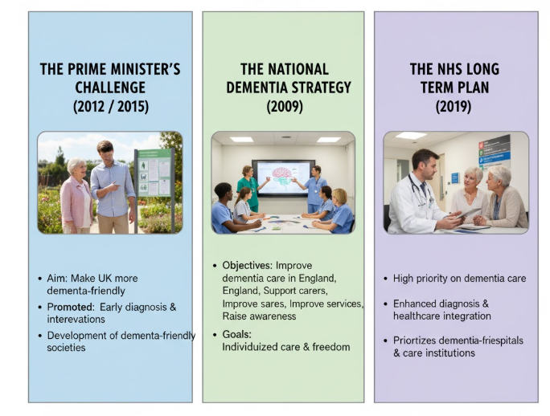
- The Prime Minister’s Challenge on Dementia (2015): Making the UK more dementia-friendly was the ambition of the Prime Minister's Challenge on Dementia launched in 2012. The early diagnosis and early intervention for people with dementia, the provision of adequate support to informal carers and the development of dementia-friendly societies have been highlighted since 2015 (Pritam et al., 2022).
Figure 13: National Dementia Strategies and Policies: UK - Key Initiatives Driving Advancement in Dementia Care

- The National Dementia Strategy (2009): The National Dementia Strategy in 2009 explored how dementia care would improve in England. Its objectives were to support carers, improve services and raise awareness The goals of the project for persons with dementia were to offer individualized care and freedom (Scheltens, 2021).
- The NHS Long Term Plan (2019): The National Health Service Long Term Plan for 2019 places a high priority on dementia care. The provision of specialised care, post-diagnostic assistance, and early diagnosis are all ways in which the diagnosis of dementia and the integration of healthcare can be enhanced. The plan gives priority to hospitals and care institutions that are dementia-friendly in order to provide high-quality treatment that is also compassionate (Lee-Cheong, Amanullah and Jardine, 2022).
Local Policy Variations and Support Services
Care for dementia patients in the United Kingdom is influenced by local policies that are reflective of regional healthcare goals and the requirements of the community. Local administrations implement national regulations in order to provide a higher level of service to their constituents (Pritam et al., 2022).
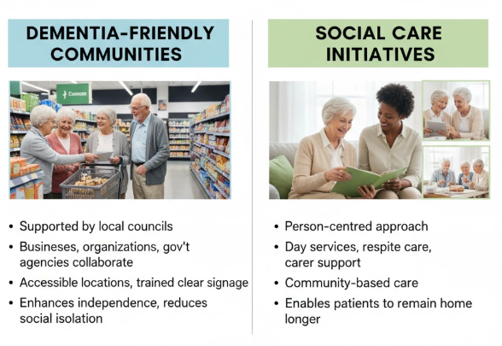
Figure 14: Local Policy Variations and Support Services
- Dementia-Friendly Communities: Communities that are dementia-friendly are supported by local governments in the United Kingdom. These communities encourage businesses, community organisations, and government agencies to assist and integrate dementia patients. Accessible locations, staff that has received enough training, and visible signage are all covered (Pritam et al., 2022).
- Social Care Initiatives: There is a person-centred approach to dementia care that is provided by local health authorities and social care providers. Patients suffering from dementia have access to day services, respite care, and support for their carers. Community-based dementia care is encouraged by local legislation, which enables patients to remain in their homes for longer periods of time (Chen, 2022).
Investment in Dementia Care Programs
Research on dementia, awareness initiatives, and novel care models are all funded by the government of the United Kingdom:
- Dementia Research Funding: Neurodegenerative disease research is funded by the National Institute of Health Research as well as the public Ssector. Research on early diagnosis, therapy, and dementia prevention is expanding in order to improve the quality of life for people living with dementia (Sleeman et al., 2021).
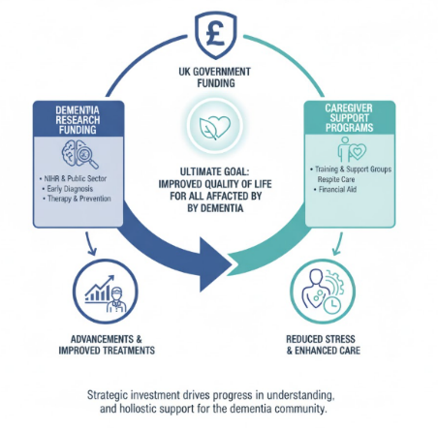
- Caregiver Support Programs Carer training, support groups, and respite care are all covered by the funding. These services make dementia carers more prepared, which in turn reduces stress and improves care (Rossini, Miraglia and Vecchio, 2022).
Figure 15: Investment in Dementia Care Programs: UK Model - Funding Innovation & Support for a Brighter Future

7. Recommendations for Person-Centered Care Approaches
It is crucial to provide dementia care that is person-centred. This paradigm places the patient's needs, preferences, and values at the forefront of consideration. Patients with dementia are afforded dignity, autonomy, and respect when they receive individualised care (NHS, 2022).
Person-Centered Care Framework
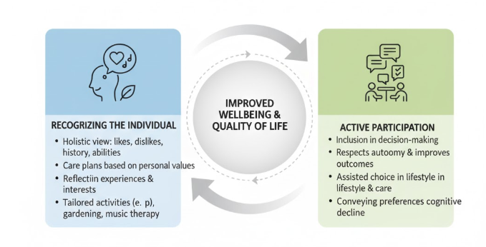
- Recognizing the Individual: A person-centred approach entails seeing the person as a whole and taking into account their likes, dislikes, and personal preferences. Care plans should be based on what is most important to the person with dementia. A history, preferences, and abilities are taken into consideration. It is important that their experiences, interests, and priorities are reflected in their care plans. Those who are interested in gardening and music may find solace in activities that take place outside and in music therapy (Wolverson et al., 2023).
- Active Participation: Patients with dementia should be included in decision-making regarding their care whenever it is feasible. Patients with dementia are able to convey their preferences and make decisions regarding their lifestyle and care with assistance, despite the fact that their cognitive abilities are deteriorating (Frost et al., 2020).
Support for Family Caregivers
Figure 16: Person-Centered Care Framework - Empowering Individuals Through Respect & Participation
Families who provide care for dementia patients encounter problems on a daily basis, both financially and emotionally. Assistance with dementia care is required for both patients and carers (Chirico et al., 2021).
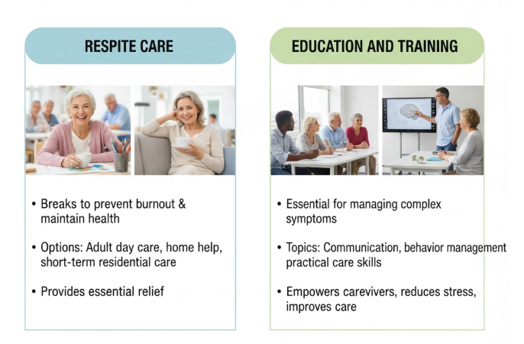
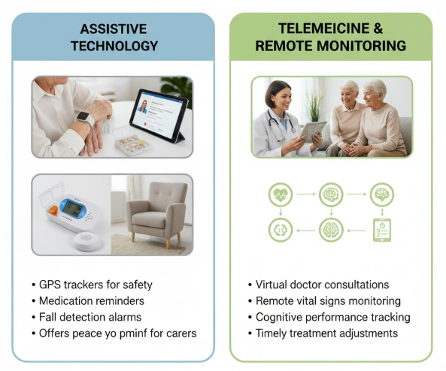
- Respite Care: Carers require breaks in order to prevent burnout and maintain their health. Adult day care, home care help, and short-term residential care are all options for carers who require a break on a regular basis (Lopez-Lee et al., 2024).
Figure 18: Use of Technology in Dementia Care - Empowering Independence & Providing Reassurance
- Education and Training: It is essential for carers with dementia to receive education and training, as they may feel unprepared to manage the complicated symptoms of dementia. Carers are given more agency and care is improved when they receive training in communication, behaviour control, and dementia care (Roche et al., 2025).
Use of Technology in Dementia Care
By utilising technology, carers can assist dementia patients in maintaining their independence (Department of health, 2009).
- Assistive Technology: People with dementia can use useful technology to make their daily lives simpler. These include alarms for when someone falls , GPS trackers for safety, and reminders to take their medicine. If these technologies are able to monitor a loved one when they are away from home, carers may have a sense of relief (Tan, Lo and Ho, 2024).
Figure 17: Support for Families and Caregivers - Addressing Daily Challenges & Preventing Burnout
Source: (Zhang et al., 2021)

8. Conclusion
Individuals, families, and healthcare providers all face a variety of challenges as a result of dementia conditions. Memory, cognitive abilities, physical health, and emotional well-being are all detrimentally affected by this degenerative condition. Carers and the community are both impacted by dementia, which is a significant public health concern.
Even though there is no cure for dementia, it's crucial to work on making life better for both the person with dementia and the person who cares for them. A good care plan can make a tremendous difference. For dementia management to be successful, early diagnosis, treatments based on scientific evidence, and personalised care are required. We are able to provide the best possible care for dementia patients, respect their dignity, and assist them in living a life of freedom if we have an understanding of their requirements, preferences, and values.
People with Alzheimer's disease (AD) can gain more independence and safety with activities as well as increased functioning within the capacity for the carer. Telemedicine, cognitive aides, and assistive technologies can all improve the quality of life of dementia patients and their caretakers.
There is worth in familial carers Dementia leaves carers with emotional, physical and financial burdens. As long as they are given respite, education and emotional support, carers can provide high quality care without risking their own well-being.

9. References
- Akinyemi, R.O., Yaria, J., Ojagbemi, A., Guerchet, M., Okubadejo, N., Njamnshi, A.K., Sarfo, F.S., Akpalu, A., Ogbole, G., Ayantayo, T., Adokonou, T., Paddick, S., Ndetei, D., Bosche, J., Ayele, B., Damas, A., Coker, M., Mbakile‐Mahlanza, L., Ranchod, K. and Bobrow, K. (2021). Dementia in Africa: Current evidence, knowledge gaps, and future directions. Alzheimer’s & Dementia, 18(4). doi:https://doi.org/10.1002/alz.12432.
- Beard, R.L. (2016). Living with Alzheimer’s. NYU Press.
- Chen, X. (2022). Effectiveness of Cognitive Stimulation Therapy (CST) on cognition, Quality of Life and Neuropsychiatric Symptoms for Patients Living with dementia: a meta-analysis. Geriatric Nursing, [online] 47(9), pp.201–210. doi:https://doi.org/10.1016/j.gerinurse.2022.07.012.
- Chirico, I., Chattat, R., Dostálová, V., Povolná, P., Holmerová, I., de Vugt, M.E., Janssen, N., Dassen, F., Sánchez-Gómez, M.C., García-Peñalvo, F.J., Franco-Martín, M.A. and Ottoboni, G. (2021). The Integration of Psychosocial Care into National Dementia Strategies across Europe: Evidence from the Skills in DEmentia Care (SiDECar) Project. International Journal of Environmental Research and Public Health, 18(7), p.3422. doi: https://doi.org/10.3390/ijerph18073422.
- Chouliaras, L. and O’Brien, J.T. (2023). The use of neuroimaging techniques in the early and differential diagnosis of dementia. Molecular Psychiatry, 28.
- Department of health (2009). National Dementia Strategy Living well with dementia: A National Dementia Strategy Putting People First. [online] Available at: https://assets.publishing.service.gov.uk/media/5a7a15a7ed915d6eaf153a36/dh_094051.pdf [Accessed 12 Nov. 2025].
- Desai, R., Leung, W.G., Fearn, C., John, A., Stott, J. and Spector, A. (2024). Effectiveness of Cognitive Stimulation Therapy (CST) for mild to moderate dementia: A systematic literature review and meta-analysis of randomised control trials using the original CST protocol. Ageing Research Reviews, [online] 97(1), p.102312. doi:https://doi.org/10.1016/j.arr.2024.102312.
- Dubois, B., Villain, N., Frisoni, G.B., Rabinovici, G.D., Sabbagh, M., Cappa, S., Bejanin, A., Bombois, S., Epelbaum, S., Teichmann, M., Habert, M.-O., Nordberg, A., Blennow, K., Galasko, D., Stern, Y., Rowe, C.C., Salloway, S., Schneider, L.S., Cummings, J.L. and Feldman, H.H. (2021). Clinical diagnosis of Alzheimer’s disease: recommendations of the International Working Group. The Lancet Neurology, 20(6), pp.484–496. doi:https://doi.org/10.1016/S1474-4422(21)00066-1.
- Frost, R., Walters, K., Wilcock, J., Robinson, L., Harrison Dening, K., Knapp, M., Allan, L. and Rait, G. (2020). Mapping post-diagnostic dementia care in England: an e-survey. Journal of Integrated Care, 29(1), pp.22–36. doi:https://doi.org/10.1108/jica-02-2020-0005.
- Hampel, H., Vergallo, A., Iwatsubo, T., Cho, M., Kurokawa, K., Wang, H., Kurzman, H.R. and Chen, C. (2022). Evaluation of major national dementia policies and health‐care system preparedness for early medical action and implementation. Alzheimer’s & Dementia, 18(10). doi:https://doi.org/10.1002/alz.12655.
- Lee-Cheong, S., Amanullah, S. and Jardine, M. (2022). New assistive technologies in dementia and mild cognitive impairment care: A PubMed review. Asian Journal of Psychiatry, [online] 73, pp.103–135. doi:https://doi.org/10.1016/j.ajp.2022.103135.
- Lopez-Lee, C., Ruth, E., Carling, G. and Gan, L. (2024). Mechanisms of sex differences in Alzheimer’s disease. Neuron, 112(8). doi:https://doi.org/10.1016/j.neuron.2024.01.024.
- National Health Service (2022) Personalised palliative and end of life care. Available at: https://www.england.nhs.uk/eolc/personalised-care/ (Accessed: 12 November 2025)
- National Health Service (2022) Social Prescribing. Available at: https://www.england.nhs.uk/personalisedcare/social-prescribing/ (Accessed: 12 November 2025)
- National Health Service (2021) Long Term Plan. Available at: https://www.longtermplan.nhs.uk/wp-content/uploads/2019/01/the-nhs-long-term-plan-summary.pdf (Accessed: 12 November 2025)
- National Health Service (2021) Supported self management. Available at: https://www.england.nhs.uk/personalisedcare/supported-self-management/ (Accessed: 12 November 2025)
- National Health Service (2021) Care coordination. Available at: https://www.england.nhs.uk/personalisedcare/supported-self-management/care-co-ordination/ (Accessed: 12 November 2025)

- Pritam, P., Deka, R., Bhardwaj, A., Srivastava, R., Kumar, D., Jha, A.K., Jha, N.K., Villa, C. and Jha, S.K. (2022). Antioxidants in Alzheimer’s Disease: Current Therapeutic Significance and Future Prospects. Biology, 11(2), p.212. doi:https://doi.org/10.3390/biology11020212.
- Reuben, D.B., Kremen, S. and Maust, D.T. (2024). Dementia prevention and treatment: A narrative review. JAMA Internal Medicine, [online] 184(5). doi:https://doi.org/10.1001/jamainternmed.2023.8522.
- Roche, M., Del‐Pino‐Casado, R., Leung, P. and Orgeta, V. (2025). Time to Diagnosis in Dementia: A Systematic Review With Meta‐Analysis. International Journal of Geriatric Psychiatry, 40(7). doi:https://doi.org/10.1002/gps.70129.
- Rodriguez , F.S., Jackson, J., Ware, C., Churchyard, R. and Hanseeuw, B. (2020). Interdisciplinary and Transdisciplinary Perspectives: On the Road to a Holistic Approach to Dementia Prevention and Care. Journal of Alzheimer’s Disease Reports, [online] 4(1), pp.39–48. doi: https://doi.org/10.3233/ADR-180070.
- Rossini, P.M., Miraglia, F. and Vecchio, F. (2022). Early dementia diagnosis, MCI‐to‐dementia risk prediction, and the role of machine learning methods for feature extraction from integrated biomarkers, in particular for EEG signal analysis. Alzheimer’s & Dementia. doi:https://doi.org/10.1002/alz.12645.
- Scheltens, P. (2021). Alzheimer’s disease. The Lancet, [online] 397(10284), pp.1577–1590. doi:https://doi.org/10.1016/S0140-6736(20)32205-4.
- Sleeman, K.E., Timms, A., Gillam, J., Anderson, J.E., Harding, R., Sampson, E.L. and Evans, C.J. (2021). Priorities and opportunities for palliative and end of life care in united kingdom health policies: A national documentary analysis. BMC Palliative Care, [online] 20(1). doi:https://doi.org/10.1186/s12904-021-00802-6.
- Scottish Government (2017). National dementia strategy: 2017-2020 - gov.scot. [online] www.gov.scot. Available at: https://www.gov.scot/publications/scotlands-national-dementia-strategy-2017-2020/pages/4/ [Accessed 12 Nov. 2025].
- Tan, Y.L., Lo, Y.K.J. and Ho, C.S.H. (2024). Psychological and social impacts of frontotemporal dementia on caregivers and family members – A systematic review. General Hospital Psychiatry, [online] 86, pp.33–49. doi:https://doi.org/10.1016/j.genhosppsych.2023.11.011.
- Tokovska, M., Nour, M.M., Sørensen, A. and Småland Goth, U. (2021). Informal caregivers and psychosocial support: Analysis of European Dementia Policy documents. Journal of Public Health Research, 11(1). doi:https://doi.org/10.4081/jphr.2021.2416.
- van Dyck, C.H., Swanson, C.J., Aisen, P., Bateman, R.J., Chen, C., Gee, M., Kanekiyo, M., Li, D., Reyderman, L., Cohen, S., Froelich, L., Katayama, S., Sabbagh, M., Vellas, B., Watson, D., Dhadda, S., Irizarry, M., Kramer, L.D. and Iwatsubo, T. (2022). Lecanemab in Early Alzheimer’s Disease. New England Journal of Medicine, [online] 388(1), pp.9–21. doi:https://doi.org/10.1056/nejmoa2212948.
- Vinay, R. and Biller-Andorno, N. (2023). A Critical Analysis of National Dementia Care Guidances. Health Policy, [online] 130, p.104736. doi:https://doi.org/10.1016/j.healthpol.2023.104736.
- Wiggins, M., McEwen, A. and Sexton, A. (2022). Young-onset dementia: A systematic review of the psychological and social impact on relatives. Patient Education and Counseling, 107(107585), p.107585. doi:https://doi.org/10.1016/j.pec.2022.107585.
- Wolverson, E., Hague, L., West, J., Teague, B., Fox, C., Birt, L., Mills, R., Rhodes, T., Sams, K. and Esme Moniz-Cook (2023). Building an initial understanding of UK Recovery College dementia courses: a national survey of Recovery College and memory services staff. Working with older people. doi:https://doi.org/10.1108/wwop-02-2023-0003.
- Zhang, X.-X. ., Tian, Y., Wang, Z.-T. ., Ma, Y.-H. ., Tan, L. and Yu, J.-T. . (2021). The epidemiology of alzheimer’s disease modifiable risk factors and prevention. The Journal of Prevention of Alzheimer’s Disease, [online] 8(8), pp.1–9. doi:https://doi.org/10.14283/jpad.2021.15.

