

MODULE CODE: ECPT6006

ASSESSMENT COMPONENT: A Critical Evaluation of the Role of Digital Innovation in Professional Practice

STUDENT NAME:Matthew Walters

STUDENT NUMBER:0452477

Use of Generative AI in Assessment

(Lecturer to indicate Yes or No against each element)

RESEARCH | For this assessment, you can use Generative AI to support you in research, including searching for bibliography, using tools to summarise, compare and interrogate materials. | Yes ☒  No ☐
STRUCTURE | For this assessment, you can use Generative AI to support you in structuring your submission, including creating a draft argument structure, identifying parts and headings, etc. | Yes ☒  No ☐
PROOFREADING | For this assessment, you can use Generative AI to check your own text/creation for grammatical and syntactical mistakes, including rephrasing of your own work within specific standards. | Yes ☒  No ☐
WRITING | For this assessment, you can use Generative AI to create text for submission. | Yes ☐  No ☒
CREATIVE | For this assessment, you can use Generative AI to create creative materials, such as images. | Yes ☒  No ☐
PROGRAMING | For this assessment, you can use Generative AI to create and check code. | Yes ☐  No ☒
NONE | For this assessment, you are not allowed to use any type of Generative AI support. This includes research support, structure support, writing/proofreading support and creative support. | Yes ☐  No ☒

General Introduction
Section 1 looks the tension between the rapid integration of digital tools and platforms into education and societal implications On one hand, digital innovation offers unlimited opportunities for creativity, collaboration, and self directed learning. On the other, it raises critical concerns about equity, inclusion,the digital divide, and the erosion of humanistic values in education. The first section draws on the importance of a community of learning based on a traditional constructavist pedagogy which can maintain the primary importance of people working together to learn. It suggests that this should be maintained in relational to digitals tools and platforms which may be run by individuals and businesses who are openly hostile to those values.
This idea of a community of learning informs the other stages of the report.The second section looks at the specific use of the digital tool Youtube in an Art education setting which is widely available and can be accessed via public library for those do not have a computer. This is a widely available tool and is familiar to nearly all students in further and higher education. This section also suggests that this digital tool is at it’s best when used within a guided learning environment.
The third section looks at the specific experience of teaching the subject of film development and the practical usage of Youtube.
Section 4 reflects on the use of Youtube using the TPACK model, the Kolb reflective model and the professional and digital standards for Wales.

SECTION 1

Introduction to literature review

This literature review will examine two opposing tendencies in digital innovation and technology. The positivistic technical view which celebrates the creative possibilities of digital tools and platforms against the humanistic worries over the control that digitisation and big data has within society in general and the post 16 education sector specifically. It will look at : 1. the area of digital creativity, innovation and collaborative learning with digital tools. 2.Equity and inclusion for learners in digital education in relation to technology 3.Pedagogical responses to digital innovation These areas will also be examined in the light of the Digital Standards Framework for Welsh Post-16 Education.
To what extent does creativity within digital innovation have to be balanced against equity and inclusion for learners? Are humanistic values of higher education capable of being protected when operating in a technological field dominated by global corporations? We are living in an era of politicised political learning where different social groups are separated from each other by calculated public networks which give different groups different data. Williamson refers to the various digital platforms as examples of public pedagogies.
“The mis-education of democratic society by the public pedagogies of big data and social media is being enabled by algorithmic techniques that are designed to optimize and personalize people’s everyday experience in digital environments. But in the name of personalisation and optimization the same techniques are leading to post truth forms of mis-education and democratic polarisation.”
(Williamson et al 2017)

1. Digital creativity, innovation and collaborative learning with digital tools.

Definition of creativity
Before defining digital creativity, it must be realised that the area of creativity has a huge literature (Samper Marquez 2025) and can be defined in many ways.
For example, as Csikszentmihalyi has observed a creative individual takes part in a state of flow, a mental and psychological state in which the person is so fully immersed in an activity that he or she loses all sense of time. (Shin, 2010)
Creativity is the ability of a person to create specific methods and techniques can positively influence, develop and stimulate. It produces new and acceptable ideas, solutions and actions.(Bajuzova,)

Digital tools positives and negatives

Digital tools and platforms have transformed communication, creativity and human interaction. In the field of education digital creators need a combination of digital competence and creativity. Digital competence refers to the development of skills such as information literacy, communication and digital content creation. (Guillén-Gámez F.D.2023) Digital creativity emerges from the meeting of digital competence and creativity.(Lee M.R. 2015) . The usage of digital tools and platforms in education has both benefits and costs. Digital tools when used correctly can inspire student engagement ,comprehension, autonomy and collaboration.This can motivate students to apply digital tools to their academic work by fostering higher order cognitive skills such as critical thinking and problem solving. Digital creativity can also promote emotional resilience in students by encouraging them to engage in trial and error approaches to learning activities.Digital creativity fosters collaboration by enabling individuals to work together across geographical boundaries. Tools like social media, cloud-based platforms, and virtual learning environments democratize access to creative resources, allowing diverse groups to participate in creative processes (Ali et al., 2019; Tang et al., 2022). This inclusivity promotes a broader range of perspectives, enriching creative outcomes.
On the other hand digital tools can often rely on asynchronous communication and virtual interactions, which can hinder the development of critical social skills. Selwyn (2021) argues that over-reliance on digital tools can lead to a decline in empathy, teamwork, and communication skills. While digital platforms offer amazing opportunities for collaboration, they cannot replicate the nuanced dynamics of in-person interactions.Dependence on digital tools can stifle analogue creativity, such as hands-on art or traditional problem-solving methods. This over-reliance may limit the development of diverse skill sets (Harwood, 2013). Digital pedagogy risks creating an over-reliance on technology, which can undermine critical thinking and creativity. Traditional pedagogy encourages students to engage deeply with content through reading, writing, and discussion, fostering independent thought. In contrast, digital tools such as AI-powered writing assistants and automated grading systems may discourage students from developing these skills. As Luckin et al. (2022) note, while AI can support learning, it can also lead to passive engagement, where students rely on technology to provide answers rather than thinking critically for themselves.

2.Equity and inclusion for learners in digital education in relation to technology
Technology can result in distraction, diminished social interactions, and feelings of low self-esteem. Teachers need to be aware of these issues and at the same time be prepared to integrate digital creativity into their teaching practice. Properly trained teachers can also help students to reflect critically on online information and belief systems. Teachers need to cultivate digital skills in collaboration with students and maintain an indication on space when using digital tools which originate in a corporate value system. The values of these tools may be disruptive or even counter to the values of the institution.One of the most significant dangers of digital pedagogy is its potential to exacerbate educational inequalities. Traditional pedagogy, which relies on face-to-face interactions in physical classrooms, ensures that all students have equal access to resources and support. In contrast, digital pedagogy often depends on access to reliable internet, devices, and digital literacy, which are not universally available. Research by Czerniewicz et al. (2020) highlights how the COVID-19 pandemic exposed the digital divide, with marginalized students disproportionately affected by the shift to online learning. This inequity risks leaving behind those who lack the necessary resources, perpetuating existing social and economic disparities.
The digital divide in education refers to the gap between those who have access to digital technologies and the internet and those who do not, exacerbating inequalities in learning opportunities. This divide is influenced by socio-economic status, geographic location, and infrastructure availability. Some students will lack reliable internet access or devices, hindering their ability to participate in online learning (Van Dijk, 2020). Also the digital divide extends beyond access to include disparities in digital literacy skills, which are essential for navigating online platforms effectively (Warschauer, 2004). While addressing this divide requires solutions, such as providing money for internet costs, providing affordable devices, and offering digital skills training, the divide can also be seen as a divide in how people are affected by the new technologies in their perceptions of the world and institutions. Governments and educators must collaborate to ensure equitable access to technology, enabling all students to cope in a digital educational landscape.

.
3.Pedagogical responses to digital innovation

The integration of digital technologies has led to the development of pedagogical approaches that prioritize creativity and innovation. These approaches often emphasize active learning, interdisciplinary collaboration, and the use of digital tools. Design Thinking and Digital Creativity: Design thinking, a problem-solving approach that emphasizes empathy, experimentation, and iteration, has gained traction in higher education. Studies by Koh et al. (2021) highlight how digital tools can enhance the design thinking process by enabling rapid prototyping and user testing. For instance, 3D printing and digital modeling software allow students to bring their ideas to life in ways that were previously impossible.Project-Based Learning (PBL): PBL has been widely adopted as a means of fostering creativity and innovation. Digital tools play a crucial role in PBL by facilitating research, collaboration, and presentation. According to Bell (2020), digital PBL projects that incorporate multimedia elements (e.g., videos, podcasts, and interactive websites) can help students develop both technical and creative skills.

We are living in a period of personalised political learning, alternative perspectives are being systematically curated out of our feeds. These are public pedagogies of political mis-education polarizing public opinion along different information and education spheres. The whole experience of going to university is mediated through digital systems(Beetham H, 2020)

In contrast to this very established pedagogies such Freire’s focus on dialogue and collective empowerment aligns with the principles of a learning community. Bruner’s idea of scaffolding, where more knowledgeable individuals support learners in achieving their potential.Bruner’s work emphasizes the role of collaboration and shared cultural tools in fostering learning. Nel Noddings argued for a relational approach to education, where caring relationships between teachers and students form the foundation of learning. She emphasized the importance of creating supportive, inclusive communities.
Conclusion
The literature reflects a tension between generally positive psychology and technology based studies (often done on very small sample groups of students) which celebrate digital creativity and a literature which looks more at the politics and control elements of the new technology which seems to offer a more convincing picture of the great difficulties which exist in using technologies which contain massive societal and political influence and which have the power to destabilise institutions.
“While we were focusing on the classroom applications of these tools, we did not think about their broader social impact. We were not prepared for how social media would disrupt the body politic at large through the spread of misinformation and fake news. We did not consider how these technologies of connection might disrupt our world at a global scale. Yet, there is increasing evidence that the use of social media reduces trust in government, news media, and institutions by increasing polarization and the spread of misinformation” (Mishra 2023)
In the above quote one of the developers of the TPACK learning model addresses the fact that in this even newer age of digital development educators will have to adapt existing psychological models to take in the effects of the new technologies on learners sense of self and also their mental health. As well as the political implications of technological change.
I’ve chosen to use Youtube as my digital tool, and I’ve chosen to use it as a part of a cognitive learning framework. Creativity can still simply be defined in line with the zone of proximal development as people pass knowledge on from one to the other. The further and higher education systems are characterised by their values as well as by their resources and equipment and it is the maintaining of values through working collaboratively with students and offering guidance. This relies on teachers being given more training in the specific area of the philosophy and application of digital technology to maintain an educational area within a wider corporate controlled framework which may contain values hostile to the educational environment. Just because new technology is available doesn’t mean it is the best tool for the job. The values of meaningful community interaction need to be at the heart of education and the choice and uptake of digital systems needs to be seen as not a positivistic technology choice, but fundamentally a political choice.
References
Bajuzova, J, Hrmo, R Digital Tools in Education, The Impact of Digital Tools in Education on Student Creativity.
Beetham, H. (2020) Rethinking Pedagogy for a Digital Age: Principles and Practices of Design. 3rd edition. Routledge.

Bell, S. (2020). Project-Based Learning for the 21st Century: Skills for the Future. Journal of Educational Technology Systems, 49(1), 3-16.
Guillén-Gámez F.D., Ruiz-Palmero J., Gómez-García M.(2023) Digital competences in research: Creativity and entrepreneurship as essential predictors for teacher training. J. Comput. Educ.
Händel, M., Stephan, M., Gläser-Zikuda, M., et al. (2020). Digital Readiness and Its Effects on Higher Education Students’ Socio-Emotional Perceptions in the Context of the COVID-19 Pandemic. Journal of Research on Technology in Education, 53(2), 1-13.
Henriksen, D., Hoelting, M. and Deep-Play Research Group, (2016). A systems view of creativity in a YouTube world. TechTrends, 60, pp.102-106.
Koh, J. H. L., Chai, C. S., & Lim, W. Y. (2021). Teacher Professional Development for TPACK-21CL: Effects on Teacher ICT Integration and Student Outcomes. Journal of Educational Computing Research, 59(2), 315-343.
Lee M.R., Chen T.T. Digital creativity(2015): Research themes and framework. Comput. Hum. Behav.
Punya Mishra, Melissa Warr & Rezwana Islam (2023): TPACK in the age of ChatGPT and Generative AI, Journal of Digital Learning in Teacher Education,

Shin, R. (2010). Taking digital creativity to the art classroom: Mystery box swap. Art Education, 63(2), 38–42.
Selwyn, N. (2021). Should Robots Replace Teachers? AI and the Future of Education. Polity Press.
Tang, C., Zhang, X., & Li, Y. (2022). Digital technology and creativity in education: A systematic review. Educational Sciences, 12(5), 202.
van Dijk, J. A. G. M. (2020). The Digital Divide. Polity Press.
Warschauer, M. (2003). Technology and Social Inclusion: Rethinking the Digital Divide. MIT Press.
Williamson, B. (2017) Big data in education : the digital future of learning, policy and practice . London :, SAGE Publications Ltd.

SECTION 2

Introduction

The digital tool I have chosen to implement is the video sharing platform Youtube. In the last twenty years YouTube has become a global platform for both formal and informal education . Founded in 2005 ,it serves many different purposes apart from entertainment. It has contained education channels since it's inception eg TED talks and Khan Academy amongst many others. It also contains millions of Educational videos uploaded on different topics by individuals which cover any educational interest that one could hope for. A scoping review of the literature on Youtube and Education found(Shofan et al, 2022) three areas of uncertainty.1.The reliability of the learning content on Youtube. 2. Best practice strategies for using this platform and 3. How watching Youtube affects students’ performance and behavior.

The usage of Youtube was in line with constructivist pedagogy, the TPAK model of integrating technology and the digital standards as outlined in the Welsh government paper Digital 2030. Youtube was used as a digital tool to demonstrate the techniques of developing movie film in coffee. The negative was scanned into the computer and shared on youtube. This is a sustainable darkroom practice used by the teacher to demonstrate key features of this technique, production of a negative, hand developing leading to marks and scratches. Another negative was further developed by a learner where it was switched to a positive, music was added. It was then uploaded to Youtube then presented as part of a Phd presentation.

- Reliability of the learning content on Youtube

A findings about Youtube that has been raised in pedagogical literature which can be relevant to it’s is the issue of content quality on YouTube and how learners and teachers can find good material. It can be difficult for students to assess the value of the video presented eg fake news, incorrect description, slated slanted videos and offensive content. The reliability of educational content on YouTube was highlighted in a study( Maraza- Quipe et al 2024) which demonstrated that higher quality videos on those with better accuracy and technical quality led to an improvement in learning. The experimental group using these high quality videos found a 20% increase in evaluation scores compared to the control group. Another study by Fyfield (Fyfield 2020) highlighted the significant influence of algorithms on video selection indicating that the platforms themselves shape education practice.Digital platforms are integrated into educational institutions yet they remain at the same time beyond institutional control.
YouTube videos may sometimes contain misleading or biased information raising concerns about reliability and content quality(Goodman and Carmichael 2020) Quality assessment is part of the curation process by lecturers to maximize the educational value. One method suggested (Susan et al 2024) is a rubric to evaluate the quality of using generated content.

2.Best practice strategies for using YouTube.

Recently the right of using generated content in an educational setting has been explored in more detail. This is known as learner generator content LGC ( Sada at al ,2020) which can significantly enhance the learner experience. It involves students engaging more actively with learning material by creating sharing and evaluating content. A study of first year students showed that students prefer videos made by their illustrator of instructor over those made by other people (Pires et al, 2013) and the same study explained that shorter videos under 15 minutes are preferred.

3. Students performance and behaviour

Learner generated content (LGC) help learners engage in discussions ,share ideas and create learning communities which enhanced knowledge building. Video content can be created by students and teachers and mixed with or supported by existing YouTube content.

Constructivism, TPAK and digital standards.

This procedure is in line with constructivist educational theory where a more knowledgable other provides the scaffolding within the zone of proximal knowledge to provide the learning opportunity. The student and the teacher are in a community of knowledge that can only be fostered by the use of technology.
The usage of Youtube in this way aligns with the Welsh digital standards of digital 2030. These standards have been created in line with Welsh professional standards in higher education and with the SAMR model of technological integration which allows for different levels of technological incorporation split between enhancement and transformation.

Conclusion
The quality and reliability of YouTube content can be a problem in educational settings.. Self-guided learning through YouTube presents challenges such as false information and varying educational qualities. Two strategies can help address these issues: (1) guided learning, where educators curate the content, and (2) learning by doing, where students generate their own videos as part of the learning process. UGC can be used effectively as Learner Generated Content(LGC) in a guided classroom setting.
References

- Anderson, T., & Dron, J. (2012). Rethinking pedagogy for a digital age: Principles and practices of design. Routledge.
- Fyfield, M., Henderson, M., & Phillips, M. (2020). Navigating four billion videos: Teacher search strategies and the YouTube algorithm. Learning, Media and Technology, 46(1), 47-59.
- Maraza-Quispe, B., Rosas-Iman, V.H., Quispe-Flores, L.M., et al. (2024). Evaluating the effectiveness of YouTube as a tool for research in higher education students: An experimental approach. SN Computer Science, 5
- Pires, F., Masanet, M.-J., & Scolari, C.A. (2019). What are teens doing with YouTube? Practices, uses, and metaphors of the most popular audio-visual platform. Information, Communication & Society, 24(9), 1175-1191.
- Persada, S., Ivanovski, J., Miraja, B., Nadlifatin, R., Mufidah, I., Chin, J., & Redi, A. (2020). Investigating Generation Z's intention to use learner-generated content for learning activities: A theory of planned behavior approach. International Journal of Emerging Technologies in Learning, 15(4), 179-194.
- Shoufan, A. and Mohamed, F., 2022. YouTube and education: A scoping review. IEEE Access.
- Suson, R., et al. (2024). Quasi-experimental quality evaluation of educational-purposed user-generated content under a stochastic multi-criteria environment. Applied Artificial Intelligence, 38(1).

SECTION 3

Lesson Plan: Developing 8mm Film in Coffee with Vitamin C, Scanning, and Sharing on YouTube
Objective: By the end of this lesson, students will:
- Explore and experiment with the process of developing 8mm film using coffee and Vitamin C.
- Construct knowledge about the film development process through trial, error, and reflection.
- Engage in collaborative learning through discussions and sharing theresults on YouTube.
- Reflect on the creative and technical challenges of the project and how their understanding of film development evolves.

Duration: 3 parts
- Part 1: Developing the Film – 1.5 hours
- Part 2: Scanning and uploading the Film – 30 minutes
- Part 3: Discussing Results – 30 minutes

Materials Needed:
- 8mm Film Roll (exposed and ready to be developed)
- Coffee (instant ) – 500ml
- Vitamin C Powder (ascorbic acid) – 1–2 tsp
- Sodium Carbonate (washing soda) – 1-2 tbsp
- Scissors or film splicing tools
- Film Reel or developing tank for 8mm film
- Digital Scanner for Film ( dedicated film scanner)
- Computer
- Plain water (for rinsing)

Constructivist Approach:
In this lesson,the lecturer works with the student as the more knowledgeable other in the process of developing film.

Part 1: Developing 8mm Film in Coffee with Vitamin C (1.5 hours)
1. Explain history and process (15 minutes): A brief introduction to the Caffenol process and traditional film development?
2. Collaborative Exploration: Preparing the Developer (20 minutes): Student helps to prepare the developing solution by mixing:500ml of coffee (or 2 tbsp of instant coffee in water)1-2 tbsp of sodium carbonate,1–2 tsp of Vitamin C powder
3. Developing the Film (30 minutes):
The demonstrator develops the film in the solution
4. Rinsing and Drying (15 minutes):
Film is rinsed and dried

Part 2: Scanning the Film (30 mins)
Demonstrator scans film

Part 3: Demonstrating and Discussing Results (30 minutes)
The student projected the film to other phd students from the youtube website as part of a philosophical project to do with film and the perception of time The student loaded the film onto their own Youtube channel. The student then added music to the film and created several iterations.

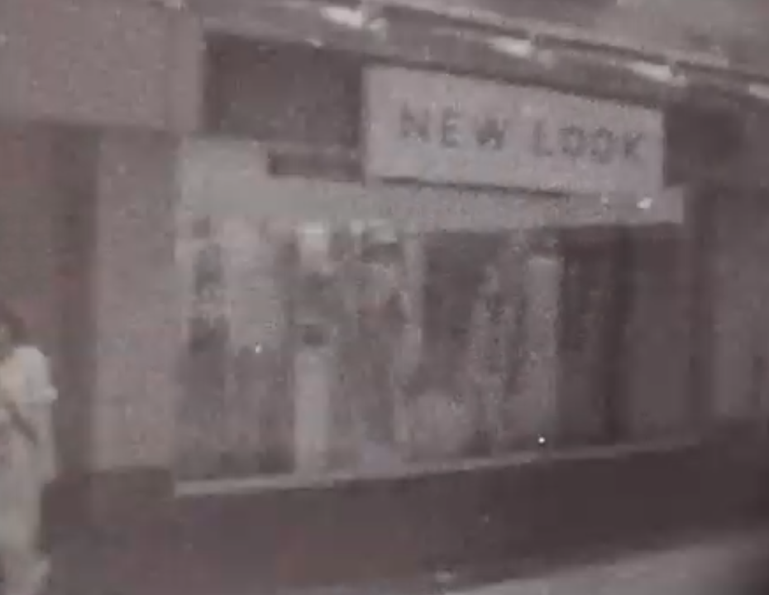

Student’s developed film. The look is very primitive and grainy, but one can see that it is a shot of the high street. The film was slowed down and the student used AI to compose some eerie music to go with the shots

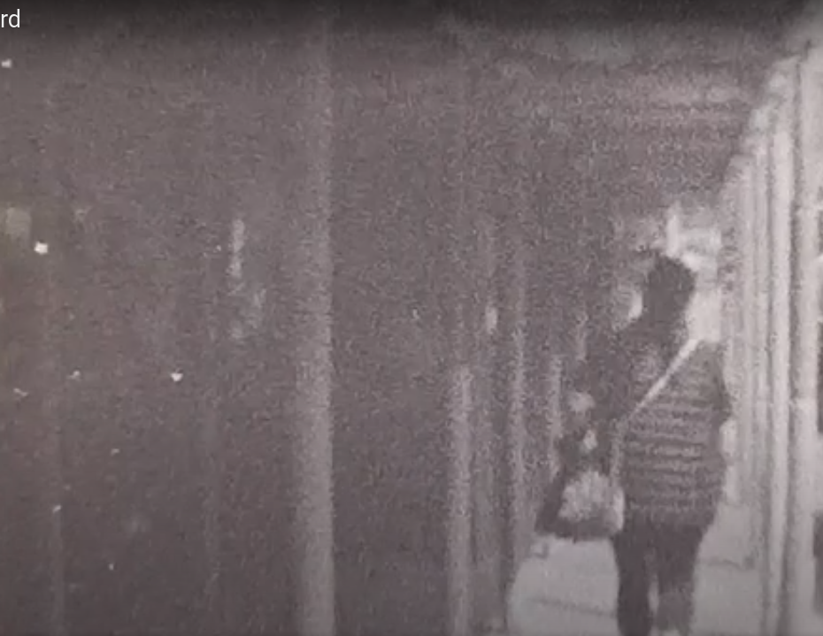
From the same reel of film , we can see a person walking away from the camera under some scaffolding (appropriate visual metaphor!)


Sometimes the film shows some of the marks due to it being developed piled on top of each other, but these marks add texture and interest that would be difficult to create digitally.
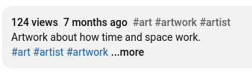Screenshot from youtube screen (with students permission) It can be seen that the views while tiny by Youtube standards are far higher than the piece of work achieved in the university setting (where it was shown to 5 people) with more keywords and an opened up comments section it would generate more dialogue.

SECTION 4
Reflective practice on lesson

I will reflect on the use of Youtube in an educational setting using the TPAK model, the Kolb reflective cycle and the professional digital standards for Wales.

The TPACK model

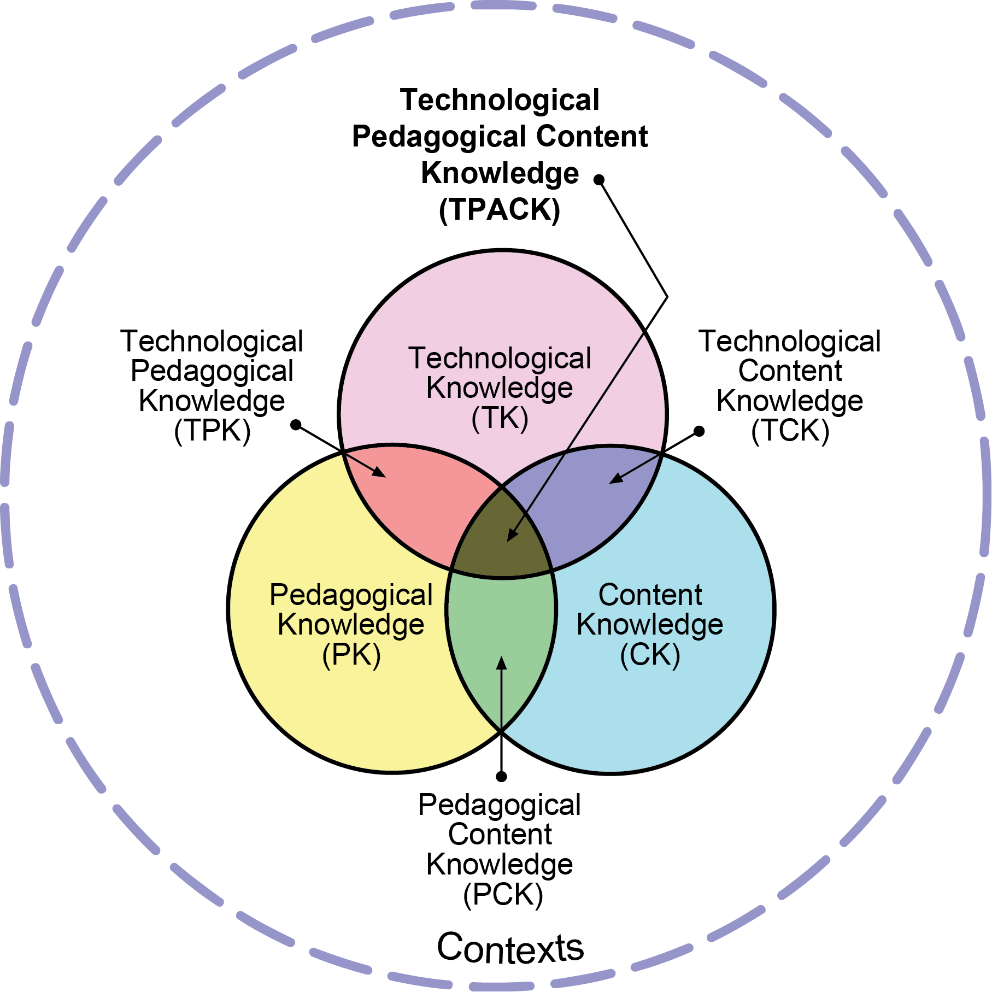

TPACK

The Technological Pedagogical Content Knowledge framework, developed by Koehler and Mishra (2009), examines the relationship between three core knowledge domains: Content Knowledge (CK) (subject matter expertise), Pedagogical Knowledge (PK) (teaching methods), and Technology Knowledge (TK) (using technology tools). Beyond these, TPACK explores their intersections: Pedagogical Content Knowledge (PCK) (teaching specific content effectively), Technological Content Knowledge (TCK) (how technology shapes content delivery), and Technological Pedagogical Knowledge (TPK) (how technology influences teaching). Where all three cross —Technological Pedagogical Content Knowledge (TPACK)—forms the foundation for effective technology-enhanced teaching.
TPACK shows that teaching with technology is context-dependent, thinking about technology, pedagogy and content knowledge. It encourages teachers to adapt their strategies to each classroom situation. Effective technology integration involves understanding how to represent concepts using technology, design lessons that are in line with pedagogy, and look at students' learning needs.
The framework demonstrates the need for teacher training that will integrate technology, pedagogy, and content knowledge, rather than treating them as separate domains. By fostering reflective practice and personalized strategies, TPACK equips educators to create meaningful, technology-enhanced learning experiences tailored to their students' needs.

TPACK applied to film developing lesson

Content Knowledge

The content knowledge was rooted in examining the science and art of film development and the environmental benefits of using a coffee developer. Coffee works as a developer of film because it contains caffeic acid, a phenol Compound that interacts with the silver highlights in film or paper to develop photos. my content knowledge could be improved by a wider use of different penal developers and a workbook with photos and recipes that the students could look at and follow. Even in the content knowledge area technology is being used by referring to online websites books and as well as Instagram posts and YouTube videos.

Pedagogical knowledge

I used a step by step demonstration based approach, but the student worked with me measuring out the solutions. There was a lot of discussion and in a second lesson I would get the student to carry out the developing themselves. There were active learning techniques.

Technological knowledge

Film scanning to digitize the film, Adobe Rush film editing software and uploading material to youtube.
PCK
I could have used more visual aids such as diagrams

TCK
Could have a list of links to relevant websites and videos that could be utilised by learners and sent to student emails.Need to be checked regularly.

TPK
Can make and upload demonstration video and make it public on Youtube so as to contact others who are interested in this area.

TPACK
The lesson did demonstrate full integration under the TPACK model. As the demonstration showed content and pedagogy together. Developed films were scanned and uploaded to Youtube . Students reviewed and analyzed the footage (technology and content together) Youtube’s platform was used to discuss the artistic and scientific outcomes( technology and pedagogy)

Kolb reflective cycle

David Kolb's Learning Cycle outlines a four-stage process for effective learning: Concrete Experience, Reflective Observation, Abstract Conceptualization, and Active Experimentation. It begins with gaining or reinterpreting an experience, followed by reflecting on it from various perspectives. Next, the learner synthesizes these reflections into abstract concepts or theories. Finally, they apply this understanding through experimentation, creating new experiences and closing the learning loop.
The critical part of Kolb's model is practice, which falls under Active Experimentation. Practice bridges the gap between theoretical knowledge and real-world application, transforming "knowing" into "doing." True learning occurs only when they practice these techniques through role-playing, simulations, or real-world projects. Without practice, learners remain stuck in theory, unable to effectively apply their knowledge. Kolb's cycle emphasizes that learning is an iterative process, requiring both reflection and action to achieve mastery.

Kolb applied to film developing lesson
Concrete experience

Explaining the chemistry behind the process (e.g., how coffee, washing soda, and vitamin C act as developers).Demonstrating how to mix the caffenol solution.Loading the film into the developing tank in complete darkness.Timing the development process and rinsing the film.Scanning the developed negatives and editing them digitally and putting them on Youtube.

Reflective observation
What myself and the student noted from the procedure was how the negative seemed almost to have nothing on it, but then did contain imagery. The coffee was difficult to use as can only dissolve (obviously) in boiling water which is the wrong temperature.

Abstract conceptualisation
The learner and I could both experiment with different developers to try and help scanning process.
We could work together more closely on our videos and share them more effectively on Youtube and Instagram.
Active experimentation
The active experimentation part of the cycle can be supplemented by the use of Youtube both in studying the videos and comments underneath the videos that are already available and by publicly posting (with permission) work by the students and the tutor on a channel that can be made publicly available on Youtube. The learner can then develop another film, in this case the learner slowed down the film for the purposes of their Phd study and added music and slowed the video down

Professional standards for further education teachers and digital standards
I’ve chosen the professional standard of critically reflecting on own values, knowledge and skills to improve learning and developing my own literacy, numeracy and digital literacy skills along with other appropriate professional skills then by looking at the matching digital standard at 10.4 using digital tools I can start an online learning portfolio using (in my case) Google sites.
Conclusion
Each of the different reflective tools has made me reflect on a different element of my teaching praxis.

AI Acknowledgement
I confirm that I have not used any AI tools in the research and creation of this assignment.
I confirm that I have not presented any AI generated materials as my own work.
I confirm that I have copies of my drafts, notes, and other resources I used, which I may be asked to provide in evidence.

