LCMB 7000 – Human Resource Management

Report on the UK's Current Labour markets and Potential HR Approaches

Dharmik Vinodbhai Soni – 2228186

Contents
1. Introduction 3
2. Review and Evaluation 3
2.1 The United Kingdom's labour market present situation 3
2.2 Human Resource Management Techniques in Post-Covid 6
2.3 Human Resource Management Plans for the post Brexit external environment 8
3. Conclusion 10
4. References 11

Introduction
The predominant approach for hiring, selecting, and supporting employees, providing assistance, impacting organization and enhancement, reviewing the quality of employees, choosing to pay and providing perks, nagging employees, keeping track of genuine relationships with employees and their professional relationships, facilitating representatives’ success, funding from the government, and good evaluations in regulations with work traditions that must be adhered to finish. As an organizational unit within a business, the administration of human resources oversees all labourers and performs a variety of tasks, including managing human resources, performing position assessments, hiring new employees, and organising new hire gatherings, assuring human resources (HR), and providing orientation, scheduling, and remuneration (Guest, 2003). Providing incentives and inputs, evaluating, managing, professional orchestration, enhancing the standard of daily life while at work, disciplining staff members, avoiding inappropriate conduct, talent analysis, and maintaining awareness of and adherence to state, and federal work regulations are all examples of good workplace practises. One competent permanent HR employee should be engaged for every hundred employees, according to the undisputed guideline concerning HR hiring needs. The actual size of a company might vary depending on factors including the level of human resources centralized operations, the location of the experts it serves, the sophistication of the representatives, and the affiliation general multidimensional structure (Richbell, 2001).

Review and Evaluation

2.1 The United Kingdom's labour market present situation
It has frequently been portrayed that the UK governmental labor market reforms, which began in 1980, included a liberty mechanism that was supposed to create an even more flexible labour market. In 1980, the nation's labour market was significantly less regulated compared to that of several countries across Europe. However, it is very evident that the direction of employment sector regulation ever then remained one of freedom (Metcalf, 1987). This analysis may be especially instructive regarding the discussion in the European Union over the directions in that successful market methods should go because it appears that the UK's knowledge regarding the labour market is misdirected compared to the experiences of other member states of the European Union (Blanchflower, 2009). Although it increased by 0.25 rate guidelines over the period to reach 76%, the United Kingdom's businesses rates remains below before pandemic standards. Even while the number of permanent workers reached a record high during the course of the quarter, this was substantially offset by a decline in the number of part-time workers. The nation's 15 to 65-year-old population's labour force participation percentage decreased by one percent during the past quarter, moving below before outbreak levels at 75%. However, 150,000 more people over the age of Sixteen were employed during the same period. Over the course of the majority of the preceding multi month period, there were more permanent employees. While temporary employment increased during the past three consecutive months. The most beneficial review of labor pay for the previous financial year reveals each recurring gain, up ninety thousand from the reconsidered month of May 2022 to a record 29.8 million. In comparison to the preceding the past three months, the overall number of weeks’ worth of employment increased by 12.5 million hrs to 1.05 billion hrs from January to April 2023 (Office for National Statistics, 2023).
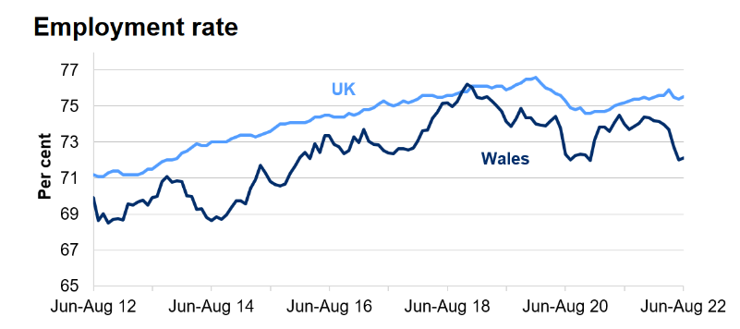
Figure 1: Employment rate in UK and Wales (Labour Market Survey, 2023)
In all events, this is 7.7 million below before pandemic estimates at this moment. The standard working hours employed by specialists are now 0.66 hrs over typical pre-Covid levels, and normal extended periods of times have reverted to rates seen during the epidemic. Due to the decreased company figures, there are fewer full-time hours than there were before Pandemic. From beginning of this year till date, the unemployment rate declined by 0.3 percentage points, moving closer to 3% (Office for National Statistics, 2023). The most significant increase since the end of 2020 was seen in those unemployed for approximately to the first half year. In any event, this was offset by declines in the number of people without a work for more than six months, resulting in the number of individuals without work for more than seven months decreasing to a historic low. Those without work for longer than a year also continued to decline. Also, the economic inactivity percent dropped by 0.2 rate points to 21.5%. Students who were economically inactive due to their education constituted a major contributor to the decrease of economic inactivity as compared to the three months preceding the study in 2022 and recent forecast reveals that international students contribute £26 billion (UK Parliament, 2023). The United Kingdom's employment market recovered better than other European countries throughout the duration of Crisis. Approximately more people were unemployed, after which it began to tepidly decline. Since around the year 2016, unemployment has been below it presume norm. The stalling in employment efficiency and income is the flip aspect of this case of overcoming ailment. Prior to 2009, productivity per hour performed was typically about 3%, but the financial meltdown caused a long pause in competence growth. This poses serious challenges for the nation's government, in addition to Brexit's consequences. The United Kingdom's labor force is a significant subject to investigate because, despite being a member of the EU before Brexit, it has historically been regarded as the largest of Europe's employment markets. In all the European Union, UK workers place the smallest emphasis on secure employment. Also, couple of nations that are comparable to the United States, New Zealand and Canada provide specialists with fewer advantages (Wadsworth, 2018). A differentiating factor is that, given the language barrier, the United Kingdom has continuously been a desirable destination between the minimal and maximum movements. The rise in long-term unemployment is a major concern for politicians as well as those in the finance industry. Temporary unemployment is a significant indicator of the dispersion of talent in the job marketplace, but large numbers of long-term unemployed people can point to structural problems in the labour markets indicating the need for transformation. Long-term unemployment also has substantial societal repercussions since a disproportionate amount of a downturn's weight is placed on a small number of individuals. It has an impact on people's mental and physical health and is a substantial contributor to poverty (Earl, 2017). Additionally, the prolonged exclusion of workers from the labour force could result in a decline in their talent pool, making it substantially more challenging for them to find employment moving forward, perhaps creating an unending cycle, and widening the economic gap. the overall rate of unemployment. Nearly 35% of unemployed workers in the United Kingdom throughout the recovery of pandemic have been unemployed for essentially a year. Although impressive, this figure pales in comparison with other countries (Gilpin, 2006).
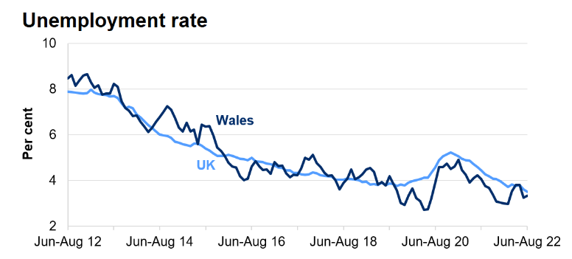
Figure 2: Unemployment rate in UK and Wales (Labour Market Survey, 2023)
Around 15 rate points more long- and exceptionally long-term joblessness existed in the EU than in the United Kingdom. Furthermore, long term unemployment in the EU is only now returning to pre-recession stages, whilst long term unemployment in the United Kingdom started to decline again in 2012, stabilizing around 2018. Younger workers who are unemployed are particularly stressed because higher unemployment rates may be expected in the future. Additionally, as young unemployed people don't attend classes or gain knowledge of the job market, this group's high unemployment rate could portend lower revenues in the future (Coe, 1997).

2.2 Human Resource Management Techniques in Post-Covid
The administrative skill focused on employing, persuading, monitoring people and interpersonal interactions within an organization is known as strategies of HR. It is based on affiliated individuals. These governance frameworks are being organised by human resource chiefs to guarantee that employee potential is utilised efficiently and economically to achieve a variety of aligned goals. encompasses the strategies, routines, or frameworks that affect the viewpoints, direction, and output of labourers.
It includes the persuading and competent application of human resources to accomplish a variety of organisational aims; it has to do with regulating work-related activities since human resources is a component of company operations and has techniques, strategies, structures, and norms that influence organization employees. The authorities and HR professionals within an organisation use HR methods, structures, processes, and procedures to help people achieve their targets, which increases their constructive dedication to the organisation and its goals (Guest, 2003). Since the beginning of February 2020, individuals from worldwide have become infected with a terrible disease known as the virus COVID that is caused by Corona virus. Organizations around the world experience different phases of managing the consequences of the COVID-19. As per the estimation twenty million individual’s jobs had been eliminated, which was unquestionably additional positions dropped throughout the whole Recession (Caligiuri, 2020). After the pandemic, there is a possibility of an increased unemployment rate stating that the pandemic had an enormous emergency, is a challenge for the upper management as well as an enormous opportunity to develop a Confidence-Based environment which necessitates accountability and confidence. Although challenges might come up at different phases of industry, company, and region growth, it is crucial to identify and put into practise the most effective representation tactics and innovative methods to handle remote employment as the most challenging and important (Azizi, 2021). Organizations are changing, offering fresh approaches, and looking out for creative experts to carry out innovative plans to smash through the barrier of obstacles to endurance in order to adapt to the epidemic's condition. The most effective way to concentrate on everyone succeeding completely while the economic downturn is still occurring is to have an organisation that is progressive. subsequently will enhance the circumstances in which workers or clientele are becoming highly helpful and advantageous. The requirement for HR rehearsals for progression is crucial (Gigauri, 2020). The key to dealing with as well as overcoming the challenges given by a global epidemic is to establish unique strategies to manage the employees successfully to produce the highest level of productivity while ensuring employee satisfaction. The most likely and identifiable factor determining whether employees live their lives within organisations and reflect the organization's responsibility to the success of its business associates will be these HR management practises. Organizations need to implement several adjustments to their pot COVID functioning methods and tactics. For them to get through a time of difficulty, their employees’ devotion is more important than ever. The employees might be dealing with feelings of seclusion, fragility, being left out, etc. Therefore, in this circumstance, the role of HR professionals as transition professionals became crucial (Hamouche, 2021). It is challenging to have standardised approaches for phases, tactics, and loyalty, which presents additional challenge for human resources professionals. Societal removal has already been accomplished and practiced. Given these numerous challenges, human resources will serve as the foundation of any organization, which means they must handle the after Covid situation with exceptional care and steadfastness. Particularly, these problems primarily revolve around the people affected by this global epidemic because of a revolutionary shift in human resources positions (Caligiuri, 2020).

2.3 Human Resource Management Plans for the post Brexit external environment
Withdrawal of UK from Europe (Brexit) was not an easy task to accomplish. It has been highly anticipated for quite some time, and even though they understand that organisations on both sides of the waters have been diligently making every effort to make arrangements for it, there currently is always going to exist a chance of new obstacles or challenges to overcome as it completes the actual process. Following the United Kingdom's official exit from European Union on January 31, 2020 (Bratton, 2021), any European Union citizens still living in the country were presumed to have till the end of June 2021 to apply to remain there. Over a section of one million applications were still pending as of the time of writing, bringing the total number of utilisations since the end of July. They either don't understand the importance that the HR expertise holds towards the advantage of the business or they do, but their level of fragility is perplexing. The debates leading up to the requirement failed to entirely address the environment because they were more concerned with political influence, movements, or on a budget and it was obvious in the 2019 election. However, as the Brexit process has developed, the environment has become an important topic because the United Kingdom's environmental policy had been heavily shaped by its membership in the European Union. According to a recent authority’s investigation into the probable impact of Brexit on departments, the Ministry for Agriculture, Food, the Environment, and Rural Development will be the one that will be most adversely affected by Brexit considering nearly eighty percent of its mission is related to the European Union. Multiple investigations have highlighted the numerous challenges involved in adapting to the environmental inventory and its administrative structure, which have caused serious concerns regarding the potential long-term impact of Brexit on the need or reliability of the United Kingdom's environmental plan (Office for Budget Responsibility, 2023). These variables are also more important for political repercussions because there existed the chance to combine euro-scepticism with an anti-climate viewpoint by pursuing environmental regulations. This act has politicised environmental policy in the way that could create uncertainty in a vital region where long term essential planning and stability are essential for achieving major goals like reducing greenhouse gas emissions. The notion of the environment's strategy as a degraded technique sector also raises important, deeper religious questions regarding the relationship among London and the backward nations. Since right now there is still a great deal of uncertainty over the final outcomes of the Brexit process, it is likely that the UK environmental policies will suffer consequently. One major concern raised by environmental organizations in the immediate aftermath of the decision was that Brexit will result in greater fragility of laws of nature. Particularly, researchers drew focus on the possibility that a highly popular method of exiting the European Union might result in operational gaps in the United Kingdom organic structure, operational gaps, terrible co-appointments and technique uncertainty throughout the nation, and deliberate technique preservation (Farndale, 2021). Therefore, it explains the problems associated to each reason in the following paragraphs. The federal government has attempted to address these concerns, and to evaluate how successful its approach has proved or, alternatively, how likely it will be to succeed. This led to a significant ecological operational gap that are like the anticipated operational deficiencies. Currently, the UK plan lifecycle has a European relationship throughout development of strategies, talent and data collection, reviewing, performance, and deployment. The United Kingdom benefits from obtaining the opportunity to solicit supplies from EU Headquarters and a variety of institutions, such as the Europe Atmosphere Activity or Europe Compounds Agency, as well as other member nations of the EU. After Brexit, the ability or development will no longer be easily available (Wadsworth, 2018).

Conclusion
Leaders now have the rare opportunity to think deeply and introspectively, which would have proven challenging in the standard course of trade. Many businesses may be compelled by the outbreak of a pandemic to improve work processes to maintain operations and quickly embrace technology. This approach will be used afterwards at regular times as well, in addition to during the duration of the lockdown. The reality relies on creativity and taking use of decentralisation within the modern work setting. The United Kingdom's experience in developing the European Union's fundamental principles over the years has not always been straightforward, as the designation of the "Dirty Man of Europe" shows. The United Kingdom's strategy developers failed to account for the probable impact of membership in the EU on domestic ecological systems as well as the cost of implementing measures designed for a different kind of the development of strategies environment. The story of the UK common support and clergy learning how to play this Brussels system more effectively in attempt to influence European policy rather than continuously, occasionally unsuccessful, is a component of the story of the Europeanization of the UK's spontaneous method.

References
Azizi, M., 2021. Innovative human resource management strategies during the COVID-19 pandemic: A systematic narrative review approach.. Heliyon, 7(6).
Blanchflower, D., 2009. The impact of the recent expansion of the EU on the UK labor market.. In EU labor markets after post-enlargement migration, pp. 181-215.
Bratton, J., 2021. Human resource management, s.l.: Bloomsbury Publishing.
Caligiuri, P., 2020. International HRM insights for navigating the COVID-19 pandemic: Implications for future research and practice.. Journal of international business studies, Volume 51, pp. 697-713.
Coe, D., 1997. Policy complementarities: the case for fundamental labor market reform. Staff Papers, 44(1), pp. 1-35.
Earl, C., 2017. The workforce demographic shift and the changing nature of work: Implications for policy, productivity, and participation.. In Age diversity in the workplace, 17(Emerald Publishing Limited), pp. 3-34.
Farndale, E., 2021. Deglobalization and talent sourcing: Cross‐national evidence from high‐tech firms.. Human Resource Management, 60(2), pp. 259-272.
Gigauri, I., 2020. Implications of COVID-19 for human resource management.. International Journal of Economics and Management Studies, 7(11), pp. 25-33.
Gilpin, N., 2006. The impact of free movement of workers from Central and Eastern Europe on the UK labour market. Department for Work and Pensions Working.
Guest, D., 2003. Human resource management and corporate performance in the UK.. British journal of industrial relations, 41(2), pp. 291-314.
Hamouche, S., 2021. Human resource management and the COVID-19 crisis: Implications, challenges, opportunities, and future organizational directions.. Journal of Management & Organization, pp. 1-16.
Labour Market Survey, 2023. Labour market overview: October 2022. [Online]
Available at: https://www.gov.wales/labour-market-overview-october-2022
[Accessed 08 April 2023].
Metcalf, D., 1987. The impact of the Thatcher years on the labour market. Cambridge Journal of Economics, 11(4), pp. 311-340.
Office for Budget Responsibility, 2023. Brexit Analysis. [Online]
Available at: https://obr.uk/forecasts-in-depth/the-economy-forecast/brexit-analysis/#indepth
[Accessed 08 April 2023].
Office for National Statistics, 2023. Labour market overview, UK: September 2022. [Online]
Available at: https://www.ons.gov.uk/employmentandlabourmarket/peopleinwork/employmentandemployeetypes/bulletins/uklabourmarket/september2022
[Accessed 08 April 2023].
Richbell, S., 2001. Trends and emerging values in human resource management‐The UK scene. International Journal of Manpower, 22(3), pp. 261-268.
UK Parliament, 2023. UK Labour Market Statistics. [Online]
Available at: https://commonslibrary.parliament.uk/research-briefings/cbp-9366/
[Accessed 08 April 2023].
Wadsworth, J., 2018. Off EU go? Brexit, the UK labour market and immigration.. Fiscal Studies, 39(4), pp. 625-649.

