Contemporary challenges: making a difference
BMSW4007/C_CARD
Name: MARIANA ORBECI
Student number:2221040

BLOG 1: CLIMATE CHANGE

HOW DOES AFFECT US THE CLIMATE CHANGE?

Do you know that every 24 hours we throw over 100 millions of gases which has greenhouse effect?
All these gases affected the Earth, and the sky became a sort of trash discharges of our civilisation. (European Association for Local Democracy, 2022)
According to one article published in 2017 the increase of medium temperature by half degrees Celsius in the last years was sufficient for the intensification of heatwaves and torrential rains in many regions of the world. (Ziare.com, 2017)
National Oceanic and Atmospheric Administration (NOAA) declared that between 1901 and 2020 the global temperature increased by 1.1 degrees Celsius.
Apart the raising of the temperature are many other things that contribute at climate change as sea level rise. We can see the impact of climate change in every aspect of the world. We are aware of the problems and solutions, and it is still time to avoid it by acting as soon as possible to reduce emissions and to limit warming. (NOAA, 13 august 2021)
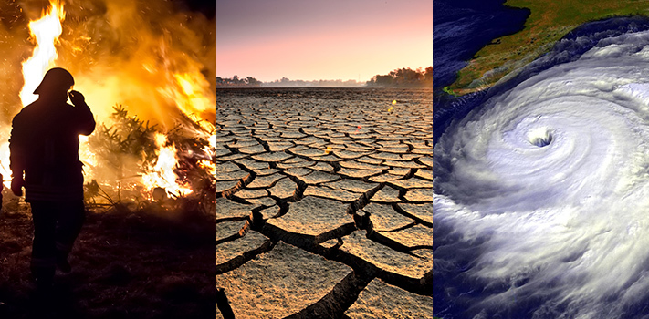

HOW CAN WE FIX IT?

TROP ICSU (“Trans-disciplinary research-oriented pedagogy for improving climate studies and understanding”), proposed to solve the problem through education, by introducing courses in the educational system and give awareness and a better understanding to the next generations.
European Court of human rights consider whether states a direct threat to the human rights as failing to decrease the emissions.
Starting by 12 December 2015 through the Paris agreement, European Union and the other members agreed to maintain the global warming at a safe level and the objective is that the European Union to become neutral before 2050 climatically speaking. (Paris Climate Agreement, 19 Feb 2021)

Actions taken by governments.

According to Imperial College London through the Paris agreement 195 state sign for:
- Responsible consumption and production
- Take urgent action to combat climate changing and its impact as millions of people were left into poverty and hunger due to increase of the temperature
- Conserve the oceans
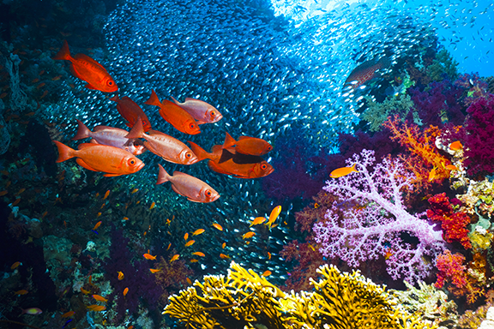-Conserve life on land
- Conserve peace

Conclusion

Every single day without taking action is a wasted day as the global warming increase daily. Climate change is the most urgent problem that humanity has and should be priority for everyone. We all can contribute to reduce the negative impact by renouncing at part of our comfort.

BLOG 2: CHALLENGES FACED BY SOCIETY

In modern times, the society face a lot of challenges. This subject is really complex and through this blog I want to bring some awareness about same of them that I believe to be the most important: inequality, health and artificial intelligence.

Does inequality matter?

First of all, let's have a look over the inequality types.
Gender inequality or sexism as it's called is still a common problem in the workplace. This can include hiring and training only one gender for a particular role, unequal pay, sexual harassment, different opportunities to promote.
Over the years the government tried to stop the discrepancies and to ensure everyone receives equal treatment by asking the companies to offer equal pay for the same jobs and equal opportunity for promotion.
“Equal Pay for Equal Work and Work of Equal Value” is the Article 14(1) of the Treaty of the European Community where the principle of equal pay was published.
To avoid discrimination between genders a company could give equal training provide childcare facilities and have a policy for fair pay.

Racial discrimination

We can see this type of inequality in the areas of employment, goods, facilities, services, on the street or housing accommodation.
This is a direct form of discrimination and the law tried to protect the individuals by covering this subject with the Equality Act from 2010 To prevent direct or indirect discrimination, harassment and victimisation.

Age discrimination

Who and how is affected by age discrimination?
You might think that the age discrimination applies only for certain groups of age but the right answer is “everyone”.
Young workers are usually underpaid meanwhile all older people may not be higher because of their age. New line the age discrimination could be prevented if the companies have a policy on equal opportunities, use age-related questions, the redundancies selection criteria should avoid age discrimination.

Educational discrimination

This problem starts in early childhood, and it is life changing.
A lot of people that live in poverty does not have access to education even if it is free. The cost of transport, food, clothes is too much for many families. As well the background and culture have an important role in education.

All human activity is subject to habitualization. Any action that is repeated frequently becomes cast into a pattern, which can then be reproduced with an economy of effort… Habitualization further implies that the action in question may be performed again and again in the same manner and with the same economic effort.
(Berger and Luckmann, 1967, p. 71)

BLOG 3: BIAS
Our mind process more information unconsciously then consciously by using our personal experiences, cultural environment and background to make instantaneous decisions.
This is wrong especially in matters that need rational thinking. Webster 's new world dictionary defines bias as” A mental learning or inclination; partiality; bent”.
Even if it is impossible to eliminate bias, we can reduce his effects by increasing our awareness about it.
There are many types of Bias:
- Affinity or similarity bias
- Confirmation bias
- The halo effect

