Clinical Decision Support Tool and Nursing Care Plans
Section 1 - Introduction
Nightingale (1860) asked ‘how valuable would the produce be if every nurse combined their experience and knowledge?’
The Welsh Governments (2018) publication A Healthier Wales, includes the core values of NHS Wales, these values set out the need to put patient safety above all else, and to provide high value evidenced based care, as well as the need to integrate improvement into everyday working, and providing NHS staff with the tools and systems to work safely and effectively to eliminate harm, variation and waste. White (2019) in her capacity as Chief Nursing Officer for Wales, identified multiple nursing risk assessment tools in in use across Wales, some of which were not evidence based and did not have embedded clinical decision support tools to assist in the prevention of risk and harm. She identified standardised nursing assessments as a key enabler to preventing harm and ensuring a patient receives care based on the same standards and expert knowledge wherever they are nursed in Wales.

This account will outline how the Welsh Nursing Care Record (WNCR) and the nursing care planning process could be enhanced with the development of a Clinical Decision Support tool (CDS) as part of digitised and standardised nursing care plans. The system would utilise computable knowledge from an expert evidence base such as the Lister et al (2022) Royal Marsden Manual of Clinical and Cancer Nursing Procedures: recognised in Wales as the primary source of evidence to plan nursing care. The use of standardised care plans and a standardised nursing language would enable the codifying of outcomes within SNOMED CT, enabling the gathering of information and new nursing knowledge to inform a learning health care system. This approach is supported by Foley et al (2021) who directed that it is not enough to publish knowledge, it must be put into practice and clinical guidelines should be represented in a standardised machine readable computable format so that they can be used to guide decision making in practice.
Ledley and Lusted (1959) in one of the earliest papers supporting the use of computers to facilitate clinical decisions, identified computers as useful to collect and process information and act as an aide memoire for differential diagnosis. Shortliffe (1987) defined CDS as any computer program designed to help health professional make clinical decisions, and Chiang (2010) identified three key components to a CDS: a knowledge base, a computerised model and a user interface. Greene (2014) identified the enormous potential of CDSs to improve quality and safety as well as the cost effectiveness of healthcare and Van de Velde et al (2018) recognised CDS as a key component of a learning healthcare system.

The nursing care plan forms the basis upon which nursing care is planned and delivered. Nightingale (1860) in her iconic notes on nursing recommended multiple interventions based on generic nursing principles; these notes are the first documented knowledge base upon which nursing care plans were formulated. Orlando (1961) found that nursing plans of care were often out of date and did not reflect the patients current condition. She introduced a cyclical nursing model known as ‘the nursing process’( table 1). She theorised the nursing process would support the development of individualised nursing care plans.
Phases of the Nursing Process
Phase | Title | Description
1 | Assessment | Collect Subjective and objective data
2 | Diagnosis | Analysing subjective and objective data to make a professional nursing judgement
3 | Planning | Determining outcome criteria and developing a plan
4 | Implementing | Carrying out the plan
5 | Evaluation | Assessing whether outcome criteria have been met and revising the plan as necessary
Table 1- Weber and Kelley (2018) Phases of the Nursing Process
Starting with the assessment of a patients’ needs, followed by the formation of a nursing diagnosis, a cyclical process of planning, implementing and evaluating nursing care is implemented. Many nursing theories have since emerged, however ‘the nursing process’ is globally adopted as the model for the assessment of a patients nursing needs.

Increasingly across Wales this assessment is completed digitally using WNCR. On admission to hospital the nurse inputs 29 sets of information on the patients’ health and wellbeing. Once collected the nurse produces a list of problems and composes paper care plans, utilising stored digital or paper care plans, the care that is implemented and the evaluation of that care are documented within WNCR, this dual process is illustrated in figure 1.

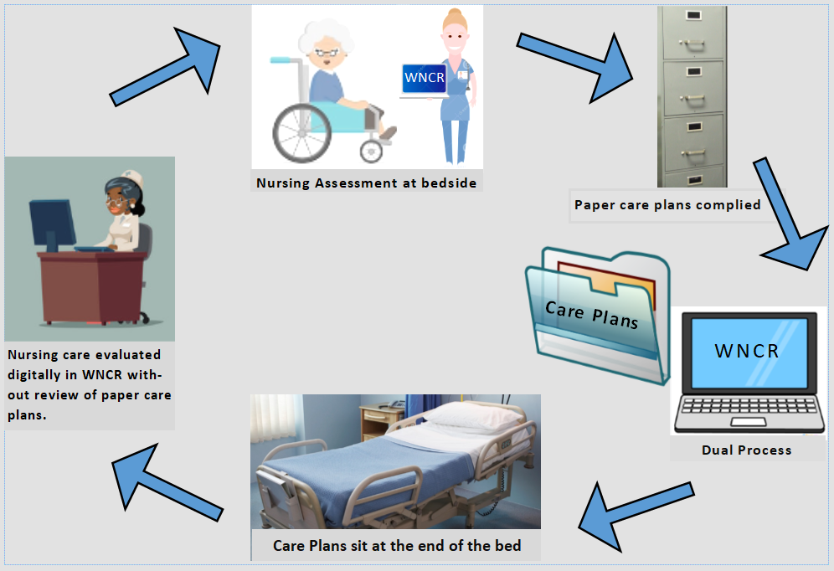
Figure 1 - Current Nursing Care Planning Process
Bevan et al (2020) in evidence collated from Welsh health boards and Healthcare Inspectorate Wales audit reports, found that care plans were not evidence based, poorly completed, seldom updated or reviewed and sat at the end of the patients bed folder, rarely referred to and having little impact on the outcome of nursing care. Beadle (2021) in another national review of care plans in Wales, found where evidence based databases of care plans were available, many wards were using out of date printed copies. Gittins (2022) in a gap analysis aimed at reviewing care plans from across Wales, found multiple iterations of the same care plans on single hospital sites and very little commonality in care plans between hospitals within a single health board or across Wales.

Therefore, it is proposed the 29 sets of information held within the WNCR record are reused to formulate a list of problems to identify care needs. Using these needs along with current evidence from the expert computable source, would reduce duplication and remove the risk of transcription error associated with a dual system. Additionally, it is theorised this approach will reduce the risk of failure to recognise nursing problems through in build alerts and as the literature review will demonstrate reduce harm.

Section 2
Evidence Review
A critical literature review was undertaken to identify relevant literature and gaps in the evidence base related to the application of CDS in the planning of nursing care and nursing documentation. Caldwell et al (2005) defines critiquing literature as the process of identifying the strengths and weaknesses of research and forming judgements relating to its overall quality and applicability. An initial search of electronic databases using the terms ‘Nursing’ and ‘care plan’ and ‘decision support’ or ‘clinical decision support’ was carried out on PUBMED, MEDLINE, CINAHL and Cochrane Library, and limited to English language and peer reviewed. There was no time period set to enable a rich understanding of decision support and the historical context of developments in this field. Multiple articles were obtained via library services and one article was obtained via interlibrary overseas loan from Finland.

The Prisma chart (Fig. 2) identifies that a total of 536 articles were screened, with 35 included in the final review. The articles were critically appraised and graded using the Caldwell et al (2011) framework which provides guidance for grading both quantitative and qualitative research. Several areas of grey literature and unpublished reports relating to WNCR were included. Of the 35 articles only 9 articles directly related to nursing care plans, studies relating to the delivery and planning of patient care and CDS in the wider hospital environments were included. There was a paucity of UK studies, Wensing et al (2022) suggests that research evidence is reviewed in context to ensure any findings are transferable. Therefore, careful screening of non UK studies was undertaken to ensure the nursing model in these countries mirrored the nursing process used in the UK.

Huter et al (2020) in a systematic review of literature relating to digital technologies supporting nursing care cautions against publication bias, finding that 74% of studies report positive results, of these studies there was a bias towards smaller studies groups, they felt that these positive results were not replicable on a wider scale, and recommend further high quality studies to provide evidence of the effectiveness of digital technologies in nursing. There was a lack of randomised control studies, this is recognised by Wensing et al (2022) who identified that quality improvement relating to redesign of processes does not lend itself easily to randomised designs, they suggested that the evidence demonstrates the affect it has had on the clinical outcomes.
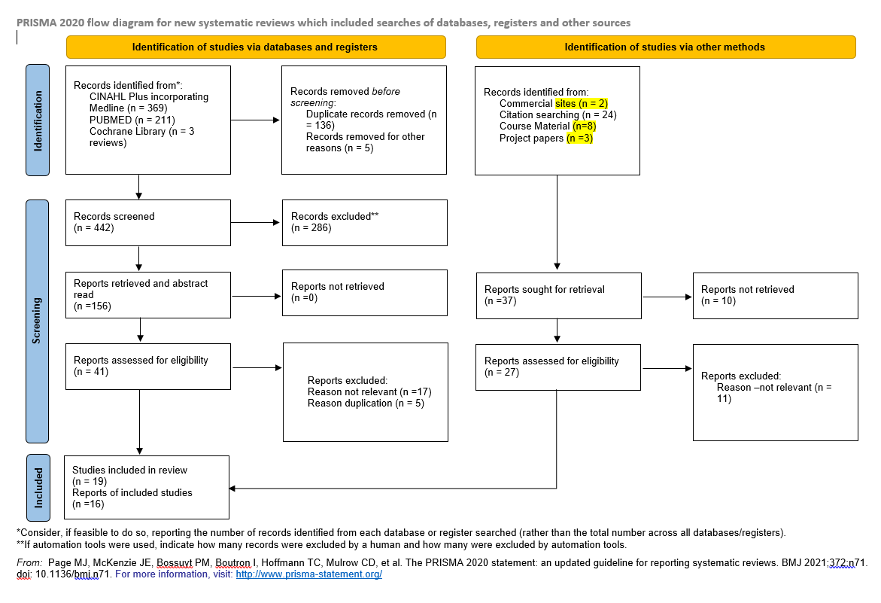
Figure 2- Prisma Chart, Page et al (2020)

Findings

Using WNCR as the platform for a CDS for Nursing Care Plans
Russell and McNeill (2023) nursing care plans are formulated a result of the nursing process, they are important to ensure the patient receives quality care and define the nurses’ role and specific nursing interventions to support the patient. White (2019) identifies the digitisation of nursing documents in Wales as fundamental to support work stream 2 of the Welsh Government (2019) Prudent Healthcare Strategy, providing a standardised platform of nursing assessments using a standard nursing language (SNL), and contributing to the Welsh Government vision of providing consistent information standards across all patient populations and healthcare settings. Bevan et al (2020) suggested that the reuse of data in WNCR to formulate care plan would support the reduction in duplication of work and support the ‘document once and use multiple times’ ethos of WNCR. Wiggins (2022) in independent review of WNCR found that the reuse of data from one section to another and the inbuilt digital prompts enhanced the care patients received and helped the nurses to use their time more efficiently.

Support for CDS and Digitised Care plans
Kilanska et al (2022) found digital documentation enhanced the decision making process, enabled better understanding of nursing needs and the measurement of care outcomes and the subsequent evaluation of the nursing process. Bolat et al (2016) introducing a rule based CDS to improve care planning found that manually generated paper records were prone to errors and omissions and insufficient evaluations, and found evidence of sustained improvement from the use of a digital tool. Further supported by Russell and McNeill (2023) who evaluated the development of a CDS for care plans, they found that prior to the systems introduction 36% of care plans were individualised, post 100% of care plans linked to the patients assessed needs, this was sustained for one-year post implementation.

Chiang (2010) identified the use of CDS as resulting in positive behaviour changes, significant error reduction and time and cost savings, and Febretti et al (2014) concluded that the use of a CDS care planning interface which was easily incorporated into their workflow influenced change and yielded better patient outcomes. However, Seildling and Bates (2016) express caution, stating it remains unclear if benefits from a CDS in one area can be reproduced in another.

CDS are commonly used within E-Prescribing programmes to support nurse decision making processes. De Bie (2017) found a significant reduction in errors at the bedside by the use of digital checklists to assist in prescribing medication, and Williams et al (2022) in their local evaluation of E-Prescribing found there was 42% reduction in medication errors by nurse which they relate to the use of CDS. Rouleau et al (2017) found that nurses identified the use of CDSs as resulting in improved patient safety and reduced medication errors, and Johansson-Pajala et al (2018) found that nurses felt the CDSs in their E-prescribing software were helpful and supported the challenging of medication prescription errors. Further evidence from Sutton et al (2020) who found that a CDS in a e prescribing module successfully reduced drug related adverse events. However, Seilding and Bates (2016) suggest that CDs alerts can will only be effective if the provider considers the displayed information and changes his behaviour, with as many as 95% of displayed alerts in some E-Prescribing modules being ignored.

Time savings with CDS in Healthcare
Romano et al (1982) found that the use of early CDS to generate digital care plans reduced time spent documenting, offered examples of best practice and increased the likelihood that the nursing care delivered was documented. Another early study by Newton (1995) compared paper and the first digital UK care plans, they found that completion of documentation more than doubled and that duplication was reduced by a third within the first 3 months of implementation. Lee (2005) in a study describing nurses’ attitudes towards digitised care plans found that nurses valued the system and felt it saved time, this was supported by Dahm and Wadensten (2007) found that digital care plans incorporating a CDS produced significant time savings as well as an improvement in the quality of care plans in use. Nurses in the study felt that the use of digital systems and standardised care plans facilitated their work and improved the quality of care, and did not present a risk of failing to notice patients’ individual needs.

More recently Keenan et al (2017) in a small American simulation study utilising a care planning tool with an integrated CDS found there were no significant time saving with initial care planning, however they found significant time savings the following day when updating the digital care plans compared to the paper control group. They also found that the system prompted nursing staff to include data items which may otherwise be forgotten, and De Bie (2017) found that whilst completion of digital documentation took longer compared to paper compliance was increased with 100% of items on their checklist checked digitally compared to 73.6% on paper, reducing complications and the need to go back over what had been done earlier in the day.

User Based Design of CDS
Burkhart and Androwich (2009) documentation should follow the basic nursing workflow, it is critical for nurses to participate in the design of systems to ensure they support nursing workflow. Greene (2014) provides ten essential commandments to aid the successful design of CDS (fig.4) and ensure their integration into the users’ workflow. Febretti et al (2014) states the knowledge needs to be delivered in a way that nurses can quickly understand and act upon as part of their routine workflow in an already temporally and cognitively demanding role. Seildling and Bates (2016) state the system should be designed to support the users’ needs and integrated be into their workflow. Russell and McNeill (2023) found that nursing staff wanted a simple nursing problems list which was easy to find and linked to the appropriate care plans. Sutton et al (2020) identify workflow modelling and evaluation of usability of the system following an iterative approach essential to ensure the system meets the needs of the end user. The CDS should be designed to fit within the users’ current workflows unless there is a deliberate goal to change the workflow.
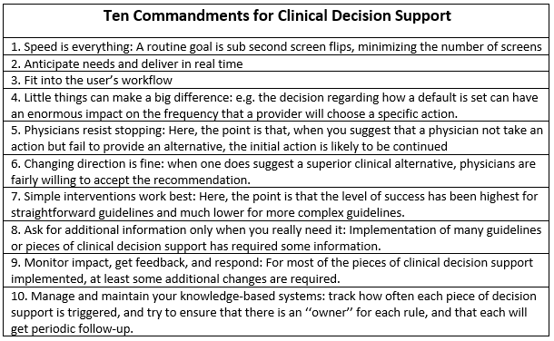
Figure 4 – Ten Commandments of CDS Design, Greene (2014)
SNL and a Learning Health Care System
Lee (2005) found a SNL was needed to apply computer technology to nursing documentation, enabling the system to recognise the nursing problem and suggest care plans. Burkhart and Androwich (2009) found the use of SNL enabled the capturing of data to measure and compare effectiveness of care plans and improved patient outcomes. However, Nantschev and Ammenwerth (2020) found that only 29% of nursing care plans used a SNL, mostly using NANDA International, and that the lack of use of SNL inhibited the use of nursing documentation for secondary use to validate and analyse nursing outcomes to identify new evidence for nursing practice.
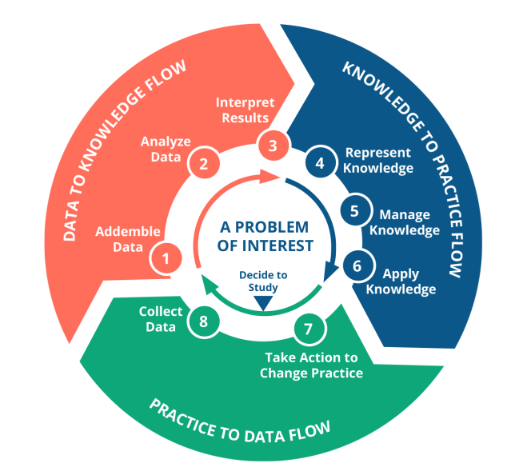
Saranta et al (2014) identified the use of SNL as enabling the codifying of nursing data for reuse for secondary purposes such as to describe outcomes, quality or process factors in care. Febretti et al (2014) suggests that without SNL it would not possible to develop a set of CDS benchmarks to guide nursing decisions, and Almasalha et al (2014) found that for efficient and effective knowledge discovery it is essential to standardise the language used to collect data. Johnson et al (2018) state it is increasingly difficult to describe nursing care within an electronic framework without the use of a SNL and Russell and McNeil (2023) state the use of SNL and data mining could support the discovery of high quality and discoverable data patterns contained in nursing care plans which could lead to effective knowledge discovery as part of a learning health care cycle.
Figure 4- A Learning Healthcare Cycle, Foley et al (2021)

Foley et al (2021) describes 8 stages within a learning health care systems (fig.4) where data is collected, analysed, interpreted, then applied to practice before the cycle is repeated. The use of a care planning CDS would support such a system. Almasalha et al (2013) in a large multi-centre study which data mined digital nursing care plan found new knowledge and examples of good practice. Febretti et al (2014) described how data extracted from patients could be used to drive improvements in care, and identify combinations of interventions which improve patient outcomes. Van de Velde (2018) found that CDS based on trustworthy clinical guidelines can be key in improving knowledge and accelerating the adoption of new evidence.

Coding Repositories, SNL and CDS
Collins (2017) exploring the feasibility of using SNOMED CT to codify patient goals and interventions, recommended that the SNOMED CT catalogue was extended to include goal dynamics and decision concepts to enable its use for CDS. An attempt by the WNCR team to use a care planning portal designed by SNOMED (2021) was abandoned early on in the design phase, Golten et al (2022) in feedback collated from Welsh health boards across Wales, found that the SNOMED CT fields not match nursing terminology.

Klehr et al (2009) found that existing coding repositories did not meet the needs of nursing care plans, and would require a team of nurses to list terms to add to the databases to enable the intelligent reuse of data from nursing documentation into care plans. ONC (2017) identified the lack of nursing terminology in SNOMED CT as a barrier to its use for nursing data. Recent developments have improved the usability of SNOMED for nursing terminolgy, with ICNP (2020) stating that SNOMED CT had been awarded the rights to use ICNP terminology; a standardised globally recognised terminology for nursing practice, and Kuru and Madarasz (2021) announced the release of the first nursing terms catalogue late 2021 in SNOMED CT and SNOMED International.

Whilst the use of SNL enables the reuse of data, there is evidence that its use takes nurses longer to complete documentation, Kilanska et al (2022) in a review of a nursing activities within a CDS utilising ICNP terminology found that whilst nurses liked the system they were frustrated by the time they wasted trying to find the correct terminology and recommended teaching of ICNP terminology in nursing schools to familiarise nurses with the terminology and optimise time savings.

Design Challenges and Barriers to CDS
Medlock (2016) suggests that a fundamental challenge in CDS research is the ability to evidence which characteristics of a CDS work effectively despite almost five decades of research, and Sutton et al (2020) suggests that using CDSs come with risk, and despite almost 30 years of development many CDSs exist as standalone systems which cannot communicate effectively with other systems. Seildling and Bates (2016) found the potential benefits of a CDS depend on the system design, what alerts it contains and how its integrated into care. De Bie (2017) highlighted the need to have a local consensus over the use of automatic rules and whether they should be applied to some patient groups. Whilst ONC (2017) identified poor design and low integration of required documentation as impacting on the adoption of CDSs, they felt this was due to CDS being based on historical paper processes and identified the need to ensure they matched the current workflow.

Greene (2014) identified the maintenance of CDS as requiring a significant amount of effort to ensure that the knowledge base remains up to date, and highlighted the need to ensure the system does not impact on workflows, he identifies this as particular challenging when the system has spread to more than one site. Sutton et al (2020) expanding on these findings, identified multiple negative consequences of a CDS including –alert fatigue, excessive trust in the accuracy of system, set up expensive both staff and capital, staff time for training and overall digital literacy, no guaranteed cost effectiveness, requirement for the system and content to be continually maintained and updated, users disregarding the guidelines, lack of interoperability, disruption to workflow and fragmentation to real world patterns. To combat some of these factors, Sutton et al (2020) suggests designers prioritise and select alerts with the greatest impact, and avoid making systems prescriptive to promote individual autonomy, and identified the need to have an expert team to maintain the system and ensure proper training of teams to read interpret and respond to alerts.

Lee (2005) found that nurses felt a CDS compromised their thinking process and professional judgement, and nurses who were used to charting in a narrative form struggled to adjust to the computerised format, he also found that experienced nurses preferred to use their own experience and knowledge to build care plans, rather than accepting what the digital system provided. Another factor to consider here is the uniqueness of human needs, and generic care plans will not cover every eventuality, especially patients with multiple co morbidities. Febretti et al (2014) identified that nurses needed to be confident that the suggested changes to plans of care were based on strong evidence derived from research and past practice. Durán and Jongsma (2021) identify that clinical data can be interpreted in several ways with differing consequences, and that a CDS should understand that there may be several correct ways of handling a decision based on the data, and must present the user with the differential options for the clinical scenario.

Medlock and Wyatt (2019) suggest that the goal of CDS is to change behaviour and that well designed CDS go unused or don’t deliver the expected benefits, this they believe is due to the way the advice is presented to the end user. In an earlier study Medlock (2016) et al proposed the use of use of a clinical stream and a cognitive behavioural stream within a CDS, this two stream model they suggest offers a classification of factors which contribute to the success or failure of CDS and provides a framework for future design which considers the impact of cognitive load and work processes on the user and how they interact with the system.

Foley et al (2021) highlights that computable knowledge in a CDS must be manipulated to produce actionable outputs, this process he describes as inference combines data about the patient with guidelines, and highlights the difficulties if there are conflicting knowledge sources and multiple morbidities, and real world issues such resource constraints. Lastly, Oluoch and Keizer (2016) felt there was a risk that clinicians would over rely on the recommendations of the CDS, and not use or develop their own judgement, whilst this article related to low income countries, the principles could be applied to understaffed UK hospital wards with junior staff who have little clinical judgement using a CDS with a lack of senior supervisory support.

Section 3 -
Implementation Issues

The literature review highlighted some of the risks and constraints which are associated with the implementation of a CDS. Van de Velde et al (2018) Guideline Implementation Decision Support (GUIDES) checklist provides 16 factors (fig. 5) within four domains which they feel influence the successful implementation and adoption of CDS guidelines.
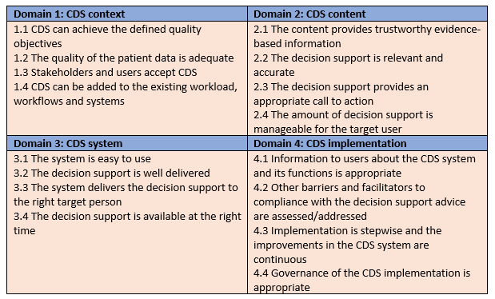
Figure 5 – Guides Checklist, Van De Velde et al (2018)
The Use of WNCR enables the CDS to have access to adequate patient data, is already used to complete part of the care planning process. Thus the reuse of data would follow a logical workflow and the computable knowledge derived from Lister et al (2022) Royal Marsden Manual of Clinical and Cancer Nursing Procedures, is seen as trustworthy evidence base which nurses have confidence in. Welsh Government (2018) directs that innovation and improvement are used to develop and evaluate new tools and better ways of working, and that they change or replace existing processes rather than an adding a permanent extra layer, therefore it’s important to ensure the CDS streamlines existing processes.

Greene (2014) identified that tools should be developed to be platform independent, whilst Sutton et al (2020) suggested there should be the use of open standards and standardised systems such as HL7, FHIR and Snomed CT, cloud based open architecture. Whilst WNCR is a standalone platform it is reliant on the Welsh Patient Administration System to generate its patient lists, and this dependency has been the source of system failures. Kennedy (2023) states that WNCR does not share information with other systems apart from the Welsh Clinical Portal utilising a SOAP web service, it does have future plans to use FHIR to send data to other platforms.

WNCR is easy to use and has excellent user acceptance, Wiggins (2022) found that staff overwhelmingly accepted WNCR and would not want to revert to paper, welcoming future developments and the day when all nursing documentation was in one system. The devices already in place for WNCR enable the delivery of the system at the bedside and are familiar to staff. The Care plan CDS needs to be designed in a manner which continues to be user friendly, there is a network of nursing and digital support in place to support any WNCR developments, the teams are well experienced in implementing digital systems and are supported by DHCW.

The stepwise approach to WNCR has enabled staff to build on competencies and ease anxiety relating to digitisation, however a stepwise introduction of a care planning CDS would not be possible as it would result in a dual process of paper and digital. This big bang introduction of a tool comes with risk and significant training needs, possibly through the use of sandbox environment.

WNCR has a robust governance framework, with a senior responsible office and a patient safety team supported by the corporate governance of WNCR. The project has a clinical owner this is identified by Greene (2014) as essential to ensuring a CDS lines of accountability, it would also be essential to ensure systems are in place to update clinical guidelines and to validate them with an expert panel of clinicians, utilising the network of nurses who work on the WNCR project.
Greenhalgh and Abimbola (2019) suggest that health information technology (HIT) projects rarely deliver all the benefits expected of them, their NASSS framework provides a tool which help to identify the multiple influences on a project, and areas of complexity which might be reduced and thus improve the chances of the technology being adopted. Expanding on this framework Greenhalgh et al (2020) provide the NASS-CAT tool which expands on the original tool providing a checklist to analyse the complexity of HIT as well as guidelines on action planning and project management to further understand the complexities of a project and to reduce the barriers to implementation. This is particularly important for developments within WNCR, the CDS in care planning, would be the first CDS tool within WNCR, multiple other tranches of future documents are planned which would benefit from the CDS. Understanding and reducing the complexities associated with a CDS will facilitate the spread and development of future documents and support the overall sustainability of the project. 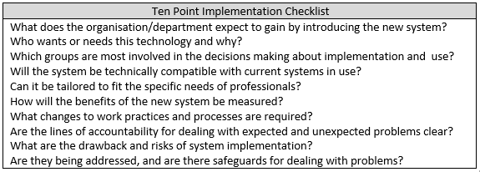
Table 2 – Georgiou and Westbrook (2006) ten-point checklist for implementation of HIT

Georgiou and Westbrook (2006) provide a ten-point checklist, (table 2) for implementing HIT. This checklist ensuring that those most affected by the change are considered in the design and implementation process. Finally, Scott and Briggs (2010) identify that projects which use sound methodologies repeated fail due to inadequate attention to the socio technical issues related to implementation. They provide the STAT – HI twenty-point checklist as a means to reflect on factors such as culture, governance, managing change and technology which may influence the success or failure of a HIT implementing. Employing both these tools would help to foresee implementation issues and organise effective strategies to overcome barriers to implementation.
Section 4 - Evaluation

Post implementation evaluation of a CDS is essential to gain an understanding of the users’ experience, the effectiveness, safety and efficiency of the CDS on the process it was designed to improve. Sutton et al (2020) suggested scheduling regular user feedback sessions to review how the CDS has affected practice and to keep both parties up to date on developments and design issues. De Bie (2017) suggested a multifactorial approach to evaluating user experiences of CDs, recommending the use of surveys using Likert scale to assess usability, training, support, behaviour change, usefulness and user satisfaction.

In order to assess the effectiveness, safety and efficiency of the tool it would be important to undertake pre and post baselining. Weir (2016) recommends the use of an interrupted time series to collect up to 30 pre and post implementation measures to provide strong evidence of a baseline trend and to enable valid statistical analysis. This data should be used to identify where attrition or diffusion is most likely to occur, and in the case of evaluation a CDS could identify nursing knowledge and compliance with the recommendations pre and post implementation.

Thus using a before and after study design, a baseline assessment should be undertaken, followed by a review of care plans during the immediate four-week post implementation period and for 12 months after implementation, utilising a feedback questionnaire, such as the example, (table 3) would enable the collection of mainly qualitative data at least 12 months pre implementation one month post and for a further 12 months would enable the assessment of the elements within Van de Velde et al (2018) Guide Framework and utilising elements of Ammenwerth, Iller and Mahler (2006) FITT Framework to assess the ‘FIT’ between the task, individual and technology, and the technology and task as well as the attributes, interventions and external factors which may have had an effect on the users’ experience. follow with focus groups and 1:1 interviews would enable the collection of qualitative data associated with the CDS. Further quantitative data could be gathered relating to time savings by direct observational studies of the care planning process pre and post implantation.
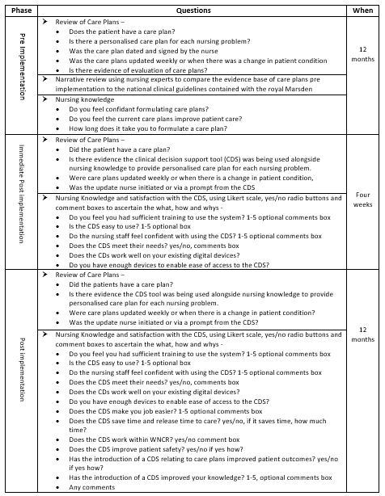
Table 3 -Sample Questionnaire

This approach is supported by Seilding and Bates (2016) who suggest immediate results may be misleading due to process changes, and that whist it is crucial to assess the risk of HIT implementation and iatrogenic errors the period immediately following an implementation is often excluded from studies due to high error rates, and recommend a period of stability to develop the new norm prior to assessing the success of the project. Further support from Creswell (2016) who highlighted the need for longitudinal studies to assess the short medium and longer term consequences of HIT, he suggests collecting qualitative data relating to staffs’ experiences of the implementation in the short term and that quantitative data should be analysed later when more robust data is available and there has been a period to in bed the system and see the full consequences of the implementation.

Rich sources of data already exist within NHS Wales, triangulating that data with the findings of the before and after study could provide further information to validate the effectiveness of the CDS. WNCR has been live for two years, the use of data mining within the WNCR databases to compare pre and post implementation patient quality indicators e.g. length of stay and falls pre and post CDS would provide further reassurance of the validity of the of the CDS. Other systems such as DATIX and the welsh levels of care would also be able to provide data on quality indicators such as falls, complaints, pressure ulcers patient satisfaction scores pre and post implementation, although it would be difficult to prove the effectiveness of the CDS against historic data without triangulating that data with staffing levels and patient acuity (Doyle and Wyatt, 2017)

Recommendations
The literature demonstrated evidence to support the use of a CDS to formulate nursing care plans. The use of SNL has been highlighted as essential to allow the reuse of data from WNCR to gain new knowledge as part of a learning health care system. Therefore, it is recommended that the use of SNL in Wales is further investigated prior to the development of a care planning CDS within WNCR, this process may be facilitated by the recent inclusion of a standardised nursing directory into SNOW CT catalogues.
5392 words
Reference List

- Almasalha, F. et al. (2013) 'Data mining nursing care plans of end-of-life patients: A study to improve healthcare decision making', International Journal of Nursing knowledge, 24(1), pp. 15-24. doi: 10.1111/j.2047-3095.2012.01217.x. (accessed on 12/01/20223)

- Ammenwerth, E. et.al. (2006) 'IT-adoption and the interaction of task, technology and individuals: a fit framework and a case study', BMC Medical Informatics and Decision Making, 6(1), pp. 3. doi: 10.1186/1472-6947-6-3. (Accessed: 12 January 2022)

- Beadle, F. (2021) Review of Care Plans Wales, DHCW, Cardiff (unpublished)

- Bevan, C. et al. (2020) 'Standardisation &Digitisation of Nursing Documentation: Care Planning, SBAR for Discussion', Directors of Nursing Business Meeting, (unpublished).

- Bolat, O. et al. (2020) ‘The effects of a nursing care plan Incorporated with a decision support system on ventilator associated pneumonia: A case study.’ International Conference on Health Informatics, Available at - https://www.scitepress.org/ Link.aspx?doi=10.5220/0009164706930698, (accessed on 12/01/2023)

- Burkhart, L. and Androwich, I. (2009) ‘Measuring spiritual care with informatics’. ANS Advanced Nursing Science, 32(3) doi: 10.1097/ANS.0b013e3181b0d6a6. (Accessed on 26/12/2022)

- Caldwell, K. et al. (2005) ‘Developing a framework for critiquing health research’, Journal of Health, Social and Environmental Issues, 6(1), available at - https://www.researchgate.net/publication/238715636_Developing_a_framework_for_critiquing_health_research. (Accessed on 26/12/2022)

- Caldwell, K. et al. (2011) 'Developing a framework for critiquing health research: An early evaluation', Nurse Education Today, 31(8), pp. e1-e7. doi: 10.1016/j.nedt.2010.11.025. (Accessed on 26/12/2023)

- Chiang, J. (2010) Decision Support Systems, London, Intech Open, doi: 10.5772/3453. (accessed on 29/12/2022)

- Collins, S. et al. (2017) 'Next generation terminology infrastructure to support interprofessional care planning', Journal of Biomedical Informatics, 75, pp. 22-34. doi: 10.1016/j.jbi.2017.09.007. (accessed on 2/01/2023)

- Cresswell, K. (2016) 'Evaluation of implementation of health IT', Studies in Health Technology and Informatics, 222, pp. 206-219. doi: 10.3233/978-1-61499-635-4-206. (accessed on 23/01/2023)

- Dahm, M.F. and Wadensten, B. (2008) 'Nurses' experiences of and opinions about using standardised care plans in electronic health records - a questionnaire study', Journal of Clinical Nursing, 17(16), pp. 2137-2145. doi: 10.1111/j.1365-2702.2008.02377.x. (accessed on 12/01/2023)

- De Bie, A. et al. (2017) 'Intelligent dynamic clinical checklists improved checklist compliance in the intensive care unit', British Journal of Anaesthesia, 119(2), pp. 231-238. doi: 10.1093/bja/aex129. (accessed on 12/01/2023)

- Doyle, J. and Wyatt, M. (2017) Welsh Levels of Care edition 1. available at -https://heiw.nhs.wales/files/all-wales-nurse-staffing-programme/welsh-levels-of-care-edition-1/ (Accessed: 12/09/2022)

- Durán, J.M. and Jongsma, K.R. (2021) 'Who is afraid of black box algorithms? On the epistemological and ethical basis of trust in medical AI', Journal of Medical Ethics, 47(5), pp. 329-335. doi: 10.1136/medethics-2020-106820. (accessed on 12/01/2023)

- Febretti, A. et al (2014) ‘Evaluating a clinical decision support interface for end-of-life nurse care’. CHI Conference, 26th April 2014, Toronto, pp.1633–1638. https://doi.org/10.1145/2559206.2581170. (accessed on 02/01/2022)

- Foley et al (2021) ‘Realising the potential of learning healthcare systems’, The Learning Healthcare Project, available at -https://learninghealthcareproject.org/wp-content/uploads/2021/05/LHS2021report.pdf , (accessed on 14/01/2023)

- Georgiou, A, and Westbrook, J. (2006). ‘Computerised order entry systems and pathology services--a synthesis of the evidence’. The Clinical Biochemist Reviews, 27(2), 79–87. available at https://www.ncbi.nlm.nih.gov/pmc/ articles/ PMC1579412/ , (accessed on 18/12/2022)

- Gittins, R. (2022), All Wales Gap Analysis of Nursing Care Plans, DHCW, Cardiff (unpublished).

- Golten, A. (2022) 'Care plans SNOMED CT Feedback Log', DHCW, Cardiff (unpublished)

- Greenes, R.A. (2014) Clinical Decision Support. 2nd ed, Amsterdam: Elsevier Academic Press.

- Greenhalgh, T. and Abimbola, S. (2019) ‘The NASSS Framework - A synthesis of multiple theories of technology implementation’. Studies in Health Technology and Informatics, 30;263: 193-204. doi: 10.3233/SHTI190123. (accessed on 02/01/2023)

- Greenhalgh, T. et al (2020). The NASSS-CAT Tools for understanding, guiding, monitoring, and researching technology implementation projects in health and social care: protocol for an evaluation study in real-world settings. JMIR Research Protocols, 9(5), e16861. available at - https://doi.org/10.2196/16861, (accessed on 23/01/2023)

- Huter, K. et al. (2020) ‘Effectiveness of Digital Technologies to Support Nursing Care: Results of a Scoping Review’, Journal of Multidisciplinary Healthcare, 13, 1905–1926. https://doi.org/10.2147/JMDH.S286193, (accessed on 08/01/2023)

- ICNP (2020) 'The Future of ICNP', available at - https://www.icn.ch/sites/default/files/inline-files/The%20future%20of%20ICNP%20-%2013OCT2020_final_0.pdf, (accessed on 03/01/2023)

- Johansson-Pajala, R. et al. (2018) 'Registered nurses’ use of computerised decision support in medication reviews', International Journal of Health Care Quality Assurance, 31(6), pp. 531-544. doi: 10.1108/IJHCQA-01-2017-0009. (accessed on 06/01/2023)

- Johnson, L. et al (2018), A systematic literature review of accuracy in nursing care plans and using standardised nursing language, Collegian, 25 (3), pp355-361, https://doi.org/10.1016/j.colegn.2017.09.006, (accessed on 14/01/2023)

- Keenan, G. et al. (2017) 'Toward meaningful care plan clinical decision support: feasibility and effects of a simulated pilot study', Nursing Research (New York), 66(5), pp. 388-398. doi: 10.1097/NNR.0000000000000234. (accessed on 12/01/2023)

- Kennedy, K. (2023) Teams Message to Tracy Jones, 23/02/2023.

- Kilańska, D. et al. (2022) 'The usability of IT systems in document management, using the example of the ADPIE Care Dorothea documentation and nurse support system', International Journal of Environmental Research and Public Health, 19(14), pp. 8805. doi: 10.3390/ijerph19148805. (accessed on 17/01/2023)

- Klehr, J. et al (2009) 'Implementation of standardized nomenclature in the electronic medical record', The International Journal of Nursing Terminologies and Classifications, 20(4), pp. 169-180. doi: 10.1111/j.1744-618X.2009.01132.x. (accessed on 23/01/2023)

- Kuru, K. and Madarasz, G. (2021) 'New ICNP-SNOMED CT nursing practice refset is first product to increase nursing visibility, safety and quality', Snomed International Confluence available at https://confluence .ihtsdotools.org/display /ILS/2021/10/ 22/New+ICNP-SNOMED+CT+Nursing+Practice +Refset+is+first+product+to+increase +nursing+visibility %2C+safety+and+quality#:~:text=New%20ICNP-SNOMED%20CT % 20Nursing%2 0Practice%20Refset%20is%20first,Nursing%20Practice%20%28ICNP %2 9%20 SNOMED%20CT% 20Nursing%20Practice%20Refset.(accessed on 03/01/2023).

- Ledley, R.S. and Lusted, L.B. (1959) ‘Reasoning foundations of medical diagnosis; symbolic logic, probability, and value theory aid our understanding of how physicians reason.’ Science (New York, N.Y.), 130(3366), 9–21. https://doi.org/10.1126/ science.130.3366.9 (accessed on 12/02/2023)

- Lee, T. (2005) 'Nurses' concerns about using information systems: analysis of comments on a computerized nursing care plan system in Taiwan', Journal of Clinical Nursing, 14(3), pp. 344-353. doi: 10.1111/j.1365-2702.2004.01060.x. (accessed on 14/01/2022)

- Lister, A. et al. (2022) The Royal Marsden Manual of Clinical and Cancer Nursing Procedures, 10th ed available at – https://www.rmmonline.co.uk/ (accessed on 16/02/2023)

- Medlock, S. and Wyatt, J.C. (2019) 'Health behaviour theory in health informatics: support for positive change', Studies in Health Technology and Informatics, 263, pp. 146-158. doi: 10.3233/SHTI190119. (accessed on 14/01/2023)

- Medlock, S. et al (2016) 'Modelling information flows in clinical decision support: key insights for enhancing system effectiveness', Journal of the American Medical Informatics Association: JAMIA, 23(5), pp. 1001-1006. doi: 10.1093/jamia/ocv177. (accessed on 14/-1/2023)

- Nantschev, R. and Ammenwerth, E. (2020) 'Availability of standardized electronic patient data in nursing: A nationwide survey of Austrian acute care hospitals', Studies in Health Technology and Informatics, 272, pp. 233-236. doi: 10.3233/SHTI200537. (accessed on 12/01/2023)

- Newton, C. (1995) 'A study of nurses' attitudes and quality of documents in computer care planning', Nursing Standard, 9(38), pp. 35-39. doi: 10.7748 /ns.9.38.35.s35. (accessed on 23/12/2022)

- Nightingale, F. (1860) Notes on Nursing. available at https://archive.org/details/ notesonnursingnigh00nigh/mode/1up?ref=ol&view=theater (accessed on 02/01/2023)

- Oluoch, T. and Keizer, N.F. (2016) Evaluation of Health IT in Low-Income Countries. Studies in Health Technology and Informatics, 222, 324–335. available at – https://pubmed.ncbi.nlm.nih.gov/27198114/ (accessed on 20/02/2023 )

- ONC (2017) 'Standard Nursing Terminologies: A Landscape Analysis, available at https://barrybill.org/Library/BBPAS_BP292.pdf, (accessed on 14/01/2023)

- Orlando, I.J. (1961) The Dynamic Nurse-Patient Relationship: Function, Process, and Principles, New York: National League for Nursing.

- Page, M.J. et al (2021). ‘The PRISMA 2020 statement: an updated guideline for reporting systematic reviews’. BMJ 2021; 372 (71). doi: 10.1136/bmj.n71, accessed on 23/12/2022

- Romano, C. (1982) 'Nursing documentation: a model for a computerized data base ', Advances in Nursing Science, 4(2), pp. 43-56. available at https://journals.lww.com/ /Citation/1982/01000 /Nursing_documentation __a_model_for_a_computerized.8.aspx (accessed on 13/01/2023)

- Rouleau, G. et al (2017) ‘Impact of Information and Communication Technologies on Nursing Care: Results of an Overview of Systematic Reviews’, Journal of Medical Internet Research, 19(4), e122. https://doi.org/10.2196/jmir.6686, (accessed on 09/01/2023)

- Russell, C.K. and McNeill, M. (2023) 'Implementing a care plan system in a community Hospital Electronic Health Record', Computers, Informatics, Nursing, 41(2), 102–109. https://doi.org/10.1097/CIN.0000000000000904, (accessed on 01/02/2023)

- Saranto, K. et al (2014) ‘Impacts of structuring nursing records: a systematic review’. Scandinavian journal of Caring Sciences, 28(4), PP. 629–647. https://doi.org/ 10.1111/scs.12094 accessed on 23/012/2022)

- Scott, P. J. and Briggs, J. S. (2010). ‘STAT-HI: A socio-technical assessment tool for health informatics implementations.’ The Open Medical Informatics Journal, 4, pp. 214–220. https://doi.org/10.2174/1874431101004010214. (accessed on 12/01/2022)

- Seidling, H.M. and Bates, D.W. (2016) 'Evaluating the impact of health IT on medication safety', Studies in Health Technology and Informatics, 222, pp. 195-205. doi: 10.3233/978-1-61499-635-4-195. (accessed on 02/01/2023)

- Shortliffe, E.H. (1987) 'Computer programs to support clinical decision making', JAMA : Journal of the American Medical Association, 258(1), pp. 61-66. doi: 10.1001/jama.258.1.61. (accessed on 12/01/2023)

- SNOMED CT (2021) 'SNOMED CT DEMO Care Plan WNCR', available at – https://wrts.github.io/ (accessed on 19/02/2023)

- Sutton, R.T. et al. (2020) 'An overview of clinical decision support systems: benefits, risks, and strategies for success', NPJ Digital Medicine, 3(1), pp. 17. doi: 10.1038/s41746-020-0221-y. (accessed on 10/01/2023)

- Van de Velde, S. et al. (2018) 'The GUIDES checklist: development of a tool to improve the successful use of guideline-based computerised clinical decision support', Implementation Science, 13(1), 86. https://doi.org/10.1186/s13012-018-0772-3 (accessed on 12/01/2023)

- Weber, J.R. and Kelley, J.H., (2018) Health Assessment in Nursing, 6th ed, London: Wolters Kluwer.

- Weir, C.R. (2016) 'Ensuring the quality of evidence: using the best design to answer health IT questions', Studies in Health Technology and Informatics, 222, pp. 90-101. doi: 10.3233/978-1-61499-635-4-90. (accessed on 20/01/2022)

- Welsh Government (2018) A Healthier Wales: Our Plan for Health and Social Care. Available at: https://www.gov.wales/sites/default/files/publications/2019-04/a-healthier-wales-our-plan-for-health-and-social-care.pdf (accessed on 02/01/2023)

- Welsh Government (2019), Prudent Healthcare Securing Health and Well-being for Future Generations, available at - https://www.gov.wales/sites/default /files /publication s/2019-04/securing-health-and-well-being-for-future-generations.pdf, (accessed on14/01/2023 )

- Wensing, M. et al (2022) ‘Evidence for objects of implementation in healthcare: considerations for Implementation Science and Implementation Science Communications’. Implementation Science 17, pp. 83. https://doi.org/10.1186 /s13012-022-01249-w, (accessed on 12/01/2023)

- White, J. (2019) ‘Nationally Standardised Adult inpatient Assessment and Core Risk Assessments’ Welsh Health Circular (2019) 026, available at –https://www.gov.wales/sites/default/files/publications/2019-08/nationally-standardised-adult-inpatient-assessment-and-core-risk-assessments_0.pdf (accessed on 25/01/2023)

- Wiggins, L. (2022) An Evaluation of the Initial Implementation, Integration, and Impact of the Welsh Nursing Record (WNCR). University of Bangor, (Unpublished)

- Williams et al (2022) Hospital E- Prescribing and Medicines Administration (HEPMA) Evaluation, Swansea Bay University Health Board, (unpublished)

