Supporting pupil progress: a detailed analysis of one child’s holistic development, with justification for the next steps in learning (4500 words).

Introduction (approx. 250 words)
Holistic child development is acknowledging that each of learning and growth are linked and entwined together. This approach to child development is significant due to children not learning each area of learning separately; different aspects from different areas of learning will be developed at the same time (Brodie, 2018). Furthermore, assessing pupils’ learning through a holistic approach can indicate any developmental delay in specific areas and can therefore help provide essential next steps for the learner (Brodie, 2018). Before collecting the data and beginning a detailed analysis of the learners’ holistic development, it was crucial and essential to be aware of the school context and any additional leaner information. This would provide further information and awareness of pupils’ needs and background. School A is a primary school located on the outskirts of Swansea for children between the ages of three and eleven. The school holds 12 mainstream classes and 2 specialist classes for pupils with ASD. Child A is taught within a mainstream class of 30 pupils in year 2. Child A is age 7 and demonstrates a positive attitude towards her learning which will be analysed further within this essay.
With the new curriculum approaching, School A has begun to make essential changes to their planning and organisation of their teaching and learning. Staff teams are organised into ‘Areas of Learning’ and focus on providing exciting learning opportunities through these areas (Swansea Edunet, 2019). In 2013, Estyn reported that approximately 8% of pupils were eligible to receive free school meals (FSM) and 10% of pupils had additional learning needs (ALN) (Estyn, 2013).
Methodology (approx. 600 words)
To ensure a meaningful analysis of the pupil’s learning, a holistic approach was used when collecting and assessing the data. Nottingham (2013) suggests that one of the main purposes of education is to help children learn how to learn. Furthermore, this can be achieved when teachers acknowledge the purpose and effect of three specific aspects within education, which are attitudes, skills and knowledge. When pupils develop their attitudes, skills and knowledge they begin to understand how these factors influence their own learning. It is valuable and essential that teachers implement these three aspects within their planning to ensure pupils develop in each area. Nottingham (2013) refers to this holistic view of learning as the ASK model. This approach to learning can also be used to review the whole child’s development, therefore this view was reflected through the data collection. The collection of data will also adhere to the principles of anonymity; all data will be anonymised to ensure pupils identities cannot be identified. Denscombe (2014) highlights the importance of gaining informed consent to ensure participants are aware of anonymity, their right to withdraw and the data being collected. Therefore, a consent form was provided for the participant’s guardians explaining these principles and the purpose of the data collection (see appendix 1).
The methodology used to gather data and help provide a detailed analysis of the learner was the Mosaic Approach. Clark and Moss (2011) state that this approach has been designed to gain children’s perspectives and experiences. Furthermore, this multi-method approach involves children expressing their views and opinions through creative ways and not just limited to the spoken word. This approach demonstrates and highlights a consideration of the whole child’s development, rather than focussing only on the learner’s understanding and knowledge. Clark and Moss (2011) describes this data collection method and analysis approach in three stages. The first stage involves the child and the adult gathering information and evidence of the pupil’s learning, views and other factors which may influence their education and well-being. As previously discussed, this data collection and analysis consisted of gathering information on the learner’s attitudes, skills and knowledge. The second stage is analysing the data to assess the whole child’s development, and the third stage focusses on identifying next steps and change.
Pieces of the Mosaic
Clark and Moss (2011) suggest that specific data collection methods within the Mosaic Approach have been selected to ensure a detailed analysis of the learner. As previously discussed, one of the main focusses of the Mosaic Approach is gathering pupils’ perspectives. Therefore, to ensure pupils’ perspectives were considered and recognised throughout the data collection, it was decided that a pupil conference would take place at the beginning. This correlates with Roberts-Holmes’ (2005) view that a possible weakness of interviews with children is researchers holding strong opinions about the respondents’ views or having pre-conceived ideas on what is being discussed. By collecting pupils’ perspectives being collecting evidence on their learning, no pre-conceived ideas would have been developed. A pupil conference will also take place at the end of the data collection process, to discuss the evidence gathered and gain any further information. The second data collection used from the Mosaic Approach is observation; however, it has been identified as having many weaknesses in addition to its strengths. Burton and Bartlett (2009) suggest that one weakness of observation is the observer having an affect on the situation. Thus, this was acknowledged before collecting data and it was concluded to use a non-participant observation method. Despite this, Clark and Moss (2011) highlight the effectiveness of using observation as it can give evidence for all pupils’ learning and development, including pupils with additional learning needs or pre-verbal children. The third data collection method used was photographs. This form of data collection involved pupils using cameras to take photographs around the classroom and school of what is important to them. Clark and Moss (2011) suggest that this method is essential in the Mosaic Approach as provides an in-depth view of the pupil’s experiences and life. However, Hobart and Frankel (2009) state photographs can be difficult to use due to obtaining parental consent. Therefore, as previously discussed, a consent form was completed to ensure the participant’s guardians were aware of the purpose of the data collection, and Child A was asked only take photos of places and objects to ensure the safeguarding of herself and other children within the school. The fourth form of data collection was asking Child A to guide me on a tour around the school. In addition to Child A taking photographs, this method of data collection is very useful in extending adults’ opportunities to listen to children in different ways (Clark and Moss, 2011). The final form of data collection was assessing annotated samples of Child’s A work to gain further understanding and evidence of her learning and development. Furthermore, these methods of data collection were used to diagnostically assess all of the Child A’s learning and therefore identify any areas of learning which may need further consolidation.
Confidentiality?
Analysis of learner (approx. 1700 words)
Step two of the Mosaic Approach involves assessing pupils’ learning throughout all methods of the data collection. Five areas of learning were analysed and assessed: Language, Literacy and Communication Skills; Mathematical Development; Personal and Social Development, Well-being and Cultural Diversity; Physical development and Creative Development. As previously discussed, each of these areas of learning will be analysed in relation to the ASK model, which consists of acknowledging pupils’ attitudes, skills and knowledge.
Language, Literacy and Communication Skills
Whilst assessing Child A’s Language, Literacy and Communication skills, all data collection methods were effective in establishing her outcome level. During the first child conference, Child A was asked about her feelings and thoughts of English (see appendix 2). She explained that should thought reading was difficult and that she felt “okay” about learning English. Pupil photographs also established Child A’s attitude towards English; she only took one photograph of an English area which she enjoyed and that supported her learning (see appendix 3). Whitehead (2009) suggests that children’s attitudes and perceived ideas towards books and literature can have a huge impact on their development on literacy development. Their attitudes can impact how they read, write and furthermore their overall learning. This correlates with the evidence of Child A’s attainment and outcome level from observation and annotated work, as Child A’s skills and knowledge within English appeared more limited than other subjects.
From assessing Child A’s skills and knowledge in Language, Literacy and Communication, Child A is currently at outcome 5 within the Curriculum Foundation Framework (Welsh Government, 2015). For example, as demonstrated in appendix 4, Child A has knowledge of different punctuation marks and can use them accurately when forming a piece of writing. She is able to use upper- and lower-case letters, capital letters and full stops accurately throughout her writing. The completed work within appendix 5 is the most recent piece of work written by Child A, which also demonstrates her ability to form letters accurately with consistent size and orientation. During the tour of the school, Child A demonstrated a range of vocabulary and used complex sentences to express her opinion and explain the organisation of the school. For example, Child A demonstrated her oracy skills by confidently explaining that each class has been named after an endangered animal and explained the reasons behind this. Many observations also demonstrated Child A contributing to classroom discussions and respecting other children’s rights while talking. Her reading skills and knowledge was evidenced through individual reading sessions (see appendix 6). Child A was able to choose her reading materials independently and enjoys expressing what she enjoys and dislikes about the story. She can explain and retell small sections of the story and draw upon personal experiences. However, whilst assessing Child A’s reading skills, she met some of the expectations within outcome 4 and 5. For example, Child A is able to decode words, but her fluency and accuracy needs improvement. Despite this, Child A demonstrated many skills and requirements highlighted within outcome 5 for writing and oracy, and therefore this outcome was decided as her overall achievement. Afflerbach (2016) highlights that the inferences we make on assessment data are limited to the assessment strategies used. Therefore, it is reasonable to suggest that the reading record is not reliable enough to determine Child A’s outcome. Moreover, the limitations of this strategy have been recognised, however it was significant in demonstrating her reading skills. Furthermore, through diagnostically assessing the evidence of Child A’s learning, it is reasonable to suggest that she is currently at outcome 5 within Language, Literacy and Communication.
Mathematical Development
Whilst assessing Child A’s learning and development in language, many of her skills and knowledge met the requirements and expectations within outcomes 4 and 5. However, her mathematical development met all of the requirements within outcome 5. During the child conference, (see appendix 2) Child A stated that she feels ‘excited’ when learning maths. Whilst taking photographs of her learning environment of what helps her learn and what she enjoys about learning, Child A took many photos of the mathematical equipment and areas. Nottingham (2013) states that children’s attitudes are likely to be a key influence towards their success within an area of learning. The findings of this data collection correlate with Nottingham’s (2013) view, as Child A is achieving all expectations set out in outcome 5.
Appendices 7 and 8 illustrate Child A’s understanding and knowledge of two-digit numbers, and her ability to add, subtract and divide numbers. An observation of her using the enhanced provision also provides evidence of her transferring her knowledge into skills when using the enhanced provision. For example, observation 1 (see appendix 9) highlights Child A’s skills of multiplying numbers to complete a game with a partner. She explained to her friend how to complete the game and that they needed to multiply the numbers together and not use addition. Another aspect within outcome 5 is to find halves and quarters in practical situations. During a focus task, Child A demonstrated her knowledge of finding halves and quarters (see appendix 10). Child A then applied these skills during an enhanced provision task, which involved halving petals on a flower (see appendix 11). However, during this activity Child A received support from a more knowledgeable other; therefore, it is reasonable to suggest that the scaffolding provided hindered the assessment’s validity. Stobart (2012) highlights the impact validity can have on assessment, and therefore impact the teacher’s understanding of their learning and development. Furthermore, it is important that the assessment is fit-for-purpose and can effectively inform future learning and teaching. The final skill analysed to assess Child A’s mathematical development was her knowledge and skills of using money and calculating change. Whilst observing Child A using money, she was able to calculate what coins could be used to pay for £1 items, mainly using 10p and 20p coins; however, Child A found it difficult to answer sums beyond £1 (see appendix 12). Furthermore, from analysing the results of the data collection, it is reasonable to conclude that Child A is currently achieving an outcome 5 level within mathematical development.
Personal and Social Development, Well-being and Cultural Diversity
Fitzpatrick, Twohig and Morgan (2014) highlight the significance and impact children’s personal and social development can have on their learning. Furthermore, if teachers support children to become socially well-adjusted and happy children who demonstrate kindness and consideration for others, this will encourage effective learning and support their holistic development. Whilst analysing Child A’s personal and social development, it was highly recognisable that she demonstrated many of these characteristics. During the child conference, (see appendix 2) Child A explained that she attends school to learn and to be kind to her friends. She continued by explaining her favourite day in school and listed many children and teachers as her favourite people. From analysing Child A’s personal and social development against the expectations set out in Foundation Framework, it was concluded that she is currently achieving outcome 5. For example, one of the expectations stated within outcome 5 is to have an awareness of other people’s feelings and views. As previously highlighted, Child A demonstrated her knowledge of being attentive to other people’s feelings during the child conference. To support her statement, the class teacher suggested that Child A is very understanding towards other pupils’ feelings and the classroom rules. However, it was emphasised that Child A could show improvement in her independence and perseverance. Moreover, the findings and analysis of the data collection indicates that Child A is currently achieving outcome 5. As Child A is currently achieving the expected outcome in all areas of learning addressed, this correlates with the view proposed by Fitzpatrick, Twohig and Morgan (2014). Thus, it is reasonable to suggest that due to Child A achieving the expected outcome with personal and social development, this has influenced her achieving the expected outcome in all other areas of learning.
Physical Development
During the guided tour of the school (see appendix 13 for tour field notes), Child A revealed that she would like to take a photo of the physical education equipment because she enjoys learning how to use it (see appendix 3). When extending this discussion further during the child conference (see appendix 2), she stated that physical education was fun and different from other areas of learning. This demonstrates her attitude towards physical development and physical activities undertaken within the school. Observations highlight Child A’s knowledge of how to throw and catch a ball with a partner. During this activity, the class teacher asked her how she could improve her performance. Child A suggested that her and her partner could move closer together so it could be easier (see appendix 14). Black and William (1998) state assessing pupils’ understanding can be highly effective when teachers encourage self-assessment, and pupils are able to hold a clear and honest discussion about their learning with teacher: “when pupils do require such overview, they then become more committed and more effective as learners: their own assessments become an objects of discussion with their teachers and with one another” (Black and William, 1998, p. 10). Therefore, it is reasonable to suggest that this observation was effective in assessing Child A’s knowledge and understanding of the activity, and moreover her physical development. Furthermore, further observations were made by her class teacher, who commented that Child A is extremely active on the yard and uses all the equipment safely and accurately (see appendix 2). This demonstrates Child A ‘s skills and meeting the expectations of outcome 5 in the Foundation Phase Framework.
Creative Development
As previously discussed, Child A meets the expectations of outcome 5 for each area of learning that has been analysed. This analysis of her learning and development has indicated that she is meeting some expectations within outcome 4 and 6; however, the evidence has identified her achieving majority of the aspects highlighted in outcome 5, and this continues through her creative development. During the child conference (see appendix 2), Child A stated that she finds art and creative opportunities exciting. It was also evident that she thoroughly enjoyed completing the enhanced provision challenge within the creative area throughout the week. Thus, Child A demonstrates a positive attitude towards aspects within her creative development. Her skills and knowledge were also evident through independent work within the enhanced provision, and focus group activities (see appendix 15). One expectation within outcome 5 states pupils should organise sounds in response to a piece of music and play a simple pattern on an instrument. During the child conference (see appendix 2), Child A demonstrated her knowledge and understanding of composing a piece of music. Jones and Robson (2008) state that children’s skills and knowledge in music can be difficult to assess unless the observation is focussed. Moreover, teachers may find it difficult to recall accomplishments made by each individual within the lesson. Furthermore, this was apparent when assessing Child A’s knowledge and skills within music because no formal observation was undertaken. It is therefore reasonable to suggest that the child conference is not reliable form assessment. Despite this, the method was still effective in gathering pupils understanding and knowledge. To conclude, the data analysed has demonstrated that Child A is meeting the expectations and requirements of outcome 5 within the Foundation Framework (Welsh Government, 2015).
Next Steps (1700 words)
The final step of the Mosaic Approach is identifying any areas needing further consolidation, and indicating the strategy, intervention or the appropriate step to make in order to support and help make progress their learning and development. As previously discussed, Child A is achieving the expected outcome within all areas of learning. Therefore, this section will involve extending her knowledge and skills in all areas of learning to achieve outcome 6.
Language, Literacy and Communication Skills
Analysis of Child A’s language, literacy and communication skills has highlighted aspects within the Foundation Framework needing further consolidation. One of these aspects involves developing and improving her fluency during reading. Therefore, an intervention developed by Marcell and Ferraro (2013), which has been proven to improve fluency, would be implemented during individual reading session. This intervention involves pupils and teachers reading poetry to improve their fluency. These poetry-based activities support and promotes children’s fluency by introducing superhero and evil characters such as ‘Flat Man’, who encourages children to be aware of their tone of voice and pace throughout the activity. Furthermore, Marcell and Ferraro (2013) suggest that poetry is essential to promoting the integration of fluency. Thus, children begin to improve their fluency skills when exposed to aspects within poetry such as expression and accuracy. In addition to Child A improving her reading skills, her attitude has also been identified as an influential factor towards her reading development. Bronfenbrenner (1979, cited in Gray and MacBlain, 2012) suggests that children will learn and imitate the behaviours of those surrounding them. His ecological system highlights the many influential factors surrounding the child how they can affect their learning and development. The microsystem refers to the people the individual child ha direct contact with, such as their families. Therefore, it is reasonable to suggest that the behaviour and attitude of family members can influence the individual pupil’s learning and development. Moreover, to gain further understanding of the influential factors surrounding the child, a parents evening would be effective to establish behaviours and attitudes.
Mathematical Development
As previously discussed, Child A demonstrates a high motivation for learning mathematics and a significant amount of skills and knowledge. Therefore, to extend her knowledge and skills further, Child A will be aiming to achieve the expectations set out in outcome 6. Observation 2 (appendix 2) demonstrates her ability to add coins together to make £1; however, she found it difficult to add coins together that resulted in bigger than £1. From this, it is reasonable to suggest that Child A does recognise the relationship and link between £1 and 100 pennies. Nottingham (2013) highlights that sufficient knowledge is one important aspect within the three dimensions of learning. Furthermore, it is important for teachers to see the link between these three dimensions and how they are all significant in ensuring effective teaching and learning. For example, due to Child A not having sufficient knowledge of money, she did not hold and use the appropriate skills to complete the activity. Therefore, the next step will involve enhancing Child A ‘s understanding and knowledge of money, and then transferring these skills to complete an activity.
McAteer (2012) suggests that using authentic learning experiences can be highly effective in developing children’s understanding of money. Furthermore, pupils become more engaged and enjoy using money in real-life situations. From this, to improve Child A’s knowledge and money skills, authentic learning opportunities would be embedded throughout money lessons. This would allow Child A to explore and investigate how to use the money in real-life situations. It also provides further opportunities for the class teacher to explain and demonstrate the value of a £1 and £2 coin. Additionally, authentic learning opportunities could also be embedded throughout the enhanced provision. For example, it would be highly effective to create a shop role play, so that Child A can transfer the knowledge she has gained through focus tasks into skills and apply them to complete the challenges within the role play area. Previous experience of developing enriching and real-life context opportunities within the enhanced provision has proven to be valuable and effective in developing mathematical understanding and skills. Haylock and Manning (2014) supports this view, emphasising the importance of teachers creating play opportunities that convey mathematical skills and concepts.
Personal and Social Development, Well-being and Cultural Diversity
As highlighted within the analysis, children’s personal and social development can affect their overall development and learning. The findings of the data collection illustrated that Child A is currently achieving the requirements set out in outcome 5, which could suggest that this has influenced her development in other areas of learning. However, Child A’s class teacher suggested that she needs to develop more independence, as this has impacted some potential learning opportunities within the enhanced provision. Moreover, to ensure Child A is able to fully engage in these valuable learning experiences, an intervention would be implemented to support her gaining further independence and perseverance.
Boyne (2014) suggests Lego Therapy is a highly effective intervention to develop children’s independence and confidence. The intervention was created to support children’s social communication difficulties; however, research has also identified its effectiveness in developing primary school children’s overall independence. This intervention involves children working together and independently to create a finished Lego set. Each pupil has an individual task to complete in order to successfully complete the challenge. Therefore, this intervention would be implemented to support and further Child A’s independence. However, Boyne (2014) does highlight the limitations of using this intervention, such as limited research on its effectiveness. Despite this, previous experience of using the intervention, correlates with Boyne’s (2014) findings of being successful in developing pupils’ independence and perseverance. A previously discussed, Bronfenbrenner (1979, cited in Gray and MacBlain, 2012) states that children are affected by the behaviours and attitudes they observe. Therefore, it would be highly effective to explain and encourage Child A to continue to develop her independence at home, in addition to at school. This collaboration with parents would be discussed at parents’ evenings, to ensure all adults surrounding the child are fully aware of her achievements and targets. Lazer and Slostad (1999) suggest that parent and teacher collaboration is fundamental to children’s learning and achievements. Furthermore, parental involvement should be used effectively to support and facilitate children’s learning and development.
Physical Development
From reviewing Child A’s physical development, it was clear that she met the requirements and expectations of outcome 5 within the Foundation Phase Framework (2015). Whilst reviewing observation 3 (appendix 14), Child A suggested that moving closer together could help improve their performance. However, despite Child A making simple suggestions, it would be beneficial to provide and implement further opportunities that allows more in-depth and critical assessment. Within outcome 6 of the Foundation Phase Framework (2015), it states that children should be able to assess their learning by highlighting what were positives and negatives of their performance. Therefore, a physical education lesson would take place which involves pupils reviewing and assessing other pupils’ performance, in addition to their own.
Williams and Cliffe (2011) suggest that the use of technology can enhanced children’s learning in physical education. The range of technologies available should be utilised by teachers to help children assess their physical performance. For example, during observation 3 (appendix 14) Child A was asked to reflect on her performance; this reflection and assessment would be more significant and valuable if she was able to review her performance and hear the views of her peers. Therefore, technology would be used to help children assess their learning and performance in the next lesson. However, the use of technology can include many limitations. One of these implications involves teachers having limited experience in using different software. It could be suggested that support could be provided from technicians, however this would be time-consuming and not achievable within some schools (Williams and Cliffe, 2011). However, before undertaking this lesson, trials of using the equipment would take place to ensure teachers feel confident with the software and their ICT skills.
Creative Development
During the child conference (appendix 2), Child A demonstrated her knowledge and understanding of what she learnt in a music lesson. This also provided any opportunity for the class teacher to comment on Child A’s creative development in music. The teacher commented that Child A struggled to continuously keep in time to the beat. Despite Child A meeting many of the requirements within outcome 5, this particular skill appears to be a difficulty. Minto (2009) suggests a strategy that can support children who are learning rhythmic skills. This approach of developing children’s skills in music involves children reading a sheet of music and focussing on sustaining rhythm and pace. Due to Child A’s difficulty in reading, this activity can also be differentiated by replacing words with pictures. Minto (2009) states that these approaches and activities to developing musical skills can help provide children with strong rhythmic skills and an awareness of feeling the beat within a piece of music. However, personal experience of teaching music has highlighted pupils’ lack of motivation and enthusiasm of developing their skills and understanding. For example, one pupil commented that music ‘doesn’t matter’ but it’s ‘fun’. Jones and Robson (2008) support this view, stating the children’s motivation within music is influenced by how the subject is perceived. For example, children may view music as an extra-curricular activity, rather than subject with high importance. Moreover, this could impact the purposefulness and success of using the approach identified by Minto (2009), as children will not feel motivated to achieve their full potential. To reduce the likelihood of this limitation occurring, Child A would be given the opportunity to assess her learning at the start of the lesson. By doing this, pupils might become more familiar with assessing their music skills and therefore establishing it as a learning experience.
Conclusion (approx. 250 words)

Evaluate the data in terms of strengths and limitations. Reflect on what you have learnt from the process.
You should also reflect on your data collection (e.g. whether there are missing pieces of evidence and how you could fill the gaps).

References
Afflerback, P. (2016) ‘Reading Assessment’, Reading Teacher, 69(4), pp. 413-420.
Black, P. and William, D. (1998) Inside the black box. London: Department of Education and Professional Studies.
Boyne, S. (2014) An evaluation of the ‘Lego® Therapy’ intervention used to support children with social communication difficulties in their mainstream classroom. Available at: http://eprints.nottingham.ac.uk/14603/1/Sarah_Boyne_D.App.Ed.Psych_Doctoral_Thesis_FINALforHARDBINDING_Sept_2014.pdf (Accessed: 19th May 2019).
Brodie, K. (2018) The Holistic Care and Development of Children from Birth to Three an Essential Guide for Students and Practitioners. London: Routledge.
Burton, D. and Bartlett, S. (2009) Key Issues for Education Researchers. London: SAGE Publications Ltd.
Clark, A. and Moss, P. (2011) Listening to Young Children: The Mosaic Approach. 2nd ed. London: National Children’s Bureau.
Denscombe, M. (2014) The Good Research Guide: For small-scale social research projects. 5th ed. England: Open University Press.
Estyn (2013) Inspection Report. Available at: https://www.estyn.gov.wales (Accessed: 19th April 2019).
Fitzpatrick, S., Twohig, M. and Morgan, M. (2014) ‘Priorities for Primary Education? From Subjects to Life-Skills and Children’s Social and Emotional Development’, Irish Educational Studies, 33(3), pp. 269-286.
Gray, C. and MacBlain, S. (2012) Learning Theories in Childhood. London: SAGE Publications Ltd.
Haylock, D. and Manning, R. (2014) Mathematics Explained for Primary Teachers. 5th ed. London: SAGE Publications Ltd.
Hobart, C. and Frankel, J. (2009) A Practical Guide to Child Observation and Assessment. 4th ed. United Kingdom: Nelson Thornes Ltd.
Jones, P. and Robson, C. (2008) Teaching Music in Primary Schools. Exeter: Learning Matters Ltd.
Lazer, A. and Slostad, F. (1999) ‘How to Overcome Obstacles to Parent-Teacher Partnerships’, Clearing House, 72(4), pp. 206-10.
Marcell, B. and Ferraro, C. (2013) ‘So Long, Robot Reader! A Superhero Intervention Plan for Improving Fluency’, The Reading Teacher, 66(8), pp. 607.
McAteer, M. (2012) Improving Primary Mathematics Teaching and Learning. Berkshire: Open University Press.
Minto, D. (2009) Games, Ideas and Activities for Primary Music. Edinburgh: Pearson Education Limited.
Nottingham, J. (2013) Encouraging Learning: How you can help children learn. London: Routledge.
Stobart, G. (2012) ‘Validity in Formative Assessment’, in Gardner, J. (2nd ed) Assessment and learning. London: SAGE.
Swansea Edunet (2019) School A Primary School. Available at: https://swansea-edunet.gov.uk/en/schools/dunvant/Pages/Default.aspx (Accessed: 19th April 2019).
Welsh Government (2015) Curriculum for Wales: Foundation Phase Framework. Cardiff: Department for Education and Skills.
Whitehead, M. (2009) Supporting language and literacy development in the early years. 2nd ed. New York: Open University Press.
Williams, A. and Cliffe, J. (2011) Primary PE Unlocking the Potential. England: Open University Press.

Appendices
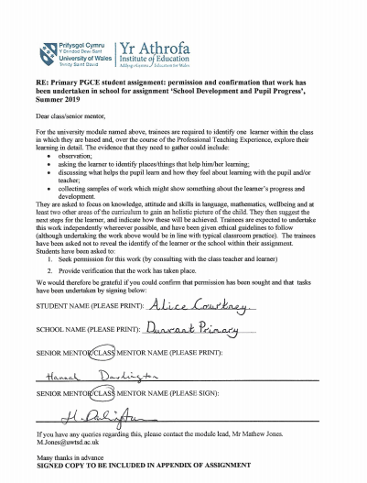
Appendix 1 – Signed Consent Forms

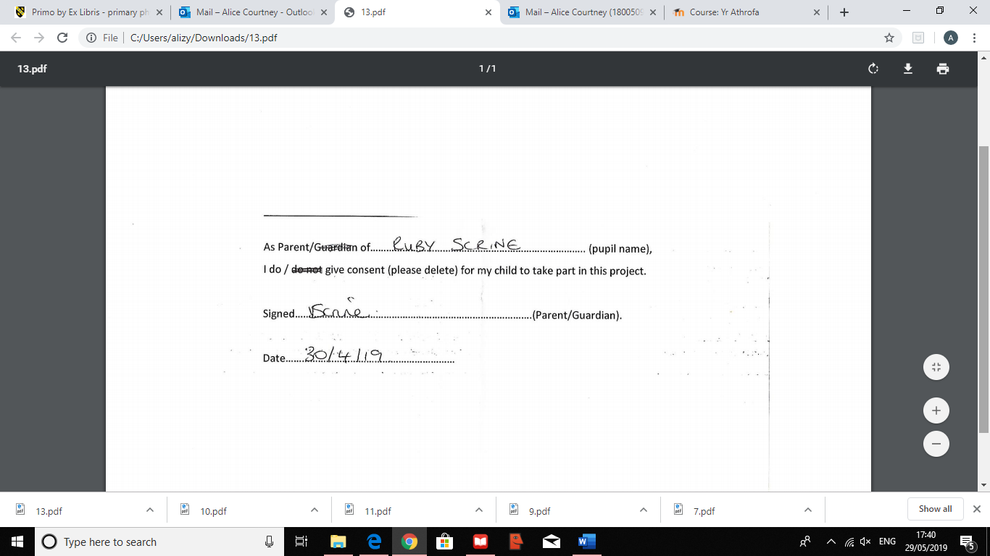

Appendix 2 – Child Conference
Conference 1:
- Why do you come to School?
Child A: To learn, to read, to help people, to be kind to friends.
- What do you like best?
Child A: Maths
- What don’t you like about being here?
Child A: Nothing
- Who are your favourite people?
Child A: (names 6 friends) and Miss Courtney and Miss Darlington.
- What do your teachers do for you?
Child A: If you get stuck, the teacher will help you.
- What should they do for you?
Child A: Help you
- What do you find difficult?
Child A: Reading
- What has been your best day in school?
Child A: Going to the forest to see the fairy house.
- How do you feel about Maths?
Child A: Excited!
- How do you feel about English?
Child A: Okay
- How do you feel about PE?
Child A: Excited – fun and different (took a photo of it)
- How do you feel about art?
Child A: Excited
- How do you feel about coming to school?
Child A: Excited

Conference 2 (same questions but with Child A’s teacher):
- Child A: To learn, to be kind
Teacher: You understand people’s feeling and classroom rules. You always tell me when something is wrong, which is good! Sometimes we could be a little more independent.
- Child A: Maths
Teacher: agrees
- Child A: same answer
- Child A: same answer
- Child A: Help when you’re stuck.
- Child A: Help
- Child A: Reading
- Child A: Today! Music because we made the different sounds you hear in the rainforest.
Teacher: You found it difficult to keep in time with others sometimes
- Child A: Excited
Teacher: You love the challenges! (mental maths)
- Child A: Okay
Teacher: Huge progress in reading, beginning to enjoy reading.
- Child A: Excited
Teacher: You like playing with the equipment on the yard as well!
- Child A: Excited
Teacher: agrees, however enthusiastic about being with friends more than being alone.
- Child A: Happy

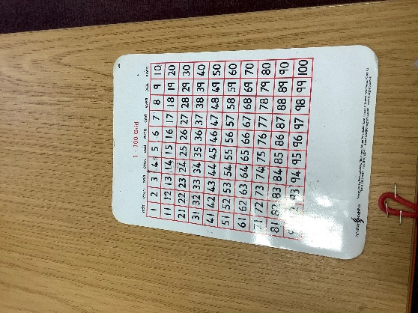
Appendix 3 – Photographs
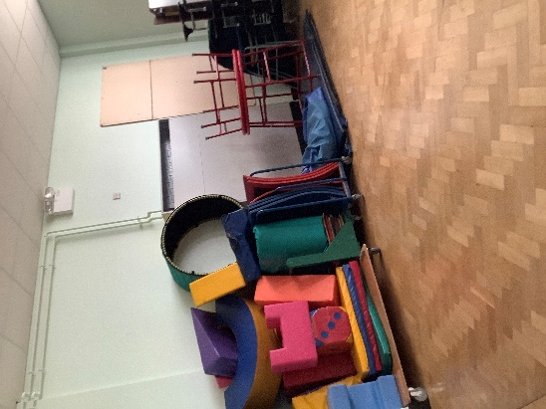
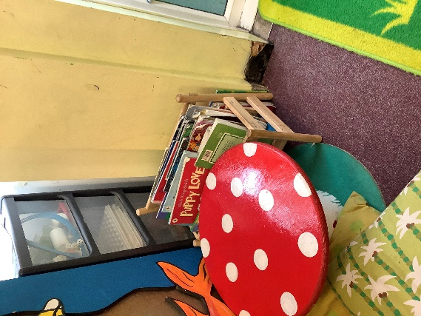
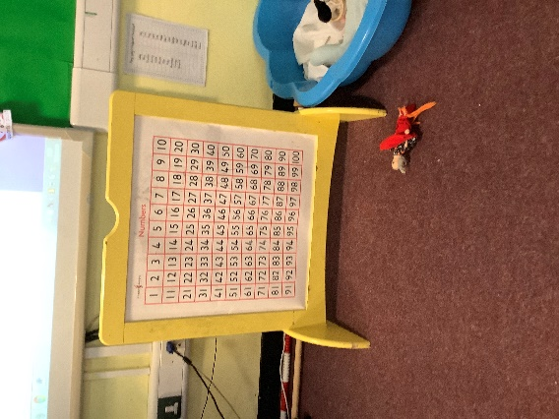
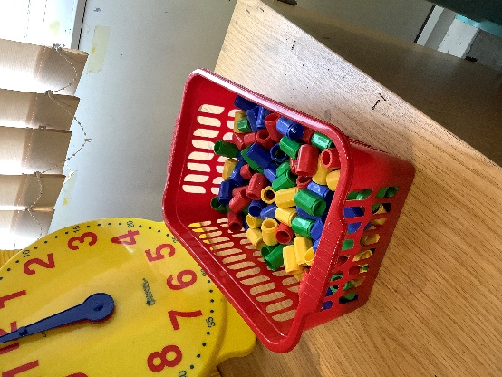
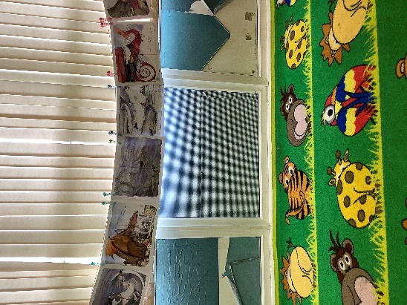
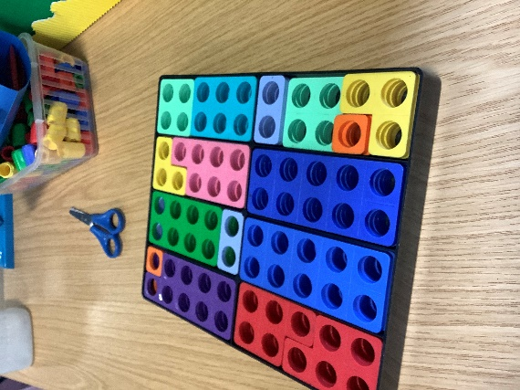
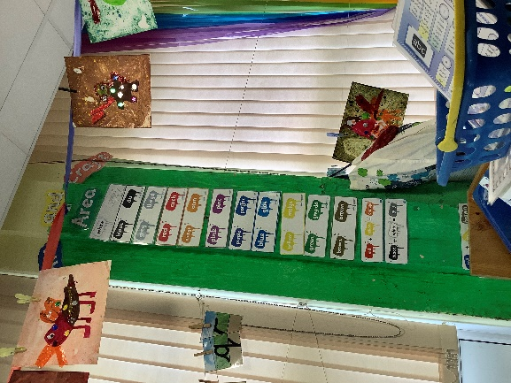

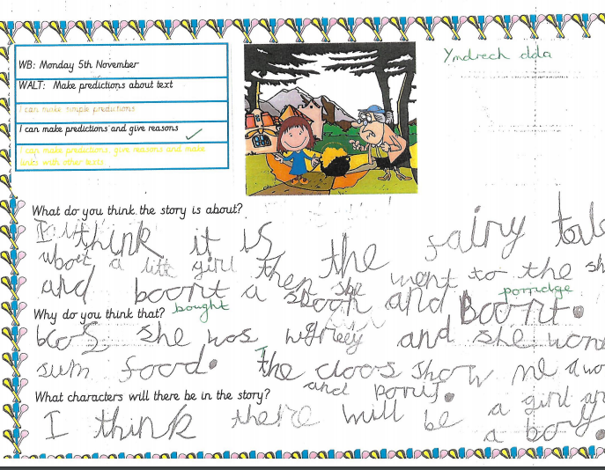
Appendix 4

Appendix 5
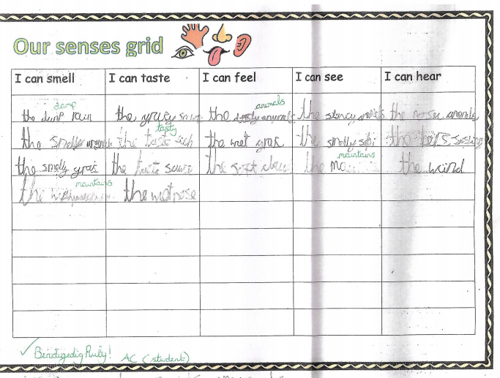

Appendix 6
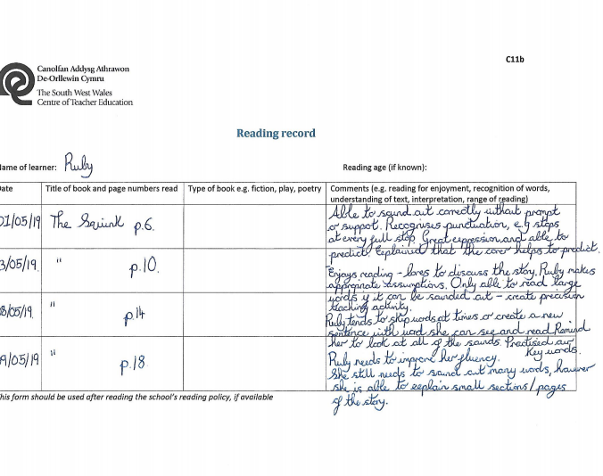

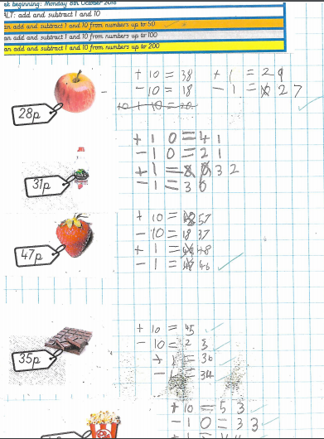
Appendix 7

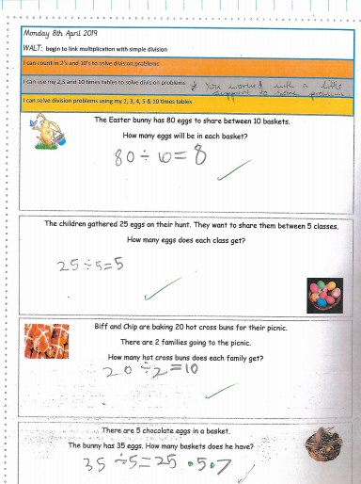
Appendix 8

Appendix 9 – Observation 1

Name of learner(s): R Class: Snow Leopards
Time: 09:45 Date: 21/05/19
Activity: Using the enhanced provision – Mathematics Jenga Game

- R asks W to play with her in the maths area. She explains that they haven’t attempted this challenge yet.
- W is confused about how to play the game. R takes the dice from W and explains that they need to ‘times the numbers on the dice’ to play the game (once they calculate the answer, they need to remove the block with the correct answer written on it). They start playing sensibly together.
- R is using her 2, 3, 5- and 10-times tables. If a sum is too difficult such as rolling a 6x4, R rolls the dice again until she rolls a sum she can complete. She struggles with 3x but does show some awareness.
- R and W begin to add the numbers, the answers are correct, but they are forgetting the rules of the game (they need to multiply the numbers). W notices that they have been multiplying and tells R. R laughs and asks W if they need to start again.
- They play the game for another 2 minutes, this time they are multiplying, and R is supporting W with her multiplication tables. 9:55 they are asked to tidy up.

Appendix 10
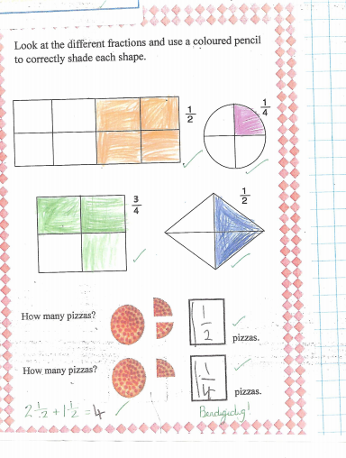

Appendix 11
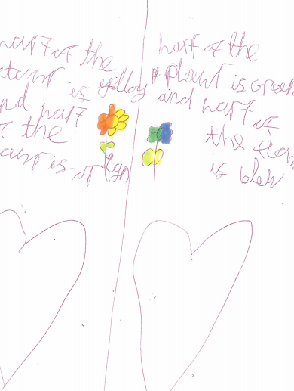

Appendix 12 – Observation 2

Name of learner(s): R Class: Snow Leopards
Time: 11:30 Date: 17/05/19
Activity: Using money (support from additional adult)

- R is looking at the coins, ordering them from smallest to biggest.
- The class teaching assistant notices what she is doing and praises her on her good work. She scaffolds her learning further by asking her to make coins that add up to £1. R is able to do this with little support (R has completed this activity before during the morning challenge and appears confident and quick when answering the question).
- After 4/5 minutes, R has calculated many different ways of making £1, mainly using 10p and 20p. She does this independently and points to her work once she has finished. R appears very pleased with her work and demonstrates a clear enjoyment for maths.
- The class teaching assistant recognises her clear understanding and therefore extends her learning further by asking her to calculate £2. R asks the teacher how much she needs to get for £2.
- The teacher begins explaining the value of £1. R begins to understand and calculates one way of making £2. She shows some good progression and understanding but does not appear completely confident (further consolidation and support needed).

Appendix 13 - Tour field notes
- Explained reading areas
- Not a free reader yet but understands a lot about organisation
- Good communication skills
- Very good understanding of STF – shows understanding and empathy – PSE (understands strategies and reasons)
- Explains displays in detail
- Explains the indoor PE equipment and asks to take a photo because she enjoys learning how to use it.
- Hall – assemblies, singing, star of the week, competitions and breakfast club
- Understands the reason of class names (endangered animals)
- The office – helps out with talking to parents (great understanding of safety and well-being)
- Enthusiastic, high energy and fully engaged

“Important things”
- Maths area
- Friends – playground
- Seeing work on displays

Appendix 14 – Observation 3
Name of learner(s): R Class: Snow Leopards
Time: 14:15 Date: 30/04/19
Activity: Physical Education Lesson
- The teacher asks the children to find a partner. R does this quickly and appears happy in her pair.
- The teacher demonstrates how to correctly throw the ball. R mimics correctly.
- R is secure on her feet and stretches her arms high and low to catch the ball if needed.
- R can confidently catch the ball, however sometimes she is hesitant to move her feet.
- She tends to remain in the same spot and her partner struggles with throwing the ball accurately. This is resulting in the ball not being thrown in the right direction and R is hesitant to move to catch it.
- R has fast pace and appears to not struggle with the activity.
- The class teacher has asked R how they could improve their catching and throwing. R replies asking if they could move closer together so they can improve. The class teacher agrees that this might be a good idea to help them.

Appendix 15 – Independent artwork


