
An Investigation into The Effects of Resonance on LRC Circuits
Oliver Atkinson
15/04/2024

Electronic and Electrical Principles
ACDA4006

Steve Mosey

Contents
Abstract 3
Introduction 4
Simulation setup (software based) 8
A breakdown of the components 8
Simulation setup (real-life) 11
Results 13
Proteus Simulation 13
Real life simulation 15
Discussion 16
How does this compare to other experiments? 18
Conclusion 19
References 20

Abstract

In this paper, the effects of resonance on an LRC circuit will be discussed. It uses evidence from an experiment performed by the author, as well as basic theory back this up.

It acts as a comparison between circuit simulation software and real-life scenarios by constructing the same filter in both proteus and real life and taking readings from the same frequency ranges. The results were as expected with a pointy frequency response graph however there were some differences.

Introduction

If an inductor is place in parallel with a capacitor, a circuit with incredibly accurate frequency characteristics is created. A resonant circuit, also known as active filter. These are extremely active at certain frequencies but the exact opposite at others. [1]

Resonance is a natural occurrence most commonly seen in music and the theory of sound however it has had both benefits and issues in the engineering world. Resonance becomes an issue when the objects natural frequency amplifies the generated frequency from an external source. A few examples of this include the millennium bridge in year 2000 and someone braking a glass from singing.

In the case of the millennium bridge, the bridge was built to have a natural ‘swinging’ frequency. This frequency acted much like the resonant frequency in the circuits below, where close to the particular frequency the output is amplified into an extremity. The downfall of this bridge came when the frequency of people walking across the bridge matched with the natural frequency of the structure. This caused the bridge to vibrate violently and be shut for a period of time.

Resonance has become a widely studied aspect of physics where benefits of achieving resonance allow for the use of filters much like those below.

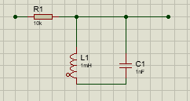

Main uses of the LRC resonance circuits include a wide range of devices from audio pick up devices to RF test equipment. [2] This requires them to be used in a variety of filters:
- high pass
- low pass
- band pass filters

Whereas the low pass and high pass filters do not use inductors, the band pass (pictured above) does. This means that what we created was a band pass filter.

A band pass filter allows a range if frequencies and rejects any outside this range. Any input signal higher or lower than the specified boundary if the filter will be attenuated more than the “allowed” range.

Uses of a band pass filter include:
- Audio systems – filtering out noise above or below the frequency threshold
- RF antennas – where specific frequencies are needed

Resonant Frequency

The frequency at which the object in question reacts the most. In filters this would be when the output is at its maximum. The natural frequency of the object amplifies this resonant frequency and has a profound effect. Either catastrophically or in a good way.

Q factor

A ratio that measures the efficiency of components, Quality factor is a measure of the bandwidth in an associated circuit. With a higher ‘Q’ value the component will have a narrower bandwidth and hence be more efficient as a filter. [3]

Theory

The theory used throughout this report will be based on inductor, resonance and capacitance.

Inductor theory:

X_{L} = 2πfL

- X_{L} – Inductive Reactance
- f – frequency
- L – inductance [4]
This equation shows that inductive reactance is directly proportional to the frequency.

Capacitor theory:

X_{c =} $\frac{1}{2πfc}$
- X_{c} – Capacitive reactance
- f – frequency
- c – capacitance [5]
This equation shows that capacitive reactive is inversely proportional to frequency.

Resonance theory:

f_{r} = $\frac{1}{2π√lc}$
- f_{r} – resonant frequency
- l – inductance
- c – capacitance [6]

Q factor (Quality factor) theory:

Q = $\frac{fr}{∆f}$
- Q – quality factor
- F_{r} – resonant frequency
- Δf – width of the peak at its half height with a 3dB (decibel) bandwidth [7]
Q factor is inversely proportional to the bandwidth
Or

Q = $\frac{Xl}{R}$
- Q - quality factor
- X_{l} – Inductive reactance
- R – resistance [8]

The resonant frequency can be calculated based on the theory before the simulation is tested. The results can then be compared.

Using the equation shown above we can calculate the resonant frequency, with the values of the components in the circuit.

f_{r} = $\frac{1}{2π√(1μf*1mH)}$

When the correct Standard form units are used, the resonant frequency is 5032.921Hz. This will be shown in the result chapter.

In the rest of the report, the results of the simulation will be compared to the real-life circuit build. As well as determine the Resonant frequency from my findings and compare that number to the calculated frequency using the basic theory.

Also, from the produced attenuation against frequency graphs, the Q factor (quality factor) for both simulation and real-life circuit will be calculated and then compare the two values from either system.

Furthermore, the differences between each circuit type will be discussed with reasonings behind them.

Simulation setup (software based)

The circuit that was simulated was an LRC filter, set up to show how resonance effects the output of the filter. LRC meaning inductor, resistor and capacitor, with the inductor and capacitor arranged in parallel. Aside from the obvious components the simulation also included a signal generator and an oscilloscope.

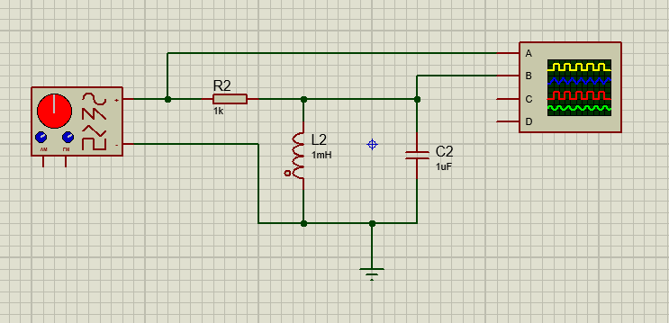

A breakdown of the components

Resistor

A resistor acts to oppose the flow of current within the simulation. The resistor used in this circuit was a 1K ohm (Ω) resistor.
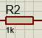

Capacitor

A capacitor temporarily stores charge between its parallel plates. Capacitors charge exponentially so the time taken to fully charge is five-time constants where the time constant is calculated via the equation T=RC (R= resistance and C = capacitance). The capacitor used has a value of 1µF (Farad) [9]

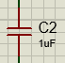

Inductor

Much like resistors, an inductors main purpose is to slow down current flow. Whilst the inductor is hooked up to an ac current the performance of the inductor will change dramatically. These performance changes mean that certain frequencies are allowed through the inductor whilst others are not. This is why it is used in a filter along with a capacitor. The inductor used in this circuit has a value of 1mH (Henry). [10]
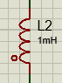

Signal Generator

Why use the signal generator instead of a sine wave voltage source? Well, the signal generator allows for a variety of input signals instead of one value. For example, the peak to peak voltage selected for this simulation was two volts. However, the input frequency was varied from 100Hz to 20KHz (Hertz). This was to achieve the specific shaped graph with a distinct point where the resonant frequency was.
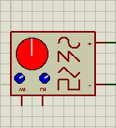
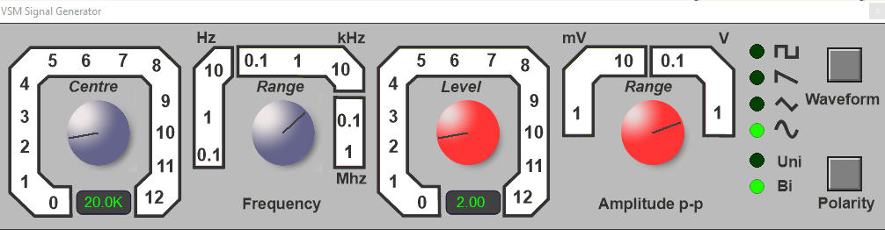

Oscilloscope

The oscilloscope was used to see the various signals in the simulation. On the oscilloscope two waves were shown, the input two-volt wave and the output wave with varying voltages. Only channels A and B had a signal so channels C and D were turned off.
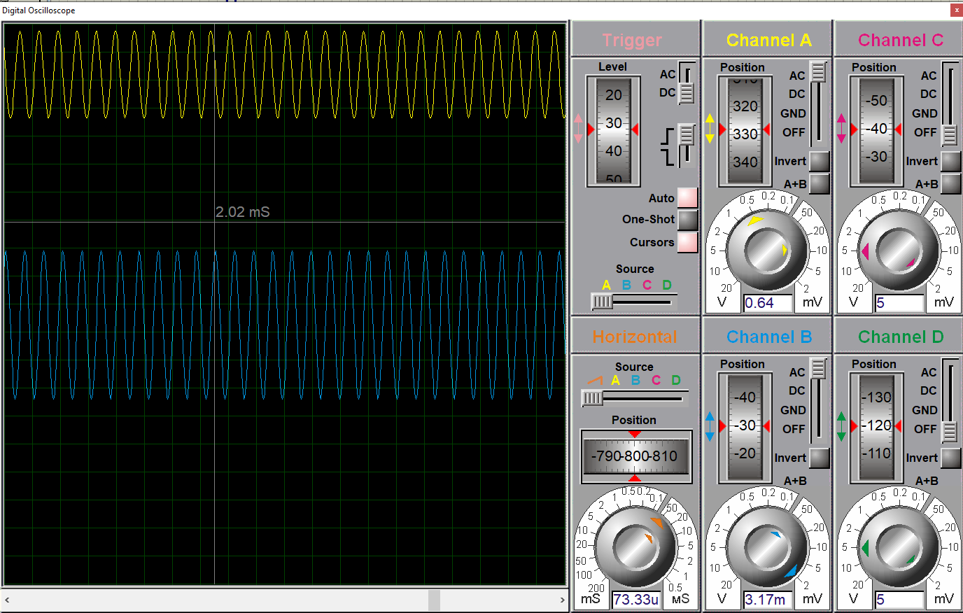
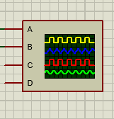

Simulation setup (real-life)
The real-life construction of the circuit used a breadboard as well as the components mentioned before. As shown below the circuit was very minimal in construction.

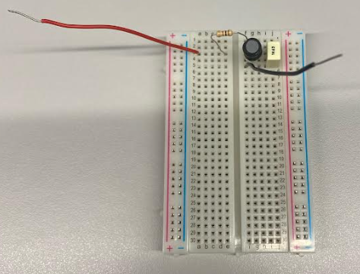

The red wire was the input wire which attached to the positive node on the signal generator. Whereas the black wire acted as a ground. The capacitor used was a polyester capacitor with a 10% tolerance and a 1µF capacitance. The resistor also had a 10% tolerance for the 1kΩ resistance. The inductor did not have a value associated to it, however assume an inductance of 1mH (Henry) and a tolerance of 10%.

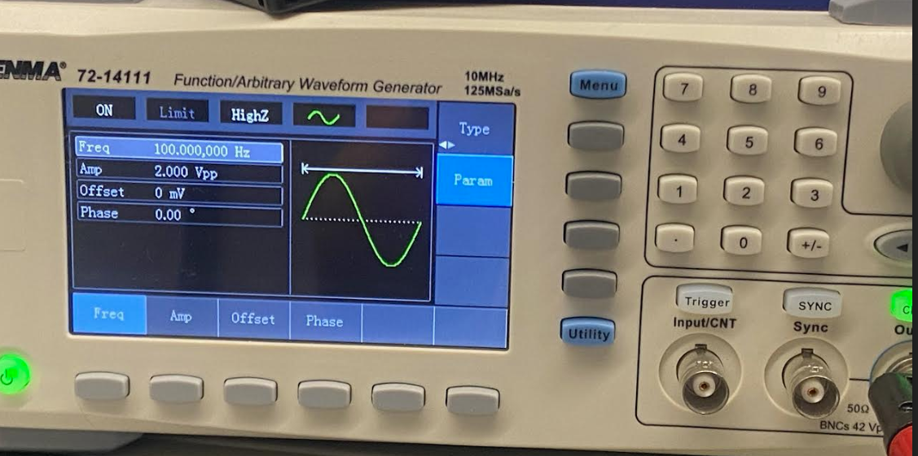

The signal generator, much like the simulation, was set with a peak to peak voltage of two volts. Also, the frequency was adjustable with a range of 100Hz to 10KHz (Hertz). Both the positive terminal and the ground terminal of the system plugged into the output port on the signal generator.

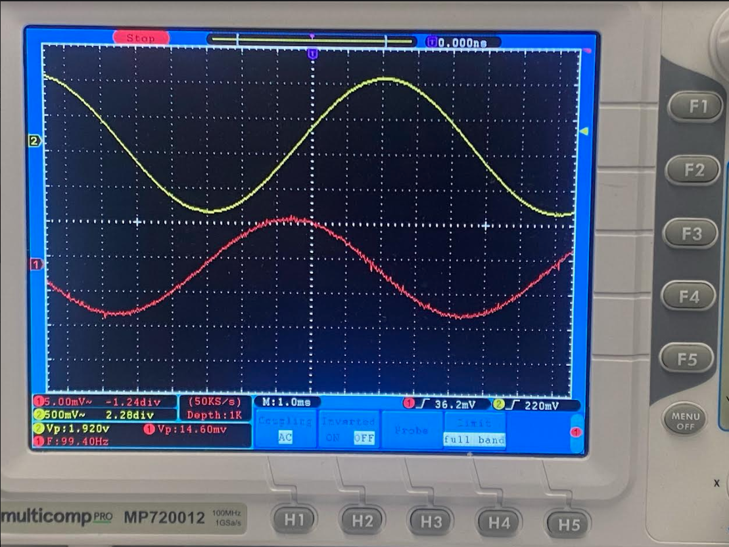

The oscilloscope shows both the input signal (yellow wave) and the output signal (red wave). The input signal is locked at 2 volts peak to peak, whereas the output signal varies in accordance to the resonance of the system. Whilst6 this will be further discussed in the next section; the output of the system was maxed out around 5000 Hz.

In order to hook the oscilloscope up to the bread board, two voltage probes were used. One of these, the yellow probe, was connected to the input wire (red) to provide the input wave on the scope. The other (red probe) was connected to the second leg of the resistor providing the output wave (red wave) on the scope. Both probes had a connection to ground.

Results

The results are split into different simulation types, then compared after.

Proteus Simulation

For this simulation the input frequency was varying from 100Hz to 20KHz. This was to give a wide range of values to then plot a graph. The graph that was plotted was attenuation against frequency.

In order to plot attenuation, it first had to be calculated. This calculation is where the graphs logarithmic scale came from. The equation seen below takes the voltages from our scenario and converts them into dBs (decibels).
$$a=20*\log\left(\frac{Vout}{Vin}\right)$$

The Results table

Frequency | Vin | Vout | Attenuation
100 | 2 | 1.30E-03 | -6.37E+01
200 | 2 | 2.50E-03 | -5.81E+01
500 | 2 | 6.40E-03 | -4.99E+01
1000 | 2 | 1.32E-02 | -4.36E+01
2000 | 2 | 3.04E-02 | -3.64E+01
4000 | 2 | 1.44E-01 | -2.29E+01
5000 | 2 | 1.60E+00 | -1.94E+00
6000 | 2 | 1.56E-01 | -2.21E+01
7000 | 2 | 8.75E-02 | -2.72E+01
10000 | 2 | 4.04E-02 | -3.39E+01
20000 | 2 | 1.65E-02 | -4.17E+01

This results table shows the frequencies at which the system was simulated. Both the Vout and the attenuation columns show a distinct pattern where is peaks around 5000Hz. This links with the calculated resonant frequency based on theory, where the resonant frequency was close to 5032Hz. This is visualized further on the graph below.

The graph better depicts the resonance of the simulated circuit however the software has a perfect inductor. This is very rarely the case as will be shown in the result for the real-life circuit. This affects the “pointiness” of the graph. This graph comes to a distinct point at the 5000Hz mark.

The Q factor can be calculated from this graph using the equation stated previously.

Real life simulation

The same calculation applies to the results of this circuit. To find the attenuation use the equation mentioned earlier.

Shown above is the distinct pattern of a peak around 5000Hz. However, I have included the calculated value for the resonant frequency of 5032Hz.

This graph shows the information from the table. When the two graphs are compared side to side the second graph has a shallower incline and a larger bandwidth.

Discussion

The difference in the results is a result of Proteus always using a perfect input signal with minimal noise. The Proteus results come close to zero attenuation with a max attenuation of -1.94E +00. Compared to the real life this number is fairly accurate.

Q Factor Calculations

Using the stated equations from the start of the report (Q = $\frac{Xl}{R}$, Q = $\frac{fr}{∆f}$), the Q factor of both circuits can be calculated and compared to the Q Factor from basic theory.

Basic Theory

Using the first equation and substituting in all the values the equation becomes Q = $\frac{2πfl}{R}$. Further substituting numerical values into this equation, it becomes Q = $\frac{2π5032*1e-3}{1e+3}$ (using the resonant frequency). When calculated this equates to 0.00316. This is the value of which the other simulations will be compared to.

Using the graphs

Now using the second equation (Q = $\frac{fr}{∆f}$) the Q factor of the simulated data can be calculated. First the proteus simulation:

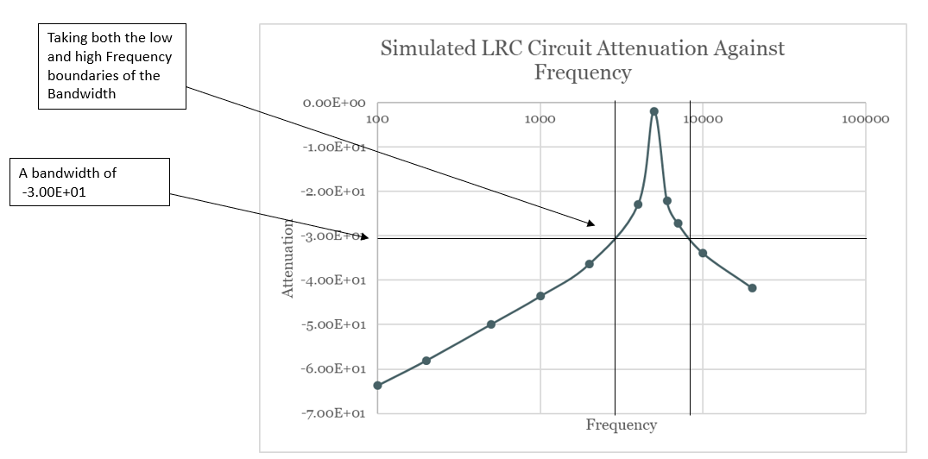

Using the resonant frequency from the graph of 5000Hz and the frequency range determined by the bandwidth, the Q factor can be calculated for the proteus simulation. The value for the Q factor comes out at 0.6. Now the real-life circuit results

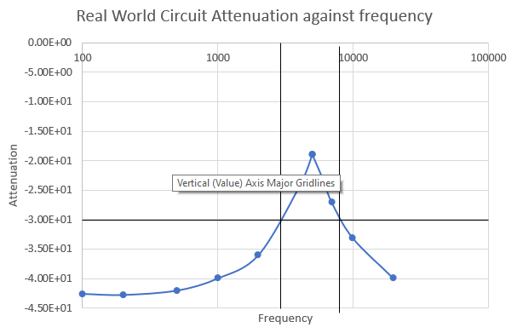

Using the resonant frequency of 5032Hz and a frequency range of 4500Hz and plugging them into the same equation the value of 0.894 is achieved.

So why are they different?

Q factor is a very significant term for all components. In the case of an inductor, if the inductor is ideal then it will have zero output resistance and a Q factor of infinity. The sane goes for a capacitor also. When the capacitor has zero leakage resistance the Q factor will be infinity. [11]

This explains why the q factors are different across the different calculations. In the basic theory the calculations are taken to be close to ideal, hence the 0.00316 Q factor. This incredibly close to zero as the components and they’re values are considered ideal with infinite Q factors.

The proteus simulation has a very different Q factor value, as it considers the tolerances in the components, as well as the discrepancies in the power supply. The same goes for the real-life circuit. However, the Q factor is even bigger for this do to the leakage resistance of the capacitor and the output resistance of the inductor. And the resistance of the wires and internal resistance of the oscilloscope.

In order to achieve the same results in both, the values of the components in the proteus simulation have to be altered.

How does this compare to other experiments?

The out come from this experiment was as expected. The ‘pointiness’ of the graph delivered the results that the group expected. With a peak around the resonant frequency of around 5000Hz. Looking at the documented work of Getinet Ashebir et al [12]and the frequency response graph there worked produced it can be observed that the specific steep curve of a resonance circuit is common across all LRC filters.

Conclusion
During this experiment it was discovered that when and inductor and a capacitor is placed in parallel they act as a filter. In the figures above, it was shown that the filter attenuates signals that are too high above and too far below the resonant frequency. However, when the frequency is close the to the resonant, so within a 3-decibel bandwidth, the signal is amplified giving a pointy or spikey graph.

It was also discovered that when considering values for a q factor calculation they are almost never ideal. This means that noise and leakage occur throughout the whole system and to achieve an accurate ‘Q’ value this discrepancy must accounted for. This is shown by comparing the difference in values from the two simulations and the basic theory.

References

[1] | W. H. P. Horrowitz, The Art of Electronics, vol. Third, New York: Cambridge University press, 2015, p. 52.
[2] | Eletronics Technician Training, "Application of Resonant Circuits," George Brown College, 26 1 2022. [Online]. Available: https://www.etcourse.com/news-blog/5-applications-resonant-circuits. [Accessed 22 4 2024].
[3] | All about circuits, "Q factor and bandwidth in resonant circuits," All about circuits, [Online]. Available: https://www.allaboutcircuits.com/textbook/alternating-current/chpt-6/q-and-bandwidth-resonant-circuit/. [Accessed 30 04 2024].
[4] | Panasonic, "Basic knowledge of inductors," Panasonic, 25 08 2020. [Online]. Available: https://industrial.panasonic.com/ww/ss/technical/b5. [Accessed 28 04 24].
[5] | J. C. R. M.S., Basic AC Circuits, Dallas: Butterworth-Heinemann, 2000.
[6] | WJEC Exam Board, "Chapter 4: AC Circuits and Passive filters," WJEC, Cardiff, 2018.
[7] | Z.-G. Ye, Handbook of Advanced Dielectric, Piezoelectric and Ferroelectric Materials, Cambridge: Woodhead Publishings Limited, 2006.
[8] | J. Serway, Physics for scientist and engineers, Belmont: Mary Finch, 2010.
[9] | University of Birmingham, "Physics A Level revision resource: Introduction to capacitors," University of Brmingham, 2024. [Online]. Available: https://www.birmingham.ac.uk/study/undergraduate/schools-and-colleges/post-16/a-level-stem-resources/capacitors#:~:text=Unlike%20the%20battery%2C%20a%20capacitor,to%20create%20a%20potential%20difference.. [Accessed 28 04 2024].
[10] | RS circuits, "How do inductors work?," RS Circuits, 12 6 23. [Online]. Available: https://uk.rs-online.com/web/content/discovery/ideas-and-advice/inductors-guide. [Accessed 28 4 24].
[11] | D. Patranabis, "Principles of Electronic Instrumentation," PHI Learning Private Limited, New Delhi, 2009.
[12] | S. Z. U. M. R. S. M. H. D. T. B. Getinet Ashebir, "Fully screen printed LRC resonance circuit," Elsevier, Amsterdam, 2016.

