ACUA 6001

"A Research Report on Data Centre Virtualization"

Submitted in the partial fulfilment for the award degree of
BSC CLOUD COMPUTING
to
University of Wales Trinity Saint David, London

Submitted by:

1805315
Giuseppe Ventimiglia

Under the guidance of:
Koushik Modak

Academic Year 2020/2021


Abstract

In recent times, the evolution from the on-premises data centres to virtualised data centres has gained extensive attention from academia and the industry for the series of benefits that the cloud offers, leading more organisation to consider a virtualised solution to centralise their IT operations.
This report combines two scenarios: From a customer perspective, the first scenario analyses various aspects of on-premises and cloud data centres, such as design, scalability, security, secure energy supply, storage, sustainability, and cost, to consider a suitable architecture for the UWTSD university. For this research, a mix of qualitative and quantitative data is used on secondary sources. In the second scenario, a study on three topics related to ABC Data LTD's data centres is performed, based on the importance of storage area networks for protecting data against corruption and the necessity of IT security policies and disaster recovery system in the organisation. These three aspects have been added as sub-chapters to related aspects of the UWTSD scenario, respectively storage, security, and secure energy supply, to provide a service provider perspective in addition to the customer standpoint. The research terminates proposing the virtual data centre as the most appropriate architecture for the UWTSD.

Table of contents

Abstract 2
1 Introduction 4
2 Background 4
3 Research Methodology 5
4 Analysis 6
4.1 Design 6
4.2 Scalability 6
4.3 Storage 7
4.3.1 SAN and data corruption 7
4.4 Security 8
4.4.1 IT Policy 9
4.5 Secure energy supply 10
4.5.1 Disaster Recovery 11
4.6 Sustainability 11
4.7 Cost 12
4.8 Considerations 13
5 Results 14
6 Conclusion and future work 14
7 References 16

1 Introduction
In recent decades, the IT industry's advancements, in combination with an unforeseen quantity of connected devices and network traffic, have led to phenomenal demand for data centres [1]. A data centre is a repository that hosts an organisation's critical ICT assets, such as servers, routers, switches, and storage devices for the management, elaboration, and sharing of data, becoming the foundation of a wide diversity of online services, including e-commerce, social networking, and e-learning [2]. Today, the planet's largest organisations, such as Google, Amazon, and Microsoft, heavily rely on their data centres to supply resources and services to millions of customers worldwide. More businesses and organisations, such as the UWTSD university, are initialising a transitioning process towards the data centre to centralise operations and the ICT equipment. A data centre solution can be on-premises, traditionally hosted in a building and entirely managed by the owner, or virtualised, supplied by a cloud provider with a shared management model. Both types are part of the data centre's evolution process and present various characteristics that make a virtual or traditional data centre more suitable to an organisation's requirements.
Moreover, cloud storage has become an essential part of today's life for being cost-effective, elastic, and easy to operate. Enterprises and organisations have started a data migration process towards the cloud to gain agility and flexibility, and technologies, such Internet of Things, are completely cloud-dependent due to the limited hardware capabilities. This process has led to petabytes of sensitive data stored in data centres worldwide, creating a significant challenge for Cloud Service Providers (CSP) like ABC Data Ltd to protect users' data and privacy efficiently. Indeed, such an enormous quantity of data can create an open-handed wealth at risk of infrastructure failure, data corruption, and unauthorised access [10] that can compromise the provider's reputation and reliability.

2 Background
Even though the data centre concept became widely adopted in the 1990s, the first rudimental data centres (DC) have been around since the 1960s, creating the standards of the traditional data centre [2]. This type of infrastructure can be bound to unique or multiple physical locations, and its realisation is a long-term and complex task that involves the analysis and planning of various aspects. Some of the most critical factors involve the selection of the site, the design of a structural, energetical, and communicational system, the implementation of physical and logical security, the access to the necessary financial resources, and ongoing maintenance and management to meet the stakeholders' and Service level Agreement' expectations [3].
However, Cloud Computing has simplified this entire process for businesses and organisations that require this type of infrastructure. Indeed, the DC is also the core infrastructure for Cloud Computing services that leverages the virtualisation technology to abstract the underlying physical infrastructure and provide virtualised resources on demand.
Virtualisation creates an abstraction layer over the host's hardware components by empowering a category of software called hypervisor, which is categorised into two types [8]. Type 1 hypervisor is installed on the host's hardware without an operating system, allowing the virtualisation of storage, network, and computing resources. The most common solutions include Microsoft Hyper-V, VMware ESXi, and Citrix Xen. Type 2 Hypervisor is installed on an existing operating system, which is dependent on, providing limited virtualisation capability. The most common solutions are Oracle Virtual Box and VMware Workstation that allow the abstraction of the operating system to host multiple virtual machines [5]. Type 1 virtualisation, hence, enables a cloud provider to use physical DC as the backbone for multiple virtual DC that can be replicated, migrated, and accessed anywhere online as a utility service. These services are categorised in three models, including Software-as-a-Service (SaaS), Platform-as-a-Service (PaaS), and Infrastructure-as-a-Service (IaaS), distinguishing the virtual DC service in the IaaS model.
In SaaS, the service provider hosts, manages, controls, and offers applications to customers who have no control over the underlying system. Examples of SaaS are Google Apps, Office 365, and Slack. In the PaaS model, the cloud provider gives customers the ability to develop applications by supplying a development environment; however, the customer's level of control is limited to the application and data. PaaS examples include Heroku, Google App Engine, and Windows Azure. Instead, in the IaaS model, the provider supply customers with the ability to provision computing, storage, and networking resources according to their own needs. In this model, the customer controls what software and services can be deployed within the cloud [6]. IaaS representatives comprise Amazon Web Services (AWS), Google Compute Engine, and Digital Ocean.
A further distinction is made upon the deployment model of cloud services, by which the IaaS model is typically deployed in a public cloud:
- Public cloud: the infrastructure is delivered on the CSP platform and is accessible over the Internet for a usage fee.
- Private cloud: It consists of a hosted infrastructure on a private platform.
- Community: cloud: The model is shared between organisations with common interests.
- Hybrid cloud: The hybrid model consists of a combination of two models.

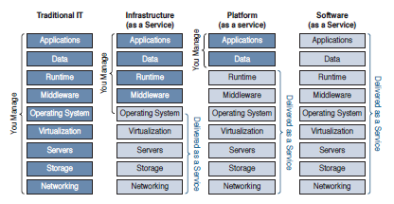
Figure 1 Cloud models management level [6]

3 Research Methodology
This research is conducted on previous studies performed in the field, using quantitative and qualitative data. The analysis includes the study and comparison of various aspects of the on-premises and virtual data centre, including design, scalability, security, secure energy supply, sustainability, and costs.

4 Analysis

4.1 Design
The DC's design determines the physical connection of all the network components. Many designs have been developed in the past, but one of the most effective topologies is the Spine-Leaf architecture, created to handle the traffic generated between hosts in the same DC, called "East-West" traffic [14].
An on-premises infrastructure would enable the UWTSD to have direct and granular control over the network; however, tasks such as network configuration, management, maintenance, and troubleshooting must be carefully considered to ensure performance and cost-effectiveness.
In virtualised solutions, the design is an aspect hidden to the end-user. Indeed, the CSP manages the underlying infrastructure in the IaaS model dealing with all the related aspects. However, the customer can design the infrastructures built on the IaaS model with platforms and software of their own choice. Fig. 2 presents a suitable cloud design for the UWTSD. The UWTSD can use the IaaS model to create its virtualised infrastructure, managed by the IT department and used by researchers and developers. On top of the IaaS infrastructure, PaaS services can be implemented to develop platforms, including databases for managing the students' records and applications for students and lecturers' productivity delivered as part of the SaaS service model.
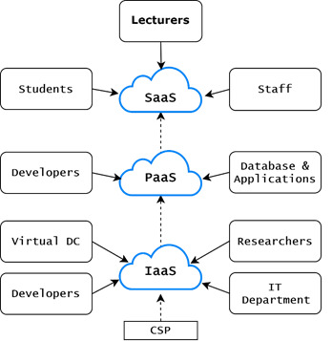
Figure 2 Cloud infrastructure.

4.2 Scalability
Scalability refers to the ability of a network to expand in response to increased traffic requests. For an on-premises UWTSD solution, this ability is determined by the size and topology of the infrastructure. Both aspects require extensive planning and consideration for future growth. Over-building the DC can result in a waste of resources and high management and maintenance costs; instead, under-building can lead to running out of resources earlier than planned and scaling up the network can compromise the network topology's properties, generating further costs [15].
On the other hand, a virtual DC has inherited various benefits from the cloud that allows customers to gain high scalability without purchasing or renting new equipment [6]. A cloud UWTSD infrastructure can indeed benefit of:
- Rapid elasticity: the number of necessary resources can be increased or lessened according to the infrastructure's needs. Scaling up or scaling down resources such as memory and processing is defined as Cloud Vertical Scaling; instead, when referred to, the provisioning of servers is defined as Cloud Horizontal Scaling.
- On-demand self-service: The CSP guarantees high availability of the infrastructure, providing all the necessary resources without any time constraint and human interaction but solely through service automation.
- Resource pooling: the cloud DC is a shared pool of resources from multiple sites employed to supply customers with all the requested services.

4.3 Storage
Storage is an essential aspect for an organisation to ensure data confidentiality, integrity, and availability. The storage area network (SAN) is a technology that has become the standard for a DC and consists of a high-performant dedicated network based on the Fibre Channel data transmission protocol. A SAN offers improved performances, reliability, scalability, and management over previous technologies such as NAS and DAS and comprises a three-layer structure: the Host Layer, which contains server applications queried by the clients; the Fabric Layer, which hosts switches that link the servers to the last layer, the Storage Layer, containing storage devices such as disks. In an on-premises solution, the implementation of a SAN must be considered by the UWTSD for the large quantity of data hosted and required by the various campuses.
However, a virtual DC simplifies this process as SANs are not directly implemented. Indeed, storage is provided as a utility, offering various services based on the same storage array type SAN, NAS, and other technologies offer [16]. Two examples are Amazon Elastic Block Store [17] which uses block-level storage, used by SAN, and Amazon Elastic File System [17], which uses Network File System storage, traditionally serviced on NAS. The UWTSD can benefit from the cloud solution to quickly scale the storage space, save costs for hardware and maintenance and gain agility across the various campuses.

4.3.1 SAN and data corruption
Data corruption is a type of error that can affect the data's accuracy and consistency, especially in large storage systems, such as SANs. This error can be unexpectedly generated during the writing, reading, storing, transmitting, and processing data, making it unreadable and unusable [12]. Data corruption is usually associated with various factors such as power and hardware failures, electromagnetic interferences (EMI), and firmware bugs. Moreover, as data transfer rates are rapidly increasing, legacy integrity checks such as the Transfer Control Protocol (TPC) checksum fail to detect errors [11].
The ABC Data LTD can provide a solution against data corruption by adopting a technology implemented on SAN called Redundant Array of Independent Disks (RAID).
The RAID is a data storage virtualisation technology that uses several physical disks as one logical unit to enhance data transfer rates, load balance traffic across the disks, and provide reliability. RAID ensures data redundancy and protection against corruption through the parity mechanism, consisting of the mathematical calculation of a binary value, called a parity bit, by performing the exclusive OR (XOR) logic operation with each byte of the sent and received data. Two types of parity are used for this purpose: even parity, which sends a 1-parity bit if the number of 1-bits in the byte is even, and odd parity that operates oppositely, sending a 1-parity bit if the number of 1-bits is odd. The sender and receiver must be configured to use the same type of parity, so when data is sent, the receiver performs a parity check using the same algorithm as the sender. If the two values are the same, the byte is accepted as valid, ensuring its integrity. However, in case of a mismatch, a transmission error is detected, causing the receiver to cancel the reception.
In the RAID system, all data's parity is computed and stored across various disks, so in case of data errors or loss, they can be detected, and data can be re-generated [13]. RAID can be designed in many different ways; however, only specific configurations such as RAID 3, RAID 5, and RAID 6 provide parity. The RAID 6 design provides the highest level of data redundancy, using a dual parity technique on a minimum of four disks [13]. This configuration indeed copies and spreads data across the disks, divided into several blocks of memory, reserving several blocks on each disk to store the dual parity. This method allocates half of the total RAID space for storage and the other half for parity, allowing in case of a disk failure to restore data using the parity stored on other disks. Moreover, thanks to the dual parity technique, it can also support the simultaneous failure of two disks.

4.4 Security
A DC can be a promising and profitable target for cybercrime due to the cruciality of the operations provided and the quantity of hosted data. An on-premises UWTSD DC should ensure security on two aspects: physical and logical [8]. Physical security refers to protecting the building from unauthorised access, while logical security refers to safeguarding the network from internet intrusions. The network indeed can be susceptible to many attacks and requires the adoption of defence mechanisms such as NIDS, Next-Generation Firewall (NGF) and DDOS mitigators, considering the importance of regular staff training, vulnerability scanning and penetration testing.
In a virtual DC solution, the UWTSD would assume shared responsibility with the provider. Considering the IaaS model indeed, the CSP is accountable for the physical and logical protection of the underlying infrastructure, while the customer is responsible for the platforms and applications built on top, as depicted in Fig 3.
One of the most debated aspects of the cloud is related to data security. The virtual solution would imply the UWTSD to store student's sensitive data on the cloud with the risk of leakages and authorised access. However, to ensure trust and reliability, the CSP must undergo strict controls to prove compliance to legal, governmental, and industrial regulations such as GDPR, SOX, HIPAA, and ISO 27001. The CSP also has to guarantee confidentiality, transparency, user control, and solid legal protection [8].

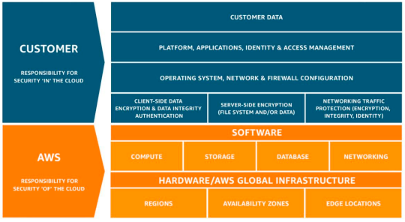
Figure 3 Shared responsibility model on AWS [18].

4.4.1 IT Policy
Trust is one of the fundamental aspects motivating users and organisations to move their data to the cloud. Indeed, once data is uploaded, it is stored over the internet, and its physical ownership is delegated to the CSP, which has complete control of the underlying structure, assuming a certain degree of control over the data[10]. If not rigidly controlled and regulated by the organisation, this control can lead to improper data management and increased cybercrime activity. Indeed, the lack of information security awareness, carelessness, and ignorance constitute the pillars by which users are considered the weakest link in the cybersecurity chain, therefore the hacker's most preferred victims [9]. Moreover, the threat of malicious insiders cannot also be overlooked. ABC Data LTD, hence, must establish a rigid set of security policies to regulate and control unauthorised access to data and provide data security compliance.
An IT security policy is a set of rules and procedures that define the correct behaviour all the employees must follow to ensure data confidentiality, integrity, and availability [9]. A policy plays a vital role in the organisation's management, and its creation must integrate with the company's culture to not cause conflicts with its mission, considering factors such as the level of risk tolerance and data security established in the company. A clear and concise policy must contain specific aspects besides the policy itself [8], such as a scope statement that briefly introduces the intent of the policy; policy overview statement, which explains the expected goal; policy statement, which expresses the substance of the policy; accountability statement, that defines who is responsible for its enforcement and the actions that are taken in case of noncompliance without leaving any doubts for misinterpretation; and exception statement, that provides guidance in case of a needed deviance eventuality.
The most common IT security policies include:
- Separation of duties: Separation of duties policies are conceived to minimise the risk of fraud and loss by requiring more than one person to complete a critical process.
- Clean desk: a clean desk policy aims to ensure the physical security of data by requiring employees to limit documents on their desk to only what is related to their current task, safely storing anything else not necessary.
- Nondisclosure agreement (NDA): An NDA is a legal contract between the employer and the employee to ensure the confidentiality of material, knowledge, or information shared.
- Acceptable Use Policies (AUP): The AUP delineates how the organisation's IT assets, both hardware, and software, can be used by the employees.

4.5 Secure energy supply
Secure energy supply refers to the DC's capability of providing continuous and uninterrupted energy during a disaster. Energy supply is a critical aspect, as almost every component in a DC depends on it.
In an on-premises DC, the UWTSD can ensure energy redundancy by adopting two appliances: Uninterruptable Power Supply (UPS) and backup generators [8]. A UPS is a system that stores electricity on its internal batteries to supply power in case of emergency. A UPS is a temporary solution able to provide energy for a short amount of time that can either be used to power down the equipment properly or switch for a backup generator. A backup generator is a system that can run on gasoline, propane, natural gas, or diesel to generate and supply steady electrical power. A DC typically employs room-size generators to provide enough energy to the whole infrastructure. Generators often use UPS systems in conjunction due to the initial warm-up time required to function at total capacity, as shown in Fig. 4.
In a virtual infrastructure, the provider manages the secure energy supply of the infrastructure to ensure high availability. For this purpose, most cloud providers rely on several data centres hosted worldwide to create availability zones. This technique reduces the probability of downtime, as if a disaster strikes in a location, resources can be pooled from multiple sites. The UWTSD, however, must ensure a certain level of secure energy supply to guarantee uninterrupted access to the cloud.
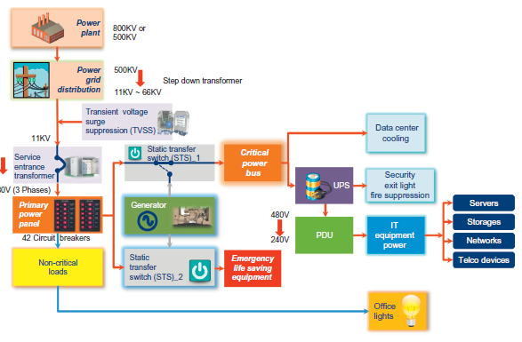
Figure 4 DC power distribution [16]

4.5.1 Disaster Recovery
The data centre's services and operations can be affected by many risks that can impact its availability and severely test its resiliency. A disaster is an occurrence of devastating consequences that can disrupt the system's accessibility for an intolerable interval of time. Disasters are divided into environmental, such as tornados, earthquakes, floods, or human-made, such as cyberterrorism, power-outage, and malware [7]. In both cases, data centres face a significant challenge to ensure full functionality. An organisation needs to be prepared to handle any catastrophe, aiming to minimise downtime and loss and recover operations as soon as possible to ensure business continuity. For this purpose, a disaster recovery system is essential for ABC Data LTD to create various protocols, controls, and procedures that must be followed to counteract a disaster efficiently.
The Disaster Recovery Plan (DRP) is the main document of a disaster recovery system whose primary goal is to enable an organisation to survive a catastrophe by allowing critical business functions to resume and providing safety to the people on-premises. The DRP addresses three essential stages [8]: Prevention, which is the pre-disaster phase in which the organisation must maintain mirrored servers, storage backup systems, UPS, generators, and other physical ready-to-operate sites. This phase also includes personnel training and emergency simulation to minimise the disaster's impact and maximise recovery time. Continuity is the second phase that takes place during the catastrophe. At this stage, the organisation must ensure the availability of core mission-critical systems by switching operations on alternative systems. Recovery is the post-disaster phase that focuses on re-establishing all systems and resources to the ordinary operational status.
It is also essential for any disaster recovery plan to have a backup system that can perform regular backups of the data, including essential information such as email storage, event logs, and user account files. Backups can be performed on disks or the cloud. In the former category, data is automatically copied on disks stored off-site, usually in a location geographically distant to the data centre, to reduce the probability of both being affected by a disaster. In the latter category, backed-up data is stored on the cloud, allowing immediate recovery, easy management, and flexibility. Storage Area Network implements another data backup technique. The SAN Replication is a service that duplicates all the data contained in the SAN into another SAN infrastructure. SAN replication supports interoperability between different platforms, resulting in a cost-effective, easy-to-manage, and performant solution for data recovery.

4.6 Sustainability
Sustainability represents one of the most significant challenges for a DC to protect the environment from emissions and reduce power consumption. A DC indeed consumes a considerable quantity of power to operate and cool down the equipment. Moreover, the carbon emissions percentage (CO2) generated in 2020 corresponds to 3.5% of the global emission, expected to rise to 14% within 2040 [24]. The main factors that prevent DCs from becoming sustainable include factors such as:
- Use of fossil-based fuel to produce energy.
- Inefficient management of the cooling infrastructure.
- Enterprise-level equipment can be expensive and power-hungry.
- Unused network resources can result in wasted energy.
A physical UWTSD facility, hence, would require to ensure sustainability and compliance to environmental laws that can be achieved by adopting renewable sources of energy such as solar, water, or wind; purchasing energy-efficient equipment and ensuring efficient management of the green IT equipment by creating policies and power-aware cooling infrastructure [19].
On the contrary, a virtual DC can increase the CSP power consumption; however, virtualisation has significantly reduced the necessity to build and operate physical infrastructure. According to Accenture[20], the IaaS model can decrease the CO2 emission by more than 84% than typical on-premises infrastructure. The percentage can be even higher, reaching 98%, by operating cloud-native apps on the virtual DC.

4.7 Cost
Building a DC is an operation that requires significant monetary funds over a period of time. The main costs are classified into Capital expenditures (Capex), which refer to the expenses for purchasing significant assets, and Opening Expenditures (Opex), which includes the required expenses for the day-to-day functioning of the infrastructure.
The size of a hypothetical infrastructure for the UWTSD can be assumed to be medium, able to host between 50 and 100 racks [16]. This assumption takes into consideration the UWTSD number of students [25] and the infrastructures created for other universities [22], [23] with a similar student population. The estimate also considers various factors related to the data centre environment and redundancy level to ensure high performance.
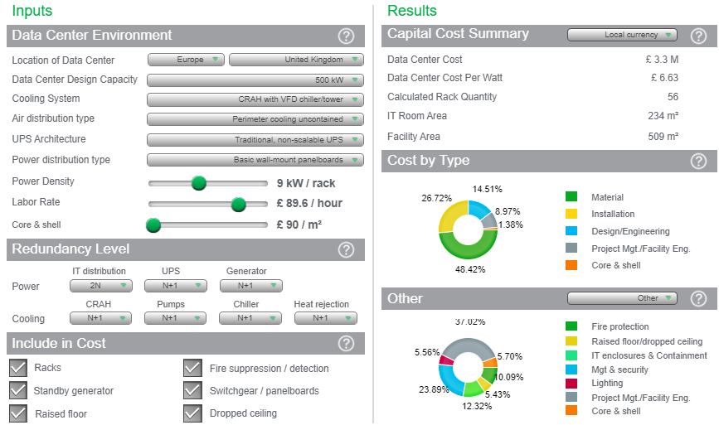
Figure 5 CAPEX calculation [29]
The calculation shows that the new DC's CAPEX could approximately amount to £ 3.3M, with the most significant costs represented all the necessary material, including network equipment and installation.
In Fig 6, another calculation shows that virtualising the UWTSD on-premises infrastructure could reduce the number of necessary servers and racks by over 70%, decreasing the power consumption and annual electrical bill by 50%.
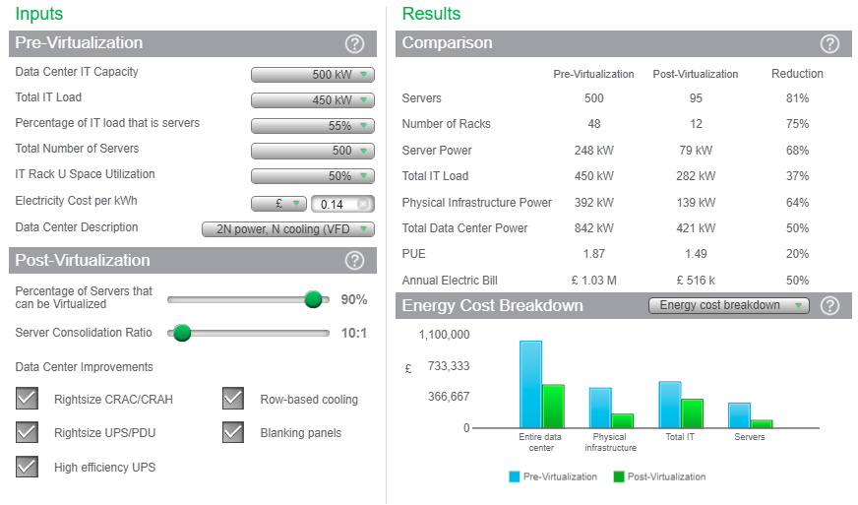
Figure 6 Pre-virtualisation vs Post-virtualisation [28]
A complete virtual DC, on the contrary, would eliminate any initial costs for the UWTSD as a result of one of the key advantages of the cloud, which consists of the pay-as-you-go pricing scheme. Indeed, the CSP measures resources utilisation, billing the customers accordingly and providing cost transparency and optimisation [21]. In Fig. 6, a monthly cost estimate is performed on Amazon AWS for an infrastructure of 95 instances, which represents the number of needed servers post- virtualisation, each with 16 vCPU and 32 vRAM. The estimate also includes 100 TB of storage and AWS support, generating a monthly cost of less than £22,000.
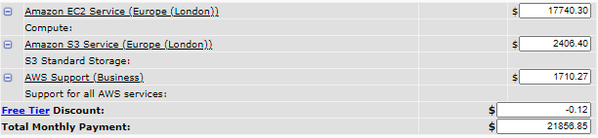
Figure 6 AWS cost estimate [30]

4.8 Considerations
The choice of a virtual data centre involves the consideration of additional aspects and limitations, including:
- Vendor lock-in
Vendor lock-in refers to the condition by which customers, for financial pressure, need to avoid interruptions or insufficient workforces remain locked-in with a provider. This circumstance occurs due to a lack of standardisation from the CSP that uses proprietary data formats or software not interoperable with other providers, leading a customer to become dependent on a vendor, even if prices rise or the service becomes inefficient. This risk can be mitigated by carefully studying the services offered, including terms and conditions, and considering how easily data can be moved using the industry's standards [26].

- IT support
The virtual infrastructure eliminates the need for an entire IT department to manage it. However, the UWTSD must ensure that IT staff on-premises has specialistic knowledge about the cloud and each related aspect. The organisation must also invest a specific budget for cloud training [27].

- Internet connectivity
The virtual infrastructure is cloud-dependent and not locally accessible; therefore, uninterrupted Internet access is critical for the UWTSD. Redundant internet access is achieved using multiple wan links to the ISP and load balancing the traffic across the various lines.

5 Results
The analysis of the various aspects between on-premises and cloud DC provides a complete overview of each architecture, fundamental for choosing the most appropriate solution for the UWTSD university.
An on-premises infrastructure would benefit from the complete control of the infrastructure and the total retention of data on-site without relying on third-party organisations. However, factors such as the design, implementation, maintenance of the network topology and SAN, in addition to ensuring scalability, secure energy supply, and sustainability, drastically increase the infrastructure's complexity and the amount of necessary financial resources required. The characteristics of on-premises infrastructure are more suitable for large organisations by which business goals entirely rely on Internet services, requiring a DC of large scale, or multiple DCs, to host critical workloads and sensitive data for millions of users.
The virtual DC benefits various characteristics that ensure high performance and scalability, minimum risk of downtime, zero maintenance of the underlying infrastructure, and customisation of the applications and platforms. Costs are based on the pay-as-you-go system, allowing the UWTSD and other organisations to access any cloud service that otherwise could have been financially restrictive.
Hence, the features of the cloud architecture make a virtual data centre the most appropriate and convenient solution for the UWTSD under various aspects, enabling the organisation to provide services to all campuses and students efficiently. Previous cases studies, such as the University of Maryland College Park [31] and the University College of Northern Denmark' s [32] migration from a on-premises to the virtual infrastructure, have shown that the cloud can bring many advantages resulting in user's satisfaction, financial gains and infrastructure agility and flexibility.

6 Conclusion and future work
In this research, various aspects of the on-premises and virtual DC have been reviewed for evaluation, providing an insight on different areas related to the ABC Data LTD from the Cloud Service Provider perspective. The virtual DC architecture is proposed as the most appropriate solution for the UWTSD university, thanks to the main benefits inherited from the cloud. Recommendation for future work involves the application of Software-Defined Networking (SDN) to automate and orchestrate the cloud infrastructure's management.

7 References

- H. M. Helal and R. E. Ahmed, 'Performance evaluation of datacenter network topologies with link failures', in 2017 7th International Conference on Modeling, Simulation, and Applied Optimization (ICMSAO), Apr. 2017, pp. 1–5, doi: 10.1109/ICMSAO.2017.7934898.

- T. Chen, X. Gao, and G. Chen, 'The features, hardware, and architectures of data center networks: A survey', Journal of Parallel and Distributed Computing, vol. 96, pp. 45–74, Oct. 2016, doi: 10.1016/j.jpdc.2016.05.009.

- J. Marx Gómez, M. Mora, W. Nebel, R. V. O'Connor, and M. S. Raisinghani, Eds., Engineering and Management of Data Centers: An IT Service Management Approach, 1st ed. 2017. Cham: Springer International Publishing : Imprint: Springer, 2017.

- V. Sharma and R. Mishra, 'A Comprehensive Survey on Data Center Network Architectures', in 2020 8th International Conference on Reliability, Infocom Technologies and Optimization (Trends and Future Directions) (ICRITO), Jun. 2020, pp. 222–228, doi: 10.1109/ICRITO48877.2020.9197934.

- B. Dordevic, V. Timcenko, S. Savic, and N. Davidovic, 'Comparing Hypervisor Virtualization Performance with the Example of Citrix Hypervisor (XenServer) and Microsoft Hyper-V', in 2020 19th International Symposium INFOTEH-JAHORINA (INFOTEH), East Sarajevo, Bosnia and Herzegovina, Mar. 2020, pp. 1–6, doi: 10.1109/INFOTEH48170.2020.9066288.

- C. Jackson, H. Preston, and S. Wasko, CCNA Cloud CLDADM 210-455 official cert guide. Indianapolis, IN: Cisco Press, 2017.

- M. M. Alshammari, A. A. Alwan, A. Nordin, and I. F. Al-Shaikhli, 'Disaster recovery in single-cloud and multi-cloud environments: Issues and challenges', in 2017 4th IEEE International Conference on Engineering Technologies and Applied Sciences (ICETAS), Salmabad, Nov. 2017, pp. 1–7, doi: 10.1109/ICETAS.2017.8277868.

- C. Easttom and E. A. Dulaney, Comptia Security+ study guide: Exam Sy0-501. Sybex Inc, 2018.

- N. Sohrabi Safa, R. Von Solms, and S. Furnell, 'Information security policy compliance model in organisations', Computers & Security, vol. 56, pp. 70–82, Feb. 2016, doi: 10.1016/j.cose.2015.10.006.

- M. Kleppmann, A. Wiggins, P. van Hardenberg, and M. McGranaghan, 'Local-first software: you own your data, in spite of the cloud', in Proceedings of the 2019 ACM SIGPLAN International Symposium on New Ideas, New Paradigms, and Reflections on Programming and Software, Athens Greece, Oct. 2019, pp. 154–178, doi: 10.1145/3359591.3359737.

- B. Charyyev, A. Alhussen, H. Sapkota, E. Pouyoul, M. H. Gunes, and E. Arslan, 'Towards Securing Data Transfers Against Silent Data Corruption', in 2019 19th IEEE/ACM International Symposium on Cluster, Cloud and Grid Computing (CCGRID), Larnaca, Cyprus, May 2019, pp. 262–271, doi: 10.1109/CCGRID.2019.00040.

- P.-L. Guhur, E. Constantinescu, D. Ghosh, T. Peterka, and F. Cappello, 'Detection of Silent Data Corruption in Adaptive Numerical Integration Solvers', in 2017 IEEE International Conference on Cluster Computing (CLUSTER), Honolulu, HI, USA, Sep. 2017, pp. 592–602, doi: 10.1109/CLUSTER.2017.13.

- B. Li, M. Yang, S. Mohajer, W. Qian, and D. J. Lilja, 'Tier-Code: An XOR-Based RAID-6 Code with Improved Write and Degraded-Mode Read Performance', in 2018 IEEE International Conference on Networking, Architecture and Storage (NAS), Chongqing, Oct. 2018, pp. 1–10, doi: 10.1109/NAS.2018.8515729.

- H. R. H. Andersson, A. De Blanche, and T. Lundqvist, 'Flipping the Data Center Network: Increasing East-West Capacity Using Existing Hardware', in 2017 IEEE 42nd Conference on Local Computer Networks (LCN), Singapore, Oct. 2017, pp. 211–214, doi: 10.1109/LCN.2017.92.

- R. Yang and J. Xu, 'Computing at Massive Scale: Scalability and Dependability Challenges', in 2016 IEEE Symposium on Service-Oriented System Engineering (SOSE), Oxford, United Kingdom, Mar. 2016, pp. 386–397, doi: 10.1109/SOSE.2016.73.

- C. Wu and R. Buyya, Cloud data centers and cost modeling: a complete guide to planning, designing and building a cloud data center. Waltham, MA: Morgan Kaufmann, 2015.

- S. Khan, 'Comparing your on-premises storage patterns with AWS Storage services', Amazon Web Services, Aug. 20, 2020. https://aws.amazon.com/blogs/storage/comparing-your-on-premises-storage-patterns-with-aws-storage-services/ (accessed Apr. 20, 2021).

- Amazon Web Services, Inc, 'Amazon Web Services: Risk and Compliance', Mar. 11, 2021. https://docs.aws.amazon.com/whitepapers/latest/aws-risk-and-compliance/aws-risk-and-compliance.pdf#welcome (accessed Apr. 20, 2021).

- J. Shuja, A. Gani, S. Shamshirband, R. W. Ahmad, and K. Bilal, 'Sustainable Cloud Data Centers: A survey of enabling techniques and technologies', Renewable and Sustainable Energy Reviews, vol. 62, pp. 195–214, Sep. 2016, doi: 10.1016/j.rser.2016.04.034.

- K. Amin, S. Singh, S. Sharma, and S. Podder, 'Accenture-Strategy-Green-Behind-Cloud-POV.pdf', Accenture.com, 2020. https://www.accenture.com/_acnmedia/PDF-135/Accenture-Strategy-Green-Behind-Cloud-POV.pdf (accessed Apr. 21, 2021).

- A. Mazrekaj, I. Shabani, and B. Sejdiu, 'Pricing Schemes in Cloud Computing: An Overview', ijacsa, vol. 7, no. 2, 2016, doi: 10.14569/IJACSA.2016.070211.

- University of Trento, ‘University Data Center | ICTS - Università degli studi di Trento’. https://icts.unitn.it/en/university-data-center (accessed Apr. 21, 2021).

- A. Halfpenny, 'The University's new £20M green data centre leads the way in the HE sector', Oct. 23, 2014. https://www.uis.cam.ac.uk/news-archive/2014/data-centre (accessed Apr. 21, 2021).

- E. Baccour, S. Foufou, R. Hamila, and A. Erbad, 'Green data center networks: a holistic survey and design guidelines', in 2019 15th International Wireless Communications Mobile Computing Conference (IWCMC), Jun. 2019, pp. 1108–1114, doi: 10.1109/IWCMC.2019.8766705.

- HESA, 'Where do HE students study? | HESA'. https://www.hesa.ac.uk/data-and-analysis/students/where-study (accessed Apr. 25, 2021).

- J. Opara-Martins, R. Sahandi, and F. Tian, 'Critical analysis of vendor lock-in and its impact on cloud computing migration: a business perspective', J Cloud Comp, vol. 5, no. 1, p. 4, Dec. 2016, doi: 10.1186/s13677-016-0054-z.

- N. Khan and A. Al-Yasiri, 'Framework for Cloud Computing Adoption: A Roadmap for Smes to Cloud Migration', IJCCSA, vol. 5, no. 5/6, pp. 01–15, Dec. 2015, doi: 10.5121/ijccsa.2015.5601.

- Schneider Electrics, 'Data Center Virtualization Savings Calculator'. https://www.se.com/ww/en/work/solutions/system/s1/data-center-and-network-systems/trade-off-tools/data-center-virtualization-energy-savings-calculator/ (accessed Apr. 26, 2021).

- Schneider Electrics, 'Data Center Capital Cost Calculator'. https://www.se.com/ww/en/work/solutions/system/s1/data-center-and-network-systems/trade-off-tools/data-center-capital-cost-calculator/ (accessed Apr. 26, 2021).

- Amazon Web Services, Inc, 'Amazon Web Services Simple Monthly Calculator'. https://calculator.s3.amazonaws.com/index.html (accessed Apr. 26, 2021).

- Amazon Web Services, Inc, 'University of Maryland, College Park Case Study'. https://aws.amazon.com/solutions/case-studies/university-of-maryland-college-park/ (accessed Apr. 27, 2021).

- Microsoft, 'Denmark university transforms IT operations by moving to the cloud', Microsoft Customers Stories. https://customers.microsoft.com/en-au/story/795890-ucn-azure-office365-education-denmark-en (accessed Apr. 27, 2021).

