ACDB 4007: The Impact of Projectile Design on the Forces in Armour Plate
Cameron Lane- OME Apprentice


Abstract
Despite the increases in technology, the role of kinetic penetrators in tank warfare remains as important in the modern world as it did back in the Second World War. This paper seeks to compare the impact that the design of the most common types of ammunition from these two periods, armour piercing from WW2, and armour piercing fin stabilised discarding sabot from the modern day, to see the effect that the change in design had on the forces in the armour plate when impacted. Through a finite element analysis, the impact of these designs will be investigated against a plate of rolled homogenous armour, sloped at 60º, to simulate the sloped upper glacis of a tank. This looks into the tensile stress present, the compressive stress, as well as the strain cause in the armour by both rounds, before comparing the forces and velocity of both rounds, looking into the cause of the damage and the shift to subcalibre projectiles. The limitations of this simulation will then be examined, covering the software used, the simulation created, as well as the limitations on comparisons to the real world.
Table of Contents
Abstract 0
Introduction 2
Results 5
Projectile 1 – Armour Piercing Fin Stabilized Discarding Sabot 5
Projectile 2 – Full Bore Armour Piercing 9
Comparison of the Projectiles 12
Limitations 16
Conclusions 19
References 21

Table of Images
Image 1 - Russian BR-372 85mm APHE Ammunition Cutaway [3] 2
Image 3 - American M829A1 APFSDS Cutaway [9] 3
Image 4 - The Path of Projectile One through the Plate 5
Image 5 - Cutaway of 120mm APFSDS Impact on Steel Armour [4] 6
Image 6 - Tension and Compression Stress in Projectile One 6
Image 7 - Tension and Compression in Projectile One 7
Image 8 - Tension and Compression in Projectile One Final Frame 7
Image 9 - Shear Strain in the Plate 8
Image 10 - Shear Strain in the Plate 8
Image 11 - The Penetration and Ricochet of Projectile Two 9
Image 12 - Tension and Compression Stress from Projectile Two 10
Image 13 - Tension and Compression Stress from Projectile Two 10
Image 14 - Tension Stress from Projectile Two 11
Image 15 - Stress and Strain from Projective Two during Penetration 11
Image 16 - Stress and Strain from Projectile Two late in Penetration 12
Image 17 - Tensile Stress at Impact 12
Image 18 - Tensile Stress at Point of Crash 13
Image 19 - Compression Stresses of the Two Projectiles 13
Image 20 - Strain for the Two Projectiles 14
Image 21 - Cutaway of 120mm APFSDS impact on steel armour [4] 17
Image 22 - Impact Locations of Soviet Testing of King Tiger Armour [2] 18
Image 23 - Deformation of Depleted Uranium and Tungsten Projectiles [15] 19

Introduction
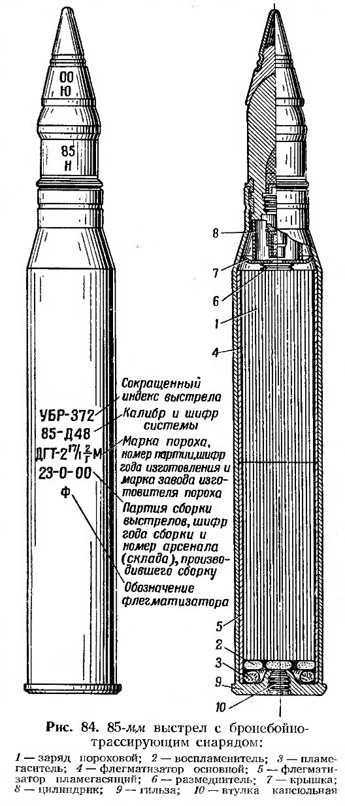
Since the first introduction of armoured vehicles, there has been a constant struggle between countries over armour and the weapons designed to defeat them. World War 1 saw the use of hardened steel rifle bullets and cannon shot as an attempt to improve armour penetration. By the Second World War, the science behind both armour and ammunition had improved significantly, resulting in the use of thick, high hardness, angled armour as seen on the T34 and Panther tanks. Improvements in anti-tank warfare led to the introduction of dedicated anti-tank weapons, high velocity gun with specially designed ammunition to defeat these improved armour schemes, with guns such as the 17 pdr and the KwK 36, the famous 88mm gun well feared by allied tank crews. By this time ammunition fired was mostly armour piercing high explosive, (APHE), as seen below in the cutaway of Russian 85mm ammunition, however solid metal shot was the only ammunition in British service [3].
Image 1 - Russian BR-372 85mm APHE Ammunition Cutaway [3]

All this ammunition was however full calibre, ammunition where the diameter of the projectile fired is the diameter of the barrel of the gun. It is not until the end of the war and the start of the cold war that ammunition design moves from full calibre to subcalibre projectiles, where the diameter of the projectile is only part of the diameter of the gun barrel. This is first seen in the use of armour piercing discarding sabot rounds, (APDS), notably used by the British for the 20 pdr and L7 105mm guns. This shift in design is down to the physics of the projectiles. As kinetic energy is mass times the square of velocity, the design approach taken in earlier years of increasing the gun size has less of an impact on the energy of the projectile than increasing the muzzle velocity. Through the use of subcalibre projectiles, the same chemical energy is imparted on a smaller, lighter more aerodynamic projectile, significantly increasing the muzzle velocity. On the 17 pdr gun for example, the subcalibre projectile saw velocities of 1200 m/s, a significant increase over the 908 m/s of the full calibre ammunition [13]. The popularity of subcalibre ammunition only increases through the cold war to the modern day, with armour piercing fin stabilised discarding sabot ammunition, (APFSDS), the sole kinetic penetrator used in all modern tanks, seen below in Image 3. The design of modern ammunition is a highly optimised artform, with the length of the projectile carefully balanced against the diameter for maximum penetration, the propellant carefully controlled for size and shape to ensure consistent burn time, resulting in a consistent muzzle velocity, with most guns sitting in the region of 1400-1500 m/s.

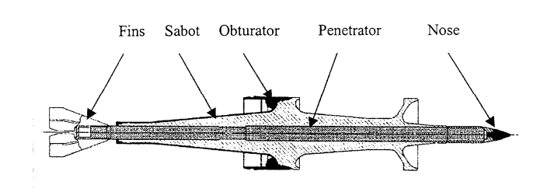
Image 3 - American M829A1 APFSDS Cutaway [9]
The simulation conducted in this project seeks to investigate the significance of this change, looking at the changes in the forces subjected on the armour from both a full calibre and a subcalibre projectile hitting an armour plate. For this, a full calibre 120 mm projectile has been modelled, to be compared against a simplified model of 120mm M829 APFSDS. Modern APFSDS ammunition utilised depleted uranium alloys for kinetic penetrators, due to its high density, and its self-sharpening properties, explained later in the piece in limitations. As such, both projectiles have been modelled as being constructed of depleted uranium. The initial velocity of Projectile One, the APFSDS, was set at 1500 m/s for Projectile One, and 492 m/s for Projectile Two [10]. 1500 m/s is roughly the velocity of modern APFSDS projectiles, while the velocity for Projectile Two was calculated through measuring the kinetic energy of projectile one, and calculating the velocity from this based on the far greater mass of Projectile Two, resulting in the velocity of 492. This ensures that differences in forces in the armour are due to the differences in projectile, rather than differences in energy

For the armour, rolled homogenous armour, (RHA), has been modelled. While modern tanks utilise numerous different materials for armour, including depleted uranium, ceramics, and rubber, RHA is often used as to compare the effectiveness of different armour schemes and weapons. It is a form of hard steel, rolled while hot to give uniform structure throughout the material. For the simulation, a plate 60x70cm was used, 20cm deep. This was then angled at 60º from normal to simulate the sloped upper glacis of a tank, giving an effective thickness of 400mm of armour.

Abaqus was used as the ballistics solver for this project, as it is industry standard for physics simulations. To simulate the damage to the armour plate, the Johnson-Cook material and damage equations were used. Table 1, below, shows the material properties used for both projectiles, while Tables 2,3 and 4 showing the basic material properties, the Johnson-Cook parameters, and the Johnson-Cook damage parameters respectively for the RHA used in the armour plate [15] [17] [18] [19] [20]. These parameters were used based upon the aggregation of a thorough literature review looking at previous research done into ballistics testing of RHA using both physics testing and simulations.

Density, kg/m³ | Young’s Modulus | Poisson Ratio
18990 | 190000000000 | 0.267
Table 1 - Material Properties of Depleted Uranium
Density, kg/m³ | Young’s Modulus | Poisson Ratio
7980 | 210000000000 | 0.33
Table 2 - Material Properties of RHA Steel
A | B | n | m | Melting Temp | Transition Temp | C | Epsilon dot zero
1680000000 | 1308000000 | 0.37 | 1.4 | 1427 | 724 | 0.05 | 0.01
Table 3 - Johnson-Cook Parameters of RHA Steel
d1 | d2 | d3 | d4 | d5 | Reference Strain Rate | Fracture Energy
0.16804 | 0.034994 | -2.44 | -0.04502 | 0.918998 | 0.0001 | 0
Table 4 - Johnson-Cook Damage Parameters of RHA Steel

Results

Projectile 1 – Armour Piercing Fin Stabilized Discarding Sabot

The Model and the Penetration
Projectile One is a simplified model of the M829 120mm APFSDS. The 4 panels below show the results from the simulation, showing just before impact, the initial impact, during penetration, and the final panel the last frame of the simulation before it crashed. From this it can be seen that there is very little damage to the plate besides the hole from the projectile, with the projectile also continuing on the same trajectory as before impact, with no deviation. The only visible impact on the projectile is the slight bending, most visible in frame 4. This is due to the strength of the forces acting on the projectile, accentuated by the extremely small diameter for the length of the projectile. Image 5, further below, shows the cutaway of a similar APFSDS projectile through steel. Comparing the simulation to this, we can see that the simulation is progressing accurate to real life, with a small channel not too much larger than the projectile, with little damage to the plate besides the area immediately surrounding the projectile.
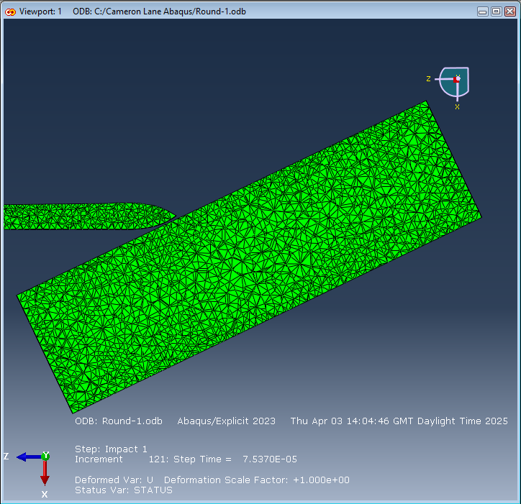
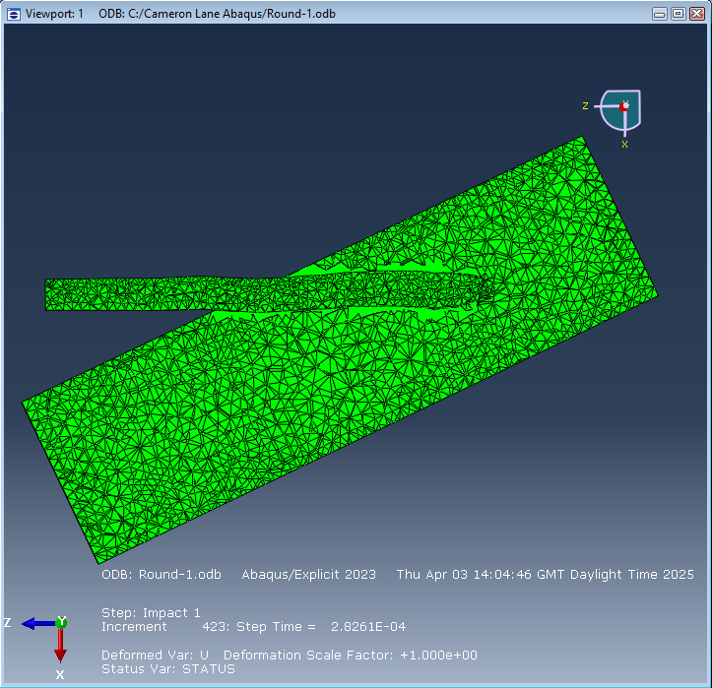
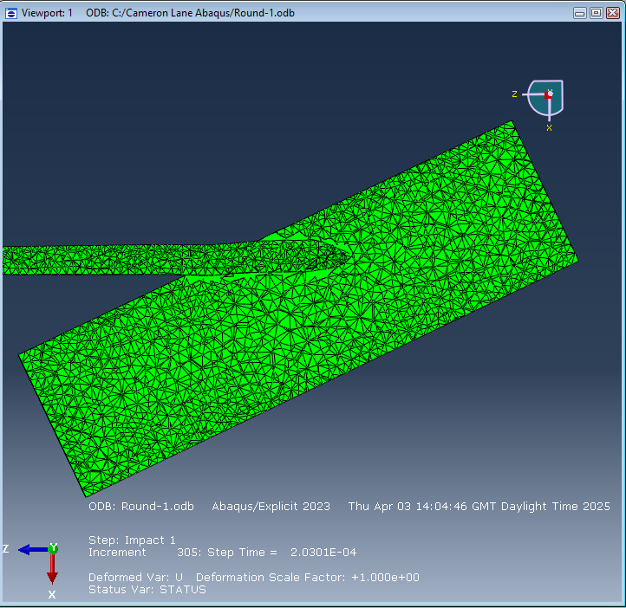
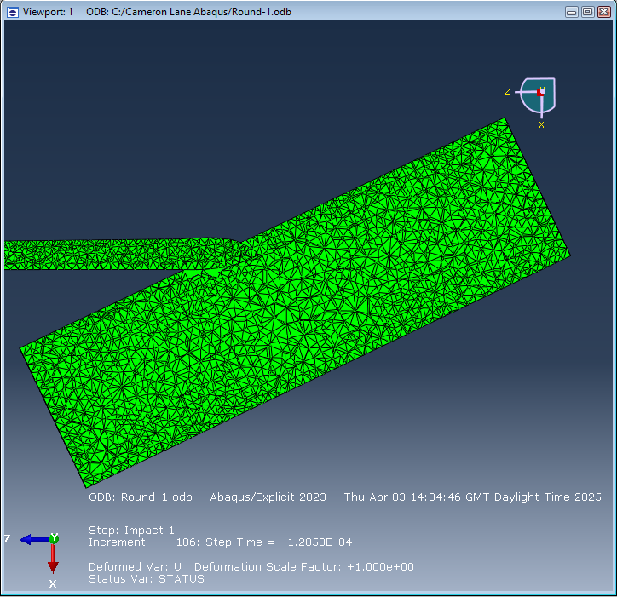
Image 4 - The Path of Projectile One through the Plate
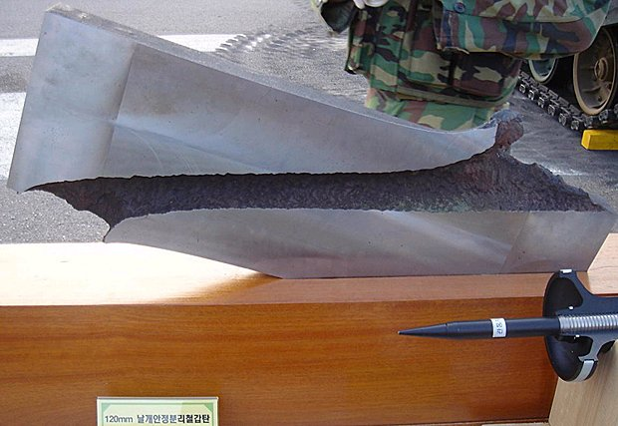
Image 5 - Cutaway of 120mm APFSDS Impact on Steel Armour [4]

Tension and Compression Stresses in the Plate
Image 6 shows the stress forces present in the armour plate just after the initial impact. From this, the initial compression wave can be seen, the black band on the left frame, and the light blue area on the right-hand frame. At this stage, compression is the major force present, in the region of 1E^7 Pa. The peak forces however are tension forces, the brief areas of red visible on the left frame, peaking at over 4E^8 Pa.
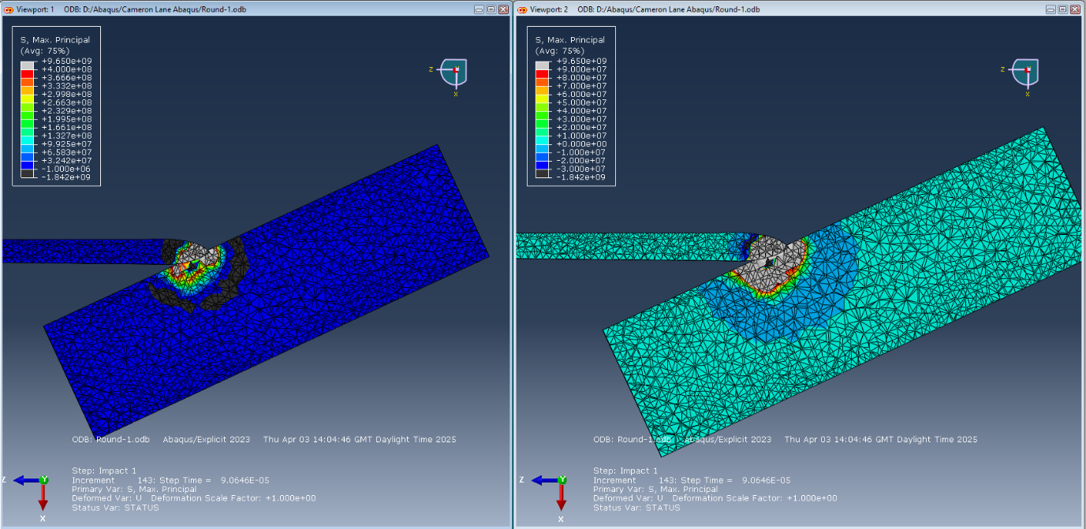
Image 6 - Tension and Compression Stress in Projectile One
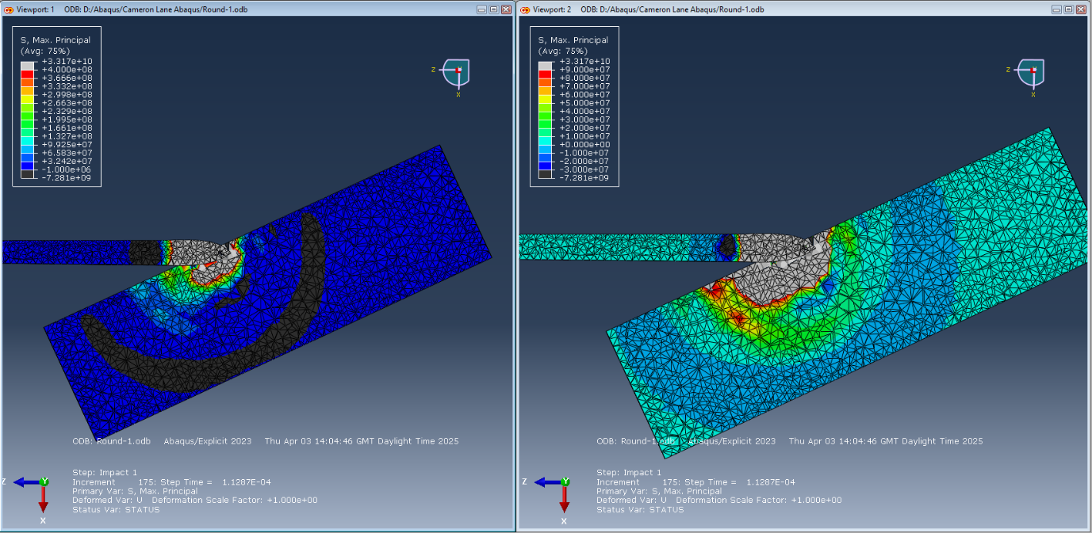
Image 7 - Tension and Compression in Projectile One
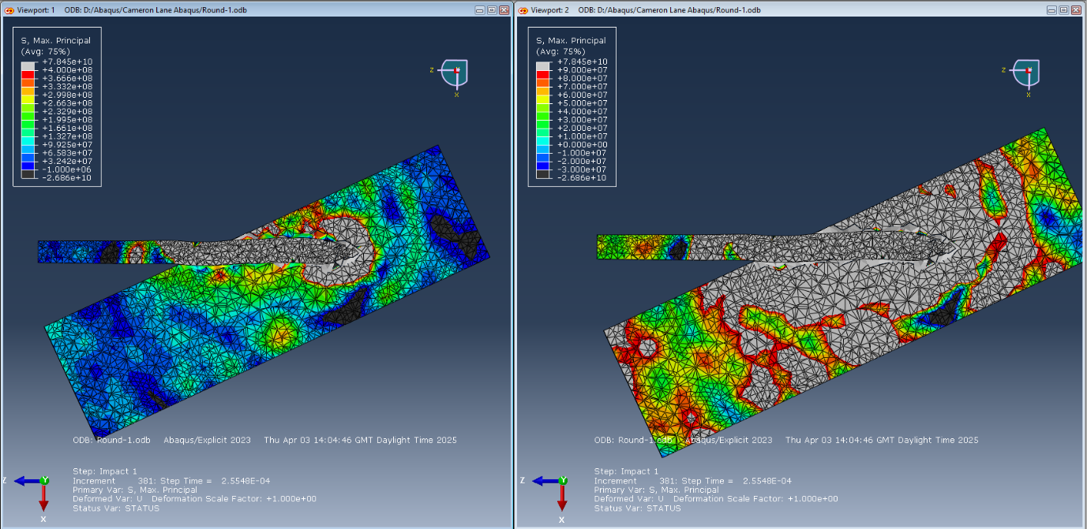
The waves of compression stress throughout the plate remain clear to see in Image 7, with the thick bands of force progressing through the material. However, it is still the areas of red and grey in the left-hand frame that remain the most important in the plate.

Image 8 - Tension and Compression in Projectile One Final Frame
The final frame simulated for projectile one shows how the stresses in the plate have changed once the projectile penetrates further into the plate. The large bands of compression have been replaced with high tension forces through the plate, with only isolated pockets of blue and black visible on the right frame. The large pocket of grey ringed by red show the extreme tension forces at the head of the penetrator, reaching stresses well over the0 4E^8 Pa the colours are showing. The large areas of green and yellow on the left are showing other areas of high tension, all between 1E^8 Pa and 3E^8 Pa, a magnitude higher than the peak compression stresses seen from this projectile.

Shear Stresses in the Plate
Image 9, below, shows the shear strain present in the plate, in the righthand frame, with stress shown on the left. From the righthand frame, it can be seen that there are extremely limited areas of high strain within the plate, surrounding the head of the projectile, reaching below -2E^8. However, compared to the large grey area visible on the left, which the previous section showed large areas were above 4E^8 Pa, it is clear that tension stress is the main force at work in the plate.
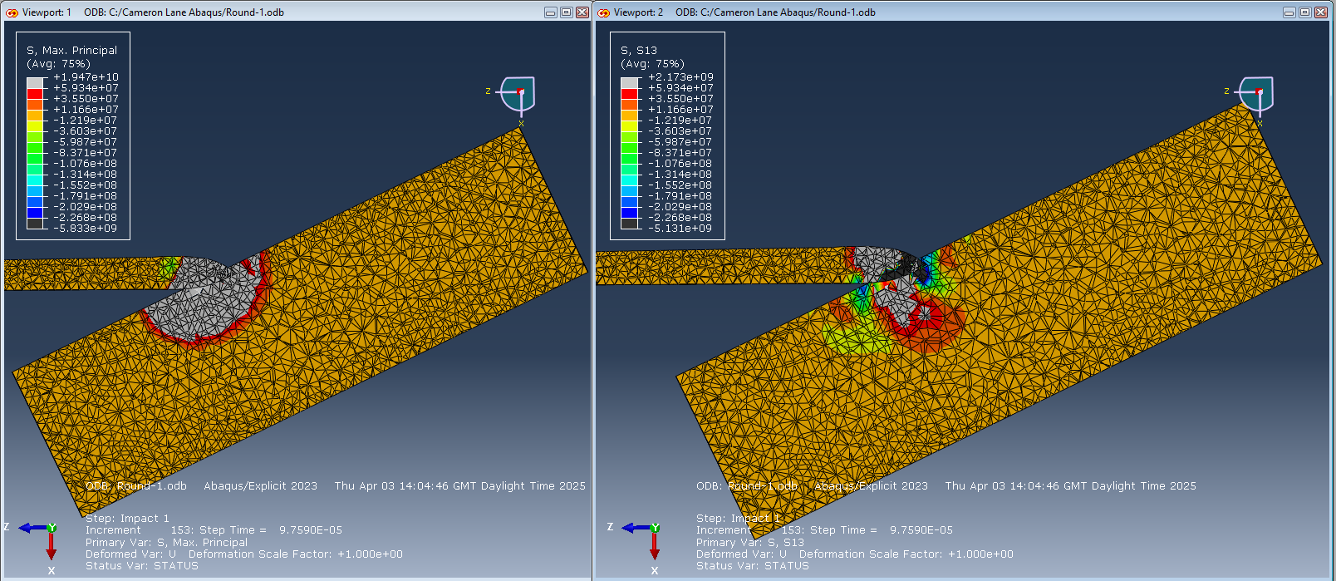
Image 9 - Shear Strain in the Plate
The stress and strain forces later in the penetration of the plate can be seen below in Image 10. Similar to in Image 9, there are only limited pockets of extremely high strain present in the plate, with a couple of areas below -2^8, and a small number of grey areas above 6E^7. However, again as show above, and highlighted in the left-hand frame, tension stress in the plate remains the dominant force throughout the armour plate, still having large areas above 4E^8 Pa.
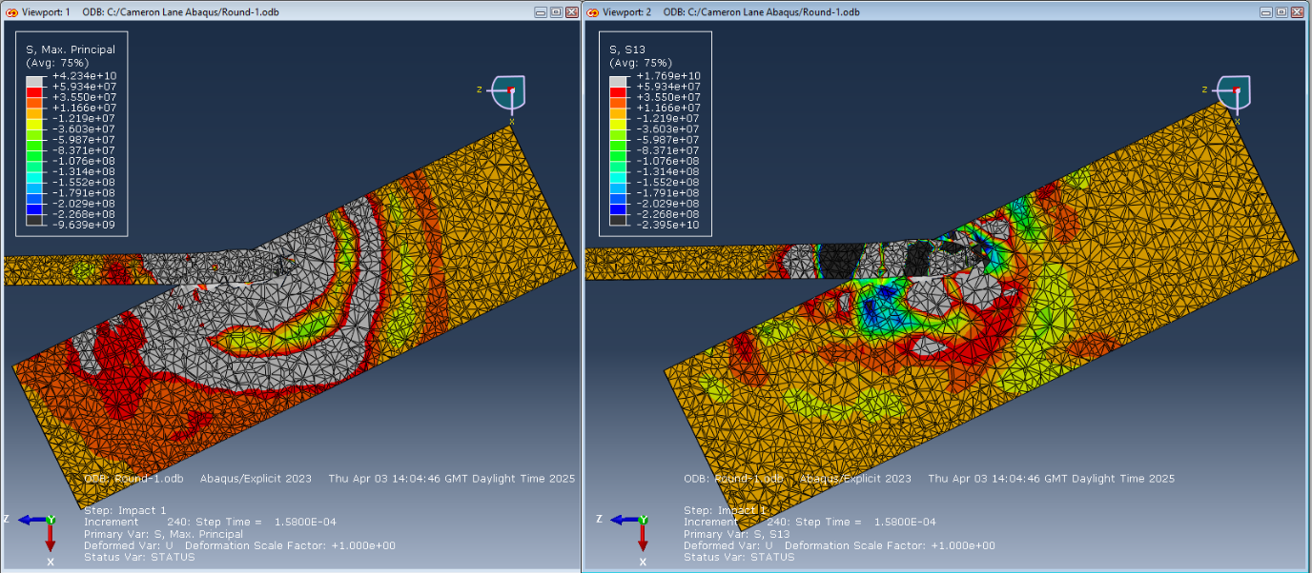
Image 10 - Shear Strain in the Plate

Projectile 2 – Full Bore Armour Piercing

The Model and the Penetration
Projectile Two is a model of a full calibre amour piercing projectile. The 4 panels below show an overview of the simulation of this projectile hitting the plate. As expected, there is a far greater channel of damage through the plate compared to Projectile One due to the greater diameter of the round. However the most important point to notice from these panels is the angle of the round. The round is impacting the panel at 60º, with the round horizontal to the frame halfway up. However, as visible in frames three and four, the round is ricocheting through the armour, angling away from normal, and exiting the screen in the top third of the frame. This effect was not noticeable at all in Projectile One, as APFSDS rounds require far more oblique angles to ricochet, often shattering leaving damage on the face of the armour but not penetrating. Ricochets are far more likely with full calibre rounds such as modelled here, and were somewhat common occurrences during the Second World War, due in large to the slower shells not ‘digging’ into the armour as much. There is however a major flaw with the simulation presented here, which is most blatant in frames three and four. That is the lack of deformation of the plate. A projectile ricocheting with as much energy as is present in this simulation will not simply leave a channel in the armour. The backface of the plate should be dented and deformed, pushing in. This flaw in the model is explained further in the limitations described below.
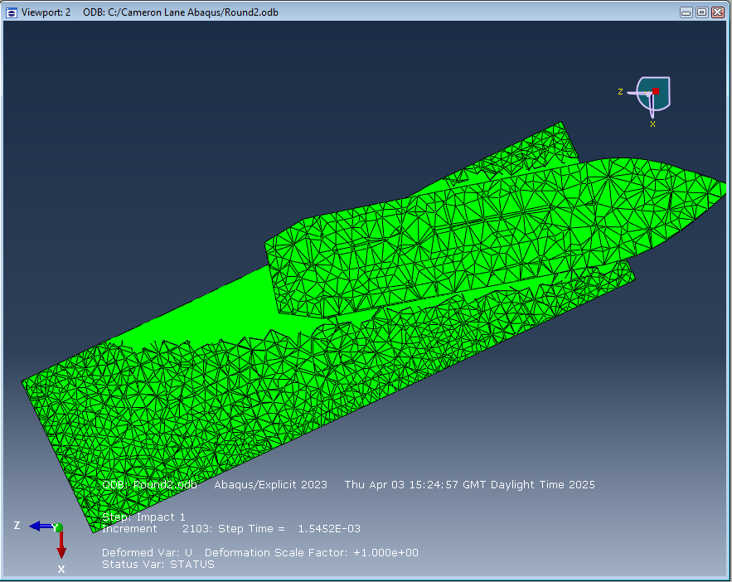
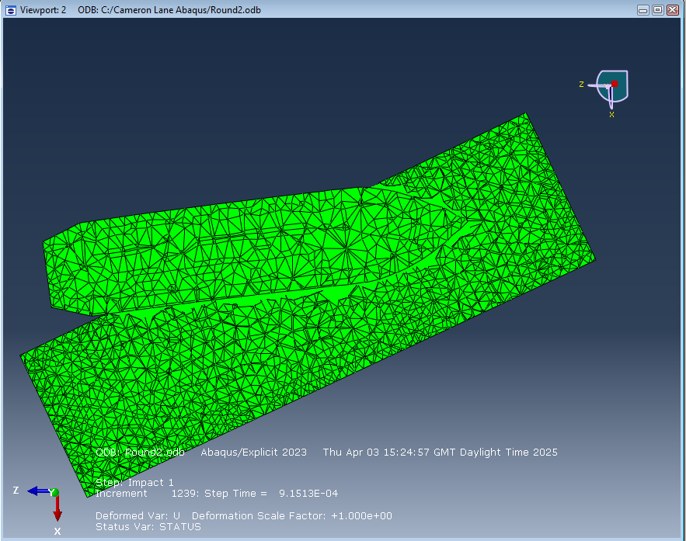
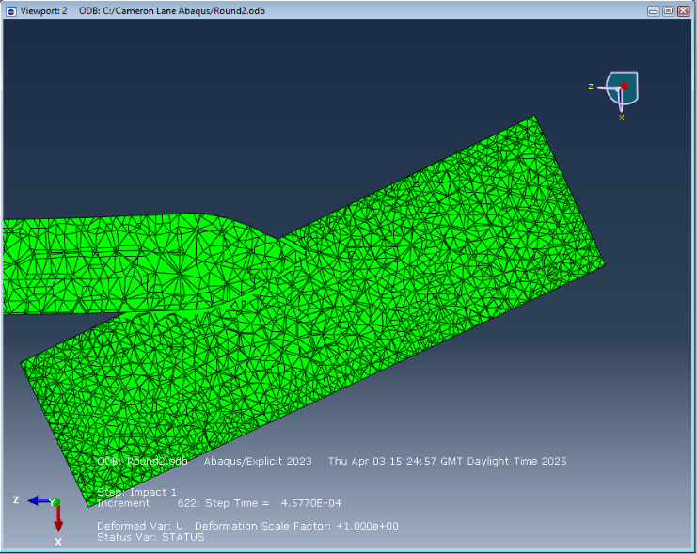
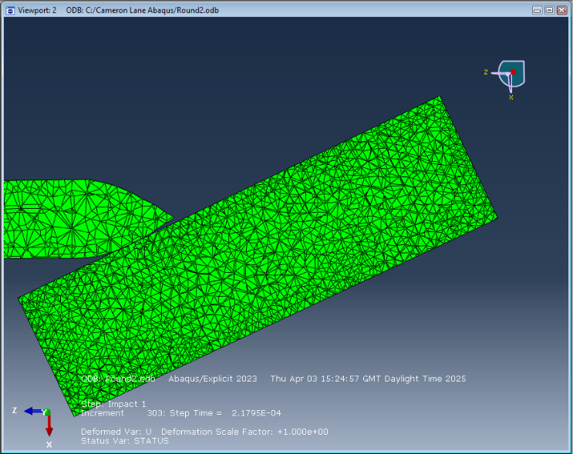
Image 11 - The Penetration and Ricochet of Projectile Two

Tension and Compression Stresses in the Plate
Similar to Projectile One, the tension and compression stresses for the initial impact of Projectile Two is show below. On the right, the dark blue band of compression stress can be seen, in the region of -2E^7 Pa, however the left shows the band of tension stress in the region of 3E^8 Pa.
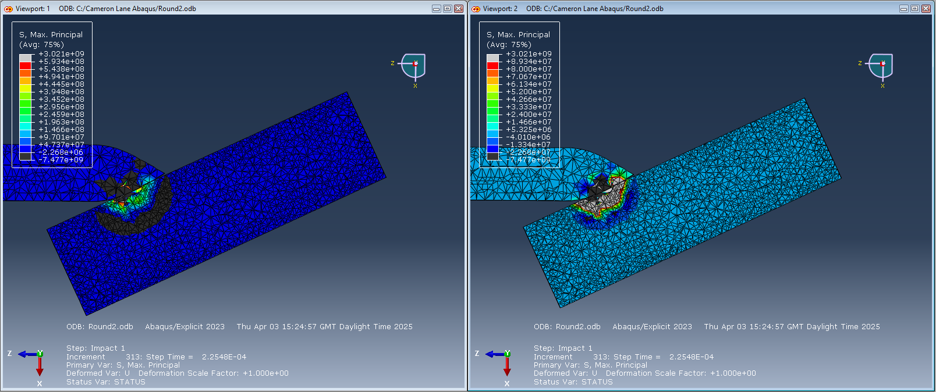
Image 12 - Tension and Compression Stress from Projectile Two
Further on in the penetration, the bands of compressive stress can be seen in the dark blue on the right and the black on the left. However, as highlighted by the large grey area on the right, tension stress is the vast majority of the forces in the armour plate, with that entire area of the plate enduring over 1E^8 Pa of force.

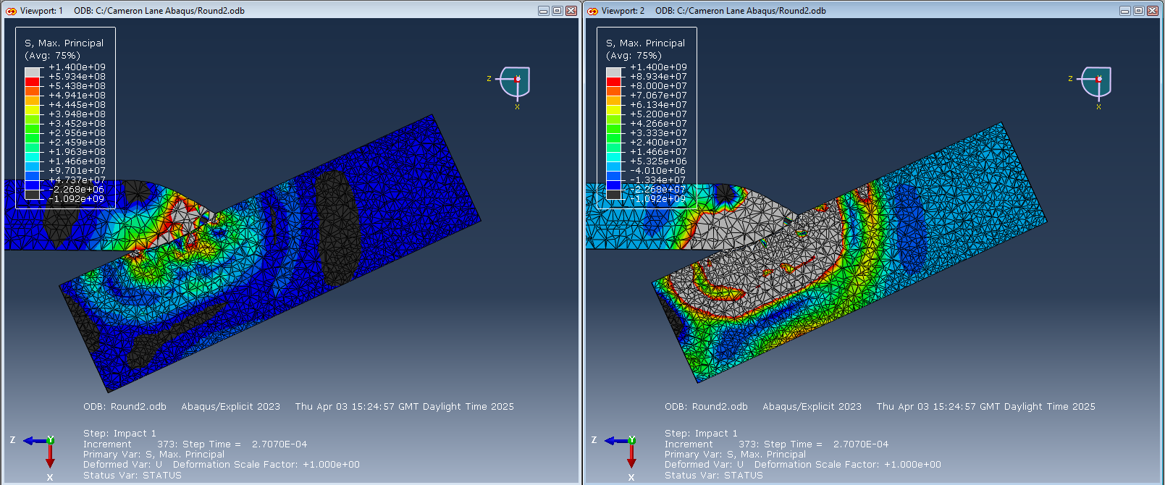
Image 13 - Tension and Compression Stress from Projectile Two
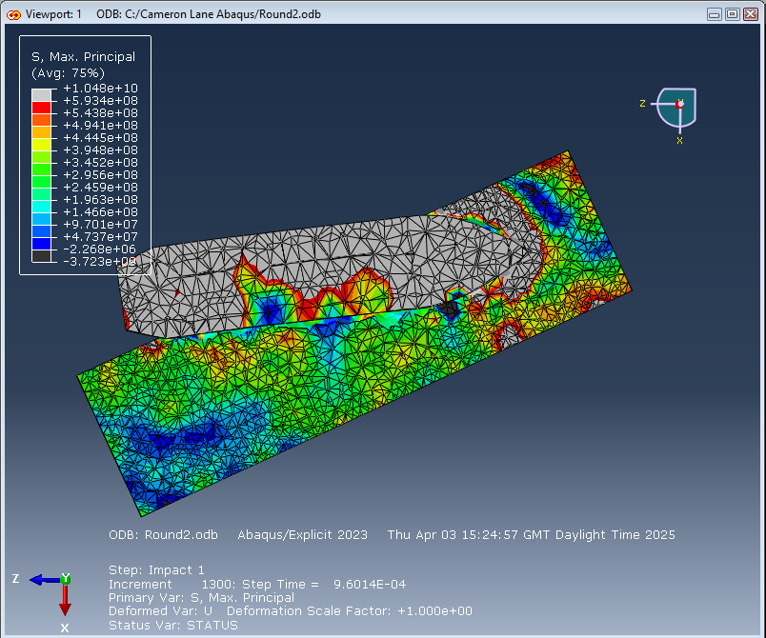
Image 14 - Tension Stress from Projectile Two
Due to the lack of compressive stress present, that frame has been removed. There are only brief pockets of compressive stress present in the plate anymore, with a thick band of tension stress reaching numbers well over 6E^8, with higher stresses than seen in Projectile One. These extremely high stresses remain throughout the rest of the simulation, with the entire plate enduring these forces.

Shear Stresses in the Plate
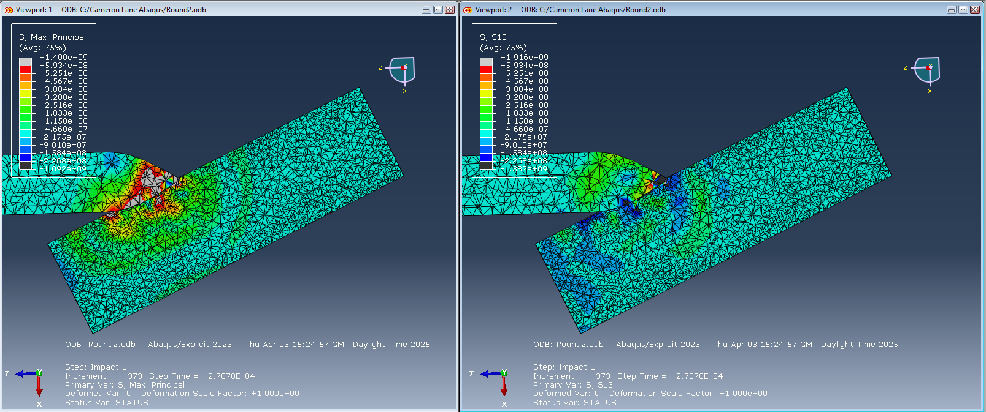
Compared to the strain seen in Projectile One, strain is extremely similar to the stress seen, with large areas of strain seen in the green on the right. However, as seen in Image 15, once the projectile has started to penetrate further, it can be seen that stress takes over as the majority of the forces present in the plate, with only limited pockets of strain. However, as highlighted in Image 16, later in the penetration there are large areas of high strain throughout the metal plate. Similarly through, there are also extreme tensional stresses all throughout the armour, which remains the main source of damage in the plate.
Image 15 - Stress and Strain from Projective Two during Penetration
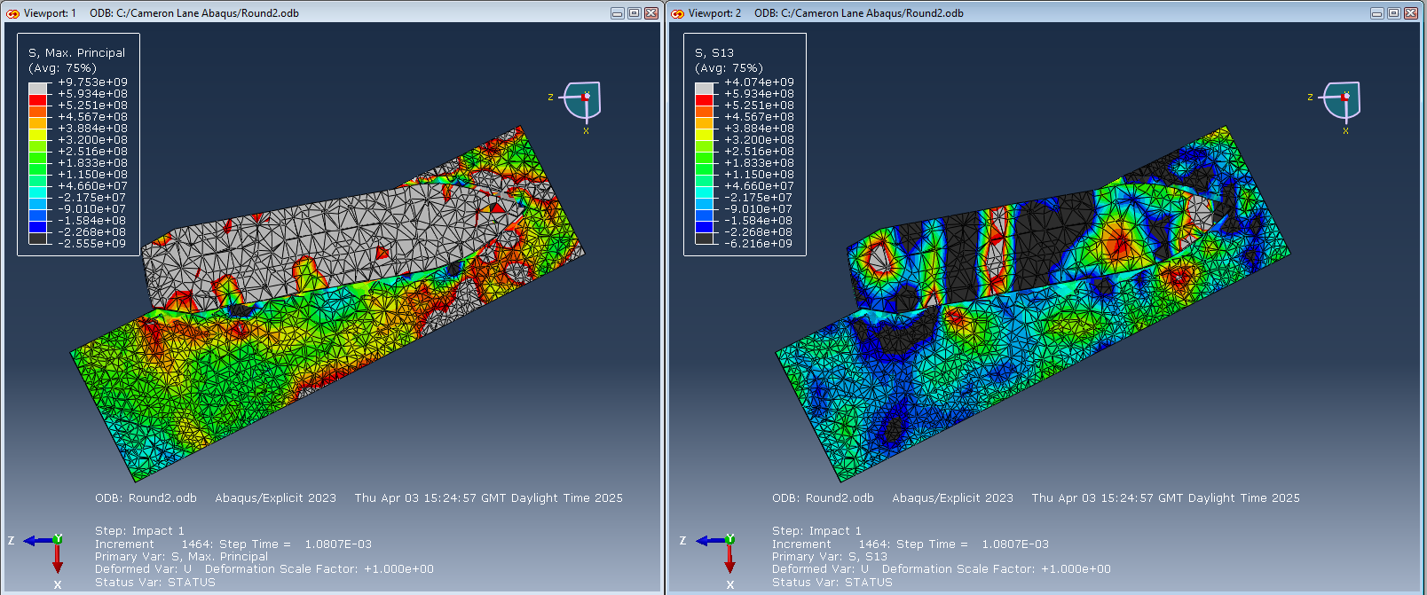
Image 16 - Stress and Strain from Projectile Two late in Penetration

Comparison of the Projectiles

Tensile Stress Comparison
Comparing the differences in the stress and strain reveals the differences in forces faced by the armour plate, and highlights the reasoning behind the switch from full calibre to sub calibre projectiles. Image 17 shows the tension in the plate at the point of impact. From this it ca be seen that there are far higher peak stresses from Projectile One, the grey indicating higher than 7E^8 Pa, compared to Projectile Two topping out at 5E^8 Pa.

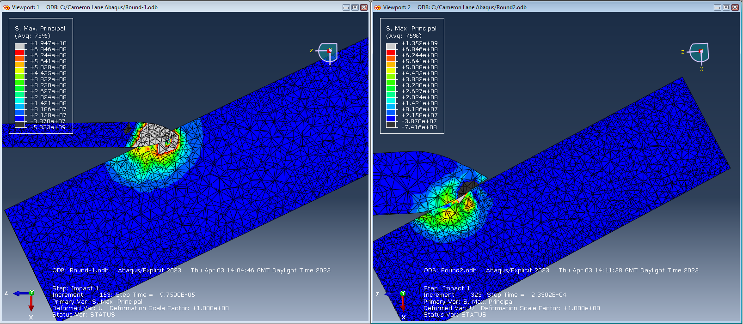
Image 17 - Tensile Stress at Impact
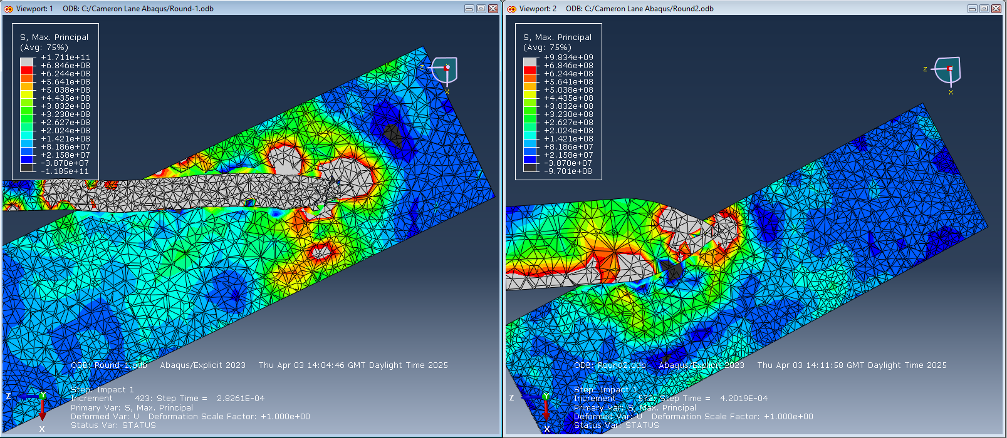
Image 18 - Tensile Stress at Point of Crash
Image 18, above, shows the tensile stresses at the point the simulation crashed for Projectile One. It is clear that tensile stresses remain higher for the subcalibre round throughout the simulation, with the large pockets of grey surrounding the head of the projectile, and the thick band of green radiating out from this. By comparison, while there is a small pocket of high stress at the very peak of Projectile Two, this is localised to the point, with only a narrow band of stress radiating out from the impact. While further data on Projectile One doesn’t exist, looking at the individual data for Projectile two reveals that the tensile stresses for the rest of the simulation remain lower than those seen from the first projectile, as should be expected for the same kinetic energy focused in a smaller surface area.

Compression Stress Comparison
Similar results occur for compression stress from the two rounds. While there is an initial band of compression that is stronger from Projectile Two, through the entire simulations for both rounds the bands of compressive stress are far stronger from Projectile One, with peak forces reaching below -1E^10 Pa, a magnitude stronger than the forces seen in Projectile Two. Again, data cuts for the first projectile due to the crash, however using the individual data as described above in the individual section on Round Two, compressive strength is not a major feature of this round later in the penetration of the plate.
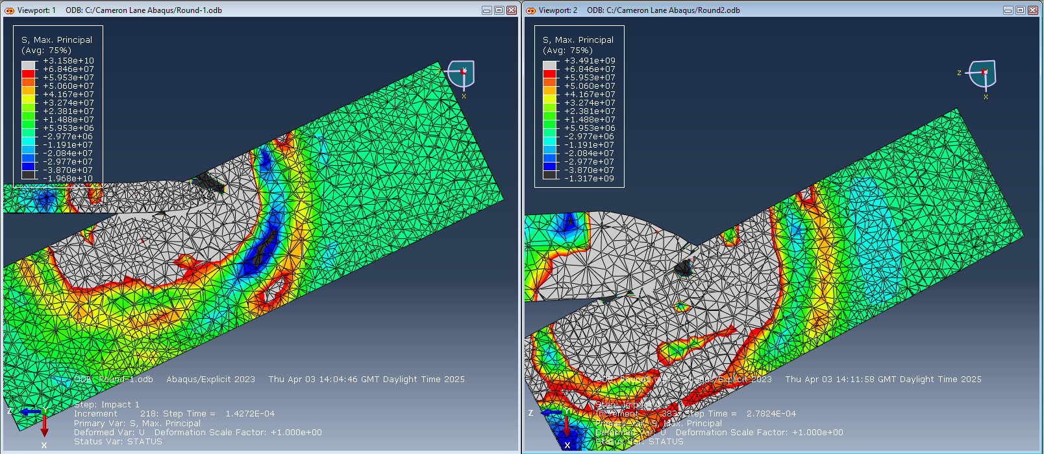
Image 19 - Compression Stresses of the Two Projectiles

Strain Comparison
Strain is the area where the most difference in seen between the two different projectiles. Looking firstly at Projectile One, we can see while there are areas of high strain, it not in distinct bands, with only areas of high strain. Comparing this to Projectile Two, we see significant bands of strain forming throughout the plate radiating out from the point of impact. This pattern remains throughout the simulation for both projectiles, with far more defined bands of negative and positive strain throughout the armour plate. Strain is the only area where Projectile Two results in more consistent higher forces in the metal plate. This fits in with literature surrounding armour penetration, which highlights the role that shear has in armour penetration for blunt projectiles, compared to APFSDS projectiles that result in far greater deformation due to tensile stresses in the material.

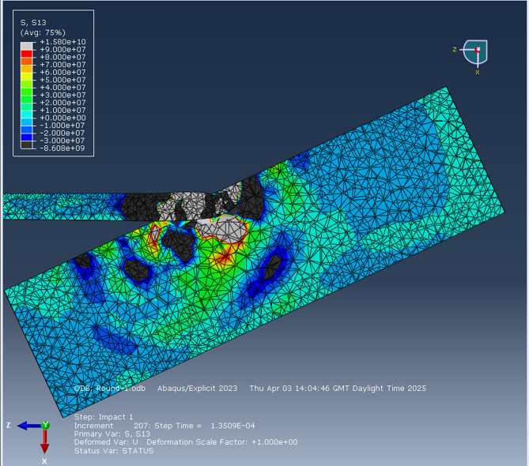
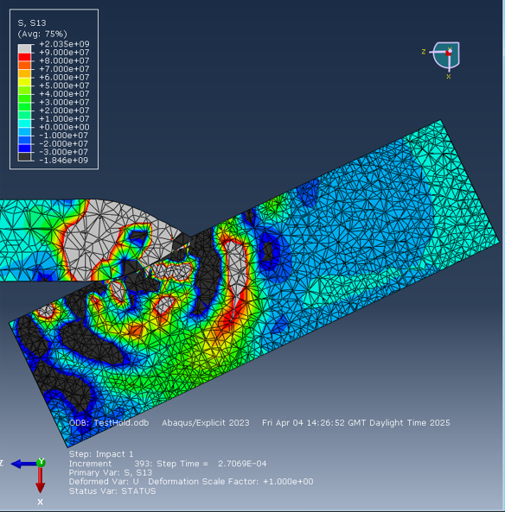
Velocity Comparison
Image 20 - Strain for the Two Projectiles
Another area of comparison between the two projectiles is in the velocity of the projectiles. The velocities of the two projectiles were calibrated to ensure that the kinetic energy of the projectiles remained constant. Projectile one had a velocity of 1500 m/s, with projectile two far slower at 492 m/s, due to its greatly increased mass. The plots of the velocity across the simulation can be seen below. The graph for projectile one has been created outside of Abacus. Due to the projectile being a long thin rod, it distorted significantly during penetration, resulting in the readings showing the rod accelerating and decelerating over the course of the simulation. Due to this, a scatter graph has been generated with an average of the velocity shown, in order to give a better understanding of how velocity of the overall projectile was changing. This was not an issue for projectile two, due to its shape resulting in a far more rigid projectile.

Graph 1 - Projectile 1 Velocity
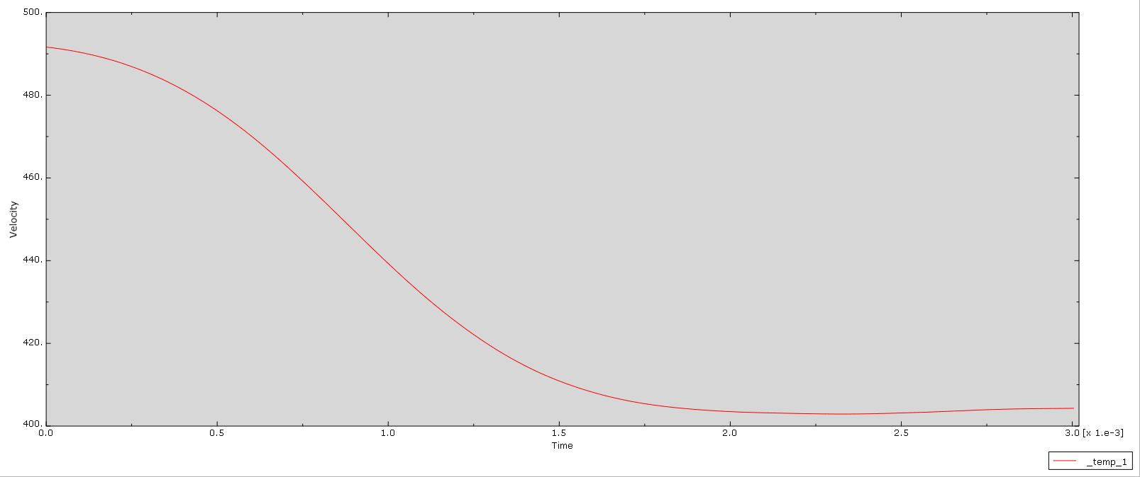
Graph 2 - Projectile 2 Velocity
While the simulation for projectile one was not complete, it still penetrated roughly half of the target plate. It can be seen from the graph, that despite penetrating a significant amount of material, very little energy is lost in the process, slowing by roughly 50 m/s. By comparison, projectile two, starting at the far lower velocity, leaves the plate at roughly 405 m/s, slowing by just under 90 m/s. While numerically, the slowing of both projectiles is similar, it is the percentage of velocity lost that is of importance. Projectile Two loses almost a fifth of its initial velocity, whereas projectile one slows by roughly one fifteenth. Even if this projectile continues slowing at this rate for the rest of the penetration of the plate, it will still have retained the majority of its velocity, and penetrative power.

One important point that the graph does not adequately show however, is the change in the angle of the velocity. As seen in the results for Projectile Two above, the projectile can be seen ricocheting off the armour plate, changing the angle of travel. The velocity shown on the graph above is the overall velocity of the projectile, showing that despite impacting the armour, causing a significant amount of damage to the plate in the process, the projectile was not stopped by the armour, only diverted away.

Limitations
Simulations of all types face numerous limitations in the accuracy and the fidelity of what is simulated. This can range from minor effects that only serve cosmetic benefits, to major flaws in the modelling that can significantly impact the validity of the simulation. The simulation conducted above is no different in this regard, with a number of limitations of various impacts present.

The most major limitation faced in this project is one common to all modelling, limits on the number of elements present in the simulation. Finite element analysis works by breaking down the model into a number of pieces, called elements. The software is then calculating how each of these elements interacts with each other, in order to calculate how the model as a whole would interact. A 1m³ box broken down into 10 cm³ elements would consist of 1000 elements, however breaking it down into 1cm³ elements would result in 1,000,000 elements. As the software works by calculating the interactions of each individual element, increasing the number of elements present in the simulation will result in an increase in the accuracy of the simulation, if all other factors remain the same. The software used for the simulation in this project had a limit of 250,000 elements. While this allows for a small enough mesh on the models to get an accurate simulation allowing for conclusions to be drawn and measurements to be made, increasing the number of elements would improve on this. This would be of most help in the armour plate, as more elements would allow for the damage to be better modelled, as currently large chunks are removed when damaged. More elements would also showcase the deformation of the plate to a greater degree, had that been modelled.

Another limitation that severely limited the accuracy of the simulation for this project is tied in with the elements used in the modelling. The APFSDS round was impacting the plate at 1500 m/s, an extremely high speed for most areas [10]. By comparison, standard NATO rifle rounds are roughly 900 m/s. The impact simulated is therefore an extremely high speed, with a significant mass, imparting a significant amount of energy into the armour plate, which would cause it to deform significantly. While material deformation was not modelled, the simulation still resulted in distortion of elements during its processing. This led to a crash in the software roughly halfway through the simulation of Projectile One. While some results are still available, allowing for comparisons and conclusions to be drawn, this is still not ideal. One potential solution to this would be through the use of Smoothed-Particle Hydrodynamics [6]. This approach to simulation breaks models down into a net of particles rather than a mesh of elements, and it is the movement of the particles that shows the material movement, rather than the deformation of the elements. This would fix the issue faced in simulating Projectile One, as there would be no elements to deform, however it is possible that there would be other issues with utilising SPH that are unknown without attempting it.

As mentioned above, the deformation of the steel plate was also not modelled. This is due to an error in the parameters of the material used that was not able to be identified and corrected. While a limitation, this would not however have significantly affected the results in this situation. While there would be significant deformation of the armour plate when hit by projectile two, the full-bore projectile, due to the high energy of projectile one there would not be significant deformation. The difference in the damage caused by these impacts can be seen in the two images below. The first shows the impact of a 120mm APFSDS round against angled steel, where its clear the round has gone clean through, with little deformation at either the entry or exit point. By comparison, the second shows where rounds hit during Soviet testing of the German King Tiger heavy tank [2]. Of particular note are impacts two and three, using 100mm armour piercing ammunition against the 160mm upper glacis sloped at 45º. In both of these impacts, the shell failed to penetrate, however resulted in a 150x250 mm dent 100mm deep, and resulted in bulging of the armour on the inside of the vehicle. Given the similarities between these tests and the simulation conducted above, it is likely that a similar result should have been observed in the simulation. Due to the lack of deformation observed on the APFSDS round, it is unlikely that the lack of deformation in the simulation would have significantly affected the results, with the subcalibre round still resulting in energies a magnitude higher than that of the full calibre round.
Image 21 - Cutaway of 120mm APFSDS impact on steel armour [4]
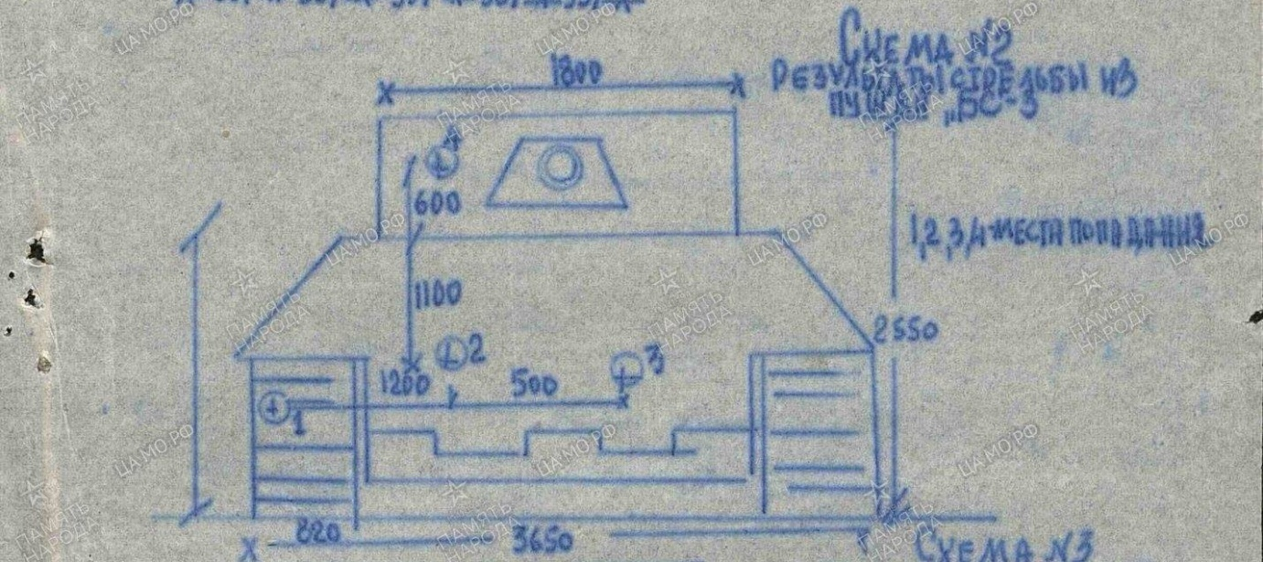
Image 22 - Impact Locations of Soviet Testing of King Tiger Armour [2]

There is a third limitation that would have potentially had a limited impact on the results of the simulation. One of the key properties of depleted uranium that results in its significant usage in modern ammunition over other dense materials such as tungsten is its self-sharpening property. This is down to the properties of the materials, in particular how adiabatic shear forms in the materials during penetration [14] [16]. During penetration, depleted uranium undergoes continuous formation of shear bands, “narrow region of rapid, intense plastic deformation”, resulting in the projectile forming and maintaining a sharp point as material is deformed and discarded [16]. By comparison, the majority of the deformation seen in tungsten penetrators is plastic deformation due to thermal softening of the material, with shear band formation only seen at points of maximum shear force. It cannot be concluded the impact that self-sharpening would have had on the full calibre round as no available research has been done on this topic due to the lack of use of these rounds in combat for some time. It is however undeniable that there would have been an impact on projectile one, with testing showing depleted uranium projectiles losing less energy due to self-sharpening that comparable tungsten projectiles. This could potentially lessen the differences in the stress and strain seen in the armour between the two projectiles if less energy is being transferred from the projectile to the plate, however, is not likely to have changed the conclusions gained from the comparison between the two.
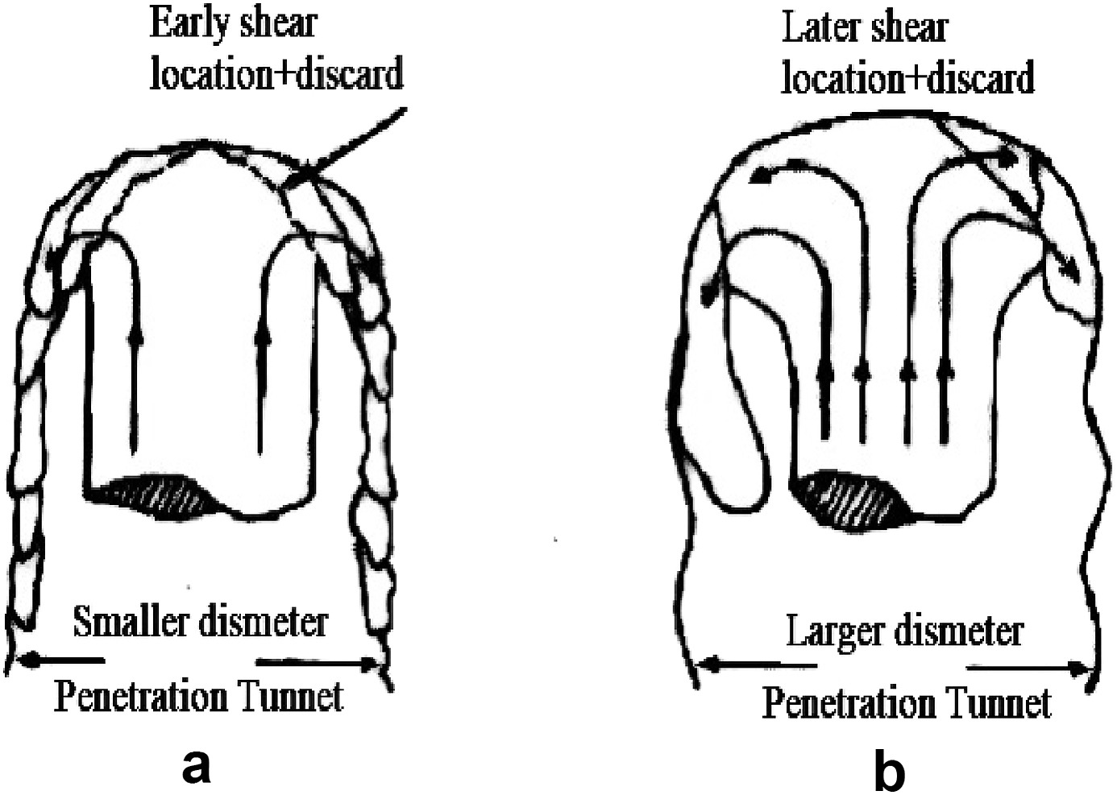
Image 23 - Deformation of Depleted Uranium and Tungsten Projectiles [15]

One final limitation on this project is in how it can be related to the physical world. While the materials were kept the same for the projectiles, and the velocity was calibrated to keep the kinetic energy the same to allow for comparisons to be drawn regarding the armour plate, this resulted in a full calibre round that weights roughly 170kg. The closest land-based equivalent to this is 203mm guns, with the Soviet 2S7 firing a 110kg shell at 960 m/s [1]. Getting such performance from a 120mm gun would also allow for greater performance of APFSDS from the same gun. This severely limits the ability to compare the results with real world performance when looking at how the armour performed against full calibre projectiles. It does however how significant the performance increase of subcalibre projectiles is, that current ammunition is able to outperform a round that is not possible with current guns.

Conclusions
The two simulations conducted highlighted the role that changing projectile design has on the forces present in the armour plate upon impact. It can be seen from the results of the simulations that in both tensile and compression stresses, the plate was subjected to far higher forces upon impact from Projectile One compared to Projectile Two, often an order of magnitude higher in strength. From these simulations we can see that the major cause of failure in the armour plate is the extreme stresses cause by the projectiles, rather than the strain on the plate. This aligns with literature surrounding metallurgy and armour design, which highlights that it is only in extremely high hardness materials where strain becomes the dominant force behind armour failure [7]. While RHA is a hard steel compared to many steels, it sits between 302-400 on the Brinell Scale, whereas shear due to strain dominant in materials above 380.
The decision to move from full calibre to subcalibre projectiles is clear to see from the results presented, however it is important to note that there are sever limitations in the applications of the results to the real world. As highlighted above, there are limitations surrounding the software used causing errors in simulations, the limits on element numbers in the model, the lack of deformation of both the armour plate and the projectile, and the impossibilities of such a projectile in the real world. Combining all these limitations, it is clear that only surface level analysis should be conducted using these results, and that to truly draw accurate conclusions from the results a far more detailed and accurate simulation would need to be conducted, with higher element count, more accurate material properties, and a fix to the simulation crashing at high distortion.

References
[1] Anonymous . Soviet 2s7 Pion SPG (1975). Available: https://tank-afv.com/coldwar/ussr/2s7-pion.php.
[2] Anonymous "King Tiger Battlefield Penetration Trials," 2021. Available: https://www.tankarchives.com/2020/12/king-tiger-battlefield-penetration.html.
[3] Anonymous "Tankograd: Soviet Towed Anti-Tank Guns," 2020. Available: https://thesovietarmourblog.blogspot.com/2020/12/soviet-towed-anti-tank-guns.html.
[4] Anonymous . Tank armour penetrated by 120mm APFSDS round. Available: https://www.reddit.com/r/ThingsCutInHalfPorn/comments/5ej9ei/tank_armour_penetrated_by_120mm_apfsds_round/.
[5] A. Bose, J. Lankford Jr. and H. Couque, "Development and characterization of
adiabatic shear prone tungsten
heavy alloys," Army Research Laboratory, Aberdeen Proving Ground, Maryland, 1993Available: https://apps.dtic.mil/sti/tr/pdf/ADA270477.pdf.
[6] M. Buyak et al, "Moving beyond the finite elements, A comparison between the finite element methods and meshless methods for a ballistic impact simulation," in 8th International LS-DYNA Users Conference, Available: https://lsdyna.ansys.com/wp-content/uploads/attachments/08-7.pdf.
[7] S. J. Cimpoeru, "The mechanical metallurgy of armour steels," Defence Science and Technology Group, Fishermans Bend, Victoria, 2016Available: https://www.dst.defence.gov.au/sites/default/files/publications/documents/DST-Group-TR-3305_0.pdf.
[8] F. Coghe and B. Dodd, "Damage caused to metals by kinetic and chemical energy projectiles," 2015Available: https://www.researchgate.net/publication/278409150_Damage_caused_to_metals_by_kinetic_and_chemical_energy_projectiles.
[9] W. De Rosset, "An overview of Novel penetrator
technology," Army Research Laboratory, 2001Available: https://apps.dtic.mil/sti/tr/pdf/ADA387329.pdf. DOI: ARL-TR-2395.
[10] B. Guidos, "Static aerodynamics CFD analysis of 120mm hypersonic KE projectile design," Army Research Laboratory, Aberdeen Proving Ground, Maryland, 1994Available: https://apps.dtic.mil/sti/tr/pdf/ADA285471.pdf.
[11] N. K. Gupta and V. Madhu, "An experimental study of normal and oblique impact of hard-core projectile on single and layered plates," International Journal of Impact Engineering, vol. 19, (5), pp. 395–414, 1997. Available: https://www.sciencedirect.com/science/article/pii/S0734743X97000018. DOI: 10.1016/S0734-743X(97)00001-8.
[12] G. Y. Huang et al. Performance of Different Projectile Nose Shapes in Normal Penetrating Armor Targets. Available: https://colab.ws/articles/10.4028%2Fwww.scientific.net%2Famr.308-310.1420. DOI: 10.4028/www.scientific.net/amr.308-310.1420.
[13] Y. Pasholok, "17-Pounder: Britain's Long Arm," 2016. Available: https://www.tankarchives.com/2016/08/17-pounder-britains-long-arm.html.
[14] B. Wang, Y. Dong and G. Huang, "An Investigation on the Adiabatic Shear Bands in Depleted U-0.75 wt % Ti Alloy under Dynamic Loading," Metals, vol. 8, (2), pp. 145, 2018. Available: https://www.mdpi.com/2075-4701/8/2/145. DOI: 10.3390/met8020145.
[15] F. Zhu, Y. Chen and G. Zhu, "Numerical simulation study on penetration performance of depleted Uranium (DU) alloy fragments," Defence Technology, vol. 17, (1), pp. 50–55, 2021. Available: https://www.sciencedirect.com/science/article/pii/S221491471931089X. DOI: 10.1016/j.dt.2020.01.002.
[16] R. C. Batra and J. B. Stevens, "Adiabatic shear bands in axisymmetric impact and penetration problems," Computer Methods in Applied Mechrnics 8nd, vol. 151, 1998. Available: https://www.sciencedirect.com/science/article/pii/S0045782597001564.
[17] W. N. M. Jamil et al, "Mechanical properties and microstructures of steel panels for laminated composites in armoured vehicles," International Journal of Automotive and Mechanical Engineering, vol. 13, pp. 3741–3753, 2016. Available: https://www.researchgate.net/publication/317023642_Mechanical_properties_and_microstructures_of_steel_panels_for_laminated_composites_in_armoured_vehicles. DOI: 10.15282/ijame.13.3.2016.16.0306.
[18] M. Md. Isa et al, "Simulation on the shock attenuation behavior of coupled RHA and sandwich composite panel under blast loading," Journal of Fundamental and Applied Sciences, vol. 9, pp. 555, 2018. Available: https://www.researchgate.net/publication/322809294_Simulation_on_the_shock_attenuation_behavior_of_coupled_RHA_and_sandwich_composite_panel_under_blast_loading. DOI: 10.4314/jfas.v9i3s.43.
[19] D. Kleponis and H. Meyer, "An analysis of parameters for the
johnson-cook strength model for
2-in-thick rolled homogeneous armor," Army Research Laboratory, Aberdeen Proving Ground, Maryland, Available: https://apps.dtic.mil/sti/pdfs/ADA392414.pdf. DOI: GRL-TR-2528.
[20] S. Schraml, "Constitutive model parameter study for armor steel and tungsten alloys," Army Research Laboratory, Aberdeen Proving Ground, Maryland, 2012Available: https://apps.dtic.mil/sti/pdfs/ADA556741.pdf. DOI: ARL-RP-351.

