  Digital Skills | Natasha Brookes 1807564  Balendran Kandasamy

Table of Contents
My Mac 2
iCloud Dropbox 3
Creativity and Innovation 5
Technology advantages 5
Mobility Technology 6
Disadvantages of Technology in the Workplace ……………………………………………………….………6
Causes Distraction at Work……………………..……………………………………………………………………….6
Devices Maintained……….…………………………………………………………………………………………….…..7
Employees becoming complacent ………………………..………………………………………………………… 7
The Risk …………………………………………………………………………………………………………………………. 7
Website Screenshots………………………………………………………………………………………………………..8
Conclusion……………………………………………………………………………………………………………………….9
References…………………………………………………………………………………………………………….……… 10

Introduction
My digital skills report will analyses the different skills used in a modern technology environment within the work place. My report will highlight the advantages and disadvantages of the work place in the 21st century. I will analysis two different storage devises and how they operate, I will be focusing on iCloud and Google Drive.
My Mac is an iCloud product that allows users to access from anywhere remote to any other individual who has this software installed on their computer they can access the web site externally has long has they have the same Apple Identification. Another thing which can be installed is one of apples newest applications is iTunes when using it people can listen to different music and albums on iTunes for free
My Mac This is supported by (Gil L) (19.5th.2018) iCloud key opponents include Amazon Cloud Drive, Dropbox, and Microsoft SkyDrive. Amazon Cloud Drive is a storage component similar to the iCloud, this was released in March 2011 by Amazon, similar to iCloud it offers 5 GB of free storage, any extra storage can be acquired, the price is one pound per GB for a year, which is a lot cheaper than the product that Apple Inc. offers. Dropbox is a file hosting service operated by Dropbox Inc. which offers customer software, file synchronization and cloud storage.
iCloud Dropbox
Apple introduced iCloud in 2012 to enable users to store data securely. The value of the company was worth 624 billion dollars the is the equivalent to the value of 489 billion pounds. iCloud is one of the top running applications that enables users to store their data and information – such as photos, videos, files and much more to computers from external device. This allows users to access their information from any devices or computer from anywhere in the World. This is very helpful to retrieve and store any information to and from your computer device which is external. Devices which is compatible with IOS system. Via iCloud users can also download, pictures, files, music, and accounts. The iCloud accounts offer 5GB free storage space. Extra storage can be provided at an additional cost they can purchase a for £10, £20 or even £50. iCloud also offers additional applications such as find my friend all under the umbrella of Apple. This enables users to share where each other are located where ever they are anywhere in the world. Another application which can be very helpful is Find my Phone this allows anyone who has lost their phone to find were it is located anywhere. iCloud a has long so has My Mac, this permits users to login from anywhere worldwide in a remote location has long has you have this installed on your computer or you can log in via the website to access your data.
Dropbox is designed for users to create folders individually on their own computer this synchronizes with any other computer or on any other devices which can be accessed anywhere which is different to Amazon, Apple and Dropbox they only offer 2GB of free space. Dropbox works along side IOS, Tablets, android for mobile users is also available on Linux, Mac and Windows operating systems. This is very good because this is one of a few storage services that users can use different software platforms. Dropbox has been in operation since 2005 and has been an active force for storage devices.
When looking at YouTube I have seen the people use this for marketing purpose. With the information provided. On analysis we have seen haw marketing is very effective in this sector. Users are constantly uploading their images and blogs. With is the producer is given enticement by receiving monetized adds and this can be profitable revenue. YouTube which is built for its marketers are mostly users with high content application.
Multiple organizations and companies are all using several ways with communication within the work place. Technology has rearranged the way team member communicate when working together. Many companies can use different forums for their communicational tools which help them interact and the data can be exchange. Employers and employees who work in different departments can use video conferencing and text messaging applications such as skype many people can interact together in screen sharing. This tool is great for business where ever you are in the world. When making a group conclusion this method of decisions can work well with the help of skype services. Customer services department can utilize communication technologies to for fill customer satisfaction quickly. With this method things are getting done much more sufficiently and accurate. This way of communicating can say finances for the organization. This is now seen as a faster and safer way to communicate and it also saves companies and organization currency within their postal system. These views are supported by (Chron. James T ).
Creativity and innovation
Most corporations run technical tests which grant staff with rewards who come up with resourceful ideas using strategies and structures. They can reform new outlooks in recommending platforms such as Facebook can be used with their original workers in order to mix a network with other cooperation’s in other locations local are nationally, This can help each other transfer information this can help with brainstorming ideas which can relate to work issues, in the working environment
Employment in technology work environment has help company resources, many directors and HR staff are using to advertise job vacancies. Using the source of marketing to get applicates can apply directly for the position on line through the company’s web sites as well has being able to use site such has Indeed, Reed and CV Library the can forward their CV on to the correct resource management team. With doing this it saves time and you can trail production and performance of each individual working for their employment environment. With the employer monitoring staff company’s productivity should increase greatly. (frobes 2018)
Advantages of Technology
Many workplaces need technology to help organize different assignments that need to be addressed within the working environment. Using computer technology many organizations will help improve efficiency in the work place. While in the working environment the use of smart devices can reduces
Technology may be operated to assist various assignments in the workplace, this computerization will assurance productivity and will also increase on efficiency in the workplace. The use of smart devices to achieve specific responsibilities in the work place which products space of making alterations instantaneously this also reduces work clerical faults. With databases to upload and store information can enable rapid immediate decisions making at the workplace. Employees can easily access business material via this individual database. This information can be edited and saved for future use at induvial household or at the work place. Custom usage of inside networks within the workplace can assist in distribution of gadget alike laser printer and scanners, so workers don’t have to go to separate departments to share technological apparatuses. This is according to (information age Ismail N) (2017)

Technology Mobility
Nearly every company nationwide have computers on site or within the cooperation this helps reduced space and give staff more flexible time. When there are meeting internal or external technology become a great thing to have in the working environment helping with virtual conference meetings, with call applications this saves the company and staff time plus expense with them not having to be physically at that meeting location any were remote with all the same data being able to be accessed anywhere, while being shared together at the same time for instance using skype which grants assistance while presenting your time work to anybody plus sharing any work needed to help the company progress with these meetings in the working environment
Distractions in the workplace
Many companies have a lot of problems with their staff getting confused with the technology in their workplace, social network sites can disturb your members of staff and cause a lot of problems with all staff while they are working. With this occurring frequent a lot of cooperation’s have put on a restriction to many networking sites for example You tube, Instagram and snap chat. Many companies will also not allow staff to use their phones, laptops(tablets), or skype with in office hours that is most policies in this industry.
Device maintenance
In the working environment, it can be quite a highly cost to buy and maintain technology in big corporations. Companies that are smaller find it more difficult to purchase. They tend to employ people from agencies, so they are only charged for the work undertaken there and then. The technology side of any company weather large or small have checks periodically maintained has over any amount of long term start to deteriorate and the cost of purchasing more new ones or any additional technology variation will come at a much more cost to replace.

Workers becoming complacent
Research shows according to (Lipman.V) 2017 Most of the modern technology workers in this area become complacent, most of manual work is now replaced with work done with computer technology this has slowed down workers creativity skills. Many tasks undertaken while working like tracking inventory or calculating plus inputting correct information. Most computers operate off an automatic system which have much greater knowledge than any humans mind. In business employees dont use all of their full potential while working staff assistants find it much easier to resolve any problems which occur, the reason for this is because computer or software programs are designed to resolve the problem without any extra man hours or extra expense.
Employees can communicate through many forums of modern technology smart phones, text messages, email or virtual video conferencing tools. This type of messaging technology eliminates first instance workplace interaction and social dialog. Interpersonal communications are significant in creating work-based connections because workers will get an opportunity to identify each other in person, occasionally they can even share non-work-related data, this kind of interaction has sometimes abolished original forums communication as technology applications evolved. Workers are more lackadaisical and egocentric they become over whelmed into individuals work commitments which can be of great damaging to their corporate prospects.
The Risk
Many companies that have technology within the work place can be very problematic and can cause hazards especially when dealing with on and offline security data. Many people in the working environment have to abide by significant policy roles and with permission need access to private information kept within the cooperation, which can become a problem to monitor this level of confidentiality when dealing with this type of data. Many staff can use storage space while they are working so they can all be able to use vital information to help them individually.
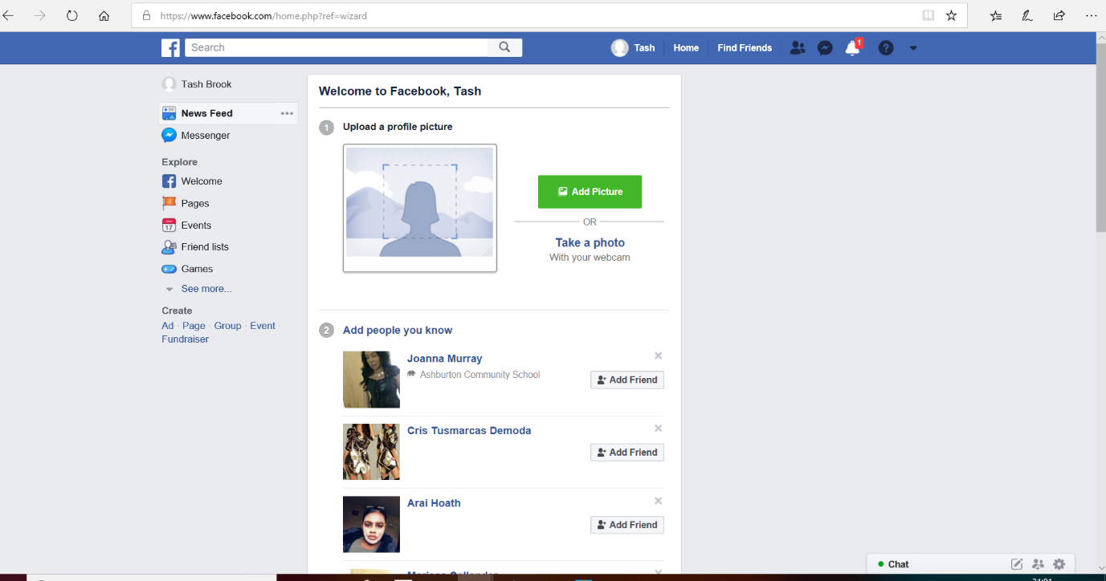
Twitter Web Page
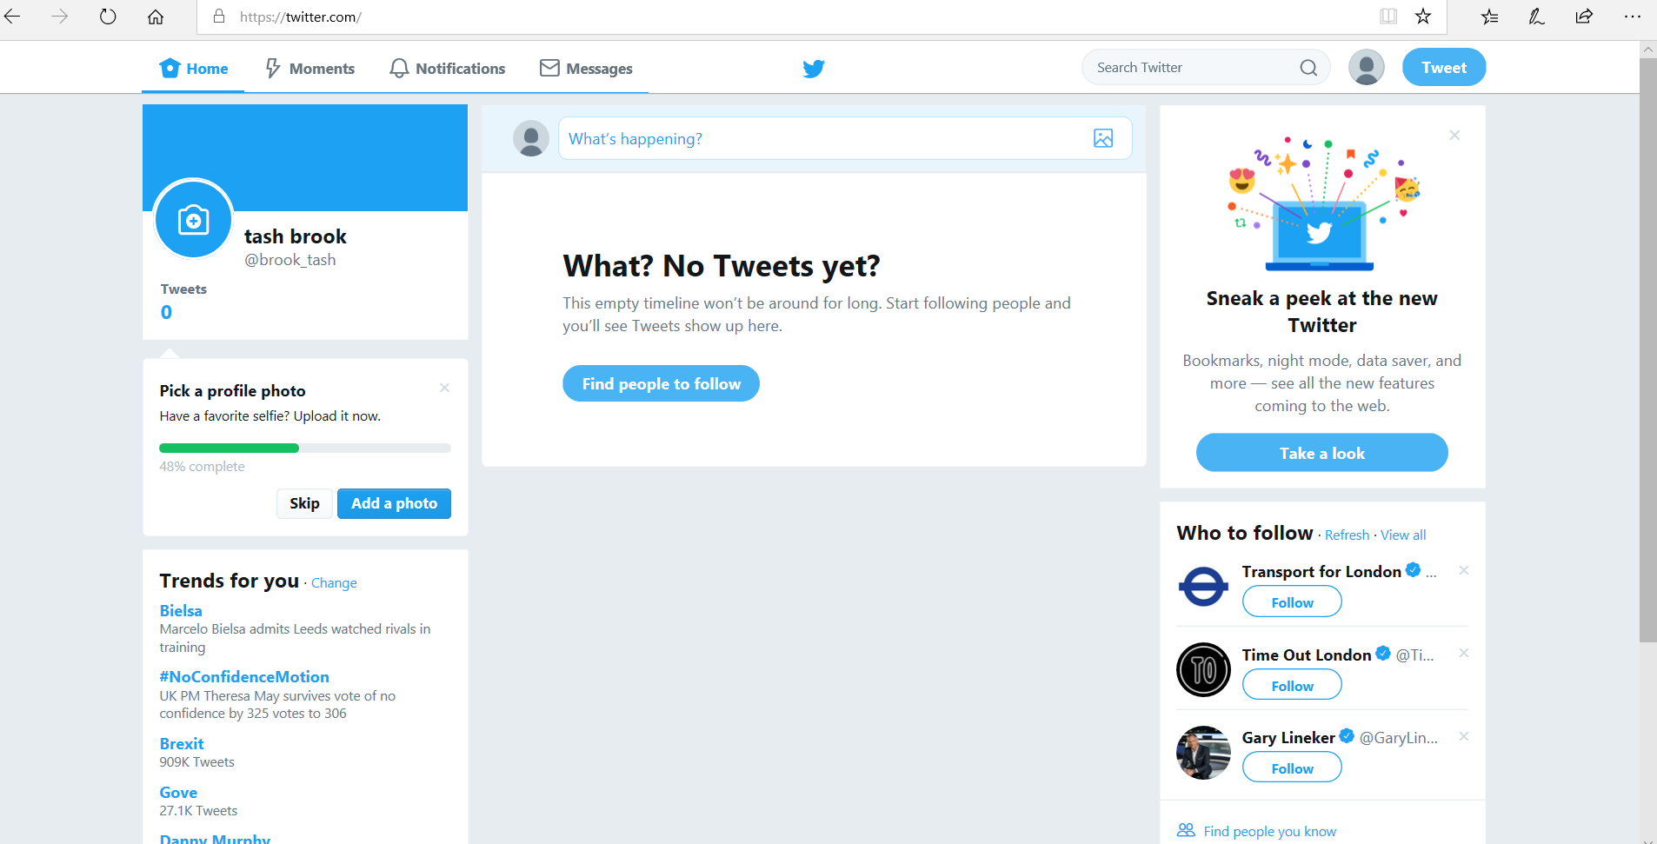
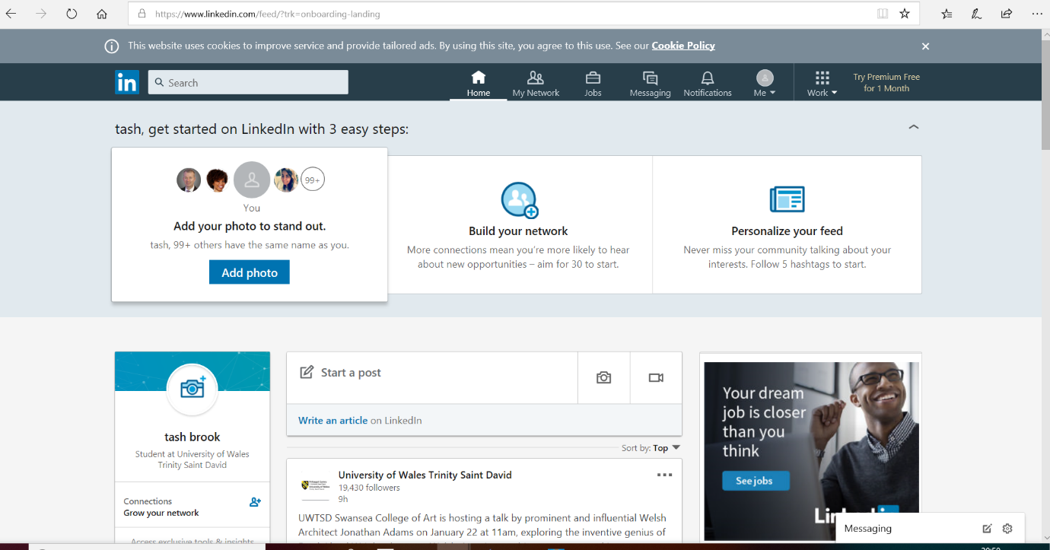
Conclusion.
My conclusion on what I have found about digital skills and how all employers and employees while using iCloud, skype and Dropbox. My information I have provided looking into these creditable skills which are required while working in today’s business environment this is paramount when working in the 21-century workplace. My views have been analyzing how technology is incorporated while working in this industry has a employee or employer weather a sole trader or an international franchise, The things that’s can be done is increase efficiency and accuracy, enhance communication and speed up production this will help boost team building and increase marketing. Technology has a very big impact on businesses today, giving the working environment a better future.
References
[Gil.l](2018)iCloud the ultimate guide: available :https://www.google.uk/amp/s/www.imore.com/icloud%3famp (Accessed 23th Oct 2018)
[Lipman.v] (2017) Forbes media are your employees engaged or happily complacent. Available at
https://www.google.co.uk/amp/s/www.forbes.com/victorlipman/2017/09/20/are-your-employees-engaged-or-happily-complacent/amp/ (Accessed 27th Nov 2018)
[James T](2018) How does skype work and is it expensive to use. https: ://smallbusiness.chron.com/skype-work-expensive-use-61381.html(Accessed 19 Nov 2018)
[Information/Age][ismail N] Morden technology advantages and disadvantages. (Accessed 24thNov 2018)

