Contemporary Theme: Technology Integration of Marriott’s Hotel

(PowerPoint slides & Ref are listed below)

Student Name : AKM Baizidur Rahman Khan
Student ID : 2013237
Course : IHM Level 6
Module code : BMIH6001
Date : 09.06.2023
Presenting to : Lisa Knight
Institute : UWTSD, SWANSEA
MSStream Link : PRESENTATION_REPORT_BMIH 6001 Contemporary Themes Presentation 1.mp4
PPT REF: Aznar, J. et al. (2016) ‘Sustainability Commitment, new competitors’ presence, and Hotel Performance: The Hotel Industry in Barcelona’, Sustainability, 8(8), p. 755. doi:10.3390/su8080755.
Chon, K.S. and Maier, T.A. (2010) Welcome to hospitality-- an introduction. Clifton Park, NY: Delmar.
Haywood, K.M. (2012) ‘A strategic approach to managing technology’, Cornell Hotel and Restaurant Administration Quarterly, 31(1), pp. 39–46. doi:10.1177/001088049003100112.
Jackson, E. (2018) Hotel Management. New York, NY: Larsen &amp; Keller.
Kasavana, M.L. (2016) Managing technology in the hospitality industry. Lansing, MI: American Hotel &amp; Lodging Association, Education Institute.
Marriott (2023) About Marriott International: Corporate Information, About Marriott International | Corporate Information. Available at: https://www.marriott.com/marriott/aboutmarriott.mi.
Rezaee, Z. and Choi, E.K. (2016) ‘The relevance of business sustainability in the hotel industry’, Sustainability in Hospitality: How Innovative Hotels are Transforming the Industry, pp. 25–40. doi:10.9774/gleaf.978-1-78353-197-4_4.
Roy, S. (2019) How Marriott International uses technology to delight its guests, Tech Wire Asia. Available at: https://techwireasia.com/2019/06/how-marriott-international-uses-technology-to-delight-its-guests/.
Yoo, D., Kim, G. and Suh, Y. (2011) ‘Hotel-domain ontology for a Semantic Hotel Search System’, Information Technology &amp; Tourism, 11(1), pp. 67–84. doi:10.3727/109830509788714622.
Marriott (2023) About Marriott International: Corporate Information, About Marriott International | Corporate Information. Available at: https://www.marriott.com/marriott/aboutmarriott.mi.
McNidder, S. (2018) The General Data Protection Regulations (GDPR): How to get GDPR Consent. London, United Kingdom: ARK Group.
Mustafa, E. (2022) ‘Technology in hotel sector’, Technology Application in Aviation, Tourism and Hospitality, pp. 73–87. doi:10.1007/978-981-19-6619-4_6.
Lauren, J. (2021) Marriott International Reports on environmental, social, and governance progress, Marriott International Newscenter (US). Available at: https://news.marriott.com/news/2021/09/14/marriott-international-reports-on-environmental-social-and-governance-progress.
Lawrence (2022) Hotel Technology, Marriott International. Available at: https://www.marriott.com/meeting-event-hotels/meetings/mobility-and-tech.mi.
Lehman, S.M. (2011) Technology integration. Oakland City, IN: Oakland City University.

PPT SLIDES:
Slide1: 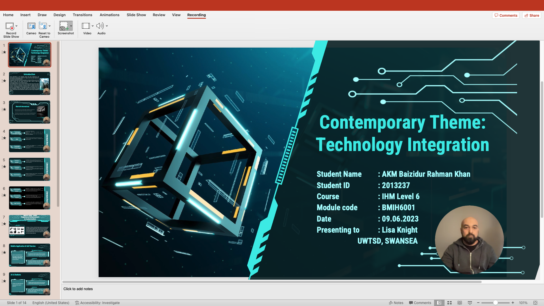
Slide2: 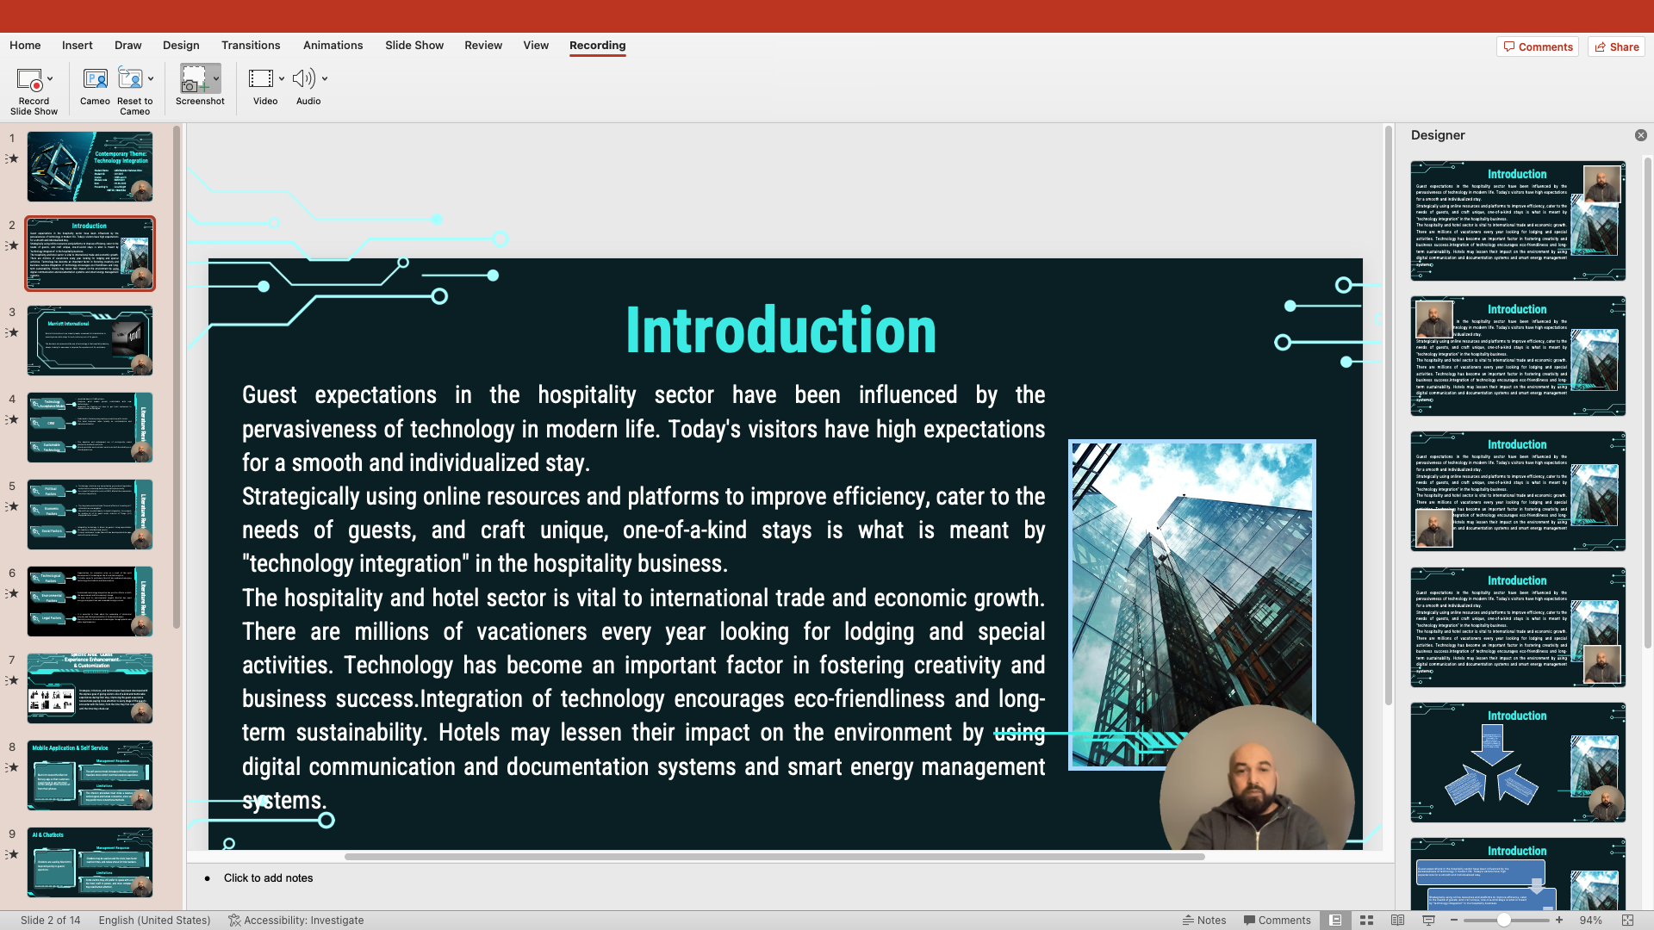
Slide3: 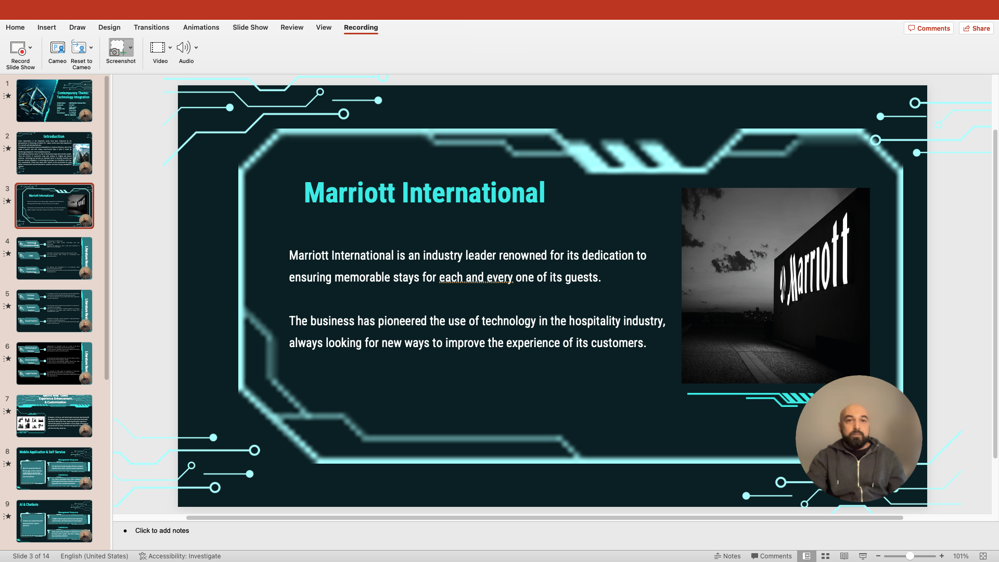
Slide4: 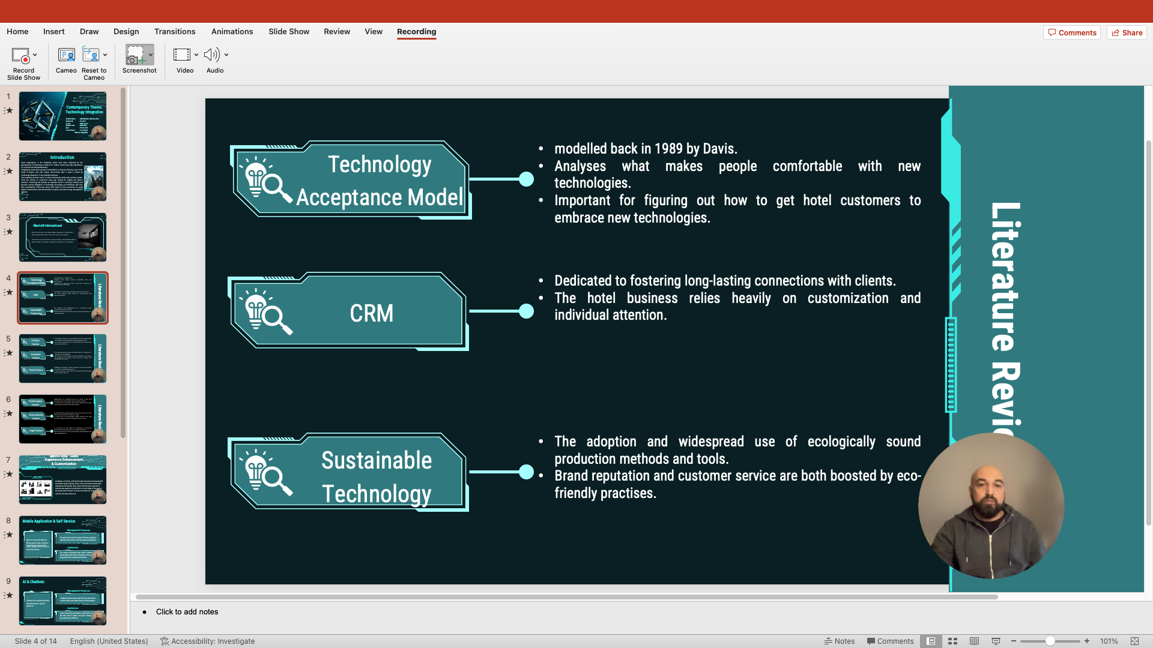
Slide5: 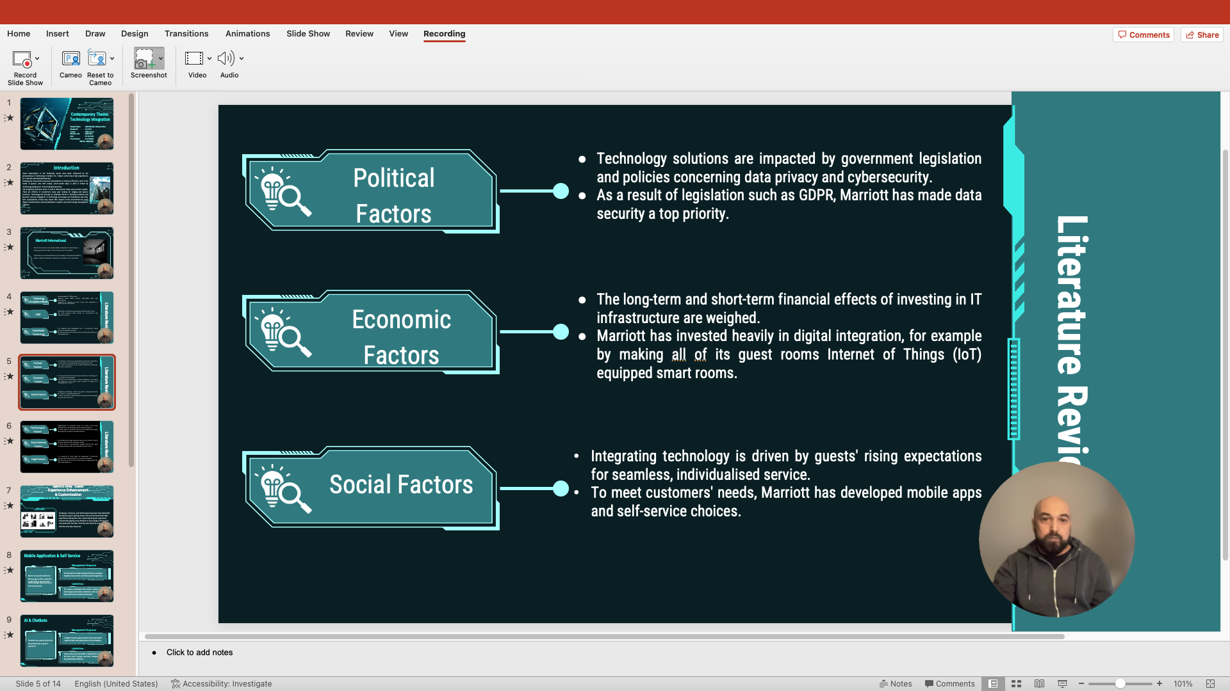
Slide6: 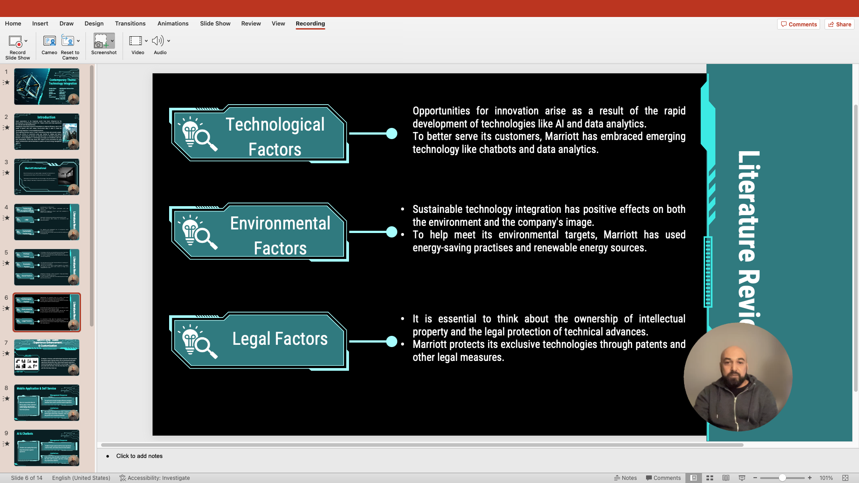
Slide7: 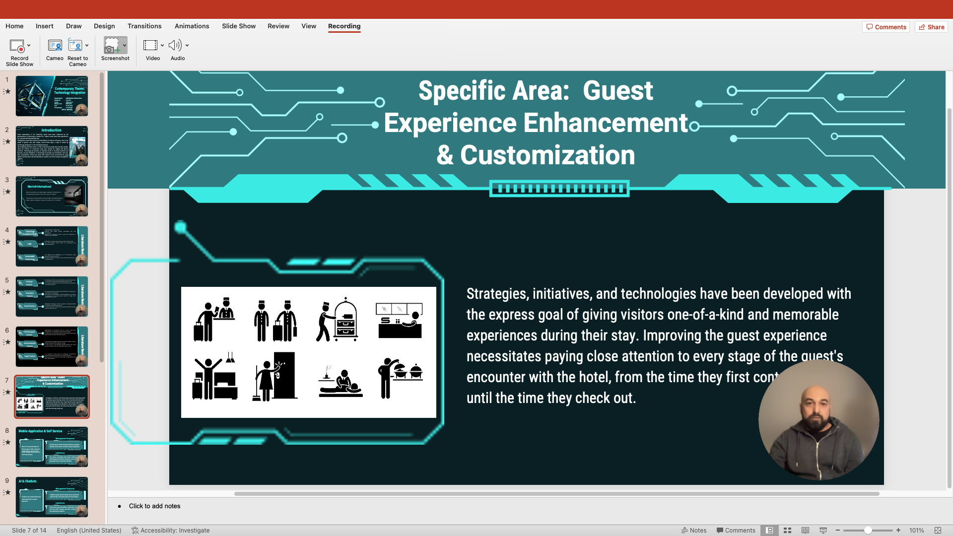
Slide8: 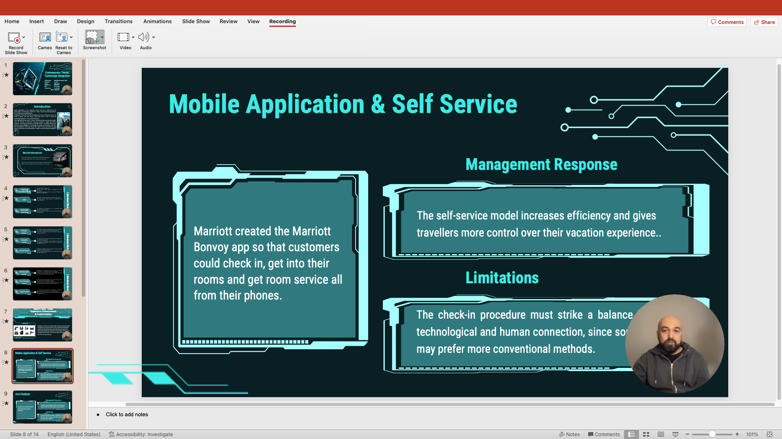
Slide9: 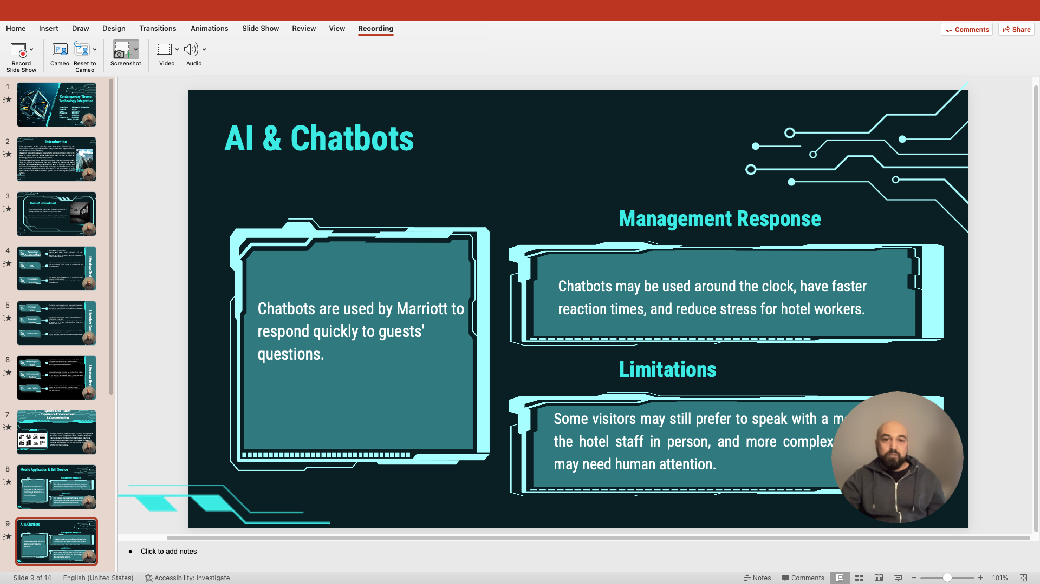
Slide10: 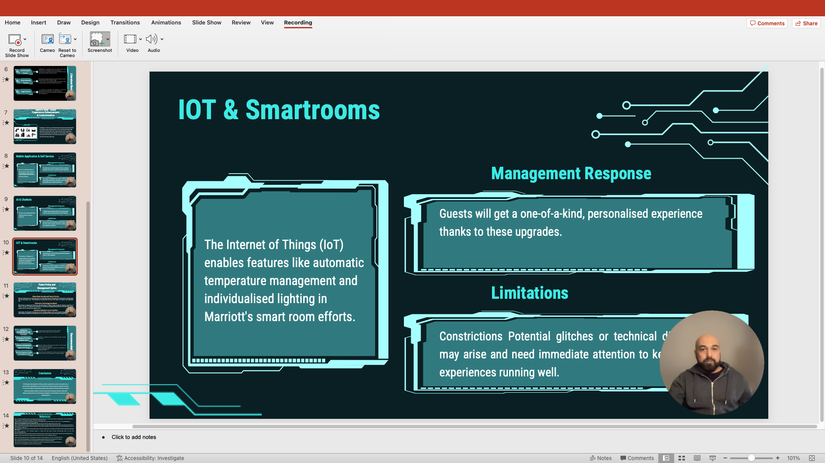
Slide11: 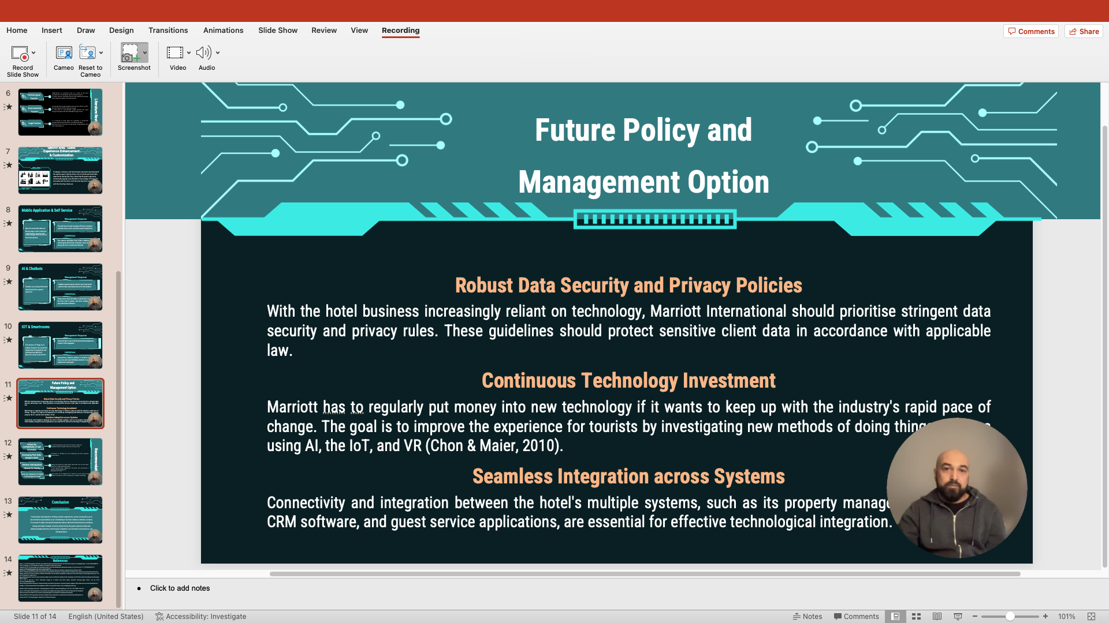
Slide12: 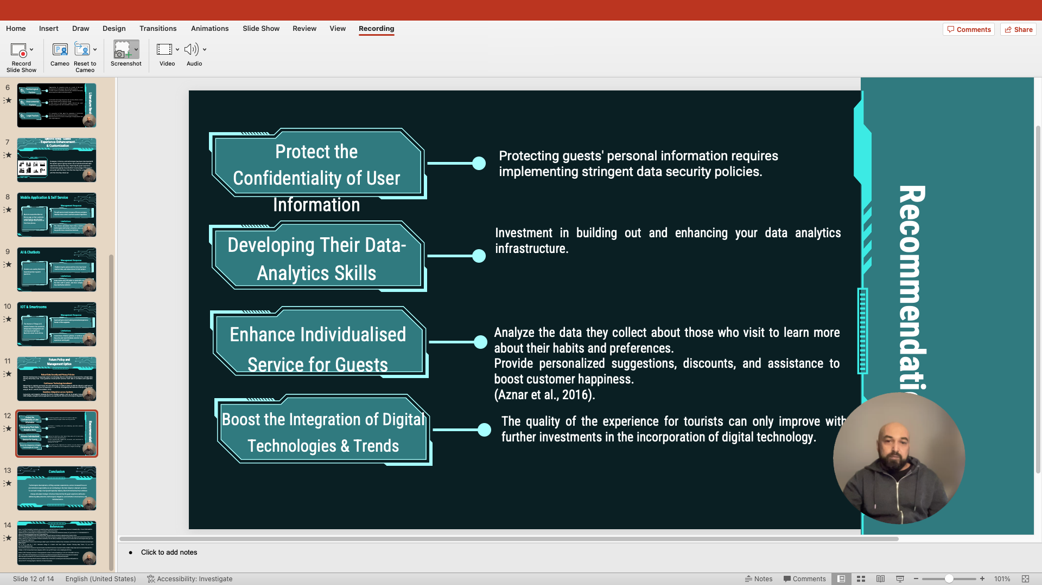
Slide13: 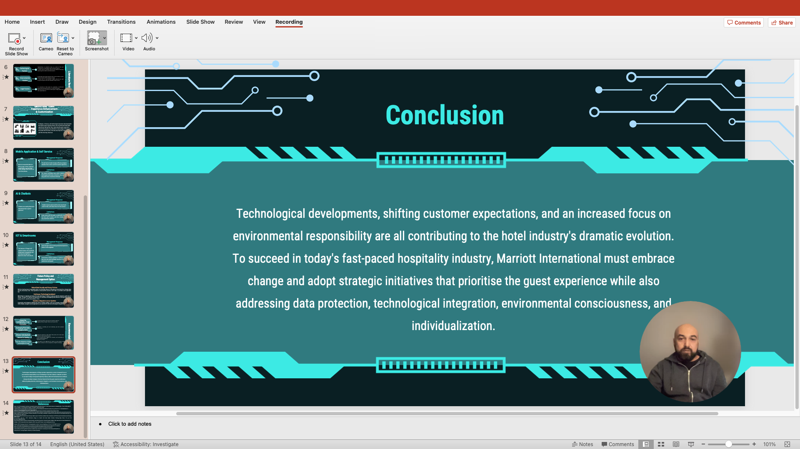
Slide14:


