Internet of Things – Smart City Application
ACDA6005

1706594@student.uwtsd.ac.uk
Asgar Ali
School of Applied Computing
University of Wales Trinity Saint David
Supervisor: Professor John Rees.
13th December 2019
2500 Words

Table of Contents
Abstract 0
1. INTRODUCTION 0
2. RELATED WORK 1
GSMA trial. 1
Cambridge smart city study 2
BT In-Link 2
3. PROBLEM FORMULATION 2
4. IMPLEMENTATION 3
Design 3
Network addressing and components 3
Micro-controller unit (MCU). 3
Wireless router 4
Sensors 4
Environment Window 5
Emissions setup 5
Cloud server 6
5. RESULTS 6
IoT network simulation 6
Troubleshooting using the Serial Console 6
Viewing sensor data 6
Editing the programming 7
Triggers for the web interface 7
6. CONCLUSION 7
Problems encountered 7
Future improvements 7
7. REFERENCES 8
Appendix A 9
Appendix B 9
Appendix C 10
Appendix D 11
Appendix E 11
Appendix F 11

Figure 1 – What can be measured [5]. 1
Figure 2 - Health effects [7]. 1
Figure 3 -Wasp Mote powered by a solar panel. 2
Figure 4 – AQMesh pod 2
Figure 5 - Air pollution flow diagram 3
Figure 6 - Arduino Uno MCU 4
Figure 7 - Linksy WRT300N 5
Figure 8 – NOX (MQ9) sensor for Arduino. 5
Figure 9 – CO gas sensor (MQ7) for Arduino. 5
Figure 10 – PM2.5 air quality sensor for Arduino. 5
Figure 11 - environment temperature change. 6
Figure 12 - timescale adjustment. 6
Figure 13 - Old car emitting 6
Figure 14 – Emissions code 6
Figure 15 -Packet Tracer network topology. 7
Figure 16 - Old car off. 7
Figure 17 - Web browser displaying warning. 7

Table 1 -Common air pollutants in cities. 4

Abstract

This report will discuss the design and implementation of an Internet of Things (IoT) air pollution Smart City Application (SCA) implemented using Cisco Packet Tracer 7 simulation software. The introduction will detail discuss the problem of air pollution in cities and the use of IoT to tackle this problem. Related work highlights examples of some research already implemented in measuring traffic air pollution in cities and the results. A problem formulation section will show how this SCA project can be tackled. The implementation section will detail how the SCA was implemented by the author, followed by the results. The conclusion will discuss the outcome of the project including any future recommendations.

Keywords - Internet of Things (IoT); air pollution monitoring; smart cities

INTRODUCTION

It is estimated that by 2050, 70% of earth’s population will be urban, with many cities having over 10 million inhabitants [1]. A “smart” city can be defined as a city that utilises different types of sensors and devices to collect data and provide information that is used to efficiently manage resources in order to positively impact the inhabitants [2]. A smart city has lots of use cases for IoT-enabled technology, from maintaining a healthier environment to enhancing public transport and safety [3]. 66% of US cities are now committed to investing in IoT [4]
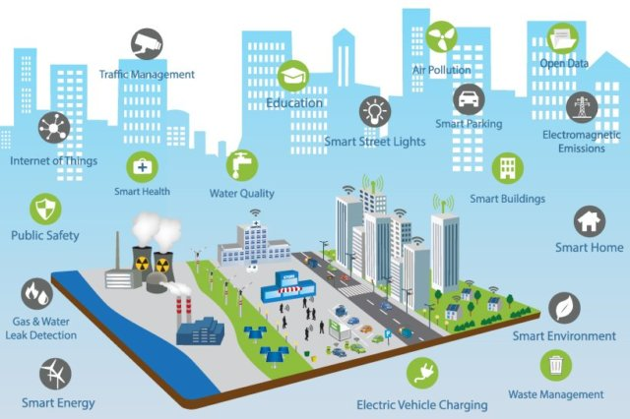

Figure 1 – What can be measured [5].
The World health Organisation (WHO) estimates 7 million people a year die globally from outdoor and indoor air pollution. Poor air quality contributes to strokes, heart disease, lung cancer and asthma (fig.2). More traffic fumes and chemicals are being released every year with the increase in the number of vehicles [6].
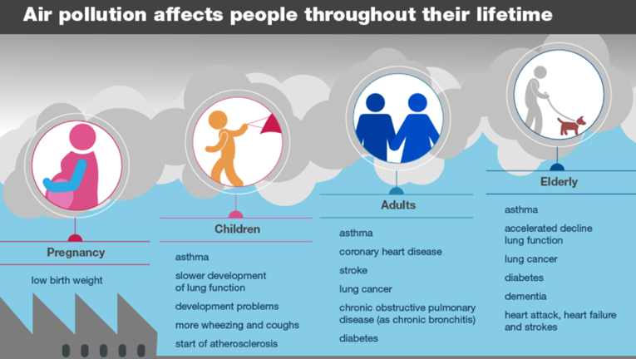
Figure 2 - Health effects [7].
The SCA project will focus on measuring the most important traffic air pollutants in cities (Table 1.)[8][9][10].

TABLE 1 -Common air pollutants in cities.
Pollutant | Health affects
Nitrogen dioxide (NOX) | Mostly from diesel vehicle combustion. Known to cause bronchitis, asthma and other respiratory diseases [11].
Particular matter (PM) | Ultra-fine particles known to cause cardiovascular and respiratory diseases, as well as lung cancers [11].
Carbon monoxide (CO). | Impairing vision and poor learning ability [11].

Although relative humidity plays a big role in air pollution, this data can be captured externally, therefore, will not be included [12].

RELATED WORK

According to the Huawei Smart cities Index 2017, there has been significant technological advancements in some UK cities in the adoption of IoT[13]. In the UK, there have been three recent trials utilising IoT in cities to monitor air pollution.

GSMA trial.

A 2018 air quality study conducted by the GSM Association and Greenwich council, utilised fixed and mobile IoT monitoring equipment. The IoT gas sensor product utilised was ‘Wasp Mote’ (fig.4), which connected to a cloud-based MySQL database. The device is designed to be scalable, easy to deploy and maintain. It consists of an IP65 waterproof enclosure, a 45-degree solar panel option and over the air programming via Wi-Fi or 4G. The battery can also be charged via a waterproof USB cable. Lo-Ra network technology was used for long range communication. Smog mobile, an electric vehicle containing IoT gas sensors was also used [14] [15].

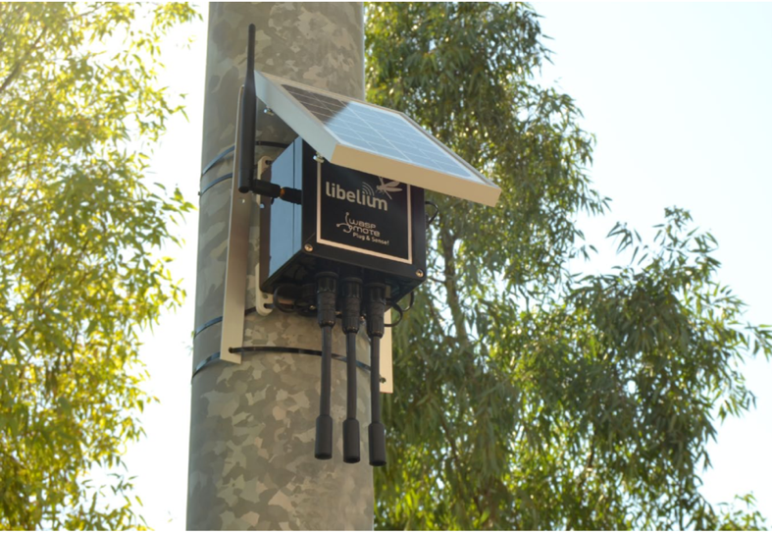
Figure 3 -Wasp Mote powered by a solar panel.

Cambridge smart city study
Cambridge council have installed ‘AQMesh’ IoT devices to measure NO, NO2, NOx, O3, CO, SO2 and PM gases. It also measures humidity, pod temperature, atmospheric pressure and noise. They are designed to be easy to install, small and are either battery or solar operated. Data is transmitted via 4G cellular or Wi-Fi in real time. [16].

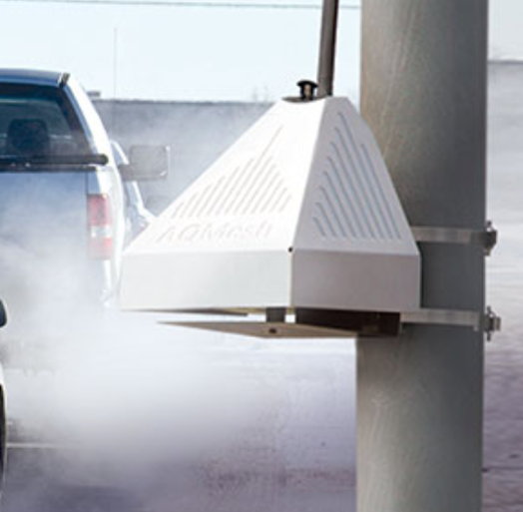
Figure 4 – AQMesh pod.

Machine learning was used in Sao Paolo to predict NOX levels 24-48 hours in advance, from received data, so authorities could take action. Time series analysis, scatter plots, spatial plots and heat maps have been used for visualisation [17].

BT In-Link

In 2019 Bradford and Birmingham cities began trialling air quality IoT sensors provided by stationary BT In-Link digital street units. The units collected data and transmit it via ultra-fast Wi-fi which were then analysed by scientists[18].

PROBLEM FORMULATION

The SCA will be modelled on the GMSA and Cambridge studies which detect different pollutant gases simultaneously. A DC power supply will be chosen, as opposed to battery or solar.

Although mainly cellular was utilised in the above studies, it would be easier to implement a Wi-Fi based network in the Packet Tracer simulation.

Large amounts of real-time data will be generated by the gas sensors; therefore, a cloud-based data science server will be required, that will have machine learning and big data capabilities in order to understand how air pollution varies in different locations and find patterns in the data. Amazon, Google and Microsoft provide machine learning dashboards.

IMPLEMENTATION

Design

IoT gas sensors will be installed around city locations in order to measure and monitor air pollution. The three chosen sensors types will collect data from the air and forward to an MCU. The MCU transmits the data to the cloud via Wi-Fi. The server will store and analyse this data. If the reading is high, a warning will be displayed on a web browser page.

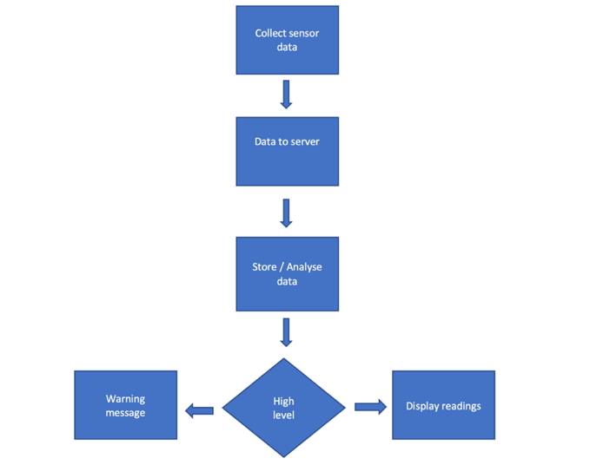
Figure 5 - Air pollution flow diagram.

Network addressing and components
The network is configured with no NAT services to avoid the need for port forwarding in this simulation. Wireless is provided by a WRT300N router as a gateway. An ISP router is connected to the Cloud server.
Cluster 1:
- Internal: 192.168.1.0/24
- External: 32.64.128.1
- MCU: 192.168.1.10
Cluster 2:
- Internal: 192.168.2.0/24
- External: 32.64.128.2
- MCU: 192.168.2.10
Cluster 3:
- Internal: 192.168.3.0/24
- External: 32.64.128.3
- MCU: 192.168.3.10
Cloud server:
- Internal: 192.168.4.0/24
- External: 222.22.2.1/30
ISP Router:
- GigabitEthernet0/0/0: 222.22.2.2/30
- GigabitEthernet0/0/1: 32.64.128.6/29
External PC:
- IP: 32.64.128.4
- Gateway: 32.64.128.6

Although generic components were used in the Packet Tracer simulation, the author has researched possible components that could be used in a physical prototype. The most common being Arduino and Raspberry Pi compatible.

Micro-controller unit (MCU).
An MCU is a small computer that controls the gas sensors. The collected sensor data is sent to the server by access point (Gateway).
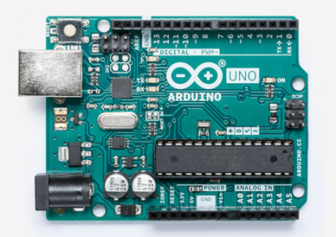
Figure 6 - Arduino Uno MCU.
The MCU runs a script (see appendix B). This script reads the values of three gas sensors, NOX, CO, and PM. These three sensors output an analogue signal that is read on analogue pins 0, 1, and 2 respectively. Internally these values are read using a helper function that maps the 10-bit analogue read to an 8-bit analogue value. This value is then mapped to the respective limitations of each sensor.
The MCU uses the wireless network hat and is configured with the 10th host address available within its respective subnet and uses the gateway of the first host address available within its respective subnet.
To configure the MCU network settings one must go to the config tab, and Wireless0. The SSID must match the respective container wireless. Once the SSID is set, and address may be added on the same page. After the address and gateway have been applied, one must go back to the Setup section of Config and set the default gateway.
Installing the script is accomplished by going to the programming tab of the MCU, choosing blank JavaScript, and then writing into main.js. Clicking run within the programming tab will run the monitor functions.

Wireless router
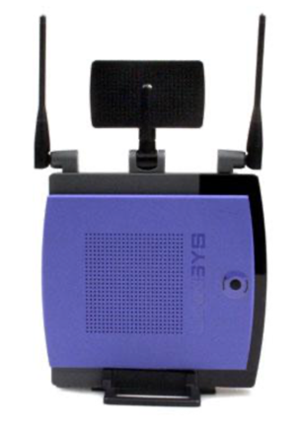
Figure 7 - Linksy WRT300N.
To provide wireless access to each cluster. The SSID for each is relative to the cluster. For example, cluster 1 is C1 then just 80211 after. The wireless router has the DHCP function disabled. It is important to disable this functionality before connecting to the router using one of the provided fast ethernet ports on the switch side of the WRT300N.

Sensors
The gas sensors have an 8-bit limit (255 unique digital values) which is a limitation which exists within Packet Tracer. Because of this it is necessary to limit the range of the sensor to ranges that make sense. These ranges are set in the MCU script (appendix B) and the individual sensor scripts. To attempt to increase accuracy it may be necessary to limit the output range of the sensor to have less than the 255 values that it is capable of. As such there is a Max Limit option that is specified in the Sensor and must be applied when the analogue data is read at the pin.
- Nitrogen Oxide (NOX) Limitations: 0 to 1.0 in 250 steps.
- Carbon Monoxide (CO)Limitations: 0 to .008 in 250 steps.
- Particulate Matter Limitations (PM): 0 to 50 in 250 steps.
The sensors also have a digital trigger that can be used to aside from the analogue output. This digital trigger has a trigger point in the respective sensor script files. These values correspond with the values that are considered high in other parts of the project as well.
- Nitrogen Oxide Trigger: 0.02
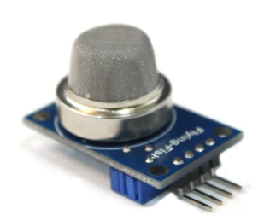
Figure 8 – NOX (MQ9) sensor for Arduino.
- Carbon Monoxide Trigger: 0.004

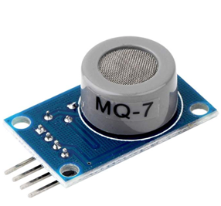

Figure 9 – CO gas sensor (MQ7) for Arduino.

- Particulate Matter Trigger: 24
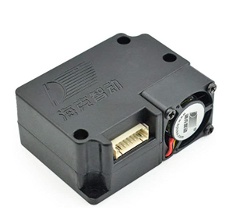
Figure 10 – PM2.5 air quality sensor for Arduino.

Environment Window
This is used to set up the environment and tracks contributions from devices and objects. Simulation speed was adjusted, and custom resources were added.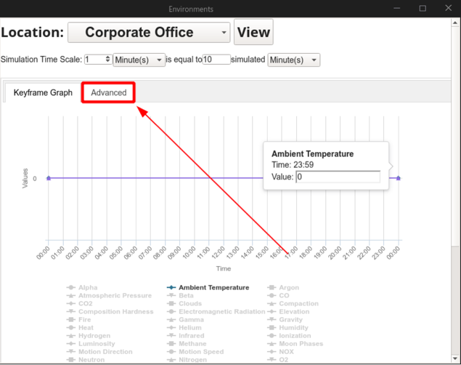
Figure 11 - Environment temperature change.
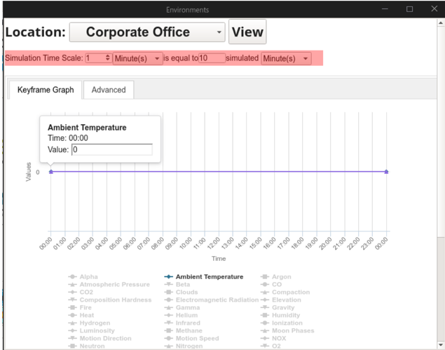

Figure 12 - Timescale adjustment.

Emissions setup
An ‘old car’ object has been modified to emit NOX and PM using JavaScript. This can be changed to emit other pollutant gases. Pressing Alt + left click turns it on, so it pollutes the air and triggers the LED’s to come on and turn green.

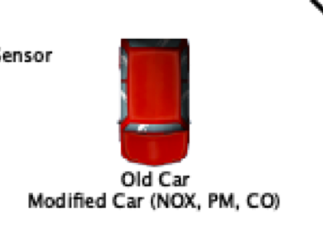
Figure 13 - Old car emitting

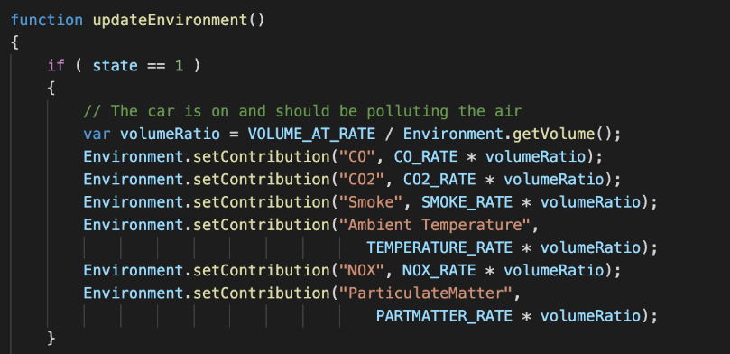

Figure 14 – Emissions code.

Cloud server
A JavaScript HTTP server was created in order the replicate the cloud server, where the data will be analysed to provide information on the air quality [19]. The data is accessed via typing in the IP address (192.168.4.2) of the MCU in a web browser on a PC. The 10 most recent values monitored in each cluster are reported. This can be changed by setting the global variable ‘MostRecentCount’ to another value.

RESULTS

IoT network simulation

A star network of 3 cluster nodes was created that was combined into a larger star attached to a cloud server.

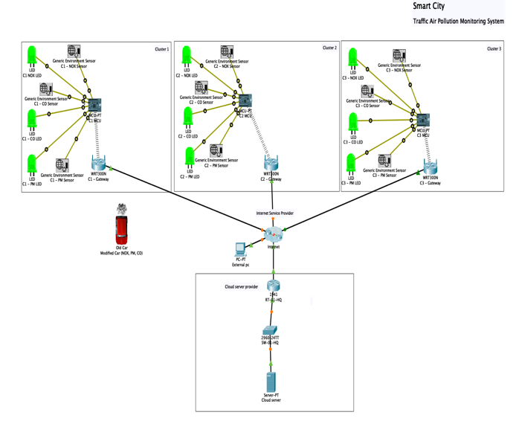
Figure 15 -Packet Tracer network topology.

Troubleshooting using the Serial Console
Within the sensors and server serial console information is used for troubleshooting. This information can be viewed by going to the device that one would like to gather information on and choosing to view the programming tab. Information provided by the MCU is provided when a sensor passes the threshold defined within the programming. Once this threshold is passed the LED of the associated value is set to HIGH (On). The trigger data is there just for the purpose of ensuring that the values are being read properly by the MCU. Within the server, the reported data is about the cluster connection event and the data that the cluster is sending to the server. This data includes the cluster name, the NOX value, the PM value, and the CO Value in respective order.

Viewing sensor data
The server script runs within the programming section of the Packet Tracer Cloud server, while it is running and collecting data from the three clusters, it will show that data by pointing a browser from the external PC connected to the internet, and properly configured to the IP address of the cloud server: 192.168.4.2. As configured, the 10 most recent values monitored in each cluster are reported. This can be changed by setting the global variable ‘MostRecentCount’ to another value. Warnings are displayed when the values are high.
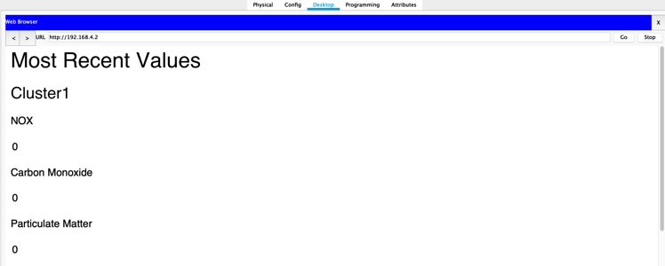
Figure 16 - Old car off.
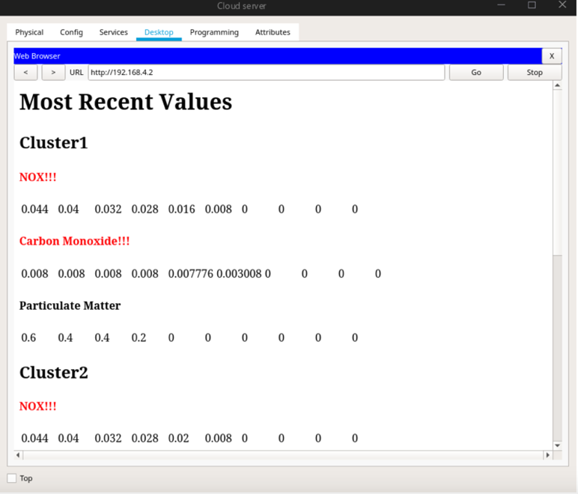
Figure 17 - Web browser displaying warning.

Editing the programming
The predefine values of each sensor are able to be edited from within that sensor. The values that are edited must also be updated in each of the MCU's map functions. To edit this programming, one must choose advanced on the sensor, and then choose the programming tab.
‘rangeMin’ - is used to denote the lowest value that the sensor will report on.
‘rangeMax’ - denotes the highest value, values beyond this will just report as if they are this value.
‘outputMax’ - is used to determine the maximum output of the 8-bit analogue write operation (value between 0 and 255). This value should be chosen to allow near lossless division of expected input values. The combination of these values determines the effective resolution of the sensor. A higher variance between min and max results in lower resolution, as does a lesser output max.

Triggers for the web interface
Choosing to edit the web interface to have alternative trigger points can be accomplished by visiting the programming tab of the Cloud server. At the top of the server programming are three variables that are used to determine the point at which the server reports the values as being considered high. This can be set separately of the LED trigger values, and the MCU's high values. The names of limits are documented in code. Once the server gets a report of this limit being passed, the server will change the text to the colour red and then add exclamation points to the attribute (fig. 17). The high warning can be changed within the same code by visiting ‘clusterObject’, and then changing the lines found within the call-back function for ‘this. clusterReport’.

CONCLUSION

Problems encountered

The JavaScript that Packet Tracer uses is not fully compliant with real JavaScript and no reference material was available. The author found writing a graph API that works with the limited JavaScript functionality in Packet Tracer would be cumbersome. The Arduino C language Sketch library was heavily relied upon for the task of implementing programming to the SCA project through trial and error [20]. The Web browser did not behave like a real browser either.

Future improvements

Although the SCA was implemented successfully, improvements can be made. 4G /5G wireless cards can be added to the MCU in order to transmit data via the cellular network as this will be a more reliable method than Wi-Fi, as the coverage will be greater. More IoT sensors can be added to the simulation to include weather and temperature data capture, which would give better incites and predictions on air quality. In a real-world scenario, A Geographical Information System (GIS) can be created to map pollution hotspots, as in the GSMA study. Local authorities can use this information for traffic management and speed adjustments in affected areas. The public can also be informed of health risks.

REFERENCES

[1] ‘World Urbanization Prospects - Population Division - United Nations’. [Online]. Available: https://population.un.org/wup/DataQuery/. [Accessed: 27-Nov-2019].
[2] ‘Smart cities | European Commission’. [Online]. Available: https://ec.europa.eu/info/eu-regional-and-urban-development/topics/cities-and-urban-development/city-initiatives/smart-cities_en. [Accessed: 27-Nov-2019].
[3] ‘1: Smart cities definitions | Centre for Cities’. [Online]. Available: https://www.centreforcities.org/reader/smart-cities/what-is-a-smart-city/1-smart-cities-definitions/. [Accessed: 27-Nov-2019].
[4] ‘66% of US cities are investing in smart city technology - TechRepublic’. [Online]. Available: https://www.techrepublic.com/article/66-of-us-cities-are-investing-in-smart-city-technology/. [Accessed: 09-Dec-2019].
[5] ‘Global smart city platform market to reach $755m by 2027 | Internet of Business’. [Online]. Available: https://internetofbusiness.com/global-smart-city-platform-market/. [Accessed: 03-Dec-2019].
[6] ‘Air pollution’. [Online]. Available: https://www.who.int/health-topics/air-pollution#tab=tab_1. [Accessed: 27-Nov-2019].
[7] ‘Health matters: air pollution - GOV.UK’. [Online]. Available: https://www.gov.uk/government/publications/health-matters-air-pollution/health-matters-air-pollution. [Accessed: 27-Nov-2019].
[8] ‘Causes of air pollution - Defra, UK’. [Online]. Available: https://uk-air.defra.gov.uk/air-pollution/causes. [Accessed: 27-Nov-2019].
[9] ‘Monitoring Networks - Defra, UK’. [Online]. Available: https://uk-air.defra.gov.uk/networks/. [Accessed: 27-Nov-2019].
[10] ‘Air Pollution Sources - Environmental Protection UK’. [Online]. Available: https://www.environmental-protection.org.uk/policy-areas/air-quality/about-air-pollution/air-pollution-sources/. [Accessed: 28-Nov-2019].
[11] M. Geiser et al., ‘Ultrafine particles cross cellular membranes by nonphagocytic mechanisms in lungs and in cultured cells’, Environ. Health Perspect., vol. 113, no. 11, pp. 1555–1560, Nov. 2005.
[12] ‘Season and humidity dependence of the effects of air pollution on COPD hospitalizations in Hong Kong - ScienceDirect’. [Online]. Available: https://www.sciencedirect.com/science/article/abs/pii/S135223101200698X. [Accessed: 28-Nov-2019].
[13] ‘Smart Cities Index Report 2017’. [Online]. Available: https://e.huawei.com/uk/special_topic/solution/smart_cities_index_2017. [Accessed: 09-Dec-2019].
[14] ‘GSMA | Air Quality Monitoring With IoT Big Data | Internet of Things’. [Online]. Available: https://www.gsma.com/iot/iot-big-data/smart-london-air-quality-monitoring-big-data/. [Accessed: 07-Dec-2019].
[15] ‘The Smogmobile | Portable Air Quality Monitoring | Enviro Technology’. [Online]. Available: https://www.et.co.uk/the-smogmobile. [Accessed: 07-Dec-2019].
[16] ‘Applications – AQMesh’. [Online]. Available: https://www.aqmesh.com/product/applications/. [Accessed: 07-Dec-2019].
[17] ‘GSMA Telefónica Case Study: Predicting air pollution levels 24 to 48 hours in advance in São Paulo, Brazil - #BetterFuture’. [Online]. Available: https://www.gsma.com/betterfuture/resources/telefonica-case-study-predicting-air-pollution-levels-24-to-48-hours-in-advance-in-sao-paulo-brazil. [Accessed: 07-Dec-2019].
[18] ‘IoT air quality devices deployed in UK cities | Government Europa’. [Online]. Available: https://www.governmenteuropa.eu/iot-air-quality-devices/93974/. [Accessed: 07-Dec-2019].
[19] ‘Daily Air Quality Index - Defra, UK’. [Online]. Available: https://uk-air.defra.gov.uk/air-pollution/daqi. [Accessed: 27-Nov-2019].
[20] ‘Arduino Reference’. [Online]. Available: https://www.arduino.cc/reference/en/#page-title. [Accessed: 12-Dec-2019].

Appendix A

Old Car Script.

// This file is a modification of the original old car javascript file
// provided by Cisco. This file needed to be modified in order to add emissions
// of NOX and Particulate Matter. These variables must be added to the

var CO_RATE = 1/3600; // Definitions for rates to be added into the
var CO2_RATE = 2/3600; // environement over time. The measurment is in
var SMOKE_RATE = 3/3600; // units over hours as measured in seconds
var NOX_RATE = 3/3600; // EXAMPLE: 3/3600 = 3% increase per hour
var PARTMATTER_RATE = 300/3600;// Particulate matter is an exception
var TEMPERATURE_RATE = 1/3600; // it is raw units per hour
var VOLUME_AT_RATE = 100000;

var state = 0; // Enabled or disabled

function updateEnvironment()
{
if ( state == 1 )
{
// The car is on and should be polluting the air
var volumeRatio = VOLUME_AT_RATE / Environment.getVolume();
Environment.setContribution("CO", CO_RATE * volumeRatio);
Environment.setContribution("CO2", CO2_RATE * volumeRatio);
Environment.setContribution("Smoke", SMOKE_RATE * volumeRatio);
Environment.setContribution("Ambient Temperature",
TEMPERATURE_RATE * volumeRatio);
Environment.setContribution("NOX", NOX_RATE * volumeRatio);
Environment.setContribution("ParticulateMatter",
PARTMATTER_RATE * volumeRatio);
}
else
{
//Disable all contrubition when the car is turned off
Environment.setContribution("CO", 0);
Environment.setContribution("CO2", 0);
Environment.setContribution("Smoke", 0);
Environment.setContribution("Ambient Temperature", 0);
Environment.setContribution("NOX", 0);
Environment.setContribution("ParticulateMatter", 0);
}

}

function setup() {
state = restoreProperty("state", 0);
setState(state);
}

function restoreProperty(propertyName, defaultValue)
{
var value = getDeviceProperty(getName(), propertyName);
if ( !(value === "" || value == "undefined") ){
if ( typeof(defaultValue) == "number" )
value = Number(value);

setDeviceProperty(getName(), propertyName, value);
return value;
}

return defaultValue;
}

function mouseEvent(pressed, x, y, firstPress) {
if (firstPress)
setState(state ? 0 : 1);
}

function setState(newState)
{
if ( newState === 0 )
digitalWrite(1, LOW);
else{
digitalWrite(1, HIGH);
}
state = newState;
setDeviceProperty(getName(), "state", state);
updateEnvironment();
}

Appendix B

MCU Script.

// Global variables.
var serverIP = "192.168.4.2"; // Used for establishing a connection to server
var serverPort = 22335; // Currently, these values are random.
var clientName = "Cluster1"; // Name used to keep track of the client

var prevNOX = 0; // These variables are used to reduce redundent serial messages
var prevCO = 0; // They are set to the previous trigger value for the monitor
var prevPM = 0; // and are only changed when the value increases or decrease.
var clientConnection; // Used to contain the TCPClient Connection See: setup()

// analogRead is an 10 bit function, analog write is an 8 bit function, this
// helper function exists to assit in resolving the difference by using a simple
// bitshift. Call in place of analogRead.
function eightbitRead(pin){
var value = analogRead(pin);
return value >> 2;
}

// We need to know the expected output range for each sensor. Even though there
// are 255 steps of accuracy, to reduce rounding issues in transmission it may
// be nescessary to choose values that devide nicely into each other in an
// attempt to preservce accuracy.
function translateValue(value, inMin, inMax, outMin, outMax){
if (value > inMax){
return outMax; // This condition shouldn't exist, this is a just incase
}
return (map(value, inMin, inMax, outMin, outMax));
}

function setup() {

// Create a TCP Client
clientConnection = new TCPClient();
// Assert callback function for client status changes
clientConnection.onConnectionChange = function (type) {
// What to do whent he connection status changes
// Write a line to Serial connection
Serial.println("TCP Connection change: " + type);
}
// Callback for handling income data
clientConnection.onReceive = function (data) {
// What to do when we get data from the server
// Right now we don't have a reason to react to this data.
}
clientConnection.connect( serverIP, serverPort);

}
function loop() {
// Read Environment Sensor
var NOXAlarm = eightbitRead(A0); // Read the analogValue of the PINs
var COAlarm = eightbitRead(A1); // which have sensors connected to
var PartMatterAlarm = eightbitRead(A2); // them
Serial.println("CO + " + COAlarm);
// Translate the read values to expected values
NOXAlarm = translateValue(NOXAlarm, 0, 250, 0, 1.0);
COAlarm = translateValue(COAlarm, 0, 250, 0, 0.008);
PartMatterAlarm = translateValue(PartMatterAlarm, 0, 250, 0, 50);
Serial.println("CO + " + COAlarm);
if (NOXAlarm > 0.1){
//We're getting an alert
if (prevNOX !== NOXAlarm){
Serial.println("NOx HIGH: " + NOXAlarm);
prevNOX = NOXAlarm;
}
digitalWrite(0, HIGH);
} else {
digitalWrite(0, LOW);
}

if (PartMatterAlarm > 24){
//We're getting an alert
if (prevPM !== PartMatterAlarm){
Serial.println("Particulate Matter HIGH: " + PartMatterAlarm);
digitalWrite(2, HIGH);
prevPM = PartMatterAlarm;
}
} else {
digitalWrite(2, LOW);
}

if (COAlarm > 0.004){
//We're getting an alert
digitalWrite(1, HIGH);
if (prevCO !== COAlarm){
Serial.println("Carbon Monoxide HIGH: " + COAlarm);
prevCO = COAlarm;
}
} else {
digitalWrite(1, LOW);
}

// Handle data to be sent to the TCP sever. This data will be accessible
// from a webpage on the server.

if (clientConnection.state() == 3){
// Connected to server, so the client will send a comma seperated set
// of all the sensor values.
clientConnection.send(clientName + "," + NOXAlarm + "," + COAlarm +
"," + PartMatterAlarm);
} else {
// There has been a connection issue. We're going to go through setup
Serial.println("Connection to server interuppted, reconnecting...");
setup();
}
delay(1000);

}

Appendix C

CO sensor Script.

// sensorCO.js - For use reading Carbon Monoxide values
var rangeMin = 0; // Lowest value of value we care about
var rangeMax = 0.008; // Upper limit of value we care about (8000ppm)
var outputMax = 250; // <255: Recommend something that neatly devides range.
var threshold = .004; // The point at which the digital pin triggers
var rate = 250; // Milliseconds between updates
var environmentRead = "CO";

// Function called by Packet Tracer while the script is in a run state
function loop() {
var newLevel = Environment.get(environmentRead);
// Convert the value to something that can be transmitted with resonable
// accuracy over the 8 bit analogWrite function.
newLevel = Math.floor(map(newLevel, rangeMin, rangeMax, 0, outputMax));
if (newLevel > outputMax){
newLevel = outputMax;
}
analogWrite(A0, newLevel);

// Ability to use the device as digital out
if (newLevel > threshold){
digitalWrite(0, HIGH);
}else{
digitalWrite(0, LOW);
}
delay(rate);
}

Appendix D

NOX sensor Script.

// sensorNOX.js - For use reading NOX values
var rangeMin = 0; // Lowest value of value we care about
var rangeMax = 1.0; // Upper limit of value we care about
var outputMax = 250; // <255 : Recommend something that neatly devides range.
var threshold = .02; // The point at which the digital pin triggers
var rate = 250; // Milliseconds between updates
var environmentRead = "NOX";

// Function called by Packet Tracer while the script is in a run state
function loop() {
var newLevel = Environment.get(environmentRead);
// Convert the value to something that can be transmitted with resonable
// accuracy over the 8 bit analogWrite function.
newLevel = Math.floor(map(newLevel, rangeMin, rangeMax, 0, outputMax));
if (newLevel > outputMax){
newLevel = outputMax;
}
analogWrite(A0, newLevel);

// Ability to use the device as digital out
if (newLevel > threshold){
digitalWrite(0, HIGH);
}else{
digitalWrite(0, LOW);
}
delay(rate);
}

Appendix E
PM sensor Script.

// sensorPartMatters.js - For use reading Particulate Matter
var rangeMin = 0; // Lowest value of value we care about
var rangeMax = 50; // Upper limit of value we care about
var outputMax = 250; // <255 : Recommend something that neatly devides range.
var threshold = 24; // The point at which the digital pin triggers
var rate = 250; // Milliseconds between updates
var environmentRead = "ParticulateMatter";

// Function called by Packet Tracer while the script is in a run state
function loop() {
var newLevel = Environment.get(environmentRead);
// Convert the value to something that can be transmitted with resonable
// accuracy over the 8 bit analogWrite function.
newLevel = Math.floor(map(newLevel, rangeMin, rangeMax, 0, outputMax));
if (newLevel > outputMax){
newLevel = outputMax;
}
analogWrite(A0, newLevel);

// Ability to use the device as digital out
if (newLevel > threshold){
digitalWrite(0, HIGH);
}else{
digitalWrite(0, LOW);
}
delay(rate);
}

Appendix F
Cloud Script.

var NOXLimit = 0.02;
var COLimit = 0.004;
var PMLimit = 24;

var MostRecentCount = 10;

var port = 22335;
var server;

// Just for ease of execution this application will use static containers and
// logic to house each client.
var clusters = [0,1,2];

function clusterObject(name){
this.name = name;
this.NOXValues = [];
this.COValues = [];
this.PMValues = [];
this.clusterReport = function(){
return "<h2>" + this.name + "</h2>" +
(this.NOXValues[0] > NOXLimit
? "<h4 style='color:red;'>NOX!!!</h4>"
: "<h4>NOX</h4>") +
"<table><tr>" +
this.mostRecentNox(MostRecentCount) +
"</tr></table>" +
(this.COValues[0] > COLimit
? "<h4 style='color:red;'>Carbon Monoxide!!!</h4>"
: "<h4>Carbon Monoxide</h4>") +
"<table><tr>" +
this.mostRecentCO(MostRecentCount) +
"</tr></table>" +
(this.PMValues[0] > PMLimit
? "<h4 style='color:red;'>Particulate Matter!!!</h4>"
: "<h4>Particulate Matter</h4>") +
"<table><tr>" +
this.mostRecentPM(MostRecentCount) +
"</tr></table>";
}
this.mostRecentNox = function(count){
var iter = 0;
var output = "";
if (this.NOXValues.length < count){
count = this.NOXValues.length;
}
while(count--){
output = "<td width=50px>" + this.NOXValues[count] +
"</td>" + output;
}
return output;
}
this.mostRecentCO = function(count){
var iter = 0;
var output = "";
if (this.COValues.length < count){
count = this.COValues.length;
}
while(count--){
output = "<td width=50px>" + this.COValues[count] +
"</td>" + output;
}
return output;
}
this.mostRecentPM = function(count){
var iter = 0;
var output = "";
if (this.PMValues.length < count){
count = this.PMValues.length;
}
while(count--){
output = "<td width=50px>" + this.PMValues[count] +
"</td>" + output;
}
return output;
}
}

function setup() {
clusters[0] = new clusterObject("Cluster1");
clusters[1] = new clusterObject("Cluster2");
clusters[2] = new clusterObject("Cluster3");

// Setup the TCPServer to get information from clusters
server = new TCPServer();
// Setup callback function for when a client connects
server.onNewClient = function(client) {
// A new client has connected, this is what will occur
Serial.println("New Client: " + client.remoteIP()
+ ":" + client.remotePort());
// Unique call back for this client when the connection changes
client.onConnectionChange = function(type) {
Serial.println("connection changed: " + type);
};
// What to do when we get data from this client
client.onReceive = function(data) {
// Split the data into parts
data = data.split(",");
// Log it to this client's arrays

if (data[0] === "Cluster1"){
clusters[0].NOXValues.unshift(data[1]);
clusters[0].COValues.unshift(data[2]);
clusters[0].PMValues.unshift(data[3]);
}
if (data[0] === "Cluster2"){
clusters[1].NOXValues.unshift(data[1]);
clusters[1].COValues.unshift(data[2]);
clusters[1].PMValues.unshift(data[3]);
}
if (data[0] === "Cluster3"){
clusters[2].NOXValues.unshift(data[1]);
clusters[2].COValues.unshift(data[2]);
clusters[2].PMValues.unshift(data[3]);
}
Serial.println("received: " + client.remoteIP()
+ ":" + client.remotePort() + ", " + data);
};
};

// Let the TCP server begin to listen
server.listen(port);

// Setup the HTTP server
HTTPServer.route("/*", function(url, res) {
Serial.println("Request for /");
res.send(
"<h1>Most Recent Values</h1>" +
clusters[0].clusterReport() +
clusters[1].clusterReport() +
clusters[2].clusterReport()
);
});
// start server on port 80
HTTPServer.st

