Blended learning
By NARGAS AHMADZAI
2106756@student.uwtsd.ac.uk
Academic and Employability Skills Module (BMSW 4001)
Task 1: Blended Learning
Lecturer Name: TERKIMBI ATONDE

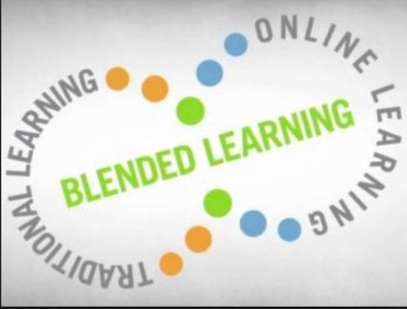
(Bates, 2018)

TABLE OF CONTENT
- INTRODUCTION
- PROS AND CONS OF BLENDED LEARNING
- THE MAIN ADVANTAGES OF BLENDED LEARNING
- CHALLENGES LEARNERS FACE IN BLENDED LEARNING
- PROS AND CONS OF TRADITIONAL CLASSROOM LEARNING.
- ADVANTAGES FOR LEARNERS IN CLASS.
- DISADVANTAGES OF TRADITIONAL CLASSROOM LEARNING.
- EVALUATION OF BOTH FORMS OF TEACHING AND LEARNING.
- RECOMMENDATIONS
- REFERENCE LIST

Introduction
Why blended learning?
How does this affect the education system?
What is the importance of blended learning for students and teachers?

Each day of life brings new challenges and new trails. Therefore, every time we all work hard to face it and find solutions. 2019 was a year which bought Covid-19 due to this pandemic our normal life changes a lot. One of these changes affects learning and education sites. The new method of learning was introduced as blended learning. This report is about blended learning and traditional learning. What are the pros and cons of both blended learning and classroom learning and evaluate some recommendations? Let start with its definition.

What is blended learning?
Blended learning is the modern style of education in which students can learn using digital technology and online services and traditional classroom or face to face learning. It provides a good opportunity for students to take advantage of both modes of learning. They can enjoy face to face education and use their electronics to complete their homework.
The education process is different these days compared to the old world. Along with other technology, developments in teaching style and delivery are also changed. Teaching and learning programmes have adapted new circumstances, opportunities, and environments, making it easier for students and teachers to communicate in non-traditional classroom methods. Kaplan Inc (2021)
Tucker, Wycoff and Green, (2016) have written that Blended learning is the new inventor of education, and it brings new skills and approaches towards education. Students will engage through technology in the classroom and online. This will help students and teachers to learn new strategies and ideas for managing new devices for their assignments and any tasks.

This report aims to identify these four points.
Pros and cons of blended learning in university
Pros and cons of traditional classroom learning
Evaluation of both forms of teaching and learning
Recommendations based on my evaluation

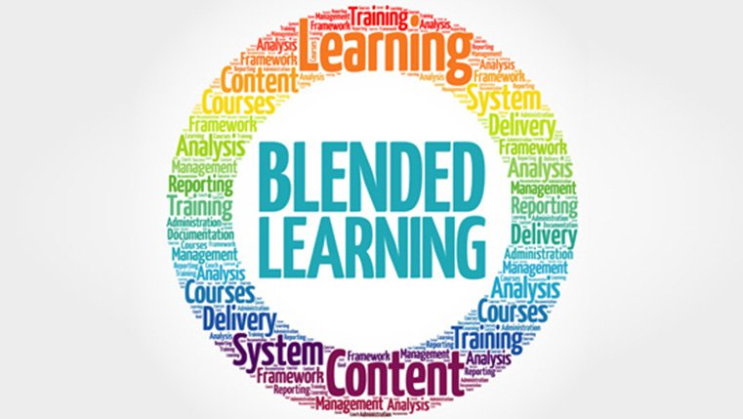
(commLab India bloggers, 2010)

- pros and cons of blended learning in university.
As we know that Blended Learning is a combination of traditional, classroom-style learning and independent, online study. It has both advantages and disadvantages.
  - THE Main Advantages of Blended learnings.
The first advantage of blended learning is that learners can access it anywhere.
Whatever learners so they can attend, follow their tutors, and learn. This is more fun and enjoyable method. Students can move at their speed and time. Kaur (2013) has mentioned that in blended learning students can learn together or alone.
Students who, are more confident with the subject can work through online material faster, while those who are less confident and has less familiarity with digital devices can pause and re-watch the difficult parts.

Most of the lectures are recorded and students can access them whenever they need to listen and to understand. Students can get prepared before class. When looking at blended learning for practical work, students can explore the main ideas and main topics, so they can understand everything before their tutor, start talking about it. This allows them some familiarity with the subject so they can spend more time on interesting and engaging activities.
Some studies from recent years suggested that blended learning helped students to maintain more information.
This can support students with their ideas and independent effort. It introduces new technologies. Blended learning gives the ability for learners to experience new software and hardware. Discovering how to use such technology can prepare them for future activities. ((Everything you need to know about blended learning - FutureLearn, 2021)
Tayebinik (2013, p3) has added in her article that blended learning is one of the best environments for learners to use different sources and improve their quality of learning.

1.2 Challenges learners face in blended learning.
Access to resources is the biggest disadvantage of online classes. Blended learning is more based on technology and digital resources. Students need to have familiarity with their usage. There is a chance that every student may not have equal access to devices and for this reason, it might have increased difficulty for learners.
Drotárová, Kačíková, Kelemen and Bodor (2016) have argued that blended learning has brought many changes in the learning system and some changes are a burden for school and trainees to provide all the facilities for learners to carry on their blended learning.

Sometimes connection issues increase stress levels, while weak internet service can affect a lot in class during the lesson.
Supporting single learners or one to one is a hard thing for teachers. Students with different requirements and having issues with lack of skills for accessing digital media. They may lose interest in daily tasks and assignments.
Students with no daily connection or face to face with their teachers can create more questions and problems. Some questions with no immediate answers can affect their confidence level. (BLENDED LEARNING.docx - BLENDED LEARNING Description the Blended learning methodology is a multichannel system that works by combining traditional | Course Hero, 2006)

2. pros and cons of traditional classroom learning.
2.1 Advantages for learners in class.
Learning in the classroom helps more to engage with teachers and other students. Any support can be given on the spot. Students can understand the subject more easily and ask questions at the same time.
Mekhitarian (2021) argues that face-to-face learning is convenient, and students might easily access their studies, but they will feel the lack of face-to-face and classroom activities.
Especially if you are struggling to get something and want to ask questions you can get help and feedback from teachers’ straightaway. On the other side eLearning will often have to contact someone via email to someone for help, they will not usually get an immediate response.
Sharing experiences and ideas with other learners on a course can be extremely useful and precious. Socialising with other students and discussing the topic or any task is the best way to understand. In the classroom, students have the atmosphere and energy to get engage with teachers. Some topic related exercises in class can be done more practically or competitively.
when you are in a classroom generally phones are on silent, and learners are not distracted by work emails and social media. This makes students more focused and concentrated. While at home e-learners can be easily distracted by any house chores, doorbells, kids etc.
Teamwork at school for any task can bring students together and understand each other and their values and ideas. Interacting during studies may be helpful to search or explore books and share information.
Traditional classroom’s main benefits are building personal relationships, learning from class fellows, practice, discussions and arguments, more focus and interesting with teachers, one to one support when needed (skillogic.com august 30,2018)
2.2 Disadvantages of traditional classroom learning.
One of the disadvantages of classroom learning is travelling. Many students will face difficulties and issues with transportation. Getting bus and attending class on time and if the weather is against you then, it may be the hardest day of a student s Life. However, sitting in front of your laptop and just one click can lead you to your classroom and learning time.
Traditional classroom learning is additionally more expensive due to arranging all the materials for students. Electricity, other facilities are needed for college students to access.
The tutor needs to get everyone into the lesson and help them with their learnings and other activities. For those who need extra support teachers need to give them one to one time for solving their issues. Learners face difficulty getting messages among many people. (Wilcox, 2021)
Attendance is more restrictive. Students must sit through all their lecture time even though they knew most of their lesson.
Lankshear, Knoble (2003) have written that education requires a change of lecture delivery and shift of mindset, and need to observe, where progressive change need to be taken.

3. Evaluation of both forms of teaching and learning.
When evaluating both varieties of learning in past and present styles different ideas and opinions occur. Some opinions are in support of online learning but on other hand, more supporters are encouraging traditional face to face learning. Casanova and Moreira (2017)
mentioned in a journal that face-to-face learning is simpler and has more quality of understanding. Face to face learning and teaching process quality is more capable than modern style online learning.
Teachers assess their students more effectively while understanding their requirements, their needs and that they can support every category they need help. In Blended learning, a more common situation is that teachers deliver the identical topic or subject, but their delivery is different, and it affects them in different ways.
Teachers at school can easily monitor their students while on the other hand teachers can monitor students’ activities online more effectively and check their progress in seconds. Both have right and left sides, some teachers may find this more relaxing, sitting in their comfortable sofas and directing their students with presentations, sharing their screens, and delivering their lectures. Maybe some teachers may miss the social part of teaching, interaction, and engagement of teachers with their students are the best part of education.
On the other side, students may also have different opinions. Some learners will enjoy online but others will prefer classroom education more. The focus is getting knowledge and learning, whether it is online or face to face classroom learning. Teachers and students both need to make either way more fun and enjoyable to attend.

4. Recommendations
After evaluating different aspects of blended learning, the purpose to consider blended learning is because of the requirement of the new education system. Therefore, it has both sides of pros and cons. Some writers suggest that blended learning is the best addition to the education world. On the opposite, some argue that in blended learning teachers work effortlessly to manage and support learners in two different ways. Teachers need to pay attention at the same time to face-to-face and online learners, which make teachers overwork. Same as creating issues for teachers blended learning has brought challenges in some learners’ life too. In Manchester some students at the University of Manchester sign petitions against blended learning. Evans (2 august, 2021). These students have online access issues through devices and some learners with disabilities have been affected the most. Students complained that alongside device accessibility teaching in a blended system is additionally not acceptable. They argue that teachers pay more attention to face-to-face learners while we expect our questions to be answered, and most of the time they were not approached. One of the major disadvantages of online learning is a smaller amount of social interaction with teachers and other fellows.
The recommendation should be made to fulfil each side of blended learners’ requirements.
(Harris, Connolly, and Feeney (2009) recommended in the article that blended learning should be appropriately measured, and teacher and production team should consider learning outcomes, motivation, clear goals and contents, interactions, appropriate support, access to resources, easy to understand, confidence and supportive environment. Lack of coaching is affecting the delivery of the programme. New skills are needed to introduce to staff and students. IT skills are the most important part of new strategies to make blended learning simpler. Appropriate resources should be available with the new approach of delivering support.
McGee (2014) has spotted some main mistakes that have been carried out during blended learning.
He has mentioned that less interaction between online and face to face mode can cause issues because when students have no interaction they tend to less participate. He suggests that the teachings should be designed in a way that both sides of blended learning can participate equally and improve. Assessments are challenging in blended learning because it is more hooked on learning outcomes.
The main thing is designing daily lectures and deciding what parts of the course are only within the classroom and what part of the course should be exclusively online. Lesson planning and scheduling are very important, so the student understands after they need to be in class or online.
Blended learning can be more effective if students interact with each other.

Reference List:

- bates, T. (2018) online learning and distance education resources. [image] Available at: <http://www.tonybates.ca/latest/> [Accessed 25 November 2021].
- Casanova, D. and Moreira, A. (2017) ‘A Model for Discussing the Quality of Technology-Enhanced Learning in Blended Learning Programmes’, International Journal of Mobile and Blended Learning, 9(4), pp.1-20. (Accessed:03 November 2021)
- commLab India bloggers, 2010, blended learning's octet of advantages for your organisation. [image] Available at: <http://blog.commlabindia.com/elearning.-design/blended-learning> [Accessed 16 November 2021].
- Coursehero.com (2006) BLENDED LEARNING.docx - BLENDED LEARNING Description the Blended learning methodology is a multichannel system that works by combining traditional | Course Hero. [online] Available at: <https://www.coursehero.com/file/112771730/BLENDED-LEARNINGdocx/> [Accessed 22 November 2021].
- Drotárová, J., Kačíková, D., Kelemen, M. and Bodor, M. (2016) THE POSSIBILITIES OF USING BLENDED LEARNING IN FIRE SAFETY EDUCATION. CBU International Conference Proceedings, 4, pp.283-286.
- FutureLearn (2021) Everything you need to know about blended learning - FutureLearn. [online] Available at: <https://www.futurelearn.com/info/blog/everything-about-blended-learning> [Accessed 23 November 2021].
- Harris, P., Connolly, J. and Feeney, L. (2009) ‘Blended learning: overview and recommendations for successful implementation’, Industrial and Commercial Training, 41(3), pp.155-163. (Accessed:01 November 2021)
- Kaplan Inc, (2021) what is the blended-learning UK available at: https://www.kaplanpathways.com/contact/ (Accessed: 1 October 2021)
- Kaur, M. (2013) ‘Blended Learning - Its Challenges and Future’, Procedia - Social and Behavioural Sciences, [online] 93(1877-0428), pp.612-617. Available at: <http://www.sciencedirect.com/science/article/pii/s187704281303351x> [Accessed 8 November 2021].
- Lankshear, C. and Knobel. M (2003) new literacies: changing knowledge and classroom learning. open university.
- McGee, P. (2014) Blended Course Design. International Journal of Mobile and Blended Learning, 6(1), pp.33-55. (Accessed: 28 October 2021)
- Mekhitarian, S. (2021) ‘The essential blended learning PD planner: where classroom practice meets distance learning. Thousand Oaks, California: Corwin, a Sage company. (Accessed:10 November 2021)
- Olivia Devereux Evans (2 august 2021) Thousands of students at the University of Manchester sign petition against ‘blended learning. Available at http://www.manchestereveningnews.co.uk/news/thousands-students-university-manchester-sign-2116906.amp( Accessed date:09 November 2021)
- Skillogic.com (30 august 2018) 8 Major Advantages of Classroom training. Available at https://skillogic.com/blog/8-major-advantages-classroom-training/ (Accessed :(2 November 2021)
- Tayebinik, M, and puteh, M. (2012) blended learning or e-book learning? International magazine on advances in computer science and telecommunication, 3(1),103-110., Available at SSRN: https://ssrn.com/abstract=2282881(Accessed: 02 November 2021)
- Tucker, C., Wycoff, T. and Green, J. (2016) Blended learning in action. SAGE Publication,2016, p.224.(Accessed:04 November 2021)
- Wilcox, M. (2021) What are the disadvantages of classroom learning? [online] Colors-newyork.com. Available at: <https://colors-newyork.com/what-are-the-disadvantages-of-classroom-learning/> [Accessed 25 November 2021].

.

