Name: Halima Bibi
Student Number: 2129612
Module Code: LCHS4004
Module Name: Public Health
Lecturers Name: Aishat Bakre
Assignment Title: Measuring, Monitoring and Controlling Chickenpox

Contents Page
Introduction…………………………………………………………………….3
Measuring the Incidence of Chickenpox……………………………………3
Monitoring the Incidence of Chickenpox……………………………………4
Controlling the Incidence of Chickenpox……………………………………5
Conclusion……………………………………………………………………..6
References…………………………………………………………………….7

Introduction
Chickenpox is a communicable disease common in children under ten, although it can be contracted at any age. It is caused by the Varicella zoster virus and is easily spread via touch or proximity to an affected person (NHS, 2021). Once infected, a person becomes immune to chickenpox although the virus remains “in nerves in your spine” (McKie, 2021) and can reactivate and present itself as shingles later in life or whensoever the immune system is weakened (McKie, 2021). Chickenpox is diagnosed by the appearance of itchy red spots which can develop into fluid filled blisters and is accompanied by symptoms such as fever and loss of appetite (NHS, 2021).
The U.K has comprehensive strategies in place implemented by government departments to deal with infectious diseases which affect the health of the general public. This report will discuss the main approaches and strategies used to measure, monitor and control the incidence of chickenpox in the U.K. and attempt to critically evaluate each of them.
Measuring of Incidence of Chicken pox
The incidence of disease in the U.K is measured by looking at data concerning mortality and morbidity rates. Prevalence and incidence rates are the two ways to measure the frequency of disease. Prevalence reflects the number of people who have the disease and incidence is the number of “new cases of the disease” (Noordzij, Dekker, Zoccali and Jager, 2010). These give health authorities an idea of the severity of the burden of disease. Mortality is a medical term which describes the number of deaths in a particular time and place (Naidoo and Wills, 2016). The Office of National Statistics (ONS) records data regarding cause of death. The records show that chickenpox was the cause of death for seven people in England and Wales in 2021 as is evident in the table below:
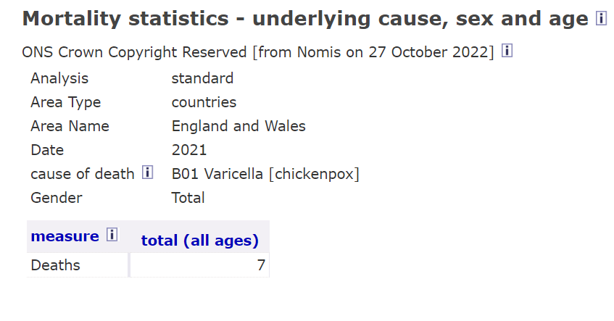

Morbidity is a term used to describe the incidence of suffering from a particular illness or health issue and can be given as a percentage to highlight the rate of morbidity (Naidoo and Wills, 2016). Unfortunately, data for morbidity rates for chickenpox are unavailable as G. P’s are not dutybound to report this data to officials although other infectious diseases such as COVID-19 and influenza are reported to officials (UKHSA.2022). These rates and figures are collected weekly and build a vivid picture of the spread and severity of disease allowing health authorities to deal with outbreaks effectively.
Monitoring of incidence of Chicken Pox
Monitoring the incidence of disease is a duty undertaken by the U.K Health Security Agency (UKHSA) formerly known as part of Public Health England (PHE) to know the extent of disease. These surveillance systems ease the burden of disease. When a health worker suspects a notifiable infectious disease, they are legally required to report this to the local council or local health protection team (HPT) within twenty four hours. They must then pass this information to UKHSA within three days. The UKHSA lists the names of all notifiable diseases on its website. These are diseases which the government considers a threat to public health. Chickenpox is not listed as the UKHSA does not consider it a threat. Subsequently, surveillance data is unavailable. In contrast to this, chickenpox is considered a notifiable, highly contagious disease by the Council of State and Territorial Epidemiologists (CSTE) in the U.S (CDC, 2021). Therefore, suspected and confirmed cases are reported to the National Notifiable Disease Surveillance System building a greater insight into the morbidity rate of chickenpox allowing the government to deal swiftly with the problem. This would be a great example for the U.K to follow whereby the chain of chickenpox infection could be broken swiftly.
Control the incidence of Chickenpox.
The ways to control the incidence of disease is to recognise the way it is spreads; this is called the chain of infection. Identifying and controlling any parts of this would help eradicate disease.
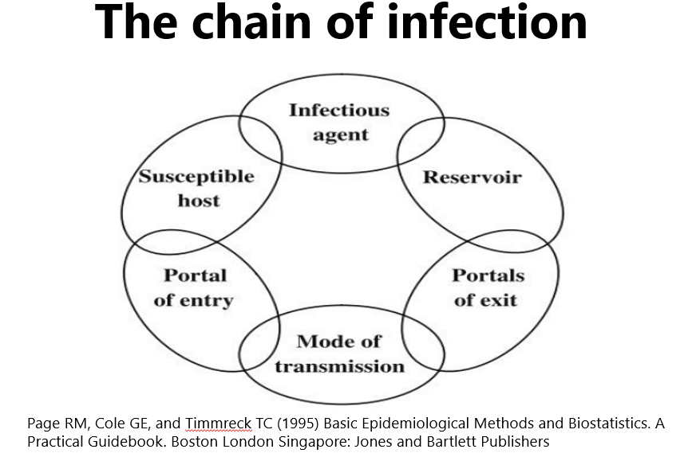

Vaccinations are the governments best way to control and eradicate disease (NHS,2019) and provide immunity to the disease. Vaccines are offered routinely to the public and have helped eradicate harmful diseases like polio (NHS, 2019) and also lower the number of deaths associated with disease. The vaccine for chickenpox is only available to people who are at high risk of developing complications such as secondary infections and those with weakened immune systems or if there is close contact with a person who is immunosuppressed. For example, a child will be vaccinated if their parent has a weakened immune system (NHS, 2021). As the vaccine is only offered to select people, it still remains widespread in communities and is not controlled well. In comparison, the U.S has been offering vaccines for preventing and controlling chickenpox since 1996 and has seen cases drop by 90% (McKie, 2021). This proves how effective the immunisation programme is. Perhaps a similar programme adopted by the U.K would better control the spread of the Varicella zoster virus.
Another strategy to deal with outbreaks of chickenpox in the U.K is the recommendation to stay at home thus limiting/preventing contact with others (NHS, 2021). This strategy recognises that chickenpox is spread by touch and proximity (NHS,2012). The biggest flaw is this means a person with chickenpox can remain undetected and pass on the virus. In America, the Centre for Disease Control (CDC) has an excellent surveillance system which quickly deals with chickenpox outbreaks and offers vaccinations (CDC,2021).Therefore, the only feasible way to fully prevent and control chickenpox is by offering the vaccine to the public in the U.K along with the status of chickenpox disease changing to a notifiable disease thus allowing for enhanced surveillance and detection of the disease.
Conclusion
The U.K government policies and strategies pay a key role in preventing, managing and controlling disease. It has a great surveillance system, the UKHSA, which collects weekly data on notifiable disease and outbreaks, and monitors disease (GOV.UK, 2021). Due to chickenpox not being classed as a notifiable disease, perhaps because mortality rates are not high, it still remains prevalent in the U.K. Changing the status of chickenpox to a notifiable disease would enhance data surveillance and greatly reduce the spread of infection. The U.K government should consider the complications associated with chickenpox, e.g., Shingles, and recognise the need to implement a vaccination programme thus providing immunity to the disease.

Reference List
CDC, (2021) Varicella reporting and surveillance, Available at : https://www.cdc.gov/chickenpox/health-departments/conducting-surveillance.html (Accessed:24.10.2022)
McKie,R. (2021) ‘The chickenpox party is over as scientists call for UK vaccine rollout’, The Guardian, available at: https://www.theguardian.com/society/2021/may/02/the-chickenpox-party-is-over-as-scientists-call-for-uk-vaccine-rollout [ Accessed: 27.10.2022]
Naidoo, J. and Wills, J. (2016) Foundations for health promotion. Fourth edition. Place of publication not identified: Elsevier.
NHS (2021) Chickenpox, Available at: https://www.nhs.uk/conditions/chickenpox/?src=conditionswidget (Accessed: 22.10.2022)
NHS (2019) Chickenpox vaccine overview, Available at: https://www.nhs.uk/conditions/vaccinations/chickenpox-vaccine/ (Accessed:23.10.2022)
Noordzij M, Dekker FW, Zoccali C, Jager KJ. Measures of disease frequency: prevalence and incidence. Nephron Clin Pract. 2010;115(1):c17-20. Available at: https://pubmed.ncbi.nlm.nih.gov/20173345/ (Accessed: 23.10.2022)
Office of National Statistics,(2022) Available at: https://www.nomisweb.co.uk/query/asv2htm (Accessed: 24.10.2022)
U.K Health Security Agency, (2014) Chickenpox: public health management and guidance, Available at: https://www.gov.uk/government/collections/chickenpox-public-health-management-and-guidance (Accessed: 25.10.2022)
U.K Health Security Agency (2010), Notifiable diseases and causative organisms: how to report, Available at: https://www.gov.uk/guidance/notifiable-diseases-and-causative-organisms-how-to-report, (Accessed:25.10.2022)
UKHSA, (2022), Influenza Surveillance graphs, Available at: https://assets.publishing.service.gov.uk/government/uploads/system/uploads/attachment_data/file/1088930/Weekly_COVID-19_and_Influenza_Surveillance_Graphs_w27.pdf (Accessed 27.10.2022)

