

Student name and code: Millie Tamareviciute
Module name and code: Digital Skills for Personal Growth (BMSW4008)
Module Lead: Philippa Fitzgerald
Subject: 1,000-word Analysis report
Due date: Monday 16th March 2026

Contents
- Introduction……………………1
- Methodology………………………….2
- Analysis of Key Survey Findings……………..3
  - Shopping Frequency…………….3
  - Factors Influencing Entry into a clothing store……………4
  - Budget When Shopping for clothes………5
  - Customer Comfort with Staff Measuring services……………….6
- Audience Segmentation…………………7
- SEO Strategy for the Website…………8
- Impact on Website and Marketing Materials………….9
- Conclusion……………….10
- Reference list……………….11

AI Statement: I confirm that I have not presented any AI generated text as my own work. I confirm I have copies of my drafts, notes, and other resources I used before, and after the use of AI tools which I may be asked to.

Market Research Analysis Report – Ascend Shop
- Introduction
Market research is an important process when developing a business because it helps identify customer needs, preferences, and behaviours. Businesses use market to understand their target audience and make informed decisions about products, pricing and marketing strategies. Understanding consumer behaviour helps businesses design products and services that better meet customer expectations (Kotler and Keller, 2016).
For this project, a questionnaire was created using Microsoft Forms to collect primary research about customer shopping habits and preferences when purchasing clothing. The questionnaire received twelve responses and included questions about shopping frequency, clothing budgets, and factors that influence customers to enter clothing stores.
The results of the questionnaire helped guide the development of the Ascend Shop website and the marketing strategy for the business. The findings were also used to help design promotional materials and understand the target audience. This report analyses the questionnaire results and explains how the data influenced business decisions.
- Methodology
The research was conducted using an online questionnaire distributed through Microsoft Forms. Surveys are commonly used in marketing research because they allow businesses to collect information directly from potential customers (Malhotra, 2019).
The questionnaire consisted of multiple-choice questions and one open- ended question. The questions were designed to gather information about customer shopping behaviour, spending habits and preferences when buying clothing. The responses were automatically analysed by Microsoft Forms and displayed using charts and graphs.
Primary research like this is useful because it provides real opinions from potential customers rather than relying only on existing information from other sources.
- Analysis of Questionnaire results
  - Shopping Frequency
One of the first questions asked respondents is how often they shop for clothes. The results showed that 58% of respondents shop monthly, 33% shop weekly, and 8% shop seasonally.
Appendix 1: 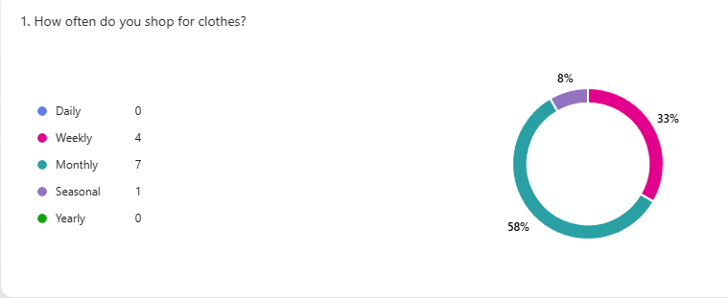
These results suggest that most customers buy clothes regularly but not extremely frequently. Monthly shopping appears to be the most common behaviour among respondents. This information is important for planning marketing campaigns and product releases.
Retail businesses often introduce new collections regularly to encourage repeat purchases and keep customers interested. Understanding customer shopping behaviour helps businesses plan stock levels and promotional campaigns more effectively (Armstrong and Kotler, 2020).

  - Factors That Influence Customers to Enter a clothing store
Another important question asked respondents what factors influence their decision to enter a clothing store. The results showed that quality of merchandise was the most important factor, followed by window displays.
Appendix 2: 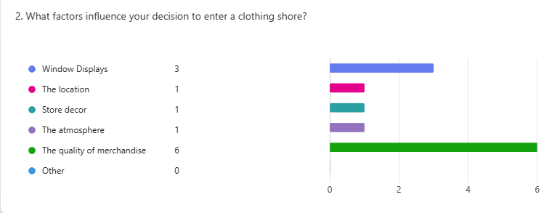

This shows that customers care strongly about the quality of the clothing beong sold. If customers believe that the products are high quality, they are more than likely to enter the store and browse the items available.
Visual presentation also plays an important role in attracting customers. Eye catching displays can attract attention and encourage people to explore the store. Retail research shows that visual merchandising can significantly influence customer behaviour and increase store traffic (Levy and Weitz, 2012).
Because of this finding, the Ascend Shop website was designed with clear product images and simple navigation so that customers can easily view clothing items and understand their quality.
  - Budget when shopping for clothes
Another question in the questionnaire asked participants how much they typically spend when shopping for clothing. The results showed that 33% of respondents spend between £50 and £100, while 25% spend under £50, 17% spend between £100 and £200, and 25% selected unlimited spending. These results suggest that most customers prefer to spend a moderate amount of money when purchasing clothing rather than buying very expensive items.
Appendix 3: 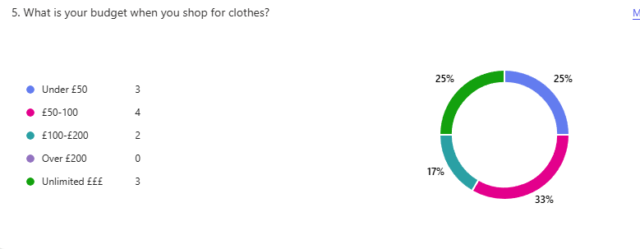
Understanding customer budgets is important for businesses because pricing plays a major role in purchasing decisions. Customers often compare the price of clothing with perceived quality and value of the product before deciding to make a purchase (Kolter and Keller, 2016). If clothing is priced too high, customers may choose to purchase similar products from competing brands that offer a better value. The results from the questionnaire helped influence the pricing strategy for the Ascend Shop brand. Since many respondents indicated that they usually spend between £50 and £100, it would be beneficial for the businesses to price products similar range, so they remain affordable for the target audience.
  - Customer comfort with staff Measuring services
The question also asked respondents how comfortable they would feel if a member of staff measured their body size to help them find the correct clothing size. The results showed that 75% of respondents said they would feel very comfortable, while 17% said they would feel somewhat uncomfortable. 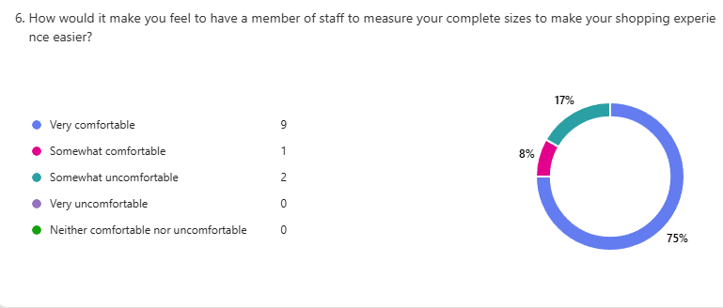
These results suggest that many customers would appreciate assistance when trying to find the correct clothing size. Customer service plays an important role in the overall shopping experience and can influence whether customers return to the business in the future (Chaffey and Ellis-Chadwick, 2019).
- Audience Segmentation
Audience segmentation refers to the process of dividing a market into smaller groups of customers who share similar characteristics such as age, interests or purchasing behaviour (Smith, 1956). Understanding the target audience helps businesses design products and marketing campaigns that appeal directly to their customers.
- SEO Strategy for the Website
Search engine optimisation (SEO) is a digital marketing strategy that helps improve a website’s visibility in search engine results. When a website is optimised for a search engines, it’s more likely to appear higher in search results when users search for related products or services ( Fishkin and Hogenhaven, 2013). For the Ascend Shop website, several SEO techniques can be used to increase online visibility.

- Impact on Website and Marketing Materials
The results of the questionnaire influenced the design of the Ascend Shop website and the marketing materials created for the brand.
Appendix- Ascend Website
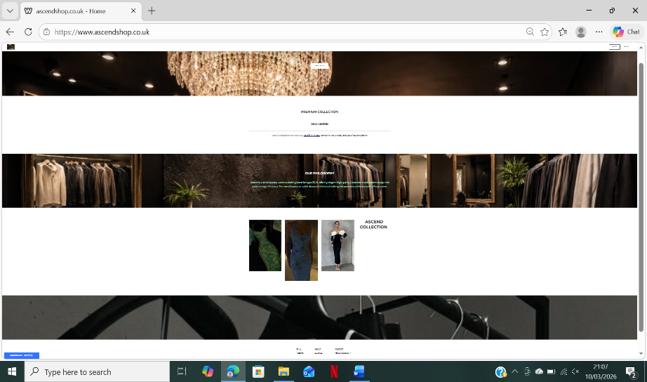

Appendix- Marketing Materials
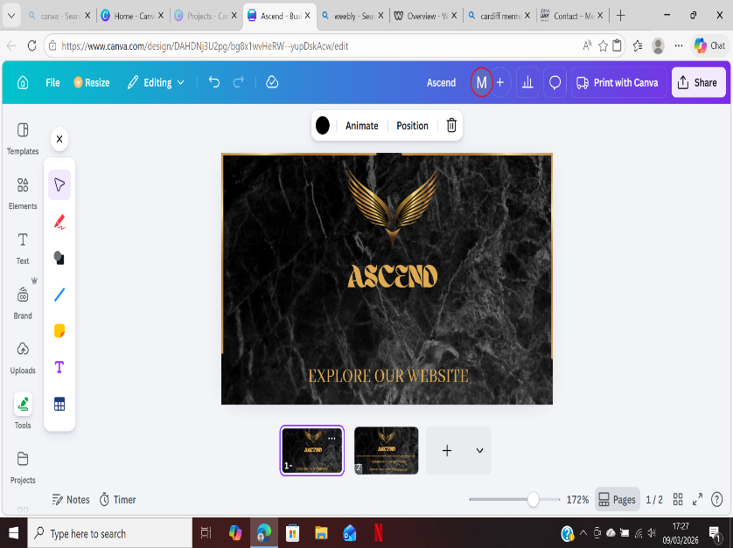
Business card
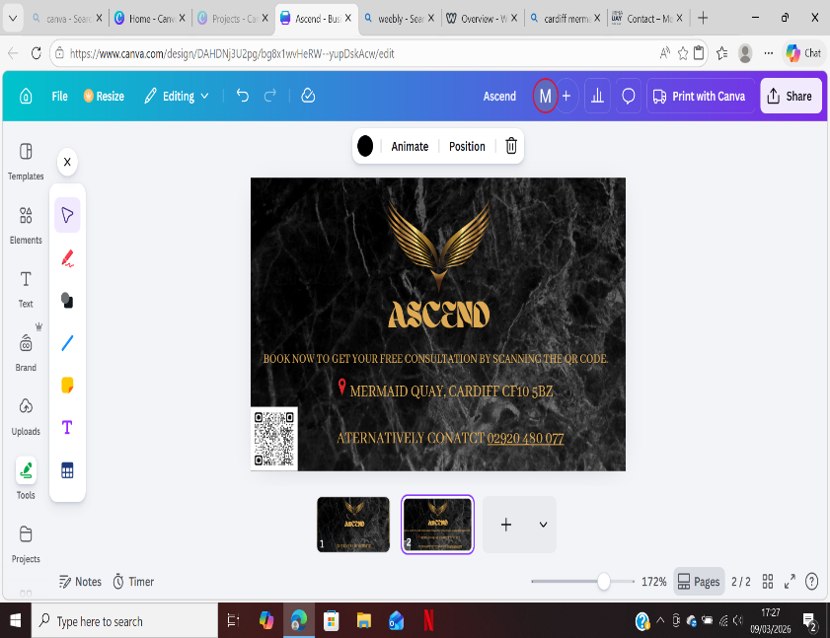
Appendix- Poster
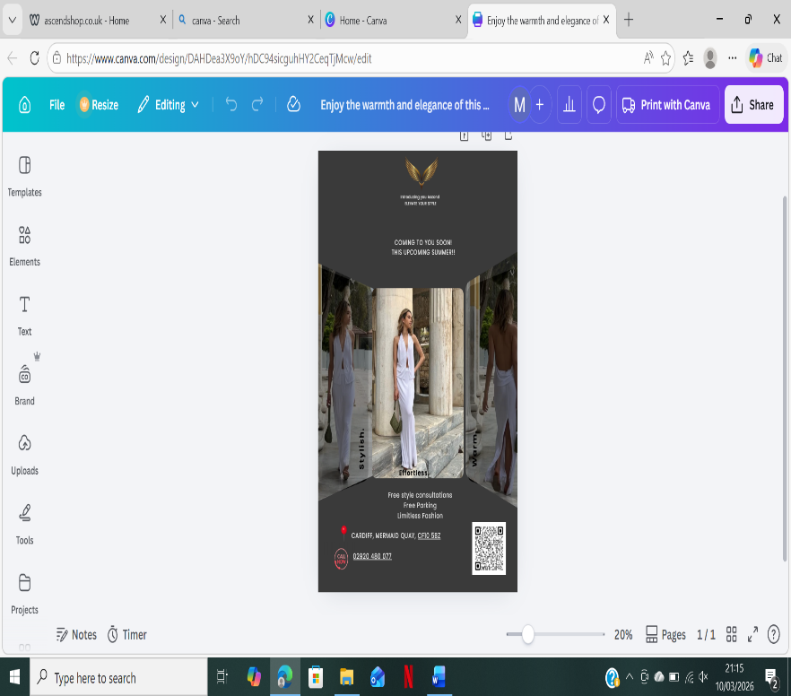
Visual merchandising and presentation play an important role in influencing customer behaviour and encouraging purchases (Levy and Weitz, 2012). High quality images and appealing product displays can attract customers and encourage them to explore the website.
- Conclusion
In conclusion, the questionnaire provided valuable insights into customer shopping behaviour and preferences when purchasing clothing. The research helped identify key factors that influence customer decisions, including product quality, pricing and visual presentation.

- Reference list
- Armstrong, G. and Kotler, P. (2020) Marketing: An Introduction. 14th edn.

- Harlow: Pearson Education Limited.
Chaffey, D. and Ellis-Chadwick, F. (2019)

- Digital Marketing. 7th edn. Harlow: Pearson Education Limited.

- Fishkin, R. and Høgenhaven, T. (2013) Inbound Marketing and SEO: Insights from the Moz Blog. Hoboken, New Jersey: John Wiley & Sons.

- Kotler, P. and Keller, K.L. (2016) Marketing Management. 15th edn. Harlow: Pearson Education Limited.

- Krug, S. (2014) Don’t Make Me Think: A Common Sense Approach to Web Usability. 3rd edn. Berkeley: New Riders.

- Levy, M. and Weitz, B.A. (2012) Retailing Management. 8th edn. New York: McGraw-Hill Education.

- Malhotra, N.K. (2019) Marketing Research: An Applied Orientation. 7th edn. Harlow: Pearson Education Limited.

- Ryan, D. (2016) Understanding Digital Marketing: Marketing Strategies for Engaging the Digital Generation. 4th edn. London: Kogan Page.

- Smith, W.R. (1956) Product differentiation and market segmentation as alternative marketing strategies. Journal of Marketing,
21(1), pp.3–8.

- Ascend Shop (2026) Ascend Shop Official Website. Available at: http://www.ascendshop.co.uk/(Accessed: 9 March 2026).

Student name and code: Millie Tamareviciute
Module name and code: Digital Skills for Personal Growth (BMSW4008)
Module Lead: Philippa Fitzgerald
Subject: Importance of Microsoft excel in the digital era with excel spread sheet
Due date: Monday 16th March 2026

AI STATEMENT: AI STATEMENT: I confirm that I have not presented any AI generated text as my own work. I confirm I have copies of my drafts, notes, and other resources I used before, and after the use of AI tools which I may be asked to

- The importance of Excel in the digital era

In the modern digital era, data has become one of the most valuable resources for organisations. Businesses, universities and government institutions all rely heavily on digital tools to store, analyse and manage information. One of the most used tools for this purpose is Microsoft Excel. Excel is a spreadsheet program that allows users to organise data, perform calculations and create visual representations of information. Because of it’s flexibility and ease of use, Excel has become an essential skill in many workplaces. This essay will discuss the importance of Excel in the digital era, focusing on it’s role in data management, decision-making and workplace productivity.
One of the main reasons Excel is important is because it helps people organise large amounts of data efficiently. In today’s digital world, organisations collect and generate a huge amount of information every day. Excel allows users to structure this information into rows and columns, making it easier to read and manage. Users can also sort and filter data to quickly find specific information. According to Walkenbach (2015), Excel provides a structured environment that helps users manage complex datasets in a simple and organised way. This makes it especially useful in areas such as fiancé, administration and research.
Another important feature of Excel is its ability to perform calculations automatically. Instead of calculating numbers manually, users can apply formulas and functions to complete tasks quickly and accurately. Functions such as SUM, AVERAGE and VLOOKUP allows users to analyse data in a more efficient way. This is particularly useful in business environments where employees need to analyse financial information or track performance data. (Frye 2018) explains that Excel’s built-in formulas reduce human error and help users work with data more efficiently. Another important advantage of Excel is it’s ability to present data visually through charts and graphs. In many organisations, large amounts of numerical data can be difficult to interpret when presented only in tables.
Excel allows users to create a wide range of visual tools such as bar charts, line graphs, pie charts and dashboards that transform complex datasets into clear and meaningful visuals. These visualisations help managers and employees quickly identify trends, patterns and relationships within data. For example, a sales manager can use bar charts to monitor monthly performance and easily compare results across different regions or products. This makes it easier to identify areas that require improvement and to make informed decisions. In addition, Excel’s conditional formatting feature highlights important values automatically, such as the highest or lowest numbers in a database, which further improves data analysis. By turning raw data into visual insights, Excel supports faster understanding and more effective communication of information. As a result, organisations can respond more quickly to changes in the market and improve their overall strategic planning.
Excel is also very useful when it comes to decision making. In the digital era, organisations rely heavily on data to guide their strategies and planning. Excel allows users to convert raw data into charts, graphs and pivot tables, which makes the information easier to understand. For example, a business can use Excel to analyse dales data and then be used to support better business decisions. McFedries (2019) states that visual tools in Excel help organisations interpret data and identify opportunities for improvements.
Excel has also adapted to modern digital work environments by supporting collaboration. With the development of cloud services such as Microsoft 365, multiple users can now work on the same Excel file at the same time. This makes teamwork easier, especially for organisations that use remote or hybrid working models. Employees can share files, update data and review changes in real time. Microsoft (2023) highlights that cloud-based Excel tools have made collaboration faster and more efficient in digital workplaces.
In conclusion, Microsoft Excel plays an important role in the digital era because it helps individuals and organisations manage and analyse data effectively. Its ability to organise information, perform calculations and create visual reports makes it a valuable tool in many industries. Excel also supports better decision-making and improves productivity in the workplace. As data continues to play a major role in modern organisations, having strong Excel skills will remain an important advantage for students and professionals in the future.
In addition, Excel continues to develop with modern technology, including cloud storage and real-time collaboration through Microsoft 365, these features allow users to share data easily and work together from different locations. Therefore, developing strong Excel skills will remain highly valuable for both academic studies and future careers.
- Excel Spreadsheet and chart

- References and AI statement
- Alexander, M. and Kusleika, R., 2016. Excel 2016 Power Programming with VBA. Indianapolis: Wiley.

- Frye, C., 2018. Microsoft Excel 2016 Step by Step. Redmond: Microsoft Press.

- Laudon, K.C. and Laudon, J.P., 2020. Management Information Systems: Managing the Digital Firm. 16th ed. Harlow: Pearson.

- McFedries, P., 2019. Excel Data Analysis for Dummies. Hoboken: Wiley.

- Microsoft, 2023. Microsoft Excel documentation. Available at: Microsoft Learn.

- O’Brien, J.A. and Marakas, G.M., 2017. Introduction to Information Systems. 16th ed. New York: McGraw-Hill.

- Walkenbach, J., 2015. Excel 2016 Bible. Indianapolis: Wiley.

