An inscription found at Polla (forum Popillii) (CIL X 6950 (add p. 1019) =InscrIT-III.1, 272= ILLRP 454 (add p.3300 = ILS 23= AE 2008. 264
[P(ublius) Popilius C(ai) F(ilius) co(n)s(ul) / viam fecei ab Regio ad Capuam et / in ea via ponteis omneis miliarios / tabelariosque poseivei hince sunt / Nouceriam meilia LI Captuam XXCIIII / Muranum LXXIIII Consentiam CXXIII Valentiam CLXXX ad Fretum ad / Statuam CCXXXI Regium CCXXXVII / suma af Capua Regium meilia CCCXXI / et eidem praetor in / Sicilia fugiteivos Italicorum / conquaeisivei redideque / homines DCCCCXVII eidemque / primus fecie ut de agro poplico / aratoribus cederent paastores / forum aedisque poplicas heic fecei.

This essay will attempt to analyse the nature of the text, provided above, in order to critically engage with any linguistic issues which may be present as well as examining the content of the text. This essay will also take into account and discuss the historical and political context of the piece.
This inscription is taken from a milestone, located near the forum Popillii (polla) in Lucania, recording the public services of Publius Popilius Laenas; who performed the role of consul in the year 132 BC. According to this inscription during his life P. Popilius served as a praetor in Sicily as well as a consul in Rome a term of which the testimonies of Cicero and Diodorus attest to him having served, which bares evidence to his senatorial class and career. P. Popilius served time in exile due to a law laid down by C. Sempronius Gracchus. However, he was later vindicated by L. Optimius, a law of the tribune, L. Calpurnius Bestia allowed him to return to Rome. An account of this can be found though the letters of Cicero who claims that “Popilius’ recall to Rome was procured by L. Bestia.” As consul P. Popilius ordered the construction of and completed the via Popillia with a forum popillii and furthered agrarian reform as an optimate response to Ti. Gracchus.
The writings of Diodorus claim that “when Popilius was sent into exile, the people accompanied him with weeping as he left the city” which he attributes to the knowledge that the sentence was unjust and that “by accepting bribes against Popilius they had lost the ability to speak out openly against wickedness.” The character of Popilius is described as a “worthy citizen”and later to Atticus at Rome Cicero writes on the treatment of Popilius.
“our friend Publius is being treated a little contemptuously! In the first place, though he was once the only man at Caesar’s house, he is now not allowed to be one in twenty: In the next place, one legation had been promised and another has been given”
From this extract we can see the prominence which Popilius held over periods of his life, which adds to the compelling nature of the milestone inscription. From the inscription itself we learn a great deal about the geographical structuring of the via Popilia which stretches over 331 miles of the south west coast line of a non-unified Italy. Stillwell argues, that “on the via Popilia from Capua to Regio, on the north pass of the upper valley of the Tanagro at the confluence of the trans-Apennine routes from the interior areas of Campania, Sannio, Apulia, Lucania, and Bruzio;” the forum Popillii is the most important of all the stations. Which is why this long inscription on a milestone was intentionally situated at Polla.
Another important piece of information we can gather from the inscription is that during his time as praetor of Sicily he returned the runaway roman slaves. This is evidence supporting the history of the slave revolt and their flight to Sicily as well as giving an exact number of slaves. Whether or not the numbers are completely accurate does not seem to be in question, it seems to be generally understood that it was a large number. The information provided by this inscription, also adds greatly in way of dating and recording event chronologically with the aid of consular dating. The milestone itself has been date from between approximately 150 - 131 BC. The text on the ilestone is in some way fragmentary however despite its age the face of it remains almost completely intact and still stands freely. In addition, the sheer scale of the roads length allows us to examine the economic state of Italy at the time of its construction. This is due to the fact that not only must the road and all bridges, which are built, be financed and were by merely one individual but the continued upkeep of 331 miles worth of road which would fall to the local communities must also be financed.
This milestone can be dated to the second century BC and includes a number of linguistical archaisms. For the first case, the use of fecei and poseivei. The use of these verbs in a first person perfect indicative active form demonstrates a linguistic tradition of verb formation from the Roman Republic which there is not much evidence for during the Imperial period. Also, the use of double vowels to indicate a long vowel sound, such as with paastores is indicative of phonetic spelling which occurs most commonly within Rome during the Republic period. It is also important to note that the graphology of the inscription, too, alludes to it being from the second century as it is styled with a cursive script.
As the inscription names Popilius as consul whilst listing his previous achievements it is safe to make the assumption that this dedication was made during his consulship in 132 BC. A time in while Rome was, according to Barghusen, recovering from the Sicilian slave revoltGracchus’ land reforms and his subsequent assassination.
“For while Publius Popillius and Publius Rupilius were consuls, slaves, runaway slaves, and barbarians, and enemies, were in possession of that place; but yet the slaves ware not so much slaves to their own masters, as you are to your passions; nor did the runaways flee from their masters as far as you flee from all laws and from all right.”
This section from Cicero’s law speech demonstrates the delicacy of the Republic during this time as he makes an account of the slave revolt as them having taken over Sicily which as can be imagined was problematic for Rome and thus Popilius as consul at the time.
It would appear that this milestone is not merely functional in demonstrating distances between towns or largely inhabited places. This piece seems to also work as propaganda for an individual with a senatorial career as well as publicising his public works. With the context of dating taken into account, it seems that the dedication to Publius Popilius could also be a way of demonstrating stability in leadership which is what the late Roman Republic craved.

(1459)

Appendix:
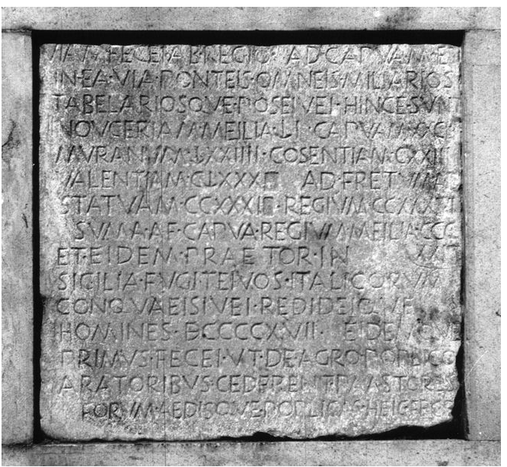

Picture 1
photo of the milestone located at the forum Popillia demonstrating the cursive script and slight fragments of missing letters or words.
http://db.edcs.eu/epigr/bilder.php?bild=$OH_CIL_10_06950.jpg;$CIL_10_06950_1.jpg;$CIL_10_06950_2.jpg;PH0003366;PH0003367;$b.jpg&nr=1
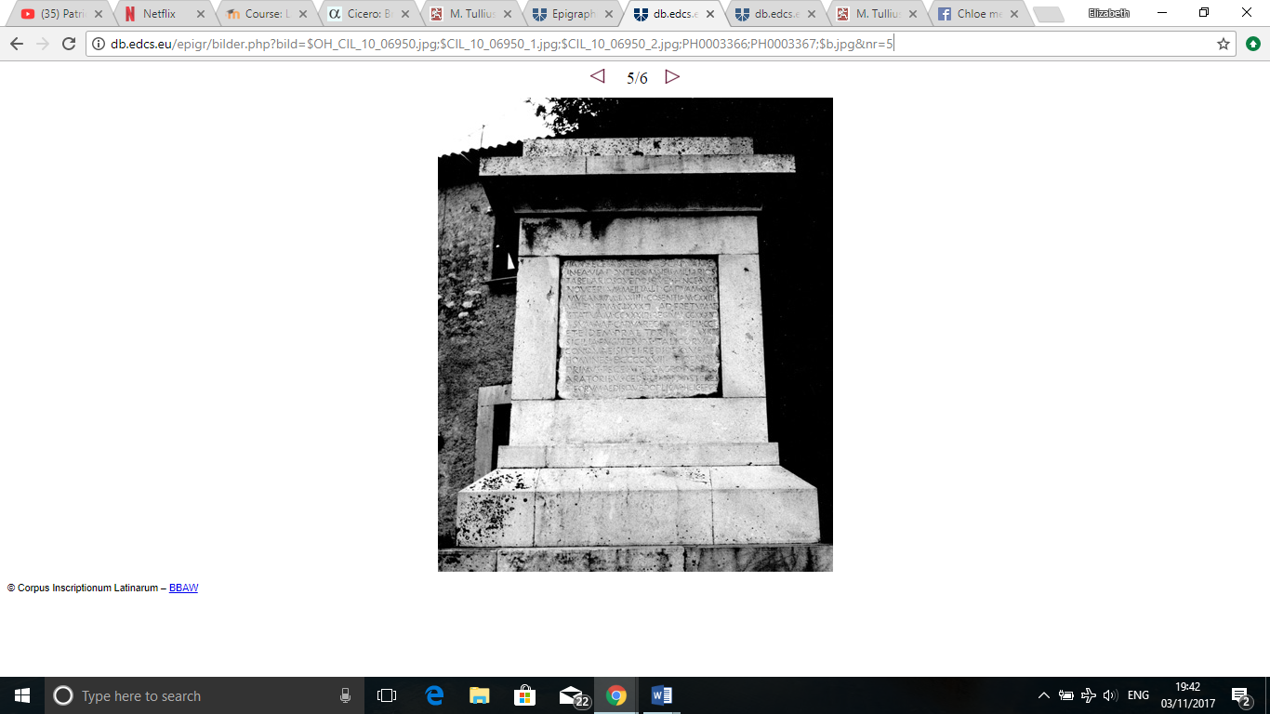

Picture 2
Photo of the milestone from a distance in order to show the size and scale of the monument whilst also showing that it is still free standing.

http://db.edcs.eu/epigr/bilder.php?bild=$OH_CIL_10_06950.jpg;$CIL_10_06950_1.jpg;$CIL_10_06950_2.jpg;PH0003366;PH0003367;$b.jpg&nr=5
Bibliography
Primary sources
Cicero. Brutus. 2016. [trans. A. Smith.] http://www.attalus.org/old/brutus2.html [accessed 19/10/2017].
Cicero. Letters. 2003. [trans. S. A. Pavla.] Aikaterini Laskaridis foundation. https://topostext.org/work.php?work_id=136#45.609 [accessed 23/10/2017].
Cicero. Against Verres. 1903. [trans C. D. Yonge.] London: George Bell & Sons.
Diodorus. Siculus. 2016. [trans. A. Smith.] http://www.attalus.org/translate/diodorus34.html [accessed 19/10/2017].

Secondary sources
Adkins. L, Adkins. R. A (2004). “Handbook to Life in Ancient Rome.” New York: Lesley Adkins and Roy A. Adkins.
Badain. E. (2005). “The Oxford Classical Dictionary.” S. Hornblower, A. Spawforth. (eds.) Oxford: Oxford University Press.
Barghusen. J. D. (1999) “Daily Life in Ancient and Modern Rome.” Minnesota: Runestone Press.
Kelly. G. P. (2006). “A History of Exile in the Roman Republic.” Cambridge: Cambridge University Press.
Manfred. C, Kolb. A, Wolfgang S. A. (2017). “EDCS-21800404.” Epigraphik-Datenbank Clauss. Slaby EDCS. http://db.edcs.eu/epigr/epi_einzel.php?s_sprache=en&p_belegstelle=CIL+01,+00638 [accessed 14/10/2017]. Also, 2 photos of stone inscription taken from same sight. http://db.edcs.eu/epigr/bilder.php?bild=$OH_CIL_10_06950.jpg;$CIL_10_06950_1.jpg;$CIL_10_06950_2.jpg;PH0003366;PH0003367;$b.jpg&nr=1 [accessed 14/10/2017]. http://db.edcs.eu/epigr/bilder.php?bild=$OH_CIL_10_06950.jpg;$CIL_10_06950_1.jpg;$CIL_10_06950_2.jpg;PH0003366;PH0003367;$b.jpg&nr=5 [accessed 14/10/2017].
President and fellows of Harvard College. (2017). “Archaic Latin Inscriptions. Inscriptions proper 4. Inscriptions on and concerning public works.” Loeb Classical Library. Harvard University Press.
Stillwell. R, Macdonald. W, McAlister. L, Holland. M. (1976). “the Princeton encyclopaedia of classical studies.” Princeton: Princeton University Press.

Harvard Fellows. 2017: 151.
Badian. 2005.
Cic. Brut. 128. 3.
Badian. 2005.
Diod. 34. 26. 1.
Diod. 34. 26. 3-4.
Cic. Brut. 95. 1.
Cic. Let. 59. 3.
Stillwell. 1976. [Ref. f. 2. Forum-Popillii].
Manfred. C, Kolb. A, Wolfgang S. A. 2017.
See appendix picture 1.
See appendix picture 2.
Stillwell. 1976.
Barghusen. 1999: 60.
Adkins. L, Adkins. R. A 1999: 4.
Cic. Ver. 2. 4. 112

