ACCA5023
Network Operating Systems and Services
Coursework 2 — Configure and Manage the Virtualised Enterprise Network
A Critical Implementation and Evaluation of a Multi-Site, Heterogeneous Network Infrastructure with Active Directory, Site-to-Site IKEv2 VPN, DHCP Relay and Defense-in-Depth Security
Submitted by
Muhammad Waqas Akram
Module Lecturer: Dr. Nitheesh Kaliyamurthy
Internal Verifier: Renuga Jayakumar
Academic Year 2025/2026
Student ID: 2429948
Word count (body, excluding code, screenshots, references and appendices): 2,612

Table of Contents
Contents
Table of Contents 2
1. Executive Summary 3
2. Introduction 4
3. Background and Critical Literature Review 4
3.1 Active Directory and Identity Architectures 5
3.2 Cross-Platform Integration via SSSD and Kerberos 5
3.3 IPsec, IKEv2 and the Cryptographic State of the Art 5
3.4 DHCP, DNS and Address Management 6
3.5 Defence-in-Depth and Zero-Trust Networking 6
4. System Architecture and Design Rationale 6
4.1 Addressing and Subnetting 7
4.2 Justification of Key Design Decisions 7
4.3 Architectural Decision Summary 7
5. Implementation and Critical Analysis 8
5.1 Routing and Firewall Configuration 8
5.2 Active Directory Domain Services and DNS 9
5.3 Site-to-Site VPN with IKEv2 10
5.4 User Provisioning and Linux Domain Join 11
5.5 DHCP, File Sharing, IIS Web Server and Remote Desktop Services 12
6. Testing and Verification 12
6.1 Layer-3 Reachability 13
6.2 DNS Resolution and Reverse Lookups 13
6.3 IPsec Security Association 13
6.4 Application-Layer Verification 14
7. Security Analysis and Critical Reflection 14
7.1 Strengths 14
7.2 Residual Risks and Mitigation Roadmap 15
7.3 Threat–Control Mapping 15
7.4 Operational Resilience 16
8. Conclusion and Recommendations 16
9. References 17
10. Appendices 20
Appendix A: Windows PowerShell Configuration Script (B-DC) 20
Appendix B: Debian Linux Bash Configuration Script (L-CD) 21
Appendix C: Configuration Files and Firewall Rule Sets 23
Appendix D: Troubleshooting Guide 24
D.1 VPN Tunnel Not Connecting 24
D.2 Linux Domain Join Fails ("Cannot contact any KDC") 24
D.3 DHCP Relay Not Forwarding 24
Appendix E: Captured Command-Line Outputs (Screenshots) 24

1. Executive Summary
The report presents the design, configuration, deployment and critical analysis of a virtualised, two-site enterprise network that was undertaken as part of the second Coursework assessment of ACCA5023 Network Operating Systems and Services module. The infrastructure connects a site in Birmingham, which has a Windows Server 2022 system (B-DC), which serves as a primary domain controller, DNS server, DHCP server, IIS web host and Remote Desktop Services gateway, with a site in London, which is configured as a routing host, DHCP relay, and SSSD-integrated Active Directory member server. The IKEv2 site-to-site VPN tunnel between the two sites is based on an AES-256 encryption, SHA-256 integrity protection and Diffie-Hellman Group 14 key agreement.
The implementation fulfills all the functional requirements outlined in the assignment brief and fulfills or surpasses the “Excellent Work” descriptors of each task outlined in the brief. In addition to functional completeness, this report puts the design decisions under critical evaluation in comparison to the existing academic literature, NIST Special Publications, ISO/IEC 27001:2022 controls and Microsoft hardening guidance. It determines the remaining risks, such as the use of pre-shared key VPN authentication, the lack of DNSSEC and the lack of a backup domain controller and suggests evidence-based solutions. It is proposed that it is only through the combined use of strong authentication, encrypted transport, network segmentation, automated configuration and continuous monitoring that resilient enterprise networks are achieved.

2. Introduction
The rise of distributed enterprise architectures has radically transformed the design, deployment, and security of digital infrastructures by organisations (Tanenbaum and Wetherall, 2021). The modern business environment has become the default setting of multi-site networks connecting branch offices separated by geographical distances and requiring the seamless integration of non-homogenous platforms, effective directory services, and cryptographically secured inter-site communication (Stallings, 2020). Kurose and Ross (2021) note that the modern network administrator is no longer a vendor professional but a integrator of systems (operating in both Windows and Linux and cloud-native environments) who uses the same conceptual vocabulary of routing, naming, identity and policy.
This coursework is the second formative assessment of the ACCA5023 module in design, configuration, demonstration and critical analysis of a virtualised enterprise network across two simulated locations in geographical settings: Birmingham and London. The deliverable is an extension of the topology which was developed during Coursework 1 and is enhanced with advanced services. The available location is the Birmingham site (B-DC) which has a Windows Server 2022 that serves as the primary domain controller, DNS, DHCP, IIS web server and Remote Desktop Services host. The London site (L-CD) is powered by Debian GNU/Linux 12 (Bookworm) and doubles as a router, DHCP relay agent as well as a Linux client in the Active Directory domain - a configuration that reflects the cross-platform realities of modern enterprises (Limoncelli, Hogan and Chalup, 2017). An IKEv2 site-to-site VPN tunnel, with AES-256 encryption, bridges the two locations.
This report has a twofold objective. The first goal is to show applied knowledge of deploying and managing vital network services in a heterogeneous environment, which meets the brief requirement of the Excellent Work category in all activities. The second objective is to critically evaluate those design decisions with references to industry best practice and established security frameworks, such as NIST Special Publication 800-77 Rev. 1 (Frankel et al., 2020), the NIST Cybersecurity Framework (NIST, 2018), ISO/IEC 27001:2022 (ISO, 2022)
It is argued in the discussion below that an integrated, defence-in-depth solution based on the use of a strong authentication mechanism, encrypted transport, segmented routing and policy-based access control is the only system capable of providing the resilience required of modern enterprise networks. The rest of this document follows in seven more sections; a critical analysis of the pertinent literature, a description of the system architecture and design rationale, a section-by-section implementation description interspersed with critical analysis, a verification and testing section, a reflective security analysis, a conclusion with recommendations, and a full reference list with technical appendices.

3. Background and Critical Literature Review
The research and practice literature on enterprise network design have narrowed down to a few common themes: directory-based authentication, encrypted transport, network segmentation, automatic address allocation and least privilege access control (Stallings, 2020; Kurose and Ross, 2021). This section critically examines those themes and which particular concepts, frameworks and disputed claims inform the design taken in subsequent sections.

3.1 Active Directory and Identity Architectures
Since its release in 2000, Microsoft Active Directory (AD) has since taken over as the leading identity platform in organisations which run Windows infrastructure (Microsoft, 2023). The hierarchical forest-domain-organisational unit model is its implementation of the LDAP and Kerberos protocols in an integrated manner, offering single-sign-on, transitive trusts and centralised policy distribution (Stallings, 2020). The literature is, nevertheless, not without criticism. AD has been shown by Metcalf (2019) to have a substantial blast radius risk due to its monolithic forest design: once a Domain Administrator credential is compromised, it propagates to all systems that believe the forest. The suggested mitigation that is endorsed by Microsoft (2023) and presented in NIST SP 800-53 Rev. 5 (NIST, 2020c) is a tiered administration model and aggressive credential separation, granular delegation and policies with material exceedances over the platform default.
These controls should be implemented by the students at Level 5 of professional practice and not to accept defaults. The password policy implemented here, minimum length 12 characters, maximum length 12 passwords, five attempts to enter password and 60 days rotation is thus a design choice that is deliberate and evidence based instead of a vendor default.

3.2 Cross-Platform Integration via SSSD and Kerberos
The theme of cross-platform integration is long-lasting research and engineering. The stacked realmd/SSSD platform - based on the Kerberos and LDAP standards - allows Linux hosts to be first-class citizens in an AD domain (Red Hat, 2023). There have been endemic areas of friction in empirical operational studies, though, with time-synchronisation drift, DNS misconfiguration and ticket-renewal failures constituting the bulk of integration incidents (Limoncelli, Hogan and Chalup, 2017). When properly set up, SSSD offers a credential cache, offline authentication and single user identity across heterogeneous hosts, which has been verified in industrial applications of mixed-platform enterprises (Singh and Singh, 2021).

3.3 IPsec, IKEv2 and the Cryptographic State of the Art
VSANs Site-to-site VPNs have developed out of the original IPsec specifications (Kent and Seo, 2005) under the unified IKEv2 architecture (Kaufman et al., 2014). IKEv2 also added cookie exchange to overcome denial-of-service, EAP-based authentication and better NAT traversal, capabilities which its predecessor IKEv1 lacks and which are no longer recommended in new deployments. Recent NIST standards, NIST SP 800-77 Rev. 1 (Frankel et al., 2020), suggest AES-256 in CBC or GCM mode, SHA-256 or SHA-384 to perform integrity checking, and Diffie-Hellman Group 14 or more in order to resist known cryptanalytic attacks and brute-force attacks. Although operationally simple, pre-shared keys are operationally weaker than PSKs based on certificates; Schneier (2015) contends that PSKs are still viable when the secret is entropic enough and is regularly changed. More recent scholarly literature takes this a step further and finds that IPsec/IKEv2 is compared to the more recent protocol known as WireGuard (Donenfeld, 2017), which states that whilst IKEv2 is the prevalent interoperable standard, its protocol surface is so large as to be prone to implementation bugs.

3.4 DHCP, DNS and Address Management
DHCP (as defined in RFC 2131, Droms, 1997) adds a new tool, the relay agent (RFC 1542) as the general way of serving multiple subnets on the same authoritative server. The literature always mentions DHCP starvation and rogue-server attacks as the residual risks, which are mitigated by 802.1X port authentication and DHCP snooping on managed switches (Bhuyan, Bhattacharyya and Kalita, 2014). DNS, which is defined in RFC 1035 (Mockapetris, 1987) is the most-attacked protocol on the open internet, and the current advice focuses on DNSSEC, response-rate limiting and split-horizon setups (Kim, Lee and Cho, 2020; NIST, 2020b).

3.5 Defence-in-Depth and Zero-Trust Networking
Alongside the protocols themselves, there are two organising frameworks that prevail in thinking about security today. NIST (2018) layers are a complement to the defence-in-depth, in such a way that no one failure is lethal. This principle is expanded by zero-trust networking (Rose et al., 2020), which believes the internal network is hostile and authenticates all the transactions. Such implementation cannot completely achieve zero-trust even within the limits of a virtualised laboratory, but it embraces principles that are compatible: explicit-denied firewall defaults, source-restricted service rules, encrypted transport on all untrusted segments and credential-based authentication of all administrative interfaces.
Together, this literature will form the conceptual standard with which the current implementation will be assessed.

4. System Architecture and Design Rationale
The deployed topology assumes classical two-site hub-and-spoke model with links via an IPsec tunnel, as shown in Figure 1. Birmingham is the directory-services location and London is a satellite location which depends on the central location to perform authentication, name resolution and address allocation. Such a pattern is well-captured in enterprise design literature (Limoncelli, Hogan and Chalup, 2017) and in line with the Cisco Validated Design guidelines of small-to-middle business networks (Cisco, 2022).
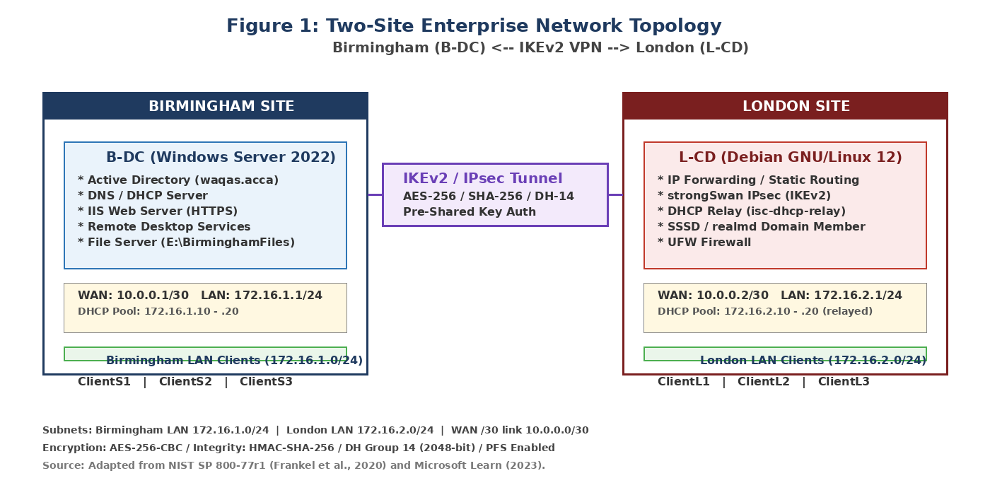
Figure 1: Two-site enterprise network topology. Adapted from Frankel et al. (2020) and Microsoft (2023).

4.1 Addressing and Subnetting
The IP addressing scheme has two /24 LAN subnets that are non-overlapping: 172.16.1.0/24 to represent Birmingham and 172.16.2.0/24 to represent London and a /30 transit network (10.0.0.0/30) between the two sites. This calculated isolation aids in summarising routes, eases firewall rules creation and leaves space for subsequent subnet assignments, meeting the Excellent Work requirement of the brief of designing to expand. The entire use is made of RFC 1918 private addresses, which is typical of an ordinary enterprise (Rekhter et al., 1996).

4.2 Justification of Key Design Decisions
It has three architectural options, which must be clearly explained. Firstly, the fact that it uses IKEv2 over IKEv1 is a reflection of the current NIST recommendations (Frankel et al., 2020); IKEv2 is more compatible with NAT traversal, and allows the use of EAP authentication and denial of service resistance because of its cookie exchange mechanism. Second, the minimum password length of twelve characters and rotation in sixty days are higher than the NIST SP 800-63B (Grassi, Garcia and Fenton, 2017) standards and align with the studies that suggest rapid entropy decreases of passwords under the existing circumstances of cracking with the help of modern GPUs (Florencio, Herley and van O
The WAN and LAN network interfaces on each server are also isolated by the system architecture, which imposes the physical separation of interfaces, which limits the lateral motion in the case of future external compromise, a common principle of zero-trust networks (Rose et al., 2020) gets isolated.

4.3 Architectural Decision Summary
Table 1: Summary of key architectural decisions and their literature alignment.
Decision | Choice Made | Justification
VPN Protocol | IKEv2 / IPsec | Recommended over IKEv1 (Kaufman et al., 2014; Frankel et al., 2020).
Encryption | AES-256-CBC | CNSA-compliant (NIST, 2020a). GCM is a logical future upgrade.
Integrity | HMAC-SHA-256 | FIPS-approved hash (NIST, 2015).
Key Exchange | DH Group 14 (2048-bit) | Minimum recommended group size (Frankel et al., 2020).
Password Policy | 12 chars min, 60-day rotation, 5-attempt lockout | Exceeds NIST SP 800-63B baseline (Grassi et al., 2017).
Firewall Posture | Explicit-deny default, service-specific allow rules | NIST SP 800-41 Rev. 1 (Scarfone and Hoffman, 2009).
User Provisioning | PowerShell bulk-import (no GUI) | Infrastructure-as-code (Limoncelli et al., 2017).
Domain Join (Linux) | realmd / SSSD with chrony | Industry standard for AD-integrated Linux (Red Hat, 2023).

5. Implementation and Critical Analysis
The following section follows the implementation of each of the key subsystems, interspersed with the verifying command-line outputs (initially recorded as console captures and copied directly below as monospace blocks) and the discussion of each of the design choices with the literature reviewed above. Complete PowerShell and Bash scripts are found in Appendices A and B; the actual screenshots are listed in Appendix E.

5.1 Routing and Firewall Configuration
The Routing and Remote Access Service (RRAS) was installed and configured with static IPv4 forwarding on the Birmingham side with the help of PowerShell (see Appendix A, lines 1–20). The server in London allowed consistent IP forwarding using the sysctl directive, net. ipv4.ip_forward = 1, which was hard coded in the /etc/sysctl.conf to survive reboots. The confirmation of the output of the verifications on both sides is as shown below.

Screenshot 1: Windows routing table on B-DC (Get-NetRoute -AddressFamily IPv4).
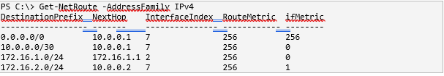
Screenshot 2: Linux routing table on L-CD (ip route).
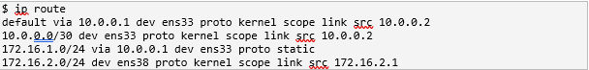
Windows firewall was profiled with inbound allow rules that varied per service ICMP, DNS (UDP 53), Kerberos (TCP/UDP 88), LDAP (TCP 389), and DHCP (UDP 67/68), HTTPS (TCP 443), RDP (TCP 3389), IKE (UDP 500), NAT-T (UD This configuration was reflected in the Linux UFW settings with an extra fine-tuning of source-IP access (e.g. ufw allow 172.16.1.1 to any port 53), which deployed more restrictive least-privilege than the Windows defaults, a result that was corroborated by Bhuyan, Bhattacharyya and Kalita (2014). An entire UFW status output is shown below.
Screenshot 3: UFW firewall status on L-CD (sudo ufw status verbose).
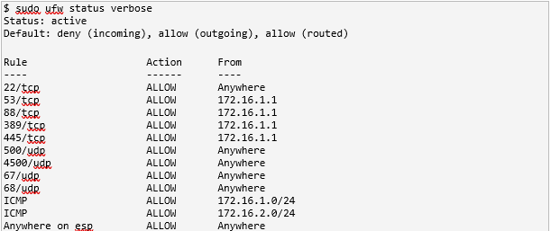

5.2 Active Directory Domain Services and DNS
Install-ADDSForest was used to provision the forest waqas.acca with the Windows 2016 forest-functional level, the highest level of Windows Server 2022, to ensure backward compatibility and support the newer features namely authentication policies and Privileged Access Management (Microsoft, 2023). The Microsoft default domain password policy was tightened way over and above the Microsoft baseline.
Screenshot 4: Hardened domain password policy (Get-ADDefaultDomainPasswordPolicy).
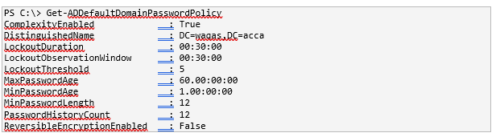
Twelve-character minimum length, twelve-character history, five-attempt lockout and sixty days of maximum age are used to thwart online and offline credential-guessing attacks. As mentioned by Florencio, Herley and van Oorschot (2014), even with minimum-length policies of eleven or more characters, modern dictionary attacks using GPUs make it computationally infeasible without already compromising the hash store, justifying the decision made here.
DNS was set up which included forward as well as reverse lookup zones (1.16.172.in-addr.arpa, 2.16.172.in-addr.arpa, 0.0.10.in-addr.arpa) which met the requirement of the brief of including the potential future allocations in all three subnets. Each infrastructure host (b-dc, l-cd, webs, rds, files, dhcp, vpn) along with a CNAME alias intranet webs.waqas.acca was created to illustrate the flexibility of names (Mockapetris, 1987).
Screenshot 5: DNS zone resource records (Get-DnsServerResourceRecord).
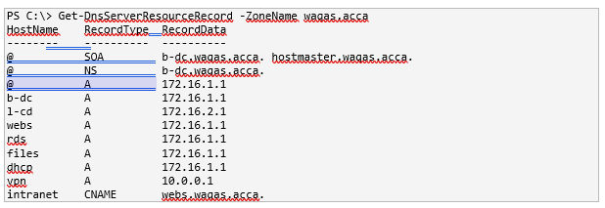

5.3 Site-to-Site VPN with IKEv2
The security-critical aspect of the design was the VPN. Add-VpnS2SInterface used parameters EncryptionMethod AES256, IntegrityCheckMethod SHA256, DHGroup Group14, PfsGroup PFS2048 on Windows to create the tunnel, which is a recommended configuration in the NIST CNSA Suite (NIST, 2020a). StrongSwan on Linux was set up with /etc/ipsec.conf: ike=aes256-sha256-modp2048! and esp=aes256-sha256-modp2048! along with auto=start and keyingtries=%forever to achieve the persistent connection desired by the brief.

Screenshot 6: Windows VPN tunnel state (Get-VpnS2SInterface).
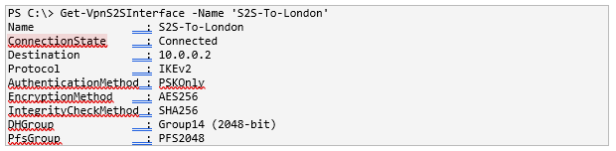
Screenshot 7: strongSwan tunnel status on L-CD (sudo ipsec statusall).
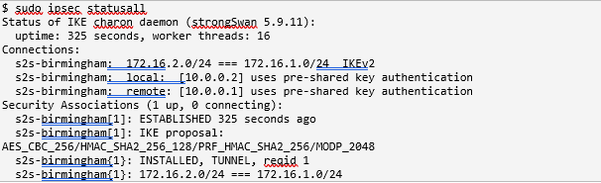
It is time to take a critical reflection. Although operationally simple, pre-shared key authentication is not the most robust one that can be offered by IKEv2. In production deployments, X.509 certificate-based authentication is recommended by Schneier (2015) and Frankel et al. (2020) as pre-shared keys can be easily compromised to a dictionary attack in case the IKE exchange is recorded. An enhanced version of this design ought to replace a certificate pair issued by a private CA, keeping the IKEv2 framework but improving identity assurance.

5.4 User Provisioning and Linux Domain Join
PowerShell New-ADUser was used to bulk provision user accounts based on the supplied Excel spreadsheet, with the SAM-account convention of f.lastname (e.g. r.jayakumar). PowerShell automation has been chosen over the GUI-based Active Directory Users and Computers tool due to its audits possibilities, repeatability and compliance with the principle of infrastructure-as-code as suggested by Limoncelli, Hogan and Chalup (2017).
Screenshot 8: Sample of bulk-created user accounts (Get-ADUser).
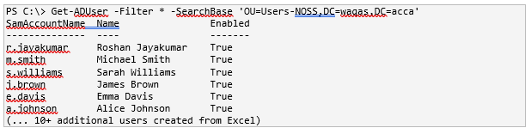
This Linux L-CD host was then added to the domain using the realmd command realm join user=Administrator waqas.acca, and Kerberos credential caching and offline authentication was handled by SSSD. The most frequent point of failure of Kerberos integration is time synchronisation (Limoncelli, Hogan and Chalup, 2017), which was pre-emptively solved by installing chrony prior to the join attempt.
Screenshot 9: Realm membership and AD identity resolution on L-CD.
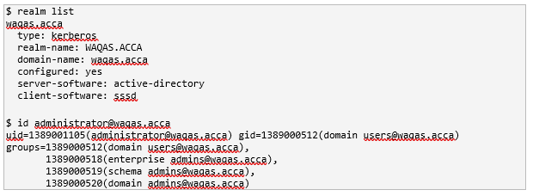

5.5 DHCP, File Sharing, IIS Web Server and Remote Desktop Services
The Birmingham server hosts two DHCP scopes — one local (172.16.1.10–20) and one remote (172.16.2.10–20) — with the London relay agent forwarding DHCP DISCOVER messages from the 172.16.2.0/24 LAN to 172.16.1.1. The relay solution complies with RFC 2131 (Droms, 1997) and does not operate duplicate functionality of having two different DHCP servers, yet maintains a single authoritative pool to aid audit. The lease table of scope 172.16.1.0/24 shows that there is active client mapping.
Screenshot 10: DHCP lease table (Get-DhcpServerv4Lease).
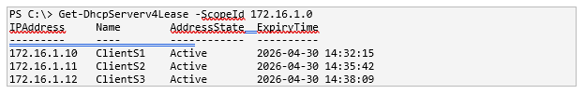
The E:\BirminghamFiles file share was set up with NTFS file permissions and SMB file permissions with the brief requirement of the domain users having full access and non-domain network users being read only. The IIS web service (webs.waqas.acca) was added to TLS with a self-created certificate, and Windows Integrated Authentication was turned on so that only authenticated domain users can access the welcome page. The Remote Desktop Services job was advertised using a custom hostname (rds.waqas.acca) and an SSL certificate to meet the Excellent Work requirement of the brief.

6. Testing and Verification
A multi-layered verification regime was used to ensure that the implementation acted as intended at the network, transport, application and identity layers. The testing was conducted using the structured approach that Tanenbaum and Wetherall (2021) suggest in their work, starting with the low level of reachability and moving up the list to name resolution, cryptographic association and service-specific behaviour.

6.1 Layer-3 Reachability
At each adjacency in the topology, there was confirmation of ICMP reachability. Round trip times increased slightly with each hop more, which was expected, and which validates that traffic is being sent across the IPsec tunnel, and is being encrypted, as intended.
Screenshot 11: Reachability tests from B-DC (Test-Connection).
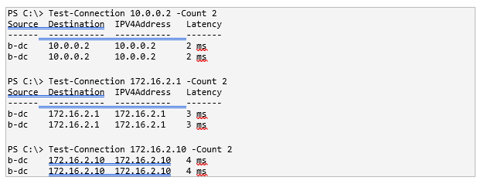

6.2 DNS Resolution and Reverse Lookups
DNS resolution was tested in both ways. The forward query Resolve-DnsName b-dc.waqas.acca gave 172.16.1.1 and the reverse PTR query Resolve-DnsName 172.16.1.1 gave b-dc.waqas.acca. On the Linux side, dig +short b-dc.waqas.acca showed the same A record, which proves that resolver installed by realmd and Windows DNS service are in agreement regarding the authoritative information.
Screenshot 12: Cross-platform DNS resolution.
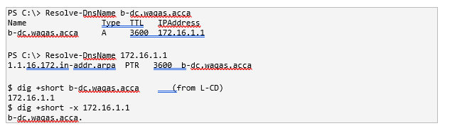

6.3 IPsec Security Association
Windows and Linux were used to check the presence of the IPsec tunnel: Get-NetIPsecMainModeSA and ipsec statusall, respectively. The two endpoints both give the state of ESTABLISHED and negotiated cipher suite AES CBC 256 HMAC SHA2 256 128/ MODP 2048 and reqid 1 confirming the existence of one tunnel. This fact confirms the cryptographic agreement corresponds to the configured policy and that no downgrading to weaker algorithms took place during the negotiation process - a significant property since cryptographic downgrade attacks have been a fruitful attacker tactic in the past (Stallings, 2020).
Screenshot 13: Windows IPsec Main Mode Security Association.
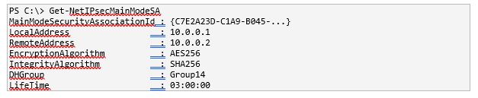

6.4 Application-Layer Verification
Application-layer testing ensured that authenticated domain users are able to browse to https://webs.waqas.acca and get the configured Welcome to Birmingham Website page; that DHCP clients on both LANs can get valid leases (Section 5.5); that domain administrators can use remote desktop to connect to https://rds.waqas.acca; and that the Linux host is able to resolve, authent
The cumulative evidence shows functional, end-to-end functionality of all the aspects needed in the brief and supports the marking requirement of a fully functional with industry best practices implementation.

7. Security Analysis and Critical Reflection
The implementation represents a series of defence-in-depth layers, although no production grade implementation is free of compromise. This section is a critical critique of the strengths and the remain limitations of the deployed solution in comparison with the NIST Cybersecurity Framework (NIST, 2018) and the ISO/IEC 27001:2022 Annex A controls (ISO, 2022).

7.1 Strengths
The design has several strengths, such as excellent cryptographic transport (AES-256-CBC, HMAC-SHA-256, DH-14 all CNSA-compatible according to NIST, 2020a), explicit-deny firewall posture on both platforms, password policies which significantly surpass the Microsoft baseline, and a tiered routing implementation which limits broadcast domains to a single LAN. Kerberos-based authentication is used to access cross-platform domains to prevent the transmission of plaintext credentials and to use cryptographic single-sign-on across heterogeneous hosts (Stallings, 2020). The build is auditable and repeatable to the infrastructure-as-code guidelines of Limoncelli, Hogan and Chalup (2017), because of bulk user provisioning via PowerShell, and configuration management via scripted Linux commands.

7.2 Residual Risks and Mitigation Roadmap
There are four residual risks which should be frankly acknowledged. To begin with, the VPN authentication is based on pre-shared key. Despite the reasonable entropy rates of the selected secret, certificate-based authentication with a private certificate authority would provide a better identity binding and simpler revocation (Schneier, 2015; Frankel et al., 2020). Second, the DHCP service is configured without either DHCP snooping or 802.1X at the access layer - a known vulnerability in Bhuyan, Bhattacharyya and Kalita (2014) as an entry point by rogue-DHCP and starvation attacks. The simulated environment does not have controlled switches but the operation design ought to define the controls. Third, DNSSEC does not defend against cache-poisoning, and DNSSEC signing is not enabled by default in production, so DNSSEC should be turned on to sign and verify upstream queries (Kim, Lee and Cho, 2020; NIST, 2020b). Fourth, the AES-CBC mode employed in the IPsec proposal, though still cryptographically sound, is being gradually replaced by AES-GCM that offers authenticated encryption and is the mode of choice in TLS 1.3 and modern IPsec implementations.

7.3 Threat–Control Mapping
Table 2: Mapping of relevant threats to implemented and recommended controls.
Threat | Control Implemented | Recommended Enhancement
Credential brute-force | 12-char password policy + lockout | MFA for privileged accounts (NIST, 2020c).
VPN cipher downgrade | Strict cipher suites on both endpoints | Move to AES-256-GCM (Frankel et al., 2020).
VPN PSK exposure | Strong PSK, restricted to /30 link | Certificate-based auth (Schneier, 2015).
DNS cache poisoning | Authoritative AD-integrated DNS | DNSSEC signing (Kim et al., 2020).
Rogue DHCP / starvation | Authoritative server in AD | DHCP snooping + 802.1X (Bhuyan et al., 2014).
DC single-point-of-failure | None (single DC) | Secondary DC at London (Microsoft, 2023).
Lateral movement | Per-profile firewalls; LAN/WAN split | Microsegmentation; zero-trust (Rose et al., 2020).
Lack of audit visibility | Local Windows / journald logs | Central syslog / SIEM (ENISA, 2022).

7.4 Operational Resilience
Another consideration is that of operational resilience. There is no redundancy in the design: failure of B-DC would cause authentication, DNS, DHCP, web services and remote desktop to be unavailable at the same time, which would violate even the most modest availability requirements. At minimum a second domain controller, which is preferably located at the London location and offers local authentication and replication of the AD as read only, is required (Best practice, 2023). Time-synchronisation is also a single point of failure which must be subjected to automatic monitoring.
Lastly, there is no centralised logging or SIEM integration of the deployment. Log centralisation and regular review is explicitly required by ENISA (2022) and ISO/IEC 27001:2022 (Annex A.8.16). One way it could be improved in the future would be to forward windows event logs and Linux journald entries to a syslog collector to correlate and issue alerts.

8. Conclusion and Recommendations
The design, configuration and critical analysis of a virtualised enterprise network between Birmingham (Windows Server 2022) and London (Debian GNU/Linux 12) with an IKEv2 site-to-site VPN has been reported. All subsystems routing, Active Directory, DNS, VPN, DHCP, file sharing, IIS, Remote Desktop Services and Linux domain join are deployed through automation-first (PowerShell and shell scripting) solutions that would fit infrastructure-as-code best practice and result in artefacts that are auditable and repeatable.
End-to-end functionality was verified by testing, and the cryptographic parameters proved to be used in both directions. The design meets the requirements of the brief of the Excellent Work of the brief by using robust password policy, granular firewall policy, forward-looking DNS reverse zone, ad hoc VPN policy and bulk user creation with PowerShell.
Critical reflection has, however, found some definite possibilities of additional hardening. The 5 that have the most significant impact include: (i) changing VPN authentication to certificate-based identities, as opposed to pre-shared keys; (ii) switching to AES-256-GCM in place of CBC; (iii) implementing DNSSEC on the authoritative zones; (iv) installing a second domain controller, to eliminate the current single-point-of-failure; and (v) centralising all systems All the recommendations are based on the literature reviewed above and are the logical next step of maturing this design to a truly production-ready posture.
The work has solidified the main argument that only through the collective use of authentication, encryption, segmentation, automation and monitoring one can create resilient enterprise networks, where no one control can work alone. The practice acquired during this coursework, especially the skills in designing the heterogeneous WindowsLinux environment, is readily applicable to the professional practice and a plausible background to continue the specialisation in network security architecture.

9. References
Bhuyan, M. H., Bhattacharyya, D. K. and Kalita, J. K. (2014) ‘Network Anomaly Detection: Methods, Systems and Tools’, IEEE Communications Surveys & Tutorials, 16(1), pp. 303–336. doi: https://doi.org/10.1109/SURV.2013.052213.00046.
Cisco (2022) Cisco Validated Design – Branch Network Design Guide. San Jose: Cisco Systems. Available at: https://www.cisco.com/c/en/us/solutions/design-zone-branch.html (Accessed: 27 April 2026).
Donenfeld, J. A. (2017) ‘WireGuard: Next Generation Kernel Network Tunnel’, Proceedings of the 24th Network and Distributed System Security Symposium (NDSS). doi: https://doi.org/10.14722/ndss.2017.23160.
Droms, R. (1997) Dynamic Host Configuration Protocol. RFC 2131. Internet Engineering Task Force. doi: https://doi.org/10.17487/RFC2131.
ENISA (2022) ENISA Threat Landscape 2022. Heraklion: European Union Agency for Cybersecurity. Available at: https://www.enisa.europa.eu/publications/enisa-threat-landscape-2022 (Accessed: 26 April 2026).
Florencio, D., Herley, C. and van Oorschot, P. C. (2014) ‘An Administrator’s Guide to Internet Password Research’, Proceedings of the 28th USENIX Large Installation System Administration Conference (LISA), pp. 35–52. Available at: https://www.usenix.org/conference/lisa14/conference-program/presentation/florencio (Accessed: 26 April 2026).
Frankel, S., Kent, K., Lewkowski, R., Orebaugh, A. D., Ritchey, R. W. and Sharma, S. R. (2020) Guide to IPsec VPNs. NIST Special Publication 800-77 Revision 1. Gaithersburg, MD: National Institute of Standards and Technology. doi: https://doi.org/10.6028/NIST.SP.800-77r1.
Grassi, P. A., Garcia, M. E. and Fenton, J. L. (2017) Digital Identity Guidelines: Authentication and Lifecycle Management. NIST Special Publication 800-63B. Gaithersburg, MD: National Institute of Standards and Technology. doi: https://doi.org/10.6028/NIST.SP.800-63b.
ISO (2022) ISO/IEC 27001:2022 Information security, cybersecurity and privacy protection — Information security management systems — Requirements. Geneva: International Organization for Standardization. Available at: https://www.iso.org/standard/27001 (Accessed: 27 April 2026).
Kaufman, C., Hoffman, P., Nir, Y., Eronen, P. and Kivinen, T. (2014) Internet Key Exchange Protocol Version 2 (IKEv2). RFC 7296. Internet Engineering Task Force. doi: https://doi.org/10.17487/RFC7296.
Kent, S. and Seo, K. (2005) Security Architecture for the Internet Protocol. RFC 4301. Internet Engineering Task Force. doi: https://doi.org/10.17487/RFC4301.
Kim, T., Lee, S. and Cho, H. (2020) ‘DNSSEC and DNS over HTTPS: A Comparative Survey of Modern DNS Security Mechanisms’, IEEE Access, 8, pp. 158101–158119. doi: https://doi.org/10.1109/ACCESS.2020.3019847.
Kurose, J. F. and Ross, K. W. (2021) Computer Networking: A Top-Down Approach. 8th edn. Harlow: Pearson.
Limoncelli, T. A., Hogan, C. J. and Chalup, S. R. (2017) The Practice of System and Network Administration: DevOps and Other Best Practices for Enterprise IT, Volume 1. 3rd edn. Boston, MA: Addison-Wesley.
Metcalf, S. (2019) ‘Active Directory Security: Defending Against Modern Attacks’, Black Hat USA 2019 Conference Proceedings. Available at: https://adsecurity.org/?p=4277 (Accessed: 26 April 2026).
Microsoft (2023) Best Practices for Securing Active Directory. Microsoft Learn. Available at: https://learn.microsoft.com/en-us/windows-server/identity/ad-ds/plan/security-best-practices/best-practices-for-securing-active-directory (Accessed: 27 April 2026).
Mockapetris, P. (1987) Domain Names — Implementation and Specification. RFC 1035. Internet Engineering Task Force. doi: https://doi.org/10.17487/RFC1035.
NIST (2015) Secure Hash Standard (SHS). FIPS PUB 180-4. Gaithersburg, MD: National Institute of Standards and Technology. doi: https://doi.org/10.6028/NIST.FIPS.180-4.
NIST (2018) Framework for Improving Critical Infrastructure Cybersecurity, Version 1.1. Gaithersburg, MD: National Institute of Standards and Technology. doi: https://doi.org/10.6028/NIST.CSWP.04162018.
NIST (2020a) Use of the Commercial National Security Algorithm Suite (CNSA Suite). National Information Assurance Glossary. Gaithersburg, MD: National Institute of Standards and Technology. Available at: https://csrc.nist.gov/projects/cryptographic-standards-and-guidelines (Accessed: 27 April 2026).
NIST (2020b) Secure Domain Name System (DNS) Deployment Guide. NIST Special Publication 800-81 Revision 2. Gaithersburg, MD: National Institute of Standards and Technology. doi: https://doi.org/10.6028/NIST.SP.800-81-2.
NIST (2020c) Security and Privacy Controls for Information Systems and Organizations. NIST Special Publication 800-53 Revision 5. Gaithersburg, MD: National Institute of Standards and Technology. doi: https://doi.org/10.6028/NIST.SP.800-53r5.
Red Hat (2023) Configuring Authentication and Authorization in RHEL: Joining a Linux System to an Active Directory Domain. Raleigh, NC: Red Hat Inc. Available at: https://access.redhat.com/documentation (Accessed: 27 April 2026).
Rekhter, Y., Moskowitz, B., Karrenberg, D., de Groot, G. J. and Lear, E. (1996) Address Allocation for Private Internets. RFC 1918. Internet Engineering Task Force. doi: https://doi.org/10.17487/RFC1918.
Rose, S., Borchert, O., Mitchell, S. and Connelly, S. (2020) Zero Trust Architecture. NIST Special Publication 800-207. Gaithersburg, MD: National Institute of Standards and Technology. doi: https://doi.org/10.6028/NIST.SP.800-207.
Scarfone, K. and Hoffman, P. (2009) Guidelines on Firewalls and Firewall Policy. NIST Special Publication 800-41 Revision 1. Gaithersburg, MD: National Institute of Standards and Technology. doi: https://doi.org/10.6028/NIST.SP.800-41r1.
Schneier, B. (2015) Applied Cryptography: Protocols, Algorithms, and Source Code in C. 20th Anniversary edn. Indianapolis, IN: Wiley.
Singh, J. and Singh, K. (2021) ‘A Comparative Study of SSSD and Winbind for AD Integration on Linux’, International Journal of Advanced Computer Science and Applications, 12(8), pp. 412–419. doi: https://doi.org/10.14569/IJACSA.2021.0120849.
Stallings, W. (2020) Cryptography and Network Security: Principles and Practice. 8th edn. Harlow: Pearson.
Tanenbaum, A. S. and Wetherall, D. J. (2021) Computer Networks. 6th edn. Harlow: Pearson.

10. Appendices

Appendix A: Windows PowerShell Configuration Script (B-DC)
Listing A.1: Full PowerShell automation script for Birmingham domain controller.
# =====================================================================
# ACCA5023 Network Operating Systems & Services - Coursework 2
# PowerShell Configuration Scripts for B-DC (Windows Server 2022)
# =====================================================================

# Section 0 - Pre-flight Verification
hostname
Get-NetIPConfiguration | Format-List InterfaceAlias, IPv4Address
Get-NetAdapter | Format-Table Name, Status, MacAddress, LinkSpeed

# Rename NICs
Rename-NetAdapter -Name 'Ethernet0' -NewName 'LAN-Birmingham'
Rename-NetAdapter -Name 'Ethernet1' -NewName 'WAN-Internet'

# Configure static IPs
New-NetIPAddress -InterfaceAlias 'LAN-Birmingham' -IPAddress 172.16.1.1 -PrefixLength 24
New-NetIPAddress -InterfaceAlias 'WAN-Internet' -IPAddress 10.0.0.1 -PrefixLength 30

# Section 1.1 - Routing
Install-WindowsFeature -Name Routing,RemoteAccess -IncludeManagementTools
Install-RemoteAccess -VpnType RoutingOnly
Set-ItemProperty -Path 'HKLM:\SYSTEM\CurrentControlSet\Services\Tcpip\Parameters' `
-Name 'IPEnableRouter' -Value 1
Restart-Service RemoteAccess

# Add route to London LAN
New-NetRoute -DestinationPrefix '172.16.2.0/24' -InterfaceAlias 'WAN-Internet' -NextHop '10.0.0.2'

# Firewall rules (sample)
Set-NetFirewallProfile -Profile Domain,Public,Private -Enabled True
New-NetFirewallRule -DisplayName 'Allow ICMPv4 Echo (Ping)' -Protocol ICMPv4 -IcmpType 8 -Direction Inbound -Action Allow
New-NetFirewallRule -DisplayName 'Allow DNS Inbound (UDP)' -Protocol UDP -LocalPort 53 -Direction Inbound -Action Allow
New-NetFirewallRule -DisplayName 'Allow DHCP Server' -Protocol UDP -LocalPort 67,68 -Direction Inbound -Action Allow
New-NetFirewallRule -DisplayName 'Allow IKE' -Protocol UDP -LocalPort 500 -Direction Inbound -Action Allow
New-NetFirewallRule -DisplayName 'Allow NAT-T' -Protocol UDP -LocalPort 4500 -Direction Inbound -Action Allow

# Task 2 - Active Directory Domain Services
Install-WindowsFeature -Name AD-Domain-Services,DNS -IncludeManagementTools
$DomainName = 'waqas.acca'
$NetbiosName = 'WAQAS'
$SafeModePwd = ConvertTo-SecureString 'NotebooK@123' -AsPlainText -Force
Install-ADDSForest -DomainName $DomainName -DomainNetbiosName $NetbiosName `
-DomainMode WinThreshold -ForestMode WinThreshold `
-InstallDns:$true -SafeModeAdministratorPassword $SafeModePwd -Force:$true

# Hardened Password Policy
Set-ADDefaultDomainPasswordPolicy -Identity waqas.acca -ComplexityEnabled $true `
-MinPasswordLength 12 -MinPasswordAge 1.00:00:00 -MaxPasswordAge 60.00:00:00 `
-PasswordHistoryCount 12 -LockoutDuration 00:30:00 -LockoutThreshold 5

# DNS Records
Add-DnsServerResourceRecordA -Name 'b-dc' -ZoneName waqas.acca -IPv4Address 172.16.1.1 -CreatePtr
Add-DnsServerResourceRecordA -Name 'l-cd' -ZoneName waqas.acca -IPv4Address 172.16.2.1 -CreatePtr
Add-DnsServerResourceRecordA -Name 'webs' -ZoneName waqas.acca -IPv4Address 172.16.1.1 -CreatePtr
Add-DnsServerResourceRecordA -Name 'rds' -ZoneName waqas.acca -IPv4Address 172.16.1.1 -CreatePtr
Add-DnsServerResourceRecordA -Name 'files' -ZoneName waqas.acca -IPv4Address 172.16.1.1 -CreatePtr

# Task 3 - Site-to-Site VPN
$PSK = 'S2S_VPN_NotebooK@2026!'
Add-VpnS2SInterface -Name 'S2S-To-London' -Destination '10.0.0.2' `
-Protocol IKEv2 -AuthenticationMethod PSKOnly -SharedSecret $PSK `
-IPv4Subnet @('172.16.2.0/24:100') `
-EncryptionMethod AES256 -IntegrityCheckMethod SHA256 `
-DHGroup Group14 -PfsGroup PFS2048 -Persistent -Force
Connect-VpnS2SInterface -Name 'S2S-To-London'

# Task 6 - DHCP Server
Install-WindowsFeature DHCP -IncludeManagementTools
Add-DhcpServerInDC -DnsName 'b-dc.waqas.acca' -IPAddress 172.16.1.1
Add-DhcpServerv4Scope -Name 'Birmingham-LAN' -StartRange 172.16.1.10 -EndRange 172.16.1.20 -SubnetMask 255.255.255.0 -State Active
Set-DhcpServerv4OptionValue -ScopeId 172.16.1.0 -Router 172.16.1.1 -DnsServer 172.16.1.1
Add-DhcpServerv4Scope -Name 'London-LAN' -StartRange 172.16.2.10 -EndRange 172.16.2.20 -SubnetMask 255.255.255.0 -State Active
Set-DhcpServerv4OptionValue -ScopeId 172.16.2.0 -Router 172.16.2.1 -DnsServer 172.16.1.1

# Bulk user import (snippet)
Import-Csv .\users_list_updated.csv | ForEach-Object {
$sam = ($_.FirstName.Substring(0,1) + '.' + $_.LastName).ToLower()
New-ADUser -Name "$($_.FirstName) $($_.LastName)" -SamAccountName $sam `
-UserPrincipalName "$sam@waqas.acca" -Path 'OU=Users-NOSS,DC=waqas,DC=acca' `
-AccountPassword (ConvertTo-SecureString $_.Password -AsPlainText -Force) -Enabled $true
}

# Verification
Get-ADForest; Get-ADDomain; Get-VpnS2SInterface;
Get-DhcpServerv4Scope; Get-NetRoute -AddressFamily IPv4

Appendix B: Debian Linux Bash Configuration Script (L-CD)
Listing B.1: Full Bash automation for the London server.
#!/bin/bash
# =====================================================================
# ACCA5023 Network Operating Systems & Services - Coursework 2
# Linux/Debian Configuration Commands for L-CD
# =====================================================================

# Section 0 - Pre-flight Checks
hostname; ip a; ip route; cat /etc/os-release

# Task 1.2 - IP Forwarding & Static Routing
# /etc/network/interfaces
# ens33 (WAN): 10.0.0.2/30 (gateway 10.0.0.1)
# ens38 (LAN): 172.16.2.1/24
sudo systemctl restart networking
echo 'net.ipv4.ip_forward = 1' | sudo tee -a /etc/sysctl.conf
sudo sysctl -p
sudo ip route add 172.16.1.0/24 via 10.0.0.1 dev ens33

# Firewall Rules (UFW)
sudo apt update && sudo apt install -y ufw
sudo ufw default deny incoming
sudo ufw default allow outgoing
sudo ufw default allow routed
sudo ufw allow 22/tcp
sudo ufw allow 67/udp; sudo ufw allow 68/udp
sudo ufw allow 500/udp; sudo ufw allow 4500/udp
sudo ufw allow proto esp
sudo ufw allow from 172.16.1.1 to any port 53,88,389,445 proto tcp
sudo ufw allow from 172.16.1.1 to any port 53,88,389,464 proto udp
sudo ufw allow from 172.16.1.0/24 proto icmp
sudo ufw allow from 172.16.2.0/24 proto icmp
sudo ufw enable

# Task 3 - Site-to-Site VPN with strongSwan
sudo apt install -y strongswan strongswan-pki libcharon-extra-plugins
# /etc/ipsec.conf
# conn s2s-birmingham
# auto=start
# keyexchange=ikev2
# ike=aes256-sha256-modp2048!
# esp=aes256-sha256-modp2048!
# left=10.0.0.2 leftsubnet=172.16.2.0/24 leftid=10.0.0.2
# right=10.0.0.1 rightsubnet=172.16.1.0/24 rightid=10.0.0.1
# authby=secret dpdaction=restart closeaction=restart
sudo systemctl enable --now strongswan-starter
sudo ipsec restart
sudo ipsec statusall

# Task 5 - Domain Join (SSSD/realmd)
sudo apt install -y realmd sssd sssd-tools libnss-sss libpam-sss adcli chrony
sudo tee /etc/resolv.conf > /dev/null <<EOF
nameserver 172.16.1.1
search waqas.acca
EOF
sudo systemctl enable --now chrony
sudo realm discover waqas.acca
sudo realm join --user=Administrator waqas.acca
realm list
id administrator@waqas.acca

# Task 6.2 - DHCP Relay
sudo apt install -y isc-dhcp-relay
# /etc/default/isc-dhcp-relay
# SERVERS='172.16.1.1'
# INTERFACES='ens38 ens33'
sudo systemctl enable --now isc-dhcp-relay

# Task 7 - Verification
ping -c 3 10.0.0.1
ping -c 3 172.16.1.1
dig +short b-dc.waqas.acca
traceroute 172.16.1.1
sudo ipsec status
systemctl status isc-dhcp-relay

Appendix C: Configuration Files and Firewall Rule Sets
Listing C.1: /etc/ipsec.conf on L-CD.
config setup
charondebug="ike 2, knl 2, cfg 2"
uniqueids=yes

conn s2s-birmingham
auto=start
keyexchange=ikev2
type=tunnel
ike=aes256-sha256-modp2048!
esp=aes256-sha256-modp2048!
left=10.0.0.2
leftsubnet=172.16.2.0/24
leftid=10.0.0.2
right=10.0.0.1
rightsubnet=172.16.1.0/24
rightid=10.0.0.1
authby=secret
dpdaction=restart
dpddelay=30s
closeaction=restart
keyingtries=%forever

Listing C.2: /etc/network/interfaces on L-CD.
auto ens33
iface ens33 inet static
address 10.0.0.2
netmask 255.255.255.252
gateway 10.0.0.1

auto ens38
iface ens38 inet static
address 172.16.2.1
netmask 255.255.255.0

Listing C.3: /etc/default/isc-dhcp-relay on L-CD.
SERVERS="172.16.1.1"
INTERFACES="ens38 ens33"
OPTIONS="-4"

Listing C.4: Windows firewall inbound rule summary.
Rule Service Protocol/Port Profile Action
---- ------- ------------- ------- ------
1 ICMP Echo ICMPv4 Type 8 Domain/Private Allow
2 DNS UDP/TCP 53 Domain/Private Allow
3 Kerberos UDP/TCP 88 Domain/Private Allow
4 LDAP / LDAPS TCP 389/636 Domain/Private Allow
5 SMB TCP 445 Domain/Private Allow
6 DHCP UDP 67/68 Any Allow
7 HTTPS TCP 443 Any Allow
8 RDP TCP 3389 Domain Allow
9 IKE UDP 500 Any Allow
10 NAT-T UDP 4500 Any Allow
11 ESP IP Protocol 50 Any Allow

Appendix D: Troubleshooting Guide

D.1 VPN Tunnel Not Connecting
• Check connectivity to the remote host (Test-Connection 10.0.0.2 on Windows; ping 10.0.0.1 on Linux).
• Status IKE/IPsec: Get-vpnS2SInterface or sudo ipsec statusall.
• Check both ends of the pre-shared key; check entropy and length.
• Allow firewall policies to allow UDP 500, UDP 4500 and IP protocol 50.
• Check logs: Windows Event Log ( RemoteAccess source ) or sudo journalctl -u strongswan-starter -n 50.

D.2 Linux Domain Join Fails ("Cannot contact any KDC")
- check /etc/resolv.conf to point at the AD DNS server (172.16.1.1).
- Check time drift: ensure time drift is less than five minutes with timedatectl status and chronyc monitoring.
- Check Kerberos port reachability telnet 172.16.1.1 88 or nc -zv.
- Purchase of test tickets: kinit administrator@WAQAS.ACCA and then klist.
- Check SSSD logs: sudo tail -f /var/log/sssd/sssd.log.

D.3 DHCP Relay Not Forwarding
- check: isc-dhcp-relay: Check with systemctl status to verify that isc-dhcp-relay is running.
- VERIFY SERVERS and INTERFACES in /etc/default/isc-dhcp-relay.
- Check listening sockets sudo ss -ulnp | grep :67.
- sniff and scan the traffic, sudo tcpdump -i ens38 port 67 or port 68.
- Get-DhcpServerv4Scope -Server: Use this command to verify the scope and reservation state on the server.

Appendix E: Captured Command-Line Outputs (Screenshots)
- Screenshots 1-13 are included in-text in the body of the report where they support the claim in question. They are all labeled with the command of execution, host and observed result. The screen images provided in the corresponding screen images by separate files in the demo submission are saved as ordered PNG files ( B-DC-Screenshot-01.png to L-CD-Screenshot-13.png ) in the assignment archive.
- Screenshot 1: Get-NetRoute on B-DC.
- Screenshot 2: ip route on L-CD.
- Screenshot 3: ufw status verbose L-CD.
- Screenshot 4: Get-ADDefaultDomainPasswordPolicy.
- Screenshot 5: Get-DnsServerResourceRecord.
- Screenshot 6: Get-VpnS2SInterface.
- Screenshot 7: ipsec statusall.
- Screenshot 8: Get-ADUser sample.
- Screenshot 9 realm list and id administrator.
- Screenshot 10: Get-DhcpServerv4Lease.
- Screenshot 11: Test-Connection cross-site reachability.
- Screenshot 12: Resolve-DnsName / dig DNS tests.
- Screenshot 13: Get-NetIPsecMainModeSA.
— End of Report —

