Name
Student Number

Human Evolution and the Origins of Modern Human Behaviour

Practical exercise 2021

Please indicate your response clearly

Looking at faces 1
Look at the following images and then compare them to the list below. Indicate clearly (circle or highlight) the name of the early hominin skull you believe this to be.
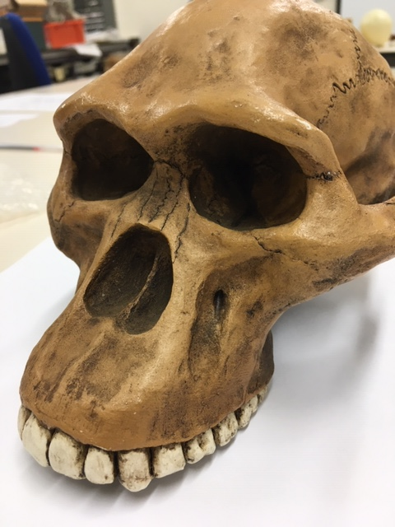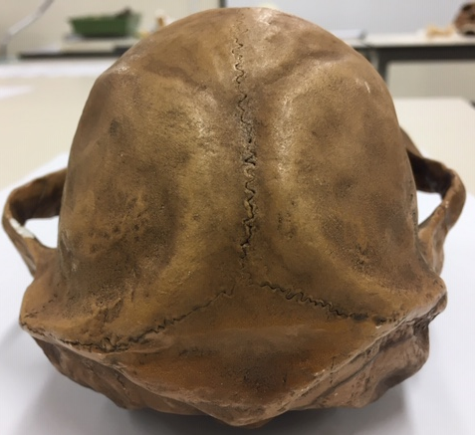

Chimpanzee

Australopithecus afarensis

Australopithecusafricanus

Australopithecus robustus

Homo habilis
Looking at faces 2
Look at the following images and then compare them to the list below. Indicate clearly (circle or highlight) the name of the early hominin skull you believe this to be.
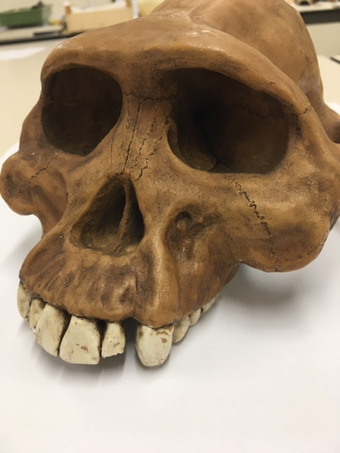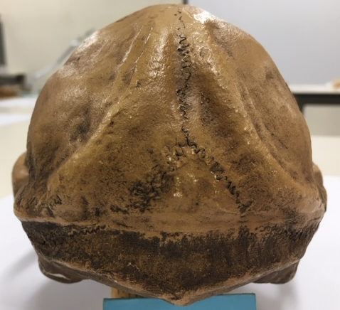

Chimpanzee

Australopithecus afarensis

Australopithecus africanus

Australopithecus robustus

Homo habilis

Looking at faces 3
Look at the following images and then compare them to the list below. Indicate clearly (circle or highlight) the name of the early hominin skull you believe this to be.
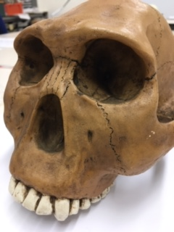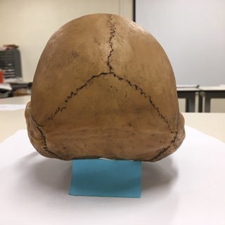

Chimpanzee

Australopithecus afarensis

Australopithecus africanus

Australopithecus robustus

Homo habilis
Maxilla (upper jaw): Identify the species these belong to
A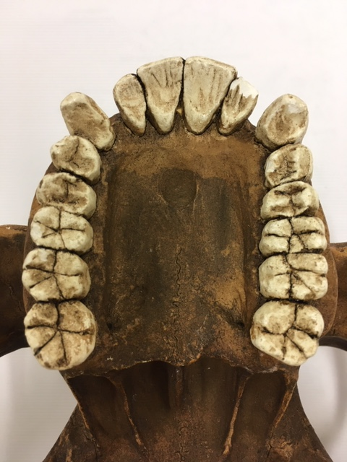B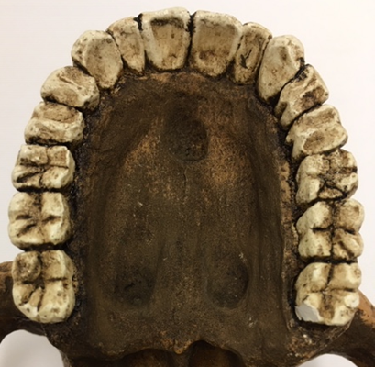
A B
Top row left Chimpanzee, Middle Australopithecus afarensis, Right modern human
Lower row Left Australopithecus africanus, Right Australopithecus robustus
Indentify the skull to genus and species level. This is a well documented juvenile.
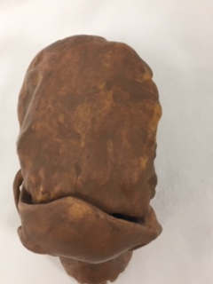
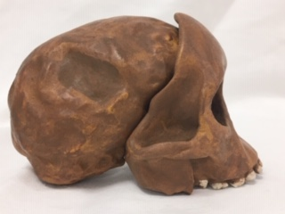
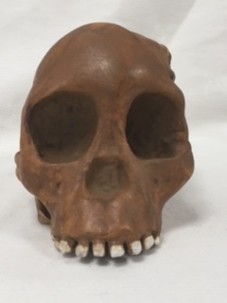
Answer
Indentify this well-kown and documented skull to genus and species level
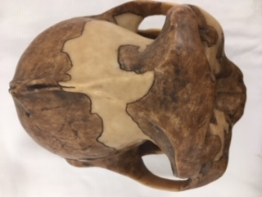
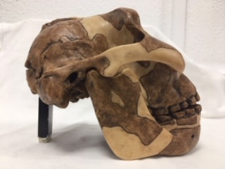
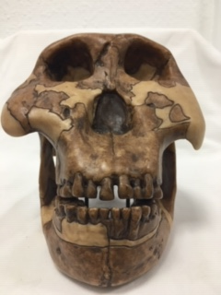
Answer
This is Peking Man, when where and by whom was the skull discovered?
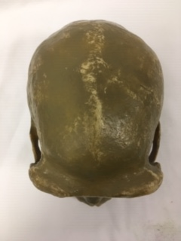

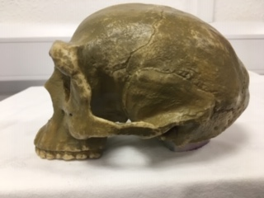

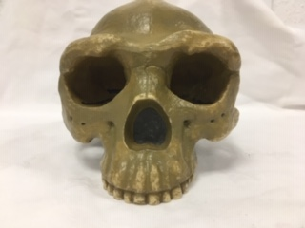
Answer

This is Cro-magnon, but which one? When and where was the skull discovered?
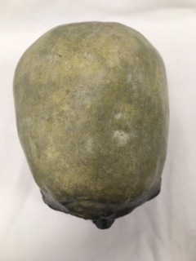
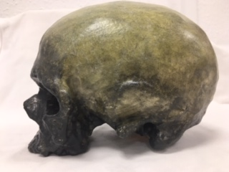
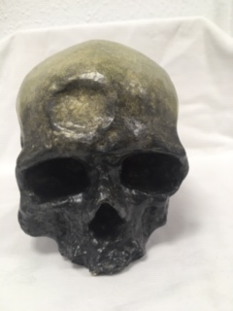
Answer

Compare and contrast these two mandibles. Use the illustration below to help if you need to. In each case state where the type specimen was found and when.
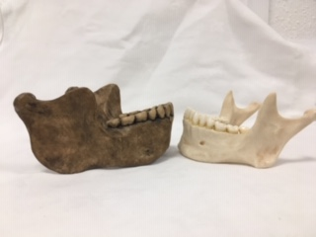
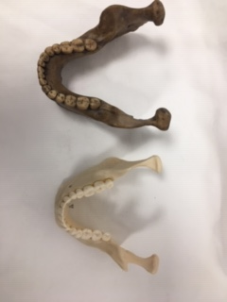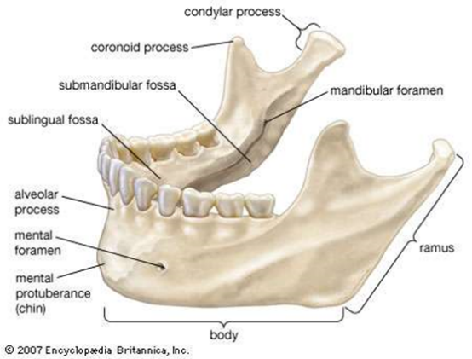
Left: Homo heidelberensis Right: Homo sapiens

Answer

Stone tools and tool technology: How to tell a stone is worked.
What suggests this has been worked?
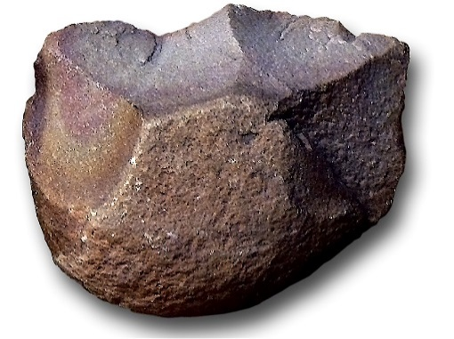
Answer

Features of stone tool flaking: identify features 1-5
1.
2.
3.
4.
5.

Stone tools and tool technology: Stone tools not to scale
Below left: Oldowan Below Right: Acheulean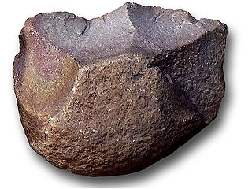 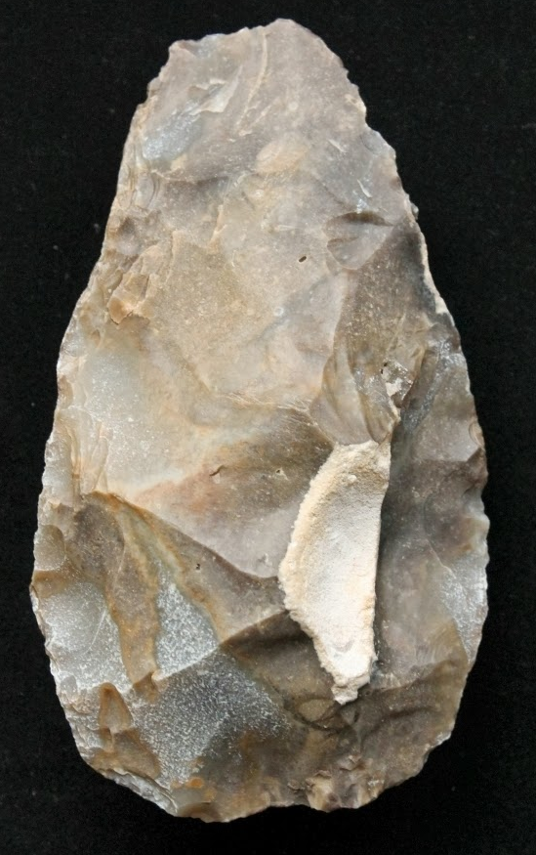
Images taken from https://images.search.yahoo.com

Task: Compare and contrast these two stone tools

