Programme: BA International Hotel Management
Module: Financial Management for the Hotel Industry
Module code: BMIH5007
Assignment 1
Title: Business Report - Comparison of Two Hospitality Organisations

Table of Contents
1 Introduction 2
2 Total revenue 2
3 Market position 3
4 Growth potential 4
5 Financial Commitment to CSR (Corporate Social Responsibility) 5
6 Bowmen strategy 6
7 Conclusion 7
8 Recommendation 7
9 References 9

Introduction
This business report compares Shangri-La Hotel and Travelodge Hotel, focusing on total revenue, growth potential, market positioning, and CSR commitments, utilizing Bowman's strategy. It analyzes their financial performances and strategic approaches. The report concludes with overall findings and provides recommendations for both hotels to enhance business growth and expansion.

Total revenue
In 2023, Shangri La Hotel PCL and Travelodge both experienced notable financial performances, but their trajectories and strategies highlighted stark differences in their operational environments and market responses. Shangri La Hotel PCL recorded a total revenue of 2.186 billion in 2023. This figure marked a recovery from a tumultuous period that spanned from December 2019 to 2023, during which their average annual income was 1.391 billion (Shangri La Hotel 2024). The lowest point came in December 2021 when revenue hit 355.9 million, reflecting the severe impact of the COVID-19 pandemic. This decline began in 2019, with a 6.9% decrease from 2.55 billion, followed by a dramatic 74.0% drop to 663.3 million in 2020. In 2021, revenue further decreased by 46.3% to 355.9 million. However, 2022 saw a substantial rebound with revenues increasing by 237.5% to 1.201 billion (Statista, 2023).
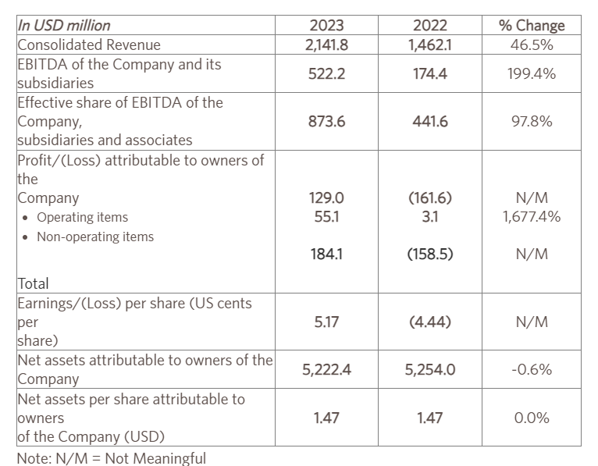
Shangri La’s diverse revenue streams include hotel management services, property development for sale, hotel and investment properties, commercial real estate, office buildings, food and beverage services, and conference and function facilities. The pandemic severely impacted these areas, particularly in the first half of 2021, due to lockdowns, travel restrictions, and reduced travel demand, which collectively caused a significant drop in revenue (Shangri-la Group, 2017). In contrast, Travelodge, a budget hotel chain, achieved remarkable financial growth in 2023, with a revenue increase of 13.7% to approximately £1,035.2 million.
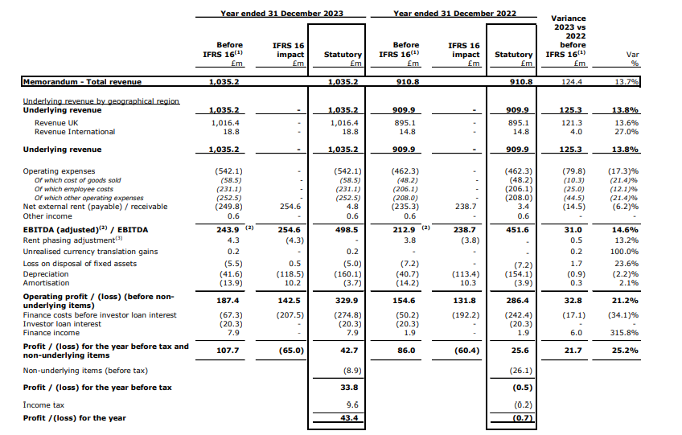
Their adjusted EBITDA also rose by 14.6%, reaching £243.9 million. This year marked a milestone for Travelodge as it was the first time their revenue surpassed the £1 billion mark. The strong performance was attributed to robust customer demand, encompassing both business and leisure travelers, and record-breaking trading days during high-profile events like Eurovision and Wimbledon. Travelodge’s revenue generation stems from its portfolio of 598 hotels and 46,000 rooms across the United Kingdom. Some of the factors that accounted to their revenue boost include the hotel upgrade program, which unveiled the luxe design that falls under the premium budget. The change here was improved bars, cafes and the next generation room concepts that helped drive the revenues up. Further, the promotion of their Better Future plan which had a strong emphasis on sustainability also ensured that their financial performance improved significantly.
Comparing Shangri La Hotel PCL to Travelodge, it is evident that different strategic approaches are applied to cope with the current opportunities and threats. The decline of the net revenue of Shangri La could be attributed to the COVID-19 that impacted most of its numerous sources of income (Davahli et al., 2020). The increase, especially in 2022, indicates that the hotel has the ability to bounce back and grow after the impact of the pandemic. Lines of business that the company specializes in like property development and hospitality services reflect a diverse operational risk exposure which although vulnerable to global volatilities has potential for innovation and growth (Jones and Comfort 2020). Travelodge, on the other hand, expanded its budget hotel brand and the following specific improvements to capture growing demand in 2023. This is due to appropriate capital investment in hotel improvements and better services provided to business as well as leisure travellers. This not only benefited the development of customer satisfaction, but also contributed to the enhancement of the position of Travelodge in the market of low-cost hotels. This highlights their expertise in exploiting the available opportunities in the market since the revenue and the EBITDA increased notably to 2023 (Shangri La Hotel, 2023).
Furthermore, both Shangri La Hotel PCL and Travelodge recorded impressive financial performances in 2023, though the two firms attained the feat in different ways. While Shangri La was able to bounce back from the effects of the pandemic, Travelodge has used upgrade and sustainability concepts for its strategic development. These approaches amplify the various tactics used by hotel chains to respond to risks in the industry and improve revenue generation.

Market position
The market capitalization of Shangri-La Hotel in 2024 $2. and is valued at 71 billion making it the 3667th company in the world in terms of worth. Shangri-La targets affluent customers, offering luxurious accommodations and high-quality services (Shangri-La, 2024). The group operates three brands: Shangri-La Hotels, five-star properties in prime city locations catering to high-income travelers; Shangri-La Resorts, luxurious hotels in exotic destinations aimed at elite families and affluent tourists; and Trader Hotels, four-star accommodations with mid-range prices targeting budget-conscious individuals (Bas and Sivaprasad 2022). Travelodge, in contrast, is a widely recognized budget hotel brand in the UK, known by 91% of the population, with 27% of people having stayed at one of their locations. The chain includes 598 hotels and 46,000 rooms across the UK, Spain, and Ireland. Travelodge's customer base is diverse, with 53.12% male and 46.88% female, predominantly aged 25 to 34. These locations are suitable for business persons and travelers in general who look for affordable, comfortable accommodations (Travelodge, 2023).
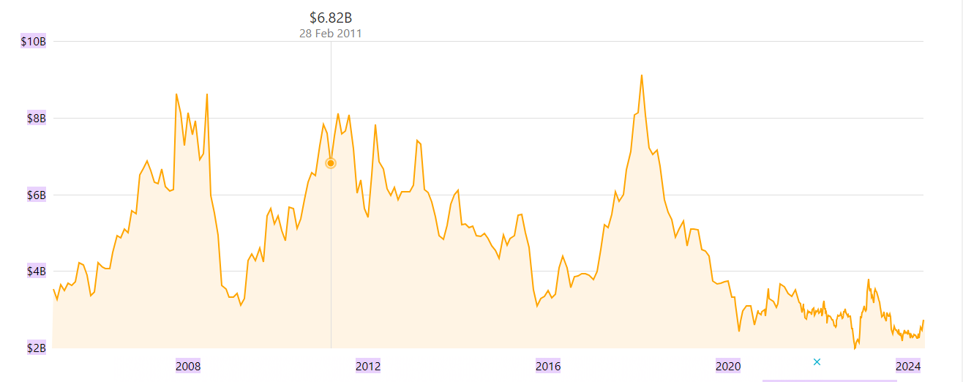
Shangri-La and Travelodge can be used both as examples of opposite strategies in the hotel business. Shangri-La has positioned its self as a luxury hotel chain provider which offers services that meet the needs of high income travelers for their brands. Instead, Travelodge offers the lowest prices, targets a large audience of people of any age who prefer simple and cheap accommodations, and businessmen. The key marketing strategies of Shangri-La are focused on offering the luxurious accommodation services in the best locations and unique and exotic places, while for Travelodge is based on having numerous locations and affordable prices. Both hotels fit in their niche markets; while Shangri-La is positioned to attract the high end clientele, Travelodge targets the business and transient travelers.

Growth potential
When it comes to expansion strategies, Shangri-La Hotels and Resorts and Travelodge Hotels are significantly different: it is all because they operate in different market segments and set different goals for themselves. One of the major strategies by Shangri-La is to expand in high growth markets with a view of increasing its revenue and ensuring that its brands are well recognized in the market. This includes the addition or addition and improvement of hotel and resort accommodations, upgrading of services to capture customer demands and needs, and the purchasing, in a related or synergistic manner, of similar or complementary businesses (Kansakar et al., 2019). It is for this reason that there are various opportunities for the growth of Shangri-La, for one, being the plans to open the company in several countries, thus being able to tap into a population with higher proportions of tourists. The brand positions itself as a customized choice for busy travelers and has ventured into emerging economies, increasing the consumption of luxury hotels. However, this expansion brings challenges, such as empowering local staff in culturally diverse regions like China, where front-line employees traditionally have less decision-making authority. Additionally, Shangri-La faces competitive pressures from other established hotel brands.
Travelodge, a budget hotel chain, also pursues various expansion strategies. They intend to expand their chain in the UK expecting to expand from 598 outlets in 2021 to 1100 outlets by 2025, thus generating 700 employment opportunities. Travelodge continues developing its network by launching 60 new hotels that would be situated in city centers, business districts as well as leisure areas. They invest in their brand for the long-term growth by improving the propositions of the hotel location, the price and the quality (Travelodge, 2024). Travelodge also takes second choice sites which cost about 30-40% less and are less saturated with competitors. But this greatly pegs them on the UK market, which can be a threat to expansion due to the macro factors that influence inflationary costs.
However, Shangri-La’s strategy is inclined more towards luxury and globalization as they focus on the superior segments and acquire compatible organizations. The challenge is how they could address both cultural and competitive forces. In contrast, Travelodge’s strategy is pretty much narrower – it aims at the economy segment exclusively and has a precise vision of development in Great Britain and strengthening its positions in the niche areas. Their weakness, on the other hand, is that they have a large exposure to the UK market and different macro factors. While the target market for Shangri-La is the wealthy guests who are ready to pay for comfort and quality, Travelodge offers guests simple and cheap temporary shelter. Still, these employees, both chains maximize on strengths in the realization of organizational growth; however, they encounter different challenges that would hinder long-term growth.

Financial Commitment to CSR (Corporate Social Responsibility)
Shangri-La Hotels and Resorts and Travelodge Hotels both highlight the importance of CSR and sustainability but do so differently. Shangri-La’s CSR initiative, "Shangri-La Cares," has two main components: They are ‘‘Embrace’’ and ‘‘Sanctuary.’ ‘‘Embrace’’ deals with meeting the healthcare and education needs of vulnerable populations while ‘‘Sanctuary’’ involves environmental conservation of species and their habitats (Su and Zabilski 2022). In 2022, volunteerism efforts by Shangri-La staff reached 26,000 hours helping COVID-19 relief efforts impacting nearly 200,000 people from disadvantaged communities. The Embrace project within Shangri-La Surabaya involved setting up training and fun activities for children and families in rural schools and children in the Bangkok hotel save up to 30% in energy and liquefied petroleum gas through the use of solar heated water facilities.
For instance, Travelodge’s CSR focus is in the area of fundraising and combating carbon dioxide emissions. The ‘Change for Charity’ program initiated in 2010 has approximately 6,000 participants who have contributed a large amount for different charities that include British Heart Foundation, Kids Out, Cancer Research UK, and Macmillan. Another focus of Travelodge is sustainability, with the company’s goal to be net zero carbon by 2040. Total carbon emissions in 2021 were 39,922 tonnes CO2e while carbon emission intensity was 70. 6 tonnes CO2e for every £million of turnover. However, Shangri-La actively participate in direct community support and environmental initiatives for local causes through volunteer work and the promotion of sustainable technologies. Travelodge, meanwhile, engages in widespread fundraising initiatives and pursues broader sustainability targets, particularly in reducing carbon emissions. Both chains demonstrate a strong commitment to CSR, but Shangri-La emphasizes targeted community and environmental programs, while Travelodge combines employee-driven charity work with a focus on sustainability (Guix and Font 2020).

Bowmen strategy
Travelodge is a British chain of low-cost hotels that focuses mainly on the United Kingdom market; the company’s main strategic approach is a “low-price” strategy. Making cost efficiency as its prime competitive strategy, Travelodge provides its guests with basic amenities at reasonable and affordable prices. This strategy helps to capture the cost-sensitive segments and drives the growth of business in the UK market. The demand curve of their products is perfectly elastic; this means that whenever the price of their products is lowered, the people’s demand is sure to rise.
On the other hand, Shangri-La Hotels has adopted a differentiation strategy because Shangri-La Hotel is a luxury brand. The core business strategy of Shangri-La is to provide quality services and special experiences, which consequently ensures the hotel’s guests’ satisfaction. This is because products that are sold under this channel offer premium pricing, to match the superior services as well as exclusivity that accompany such products. The demand curve for Shangri-La is downward sloping but is price inelastic, meaning that Shangri-La’s room prices do not significantly affect demand, as their probable market base mainly comprises high-income and upper-class people who are likely to sacrifice price in order to get quality services. In general, Travelodge is keen on achieving low costs to meet customers’ demands of an inexpensive hotel service. On the other hand, Shangri-La is the brand that positions for luxury and providing superb customer service to clients willing to pay premium price for the brand’s products and services. These strategies are diametrically opposed to show the clear market niches and target customers of these companies.

Conclusion
This report compares two distinct hotels: the luxurious Shangri-La Hotel and the cheap chain Travelodge Hotel. Thus, the total revenue of Shangri-La Hotel in 2023 was $2. 7 billion and for Travelodge it was £1,035. 2 million. Shangri-La’s market capitalization in 2024 is $2. 71 billion. Shangri-La’s strategic directions based on rapid expansion, high market growth drive the increase in sales and the development of brand awareness. On the other hand, Travelodge plans to grow internationally, with the ultimate goal of reaching 1,100 hotels by 2025. CSR in Shangri-La means that the company focuses on responsible economic, environmental, and social management. Travelodge aims at becoming environmentally friendly through cutting down on emission of carbon dioxide. All these strategies are informed by their market standing and growth aspirations.

Recommendation
For Shangri-La Hotel, issues associated with guest experiences are critical success factors when it comes to growth prospects. To increase guest satisfaction and loyalty, Shangri-La should implement preference tracking systems and provide customized welcome gifts to guests in order to successfully compete with the other luxury hotels in the market. Likewise, Travelodge needs to focus on the geographical diversification of its hotel chain outside the United Kingdom in order to reduce the effect of market dependency risks. Travelodge can expand its operations to different locations in other parts of the world, and thus reach out to new customers and potential markets for growth. This expansion strategy is in line with Travelodge’s long-term plan of becoming a worldwide player in the economy hotel sector, thus cementing its place as the first choice for cheap hotels across the globe.

References
Bas, T. and Sivaprasad, S., 2022. An Exploratory Insight into the Impact of COVID-19 on the Travel and Tourism Sector: UK Evidence. Bas, T. & Sivaprasad, S.(2022). An exploratory insight into the impact of COVID-19 on the travel and tourism sector: UK evidence. In S. Karabulut (Ed.), Economic and Financial Analysis of Global and National Developments, pp.355-369.
Davahli, M.R., Karwowski, W., Sonmez, S. and Apostolopoulos, Y., 2020. The hospitality industry in the face of the COVID-19 pandemic: Current topics and research methods. International journal of environmental research and public health, 17(20), p.7366.
Guix, M. and Font, X., 2020. The Materiality Balanced Scorecard: A framework for stakeholder-led integration of sustainable hospitality management and reporting. International Journal of Hospitality Management, 91, p.102634.
Jones, P. and Comfort, D., 2020. The COVID-19 crisis and sustainability in the hospitality industry. International journal of contemporary hospitality management, 32(10), pp.3037-3050.
Kansakar, P., Munir, A. and Shabani, N., 2019. Technology in the hospitality industry: Prospects and challenges. IEEE Consumer Electronics Magazine, 8(3), pp.60-65.
Shangri La Hotel 2024. Our brands. [Online]. Available at <https://www.shangri-la.com/>. [Accessed on 28 May 2024].
Shangri La Hotel, 2023. Online Available at: https://finbox.com/SET:SHANG/explorer/total_rev/ [Accessed on 28 May 2024].
Shangri-la Group, 2017. Online Available at: https://martinroll.com/resources/articles/asia/shangri-la-hotels-resorts-bringing-asian-hospitality-to-the-world/ [Accessed on 28 May 2024].
Shangri-La, 2024. Online Available at: https://companiesmarketcap.com/shangri-la/marketcap/. [Accessed on 28 May 2024].
Statista, 2023. Travelodege online revenue. Online Available at: https://www.statista.com/statistics/429089/travelodge-total-revenue-united-kingdom-uk/. [Accessed on 28 May 2024].
Su, Z. and Zabilski, A., 2022. What is the relationship between quality of working life, work–life balance and quality of life?. Worldwide Hospitality and Tourism Themes, 14(3), pp.247-260.
Travelodge, 2023. Online Available at: https://travelodge.co.uk/our-business/blog/press_release/record-full-year-performance-with-travelodge-well-positioned-for-long-term-growth/. [Accessed on 28 May 2024].
Travelodge, 2024. Online Available at:https://travelodge.co.uk/our-business/about-us/company-overview/ [Accessed on 28 May 2024].

