OUR VISION
Making North Wales the SAFEST place to live, work and visit in the UK
Strategic Planning – Outline Business Case
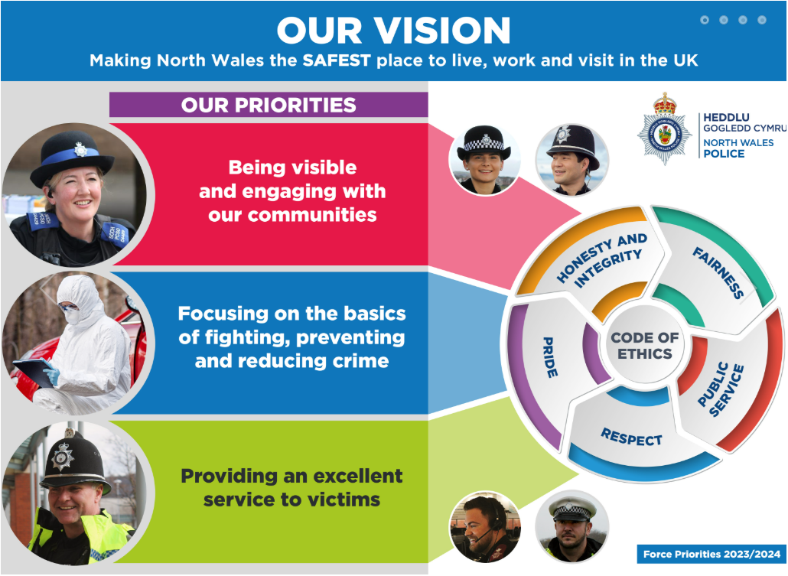
“What are priorities are and how we are doing?” - Office of the Police and Crime Commissioner North Wales (2026)
Submitted By: | Lisa Jones (Student number 2417686)
Business Area: | University of Wales Trinity Saint David
Module: | Strategic Management in Policing - BMPO7004D
Title: | Write a 4,400-word report on the development of a strategic business plan for a specialist area of policing. The business plan should include the following:  - Executive summary  - Scope of strategic proposal (including key performance indicators)  - Objectives  - Inclusion of Gant charts, risk/issue/mitigation, responsibility matrix  - Financial and budgeting resources  - Proposed implementation of the strategic proposal  - Analysis of options identified in the proposal  - Recommendations and conclusions  Consider the following: describing how theories of strategic management relate to the development of your plan and ensure that the report is underpinned with academic theory and sources  To support the strategic plan, write a 600-word abstract of your strategic plan outlining the key points of your plan

Date: 17th July 2026 | Version: 1.0

Executive Summary
Describe the current position and what the business plan sets out to achieve
This business plan proposes the implementation of Robotic Process Automation (RPA) to support the triage of police prosecution files with the aim of improving efficiency, consistency and governance within the criminal justice process. The policing environment is characterised by rising demand, greater investigative complexity, and constrained financial and human resources, requiring police organisations to identify approaches to improve productivity and effectiveness (College of Policing, 2021). Administrative activities associated with reviewing, categorising and preparing case files consume significant officer and staff time, reducing capacity for operational policing. RPA can automate routine administrative processes allowing police personnel to redirect their expertise towards investigative work, safeguarding and victim service delivery (Lacity & Willcocks, 2018).

RPA will automate elements of case file triage process, reviewing case records against predefined rules, legislation, policy standards and investigative requirements. The technology will support decision making by reducing manual administrative activity, improving processing times and increasing consistency across case management processes. Human oversight remains integral to RPA within criminal justice processes because decisions relating to proportionality, disclosure and evidential assessment require professional judgement and accountability. The implementation of automation should be designed to complement, rather than replace, professional judgement, with automated systems supporting routine processes while qualified practitioners retain responsibility for complex or ethically significant decisions. Technology should support rather than replace human decision makers through a human-in-the-loop approach (College of Policing, 2025). The proposal aligns wider policing objectives of improving service delivery, enhancing productivity and delivering greater value for money (Home Office, 2023).

This business plan sets out to demonstrate the strategic, operational and financial case for investment in RPA. It evaluates the current challenges affecting police case file management, assesses the anticipated benefits and risks of automation, and identifies governance arrangements required to ensure lawful, ethical and accountable implementation. Expected benefits include reduced case processing times, improved data quality, enhanced compliance with criminal justice procedures, comprehensive audit trails and increased organisational resilience. The strategic recommendations align with contemporary public sector digital transformation policy and the Crown Prosecution Service (CPS) approach to ethical AI deployment (Crown Prosecution Service, 2025). Digital transformation within policing requires leaders to articulate a clear vision, rationale for change and engage stakeholders throughout implementation (Kotter, 1996). Leadership commitment is essential to overcoming resistance to technological change, developing staff capacity and embedding new ways of working. Organisational readiness, including employee commitment, adequate training and effective governance has also been identified as a critical determinant of successful implementation of organisational change (Weiner, 2009).

This business plan adopts a phased implementation approach, beginning with a pilot programme to evaluate system performance, identify process improvements and minimise operational risk before wider deployment. Strong governance arrangements, continuous monitoring and regular performance evaluation will ensure compliance with legal, ethical and information governance requirements. This incremental approach reflects recognised best practice for introducing automated technologies within public sector organisations (Mergel, Edelmann & Haug, 2019). The proposal demonstrates how technological innovation can contribute to organisational effectiveness without compromising professional accountability or public confidence. By reducing administrative burden and improving workflow efficiency, RPA has the potential to deliver measurable operational benefits while enabling police officers and staff to focus on their core policing duties. This business plan seeks to provide an evidence-based framework for implementing RPA in police case file triage that aligns technological innovation with strategic leadership, organisational performance and the long-term principles of contemporary policing.

Current Challenges
Describe the current position, background, problem, opportunity, and risk of not acting.
Police services across England and Wales are under significant operational pressure due to increasing demand, complex digital investigations, reduced workforce resilience, and rising expectations around digital disclosure and evidential quality (Attorney General’s Office, 2025). Simultaneously the Crown Prosecution Service (CPS) faces substantial backlogs and workload pressures driven by increasing case complexity, rising volumes of digital evidence, and growing demands on prosecutors and criminal justice partners (Crown Prosecution Service, 2024). The introduction of the Directors Guidance on Charging and enhanced disclosure requirements has improved evidential standards but also increased administrative burdens on front line officers and investigators (Crown Prosecution Service, 2020). Delays in processing files can slow investigations, increase victim attrition, reduce successful prosecution rates and negatively impact public confidence in policing (HM Inspectorate of Constabulary and Fire & Rescue Services, 2023). Missing documentation, incomplete evidence logs or administrative errors can delay legal proceedings or result in cases being returned for remedial work. Furthermore, the growing volume of digital evidence from mobile devices, CCTV and social media places additional pressure on investigators to manage material efficiently.

Case files are reviewed by a Supervisor, the Case Quality Assurance Team (often repeatedly), a CPS triage team, a legal triage team for Crown Court cases and will then arrive with a Prosecutor for a decision. Each of these stages potentially result in remedial work and Action Plans which negatively impacts upon investigative timelines and outcomes. North Wales Police (NWP) were awarded ‘Requires Improvement’ from HMICFRS (HM Inspectorate of Constabulary Fire & Rescue Services, 2024) in terms of standards of investigation, emphasising the need to improve the timeliness of investigations as well as achieving criminal justice outcomes for victims. Internal performance data demonstrates that approximately 97% of files submitted to the Case Quality Team are sent back to officers for rework (North Wales Police, 2026). The top rework categories include triage rejections, quality issues with statements and disclosure schedules, missing signatures, missing checklists, etc. The majority are repetitive administrative errors that aren’t identified by either the officers or their supervisors prior to submission.

Case File Quality Overview:

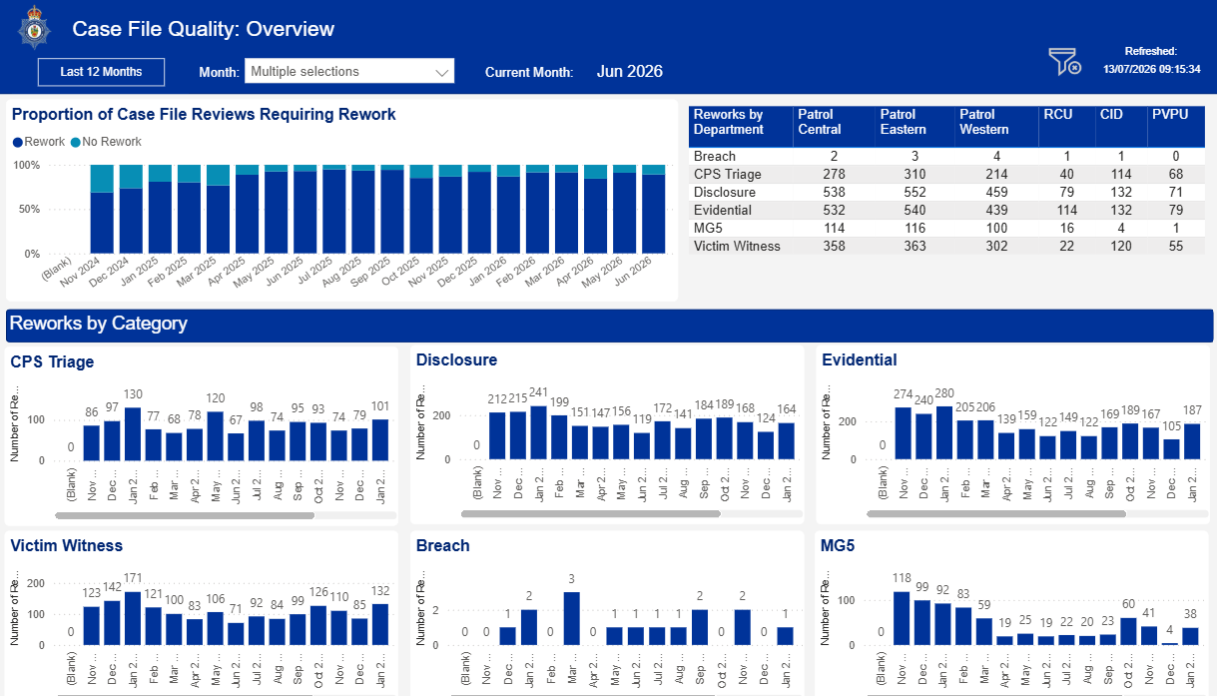

Case file quality – Rework rates North Wales Police Power BI

Case File Quality – Rework details:

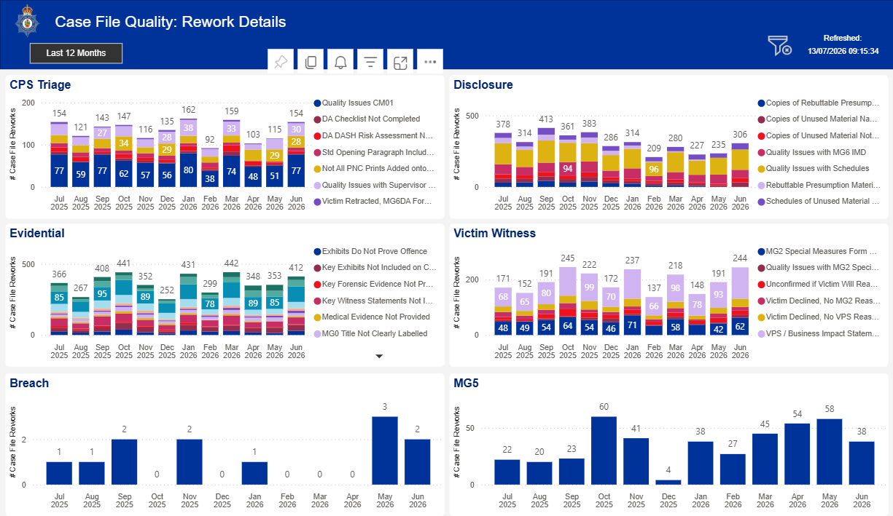

Case file quality – Rework details North Wales Police Power BI

Case File Quality – Top issues by Department:

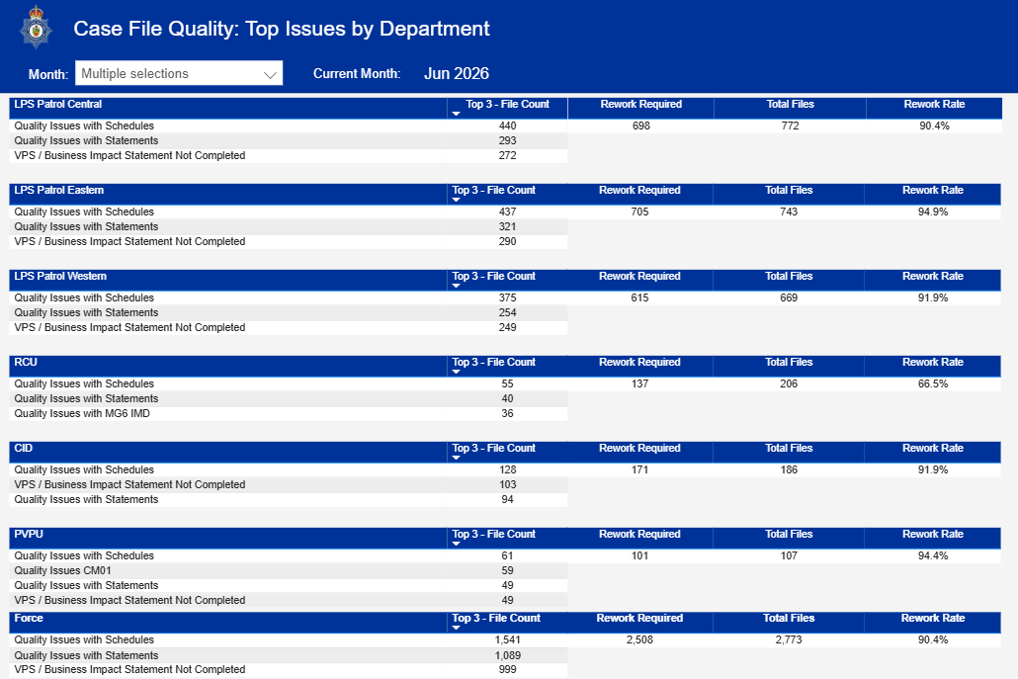

Case file quality – Top Issues by Department North Wales Police Power BI

National File Standards or DGA Compliance:

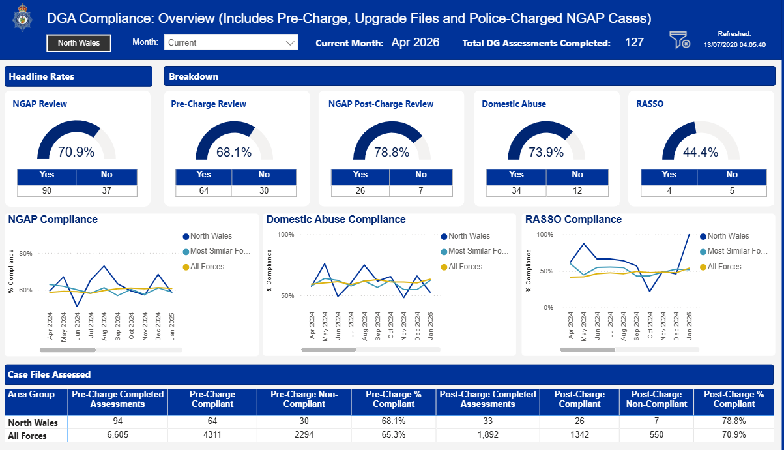

DGA compliance (National File Standards) North Wales Police Power BI report

Case files are notoriously difficult for police officers to complete because they require a mixture of accuracy, detail, legal compliance and time that is hard to balance in a fast-paced environment. Every case file must meet National Case File Standards for Court and small mistakes, such as missing signatures, wrong dates or missing entry fields can cause delays or even for cases to be dismissed from Court. Many reports are written after a long shift when officers are tired and rushed meaning critical details can be forgotten or mis-recorded. Officers juggle responding to calls, being visible and proactive alongside completing case files and the deadlines for submission can be short leading to rushed or incomplete submissions and stress and anxiety for officers. Forces also have high volumes of inexperienced front-line officers who aren’t aware of what is expected on case files and there is often little experience on rota to draw from as well as inexperienced supervisors reviewing the files for accuracy.

Recent national transformation initiatives have attempted to improve digital integration between policing and prosecution services. The Police Digital Service identified Digital Case File programme as a central mechanism for modernising criminal justice workflows (Police Digital Service, 2023). The CPS has similarly committed to increased digital capability and ethical AI implementation to support prosecution efficiency (Crown Prosecution Service, 2025). Robotic Process Automation (RPA) offers a practical solution to many of these challenges. The proposed strategy aims to establish a digital triage model capable of supporting evidential assessment, compliance checking, workflow prioritisation, and case progression while preserving legal safeguards and professional accountability. This reduces administrative workloads whilst improving speed and accuracy. Automation supports better resource allocation and enhances organisational efficiency by reducing processing times and operational costs. Despite these benefits, successful implementation requires careful governance, information compliance staff training and ongoing monitoring to ensure automated processes remain accurate and legally compliant. Consequently, this automation strategy must incorporate robust governance, transparency and accountability mechanisms.

Purpose and Scope
What does the business case aim to implement? Where applicable please quote force risks, AFIs, strategic objectives, and legislation.
The Criminal Justice environment in England and Wales has experienced substantial transformation over the last decade. Budget constraints, technological disruption, increasing cybercrime, and heightened public scrutiny have altered operational priorities across policing and prosecution services. Simultaneously, digital evidence has become central to investigations, creating unprecedented challenges relating to disclosure, data management and evidential review. Operational inefficiencies remain significant. Police officers frequently report duplication of administrative processes, repeated file rejections and inconsistent CPS requirements. Delays caused by incomplete documentation, disclosure issues and evidential inconstancies negatively affect victims, witnesses, defendants, and wider public confidence.

An RPA robotics triage solution would provide an automated front-end screening layer that reviews incoming case files, checks mandatory fields, validates attachments, compares records across systems, and routes files to the correct workflow. Its purpose is not to replace professional judgement but to prioritise work, reduce backlog and improve the quality of files before they reach charging or court stages.
The scope of the solution should include a review of case files for completeness and accuracy, checks against National File and CPS standards, duplicate detection, deadline alerts, and audit logging. It should also flag exceptions such as missing witness statements, incomplete evidence logs, safeguarding concerns or disclosure issues that require human review. Strategic objectives include getting it right first time, reducing turnaround times, strengthening compliance with disclosure and data-handling rules and freeing officers from repetitive administrative tasks to they can focus on visibility and victim support.

Key risks include poor data quality, over-reliance on automated outputs, cyber security vulnerabilities and unlawful processing of personal data. There is also a risk of automation bias where staff accept the bot-generated decisions without proper review. These risks can be reduced through role-based access controls, testing, exception handling, audit trails, and clear human-in-the-loop governance (Lacity & Willcocks, 2018). Training is also essential for staff to understand what the triage tool can and cannot do. A well-designed solution should provide management information on bottlenecks, reducing errors and compliance gaps to support continuous improvement. The solution must operate within the Data Protection Act 2018 and UK GDPR when processing personal data, the Criminal Procedure and Investigations Act 1996 for disclosure obligations and the Police and Criminal Evidence Act 1984 for lawful evidence handling. Used properly, RPA triage can improve efficiency, accountability and compliance while supporting safer and faster justice outcomes.

PESTLE analysis: A PESTLE analysis provides a structured framework for examining the political, economic, social, technological, legal and environmental factors that influence an organisations external environment (Johnson et al., 2008)

Political factors significantly affect policing and CPS transformation. Government efforts to reduce delays across the criminal justice system and improve outcomes for victims have increased the emphasis on digital modernisation and the adoption of technology to enhance efficiency, case progression and service delivery (HM Inspectorate of Constabulary and Fire & Rescue Services, 2023). High profile case collapses resulting from disclosure failings have increased public and institutional scrutiny of the criminal justice system, reinforcing the need for improved evidential management processes, stronger governance arrangements and enhanced accountability mechanisms (Attorney General’s Office, 2025).

Economic pressures are also highly significant. Police services and the CPS operate under substantial budgetary constraints while demand continues to rise. Automation offers potential efficiency savings by reducing administrative duplication, overtime expenditure, and delayed case progression. However, initial implementation costs may be substantial due to procurement, training, cybersecurity investment and systems integration.
Social factors include public expectations for justice, transparency, and accountability. Victims increasingly expect faster charging decisions and improved communication. Workforce wellbeing is also relevant because excessive administrative burdens contribute to stress, burnout and reduced morale among investigators and prosecutors.

Technological factors are central to this strategy. Advances in AI, robotic processes automation, natural language processing and workflow analysis create opportunities for intelligent case management. Integrated evidence sharing systems and cloud-based platforms support interoperability between police and CPS systems. However, technological dependency also increases cybersecurity risks and ethical concerns.

Legal factors are particularly important within criminal justice settings. Disclosure obligations under Criminal Procedure and Investigations Act 1996 require careful evidential management. Data Protection obligations under UK GDPR and the Data Protection Act 2018 require secure processing and retention of sensitive data. Automation systems must also comply with procedural fairness and evidential integrity requirements.

Environmental considerations are comparatively limited but are still relevant. Digital workflows may reduce paper consumption, physical storage requirements, and travel associated with file handling. Sustainable digital infrastructure can support broader public sector environmental objectives.

SWOT analysis: SWOT analysis is a strategic framework used to evaluate an organisations internal strengths and weaknesses alongside external opportunities and threats (Johnson, et al., 2008)

Strengths – The primary strength of automation is operational efficiency. Robotic process automation can complete repetitive administrative tasks significantly faster than manual workflows. Automated compliance checking can improve file quality and reduce rejected submissions. AI supported systems can assist investigators by identifying missing documents, disclosure gaps, and evidential inconsistencies. Automated workflows reduce variability in file preparation and support national consistency. Automation also supports workforce productivity. Officers can spend more time conducting investigations and engaging with victims rather than completing repetitive forms. Prosecutors benefit from improved evidential organisation and prioritised triage systems.

Weaknesses- A major weakness is reliance on technological infrastructure. Legacy systems within policing environments often lack interoperability and may limit implementation effectiveness. Initial implementation costs may also be significant. Another weakness concerns organisational resistance. Policing culture may be sceptical of automation, particularly where staff fear reduced professional autonomy or job displacement. Insufficient digital literacy among staff may also reduce adoption rates. Automation systems may also struggle with legal interpretation and cannot identify issues around quality issues. Contextual evidential assessment often requires professional judgement that cannot be fully replicated by AI systems.

Opportunities – There are significant opportunities for strategic transformation. Automation can improve public confidence by reducing delays and improving evidential quality. Integrated digital systems create opportunities for national criminal justice interoperability. AI assisted analytics may support strategic intelligence, workforce forecasting and resource allocation. There is also opportunity for long-term financial savings through reduced duplication and improved case progression.

Threats – Cybersecurity threats represent a major strategic risk because criminal justice systems contain highly sensitive information. Data breaches could undermine public trust and create legal liabilities. Another threat concerns ethical and legal accountability. Inappropriate reliance on algorithmic systems could create bias, procedural unfairness or evidential errors. Public concern regarding automated decision making may also undermine legitimacy. Finally, failure to implement change effectively could exacerbate operational fragmentation rather than improving efficiency.

Initial Process Assessments (IPA) - Moore (2026) Lancashire Police

Expected Timescale
Implementation Roadmap:

Project Plan – Williams (2026) North Wales Police

Governance:

Senior Responsible Owner (SRO)
Subject Matter Expert (SME)
Digital Policing Transformation lead
Operational Policing lead
Information Assurance Lead
Senior Business Analyst
RPA developer

Strategic objectives:

Faster case progression and improved outcomes for victims
Fewer rejected files and reduced rework/Action Plans
Increased officer availability to support visibility, crime prevention and quality of service
Better victim experience – less investigation delays and victim attrition
Enhanced public confidence by ensuring we get it right first time, every time

Implementation plan – Implementation should occur through a phased transition programme.

Phase 1 – Strategic planning and pilot design – this phase involves stakeholder engagement, procurement planning, governance development and pilot testing. Baseline data should be collected to support evaluation.

Phase 2 – Pilot implementation – Selected departments to implement limited automation pilots focusing on file validation and workflow triage. Independent evaluation should assess operational effectiveness, workforce perceptions and legal compliance.

Phase 3 – Integration and expansion – Successful pilot models should be integrated expanded Force wide. Training programmes and organisational support mechanisms are critical during this phase. Strategic business analyst to support performance benchmarking and policy development.

Process Design Document (PDD) – Moore (2026)

Expected Benefits
Consider improvements in service delivery, reduced risk, timescales, cost, capability, and capacity.
The implementation of RPA for case file triage within police prosecution processes offers significant opportunities to improve organisational performance and service delivery. RPA uses software robots to automate repetitive, rule-based administrative tasks, enabling organisations to process information more quickly, accurately and consistently while allowing staff to focus on higher-value activities (Lacity & Willcocks, 2016).

A primary benefit of RPA is improved service delivery through faster and more consistent processing of prosecution files. Delays in case file preparation can result in postponed changing decisions, adjournments and reduced public confidence in the criminal justice system. Automating routine validation checks reduces manual processing times and minimises human error, enabling investigators and case builders to focus on evidential quality and investigation decision-making. This aligns with public sector digital transformation literature, which argues that automation improves both efficiency and outcomes when integrated into organisational processes (OECD, 2020).

From a risk management perspective, RPA can improve compliance by checking that every prosecution file is checked against pre-defined business rules and legislative requirements. Unlike manual processes, software robots perform tasks consistently, creating comprehensive audit trails that enhance transparency and accountability. This reduces the likelihood of missing documentation, incomplete disclosure or procedural errors that may compromise prosecutions. However, automation introduces new risks including algorithmic error and cybersecurity vulnerabilities. Consequently, effective governance, regular monitoring and human oversight remain essential to ensure that automated decisions support rather than replace professional judgement (Willcocks, Lacity & Craig, 2017).

The expected reduction in processing times represents another significant organisational benefit. RPA can operate continuously without interruption, processing high volumes of prosecution files considerably faster than manual administrative processes. Shorter turn-around times enable earlier identification of incomplete case files, reducing delays before submission to the CPS and supporting swifter justice outcomes. Such efficiencies contribute to improved performance against organisational targets while enhancing victim and witness experiences by reducing unnecessary delays. In an era of increasing public scrutiny and financial constraints, effective performance management is essential to demonstrate value for money, accountability and the successful realisation of benefits from digital transformation (Marr, 2012).

Financial benefits are also anticipated although these may be realised over the medium to long term rather than immediately. Faster case progression may also reduce custody costs, court delays and overtime expenditure. Operational benefits also include reduced file rejection rates, faster CPS charging decisions, improved disclosure compliance, enhanced evidential quality, increased officer productivity, improved victim experience and better communication. Initial implementation requires investment in software, system integration, governance and staff training. However, automation reduces repetitive administrative effort, lowers rework caused by processing errors and enables existing resources to be deployed to higher value core policing activities. Lacity and Willcocks (2016) argue that RPA delivers substantial return on investment through increased productivity, improved quality and reduced operating costs across transactional processes.

Finally, RPA has the potential to enhance both organisational capability and capacity. Capability is strengthened through standardised, data-driven workflows that improve consistency, reporting and operational oversight. Capacity increase as administrative workloads are reduced, allowing police officers and staff to dedicate more time to complex investigations, safeguarding responsibilities and decision-making activities requiring professional expertise. Rather than replacing staff, RPA should be viewed as augmenting workforce capability by automating repetitive tasks while preserving human judgement requiring discretion and ethical consideration.

Overall, the introduction of RPA for robotic triage of case files has the potential to transform prosecution file management by improving service delivery, reducing operational risk, shortening processing times, generating efficiencies and increasing organisational capacity and capability. Nevertheless, these benefits will only be fully realised when automation is supported by effective governance, robust change management and continued human oversight to ensure that technological efficiency complements the principles of procedural justice and public accountability.

Supporting Strategic Priorities (check appropriately)
Chief Constable’s
Being visible to and engaging with communities. | ☒
Focusing on the basics of fighting, preventing and reducing crime. | ☒
Providing an excellent service. | ☒
Police Crime Commissioner’s
Tackle and prevent rural and wildlife crime | ☐
Improve the efficiency and effectiveness of police officers and police staff | ☒
Improve Road safety | ☐
Tackle and prevent domestic abuse and sexual violence | ☐
Safeguard vulnerable people including children | ☐
Tackle and prevent cybercrime | ☐
Establish a victims panel | ☐
Tackle and prevent Hate Crime | ☐
Introduce a North Wales Female Offender Strategy | ☐
Increase the use of Restorative Justice | ☐
Support and protect children and young people and divert them away from the Criminal Justice System | ☐
Address the root causes of offending and support the rehabilitation of people who have offended | ☐

Key Stakeholders
Departments and partners involved.
- Justice Services/Operational Support Services
- Local Policing Services
- Crown Prosecution Service
- HM Courts & Tribunals Services (HMCTS)

Risks
Risks to successful implementation.
While RPA can improve efficiency, reduce processing times and standardise workflows, it also introduces significant operational, ethical and legal risks. Ethical considerations are central to automation; the proposed RPA solution must support rather than undermine procedural justice. The primary ethical concern involves algorithmic bias; AI systems trained on historical criminal justice data may replicate existing inequalities or discriminatory practices. Governance frameworks must therefore ensure fairness, transparency and regular auditing. Professional accountability is equally important. Police officers and prosecutors remain legally responsible for evidential decisions and disclosure obligations. Automation systems must therefore operate as decision support tools rather than autonomous decision-makers. Data protection and cybersecurity are also critical. Criminal justice systems process highly sensitive personal information, including victim data, intelligence material, and evidential records. Strong encryption, access controls and auditing mechanisms are essential. Professional culture also requires consideration. Investigators and prosecutors may distrust automation systems if implementation is perceived as cost driven or insufficiently accountable. Engagement with professional stakeholders is therefore essential to maintaining legitimacy and operational confidence.

Data quality presents another significant risk. RPA systems operate according to pre-defined rules and are highly dependent on the accuracy and completeness of input data. Inconsistent, incomplete or erroneous case information can lead to incorrect triage decisions. Furthermore, where RPA is integrated with artificial intelligence or machine learning, concerns emerge regarding algorithmic bias, transparency and accountability. Historical policing data may contain embedded societal biases which automated systems can perpetuate if not carefully monitored. Information security and privacy can also represent critical challenges. Police case files contain sensitive personal and criminal justice information, making automated systems attractive targets for cyber-attacks or unauthorised access. Compliance with data protection legislation, including the UK General Data Protection Regulation (UK GDPR) requires robust governance, audit trails and human oversight.

Finally, excessive reliance on automation may reduce organisational resilience. Technical failures, software errors, or poorly designed business rules can disrupt case management processes and create significant operational risks. Consequently, RPA should be implemented as a decision-support tool rather than a replacement for professional discretion. Effective governance frameworks, continuous monitoring, regular auditing and human-in-the-loop decision making remain essential to ensure fairness, accountability and public trust in automated policing systems.

Strategic risks include system failure, data breaches, evidential errors, workforce resistance and reputational damage. Mitigation includes phased implementation, robust testing, independent auditing and contingency planning. Equality impact assessments and independent oversight mechanisms are therefore critical components of implementation.

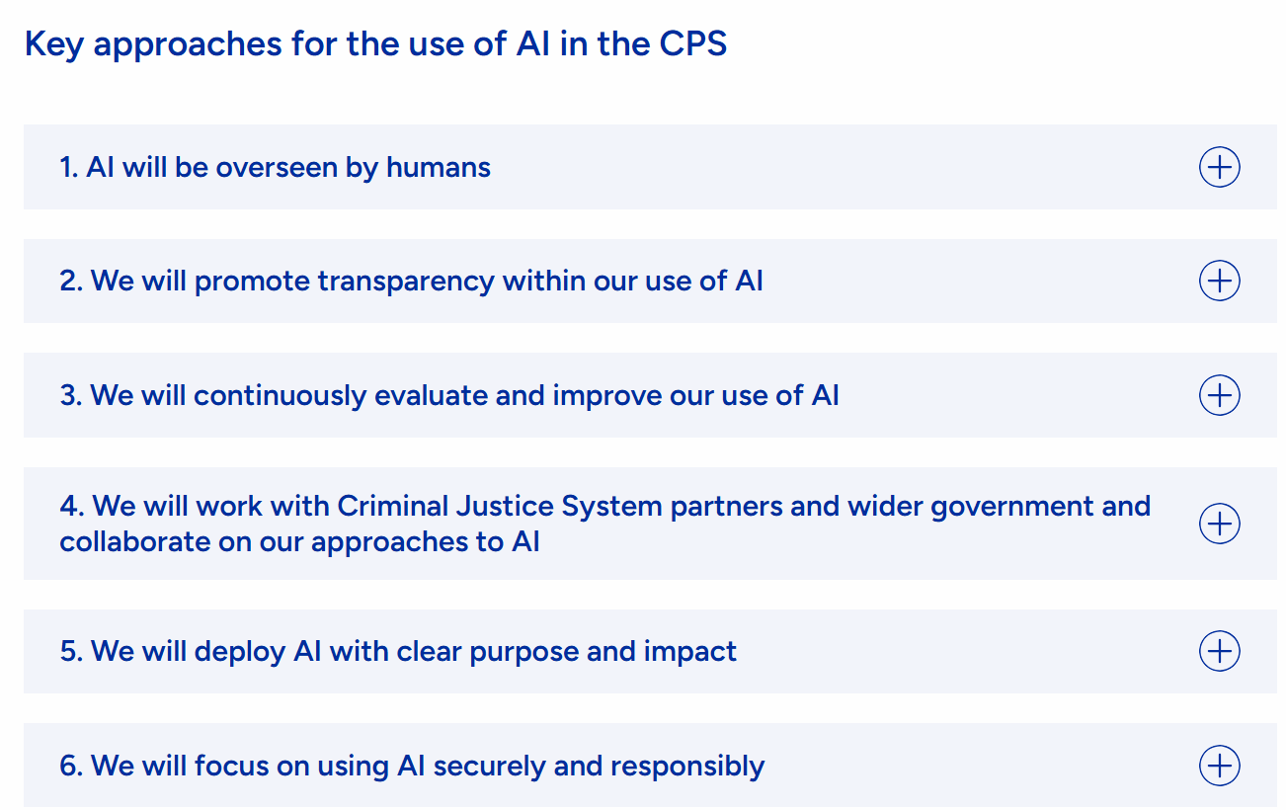

How the CPS will use Artificial Intelligence, Crown Prosecution Service (2025)

Conclusion
The implementation of RPA to triage police prosecution files presents a compelling opportunity for improving efficiency, consistency and service delivery. North Wales Police process large volumes of prosecution files, many of which require repetitive administration checks before being submitted to the Crown Prosecution Service. RPA can automate rule-based tasks such as validating documentation, identifying missing evidence, checking compliance with file standards and routing cases according to pre-defined criteria. This reduces administrative burden, shortens processing times, minimises human error and enables officers and staff to focus on investigative and decision-making elements that require professional judgement.

From a financial perspective, RPA offers opportunities to reduce operational costs, increase productivity, and improve resource utilisation without increasing staffing levels. Standardised processing also improves file quality and consistency, reducing delays caused by incomplete submissions and supporting more effective collaboration across the criminal justice system. The technology can operate continuously, providing additional resilience during periods of high demand. The analysis demonstrates that robotic process automation can improve file quality, reduce delays, support disclosure compliance and increase workforce productivity. Long-term benefits include improved operational efficiency, enhanced victim experience, reduced administrative burden and strengthened criminal justice performance.

However, successful implementation requires more that technological investment. Strategic management theories provide a framework for implementation. They help ensure that the proposal aligns with organisational objectives, creates operational value and supports long-term public sector transformation. Implementing RPA requires leadership commitment, stakeholder engagement, employee training and continuous communication to overcome resistance. This business plan will therefore be accompanied by a communication and engagement plan alongside financial and technical planning. Kotter’s (1996) Eight Step Change Model provides a useful framework by emphasising the creation of urgency, stakeholder engagement and the embedding of new working practices to achieve sustainable transformation. In parallel, transformational leadership theory (Bass, 1985) highlights the importance of leaders articulating clear vision, motivating employees, fostering innovation and addressing concerns surrounding automation. By encouraging collaboration, trust and continuous learning, transformational leaders can reduce resistance to change and promote successful technology adoption.

Overall, the business case for RPA extends beyond efficiency gains to include improved service quality, enhanced organisational resilience and better allocation of police resources. When supported by strong governance, human oversight, and effective leadership, RPA can contribute to faster, more accurate prosecution file preparation while maintaining accountability, legal compliance and public confidence in policing. If implemented effectively, automation can contribute significantly to a more efficient, transparent and resilient criminal justice system.

Abstract:
The Policing Productivity Review recommends greater focus on improving quality and timeliness of case files to the CPS given that poor submissions contribute to delays, increased rework and reduced efficiency (Home Office, 2023). The increasing volume and complexity of police prosecution files, coupled with sustained resource constraints across policing and criminal justice agencies, have intensified the need for innovative digital solutions that improve efficiency whilst maintaining evidential integrity and public confidence (College of Policing & National Police Chief’s Council, 2021). This business proposal for Robotic Process Automation (RPA) supported case file triage, directly supports these priorities by improving compliance with National File Standard requirements outlined in the Director’s Guidance on Charging (Crown Prosecution Service, 2020). It is anticipated that improving case quality at the point of submission, strengthening collaboration and streamlining processes would reduce delays and improve case outcomes (Home office, 2025).

RPA has significant potential to improve efficiency by automating repetitive, rule-based administrative tasks (Asquith & Horsman, 2019). Within policing and criminal justice sectors, these efficiencies have the potential to contribute to faster charging decisions, reduce case backlogs, and improve collaboration between police forces and the CPS (Lacity & Willcocks, 2016). Moreover, RPA generates comprehensive audit trails that strengthen governance, accountability and compliance with criminal justice procedures, supporting transparency and quality assurance (Mergel, Edelmann & Haug, 2019). Despite the potential benefits, digital innovation within policing has generated significant concerns as scholars argue that algorithmic systems may perpetuate existing biases embedded within historical crime data, resulting in discriminatory outcomes (Lum & Isaac, 2016). Researchers also highlight the risk of over-reliance on automated technologies at the expense of professional judgement and discretion (Ferguson, 2017). The effective use of data analytics in policing therefore requires robust governance and ethical oversight to ensure public trust and operational effectiveness (Barbuta & Oswald, 2020).

Organisational change management represents a further critical success factor. Pilot projects have demonstrated that RPA can deliver significant efficiency gains when accompanied by effective leadership and change management practices (Lacity & Willcocks, 2016). Research suggests that digital transformation initiatives are more likely to succeed when leaders articulate a clear vision, secure organisational commitment, engage stakeholders throughout the change process, and cultivate a culture that is receptive to innovation (Kotter, 1996). Effective stakeholder engagement is equally important, as involving employees and other key stakeholders in the change process helps build trust, reduce resistance, and increase acceptance of new ways of working, thereby improving implementation outcomes (Bryson, 2004). Successful implementation of RPA in case management, therefore, depends on effective strategic leadership, stakeholder engagement, adequate training as well as organisational readiness for change (Weiner, 2009).

In conclusion, the implementation of RPA for the triage of police prosecution files offers a strategically significant opportunity to enhance operational efficiency, improve consistency, strengthen governance and support wider criminal justice transformation (College of Policing & National Police Chief’s Council, 2021). While technological, organisational and ethical challenges remain, these can be mitigated through careful process design, effective governance and incremental implementation. A phased deployment supported by continuous evaluation will maximise the likelihood of sustainable benefits and contribute to a more responsive, efficient and digitally enabled police service (Home Office, 2023). Benefits realisation will be monitored through key performance indicators measuring processing time, error rates, staff productivity, case quality and user satisfaction to ensure anticipated efficiencies are achieved.

I acknowledge the use of ChatGBT on the 20th June 2026 to support my research using the following prompts:
Please provide me with key academic literature on the use of RPA Robotics on police case files
I confirm that I have not presented any AI generated materials as my own work. I have copies of my drafts, notes, and other resources I used before and after the use of AI tools which I may be asked to provide in evidence.

I acknowledge the use of Copilot on the 14th July 2026 to check my references using the prompts:
Please check against UWTSD Harvard Referencing style
I confirm that I have not presented any AI generated text as my own work. I confirm I have copies of my drafts, notes, and other resources I used before and after the use of AI tools which I may be asked to provide in evidence.

