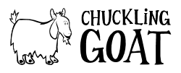  Research Project  A critical analysis of the sustainability of The Chuckling Goat | Abstract  A critical analysis of a small, rural organisation and its journey to becoming a successful and sustainable influence in Wales.  Emma-Sian Davies (1502478)  Management Ethics SBUS5120

Contents
Executive summary 2
Introduction 3
The Chuckling Goat, an introduction 4
The Chuckling Goat SWOT analysis 5
Strengths 5
Weakness 5
Opportunities 5
Threats 5
The Chuckling Goat assessment criteria 6
Critical analysis of the organisations sustainability 7
Corporate Social Responsibility 7
Staff 7
Operations 7
Environment 8
Green Award(s) 9
Assessment criteria template 10
Conclusion: Is it sustainable? 11
References 12
Appendices 13
Appendix 1 13
Appendix 2 14
Appendix 3 15
Appendix 4 16
Appendix 5 17
Appendix 6 18

Executive summary
This report will support a detailed analysis of a small, rural organisation and its values on becoming a sustainable organisation for the local environment and its long-term footing within the retail industry. The critical analysis of the methods used by The Chuckling Goat shows its capability to succeed in becoming a fully sustainable organisation and its internal, long-term targets attainable.
An analysis of the benefits and limitations of the different methods used by the organisation will show how The Chuckling Goat has grown in popularity whilst in turn confronted its limitations head on.

Introduction
For the purpose of this research project the chosen organisation, The Chuckling Goat will be critically analysed to discover its principles and practices when referring to sustainability. Through research, it is hoped the organisation will show how, with the use of a SWOT analysis, it has managed to adapt to its limitations and managed to find a niche in a very competitive industry. To gain the desired results, a qualitative approach will be taken to the research and will also involve a series of questions and answers from the owner, Shann Jones.
In an informal discussion with Mrs Jones, a number of subjects are touched upon, allowing an insight of the organisation and the owners beliefs in how it should be run and the future hopes for the expansion of the organisation. Their main principles are to sustain an organisation which will not only grow in profitability but will give back to the local community and environment.

The Chuckling Goat, an introduction
A small, rural, family run organisation. Launched in 2011 with three members of staff, and now a staff of twenty (plus an office owl) with future growth already under way. The Chuckling Goat specialise in using free-range goats milk and a unique kefir grain (containing beneficial yeasts and bacteria) to create their specialised blends of milk and cleansing products to aid the healing process for people suffering with skin conditions such as psoriasis, rosacea, eczema, acne, dermatitis and other allergies (The Chuckling Goat, 2018).
With the importance of offering free-range products, it should transpire their need to protect the environment and secure their corporate social responsibility is essential in their aim to be a sustainable organisation. A position which will be critically analysed throughout the report.
In her book, ‘Secrets from Chuckling Goat’, part-owner of the organisation Mrs Jones, explains her love of the produce created and is passionate about creating home-made products and uses as many locally produced ingredients as possible (Jones, 2015).

The Chuckling Goat SWOT analysis
Following a similar method used by the organisation, Humphrey’s SWOT analysis shows the areas of strength, weakness, its opportunities and threats presented to the organisation (Mind Tools, 2018), shown in appendix 1. The information obtained can aid in the process of improvement:

Strengths
- Quick to adapt to changes in the market
- Introduced an herbal form of treating skin condition without using harsh chemicals and medicines.
- Quick decision made by hierarchy due to small organisation and few lines of management.
- Sustainable processes in place which attracts largely good attention in current climate.
- By limiting marketing to word of mouth and social media, costs are kept low.

Weakness
- With popularity comes an increase in orders. Could cause backlog
- Lacking in marketing experience, only using social media, costs are low but with use of Google AdWords and AdSense it could be improved.
- Lack of knowledge to expand the product range.

Opportunities
- Increase product diversity by improving knowledge and understanding of ingredients and usage.
- Increase sales by selling through retail businesses.
- Expansion of farm or introduce other location and farm to increase employment and production in another area.
- To increase area of sales to other countries

Threats
- Increase in competition can result in fewer sales
- Larger competitors can produce higher quantities.
- Increased cost in machinery and technology

The Chuckling Goat assessment criteria
By creating an assessment criteria, The Chuckling Goat can determine areas in which they excel and areas which require improvement. This is represented in the assessment criteria table below and the organisation specific is in ‘bold’ type:
Trait/Performance | Is the policy in place | Requires serious improvement | Requires improvement | Meets expectations | Above expectations
CSR  - Contribution to the community | Yes | No involvement in the local community | Gives back to the community in form of prizes | Attends local events and helps in the community | Sponsors of local teams/school events
Staff  - Flexible working policy  - Agile working policy  - Recruit within community  - Interest in employee morale | Yes  Yes  Yes  Yes | Nonflexible working with no agile policy in place. Recruits from further afield. No interest in morale | Limited flexibility with no agile working policy.  Recruits within 50-mile radius  Minimum effort made to boost morale | Flexible working offered. Senior management offered agile working.  Recruits within 20-mile radius.  Ensures good morale | Fully flexible,  Offers agile working to office members.  Recruits within 20-mile radius.  Ensures good morale and takes interest in staff
Operations  - Health and welfare  - Component procurement  - Fair Trade policy | Yes  Yes  Yes | No interest in staff or animal H&W. Procures cheapest components and no Fair-Trade policy in place | Some effort made for staff and animal H&W. Sourced components within UK  No Fair-Trade policy | Staff and animal H&W priority. Locally sourced components Fair –Trade policy in process | Staff and animal H&W high priority. Locally sourced components and Fair –Trade policy established
Environmental  - Clean growth strategy  - Waste management  - GHG management  - Renewable energy | Yes  Yes  Yes  Yes | No processes in place. No effort to recycle or renew. No interest in the environment | Paper recycling in place but no other process | Recycles paper, investment made to improve renewable energy | Recycles paper and all other recyclable materials. Clean growth strategy. Renewable energy and GHG management
Green award(s)  - Welsh Green Energy Award  - Groundwork/Green Dragon Award | No  No | No process in place to aid in achieving awards | Some processes in place | Processes in place and regulated | Processes in place, regulated and consumers kept up to date

Critical analysis of the organisations sustainability

Corporate Social Responsibility
‘…where a firm takes into account the interests and concerns of a community rather than just its shareholders” (Solman, et al., 2018)
By definition, in this instance the organisations corporate social responsibility is to its employees, the environment and local community. Products sold by The Chuckling Goat are made on site with many home-grown ingredients however; by making use of as many locally sourced ingredients as possible they in turn contribute to the community in their support of local businesses. Though still a small organisation, they are keen to give back to the community and help with fud raising and run competitions via their social media sites Facebook (The Chuckling Goat, 2011) and Twitter (The Chuckling Goat, 2013), seen in appendix 2 and 3. Due to the size, the organisation sell their products online but consumers are able to go to the farm and see for themselves the processes involved. Mrs Jones prefers to sell direct to consumers to cut out the intermediary and be able to provide answers to any queries first hand.

Staff
The organisation is dedicated to its employees and prides itself in its efforts to create a fully flexible working policy and goes one step further than the government guidelines; they have introduced an agile working policy. Though this cannot be applied to all members of the organisation for production and animal welfare reasons, they are happy for office based employees to work remotely for up to two days a week (Jones, 2018). With all staff living within a 20-mile radius of the establishment, the organisation are keen to ensure that employing locally is key to reducing local unemployment and helping reduce the overall unemployment level of 4.9% in Wales (nomis , 2018), represented in appendix 5. Mrs Jones does concede however; that finding permanent employees has been difficult as wages in more rural areas are lower in comparison to those in larger cities.
In the pursuit of a successful organisation, creating a fun and happy environment is paramount to the owners of The Chuckling Goat. All employees begin with an introduction to the team and then the animals. Motivation and morale is kept up with ‘fun days’ involving team building exercises and ‘job swaps’, where management swap places with production and office employees. Shann Jones explains that this is something they like to do to keep their foot in the door and to remind themselves that it is not all plain sailing. Employee morale is of great importance within the organisation and everyone takes part in quarterly team building events with food, a few drinks and lots of prizes.

Operations
The organisation not only has a responsibility to the health and welfare of its staff but also the goats who provide the milk for their products. For the ‘human’ factor they comply to the governments Workplace (Health, Safety and Welfare) Regulations 1992 (Health and Safety Executive, 2013), a copy of which can be found by following the link in appendix 6. As for the heard of goats; they are given the freedom to roam the vast 24 acres of grass and woodland, at no point are any goats used for testing purposes and no unnecessary medication is given. If a goat is injured or sick, the owners seek medical advice from a veterinarian.
When it comes to sourcing ingredients, Mrs Jones is fastidious about where they are sourced. Many ingredients are grown on the farm or procured from local sources, but one or two components such as oils need to be sourced further afield.
"On the farm we grow the hay, feed the goats, milk the goats, make the kefir, make the skincare products, pack them up, ship them out, and talk to the customers. It's an entirely end-to-end business - and that's the way we like it. It means that we can maintain our immaculate standards, for both animals, people and products, and never have to compromise." – Shann Jones
Fair Trade processes have become hugely popular within the surrounding areas. The market town of Newcastle Emlyn was awarded its Fair Trade status in 2017 (Parkinson, 2017) and is a leading influence on other local organisations of all sizes to buy into the Fair Trade ethos. Although the organisation is not currently functioning on a Fair Trade level, it is currently revising the current source of the base oils used and is looking to procure components from developing countries.

Environment
Working on the principle that an organisations’ long term sustainability is also based on the sustainability for the environment, The Chuckling Goat strive to meet demanding internal targets in a bid to improve its sustainability. Aware that the production of materials and daily use of machinery may have a negative impact on their GHG (Greenhouse Gas) emissions, the organisation continually tests for the six most common sources of emissions; carbon dioxide, methane, nitrous oxide, hydrofluorocarbons, perfluorocarbons and sulphur hexafluoride (Molthan-Hill, 2014). A more detailed description can be found in appendix 2. During an informal meeting with Mrs Jones, she advised that the installation of energy saving light bulbs and solar panels early on has proven to be cost effective and has lowered their energy usage by over 50%. Further to this, a wind turbine was erected in 2015 to aid in the reuse of wind energy. By adapting to the governments ‘Clean Growth Strategy’ (HM Government, 2017), they hope to be a leading influence to other small organisations within the surrounding area.
Today, all organisations are encouraged to recycle and reuse what they can and though many still ignore this. All product packaging used by the organisation is recyclable, right down to the biodegradable chips used for packaging (The Chuckling Goat, 2018).
Glass is not used in the production of any products but is used in the offices. There is no specific process or designated waste bin for glass and staff are currently encouraged to take glass bottles home with them if used. It was suggested a container be placed in the staff room for glass and taken to the recycling centre when full. All paper is shredded and sent to a recycling centre once a fortnight. Due to the limited number of collections it was noticed that quite several recycling bags built up over the two-week period. Mrs Jones was concerned that although they recycle paper, the level of paper waste was higher than desired and so they are aiming to reduce the unnecessary waste by 50% by the end of the year.
As the organisation is adjacent to the owners’ property and they are keen to improve and reduce waste for the organisation and the residential property, they have arranged to have a water filtration system installed. This will harvest the rain water, filter it and recycle it for use with washing machines, dishwashers and toilets.

Green Award(s)
The organisation has been successful in obtaining awards from healthcare organisations as well as an ‘investors in people’ award but to date they have not received any awards for sustainability. This is predominantly down to the organisations focus on providing effective skincare products. Mrs Jones advised it had not been a priority for the organisation to achieve green awards but, after discussing how these could further improve the environmental perception of the organisation to current and potential consumers, she advised it would be beneficial to the brand and would be researching awards.

Assessment criteria template
This template has been designed to adapt to different organisations and can be adjusted accordingly.
Trait/Performance | Is the policy in place | Requires serious improvement | Requires improvement | Meets expectations | Above expectations
CSR
- Contribution to the community

Staff
- Flexible working policy
- Agile working policy
- Recruit within community
- Interest in employee morale
Operations
- Health and welfare
- Component procurement
- Fair Trade policy
Environmental
- Clean growth strategy
- Waste management
- GHG management
- Renewable energy
Green award(s)
- Welsh Green Energy Award
- Groundwork/Green Dragon Award

Conclusion: Is it sustainable?
Combining the results of the discussion and the research obtained an evaluation can be formed that indicates the future sustainability of The Chuckling Goat is positive. There are many areas which require improvement and some practices need to be taken up to show consumers the effort they are putting in to create a sustainable future. Keeping consumers up to date with different developments can create a more personable organisation and attract new consumers. Should they continue and expand the brand, further sustainable processes would need to be introduced so as not to deviate from their goal. By evaluating each process quarterly, they can maintain a consistent level going forward. The organisation is dedicated to its staff and animals and the products they produce, their success and popularity appears to increase daily which is a good indication they are on the right track.

References
Health and Safety Executive, 2013. Workplace health, safety and welfare, London: UK Government.
HM Government, 2017. The Clean Growth Stratergy, London: HM Government.
Jones, S. N., 2015. Secrets from Chuckling Goat. First ed. USA: Hay Horse Inc.
Jones, S. N., 2018. The Sustainability of The Chuckling Goat [Interview] (29th April 2018).
Mind Tools, 2018. SWOT Analysis. [Online]
Available at: https://www.mindtools.com/pages/article/newTMC_05.htm
[Accessed 30th April 2018].
Molthan-Hill, P., 2014. The Business Student's Guide to Sustainable Management. First ed. Sheffield: Greenleaf Publishing Limited.
nomis , 2018. Labour Market Profile - Carmarthenshire. [Online]
Available at: https://www.nomisweb.co.uk/reports/lmp/la/1946157392/printable.aspx
[Accessed 2nd May 2018].
Parkinson, D., 2017. Fair Trade signs unveiled in Newcastle Emlyn. [Online]
Available at: http://www.tivysideadvertiser.co.uk/news/15429373.Fair_Trade_signs_unveiled_in_Newcastle_Emlyn/
[Accessed 3rd May 2018].
Solman, J., Hinde, K. & Garratt, D., 2018. Economics for Business. Sixth ed. Harlow: Pearson Education Limited.
The Chuckling Goat, 2011. Chuckling goat. [Online]
Available at: https://www.facebook.com/ChucklingGoat/
[Accessed 25th April 2018].
The Chuckling Goat, 2013. Chuckling goat. [Online]
Available at: https://twitter.com/chucklinggoat
[Accessed 25th April 2018].
The Chuckling Goat, 2018. Main page. [Online]
Available at: https://www.chucklinggoat.co.uk
[Accessed April 24th 2018].
The Chuckling Goat, 2018. Our Ethics. [Online]
Available at: https://www.chucklinggoat.co.uk/
[Accessed 21st April 2018].

Appendices

Appendix 1
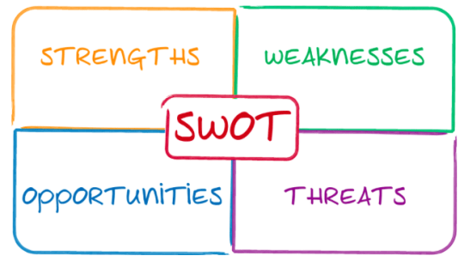

Appendix 2
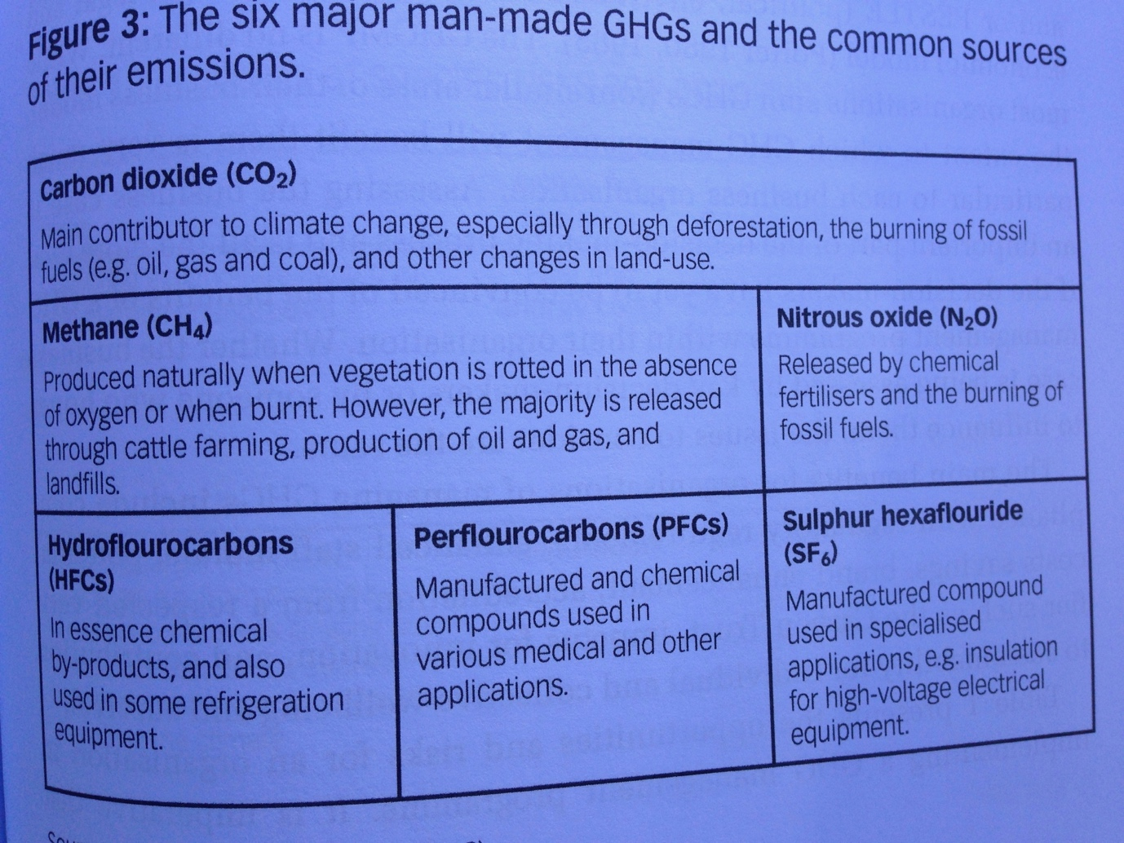

Appendix 3
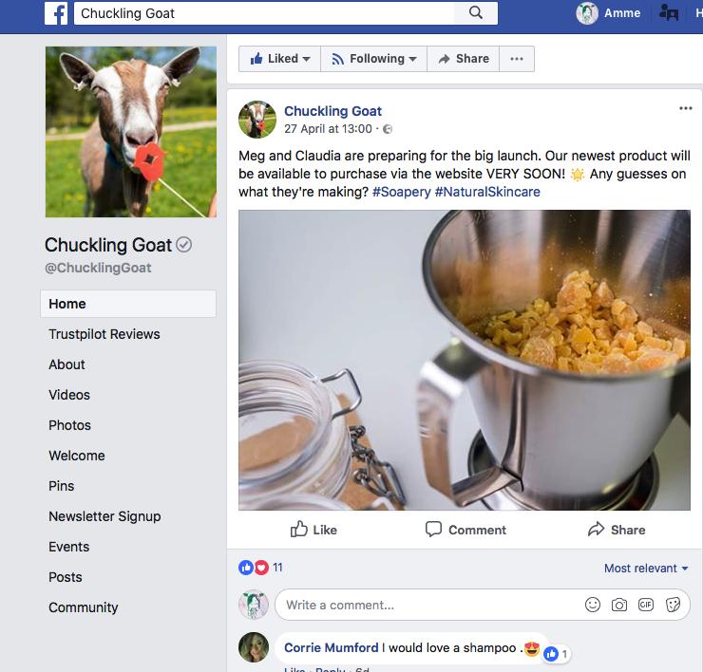

Appendix 4
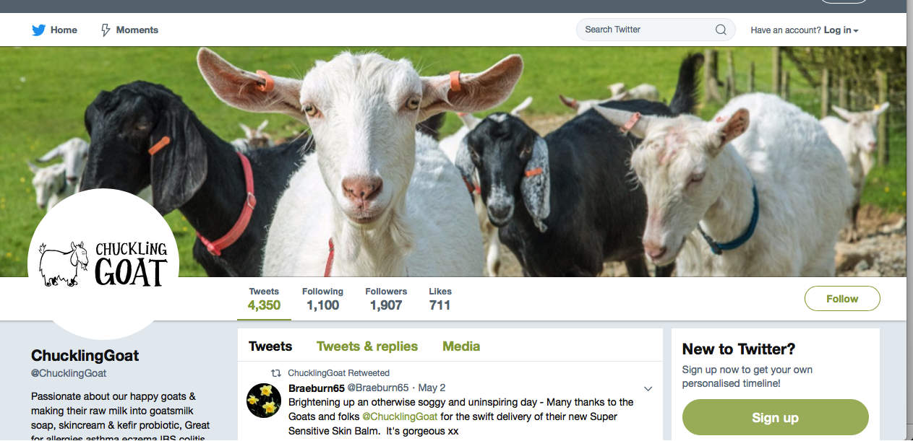

Appendix 5
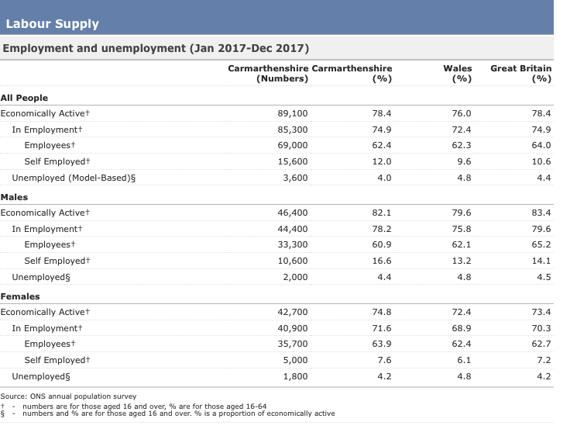

Appendix 6
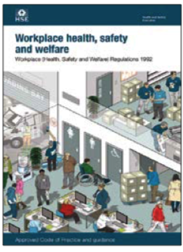
http://www.hse.gov.uk/pubns/priced/l24.pdf

