

RESULT

ASSIGNMENT DETAILS AND FEEDBACK

SOUTH WEST WALES CENTRE OF TEACHER EDUCATION

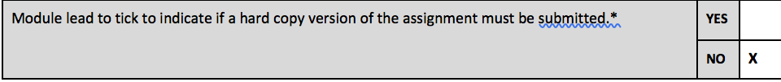
Sections marked with * should be completed by module lead
Student name: | Rebecca Goss | Student number: | 1500225
Programme: | BA Primary Education with QTS
Module: * | Enterprising and Creative Teaching and Learning / ECAD6004C - Addysgu a Dysgu Mentrus a Chreadigol | Module Level (4, 5, 6): | 6
Module code: * | ECAD6004/C | Contribution to Overall  Module Assessment (%): * | 50%
Module Lead:* | Mr T. Cox
Start date:* | 3/10/17 | Assignment No (x of x):* | 2 of 2
Submission deadline:* | 8/3/18 | Return date of provisional marks & written feedback:* | 5/4/18
Assignment Title:* | Consider how you might be able to develop the creative or enterprising skills of learners through your own pedagogy.

Referencing: | In the presentation and summary of your submission you must give credit to authors on whose research your work is based. Append to your submission a reference list that indicates the books, articles, etc. that you have read or quoted in order to complete this assignment (e.g. for books: surname of author and initials, year of publication, title of book, edition, publisher: place of publication).
Submission: | All assignments must be submitted to Turnitin unless otherwise instructed by the Lecturer.  Note: the Turnitin version is the primary submission and acts as a receipt for the student. Late submission of the electronic version of the assignment will result in a late penalty. Penalties for late submission: Up to one week late, maximum 40%. Over one week late will be recorded as a non-submission. Late submission penalties may be lifted only with the approval of the Extenuating Circumstances Panel. | Date: | 8/3/18
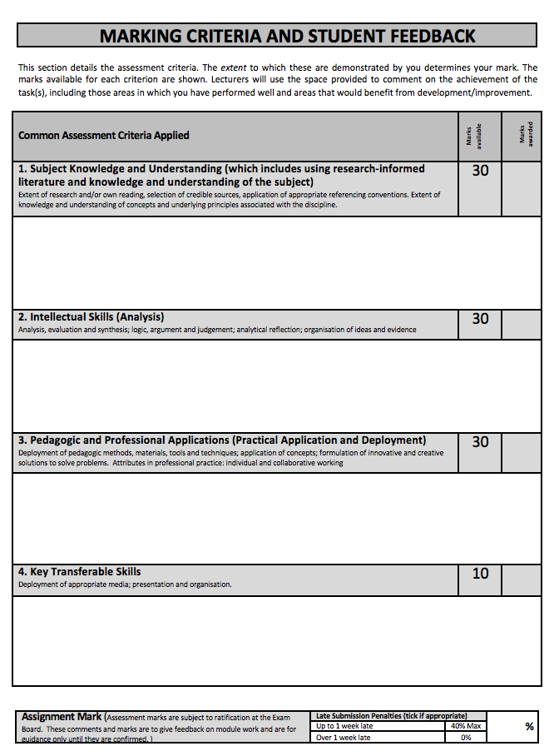
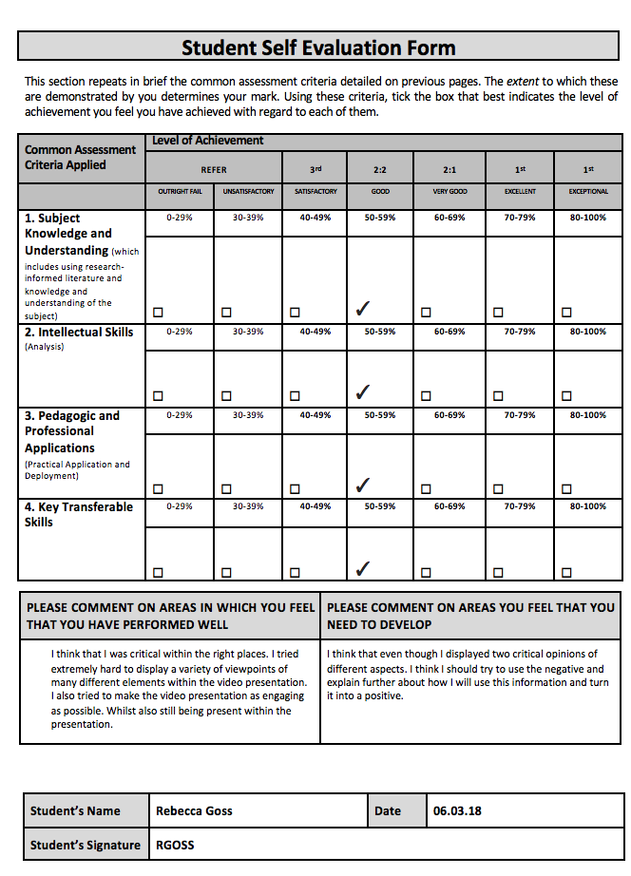
Level 6 | Assessment Criteria Descriptors for BA Primary Education with QTS  This format emphasizes the holistic nature of judgements to be made by markers. Criteria weighting is adjusted for each module.
 | 0-39 (F) | 40-49 (P) | 50-59 (P) | 60-69 (P) | 70-79 (P) | 80-100 (P)
 | Poor / Weak F | Satisfactory 3rd | Good 2:2 | Very good 2:1 | Excellent 1st
Assessment Criteria | Poor, superficial, unsystematic, incomplete and/or inaccurate | Satisfactory understanding of main issues demonstrated | Good understanding demonstrated with some analysis | Very good understanding of basic principles and relevant evidence, with a coherent and logical argument | Thoughtful answer informed by wider reading, showing clarity of thought and personal insight | Outstanding answer, well written, highly structured and informed, showing striking personal insight and originality
Module Learning Outcomes matched to: | 0-11 | 12-14 | 15-17 | 18-20 | 21-23 | 24-30
Subject Knowledge and Understanding  (Conceptual)  (Reading) | Basic misunderstanding, misconceptions, misinterpretations and/or superficial knowledge in places | Overall satisfactory knowledge of the material with some application | Good overall knowledge of key issues with evidence of understanding and application | Very good knowledge of all key issues and wider implications | Excellent knowledge of key issues, concepts and arguments | Authoritative, full understanding of key issues, concepts and arguments
Subject Knowledge and Understanding  (Conceptual)  (Reading) | Some inappropriate literature/material with limited reading range and lack of accuracy | Satisfactory range of reading drawn from the recommended list and other sources | Good range of reading drawn from the recommended list and other sources | Very good range of relevant literature from a variety of sources beyond recommended list | Clear evidence of independent thinking informed by an excellent range of reading from a variety of sources | Clear evidence of independent thinking informed by a selective and well justified range of reading from a variety of sources
 | 0-11 | 12-14 | 15-17 | 18-20 | 21-23 | 24-30
Intellectual skills  (argument)  (critical /reflective evaluation) | Argument is weak, little attempt to present differing viewpoints. Generally too descriptive | Argument is balanced with differing viewpoints | A good, balanced argument is presented with viewpoints justified | A very good argument is presented with careful consideration of viewpoints | A critical argument is presented with thoughtful consideration of viewpoints | A highly-structured critical argument is presented with evidence of synthesis of viewpoints
 | Lack of evidence of evaluation and/or critical reflection | Satisfactory critical evaluation of study; satisfactory reflection | Good critical evaluation of work with good evidence of reflection | Very good critical evaluation of work with good evidence of reflection | Thoughtful critical evaluation informed by very good reflection | Critically reflective evaluation of work informed by excellent reflection
 | 0-11 | 12-14 | 15-17 | 18-20 | 21-23 | 24-30
Pedagogic and Professional applications  (linking theory to practice)  (professional reflection) | Superficial or lack of understanding of pedagogic and professional context(s) | Satisfactory evidence of engagement and understanding with respect to the pedagogic and professional context(s) | Good evidence of integration of theory and practice with respect to the pedagogic and professional context(s) | Very good integration of theory and practice with respect to the pedagogic and professional context(s) | Excellent integration of theory and practice with respect to the pedagogic and professional context(s) | Sophisticated integration of theory and practice with respect to the pedagogic and  professional context(s)
 | Little or no evidence of reflection | Satisfactory evidence of critical reflection | Good evidence of critical reflection | Very good evidence of critical reflection | Effective evidence of critical reflection | Outstanding evidence of critical reflection
 | 0-3 | 4 | 5 | 6 | 7 | 8-10
Key/Transferable Skills  (Referencing techniques) | Weak presentation | Satisfactory presentation | Good presentation | Very good presentation | Effective presentation | Outstanding presentation
Key/Transferable Skills  (Referencing techniques) | A number of basic errors in grammar | Some errors in grammar | Few errors in grammar | Very few errors in language | Minor errors in language | No errors in language
Key/Transferable Skills  (Referencing techniques) | Weak structure of presentation in parts | Satisfactory presentation structure with a mostly coherent style | Good presentation structure with a coherent style | Very good presentation structure which supports the audience | Effective presentation structure which supports the audience | Highly coherent and mature presentation style which fully engages the audience
Key/Transferable Skills  (Referencing techniques) | Little or no use of protocols and conventions of Harvard referencing | Satisfactory use of Harvard referencing protocols and conventions | Good use of Harvard referencing protocols and conventions | Harvard system mainly used accurately, with some secondary sources | Harvard system used accurately including secondary sources | Harvard system used accurately, consistently and effectively with all sources

ECAD6004
Consider how you might be able to develop the creative or enterprising skills of learners through your own pedagogy.

YouTube link to video presentation: https://youtu.be/9wEh0BDOpO4

The video begins with a discussion revolving around the components that combine to make creativity. Amabile (2012) concludes that there are three elements. These are Domain-Relevant skills, such as knowledge and intellect, Creativity-Related processes, that include risk taking skills and independence. Finally, the last component is Task-Motivation, which mainly includes intrinsic related influencers.
This then moves on to a consideration regarding the definition of creativity. Gerlovina (2011) states that creativity is when a fully functioning and beneficial product is produced. Whereas the NACCE (1999) firmly believe that creativity is a procedure underpinned by imagination that creates value and an authentic product. It is ultimately concluded that creativity includes many different skills and elements.
It is then announced that for this assignment, the aim will focus on developing imagination within learners. Vygotsky (2004) states that the majority of our world has been created by man-kind. From cars, lights and computers to shoes, pencils and bags. Everything that has been developed has been a result of imagination.
Seelig (2012) adds to this idea through her model of the ‘Innovation Engine’ this is an internal and external loop that includes all of the elements that can release creativity. One of the elements of this is Imagination. She also explains that in education children are not educated on the processes to undertake in order to enhance their imagination.
The next segment of the video is considering the classroom atmosphere and environment when enhancing learner’s imagination. Sternberg (2006) concludes that environment is a key baseline method in aiding learner’s creativity. As a pupil could internally possess all of the components needed to be creative. Yet, their environment may never provide them the opportunity to flourish. Edwards et al (1995) further explains that the atmosphere in a classroom should include the promotion of controlled risks, as well as the mistakes that come with them. It should also foster imagination growth through the freedom of resource use, in addition to the bright and colourful displays that include pupil’s work and heavy amounts of praise. Both of these opinions are ones that have altered the perception of the classroom environment and have impacted heavily on how it will shape the enhancement of imagination. Next, the possibility of an immersive setting is considered. Grainger et al (2006) suggests that deep immersion into a theme will allow open-ended thinking and persistence to develop within learners However, Beckem et al (2012) highlights the large amount of time consumption and possibility of financial requirements to make the immersion as real as possible has been taken into consideration. It has been concluded that immersive classrooms could be a possibility if it proves extremely beneficial for the pupil’s imaginative growth.
Following on from this, there is a revelation of the teaching strategies that have been identified to develop imagination of learners in education. Both methods can be implemented into lesson time as well as different time intervals in the day, as it is understood that imagination can be developed anywhere at any given time.
The first strategy is Ryan’s Thinkers Keys. Ryan (2013) explains that they are 20 influential methods that aim to generate qualitative thinking. This includes being critical and creative to enhance learning that will occur throughout their lifetime. This method is very closely linked to Bloom’s Taxonomy (1956, as cited in, Forehand, 2011) this is a thinking model based upon six cognitive levels that become more elaborate as the levels increase.
The question from the "What If?" key proposed by the educator would naturally begin with lower-order thinking, and as the topic being learnt progresses, the children will begin to develop their higher-order thinking, as they are gaining more knowledge on the topic.
However, it is also stated that the limitation has been considered regarding the difficulty some pupils may have in moving up to higher cognitive levels, without a heavy amount of support. However, there would be restricted assistance from staff, as the learner’s imagination is wanted to flourish and not be diminished. Although, a way around this disadvantage is to administer the higher-order thinking “What If’s” towards the end of a topic, as the pupils will have been exposed to a large amount of knowledge regarding the theme.
The second strategy is a book called “365 things to make you go hmm” which is developed by a company called Sparky Teaching (2017) who state that this is a resource to develop thinking skills. Inside this book are 365 questions that help to develop imagination.
This initiative allows children to use their divergent thinking and would therefore be support by Joy Guilford (1967, as cited in Anioko, 2011) divergent thinking is described as the use of imagination in which there are many possible solutions to a question being portrayed. However, this strategy is opposite to DeBono’s Parallel thinking theory (2009, as cited in ACT Academy, 2017) parallel thinking is when all learners will think in the same viewpoint. Things that make us go hmm is a strategy used for individualised thinking that generates a variety of different answers from many perspectives.
The final segment of the video, addresses the role of the teacher when these strategies are being undertaken. Shallcross (1981, as cited in Craft, 2001) communicates that teachers regularly interfere in the early stages of a pupils learning process. This can then prevent children’s creativity. Because of this, it is also encouraged that staff members will act as facilitators of learning as well as becoming active participants. So that they can express their views, whilst not having an impact on the learner’s creativity. It can also make the children feel more comfortable that their teacher is learning with them and diminishes the idea of hierarchy between teacher and pupil.
Finally, the role of the teacher during the use of these strategies to improve imagination within learners has also been considered. As well as the views shared by Donaldson (2015) and Welsh Government (2017) around developing enterprising, creative contributors to society through the new curriculum.
Overall, there has been an intense discussion regarding the development of imagination in education. Definitions and components of creativity have been discussed, as well as the implications a learning environment and the role of the teacher has. Two strategies have also been identified and critically analysed using many key authors and theorists to presents a variety of viewpoints and opinions.

References

A crash course in creativity. Tina Seelig at TEDxStanford (2012) TEDx Talks. Stanford. TEDx Talks. [Video] Available at: https://www.youtube.com/watch?time_continue=1&v=gyM6rx69iqg [Accessed: 03.03.18]

ACT Academy (2017) Online library of Quality, Service Improvement and Redesign tools- Six Thinking Hats. [Online] Available at: https://improvement.nhs.uk/uploads/documents/six-thinking-hats.pdf [Accessed: 04.03.18]

Amabile, M, T. (2012) Componential Theory of Creativity. Harvard Business School Working Paper, No.12-096 [Online] Available at: http://www.hbs.edu/faculty/Publication%20Files/12-096.pdf
[Accessed: 01.03.18]

Anoiko (2011) Creativity. [Online] Available at: https://oiko.files.wordpress.com/2011/03/2011_wiki_anoiko_creativity1.pdf [Accessed: 04.03.18]

Beckem, J, M. Watkins, M (2012) ‘Bringing life to learning: immersive experiential learning simulations for online and blended courses’ Journal of Asynchronous Learning Networks. Vol.16, Issue no. 5, pp. 61-71. [Online] Available at: https://files.eric.ed.gov/fulltext/EJ1000091.pdf
[Accessed: 01.03.18]

Craft, A. (2001) An Analysis of Research and Literature on Creativity in Education. [Online] Available at: http://www.creativetallis.com/uploads/2/2/8/7/2287089/creativity_in_education_report.pdf [Accessed: 04.03.18]

Donaldson, G. (2015) Successful Futures - Independent Review of Curriculum and Assessment Arrangements in Wales. Cardiff: Welsh Assembly Government.

Edwards, C, P. Springate, W, K. (1995) Encouraging Creativity in Early Childhood Classrooms. (ERIC Digest) Urbana, IL: ERIC Clearinghouse on Elementary and Early Childhood Education. Available at: https://files.eric.ed.gov/fulltext/ED389474.pdf [Accessed: 04.03.18]

Forehand (2011) Bloom’s Taxonomy- Emerging Perspectives on Learning, Teaching and Technology. [Online] Available at: https://www.d41.org/cms/lib/IL01904672/Centricity/Domain/422/BloomsTaxonomy.pdf [Accessed: 04.03.18]

Gerlovina, Z (2011) Eureka! Unravelling the mystery behind Creativity. Columbia University Academic Commons. Available at: https://academiccommons.columbia.edu/catalog/ac:133035
[Accessed: 01.03.18]

Grainger, T. Barnes, J. (2006) Creativity in the Primary Curriculum. In: Arthur, T. Grainger and D. Wray (eds) Learning to Teach in the Primary School. London: Routledge. Pp.209-225. Available at: http://oro.open.ac.uk/12953/2/4C7A8273.pdf [Accessed: 04.03.18]

N.A.C.C.C.E. (1999) All our futures: creativity, culture and education, London: DfEE

Sparky Teaching (2018) ‘365 Things To Make You Go Hmm…- One Big Question- 365 Days’ Available at:
http://www.sparkyteaching.com/resources/thinkingskills/hmmm.php [Accessed: 04.0318]

Sternberg, J, R. (2006) ‘The Nature of Creativity’ Creativity Research Journal. Vol. 18, Issue no.1, pp. 87-98.

Ryan, T (2013) ‘The most inspiring gift that you can give to a child: Help them to think effectively! Available at: http://www.thinkerskeys.com/#PRODUCTS [Accessed: 04.03.18]

Vygotsky, S, L. (2004) Imagination and Creativity in Childhood’ Journal of Russian and East European Psychology. Vol.42, Issue no. 1, January-February, pp.7-97. [Online] Available at: http://lchc.ucsd.edu/MCA/Mail/xmcamail.2007_07.dir/att-0503/Vygotsky__Imag___Creat_in_Childhood.pdf [Accessed: 02.03.18]

Welsh Government (2017) Education in Wales: Our National Mission- Action Plan 2017-21. Cardiff: Welsh Government.

Image References

Amazon (2018) ‘Astronaut food’ Available at: https://www.amazon.com/Astronaut-Vanilla-Cream-Sandwich-Serving/dp/B0055QS6AK [Available at: 04.03.18]

Amazon (2018) ‘Astronaut helmet’ Available at: https://www.amazon.com/Astronaut-Helmet-Costume-Accessory-Halloween/dp/B0744J3T6P [Accessed: 04.03.18]

Ashar Group (2018) ‘Man on tightrope’ Available at: https://robottip.com/rip-offs-online-computer-repair-and-remote-virus-removal/ [Accessed: 04.03.18]

BoutiquePourbebe (2018) ‘Bag’ Available at: https://www.boutiquepourbebe.com/produit/sac-dos-enfant-skip-hop-2/ [Accessed: 04.03.18]

Clipart Xtras (2018) ‘Computer’ Available at: https://robottip.com/rip-offs-online-computer-repair-and-remote-virus-removal/ [Accessed: 04.03.18]

Dayne Tate (2018) ‘Blooms Taxonomy’ Available at: https://medium.com/@dayna.tate/elearning-research-document-87468bf58d69 [Accessed: 04.04.18]

Development Education (2018) ‘Successful Futures’ Available at: https://developmenteducation.ie/blog/2015/07/successful-futures-a-new-opportunity-in-wales/ [Accessed: 04.03.18]

Edu-Sci (2018) ‘Astronaut food 2’ Available at: https://astronautfood.co.uk/product-category/astronaut-food/?orderby=popularity [Accessed: 04.03.18]

Elizabeth Hogsten (2018) ‘Person on cliff edge’ Available at: http://www.elizabethhogsten.com/about/ [Accessed: 04.03.18]

Evangelicals for Social Action (2016) ‘Child imagining’ Available at: https://medium.com/@dayna.tate/elearning-research-document-87468bf58d69 [Accessed: 04.03.18]

Florida Politics (2018) ‘Two goldfish bowls’ Available at: https://www.theparentgroup.com/2017/09/26/9-surefire-signs-you-ve-outgrown-your-home/ [Accessed: 04.03.18]

Freecliparts (2016) ‘lightbult’ Available at: http://mariafresa.net/clipart/light-bulb-thinking-clipart.html [Accessed: 04.03.18]

Indir.com (2018) ‘Car’ Available at: http://netgaleri.indir.com/windows [Accessed: 04.03.18]

Linkedin (2018) ‘De Bono’s Thinking Hats’ Available at: https://www.linkedin.com/pulse/product-managers-magicians-least-trade-veronica-antonova [Accessed: 04.03.18]

Linkedin (2018) ‘Jigsaw Puzzle Pieces’ Available at: https://www.linkedin.com/today/posts/aca-lalit-chadha-84944b53 [Accessed: 04.03.18]

Linked in (2018) ‘Creativity stop sign’ Available at: https://www.linkedin.com/pulse/20140828215825-15311585-warning-communicators-too-busy-for-creativity-may-be-as-good-as-gone [Accessed: 04.03.18]

Louis Vitton (2018) ‘Shoe’ Available at: https://us.louisvuitton.com/eng-us/men/shoes/loafers-drivers/_/N-1fioqoiZ1ydif2z [Accessed: 04.03.18]

Moovly (2018) ‘Classroom’ Available at: https://www.moovly.com/blog/free-animation-software-yep-thats-right-2D-animations-for-free [Accessed: 04.03.18] This photograph was created by myself

Moovly (2018) ‘Immersive Space Classroom’ Available at: https://www.moovly.com/blog/free-animation-software-yep-thats-right-2D-animations-for-free [Accessed: 04.03.18] This photograph was created by myself

Newsroom (2018) ‘sketch of persons head with different elements coming out’ Available at: https://newsroom.clevelandclinic.org/2017/04/20/why-multitasking-is-bad-for-you/ [Accessed: 04.03.18]

Odyssey (2017) ‘Brain’ Available at: https://www.theodysseyonline.com/500-words-on-learning [Accessed: 04.03.18]

PD4PIC (2018) ‘Person thinking’ Available at: http://laoblogger.com/thinking-black-clipart.html
[Accessed: 04.03.18]

Picpng (2018) ‘Pencil” Available at: https://www.picpng.com/image/pencil-pen-write-sketch-author-png-95100 [Accessed: 04.03.18]

Pinterest (2018) ‘Puzzle pieces’ Available at: https://www.pinterest.co.uk/pin/107453141081523280/ [Accessed: 04.03.18]

Pinterest (2018) ‘The Innovation Engine’ Available at: https://www.pinterest.co.uk/pin/506655026802942864/ [Accessed: 04.03.18]

Requirementsinc (2018) ‘Arrow up’ Available at: http://www.requirementsinc.com/img/icon/PNG/arrow_up.png [Accessed: 04.03.18]

Shutterstock (2018) ‘Group of people working collaboratively’. Available at: https://www.shutterstock.com/video/clip-4130974-stock-footage-an-attractive-and-enthusiastic-mixed-ethnicity-team-of-young-architects-are-holding-a-business.html [Accessed: 04.03.18]

Texthelp (2018) ‘Wales our national mission’ Available at: https://www.texthelp.com/en-gb/sectors/education/education-authorities/ [Accessed: 04.03.18]

The Pinsta (2018) ‘The Moon’ Available at: http://www.thepinsta.com/about-the-moon_*X163tcTpxfeALHTGPuQH42txGRPm3n8IijcBgLOwhg/ [Accessed: 04.03.18]

TK WikiSpaces (2018) ‘Tony Ryan’s Thinkers Keys’ Available at: https://tk.wikispaces.com/Classroom+Ideas [Accessed: 04.03.18]

Simple Mind (2018) ‘Mindmap of What if’ Available at: SimpleMindapp. [Accessed: 04.03.18] This was an image created by myself

Simple Mind (2018) ‘Mindmap of What if questions’ Available at: SimpleMindapp. [Accessed: 04.03.18] This was an image created by myself

Steemit (2018) ‘Intrinsic and Extrinsic’ Available at: https://steemit.com/life/@hannahp/are-you-intrinsic-or-extrinsic [Accessed: 04.03.18]

Wayne K Spear (2015) ‘Astronaut’ Available at: https://waynekspear.com/2015/01/07/winter-tips-for-keeping-warm/ [Accessed: 04.03.18]

Workplace cleaning solutions LTD (2018) ‘What if key’ Available at: https://www.workplacecleaningsolutions.co.uk/key-holder-what-if/ [Accessed: 04.03.18]

10ORT Campus Virtual (2018) ‘Number 2’ Available at: http://campus.belgrano.ort.edu.ar/medios/2017-nm3d/economia-3 [Accessed: 04.03.18]

123RF (2018) ‘People working together’ Available at: https://www.123rf.com/photo_20406487_leader-helps-speaker-up-to-join-him-and-talk-to-a-diverse-audience.html [Accessed: 04.03.18]

