ONLINE PORTFOLIO OF SET EXERCISES

NAME: Ibrar Hussain
STUDENT ID: 2131900
PROGRAMME: BSc Health and Social Care
MODULE: Changemakers: Building your Personal Brand for Sustainable Employment
MODULE CODE: BMHP5015

TASK 1
Digital Health and Innovation Specialist
Introduction
Personal branding is an intentional process of defining, developing and advancing my personal brand, my skill and knowledge, my technology skills, and my values with future employers and colleagues in the growing digital health world. There is no such thing as a too-hard scenario. You build a personal brand and prove my ability and knowledge to navigate the convoluted healthcare system today.
Main Body
I can honestly say my professional profile is getting to be one that is flexible, loves to learn about new health technologies and wants to witness health informatics join patient care. My work is frequently connected to colleagues and mentors as innovative problem-solving and technical resourcefulness. I do need to take some progressive steps towards cross functional stakeholder management and project presentation at an executive level for my brand to grow. I will have professional public speaking masterclasses and take the lead on collaborative digital transformation projects in these areas. The transferable skills developed in these areas will give me a solid and high-level professional credibility that will ultimately help me on my path towards becoming a Chief Digital Health Officer.
Conclusion
Creating a personal brand that is continually developed and refined will allow me to adapt to new opportunities, challenges and trends and remain agile, resilient, and competitive in the changing healthcare landscape. It will be a pathway to substantive leadership achievements and a sustained part to the present healthcare environment through such a strategic agreement.
References
Brands_And_Branding_-_Rita_Clifton_And_John_Simmons.pdf https://www.culturaldiplomacy.org/academy/pdf/research/books/nation_branding/Brands_And_Branding_-_Rita_Clifton_And_John_Simmons.pdf (Accessed: 5 October 2026)
Pawar, A. and Gandhi, R. (2016) ‘The Power of Personal Branding’, International Journal of Engineering and Management Research, 6(1), pp. 840–847. Available at: https://www.researchgate.net/publication/339956223_The_Power_of_Personal_Branding (Accessed: 6 October 2026)

Task 2
Digital Health and Innovation Specialist

Network Map
My Professional Self
(Digital Health Student)

Social Network
- Tech Meetup Peers
- Hackathon Collaborators
Support Network
- Close Family
- Supportive Friends

Community Network
- Open-Source Coding Circles
- Digital Innovation Forums
Career Network
- Health Tech Developers
- Telemedicine Coordinators
- Biomedical Engineers

Rationale
People I connect with point to an open network, and that is my own network. Engage actively with a wide range of people in both the tech and clinical practice world, as well as in academia.
This open structure provides me with abundant bridging capital which enables me to obtain various views on health informatics and digital transformation but also shows constraints in terms of bonding capital and linking capital (Granovetter, 1973). Larger connections to many loose mentors mean that at times during the hard career growing season, I do not have the depth of understanding and ample support from people close to me on an emotional or practical level. More significantly, my network of linking capital is weak; I don’t have influential relationships with Chief Information Officers or hospital board members whose budgets and large-scale implementation projects dictate medical technology.
To reinforce these areas, I plan to do more networking to connect directly with a professional mentor for the health technology leader role and attend executive health technology innovation roundtables. The development of these vertical connections will be able to offer institutional counselling and strategic sponsorship. In the end, adding to my social capital this way will be crucial to developing the credibility and connections needed for success as a Chief Digital Health Officer.

​References
​Granovetter, M.S. (1973) ‘The Strength of Weak Ties’, American Journal of Sociology, 78(6), pp. 1360–1380. Available at: https://snap.stanford.edu/class/cs224w-readings/granovetter73weakties.pdf (Accessed: 8 October 2026)
Bourdieu, P. (1986) ‘The Forms of Capital’, Richardson, J.G. (ed.). Handbook of Theory and Research for the Sociology of Education. New York: Greenwood Press, pp. 241–258. Available at: https://home.iitk.ac.in/~amman/soc748/bourdieu_forms_of_capital.pdf (Accessed: 9 October 2026)

Task 3
Digital Health and Innovation Specialist Blog

Target Audience: Digital Health Practitioners, Clinicians and Health Tech Innovators
Title: Beyond digitization: Embracing digital maturity in modern healthcare
Introduction
The health care field has seen a tremendous surge in technological development, changing the face of health care as we know today. Continuous innovations are fundamentally changing the structure and delivery of patient care ranging from artificial intelligence (AI) diagnostics to virtual wards and remote monitoring systems. While IT systems are becoming ubiquitous in the healthcare space due to their complex nature, healthcare departments are relying on these systems, the industry must move from using modern technology to becoming genuinely maturing in its digitization and drive towards full digital maturity.
Main Body
Digital transformation in health and social care for several years has been all about speed, deploying software and remote technologies to serve the present moment. Designed by the King’s Fund, digital maturity sits on the principles of system interoperability, cyber security governance and patient and clinician user experience, and is today’s focus. However, a true Digital ‘mature’ organization will ensure that technology actually saves time, cuts out medical errors, and isn’t an administrative burden in the clinical workflow.
This maturity needs to be based on the development of detailed digital capability frameworks and on-going training for the health and social care workforce (Care Management Matters 2026). With intuitive digital tools and data literacy training, clinicians and care staff can leverage innovations such as predictive analytics to individualize patient care journeys. Moreover, patients and local communities can co-construct their digital solutions, making technology more inclusive and accessible for everyone.
Conclusion
Technology can only be as effective as its users. The importance of digital maturity and human-centered design can unlock the full potential of health informatics. May we celebrate innovation through thoughtfulness and real change.
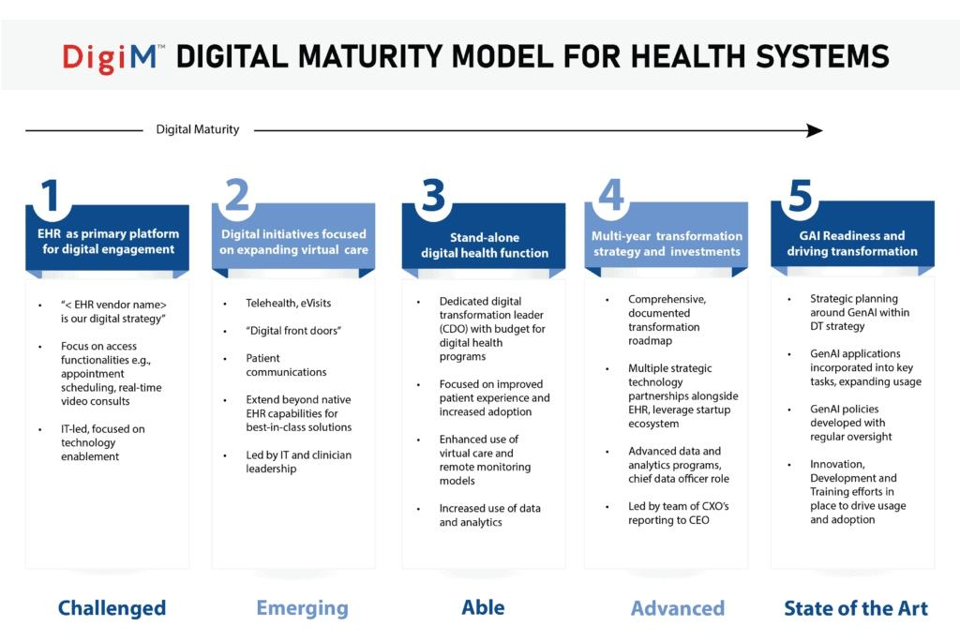

References
​The King’s Fund (2026) Digital Health and AI Conference 2026: What’s real, what’s next and what’s at stake. Available at: https://www.kingsfund.org.uk/events/digital-health-ai-conference-2026 (Accessed: 11 October 2026).
​Care Management Matters (2026) Blog: Paving the Way for Neighborhood Health: Digital Care Summit London 2026. Available at: https://www.caremanagementmatters.co.uk/blogs/ (Accessed: 13 October 2026).

​

Task 4
NHS Equality, Diversity, and Inclusion Improvement Plan
- What is the primary goal of the NHS Equality, Diversity, and Inclusion Improvement Plan?
Eliminate discrimination, raise the accountability of leaders, and create a health service that is fair, inclusive, and transparent.
- How does the NHS EDI Improvement Plan propose to tackle the gender pay gap?
Including pay transparency tools and tracking intersectional metrics in every salary band of the organization.
- What is meant by the term ‘intersectionality’ as used in the NHS EDI Improvement Plan?
Multiple social categorizations (race, gender, disability, etc.) add to systemic disadvantages.
- Why is it important for the NHS to create a psychologically safe work environment?
To foster open dialogue for employees to report experiences and expose poor practices without repercussions.
- How does the NHS EDI Improvement Plan suggest improving the experience of internationally recruited staff?
Making line managers responsible for the career development and local integration of international workers is important.
- What role does leadership play in advancing EDI objectives according to the NHS Improvement Plan?
Boards and senior leaders should access detailed data sets to identify priority areas and monitor progress through assurance processes and demonstrate inclusive values.
- Identify one way the NHS EDI Improvement Plan aims to reduce health inequalities within the workforce.
By implementing structural interventions to tackle health inequities and enhance team-working conditions of marginalized groups.
- Why does the NHS EDI Improvement Plan emphasize the importance of collecting and analyzing data on protected characteristics?
Baseline information helps trust to monitor compliance, identify inequities in sanctions, and foster accountability.
- Explain how flexible working policies can contribute to equality and inclusion in the NHS workforce.
Flexible working expands the pool of candidates and helps to keep experienced candidates who need flexible working.
- What is one strategy mentioned in the NHS EDI Improvement Plan to combat bullying and harassment in the workplace?
Formalizing disciplinary processes and applying zero tolerance policies with psychological care pathways.
Task 5
Letter to Self
​Dear Younger Me,
I can recall the aggravation felt when attempting to manage many complicated health informatics topics, while also adjusting both to the ever-changing requirements of technology and personal stress. On some nights you were watching your screen, thinking that you were completely overwhelmed or felt that if you weren’t watching your screen, someone else was better at it than you.
It was at that stage that you lost the side of your Character Scale due to some frustration and impatience that distorted your emotional intelligence. However, when technology failed, or assignments were too complex, you were prone to being anxious, not analytical. What you were in dire need of was resilience—something that comes from mental agility to have fun with technical difficulties and school challenges as fun problems to solve instead of threats to competence.
Reflecting on myself, I recall that I spend a lot of time practicing regulating my emotions as well as mastering digital tools to get the most out of this each day. The digital health and innovation field of work is crazy-tight, and there will be arbitrary work delays, system incompatibility and institutional resistance. High emotional intelligence will help you work with diverse cross-functional teams, articulate technical ideas with heart and even lead digital transformation efforts without going broke.
Pause, step away from the screen; and believe in your learning ability. Growth occurs right on the edge of pain. You will make today’s frustrations to become tomorrow’s technological breakthrough when you develop resilience and think about emotions. Your future in digital health is very promising and you’re on the right track.
With confidence and proud,
​Your Future Self
​

Task 6
Gantt Chart
Digital Transformations, eMAR and Informatics

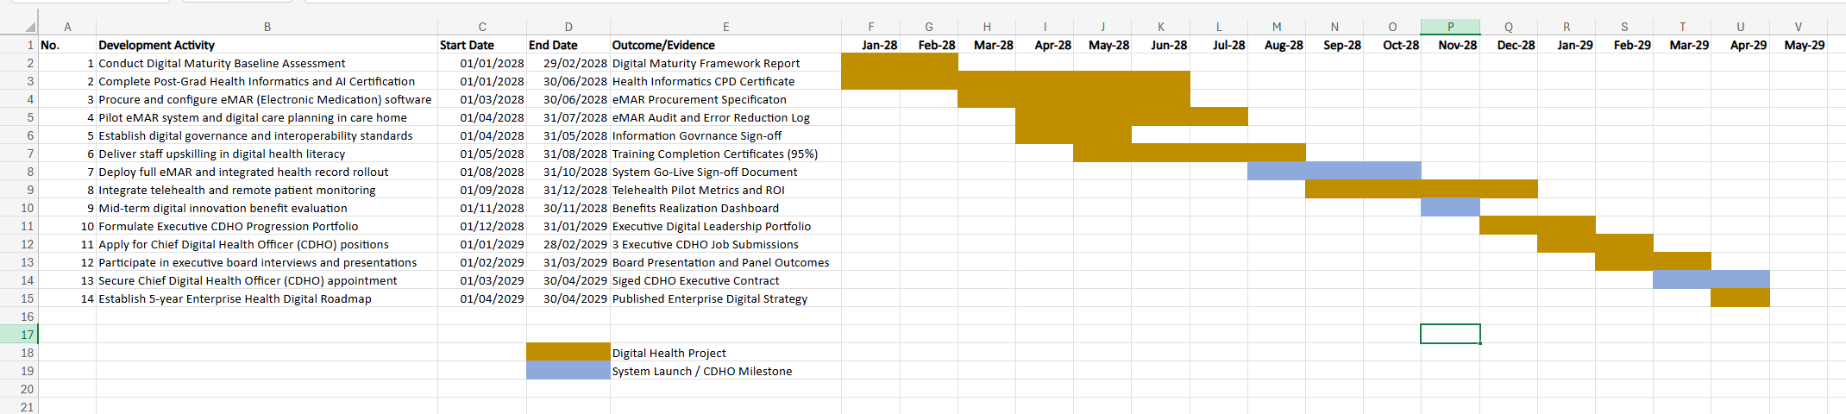

Task 7
Introducing Mobile Point-of-Care Medication Management (eMAR)

Introduction
​I am a manager of a care home in Solihull, West Midlands looking at introducing a mobile electronic Medication Administration Record (eMAR). This digital initiative has successfully reduced medical mistakes, simplified auditing processes, and dramatically improved residents’ safety at our care home.
Planning the Change
​By reviewing medication discrepancies from the past, we will spur urgency using Kotter’s 8 Step Change Model to present our team with a vision of the technology. A digital ‘change coalition’, with senior nurses, care staff and IT specialists, will be established. At our Solihull home across implementation, we will be introducing rugged handheld devices with step-by-step medication reminders. This adjustment connects the worlds of old and new methods to help residents get their doses on time and ensure regulatory compliance.
Skills Required
​In order to accomplish this digital transformation in an effective manner, I need to demonstrate high levels of digital leadership, instructional communication, and project management. Additionally, patience, critical thinking, and the ability to provide guidance on technical issues and soothe software anxiety will be required to help staff overcome technical challenges and remove software nervousness.
Barriers and Solutions
​Some obstacles are the technophobia among the staff and the resistance that may occur by the senior nurses used to the paper MAR charting. To reduce resistance, interactive workshops will be offered and practical issues with medication and administrative responsibilities will be highlighted (Log My Care, 2025). To overcome technical anxiety, individualized coaching and maintenance of a paper backup system will be made a part of the two-week transition period. Clear lines of communication will allow staff feedback to be dealt with promptly, fostering trust and confidence, and developing technological understanding within the team.
Conclusion
​Mobile eMAR technology modernizes the way medications are safely administered. This change ensures clinical excellence and operational leadership in our Solihull care home through strong leadership and structured digital training.

​References
​Log My Care (2025) What is digital care planning? Benefits, tools, and best practices. Available at: https://www.logmycare.co.uk/blog/what-is-digital-care-planning-benefits-tools-and-best-practices/ (Accessed: 19 October 2026).
​Birdie (2026) Digital care planning software: what you need to know. Available at: https://www.birdie.care/blog/digital-care-planning-software/ (Accessed: 23 October 2026).

