Research in Practice: Dissertation Proposal
“Practical effects & Visual Storytelling”

Student name: Georgia Collins
Student Number: 1810445
Course: BA(Hons) : Film & Television
Module: Level 5 “Research in Practice” (ADAD5004)
Wordcount: 2,287 Words excluding title page and bibliography

Introduction
In this proposal, I will analyse the arguably unrecognised power of visual story telling through the art of makeup in film, as well as the effect visual characterisations have on an audience and the overall reception and success of a film. I will also analyse how makeup can progress story in the form of visual developments such as injuries and transformations, whilst also exploring how visual characterisations can give the audience information that precedes what they are being shown on screen. In short, I will explore the correlation between makeup effects and semiotics, themes and subtext in film.
My aim is to argue why practical makeup effects are essential to creating a fully imperforate story world in film and television, and why this is essential to the success of a film or television show, whilst exploring the possibility that the makeup department is wrongly overshadowed by other parts of the art department. My aim is to relate the three key words of Story, Character, and suspension of disbelief to discover a research question for my future dissertation. I will use the makeup achievements of makeup artists Ve Neill, Rick Baker and Greg Nicotero to support my argument.
Character
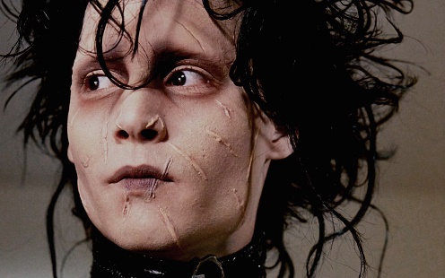
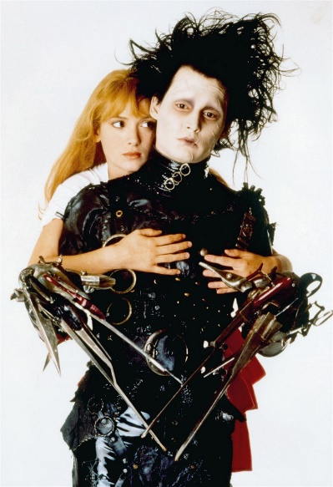
A director has a vision for how their film will turn out. In order to realise the vision and create a successful film, committed actors and well written characters are essential.
A successful film needs a good story, with engaging characters that entice the audience into suspending disbelief and engaging with the story. Characters are arguably the most essential element of a story. They are how the emotion, impact and purpose of the story are portrayed to the audience.
So, what makes a good character, and how does the makeup department affect this? Aside from writing, I would argue that an actor’s commitment to and understanding of a role greatly affects how successfully or unsuccessfully the character is received by audiences. However, there is another very important aspect of character portrayal, their visual characterisations.
Tim Burton’s Edward Scissorhands, with makeup by Ve Neill, is a great example of how character can result in the success of a film; Edward was an incredibly sensitive and caring character, as shown in the portrayal by Johnny Depp, which was able to provoke empathy from viewers. However, the story behind the character and how he came to be the person that audiences loved, would not have been possible to convey without the work of Ve Neill and her makeup department. For stories like Edward Scissorhands, it is imperative to have the visual differentiation from the story world’s “norm”. Edward looked strikingly different which invited controversy around whether he could be trusted. This is symbolised in his scars and pale face – whilst the audience may be shown part of his backstory in film, they serve as a visual reminder throughout the entirety of the feature. A true underdog always needs a reason to be rejected from society.
You could contend that the character’s backstory and development could have still been visually portrayed to viewers by the character’s costume. This would have informed the audience as to his Scissorhands, yes, but the scars on Edward’s face symbolise his struggle, his hurt, which is what provoked empathy in the audience and caused them to connect with him. Without the visual hint to his sad past, it is possible that the audience would have just considered him an oddity and not recognised the sensitivity and humanity within him. Edward’s scars are furthermore a visual explanation to both audience and characters in the story world of the film of his hesitance towards social contact, his reluctant demeanour and his fragility. The scars tell a story of their own which is tremendously useful in fleshing out Edward’s overall character and the way other characters perceive him, both elements that affect the story, aswell as a constant visual theme of exclusion and isolation. Therefore, whilst the character could exist without characterisation through makeup, it would not have had the same effect on audiences, or the same overall success.
One might also state that without the makeup department, the actor’s portrayal of the character could suffer, for a few different reasons. Many actors might use the time in the makeup trailer to mentally get into character, whilst they are physically put into character. The physical transformation process may allow the actor to become more immersed in their role, further away from themselves. It is a designated part of each day on set where the actor is only committed physically to sitting, or standing, for makeup. If the makeup department did not exist, and consequently this part of an actor’s process did not exist, the actor would have no designated time, or physical change, to transition between themselves, and the character. This could make the mental preparation harder for the actor, as well as making them feel further from the character, as they would look just like themselves, not the character they are portraying.
"The first time I made myself up, I was looking at my reflection in the mirror and it wasn’t me looking back. It allowed me to do things I couldn’t do as myself. I found out how powerful that was and how much that can mean to an actor." Rick Baker
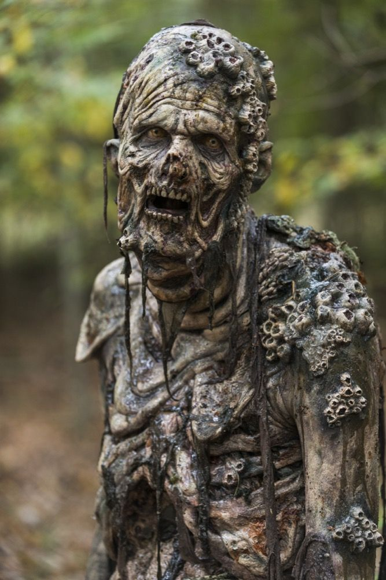
Story
We have established the importance of visual characteristics to portray character and character back story to the audience, but how important is this to the overall depiction of the film’s story?
If an audience is watching a film with a storyline that is far from reality, the visuals need to match. An audience watching a film with a post-apocalyptic story line, are not going to believe the story world they are watching unless they see visual representation of that on the screen. “There is no more frustrating experience than to stand at the back of a theatre and hear the cries and catcalls of one of today’s irreverent audiences when a film doesn’t pay off. In the fantasy and horror genres, perhaps the single most important contribution to that payoff is made by the special effects artist” (Romero, 1983,p8).
For instance, when analysing the success of makeup artist Greg Nicotero’s “The Walking Dead”, one could argue that it would have never reached the success it did if the show’s practical makeup effects weren’t so believable and realistic.
The visual representation of the state of humanity shown by the “walkers” and the threat they pose to the characters in the show creates a very real sense of fear in the audience, both from seeing such a creature and the audience immersion that this threat to the characters causes. The walkers carry a heavy subtext – the fragility and sparseness of human life within the story; every time a walker is shown, it is always recognisable that they were once human. This works to unsettle the audience and distil an underlying anxiety about the state of the world, something that couldn’t be achieved without the visual impact of makeup effects.
Without the visual depiction of the walkers, and the injuries characters sustain, the story world of the walking dead would lack realism and believability, resulting in the audience being unengaged, and struggling to suspend their disbelief. This shows not only how characters are so important to an audience’s engagement with a piece, but also that without the makeup department an on-screen story world would have an underwhelming effect on audiences.
When considering how makeup affects story, there is not only the matter of creatures, suspension of disbelief and complete story worlds to consider. There is also how makeup is used to progress plot, for example, to show the passing of time through the aging of a character or the ageing of an injury, or to depict an injury that would then change the situation on screen provoking some emotional reaction from viewers whether it be fear, sadness, anticipation, relief… For example, in The Walking Dead, zombie bites seen on characters create heightened emotional engagement, as the audience is seeing something that, though unspoken, will have serious impact on the story; a beloved character could be lost, or perhaps a villainous character concealing a bite could create audience anticipation for the consequences; all this can be conveyed with just a quick glimpse at a piece of makeup on an actor.
On the contrary, one could argue that the same plot point could be conveyed to an audience without the use of makeup, which to some extent is true. Perhaps the use of dialogue would be sufficient, or maybe the filmmakers could take advantage of the amazing technologies we now have, such as CGI. However, delivering plot points through dialogue is not always the most sophisticated or seamless method; when done right it can work just fine, but one risks spoon feeding the audience information about the story, which can destroy the experience. There’s also less emotional impact when things are told not seen – for example, this moment in The Walking Dead,
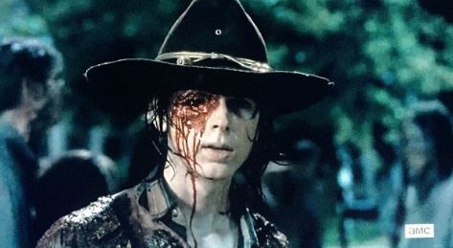
the audience see a fatal wound on one of the shows main characters, this is sure to have a much deeper emotional reaction from the audience as they have to learn and accept for themselves what’s happened to a character they’ve been following for 6 seasons of a show, rather than be told.
Though this shot could have been made with other methods like CGI, these can be incredibly expensive and time consuming; a luxury many productions might not be able to afford, though even if they could afford CGI, it is much more cost efficient, time efficient (and more often than not much more realistic) to use practical effects.

Immersion – suspension of disbelief
“The biggest challenge facing a movie director is that belief must be suspended in the audience or all is lost” (Romero, 1983, P8).
The idea of suspending disbelief – voluntarily surrendering logic and reality for the sake of enjoyment – is not only essential for a successful film experience, but also for achieving optimum impact on an audience. When it comes to non-documentary films, without suspension of disbelief, a viewer becomes passive, too aware that what they’re watching is fictional, or that they’re watching an actor play a person, not really seeing the person that is supposed to be portrayed. This then results in a disengaged audience, and with a disengaged audience comes minimal narrative impact which you could argue means limited overall success. The suspension of disbelief is important across all genres of film, however it is particularly important in the fantasy and horror genres since the stories are depicting things that don’t occur naturally in our reality.
Take for example, America Werewolf in London (Landis, 1980). This film features an iconic on-screen transformation of a man into a werewolf created by makeup artist Rick Baker. Realistic makeup effects are always important in the horror genre, however this film is unique in the fact that its transformation of an actor into a beast happens on screen, within the narrative, for the audience to see. It’s very hard to deny something when you see it happening right in front of you- and this is the case for the audience viewing An American Werewolf In London. Not only is it narratively effective for the audience to see the transformation, it’s doubly affective since the use of practical affects really is a real transformation, and the audience now gets to appreciate that rather than assume it happens in the makeup trailer. Since the effects are so realistic, and the sequence is so detailed, it is a completely immersive experience for the audience that just would not have been possible without the use of practical makeup effects. Of course, these practical effects worked in conjunction with an amiable use of sound, acting and cinematography, but the visual element the makeup gave made a film sequence that audiences would admire still to this day. Other films have done similar things with the use of CGI, and none have the impact a practical makeup transformation had on the audience of AWIL in the eighties.
However, makeup is not just essential to horror. If we consider the very realistic film, Requiem for A Dream (Aronofsky,2000), what effects of drug abuse would we have seen on the characters? No track marks, no under eye bags, no cold sweats, no pale faces. How can a film with such a dense story line and troubled characters be conveyed properly by actors who look the pinnacle of health, with no visual signs of stress on them? Of course other visual ques such as drug paraphernalia could be used, but how could an audience believe these characters were poisoning themselves if they didn’t look the part? In dramas makeup can be even more important than in horror or fantasy, because in drama for the audience to suspend disbelief they need to see something, or something near enough, scientifically and anatomically correct, even in fiction.
Conclusion
Film is first and foremost a visual artform, so naturally part of the experience is piecing together some of the story from visual ques; if the entire story was delivered to the audience through dialogue, it would be a very shallow film, disengaging to the audience. Practical makeup effects can give so much depth to a character and their backstory, the emotional stakes of the plot, the progression of the plot, and primarily, how believable the story is to an audience. One might read this proposal and argue that this thesis only applies to the horror and fantasy genres, to which I say there would be no biopics such as Bohemian Rhapsody without a team of makeup artists ready to turn rami malik into Freddie Mercury. There would be no realistic injuries in Casualty, no visual signs of drug abuse on the characters in Requiem For A Dream, no gender benders, no Mrs. Doubtfire. Actors would just be themselves in costume on a screen. Which might be passable for films like romantic comedies, or many comedies in general, but how could an audience suspend disbelief in anything other than a comedic sense without some form of makeup effect? As a result, I propose that my final year dissertation be based around the question: “Can an audience suspend disbelief without the use of practical makeup effects?”

Bibliography
Buckland, W., 1999. Film semiotics. A companion to film theory, pp.84-104.
Chandler, D., 2017. Semiotics: the basics. Taylor & Francis.
Carroll, N., 1994. Visual metaphor. In Aspects of metaphor (pp. 189-218). Springer, Dordrecht.
Coëgnarts, M. and Kravanja, P., 2012. Embodied visual meaning: Image schemas in film. Projections, 6(2), pp.84-101.
Savini, T., 1983. Grande Illusions: A Learn-by Example Guide to the Art and Technique of Special Make-up Effects from the Films of Tom Savini. Imagine (PA).
Sebeok, T.A., 2001. Signs: An introduction to semiotics. University of Toronto Press.
Whittock, T., 1990. Metaphor and film. Cambridge University Press.

