12/3/2025
University of Wales Trinity Saint David

Module Name: Software Solutions for Business
Module Code: ACCB 4026

Student Name: Alison Sherman Vas
Student ID: 2513127
Group: 1

Lecturer’s Name: Fahad Ahmed

Table of Contents
Introduction 2
Task 1. e-Commerce Website builders or software solutions 3
1.1 Big Commerce 3
3
1.2 Wix 4
Task 2. Mind-map of contemporary software applications 6
a. Mind mapping and explain the benefits of using mind mapping in business operations 6
b. Create a mind map of contemporary software applications 7
Task 3. Office Applications 8
a. Four office software solutions for business operations 8
MS Word 8
MS PowerPoint 10
MS Excel 11
MS Access 13
b. Practical demonstration of Two Office Features 15
Goal seek 15
If Statement 16
Task 4. Communication and Collaboration applications 17
a. One contemporary Communication and one Online Collaboration applications/tools 18
Trello 18
MS Teams 19
b. One feature of a freely available Communication (1) and one feature of a Collaboration (1) application 20
Trello 20
Ms Teams 22
Conclusion 23
References 24

Introduction
In the current digitalized world that is fast-paced, organizations are now dependent on the use of modern software systems in order to be more productive, streamline operations, and remain competitive. The fast development of e-commerce sites, office software, communication and teamwork-related technologies have changed the manner in which businesses operate in all fields. Since they allow making sale online with flexible web builders and optimizing company operations with office software like MS Word, MS Excel, MS PowerPoint and MS Access, nowadays, everything in daily business is based on digital tools. In addition, customer facing and internal communications and collaboration have been greatly reinforced with the modern technology like Microsoft Teams, which combines messaging, video conferencing, file-sharing, and workflow management all in one platform. Mind- mapping programs have also been required in planning, brainstorming, and strategic decision making since the complex information is simplified visually. The project examines how the use of modern software solutions, such as BigCommerce, Wix, office applications, and collaboration tools, can be used to support business processes, increase productivity, enhance communication, and facilitate the effective decision-making process in the current digital organizational environment.

Task 1. e-Commerce Website builders or software solutions

1.1 Big Commerce
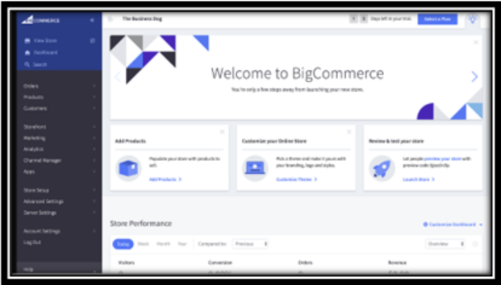
BigCommerce is one of the most famous e-commerce platforms based on SaaS that belongs to small business and great enterprise. It is reputed to have a powerful built-in functionality, good performance and can be scaled without using third party applications as essential functionality [1].
Major Features
The set of native tools provided by BigCommerce includes an unlimited number of variations of products, the sale in multiple channels with Amazon, eBay, Instagram, and Facebook, tools of SEO optimization, abandoned cart recovery, product filtering, and customization themes. Its decapitated commerce attributes enable engineers to interlink BigCommerce to outside front-end structures, permitting large brands to create a highly adaptable storefront. It also comes with inbuilt payment gateways and sophisticated analytics as well as robust inventory management. Also, BigCommerce is scalable to the enterprise level and can support high traffic and large catalogues without the need to stress the performance. It is API-based and can be easily integrated with the CRM systems, ERP, or third-party logistics providers, so it is recommended in cases of the businesses with complicated operations.
Benefits
Scalability is one of the advantages of BigCommerce. It has been built to support the large product catalogues and high traffic volumes which makes it ideal with the growing businesses. It has lower transaction charges and hence merchants retain more of their income. Numerous other features like multi-currency, professional reporting, and SEO tools are integrated as well without the need to use other applications, which makes it cost-effective in the long term. The platform is also very easy to integrate with the ERP, CRM, and marketing systems.
Limitations
BigCommerce may be difficult to use because of the features that the novice user can access though it is powerful. Its price levels upgrade automatically according to sales volumes per year which can be costly to fast growing businesses. Coding knowledge might also be needed to make some of the design customizations, particularly with a very specific layout or modification. The app market is a bit smaller than Shopify, though it remains extensive enough across the board of business requirements [2].

1.2 Wix

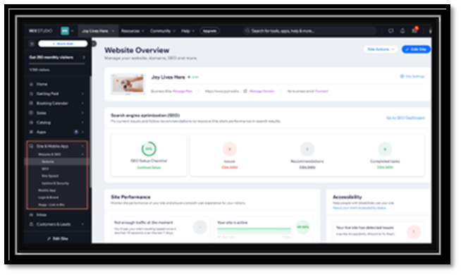
Wix is a versatile, user-friendly web host that currently supports complete e-commerce. It is best suited to smaller companies, business owners and designer brands that want an online store with visual builder that is easy to use and has in-built online selling capabilities [3].
Major Features
The strongest point is that Wix is easy to use, and no knowledge of any type of coding is needed, and the editor of the design allows a perfect preview of all the elements on the pages. It is pocket friendly and has powerful marketing features like email campaign builders, social media management, booking applications, and search engine assistance to assist the businesses to capture and keep the consumers. In the case of small businesses, Wix offers the one-stop shop in terms of web design, branding, and selling online with the minimum of preparation. Its App Market has hundreds of extensions that can be used to add capabilities such as live chat, analytic, payments, and automation and lets users expand their site according to their needs.

Benefits
The design editor gives one accurate control of each and every element in a page and no coding is required. It is not expensive and offers powerful marketing features like email campaign, social media management, booking services, and search engine optimization. To small enterprises, it is a one stop shop to build their websites, brand them, and sell online. The App Market also enables one to add functionality when there is a need [4].
Limitations
Wix cannot be scaled as easily as such platforms as BigCommerce or Shopify. It will fit well in small to medium-sized enterprises as opposed to large ones. Although it is flexible, excessive design freedom at times can result in websites that are difficult to speed up or even make mobile friendly. The more complex features of e-commerce like complex product variations, enterprise level integration's or large scale inventory operations could also be restricted compared to dedicated e-commerce solutions.

Task 2. Mind-map of contemporary software applications

Mind mapping and explain the benefits of using mind mapping in business operations
Mind mapping refers to a visual thinking methodology that is applied to the arrangement, analysis, and the presentation of information in a non-linear manner. In contrast to the old method of note taking, in which ideas are organized in a top-to-bottom or left-to-right order, mind mapping involves a central idea in the centre of a given page and gives related ideas an opportunity to radiate out in various directions. This network-like structure is the natural way that the human brain processes information - by association - and thus the mind mapping is an effective method to enhance understanding, creativity, and memory. Tony Buzan popularised the idea of mind mapping and outlined it as the way to capture ideas and to use keywords, images, colours, and curved lines to activate both sides of the brain and enable further understanding [5]. Mind maps are often made with the assistance of visual items, such as symbols, colours, keywords, and hierarchical branches.

These aspects assist in simplifying complicated subjects into small interrelated parts. The technique has been further facilitated by digital mind- mapping tools like Mind Meister, XMind, Miro, and Canva which can enable people and groups to work together live, save maps online and even incorporate them into project management processes. Mind mapping has emerged as the key organizational and decision making tool in the contemporary business setting whereby huge volumes of information need to be assimilated in a fast and strategic manner. Mind mapping has several notable advantages in the operations of the business. Better clarity and organization is among the main benefits[6].

Mind mapping helps employees to systematize the information in a manner that brings out relationships among ideas, processes, or business functions. It is particularly handy in the process of planning, strategy formulation, or solving a problem, where it is important to find relationships. To illustrate, a mind map can assist a company to divide a fresh marketing plan into branches including target audience, budget, content strategy, channels and the anticipated results and the whole structure can be easily visualized and is easy to see at a glance. The other significant advantage is increased creativity and generation of ideas. Due to the ability to freely associate and structure ideas and information without any rigid order, mind maps stimulate creativity and promote brainstorming exercises.

Employees are able to contribute ideas at a very high rate without considering order and this contributes to more innovative solutions. This comes in handy especially in product development, process improvement, and innovative marketing. Mind mapping also enhances communication and teamwork in organizations. Mind-mapping software enables members of the team to access the same workspace and generate a shared image so that all could see the relationship between their ideas and the larger objectives. A mind map simplifies the process of making contribution during meetings or planning session, clarifying of responsibilities, and making sure that every team member understands the project. This illustration eliminates misunderstanding and solidifies teamwork.

Besides, mind mapping increases productivity and decision making. The employees are able to make quicker and more informed decisions because complex information is simplified. Mind maps can also map out processes, prioritize and point out risks or challenges and so it could be worthwhile to project managers and leaders. All in all, mind mapping is a flexible and an effective tool that improves the process of thinking, planning, communication, and collaboration in business operations. It helps organisations handle information in a better way, bring creativity, and promote strategic decision making in a more complex business environment [7].

Create a mind map of contemporary software applications

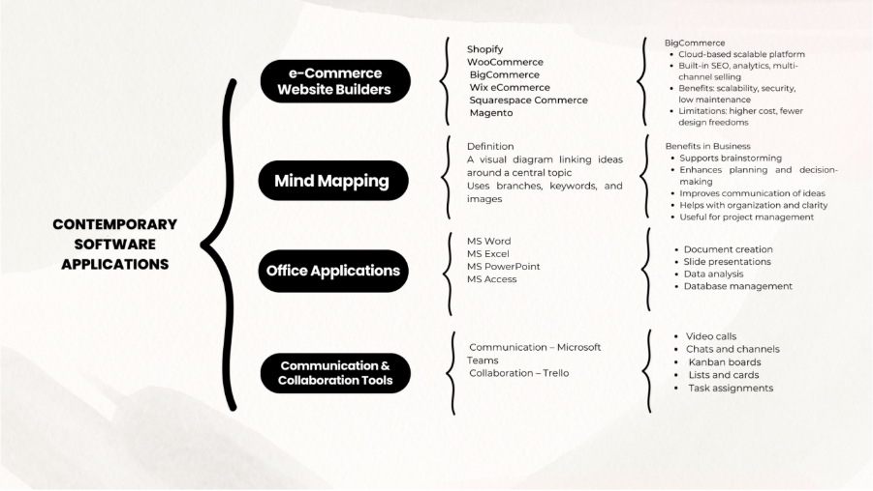
Figure 1 Mind Map

Task 3. Office Applications

Four office software solutions for business operations

MS Word

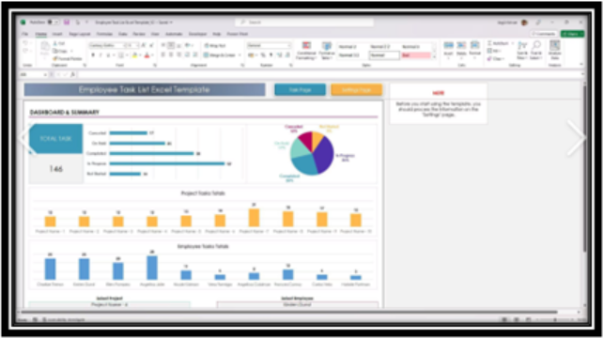
Microsoft word is a word processing program that is widely used in contemporary businesses. Word is developed by Microsoft and is a component of the Microsoft office, which can be used to create, edit, format, and share written documents with powerful tools. It is applied in all industries in writing reports, preparing proposals, business letters, memos, project documentation, forms, and policy manuals. Since the initial release of the software, it has improved greatly, and it has sophisticated features to work at high productivity, professionalism, and cooperation[8].
The extensive formatting features of MS Word are also a major strength of the software. The fonts, styles, spacing, margins, and layouts can be adjusted by the users to create properly structured and attractive documents[9]. The pre-created templates (resumes, business letters, brochures, and reports) enable the employees to save time and ensure a similar level of design of the whole organisation. Word has the Styles feature that enables the user to use the same heading, subheading, and text styles to make the document look professional and easy to navigate. MS Word can also be used because of its editing and proofreading features.
The spell check, grammar check, thesaurus, and readability statistics are some of the features that enable users to produce the best and error free documents. Track Changes and Comments are the tools of teamwork, it is necessary to use them in case of joint work with several people, who need to review or edit the document. The user can underline the recommendations, provide comments, and approve or decline edits, which makes Word a perfect experience in joint writing, like preparation of reports or reading of policies[10].
The other significant advantage is that it can be used and integrated with other Microsoft office programs. Word has the capability of importing tables in Excel, embedding Power point slides, and connecting to outlook to do mail merging. The Mail Merge option is particularly useful in the business context to produce mass personalized documents (letters, invoices), or labels. In the latest editions of MS Word, there is robust cloud integration, based on OneDrive and SharePoint.
This allows real-time collaborative work that enables several collaborators to work on the same document at the same time and at various locations. Another benefit of cloud storage is that it automatically saves data, provides a history of versions, and can access vital information remotely, furthermore, enhancing efficiency and minimizing the possibility of losing data.
The MS Word has also sophisticated functions like addition of table, image, charts, shapes, hyperlink, citation, and reference thus it can be utilized in academic writing, technical documentations, and comprehensive business reports. These applications such as the Navigation Pane and the Outline View are useful to assist users in organizing, managing, and restructuring long documents such as manuals, proposals, or research papers. Security functions such as password control, limited editing, encrypted documents and digital signatures give organizations firm control over sensitive or confidential documents. Word also has accessibility tools or has the Accessibility Checker, text-to-speech, and dictation so that every worker can use the documents.
Although MS word is a very versatile program it is not without limitations. Documents with high media density can be rather slow and some functions are not simple to learn without training in the hands of a new user. The Microsoft 365 subscription is also based on recurring expenses. All in all, MS Word is a very critical tool in the contemporary business world because of its flexibility, user-friendly interface, formatting features, professional templates, and collaboration features. It assists in a wide scope of conducting business because it allows the employees to design precise, effective, and clear documents.

MS PowerPoint

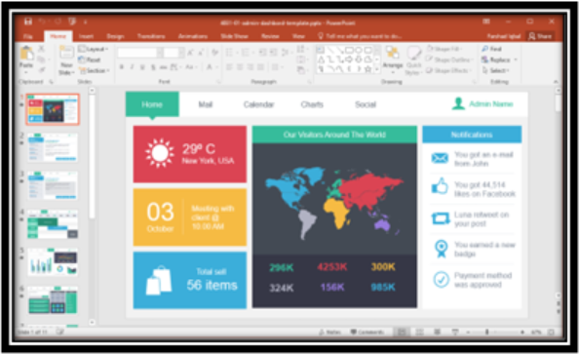
Microsoft PowerPoint is one of the most popular presentation software which is commonly used to make interesting and attractive presentations in business world. PowerPoint, which is part of the Microsoft Office package, can be used to create slideshows to use during meetings, training, marketing presentations, project updates, workshops, and conferences. It is a communication and information delivery tool that is diverse with its capacity to integrate text, images, graphics, audio, and video[11].
The user-friendly interface is one of the greatest advantages of PowerPoint as any person regardless of his or her skills can develop a structured presentation within a short time. There is a variety of ready formats and themes in the app that assists users to be consistent in the use of colour schemes, fonts, and layouts. This makes sure that the presentation appears professional without high-level skills of designing. The basic features of PowerPoint are text boxes, images, charts, tables, SmartArt graphics, and AI-assisted design suggestions[12].
The tools enable businesses to display data pictorially and make complex data easier to understand by the audience. SmartArt is especially helpful in depicting the processes, organizational chart, hierarchies and time lines. Meanwhile, chart tools assist the user to input the data contained in the Excel and transform them into a clear visual representation using bar charts, pie charts, and line graphs.
The next significant advantage of PowerPoint is that it allows multimedia. The user will be able to add videos, audio narrations, animations, and transitions to provide dynamic and interactive presentations. It increases the level of participation of the audience, particularly when it comes to training or sales presentation. Slide show mode, the presenter view, and laser pointer are features that enable presenter to present information with confidence and professionalism.
PowerPoint also enables teamwork and integration on cloud. Using Microsoft 365 and OneDrive, several users are able to collaborate on the same presentation and make comments or give feedback, in real time. This tool can prove to be particularly useful when making group presentations, interdepartmental reports, or management updates. Also added in the recent years, PowerPoint has added sophisticated functionalities like Designer, which automatically improves slide layouts, and Morph Transition, which provides smooth transition effect between the slides to tell stories in a more advanced way.
The additions allow users to create high quality presentations without needing to have sophisticated design and technical expertise. PowerPoint is also valued by the businesses because of its multi functioning in meetings. Slides can be shared via email, imported and exported in PDF form or directly presented using Microsoft Teams and Zoom or alternative conferencing software.
PowerPoint will also be able to make handouts, speaker notes as well as digital slide decks to participants. However, PowerPoint has limitations, despite its benefits. When the text on the slides is too many or the graphics are complex, the message is likely to be lost, and the audiences will be bored. Now, animated features can also be used in an excessive way, which will also draw attention out of the central content.
Moreover, PowerPoint must be designed carefully to be professional, bad designed slides may diminish the efficiency of a good message. Overall, MS PowerPoint can be viewed as an important business tool as it has a high visual content, simplicity, and collaboration features, and can be used to support presentations in a wide spectrum of business processes. It remains vital in communication, training, reporting, marketing, and decision-making in organizations.

MS Excel

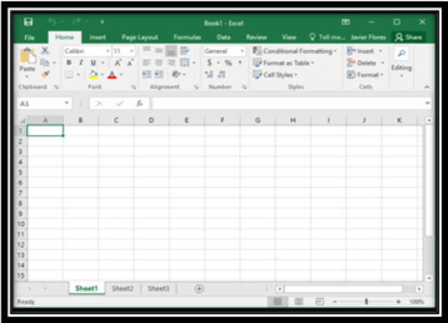
Microsoft excel is among the most robust spread sheet software applied in conducting business operations in management of data, analysis, financial planning, forecasting, and reporting. Excel allows one to arrange the data within rows and columns, use formulae, create charts, and complete complex calculations. Excel, as an element of the Microsoft Office package, is important in assisting in decision-making and enhancing efficiency within an organization. The fact that it is capable of handling massive data is one of the greatest assets of Excel[13].
Thousands of rows of information can be entered, stored, and manipulated by the user. Employees can do their calculations very fast and with high precision with sum, average, IF, VLOOKUP, and countif functions. These roles assist companies to examine sales data, monitor costs, determine profitability, and assess key performance indicators (KPIs). Excel is also reputed by the data analysis tools.
Such capabilities as PivotTables and Pivot Charts enable the users to sum up and visualize data trends without modifying the original dataset. PivotTables are applied to expenses reports, sales reports, employee performance, and customer insights used by businesses14]. Conditional formatting allows users to point out such significant patterns as growing sales, outstanding bills or depleting stocks using colour-coded formulas.
The other significant advantage of Excel is that it has financial modelling. Excel helps organizations to develop the budgets, predict revenues, calculate the investment alternatives, and develop the future operations. Functions and templates that are built-in can facilitate the work of break-even analysis, cash flow forecasts, loans, and cost-benefit comparisons. Excel also has data visualization in terms of charts, graphs, and dashboards. These graphics assist managers to learn about trends, performance comparison with time and present data at meetings. KPI tracking, project monitoring, and management reporting are common examples of using the Excel dashboards in business.
Another good characteristic of Excel is integration. It also integrates with other Microsoft packages like Word, PowerPoint, Access, and Outlook. Users are able to import data, automate processes with macros, or interpret information that has been exported out of CRM systems, accounting software, and ERP systems. Excel has also collaboration tools in the form of OneDrive and SharePoint in which more than one user can edit a file at the same time. Version history can be used to show the past changes that can be revised or restored, as necessary [15].
The above characteristics result in Excel being applicable to team work projects or financial reports that need to be fed by various departments. There are limitations to Excel however. Very large data can be rather slow in performance, and the more complex features like macro programming or intricate formulas can need expert skills. Mistakes in equations may give wrong answers unless they are thoroughly checked. Also, Excel does not serve well in real-time multi-user information entry that is on a large scale; database systems are more effective in that case. Regardless of such limitations, Microsoft Excel is one of the most indispensable business applications, because of the ability to manage data, analytical tools, and flexibility. It helps in decision making, operational planning, financial analysis and reporting in industries.
The use of Excel in many organisations still exists since it can fit in diverse situations, both simple and intricate modelling. Its ease of use, personalisation and strong calculating capabilities make Excel relevant even in the contemporary working environments despite the emergence of more advanced data analysis tools and BI platforms.

MS Access

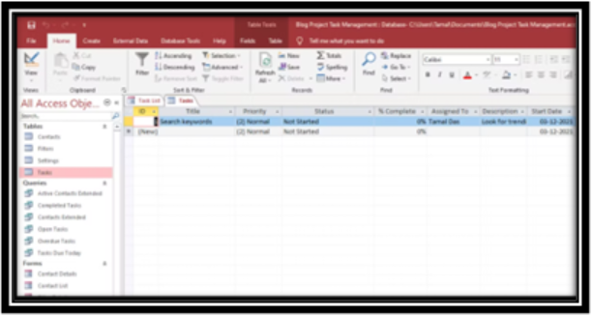
The Microsoft Access is a database management system (DBMS) creating a system to store, organize as well as manage structured data in organizations. In contrast to Excel, which is created with the main goal of spreadsheets calculations, Access is created to work with the creation of relational databases that can deal with bigger amounts of information more accurately and predictably. One of the most common uses of access is in small to medium-sized businesses to track inventory, customer records, employee details, and forms and generate reports[16]. One of the strengths of the MS Access is that it has the capability of storing data in relational tables. This implies that the information can be broken into various tables e.g. customers, orders, products and connected with each other using relationships.

This removes the duplication of data and enhances consistency. As an example, once a customer is registered, he/she can have various orders attached to its account, eliminating the possibility of errors or enhancing efficiency. Access also offers easy interface to drawing databases without the need to have advanced programming skills.

The software has default templates that are set up to track an asset, project, and contact database as well as event schedule. Users are also in a position to create custom tables, queries, form, as well as reports depending on their business requirements. The drag-and-drop interface can be used to design databases with a wizard and step-by-step instructions, which can be done by even non-technical employees.

The Query system of the Access is one of the strongest ones[17]. The queries enable the users to filter, sort, and extract certain data in large tables. This will result in Access being handy in creating customer lists, monetary overviews, pending orders, or performance analysis. It is also easy to carry out complicated data manipulation as queries can also do calculations, automatically update data and pull information across multiple tables.

Forms that facilitate easy access to data and Reports that enable professional presentation of data are also availed by Access. Form enables the employee to enter data using easy to use forms instead of manipulating tables. Reports also allow users to make formatted reports like invoices, summaries, dashboards, or performance reports to the management.

Also, Access has macros and VBA (Visual Base applications), which enables automation of repetitive procedures and optimization of workflow performance. Another advantage is its integration with other Microsoft applications. Access can read data in Excel, write out reports to Word or PDF, and integrate with Outlook to automate email. It can also be used as a front-end interface, but it stores data on SQL server and hence it is flexible to bigger organizations. This interoperability helps businesses to capitalize on the existing Microsoft ecosystems.

Nevertheless, there are drawbacks of MS Access. It cannot be used in very large databases or high-traffic multi-user facilities. It can reduce performance using millions of records or multiple concurrent users. It also lacks cloud-support as much as modern online database platforms do. Irrespective of these shortcomings, MS access will still prove useful in businesses that require low-priced and flexible database system. It is easy to use, relational, can be integrated and has strong queries making it suitable in handling operational data, enhancement of accuracy and automation of daily business operations.

Access offers a viable solution to organizations that want to consolidate their information, streamline their data management, and optimize the decision-making process without having to spend on costly enterprise systems.

Practical demonstration of Two Office Features

Goal seek
Goal seeks in excel is a tool that can be used to determine the input value required to reach a particular outcome in a formula. An example of this is when you are aware of the monthly loan payment you want, and you are not aware of the interest rate being charged, you can use Goal Seek to produce the interest rate. You give the formula in the cell (e.g., monthly payment), type in the amount to which you want the payment to be (e.g., $900) and tell Excel which cell you want to adjust (e.g., interest rate). Excel will automatically "fine-tune the input then until the formula delivers the desired result and thereby, it is an easy method of finding a solution to what-if questions without having to resort to trial and error.
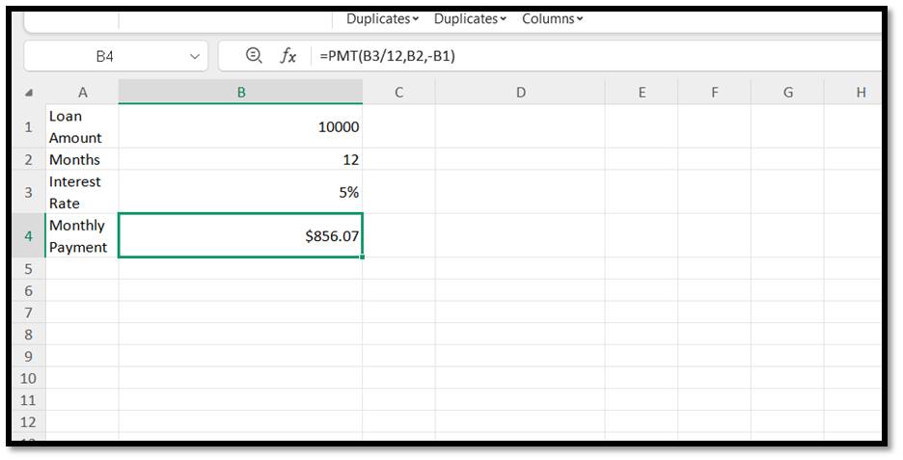
Figure 4 Goal Seek Table
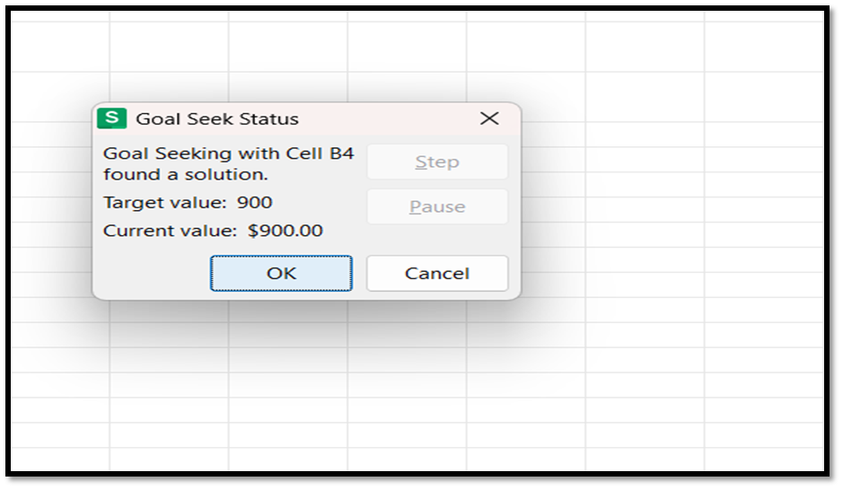
Figure 5 What-if Analysis

If Statement
The IF function of Excel is applied to test a condition and give one result in case the condition is true and another result in case it is false. In the formula =IF(B2>0, In Stock, Out of Stock), the formula will test the value in the cell B2 (the quantity of the product). When the quantity is over 0, the condition will be true, and the function will show In Stock; when the quantity is 0 or below, the condition will be false, and the function will show out of stock. This enables users to automatically calculate the availability of products on stock level, hence enabling easier and efficient data management.
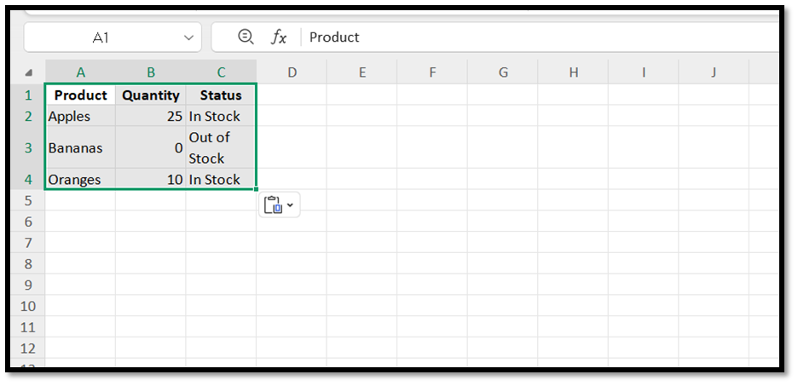
Figure 2 Data Table

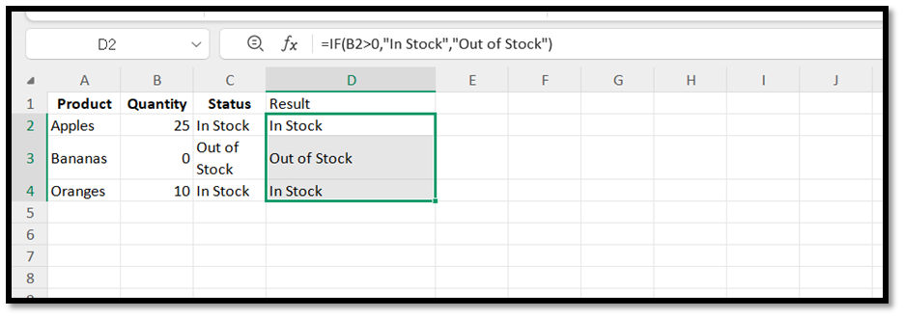
Figure 3 After Applying If Function

Task 4. Communication and Collaboration applications

One contemporary Communication and one Online Collaboration applications/tools

Trello
Trello is a renowned web-based work and online collaboration tool, which is created to assist teams to organize their activities, follow the workflow, and enhance the visibility of the project. Developed by Atlassian, Trello is a visual Kanban based system which enables users to organize their tasks in boards, lists and cards. This visually oriented design makes Trello easy to use and highly efficient in structuring business activities of the day, team, and individual productivity tasks[20]. A Trello board is a workspace where a team can plan and monitor the progress of a project. Boards consist of lists which depict workflow stages, such as To Do, In Progress and Completed. Cards are personalized tasks and might include description, checklists, attaching files, due date, labels, and nominated members. This model gives the teams a clear visualization of their work during all phases of the process. Trello is the best tool to use in team projects due to its collaboration features. As the progress is being made, multiple users have an opportunity to update the same board, make comments, post documents, tag colleagues, and drag cards between lists. These updates will be real-time so that everybody on the team will be able to stay informed about the latest information, and this will enhance the coordination process. The next significant benefit of Trello is that it contains an automation tool, Butler, which enables users to automatize repetitive tasks. Butler can automatically shuffle cards depending on triggers, assign tasks, send notifications, or generate new cards depending on rules. This enhances efficiency and fewer person-hours as well as in busy workflows. In addition, Trello is also compatible with hundreds of business applications such as Microsoft Teams, Slack, Google Drive, Jira, Dropbox, and OneDrive. These integrations are known as Power-Ups and help to expand the functionality of Trello by promoting time tracking, reporting, sophisticated workflow management, and communicative tools. As an illustration, with the implementation of Microsoft Teams, one can add Trello boards to Teams channels, which enables them to monitor tasks without losing time and communicate simultaneously. The simplicity and user-friendly design make Trello one of its strengths [21]. The tool is affordable by even users with limited technical skills as boards can be created and managed within a noticeably short time and seems to be applicable to both small and large businesses, as well as to students. The mobile app of Trello is also compatible with working together anywhere, which is why users can update their tasks. Nevertheless, Trello is limited as well. Although it is a superior choice in small and medium-sized projects, large or extremely complex projects might need more sophisticated functions like resource management or analytic detail, which can be offered only with the help of paid Power-Ups by Trello (Wilson, 2022). There is also the risk of cluttering boards with excessive cards and decreased clarity and making navigation challenging to teams. In general, Trello is an effective and versatile online teaming tool. Its visualization, automation capabilities, and vast integrations contribute to the fact that it is a vital platform in the organization of projects and teamwork in the contemporary businesses.

MS Teams
Microsoft Teams is among the most popular business communication systems where people can find a single centralized place to message and arrange calls and meetings as well as work together on documents. Introduced by Microsoft in 2017 as an Office 365 (since renamed Microsoft 365) product, Teams was created to supplant Skype for Business and bring together communication at the workplace into a single application[18]. It has become an indispensable part of the contemporary organization, particularly in the remote and hybrid work setting due to its chat and video conferencing capability with other Microsoft applications (Microsoft, 2023). Fundamentally, Microsoft Teams offers real-time chat communication in team chats and individual conversations. Departmental, project and task channel can be established and communication between them is structured and easily accessible. The users have an opportunity to send text messages, share files, react with emojis, and tag colleagues to be able to communicate quickly. It minimizes the use of the conventional email and advocates quick and open communication among the teams. One of the strong points of Teams is that it has a strong video conferencing and online meeting features. The platform allows HD video calls, screen sharing, recording of meetings, breakout rooms, live captions, and scheduling via Outlook. These characteristics have transformed Teams as a useful tool to be used in formal meetings, online lectures, training, and joint workshops. Its high security and compliance capabilities such as encryption of data and multi-factor authentication are an advantage to organizations. The integration of Teams with Microsoft 365 applications like Word, Excel, PowerPoint, OneNote, OneDrive, and SharePoint is also one of the largest benefits of Teams. This enables the users to collaboratively edit documents directly within the Teams app without having to leave applications and enhances productivity and will decrease workflow disruptions. Also, Teams has integrations of third-party apps, such as Trello, Zoom, GitHub, Adobe, and more than 700 others in the app store. The application of teams is especially useful in remote work because it is accessible through the desktop, web, and mobile platforms. Push notifications, activity feeds and cloud storage are also available so that employees can remain updated whether they are at home or at work. Another reason Teams is important in organizations is that it has powerful administrative controls that give IT managers permission to create security policies, assign permission, and control data in the organization. Nevertheless, Microsoft Teams is also limited. Its use of many resources is one of the problems that may slug an older device. The interface can also be overwhelming to new users as it has numerous features and integrations. It is a fact that large organizations may experience overload in the field of notifications that makes employees prioritize the valuable information less easily. Also, Teams can be easily integrated into other Microsoft applications, but in other cases it may not collaborate so well with other non-Microsoft products. Nevertheless, Microsoft Teams is still one of the most influential communication services in the contemporary business. Being a mixture of every one of the four, messaging, meetings, file collaboration, and app integration, it is a full-fledged solution to any organization that needs effective digital communications and teamwork[19].

One feature of a freely available Communication (1) and one feature of a Collaboration (1) application

Trello
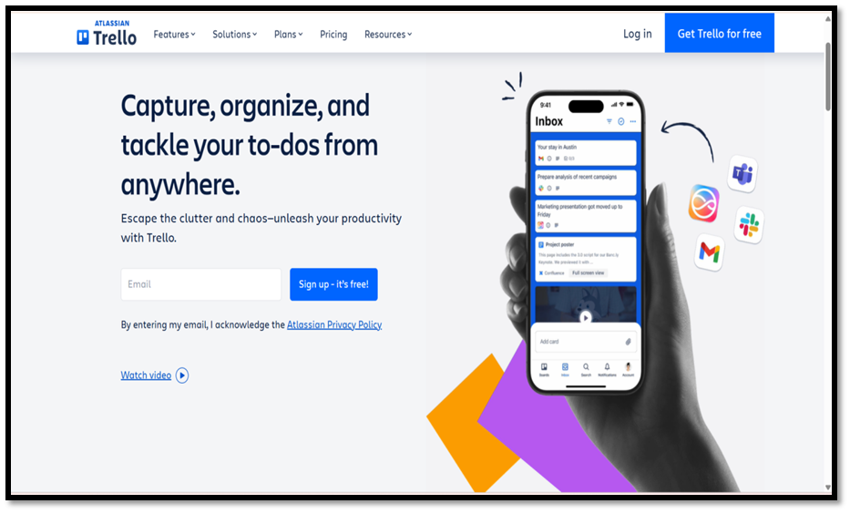
Figure 8 Trello Dashboard

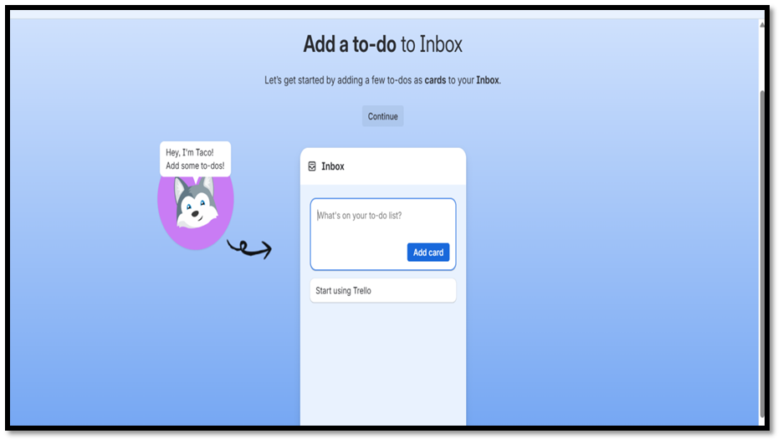
Figure 9 Trello Inbox

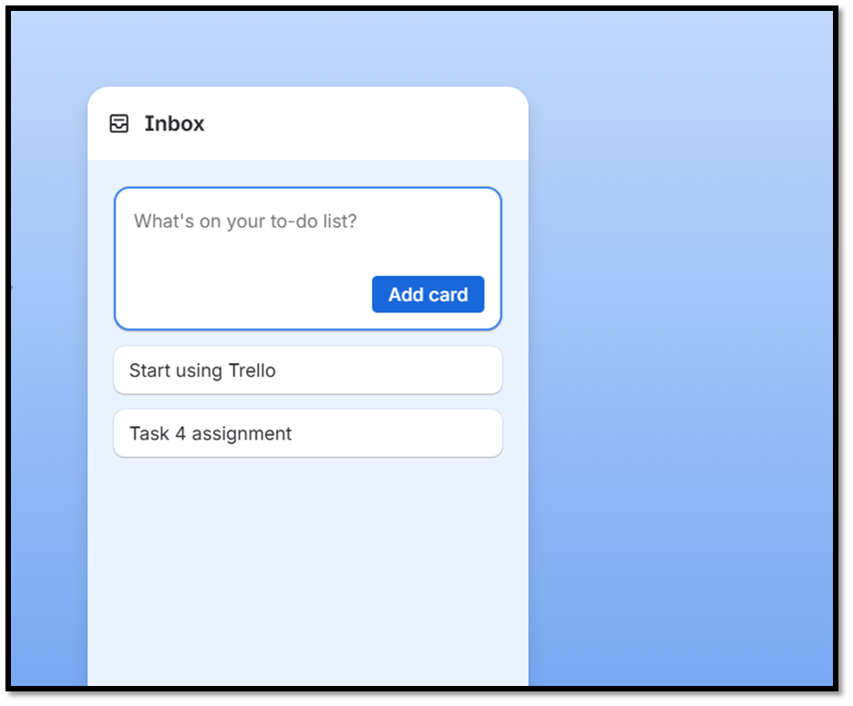
Figure 10 Added me to do Task to inbox (Trello)

Ms Teams

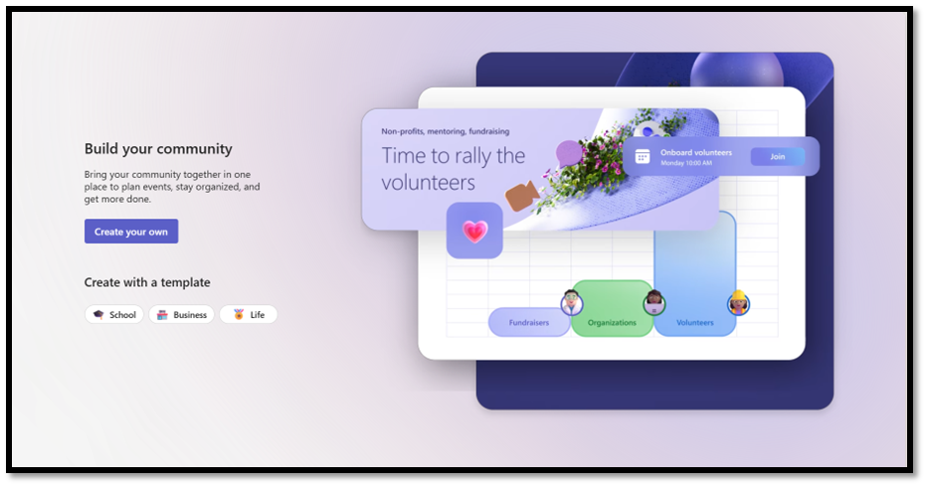
Figure 6 Teams Communities

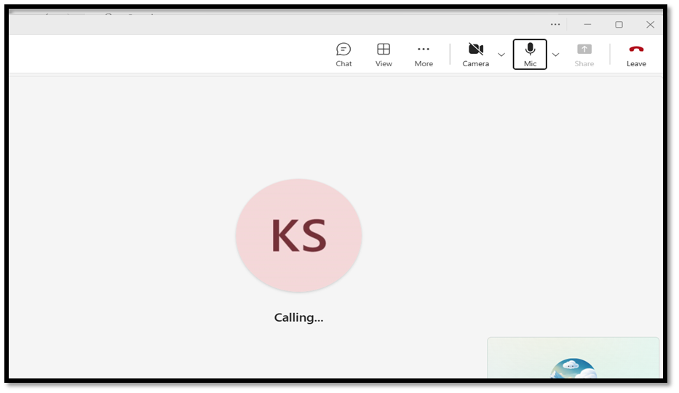
Figure 7 Teams Meeting

Conclusion
In conclusion, the current digital tools are significant in facilitating the everyday activities of organizations of the modern world. The online retail environment, such as BigCommerce and Wix, allows companies to create scalable web stores, improve customer service, and manage products with low technological difficulty. MS Word, Excel, PowerPoint, and Access are the office packages that have the potent features of generating documents, data analysis, task automation, and administration of organizational information. Similarly, communication and collaboration applications such as Microsoft Teams have revolutionized the way people interact at workplaces by enabling real-time communication, virtual conferences, and collaborative editing of documents. Besides that, mind-mapping tools aid the process of strategic thinking, generating ideas, planning, and organizing in the most efficient way possible, displaying complex ideas in a visual manner. Combined, these technologies can help businesses to work efficiently, make sound decisions, and stay competitive in an ever-digitized business world. Such software solutions integration is not optional anymore; it is a matter of organization survival and long-time development.

References

[1] BigCommerce, “BigCommerce,” BigCommerce, 2023. https://www.bigcommerce.com/
‌[2 ]Grit Global Content Creator, “Understanding BigCommerce API: Benefits and Drawbacks,” Grit Global | Make an Impact, Dec. 08, 2022. https://gritglobal.io/blog/understanding-bigcommerce-api-benefits-and-drawbacks/
‌[3] R. Tomasis, “Why use Wix? Top benefits and advantages explained,” Wix Blog, May 28, 2025. https://www.wix.com/blog/why-use-wix
‌[4] Naaz, “Benefits of Wix eCommerce: Why It’s the Ideal Platform for Your Online Store - Digitor International,” Digitor International, Nov. 26, 2025. https://digitorinternational.com/benefits-of-wix-ecommerce-why-its-the-ideal-platform-for-your-online-store/
‌[5] S. Peek, “How Mind Mapping Can Help Entrepreneurs,” business.com, Apr. 03, 2023. https://www.business.com/articles/benefits-of-mind-mapping-for-professionals/
‌ [6] “The benefits of mind mapping, backed by scientific evidence,” Lucid Software, 2024. https://lucid.co/blog/benefits-mind-mapping
‌[7] “Mind Mapping in Business,” MindMapping.com. https://www.mindmapping.com/mind-mapping-in-business
‌[8]TheKnowledgeAcademy, “What is Microsoft Word: The Popular Word Processing Software,” www.theknowledgeacademy.com, 2025. https://www.theknowledgeacademy.com/blog/what-is-microsoft-word/
‌[9] “The Styles advantage in Word,” support.microsoft.com. https://support.microsoft.com/en-us/topic/the-styles-advantage-in-word-b4a6372f-188c-93cb-831b-c4dd0cb3a881
‌[10] Microsoft, “Check grammar, spelling, and more in Word,” support.microsoft.com. https://support.microsoft.com/en-us/office/check-grammar-spelling-and-more-in-word-0f43bf32-ccde-40c5-b16a-c6a282c0d251
[11] Microsoft PowerPoint, “Microsoft PowerPoint, Slide Presentation Software, PPT,” www.microsoft.com, 2022. https://www.microsoft.com/en-us/microsoft-365/powerpoint
‌[12] “Create a SmartArt graphic from a list in PowerPoint - Microsoft Support,” Microsoft.com, 2024. https://support.microsoft.com/en-gb/office/create-a-smartart-graphic-from-a-list-in-powerpoint-ed299a87-43e2-4a18-a3ba-cc90c2149e33 ‌‌
[13] A. Kaushik, “Importance and Uses of Excel in Business,” Wecreateproblems.com, Dec. 2022. https://www.wecreateproblems.com/blog/importance-and-uses-of-excel-in-business
[14] E. Team, “Differences Between a Pivot Table and a Pivot Chart in Excel - Excel Insider,” Excel Insider, Nov. 08, 2025. https://excelinsider.com/excel-pivot-table/pivot-chart/differences-with-pivot-table/ (accessed Dec. 08, 2025).
[15] T. Bolling, A. Mitchell, T. Scott, and N. Wheeler, “15.1 Microsoft 365: Collaboration and Integration - Workplace Software and Skills | OpenStax,” openstax.org, Nov. 29, 2023. https://openstax.org/books/workplace-software-skills/pages/15-1-microsoft-365-collaboration-and-integration
[16] “What Is Microsoft Access Used for in the Workplace? - ONLC,” Oct. 19, 2023. https://www.onlc.com/blog/what-is-microsoft-access-used-for-in-the-workplace/
‌[17] Microsoft, “Create a query, form, or report in Access,” support.microsoft.com. https://support.microsoft.com/en-us/office/create-a-query-form-or-report-in-access-04eb597f-cb77-47be-83ed-1b8325b34cde
‌[18] Microsoft, “Microsoft Teams,” www.microsoft.com, 2025. https://www.microsoft.com/en-us/microsoft-teams/group-chat-software
‌[19] B. A. Chaushi, M. Nastovska, and T. V. Kurtishi, “MS Teams for Virtual Collaboration -An Overview,” Researchgate.net, 2024. https://www.researchgate.net/publication/383862857 _MS_Teams_for_Virtual_Collaboration_-An Overview
‌[20] Trello, “Trello,” Trello, 2025. https://trello.com/ ‌
‌[21] “Trello,” Trello.com, 2020. https://trello.com/templates/business (accessed Dec. 08, 2025).

