
Terrorism supportive paper
Policing Terrorism – BMPL5011

Courtney Curtis - 2204829

Account for the increase in the number of terrorist attacks and deaths around the world in recent years. What are some reasons behind this trend?

Terrorism is known to have increased all around the world in the recent years. It has been used in many different ways and for multiple reasons. Different weapons have also been used for terrorism and the motive for it can vary. This assignment will look into religious terrorism mostly, while also stating other types of examples for why people commit terrorism. It will account for how terrorism has increased, and it will identify the motives for why terrorist attacks and deaths occur and why they have increased. It will also include different examples of why people commit terrorism and what kind of weapons are used. Reasons behind this trend will also be stated. This assignment will also include multiple statistics that show how many deaths and terrorist attacks occur and what the most common weapons are in religious terrorism.

Religious terrorism is a type of violence which is used to achieve religious goals, this can be influenced by peoples’ beliefs and their identity. Religious terrorism usually aids in obtaining what people want by causing fear and trying to make a statement. Khan (2023) suggests that religious terrorism sets itself apart from other types of terrorism because it is very lethal and dangerous, this is because of its non-negotiable nature. People that commit religious terrorism tend to believe that their behaviour is approved by a higher power and that they are allowed to commit terrorism for their benefit as well as others (Harfield, 2013, p. 538). Religion is one of the many examples that drive people to commit terrorist attacks (Staniforth and Carlile of Berriew and Parkinson, 2014, p. 36). Other examples that drive people to commit terrorism include, politics, race and ideology. CPS (2022) states that for terrorism to occur, the use of threat must be committed. This is why most terrorists use threat to create fear and get what they want. In 2014, almost 45,000 people died in terrorist attacks, in 2010, less than 8,000 people had died and in 2019, around 20,000 people had died from terrorist attacks (Herre et al. 2024). This shows that more attacks had occurred in 2014 than in 2010 and 2019 and that it had started to increase in 2019. The amount of terrorist attacks differ year to year, just like the number of injuries and deaths from terrorist attacks. The amount of people that died from these terrorist attacks are world-wide and they were from multiple causes of terrorism. They were also carried out in multiple ways. In 2018, there were 32,944 fatalities in the world, due to terrorist attacks (Statista Research Department, 2023). This was the highest number of fatalities from 2007 to 2022. After 2018, the number of fatalities decreased to an average of 25,000 per year worldwide (Statista Research Department, 2023). This shows that the terrorist attacks were still increasing, however the number of fatalities within the terrorist attacks were decreasing. During 2023 and 2024, deaths caused by terrorism had then increased by 22% to 8,352, this is the highest level since 2017 (Vision of Humanity, 2024). This statement shows that terrorism has increased over the last few years.

Religious terrorism is usually used by terrorists to attack the government, the military, the police and public locations. Terrorists also use different weapons to commit terrorism such as, bombs, guns, planes and more. Explosives, incendiaries and firearms are most commonly used in religious terrorist attacks (Jones and Doxsee and Harrington, 2020).
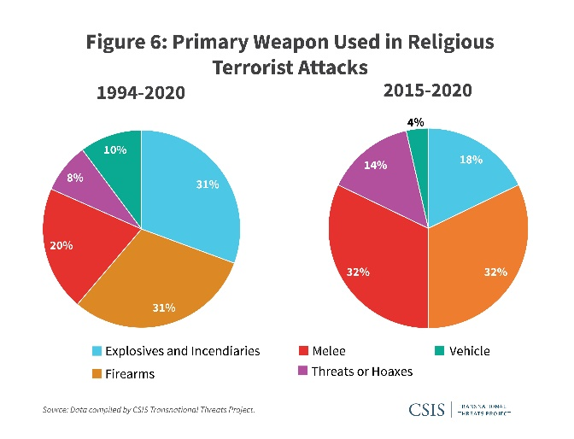(Jones and Doxsee and Harrington, 2020).
The graph above shows that throughout 1994 to 2020, the most common weapon that was used in religious terrorist attacks are firearms, and then explosives. The least common weapons that was used in religion terrorist attacks include vehicles, and then threats or hoaxes. This correlates with statement above that firearms and explosives are the most common weapons that are used in religious terrorism.
The Sri Lankan Tamil Tigers were known because they had forced the government into negotiations through their terrorist campaigns and attacks (Blake et al. 2012, p. 12). The Sri Lankan Tamil Tigers’ reason behind committing terrorism was because of religious and political reasons. According to Britannica (2024) the Sri Lankan Tamil Tigers wanted to create an independent Tamil state in response to violent persecution and discriminatory policies against them. This shows that they committed terrorism for partly religious reasons. 9/11 had happened because 19 terrorists from Al-Qaeda had hijacked four commercial airplanes, they had deliberately crashed into the 2 twin towers and the Pentagon. Around 2,996 people had died during 9/11, including the 19 terrorists who committed the terrorist act. Thousands of people were also injured. Al-Qaeda had hoped that by attacking the twin towers, they would promote widespread fear throughout the country and severely weaken the US’ standing in the world. They did this because it would have supported their religious, and political goals, in the Middle East, and Muslim world (9/11 Memorial & Museum, 2023). As well as the Sri Lankan Tamil Tigers and 9/11, the 7/7 bombings and the Manchester Arena bombings were also part of religious terrorism.

Overall, terrorism increases and decreases over the years, this is because it depends on whether terrorists commit terrorism and whether they want to commit it for a specific reason that they think turning to terrorism is necessary. It has mostly increased over the years, Vision of Humanity (2024) shows this by stating that in 2023 and 2024, deaths caused by terrorism has increased to 8,352. The reasons behind this trend can include religious, political, racial and ideological reasons to commit terrorism. Home Office (2006) concurs with this statement because it states that the use of threat is made for the purpose of advancing a political, religious or ideological cause. Terrorism is usually committed to influence the government and cause fear to the government and the public. Home Office (2006) also states that terrorism is used to influence the government and to intimidate the public. Maysun (2023) states that some people argue that religion is not the root cause of terrorism, but that religious extremism is instead. This is because it is not as restricted to one religion. This concludes that terrorism has increased over the years and that the reasons behind why people might commit terrorism include religious and political reasons mainly.

References
Blake, C. et al. (2012) Policing Terrorism. Exeter: Learning Matters.
Britannica (2024) Tamil Tigers. Available at: Tamil Tigers | Definition, History, Location, Goals, & Facts | Britannica (Accessed: 08/04/24).
CPS (2022) Terrorism. Available at: Terrorism | The Crown Prosecution Service (cps.gov.uk) (Accessed: 08/04/24).
Herre, B. et al. (2024) Terrorism. Available at: Terrorism - Our World in Data (Accessed: 08/04/24).
Home Office (2006) The Terrorism Act 2006. Available at: The Terrorism Act 2006 - GOV.UK (www.gov.uk) (Accessed: 24/04/24).
Jones, S.G. and Doxsee, C and Harrington, N. (2020) The tactics and targets of domestic terrorists. Available at: The Tactics and Targets of Domestic Terrorists (csis.org) (Accessed: 08/04/24).
Jones, S.G. and Doxsee, C and Harrington, N. (2020) The tactics and targets of domestic terrorists. CSIS, Figure 6, graph.
Khan, R.M. (2023) ‘Introduction’, The coloniality of the religious terrorism thesis. Available at: The coloniality of the religious terrorism thesis | Review of International Studies | Cambridge Core DOI: https://doi.org/10.1017/S0260210523000517
9/11 Memorial & Museum (2023) 9/11 FAQs. Available at: 9/11 FAQs | National September 11 Memorial & Museum (911memorial.org) (Accessed: 05/03/24).
Maysun, J.A. (2023) ‘Are religious beliefs truly the root cause of terrorism’, Journal of Global Faultlines, 10(2), pp. 252-263. DOI: https://doi.org/10.13169/jglobfaul.10.2.0252
Staniforth, A. and Carlile of Berriew. and Parkinson, J. (2014). Preventing Terrorism and Violent Extremism. Oxford, UK: Oxford University Press.
Statista Research Department (2023) Number of fatalities due to terrorist attacks worldwide between 2007 and 2022. Available at: Terrorism: number of deaths worldwide 2022 | Statista (Accessed: 08/04/24).
Vision of Humanity (2024) Global Terrorism Index. Available at: Global Terrorism Index | Countries most impacted by terrorism (visionofhumanity.org) (Accessed: 24/04/24).

