15/05/2025

Trainee Health & Safety Officer

Produced by Louis James (2415463)
Health, Safety and Welfare (ACBA4023)

Table of Contents
Site Details 5
Building Safety Act 2022 5
Definition of HRB’s 5
Potential impacts 5
Building control authority 5
Incorporation of ‘Golden thread’ 5
H&S legislation 6
COSHH 2002 6
LOLER 1998 6
Manual Handling operations regulations 7
Confined spaces 7
PPE at work regulations 8
The control of noise at work regulations 2005 8
RIDDOR 2013 9
Barries to H&S management 9
CDM Regulations 2015 10
Commercial Client 10
Designers 10
Principal Contractor 11
Contractors 11
Workers 11
Appendix 12
References 14

Figure List
Figure 1: Universal COSHH symbols (online) Available at: What are COSHH regulations? [Accessed 15/05/2025]
Figure 2: Tile method (online) Available at: Manual Handling | [Accessed 15/05/2025]
Figure 3: Fatal accident statistic 2023/2024 (online) Available at: Work-related fatal injuries in Great Britain - HSE [Accessed 15/05/2025]
Figure 4: Effective solutions to hazards during construction (online) Available at: The Hierarchy of Controls and Sharps Safety [Accessed 15/05/2025
Figure 5: Acoustic screen in workplace (presentation), Available at: PPE + Noise Regulations, ACBA4023 Health, Safety and Welfare [Accessed 15/05/2025]
Figure 6: Sound absorbing materials in workplace (presentation), Available at: PPE + Noise Regulations, ACBA4023 Health, Safety and Welfare [Accessed 15/05/2025]

Glossary of Terms
BSR – Building Safety Regulator
BSA 2022 – Building Safety Act 2022
CDM – Construction (Design and Management)
COSHH – Control of Substances Hazardous to Health
CPP – Construction Phase Plan
H&S – Health and Safety
HRB’s – Higher-risk buildings
HSE – Health and Safety Executive
LEV – Local Exhaust Ventilation
LOLER – Lifting Operations and Lifting Equipment
MEWPs – Mobile Elevating Work Platforms
PCI – Pre-Construction Information
PPE – Personal Protective Equipment
RA – Risk assessment
RIDDOR – Reporting of Injuries, Diseases and Dangerous Occurrences Regulations
RPE – Respiratory Protective Equipment
WAHR – Working at Height Regulation

Site Details
The proposed site is located at Kings Road, SA1, the project is currently undergoing planning. The site is set to contain 104 one, two and three bedroom flats, providing affordable housing for the local community and persons relocating to the area.

Building Safety Act 2022
BSA 2022 is a legislative framework within England and Wales, following the Grenfell tower disaster the act was introduced in response to failures in building safety, the act aims to improve the ‘design, construction and management of HRB’s’ (Mogers Drewett, 2025).
Since the introduction of BSA 2022, clear differences have been identified between England and Wales, this is because the Welsh government has control to adapt and enforce regulations under BSA 2022. As stated from (Iwan Jenkins, 2024) in April 2025 the Welsh government will fully implement and comply with requirements relating to duty holders, the golden thread of information and gateways.

Definition of HRB’s
The definition of HRB’s differ in England and Wales, As stated in (Legislation.gov.uk, 2023) a building is defined as a HRB if it is at least 18 metres in height or minimum of 7 storeys containing at least one residential unit, additionally, care homes, children homes and hospitals that provide at least one bed intended for use by an individual admitted to the premises for an overnight stay. Buildings containing entirely of military barracks, hotels and a secure residential institution are excluded.

Potential impacts

Building control authority
In Wales, local authorities act as the building control authority for HRB, whereas in England a BSR is responsible for managing HRB’s. According to (Whittaker, G. and Knight, E, 2025) the projected quantity of applications is minimal compared to England, therefore the caseload for local authorities is less significant. Additionally, local authorities are to work alongside fire specialists and other external experts that may be required to ensure the fire and structural safety of the building. As a result of this, the potential for delays is significantly increased due to insufficient documentation as well as the extension of review periods to ensure the HRB meet legislative requirements and all external experts are satisfied with the construction, further extending the projects design and construction time phrase.

Incorporation of ‘Golden thread’
As previously stated, the Welsh government is set to implement and comply with requirements in BSA 2022 including the ‘golden thread’ system in April 2025. As understanded from (GOV.UK, n,d) the purpose of the ‘golden thread’ is to ensure all information is stored and accessible, in order to understand the required actions to keep both the building and people living in it safe. If the ‘golden thread’ is incomplete or inaccurate it can lead to legal, financial and operational delays (Purcell, T, 2025).
Although this method aims to improve safety during and after construction, Welsh authorities and construction companies may struggle to implement this method into regular use, additionally, as stated from (C&C Consulting, 2025) the use of digital software may be a huge obstacle for smaller companies, the initial cost can include purchasing the software, training or hiring staff which can lead to the company facing financial problems, resulting in companies delaying projects or not complying with BSA 2022 ‘golden thread’.

H&S legislation
To ensure safety and wellbeing to all members of staff involved in the construction, it is essential to understand and identify H&S legislation that is most appropriate for the proposed project, stated below is relevant H&S legislation that impacts the construction activities. Furthermore, commonly found barriers within the industry are stated along with solutions used to manage and overcome them. It is vital H&S legislations are followed to maintain a safe working environment throughout the construction phase of the project.

COSHH 2002
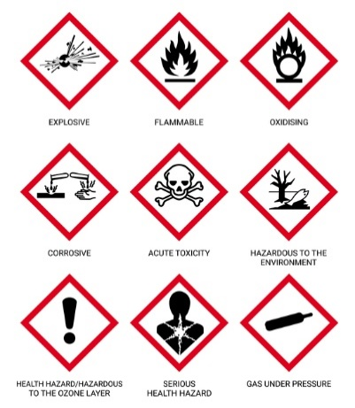
COSHH is a law that requires employers to assess and control substances and materials used or created during construction. As stated in (‌HSE COSHH, n,d) COSHH covers substances such as dust, adhesives and solvents that can pose dangerous to health. As noted from (‌Thomas, R. COSHH, 2025a) by law chemical suppliers must provide safety data sheets, if dangerous for supply. The use of data sheets provides the user with information allowing for a sufficient risk assessment and safety measures to be in place.
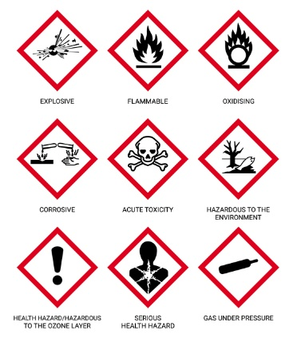
As shown in figure 1, when working with hazardous substances COSHH symbols are used to alert individuals of the presence of specific hazards, since 2015 all symbols are universal, allowing for clear understanding in all workplaces (Virtual college, 2021).
During construction, adequate safety measures are to be in place including PPE and suitable control equipment when in confined spaces, such as natural ventilation and extraction systems such as LEV (‌Thomas, R. COSHH, 2025b).
Figure 1: Universal COSHH symbols

LOLER 1998
LOLER is a legislative document designed to ensure safety when using lifting operations, this includes cranes and construction hoists. As the proposed project is to be a minimum of four storeys the use of lifting equipment will be frequent. According to (‌Thomas, R. LOLER, 2025) regulation 9 of LOLER states, all lifting operations must undergo inspections before use and require a thorough examination minimum once a year by a qualified individual. The report identifies potential of current defects and report to the owner.
As stated from (HSE FAQs, n,d) regulation 8 requires employers to ensure when a lifting operation is undergoing, it is to be carried out in a safe manner, appropriately supervised and planned correctly by a competent person.

Manual Handling operations regulations
Manual handling is the transportation or movement of a load from one place to another through lifting, handling, pushing and pulling an object. As highlighted in (‌Thomas, R. Manual Handling, 2025a) the regulation sets out clear measures to prevent and manage risks associated with manual handling, including musculoskeletal injuries.
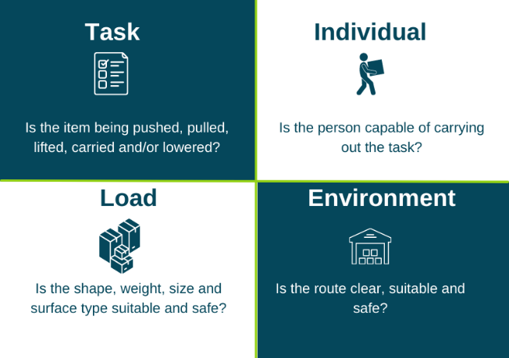
During the construction phase of the project, the employer should consider all tasks using ‘tile’, shown in figure 2, Each task should be assessed and if deemed unsafe the employer should provide aids such as trolleys and forklifts, in addition the employer should provide employees with correct training and rotate employees if manual handling is frequent (‌Thomas, R. Manual Handling, 2025b).
Figure 2: TILE method

Confined spaces
As stated in (HSE Confined Spaces, n.d) a confined space is an area which is both enclosed or largely enclosed such as attics and lifts. Confined spaces pose risks of suffocation, entrapment, fire and explosions.
When work is carried out in confined spaces, the employer must identify and assess potential risks and ensure that employees are correctly trained and supervised. Additionally, as noted from (HSE Books, 2014) under regulation 5, no one should enter or work unless appropriate emergency arrangements are in place.
WAHR 2005
As shown in figure 3, falls from height are the most common fatal accident in the construction industry. As noted in (‌Thomas, R. WAHR, 2025) duty holders must avoid work, if possible, when working at height is unavoidable the use of work equipment such as guardrails or other measures must be accounted in order to reduce the likelihood of fatal injuries should a fall occur.
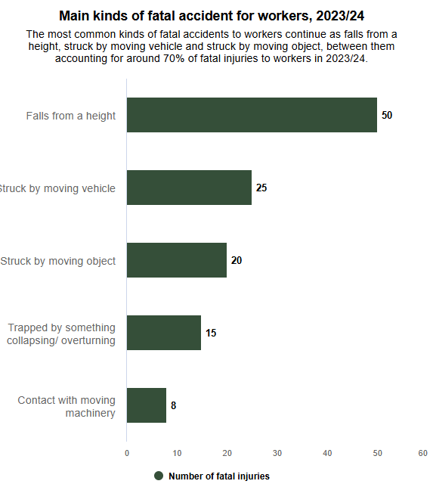
Additionally, the employer must ensure correct training is provided for employees working at height, such as ladder training.
Figure 3: Fatal accident statistic 2023/2024
If possible, to further minimise the risk of accidents from height it is suggested MEWPs are used as they allow the worker to reach the task safely as guard rails and toe boards are provided to prevent falling and can be used indoors and outdoors (Laking, A, n.d).

PPE at work regulations
PPE at work regulations were amended on the 6th April 2022, the primary amendment stated employers must provide adequate PPE to all workers, including limb (b) employees (‌HSE PPE, 2022). This includes hardhats, eye protection, safety boots, gloves and high-visibility clothing, additionally employers are to provide task specific PPE such RPE.
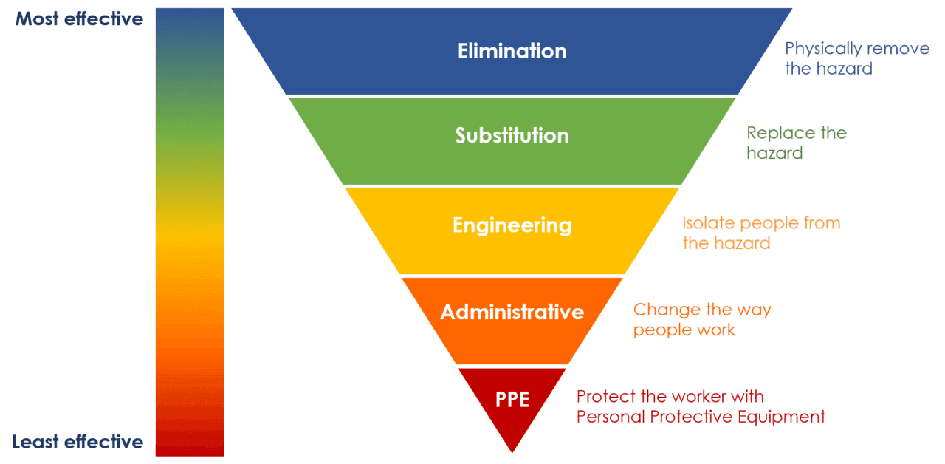
As shown in figure 4, PPE is the last resort of protection against potential risks and hazards to health and safety.

Figure 4: Effective solutions to hazards during construction

The control of noise at work regulations 2005
During construction, the combination of heavy machinery and cutting equipment can cause safe noise levels to frequently be exceeded. As stated in (‌HSE Noise regulations, n,d) the control of noise at work regulations 2005 replace the noise at work regulation 1989, the main adjustment to the regulation is employers are required to protect workers at noise levels 5dB (A) lower than the 1989 regulations, furthermore workers which regularly experience noise levels of 85dB (A) are required to receive hearing checks regularly.
(‌Thomas, R. Noise regulations, 2025) noted, employers must provide risk assessments when noise levels exceed 80dB. The use of engineering controls minimises the noise levels improving communication and ability to hear warning signals, shown in figure 5 and figure 6 the addition of acoustic screens and sound absorbing materials, prevents sound traveling and reduces exposure to unsafe noise levels.
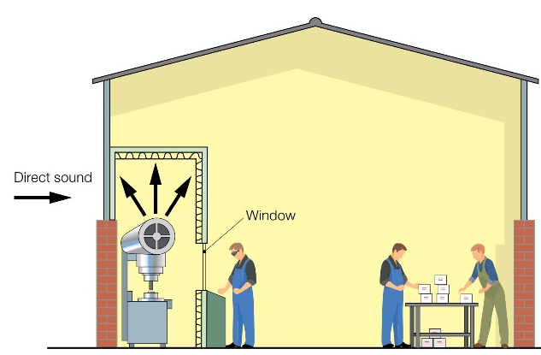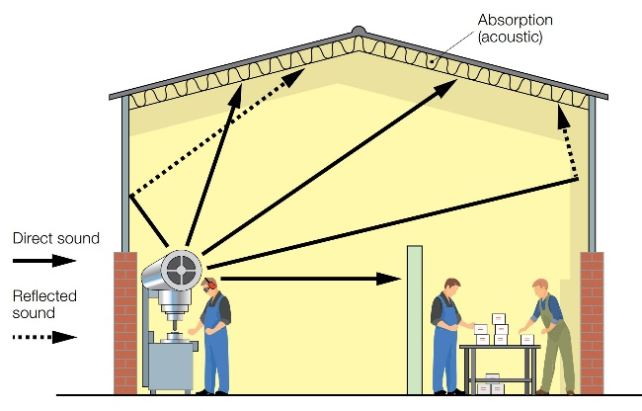
Figure 5: Acoustic screens in workplace Figure 6: Sound absorbing materials in workplace

RIDDOR 2013
RIDDOR is a law that requires employers, site managers and other duty holders responsible to correctly record and report injuries and accidents such as broken bones. Additionally, dangerous occurrences such as scaffold collapsing are also required to be reported to the HSE.
As interpreted from (Training Express, n,d), the HSE uses RIDDOR’s data to evaluates potential trends of all workplace incidents and recommend changes to improve safety in the workplace.

Barries to H&S management
Barriers | Solutions
Time constraints | - Incorporate methods (Gantt charts etc.) to organize and plan tasks  - Prioritize time consuming tasks  - Set clear deadlines and regularly communicate with workers to overcome potential issues affecting deadlines
Budget constraints | - Prioritize essential tasks  - Overview expenditures and control budgets allocated for specific tasks e.g. materials used, duration of work
Language barriers | - Universal signs / translated signs  - Translated toolbox talks and meetings  - Provide language lessons to improve communication between all members of staff.
Inadequate Training | - Supply correct task based training for staff (online and in person)  - Offer multiple methods of training to ensure all learning styles are supported  - Set clear and concise learning objectives
Behavioural issues | - Offer support for staff who have behavioural or mental health issues  - Request feedback from staff to find potential workplace issues that may lead to behavioural problems  - Improve communication between managers and workers.
Lack of Management Involvement | - Define roles and responsibilities for all members involved in the project, minimising confusion and ensuring accountability  - Monitoring and reporting systems to identify potential risks located on site  - Training for managers and duty holders to improve communication.
Complacency | - Reward systems to encourage staff to improve effort and efficiency  - Set clear objectives reducing stress and loss of focus  - Provide regular training and courses keeping workers up to date and familiar with Health and safety legislation.

CDM Regulations 2015
CDM was introduced in 1994 and has since had two amendments in 2007 and 2015. CDM 2015 is a set of regulations that manage and ensure H&S and welfare is considered during the project’s development, minimising the risk of harm to persons who build, use and maintain the construction (‌Thomas, R. CDM, 2025).
As highlighted in (‌CITB, n,d) CDM 2015 applies to all buildings and construction including new buildings, refurbishments, demolition, conversions, repair and maintenance. CDM 2015 states legal responsibilities for all duty holders involved in a project, including the client, designers, principal contractor, contractors and labourers.
(‌HSE Welfare, n.d.) has noted all workers must have access to welfare facilities including storage facilities, drinking water, somewhere to rest and eat meals, toilets and sinks provided with soap and towels.

Commercial Client
The client holds responsibility to ensure the project complies with CDM 2015, As stated in (Building Safety Wiki, 2024) before the project is planned and construction has begun the client must hire a principal designer and principal contractor if there are multiple designers and contractors involved in the project. Additionally, the client must provide necessary documentation including reports and set clear goals and deadlines to the principal contractor and designer. Finally, the client must ensure adequate welfare facilities are provided on site.

Designers
According to (‌HSE Duty holders, n,d (a) the principal designer’s responsibility in the project is to plan, manage, monitor and coordinate H&S in the PCI phase of the project, furthermore, principal designers are also required to prepare and provide information to duty holders.
If the project has more than one designer, the principal designer must ensure the designers meet deadline and follow duties set by the client. The designers are responsible for preparing and modifying designs to reduce possible risks during construction and maintenance of the building (‌HSE Duty holders, n,d (b).

Principal Contractor
CDM 2015 has noted the responsibility of the principal contractor, (Haspod, 2022) highlights the principal contractor is responsible for planning, managing, monitoring and coordinating the health and safety on site including preparing the CPP, in addition the principal contractor liaises with the client and designer to ensure the project meets the desired requirements.
in addition, if multiple contractors are employed during the project the principal contractor is to provide site inductions and toolbox talks to ensure contractors are aware of the work required and deadlines.

Contractors
As stated in (HSE Duty holders, n,d (c) contractor’s duties are to plan, mange and monitor construction work under their control and be carried out with minimal risks to H&S, also the contractor is to liaise with the principal designer to ensure all works are completed at a desired standard.

Workers
Under CDM 2015 regulations, workers such as electricians, plumbers, scaffolders are under the control of a contractor. (HSE Roles, n,d (a) gives an understanding of the responsibilities and duties required, workers are required to follow site rules and to be trained and qualified to perform specific tasks and show an understanding of H&S legislation and associated risks.
Additionally, (HSE Roles, n,d (b) state workers must report risks identified on site to contractors in control of the work, preventing the likelihood of injuries and accidents that may occur.

Appendix
The below RA provides the reader with hazards and risks associated with transportation of materials. The RA was carried out in accordance with HSE guidance INDG163, the five-step RA process identifies hazards, risks and control measures to prevent and reduce the likelihood and severity of the hazard (HSE INDG163, n.d).
Activity to be Assessed |  |  |  |  |  |  |  |  |  |  |  |  |  |  |  |  | Assessment Number
Transportation of materials on and off site for the construction at Kings Road, SA1 |  |  |  |  |  |  |  |  |  |  |  |  |  |  |  |  | 0001
Persons undertaking or affected by the activity
 |  |  | Employees |  |  | Contractor |  |  |  | Public |  |  |  |  | Pupil |  |  |  |  |  |  | Service User
 |  |  | Other …………………………………………………………………………………………….
Identified Hazards and Associated Risks |  |  |  |  |  |  |  |  |  |  | Likelihood |  |  |  |  |  | Severity |  |  |  |  |  | Risk Level
1 | Mechanical or equipment failure – Road closures, accidents, loss of materials |  |  |  |  |  |  |  |  |  | 3 |  |  |  |  |  | 4 |  |  |  |  |  | 12 (High)
2 | Road accidents – Injuries or fatalities |  |  |  |  |  |  |  |  |  | 2 |  |  |  |  |  | 5 |  |  |  |  |  | 10 (High)
3 | Slips, trips and fall during loading / unloading – broken bones, sprains, fractures |  |  |  |  |  |  |  |  |  | 3 |  |  |  |  |  | 3 |  |  |  |  |  | 6 (Medium)
4 | Unsafe access to site – Vehicle / pedestrian road accidents, congestions and delays |  |  |  |  |  |  |  |  |  | 4 |  |  |  |  |  | 4 |  |  |  |  |  | 16 (High)
5 | Manual handling during loading / unloading– Musculoskeletal injuries |  |  |  |  |  |  |  |  |  | 3 |  |  |  |  |  | 3 |  |  |  |  |  | 6 (Medium)
6 | Adverse weather – Poor visibility, slips trips and falls, floods, road collisions |  |  |  |  |  |  |  |  |  | 3 |  |  |  |  |  | 4 |  |  |  |  |  | 12 (High)
7 | Unqualified operators – Unsafe manual handling, incorrect operation of vehicles |  |  |  |  |  |  |  |  |  | 2 |  |  |  |  |  | 4 |  |  |  |  |  | 8 (Medium)
Control Measures Required
1 | - Schedule regular vehicle maintenance  - Inspect vehicles before use  - Ensure all vehicles have undergone a thorough examination and is certified and maintained
2 | - Ensure all operators are qualified and competent  - Use of black boxes and trackers to enforce speed restrictions
3 | - Ensure all areas on site are clear and level  - Adequate lighting throughout site  - All members on site to wear PPE (Safety boots, hard hats etc)
4 | - Deliveries to site to occur during set times  - Employ a traffic marshal  - Provide alternative delivery routes
5 | - Ensure all staff have undergone manual handling training  - Use of aids (Forklifts, trolleys)  - Rotate staff which frequently load / unload materials
6 | - Monitor weather conditions  - Delay deliveries
7 | - Ensure operators are trained and qualified
Reassessment of Activity Hazards |  |  |  |  |  |  |  |  |  |  | Likelihood |  |  |  |  |  | Severity |  |  |  |  |  | Risk Level
1 | Mechanical or equipment failure |  |  |  |  |  |  |  |  |  | 2 |  |  |  |  |  | 3 |  |  |  |  |  | 6 (Medium)
2 | Road accidents |  |  |  |  |  |  |  |  |  | 1 |  |  |  |  |  | 5 |  |  |  |  |  | 5 (Medum)
3 | Slips, trips and falls during loading / unloading |  |  |  |  |  |  |  |  |  | 2 |  |  |  |  |  | 2 |  |  |  |  |  | 4 (Low)
4 | Unsafe access to site |  |  |  |  |  |  |  |  |  | 2 |  |  |  |  |  | 4 |  |  |  |  |  | 8 (Medium)
5 | Manual handling during loading / unloading |  |  |  |  |  |  |  |  |  | 1 |  |  |  |  |  | 3 |  |  |  |  |  | 3 (Low)
6 | Adverse weather |  |  |  |  |  |  |  |  |  | 2 |  |  |  |  |  | 3 |  |  |  |  |  | 6 (Medium)
7 | Unqualified operators |  |  |  |  |  |  |  |  |  | 1 |  |  |  |  |  | 3 |  |  |  |  |  | 3 (Low)
Name: Louis James  Position: Trainee Health and Safety officer |  |  |  |  |  |  | Signed: L.James |  |  |  |  |  |  |  |  |  | Date of Completion: 15/05/2025
Reviews |  |  |  | Key
Review Date: |  |  |  | Likelihood |  |  |  | Severity |  |  | Severity of Injury |  | 5 | 5 |  |  |  | 10 |  |  | 15 |  |  | 20 |  | 25
Reviewed by: |  |  |  | 1 very unlikely  2 unlikely  3 likely  4 very likely  5 certainty |  |  |  | 1 nuisance  2 minor  3 medical treatment  4 major  5 fatal |  |  |  |  | 4 | 4 |  |  |  | 8 |  |  | 12 |  |  | 16 |  | 20
Review Date: |  |  |  |  |  |  |  |  |  |  |  |  | 3 | 3 |  |  |  | 6 |  |  | 9 |  |  | 12 |  | 15
Reviewed by: |  |  |  |  |  |  |  |  |  |  |  |  | 2 | 2 |  |  |  | 4 |  |  | 6 |  |  | 8 |  | 10
Review Date: |  |  |  |  |  |  |  |  |  |  |  |  | 1 | 1 |  |  |  | 2 |  |  | 3 |  |  | 4 |  | 5
Reviewed by: |  |  |  |  |  |  |  |  |  |  |  |  | 0 | 1 |  |  |  | 2 |  |  | 3 |  |  | 4 |  | 5
Review Date: |  |  |  |  |  |  |  |  |  |  |  |  |  | Likelihood of Injury
Reviewed by: |  |  |  |  |  |  |  |  |  |  |  | Low Risk |  |  |  |  |  |  | Medium Risk |  |  |  |  |  | High Risk

References
Building Safety Wiki (2024). CDM 2015 client duties. [online] Available at: https://www.designingbuildings.co.uk/wiki/CDM_2015_client_duties. [Accessed 13/05/2025]
C&C Consulting. (2025). Why Digital Tools Are Essential for Supporting the Golden Thread in Building Safety [online] Available at: https://www.ccconsulting.uk.com/why-digital-tools-are-essential-for-supporting-the-golden-thread-in-building-safety/ [Accessed 10/05/2025]
‌CITB (n,d). Construction (Design and Management) Regulations [online]. Available at: https://www.citb.co.uk/about-citb/partnerships-and-initiatives/construction-design-and-management-regulations-2015/cdm-regulations/. [Accessed 13/05/2025]
GOV.UK (n,d). Understanding the golden thread. [online] Available at: https://buildingsafety.campaign.gov.uk/building-safety-regulator-making-buildings-safer/building-safety-regulator-news/understanding-the-golden-thread/. [Accessed 10/05/2025]
HSE Books (2014) Safe work in confined spaces. [online] Available at: Safe work in confined spaces: Confined Spaces Regulations 1997. Approved Code of Practice, Regulations and guidance [Accessed 10/05/2025]
‌HSE COSHH (n,d). COSHH Basics [online] Available at: https://www.hse.gov.uk/coshh/basics/index.htm. [Accessed 10/05/2025]
HSE Confined Spaces (n.d.) Introduction to working in confined spaces. [online] Available at: https://www.hse.gov.uk/confinedspace/introduction.htm. [Accessed 10/05/2025]
‌HSE Duty holders (n,d). Construction Design and Management summary of duties. [online] Available at: https://www.hse.gov.uk/construction/cdm/2015/summary.htm. [Accessed 13/05/2025]
‌HSE FAQs (n,d). Equipment and machinery frequently asked questions (FAQs) [online] Available at: https://www.hse.gov.uk/work-equipment-machinery/faqs.htm. [Accessed 10/05/2025]
HSE INDG163 (n.d) Five steps to risk assessment. (online) Available at: INDG163 - Five steps to risk assessment [Accessed 15/05/2025]
‌HSE Noise regulations (n,d). Noise: Regulations. [online] Available at: https://www.hse.gov.uk/noise/regulations.htm. [Accessed 11/05/2025]
‌HSE PPE (2022). Personal Protective Equipment (PPE) at Work Regulations from 6 April 2022. [online] Available at: https://www.hse.gov.uk/ppe/ppe-regulations-2022.htm. [Accessed 10/05/2025]
HSE Roles (n,d) Construction workers: roles and responsibilities [online] Available at: https://www.hse.gov.uk/construction/cdm/2015/workers.htm. [Accessed 13/05/2025]
‌HSE Welfare (n.d) Have the right workplace facilities [online] Available at: https://www.hse.gov.uk/simple-health-safety/workplace-facilities/welfare.htm. [Accessed 13/05/2025]
Haspod (2022). CDM 2015 Principal Contractor Duties Explained. [online] Available at: https://www.haspod.com/blog/cdm/cdm-2015-principal-contractor-duties-explained. [Accessed 13/05/2025]
Iwan Jenkins (2024). Building Safety Act Wales – The Latest Position [online] Available at: https://www.hughjames.com/blog/building-safety-act-wales-the-latest-position/. [Accessed 09/05/2025]
Laking, A. (n.d). What Is a MEWP? Complete Guide to Mobile Elevating Work Platforms. [online] Available at: https://mewps.uk/what-is-a-mewp/ [Accessed 10/05/2025]
Legislation.gov.uk. (2023). The Building Safety (Description of Higher-Risk Building) (Design and Construction Phase) (Wales) Regulations 2023. [online] Available at: https://www.legislation.gov.uk/wsi/2023/1210/contents/made [Accessed 09/05/2025].
Mogers Drewett (2025). The Building Safety Act: What It Means for Developers, Owners, and Buyers [online]. Available at: https://www.mogersdrewett.com/the-building-safety-act-what-it-means-for-developers-owners-and-buyers/. [Accessed 09/05/2025]
Purcell, T. (2025). The Golden Thread: Implications And Requirements For UK Housebuilders? [online] Available at: https://www.sitemanagerpro.co.uk/learn/quality/the-golden-thread/ [Accessed 10/05/2025]
‌Thomas, R. CDM (2025) CDM Regulations (Presentation), ACBA4023, Health, Safety and Welfare [Accessed 13/05/2025]
Thomas, R. COSHH (2025) COSHH (Presentation), ACBA4023, Health, Safety and Welfare [Accessed 10/05/2025]
‌Thomas, R. LOLER (2025) LOLER (Presentation), ACBA4023, Health, Safety and Welfare [Accessed 10/05/2025]
‌Thomas, R. Manual Handling (2025) Manual Handling (Presentation), ACBA4023, Health, Safety and Welfare [Accessed 10/05/2025]
‌Thomas, R. Noise regulations (2025) PPE + Noise regulations (Presentation), ACBA4023, Health, Safety and Welfare [Accessed 11/05/2025]
‌Thomas, R. WAHR (2025) Working at Height (Presentation), ACBA4023, Health, Safety and Welfare [Accessed 11/05/2025]
Training Express. (n,d). What is RIDDOR: Advantages and Disadvantages. [online] Available at: https://trainingexpress.org.uk/what-is-riddor/. [Accessed 11/05/2025]
Virtual College (2021). COSHH Hazard Symbols and What They Mean. [online] Available at: https://www.virtual-college.co.uk/resources/coshh-hazard-symbols. [Accessed 10/05/2025]
Whittaker, G. and Knight, E. (2025). Welsh Government proposes new building safety regime for higher-risk buildings. [online] Available at: https://gowlingwlg.com/en/insights-resources/articles/2025/welsh-government-proposes-new-building-safety-regime-for-higher-risk-buildings [Accessed 09/05/2025]

