BMHP5014: Changemakers:

Creativity and Value Creation

Component 2: Written Assignment
Student Name:
Student ID:

28 Days, One Decision – CO-Verified Quit and Daily Coaching for 18–35s
Innovation Overview
- It is an innovation, a community-based cessation campaign aimed at stopping smoking by using a combination of carbon-monoxide (CO) breath monitoring, same-day nicotine replacement therapy, (NRT), and daily WhatsApp or SMS coaching.
- The concept is to render the process of quitting smoking to be easy, quick and personal. In a minute adults can take part by scanning QR code on posters or social media.
- The registration page introduces the 28-day program, lets the participants select the
product of NRT they want to use, and makes an appointment with a quit advisor.
- Each participant is provided with a small CO device to monitor his or her progress in quitting smoking and is receiving morning messages that can help to overcome stress, cravings, and social triggers.
- A weekly video-call with a stop-smoking advisor maintains a high level of motivation, and small vouchers are used to celebrate smoke-free weeks.
- The campaign is based on the national guidance on NICE NG209 (2025) as part of a campaign on quitting and harm-reduction (NICE, 2025).
Target Audience and Impact
- Primary target are Daily smokers between 18 and 35 years, students, apprentices and young employees. This is one of the most smoking groups that may not have the time or motivation to attend any long programmes (ONS, 2023).
- They are offered expediency and easy steps which is the QR based sign-up and local drug store pick up and there is no barrier of time, money or misunderstanding.
- Expected impact:
- Increased confirmed rates of quitting with the help of personalised coaching and CO
tracking (Lin et al., 2023; Mukadam et al., 2023).
- Reducing the rate of relapse with daily digital prompts and weekly human support (NIHR Quit Sense, 2024).
- Reduction of smoking-related diseases and deaths of young adults (ONS, 2024)..
Development and Regulation
- The innovation conforms to NICE NG209 guidelines on quitting and harm-reduction (NICE, 2025).
- Information will be in compliance with UK GDPR and Data Protection Act 2018, which will keep the information of participants safe and allow the former to leave at any point (UK Government, 2018).
- The online platform will comply with the NHS Digital Technology Assessment Criteria (DTAC), which includes such aspects as clinical safety, data protection, security, and accessibility (NHS England, n.d.).
- CO monitors will be in line with the MHRA requirements of medical device regulations and bearing a valid UKCA mark (MHRA, n.d.).

Figure 2: Example of CO tracking and digital nudges devices (Dribble, 2025)
Target Audience and Impact
- Where it happens: Community pharmacies will manage CO checks and provide NRT. GP practices, youth hubs, and employers will help people sign up.
- Who delivers it: Trained stop-smoking advisors will lead the challenge, following NICE NG209 guidance.
- How it works:
  - Scan the QR code and fill out a 1-minute form.
  - Book a short quit-date call with an advisor.
  - Collect NRT the same day at a nearby pharmacy.
  - Receive a pocket CO device, daily motivational messages, and weekly video sessions.
  - Earn voucher rewards for every CO-verified smoke-free week (Notley et al., 2025).
The Issue / Gaps in Health and Social Care
- The smoking rates are still high among young adults. As of 2023, 14 percent of the population aged 2534 and 9.8 percent of people aged 1824 in Great Britain smoked daily. This is approximately 6 million smokers in total. By 2024, the adult rate decreased to 10.6% (approximately 5.3 million), nevertheless young adults continue to smoke more than any other age group (ONS, 2023; ONS, 2024).
- A lot of young smokers desire to quit yet they cannot deal with triggers, social pressure and vague support.
- Research indicates that individualised text or instant-message based coaching is more effective in assisting more people to quit than standard messages (Lin et al., 2023; He et al., 2024).
- CO verification helps to make the process of quitting more credible since it provides actual proof of improvements (Mukadam et al., 2023).
- Small supermarket vouchers are also financial rewards that enhance quit success. According to a recent Cochrane study, rewards based on vouchers will enhance smoking cessation (Notley et al., 2025).
Technology Integration
- All the participants are equipped with a pocket CO monitor that can help them monitor their daily smoke- free progress and provide feedback (Mukadam et al., 2023).
- Motivation and advice is given out by sending daily WhatsApp or SMS messages. Research demonstrates that instant-message coaching is more effective in producing higher quit rates compared to generic texts (Lin et al., 2023; He et al., 2024).
- The weekly video sessions provide accountability and
enable the advisors to assist the participants in real time.
- The data is enclosed and encrypted and with limited data collection, in accordance with the NHS security requirements (NHS Digital, 2024).
Figure 3: Video consultation for quacking smoking (Chemist2u, 2025)

Timeline
- 4 Weeks – Setup: Build pharmacy and GP partnerships, train staff, prepare privacy documents, and finalise the digital system.
- 12 Weeks – Pilot phase: Recruit around 300 participants across 10 pharmacies, test digital tools, and gather weekly results.
- 6 Months – Scale up: Expand to 50+ pharmacies, integrate with NHS Integrated Care System (ICS) pathways, and promote in workplaces and universities.
Dissemination: How the Innovation Will Be Promoted
- The promotion of the campaign will be done via social media on campus, gym screens,
barbers, community pages, and the workplace newsletters.
- Posters containing large QR codes will be displayed by the healthcare partners including GPs, pharmacies and youth hubs.
- The stakeholders are Integrated Care Systems, wellbeing teams in universities, and employers.
- Short video clips, testimonials of advisors, and infographics about smoking tendencies, and the success rate of vouchers will be used as creative materials (ONS, 2024; Cochrane, 2025).

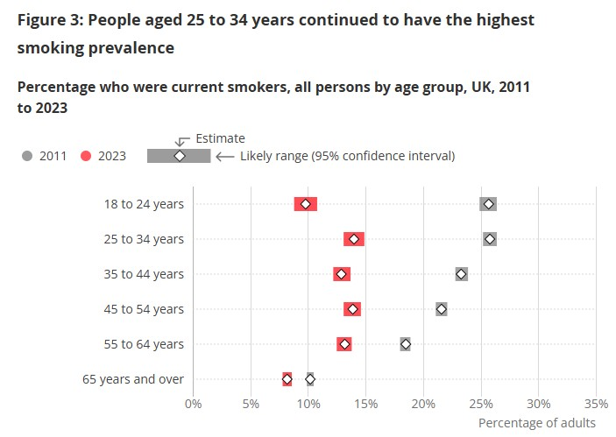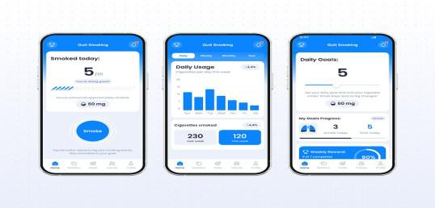
Figure 1: Year wise prevalence of smoking from 2011 to 2023 (ONS, 2023)
4 Weeks - Setup 12 Weeks: Pilot
Phase
6 Months: Scale
up
Conclusion
- Although smoking rates in the UK have declined, young adults still face major challenges in quitting successfully (ONS, 2024).
- This innovation gives them a modern and friendly way to stop—fast sign-up, easy CO tracking, personal coaching, and meaningful rewards.
- It combines the best evidence-based strategies: digital messaging, CO verification, and
financial incentives (NICE, 2025; Lin et al., 2023; Notley et al., 2025).
- The message is simple: 28 days. One decision. Scan to start today.
- By making quitting achievable, personal, and supportive, this campaign can improve health, save money, and reduce tobacco harm across the UK.

Pitch
The innovation that is proposed is the community-based smoking cessation programme specific to the young people who still demonstrate one of the highest smoking rates in the UK. Even though national patterns show a general decrease in smoking behaviour, young adults aged 1835 years are still under a huge influence, with 14 of those between the ages of 25 and 34 and almost 10 of those between 18 and 24 years of age smoking on a daily basis as of 2023 (ONS, 2023). This group continues to have poor quit attempt care even though it has dropped to 10.6% in 2024, and in many cases, this is because of social stimuli, pressure, and the inability to access personalised support (ONS, 2024). This pitch builds on the poster by giving more reasons as to why this innovation is opportune, evidence-based, and necessary to enhancing the outcomes of the community in terms of its health.
Most young adults desire to stop smoking but they lack support and adequate motivation to continue the process because they do not have time to seek help in their hectic lives. Conventional stop-smoking programmes have a tendency to take very long appointments, traveling or waiting, which demoralizes taking part. Traditional research suggests that a personalised instant-messaging approach, e.g. WhatsApp or SMS coaching, should be employed as a potent means of influencing large numbers of digitally active smokers, and it indeed results in higher rates of quitting than generic text messages (Lin et al., 2023; He et al., 2024). This programme will eliminate common obstacles by integrating digital coaching, CO tracking, same-day NRT access, and incentives given in the form of a voucher, which makes quitting seem possible, individual, and motivating.
The programme is effective because it allows young people to enrol to it within 1 minute by scanning a QR code located in community spaces like GP practices, pharmacies, workplaces and youth hubs. Having filled in a short digital form, the participants book a short appointment with a trained stop-smoking advisor and have the opportunity to pick up their selected NRT product the same day at a neighborhood pharmacy. The NRT collection instantaneity decreases drop-out rates whereas the CO monitoring increases credibility and motivation providing the participants with visible evidence of their progress. The CO verification has been proven to be a valid measure of smoking cessation, which builds confidence and responsibility in the quit process (Mukadam et al., 2023). Also, there are financial incentives with supermarket vouchers as positive reinforcements, Cochrane evidence proves that voucher-based rewards considerably influence smoking cessation results (Notley et al., 2025).
The primary audience of the campaign (daily smokers aged 18 to 35, such as students, apprentices, and young employees) is often preoccupied with low-barrier, flexible, and fast solutions. Some lack the time or the confidence to enter into long programmes and this innovation goes directly to that issue. It goes to the youths where they are, on their phones, in their communities, and in their day-to-day activities by providing CO devices, inspirational messages, and weekly video conversations. The anticipated results are enhanced confirmed quit rates, decreased relapse threat via daily digital notifications, and enhancements in bodily wellness, psychological and long-term monetary security (NIHR Quit Sense, 2024; ONS, 2024). These are also benefiting to families, places of work and the overall health and social care system through the minimization of smoking related disease and NHS pressure.
The programme has been in line with the major national policies and regulations. NICE NG209 (2025) advocates quitting and harm reduction interventions, such as the use of digital support and NRT. The personal data will also be processed in a safe manner as per UK GDPR and the Data Protection Act 2018 (UK Government, 2018) and will not be accessed by any party, as well as the participants will have complete control over their data. The digital tools employed within the programme will address the NHS Digital Technology Assessment Criteria (DTAC), where accessibility, security, and clinical safety are high (NHS England, n.d.). Any CO monitoring equipment will bear the necessary UKCA certification in accordance with MHRA legislations (MHRA, n.d.), which will help in safe and proper use of medical equipment.
The success of this campaign is pegged on public involvement. Online platforms and community spaces tend to be the favored sources of health information among young adults, which is excluded by social media, local influencers, gym screens, university channels, and workplace newsletters as important dissemination points. The maximum level of accessibility and visibility is achieved by posters that have large QR codes. Short videos, testimonials, and infographics will be used as promotional material to prove the effectiveness of CO tracking, personalised coaching and voucher rewards (ONS, 2024; Cochrane, 2025). The campaign also creates a community-based movement and not a clinical setting alone through encouraging people to join, share experiences, and promote smoke-free living.
In general, the presented innovation can be described as an evidence-based, modern, and friendly solution to smoking cessation, which is especially needed by young adults that require rapid, adaptable, and individual assistance. It uses behaviour change science, online interaction, and instant rewards to provide a practical, inspirational, and national health priorities quit programme. The idea is not very complex: it is not necessary to make quitting a complicated issue. Young adults are able to get their health under control in only 28 days with CO verification, daily coaching, same-day NRT, and weekly encouragement. This campaign provides individuals with power, helps to empower communities, and helps in mitigating the harm caused by tobacco in the UK.
References
Chemist2u. (2025). Stop Smoking Program. Available at: https://chemist2u.com.au/stop-smoking-program/
Dribble. (2025). Quit Smoking with Smoke Tracker. Available at: https://dribbble.com/shots/25900292-Quit-Smoking-with-Smoke-Tracker
He, W. J. A., et al. (2024). Effectiveness of instant-messaging group vs SMS for cessation support. International Journal of Mental Health and Addiction. https://doi.org/10.1007/s11469-024-01239-7
Lin, H., Lin, Y., Zheng, Y., Liu, Z., and Chang, C. (2023). Assessment of a text message–based smoking cessation intervention for adult smokers in China: A randomized clinical trial. JAMA Network Open, 6(3), e230301. https://doi.org/10.1001/jamanetworkopen.2023.0301
Medicines and Healthcare products Regulatory Agency (MHRA). (n.d.). Regulating medical devices in the UK. https://www.gov.uk/guidance/regulating-medical-devices-in-the-uk
Mukadam, A., Akinyemi, O., and Maduka, O. (2023). Validity of self-reported smoking cessation with carbon monoxide cut-offs. Annals of Medical Research, 30(4). https://doi.org/10.14744/AnnalsMedRes.2023.11766
National Institute for Health and Care Excellence (NICE). (2025). NG209: Tobacco—preventing uptake, promoting quitting and harm-reduction (last reviewed 04 Feb 2025). https://www.nice.org.uk/guidance/ng209
NHS Digital. (2024). Protecting patient data and the national data opt-out. https://digital.nhs.uk/services/national-data-opt-out/understanding-the-national-data-opt-out/protecting-patient-data
NHS England. (n.d.). Digital Technology Assessment Criteria (DTAC). https://transform.england.nhs.uk/key-tools-and-info/digital-technology-assessment-criteria-dtac/
Notley, C., et al. (2025). Financial incentives for smoking cessation. Cochrane Database of Systematic Reviews, 2025(2), CD004307. https://doi.org/10.1002/14651858.CD004307.pub7
Office for National Statistics (ONS). (2023). Adult smoking habits in Great Britain: 2023. https://www.ons.gov.uk/peoplepopulationandcommunity/healthandsocialcare/healthandlifeexpectancies/bulletins/adultsmokinghabitsingreatbritain/2023
Office for National Statistics (ONS). (2024). Adult smoking habits in Great Britain: 2024. https://www.ons.gov.uk/peoplepopulationandcommunity/healthandsocialcare/healthandlifeexpectancies/bulletins/adultsmokinghabitsingreatbritain/2024
UK Government. (2018). Data Protection Act 2018 and UK GDPR overview. https://www.legislation.gov.uk/ukpga/2018/12/contents

