Case study

Student Name
Catalina Denisa Bobe

Student ID number
2126723

Number of words : 2098

BMIH5007 Financial Management for the Hotel Industry

Lecturer

Jaliya de Silva

Executive summary
The case study has elaborated the financial analysis of Seaview Resort organisation in the hospitality industry. It has also defined a few strategic ideas regarding potential risk management. Apart from that, this case study has also evaluated a few combating strategies to retain its business health. Furthermore, it has made a few recommendations for the respective company to sustain in the long run.

Table of Contents
Introduction 3
Financial analysis of the organisation (2020-2022) 3
Potential reasons behind the decline in profitability 5
Strategy for managing financial risks 6
Recommendation 9
Conclusion 10
References 11

Introduction
Financial management is a process of gathering, controlling, protecting and reporting on the financial resources of any organisation. This procedure helps managers to solve current problems by developing strategic decisions. The Seaview Resort has experienced a decline in revenue, occupancy rates, and customer satisfaction in recent years. This case study will evaluate the analysis of financial information including its total revenue, operating expenses, gross and net profit and other factors. This will also explain the potential reasons behind these major losses of Seaview Resort in financial or other aspects. Additionally, a few strategies for managing financial risks will also be elaborated in this case study along with some combating strategies to sustain in the long-term.

Financial analysis of the organisation (2020-2022)
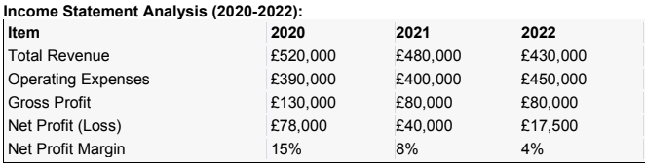
According to the analysis of Seaview Resort's financial performance over the past three years, it can be seen that the company had a total revenue of amount £520,000 in the year 2020 but the measures decreased consecutively in the next two years with a total revenue of £480,000 and £430,000 in 2021 and 2022. Then coming to the operating expenses measures, it is identified that the respective company’s expenditures due to operations amounted to £390,000 in 2020, and £400,000 in the year 2021. In 2022 the company exceeded the total revenue and amounted to £450,000 in terms of operating expenses next year. The Seaview Resort's gross profit measures were £130,000 in the year 2020 while it remained constant at £80,000 in the next two years. The company’s net profit measures have gone downwards from 2020 to 2021. The company had earned a net profit of £78,000 in the year 2020, £40,000 in 2021 and £17,500 in the year 2022 consecutively. The net profit margin has also decreased from 15% in 2020, 8% in 2021 and 4% in the year 2022.
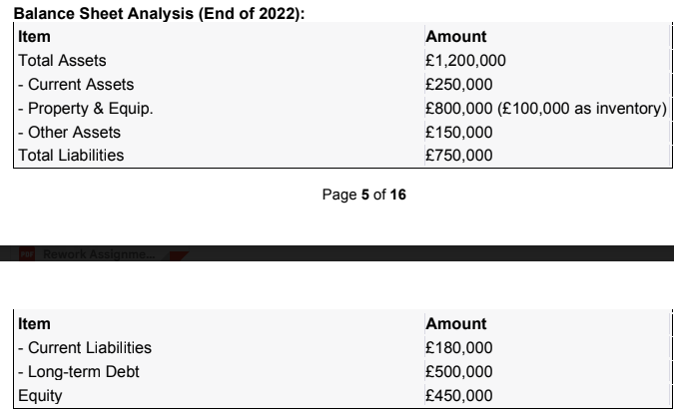
After analysis of Seaview Resort's balance sheet at the end of the year 2022, it can be seen that the company had a total asset of £1,200,000, which the current assets amounted to £250,000 and the property and equipment amounted to £800,000. Coming to the total liabilities, the company is due to pay £180,000 as their current liabilities and long-term debt amounted to £500,000. The Seaview Resort had equity amounted to £450,000 in the year 2022 as per the analysis of the balance sheet.
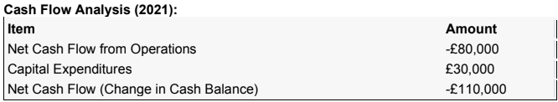
According to the cash flow analysis of Seaview Resort in the year 2021, it can be seen that the company had faced a major loss in terms of net cash flow from their operation with a negative amount of -£80,000. The respective company had capital expenditures of £30,000 in the year 2021. Furthermore, they faced a tremendous loss after changing the cash balance and it resulted in a negative net cash flow amounted -£110,000.
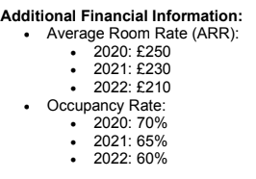
After analysis of the other financial information from 2020 to 20222, it can be seen that the Seaview Resort had seen a consecutive compression in the average room rate (ARR). In 2020 their average room rate was £250 which was reduced to £230 in 2021 and £210 in the year 2022. It is clear that the respective company has faced several losses in different aspects since 2020. Next, the analysis of the occupancy rate also decreased with a few measures. The occupancy rate of the company was 70% in 2020, 65% in 2021 and 60% in 2022.

Potential reasons behind the decline in profitability
Inflation throughout country
The United Kingdom is suffering due to a higher inflation rate in 2020. A high inflation rate raises the necessary costs of utilities and lowers the cost of capital. The cost of business operations increases along with the inflation rate and causes financial instability and potential risk for businesses. It reduces consumer spending power and demand for goods and services by which it lowers the turnover amount. The UK's inflation rate sharply raised by 11% in the year 2022 which has impacted the financial losses among several hospitality sectors including Seaview Resort (Atrill and McLaney, 2021).
Debt situation
Seaview Resort in the hospitality sector has been on a roller coaster ride over the past few years, their financial structure has been majorly affected by the economic crunch and coronavirus pandemic in 2020. Poor debt situations create significant negative effects on a company’s financial statement. Seaview Resort’s liabilities have reduced the net income and reduced profitability and earnings per share (Drury, 2021).
Competitive market
The UK has a wide range of hospitality markets which has raised several competitors for the respective company. Competitors such as Premier Inn have a strong competitive market for Seaview Resort. This has impacted a profit cut to attract customers for stay competitive among other peers (Bhimani, 2006).
Travel declining
Due to the COVID-19 measures the travel industry also has faced significant losses because of massive decline in travel. After the pandemic era, the travel industry has faced a 30% decline compared to the previous period. Travel restrictions and lockdown measurements have also caused staff shortages for serving the travellers and resulted in job losses, low revenue and low net profit. Seaview Resort also faced a significant profit margin due to this factor.
Poor customer satisfactory
Due to staff shortages, the Seaview Resort faced a significant decline in profit margins. Due to COVID measures the needed number of staff was not available at that time which led to poor customer satisfaction for the respective resort. Along with that, it has also decreased the brand reputation in terms of good service for this resort (Akande and Salawu, 2019).

Strategy for managing financial risks
Risk management is an essential factor for identifying, understanding and lowering the potential risk factors for a business organisation. This helps businesses by lowering financial losses and helps in clear decision-making by mitigating the risks and uncertainties. The Seaview Resort can overcome financial risk factors by considering several strategies such as identifying the potential risks beforehand, mitigating the uncertainties with strategic decisions and continuous monitoring (Ballotta et al., 2020).
Identifying potential risks beforehand
The process of risk management starts with the identification of the potential risk factors and uncertainties. Conducting a risk assessment to identify the potential threats and hazards affecting business health. Analysis of financial statements will help operators to know the market risks such as economic fluctuation, changes of tax or exchange rates, operational risks including system disruption, credit risks and others. It helps to combat potential obstacles affecting the overall business health.
Mitigating uncertainties with strategic decisions
Making strategic decisions is an important factor in mitigating the significance of identified risks. These strategies help businesses to fight against market fluctuation, risk exposures, and other factors to be aware of future uncertainties, and internal and external threats for the company. securing insurance policies, raising funds for emergencies and diversifying the sources of income will also help business entities to dilute the risk factors (Martinez, 2023).
Continuous observation or monitoring
Identifying financial risks is not enough, continuous monitoring of these metrics is also important for managing financial risks. Prioritising the risk factors based on their significance towards the objectives of the business is an effective step to take after assessing them. Constant monitoring allows for prior planning, tracking of occurrence and identifying eventuality over time. This process of day-to-day observation helps organisations to develop financial risk management activities to support risk decisions.
Turnaround strategy
Turnaround strategies are a bundle of measures that help businesses to identify the reason behind their declining performance. Companies use these strategies to overcome the different challenges and improve business performance. The Seaview Resort has also faced a major decline in profit therefore they need to use these turnover strategies to be back in the competition (Walker, 2021).
Lowering operating costs
Liabilities or operating costs are the other expenditures other than production. Liabilities do not affect the net income of a company while it is not deducted from revenue. Increasing operating costs indicates a reduction in profit measures. As the respective company’s operating costs were too high, it caused a lower rate of net income from 2020. The Seaview Resort needs to lower this particular expense to reach net profit (Wild, 2018).
Technological advancement
Among this tech-savvy world, it is needed to consider several new technologies to stay competitive and boost the net profit. The Seaview Resort needs to adapt these new technologies to increase its productivity and have a better outcome with the existing resources. It will lower the manual time and improve the efficiency of business by cutting costs and remain competitive in the market (Tranter et al.m 2014).
Change of leadership
Leadership plays an important role in business performance and also managing financial risks. Changes in leadership can have a significant impact on business goals in company's growth and expansions, management of the workforce and put administrative support in risk management. The respective resort can make a few changes in their administrative sections to use some turnaround strategies (Macdougall, 2023).
Diversify revenue system
It is important to change the company’s traditional revenue system to enhance the net income. Diversifying the existing revenue system by offering new attractive packages, personalised services, and hosting events and meetings can help the business grow on a diverse level. Other than that, expanding their services such as complementary services, and letting the customers access the spa, gym or movie theatre can attract more customers with higher spending (Seal et al., 2008).
Adaptation of trend and culture
The trends and culture are continuously evolving day by day in every industry. Stay updated with emerging changes between cultures that have a significant effect on the turnaround strategies of this resort. Regular monitoring of new trends and culture will help the Seaview Resort to evolve more towards profit earning. Hospitality is a dynamic country and adapting this turnover strategy can help the industry in both the short and long run (Azzahra, 2023).

Recommendation
Enhance marketing strategies
The Seaview Resort has faced several losses over the past few years, it is important for them to combat these financial risks by implementing new marketing strategies to sustain in the long term. It is a highly effective tool as it helps create a brand reputation, accelerates profit and growth and enhances customer engagement. Effective marketing will also help Seaview Resort to build a strong brand position in the competitive market. Companies that communicate with more audiences with unique marketing are highly profitable in generating profit in the short term and help establish brand value in the long-term justifying higher pricing policy and profitability (Guilding, 2014).
Maintain sustainability
Maintaining sustainable practices helps businesses to be more effective by reducing carbon footprints, lowering pollution and protecting natural resources. The Seaview resort can enhance customer loyalty and positive brand reputation which will end up in a sustainable development in the long run. Businesses with more energy efficiency reduce several costs resulting in a business with more profit and durability (Seal, 2019).
Enhancing networks
The respective company should increase their networking system with the help of their investors and shareholders which will assist the company in communication with a huge range of customers. Strategically developing relationships with stakeholders and collaborating with them will help in growing the business in the long run (Jagels, 2007).

Conclusion
The case study concludes that financial management is an important process to keep track of the financial resources of any organisation. This process of managing finances helps managers to identify and solve current problems by developing strategic decisions. The Seaview Resort has experienced a decline in revenue, occupancy rates, and customer satisfaction from 2020 to 2022. This case study has evaluated the analysis of financial information including its total revenue, operating expenses, gross and net profit and other factors to state a clear idea of their lacking performance in financial metrics. This has also explained the potential reasons behind these major losses of Seaview resort in financial or other aspects. Additionally, few strategies of managing financial risks such as enhancing marketing strategies, maintaining sustainability and enhancing networks have also been evaluated in this case study along with some combating strategies to sustain in the long-term.

References
Akande, F.I. and Salawu, R.O., (2019). Risk management and financial performance of listed deposit money banks in Nigeria. The International Journal of Business & Management.
Atrill P, McLaney E (2021) Management Accounting for Decision Makers, FT Prentice Hall
Ballotta, L., Fusai, G., Kyriakou, I., Papapostolou, N.C. and Pouliasis, P.K., (2020).Risk management of climate impact for tourism operators: An empirical analysis on ski resorts. Tourism Management, 77, p.104011.
Bhimani A, (Ed) (2006) Contemporary Issues in Management Accounting, Oxford
Drury C (2021) (11th Ed) Management and Cost Accounting, London, Prentice Hall
Guilding,C.(2014) (3rd Edition) Accounting Essentials for Hospitality Managers, London, Routledge
Jagels,M. (2007) Hospitality Management Accounting, London, Wiley.
Macdougall, N. H. a. S., (2023). The key challenges for the UK retail and hospitality industry. [Online] Available at: https://www.saffery.com/insights/articles/the-key-challenges-for-the-uk-retail-and-hospitality-industry/ [Accessed 23 February 2024].
Martinez, C. J., (2023). 8 Methods to Managing Financial Risks your Business may Face. [Online] Available at: The key challenges for the UK retail and hospitality industry [Accessed 22 February 2024].
Rhiannon Philps, C. C., (2023). Advantages and Disadvantages of Bank Loans for Small Businesses. [Online] Available at: https://www.nerdwallet.com/uk/business-loans/pro-and-cons-of-bank-loans-for-small-businesses/ [Accessed 22 February 2024].
Seal W (2019) (6th Ed) Management Accounting, London, McGraw Hill
Seal W, Garrison RH, Noreen E (2008) Management Accounting, McGraw Hill
Tranter,K. Stuart-Hill,T. Parker,J. (2014) Introduction to Revenue Management for the Hospitality Industry, London,Pearson
Walker J (2021) Introduction to Hospitality, Harlow, Pearson
Wild J (2018) Fundamental Accounting Principles, New York, McGraw Hill

