Data Analysis

Ethan Ridd – P144898 – School of Applied Computing – UWTSD
Abstract – The author has been asked to analyse 2 sets of data then build a hypothesis around his initial observations of the data. He was then asked to test the data and conclude about his findings. The author attempts to look at the differences between 2 sets of students one group of 10 with an age range of 17 to 20 and another with an age range of 45-62 in relation to the satisfaction score they gave their university. The author used the initial untested data set and came to a reasonable hypothesis that mature students were more satisfied with the course. The author used many statistical techniques including but not limited to frequency diagrams and the T Test to analyses the data to understand how it supports or disproves his hypothesis. At the end of the tests it has been concluded that the data supported the authors hypothesis, but it can be said that the data set was too small or more strenuous testing could have been done on the data to improve reliability
- Introduction
Data analysis is used daily across numerous fields from psychology to chemical biology to computer sciences[1]. Data analysis is the process of looking in depth at sets of data to understand trends and or differences between groups of data, this data can then be interpreted and tested to support or disprove a hypothesis or theory that a researcher has about her or his experiment and helping to form a clear and concise conclusion[2]. In this report the author is going to analyse 2 sets of data that he has been provided. The data shows university satisfaction ratings out of 60 from 2 groups of 10 students, one containing mature students with an age range of 45 to 62 years of age and the other containing young students with an age range of 17 to 20. The author has been asked to look at the data and then devise a testable hypothesis, once the hypothesis has been devised he is then to take the data and put it through numerous tests using 3 different significance levels (P=0.10, P=0.01, p=0.02). he will analyse the data at various stages through the testing taking note and highlighting any outliers that might affect the data and any features of the data that might support or disprove the hypothesis. Finally, the author will conclude this report talking about the different factors that could have affected the results that were not considered during the development of the experiments methodology.
- Hypothesis
From a preliminary look at the data, the author has come to a hypothesis that he will test using said data and numerous tests that will either prove or disprove his hypothesis. The hypothesis is as follows, the mature students show a higher level of satisfaction with the course than the younger students. The author has come to this hypothesis by looking at the data and observing that mature students have given higher satisfaction scores on the course than the younger students as seen in figure 1. Before the author begins testing though, he must first create his null hypothesis. Due to the way statistics work it is impossible to prove something as correct, so the only logical way around this is to test for the opposite of the hypothesis and disproving it[3]. The authors null hypothesis is as follows “mature students are less or equally satisfied with the university experience then the younger students”.
To further understand how the author will reject or accept the hypothesis it is important to acknowledge the 2 types of errors that can occur when deciding if a hypothesis is correct or not. Types I errors occur when the hypothesis is rejected when it is true causing a false positive, type II errors occur when the hypothesis isn’t rejects when is false also called a false negative[4]. The author will now begin to put his hypothesis to the test by putting the data through numerous statistical tests.
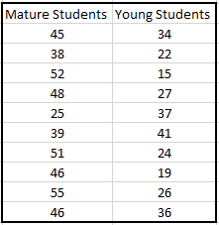
[Figure 1 – Raw data showing the satisfaction ratings of young and mature students]
- Testing
To fully understand the data and to observe if it supports the hypothesis the author will need to perform some rigorous testing on said data. In this section the author is going to be putting the data through different types of tests with different procedures, there are 3 potential tests that the author could use. The first test the author could put the data through is the Z-Test this allows for the testing of a score against a different group of scores. For this data it allows the author to compare the scores of the 2 different distributions against one another. A second test the author could use to analyse that data is the T-Test, which is a commonly used statistical test. That determines to what statistical degree the results of a data set differ. This test is used on data that consists on no more than 2 groups, this is perfect for the authors data set and could be useful in determining the validity of the hypothesis. The third and final test the author could put the data through is the analysis of variance test. This test is used to test the differences between more than two groups, this might not be necessary as there are only 2 groups of data that the author has been given.
Graphs
The First stage of Testing is to organise the data into a more structured manner, this will allow the author to display the data in a clear graph for easy interpretation. The author took the data and created a grouped frequency diagram as seen in figure 1, this is done because the data varies so much that it might be difficult to see a trend or pattern. To create the width of the of the individual ranges the author took the highest value in the data and subtracted the lowest value from that, he then divided the answer by the number of ranges he wants.
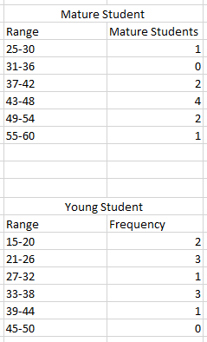
[Figure 2 – Ranges for the frequency diagram]
In figure 3 we can see the results in the form of a frequency diagram, from this we can get an idea of whether the data in the current form supports the authors hypothesis. It can be observed that a lot of the mature students rated the course at above 37/60. This supports the hypothesis at this current stage, more strenuous tests might prove otherwise. The data seems to have an inconsistent trend where the curve starts at a relatively high point of 1 student giving a score of 25-30 and then the score drastically drops to 0 students giving a score between 31-36. This could be due to the limited size of the data set for mature students, had more data been gathered a clearer trend could have been seen on the frequency diagram. It can be clearly seen that the data has a negatively skewed distribution as the scores seem to gather at the upper end of the graph, showing that overall the scores given by mature students were more positive.
[Figure 3 - diagram for mature students]
Figure 4 has a more interesting trend as can be seen below, the course satisfaction scores never go above 44/60 and never dips below 15/60. The frequency of the different scores vary dramatically, causing an inconsistent trend line this could be due to the small data set the same issue that occurs with the mature student’s data set. Gathering more data could give a predictable trend, by putting this data through more tests the author might be able to make a clearer approval or disproval of his hypothesis. Even though the data shown in figure 4 has 2 peaks in the diagram, we can see that the distribution is positively skewed to one side of the graph.
[Figure 4 – Frequency diagram for young students]
- Percentiles, Quartiles and Standard Deviation
An easy way to understand the data is to put it through some basic analysis steps such as understanding where most of the scores lay and what the averages of said scores are. The most common average used is a mean average, which adds all the score together and then divides the total by the number of scores present in the data set[5]. This results in the mean average of the satisfaction score of mature students being 44.5 and the mean average of the satisfactions score of younger students being 28.1. From these averages the author can see that on average mature students gave a higher score than the younger students.
Percentiles allows for the data to be interpreted in a way that shows where a single score lays in relation to the rest of the group [6]. Percentiles use the median average to work out the 50th percentile. The median average is calculated by placing the values in ascending order and then the middle number of the set or the halfway point between the middle 2 in case of an even set is the average[5]. From figure 5 we can see that 68% of the scores that mature students gave the university were in between 38.44 and 51.56 out of 60. Meanwhile 68% of the score that young students gave were between 20.32 and 36.56 out of 60. From this alone it can be seen that the students who were in the more mature age range rated the university higher in satisfaction than those in the younger age range.
Standard Deviation allows for the measurement of how spread out the data is from the mean average. This can only be done if there is a normal curve but due to the amount of data and the irregularity of the frequency diagram this might not be useful enough to give an accurate interpretation of the data. The Standard Deviation for the mature students is 8.237 and the younger students is 8.105, both numbers are relatively high and thus show that the data is dispersed well and not clustered around the mean average.
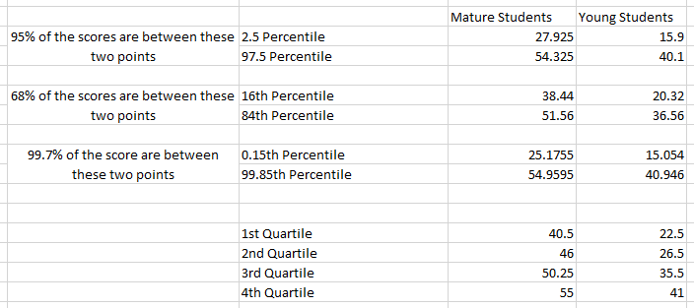
[Figure 5 – Percentiles and Quartiles]

A good way to measure how a single score in a range compares to a bunch of scores in a different range is the Z Test or the Standardized score test. The Equation that can be seen in Figure 6 allows the conversion of a raw score into a more meaningful score that can be interpreted. The author has decided that this test would not be suitable because the data set isn’t big enough and according to his research it is best to perform a Z test when the data set have more than 30 values[7].

[Figure 6 – Equation used to calculate the Z score[8]]

- T-Test
The t-test is a good method used to determine if the difference between 2 groups of data are statistically significant[2], this allows the author to tell if the data is different due to chance and randomness or if a variable has altered the data thus proving or disproving a hypothesis. When looking at the data the author has made a hypothesis but no solid prediction about the data before gathering the results, thus he must use non-directional or two-tailed testing when it comes to the T-test. Using a non-directional test results in an increased likelihood of type-II errors. The formula for the T-test can be seen below in figure 7. The variables in the Equations are as follows $\overline{X}$ is the mean of a single set of data, S is the standard deviation of a single set of data and n is the total number of values in a set of data.
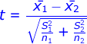
[Figure 7 – Equation used in the T-Test[9]]
An advantage of the modern age is that the math involved in the procedures of the T-test can be done accurately in a spreadsheet program thus removing the possibility of errors in the calculations. As can be seen in figure 8 Excel has produced the T-test output, from this the author can see the degree of freedom is 18 as highlighted in green and the t stat which is highlighted in red.
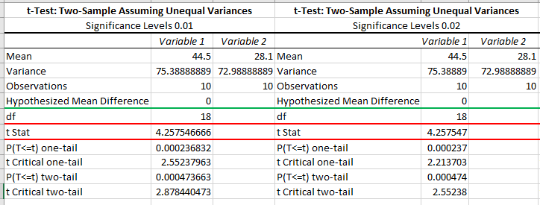
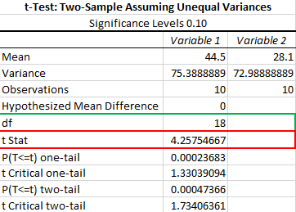
[Figure 8 – Excel T-test output on data with significance levels of 0.01, 0.02 and 0.10]
With this data the author can now look at the t table in figure 9 and figure out if the t critical value is statistically significant enough to merit the approval of the hypothesis. To do this we take the degree of freedom and cross reference it with the significance level of the test. The author has highlighted the result in figure 6 below with red=0.10, green=0.02 and black=0.01
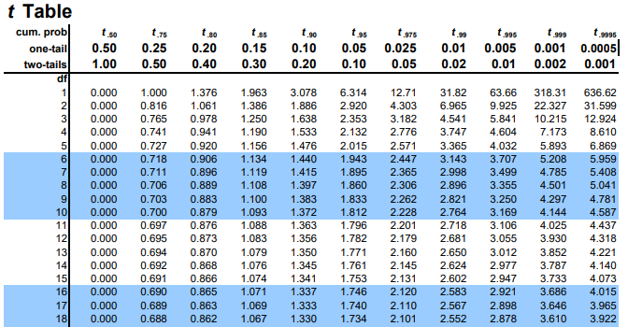
[Figure 9 - Critical T Value Table [10]]
Next the author will compare the t Critical value against the t Stat Value also known as $T_{obt}$ value if the $T_{obt}$ value is equal to or greater than t critical value in the table then the results are statistically significant, thus we must reject a null hypothesis.
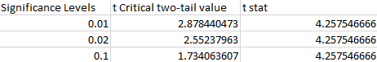
[Figure 10 - Comparison of t Critical and t Obtained values]
As can be seen in figure 7 all significance levels show that the null hypothesis must be rejected and thus proving the hypothesis that the older 10 students experience higher satisfaction rates than younger students. We reject the null hypothesis because the results are significant at the level of 0.1, 0.01 and 0.02, this means that the results fall into the large percentile of the normal curve anything less and it would be considered an outlier and that the data is not due to randomness but a statistically Significant difference between the two groups. From this we can also gather that no type I errors have occurred. As we have rejected the null hypothesis when it was proven false.
- Conclusion
To conclude the author has analysed that data in numerous ways from looking at the average score and then comparing them against on another. From this he found that on average more mature students gave a higher satisfaction rating of 44.5 than the younger students who on average gave a satisfaction rating 28.1. The author then analysed where the largest number of scores lay within a percentile and observing that when looking at the 68th percentile the mature student gave a higher range of scores (38.44 to 51.56) than the younger students in the 68th percentile of their own data set (20.32 to 36.56). Finally, the author put the data through the T-Test to find out whether the variances in the data were due to randomness of the data set or if there is a legitimate difference between the two groups. The author found that the results of the T-test show legitimate variances between thee two data sets with significance levels of 0.01, 0.02 and 0.10 with no types I errors. This allowed the author to reject the null hypothesis proving his initial hypothesis correct that more mature students did in fact have higher levels of satisfaction than younger students. The author did notice some issues with the data, had there been a larger data set then the results might be more testable with more statistical tests. For example, if the data set had 50 mature and 50 young students to give satisfaction ratings then the data might have been normalized enough to create a bell curve and bring in more predictable conclusions.
References
[1] Openstax, Introductory Business Statistics. .
[2] J. H. Kranzler, Statistics for the Terrified, Fifth Edit. Pearson Prentice Hall.
[3] J. Devore, A Modern Introduction to Probability and Statistics: Understanding Why and How, vol. 101, no. 473. 2006.
[4] J. C.Watkins, “An Introduction to the Science of Statistics : Preliminary Edition,” 2017.
[5] J. Isotalo, “Basics of Statistics.”
[6] J. L. Phillips, How to think about Statistics, Sixth Edit. New York: W. H. Freeman and Company, 2000.
[7] “T-Score vs. Z-Score: What’s the Difference? - Statistics How To.” [Online]. Available: https://www.statisticshowto.datasciencecentral.com/probability-and-statistics/hypothesis-testing/t-score-vs-z-score/. [Accessed: 03-Jan-2019].
[8] “Z Test Formula | Z Statistic Formula | Formulas@TutorVista.com.” [Online]. Available: https://formulas.tutorvista.com/math/z-test-formula.html. [Accessed: 02-Jan-2019].
[9] “T Test Formula | T Statistic Formula - Examples | Formulas@TutorVista.com.” [Online]. Available: https://formulas.tutorvista.com/math/t-test-formula.html. [Accessed: 02-Jan-2019].
[10] “t Crit Table.” [Online]. Available: http://www.sjsu.edu/faculty/gerstman/StatPrimer/t-table.pdf. [Accessed: 02-Jan-2019].

