
Taraneh Adibmehr (2005918)

Architecture BSc
History And Theory 1 (M4X01975)

Architecture In Your Hometown

In this essay I will analyse the difference between Mount Pleasant Chapel, Kingsway, Swansea and Sketty Hall Singleton Park, Swansea, south Wales.

Throughout 1825-26, Mount Pleasant Chapel was constructed on which was previously entitled ‘the Gower Road’. This only consisted of few shops, leading to the western sections of the city (Swansea Council, 2017). Architect George Morgan modelled the extended plan for the building in 1874-76 by adding the classical façade with four Corinthian pillars. Additional alterations involved the development of the lecture hall (1885) and classrooms (1905), leaving the existing chapel in the classical style.The expenses came to £4,510 which was considered a large amount at the time of construction. The chapel has historic significance to the civilians because it was the only building standing defiantly after the outcome of the Three-Nights-Blitz, so it is of great importance to the city and its history (John Ball, 2015).

Contrastingly, Singleton Park is an urban public open space park in which Sketty Hall is located. Its history is one of private ownership, particularly by the Vivian family (Coflein, 2021). In the 1720s, this property was built by Rawleigh Dawkin,then developed from 1831-1865 after Lewis Weston Dillwyn bought it for £3,800. This 19th-century re-model sought to bring more detail and character to the Hall. Similarly, both buildings have played a vital role in the history of Swansea because of the significant value they hold to the community, notwithstanding the different public services.

The rectangular plan demonstrates the strategically positioned seating arrangement, to ensure the essential view of the stage. This interior plan is ideal for the unique requirements of a chapel such as the inclusion of the baptism area. The wide stairwells by the entrance leads to sitting areas and classrooms allowing children to be taught separately. Situated alongside of the establishment is a lecture hall and coffee bar. Additionally, the inclusion of the car park facilitates for guests and members. On the opposite side of the building a courtyard is situated, where visible signs are projected, constituting to a positive as this allows for effortless publicity for the chapel.

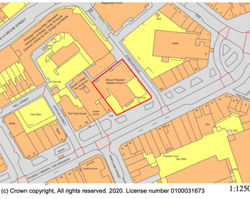
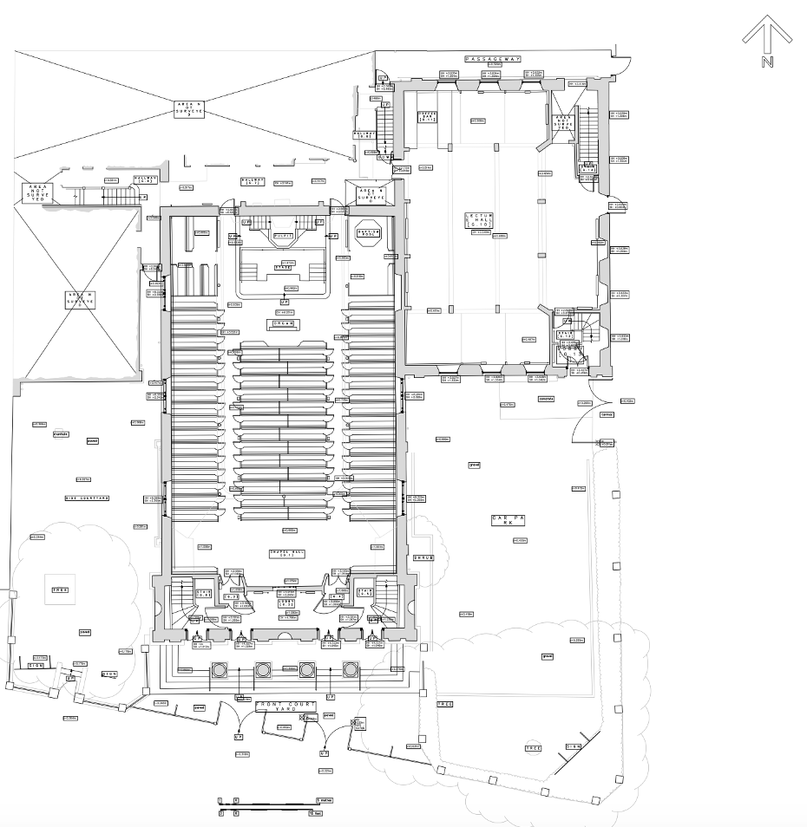

However, Sketty Hall is in a private location, yet it’s easy for the public to access due to the nearby road entrance, not to mention the convenience of a car park. The reception is facilitating due to the easy access to the other rooms of the building. Through the ground floor of the Hall, a botanical garden can be accessed via the back.

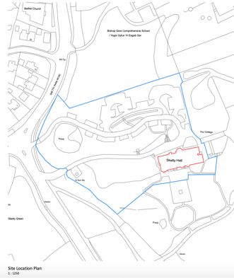

Sketty Hall has various venues for all ranges of activities. Whereas the chapel’s main function, is to gather worshipers. Another distinction evident is that Sketty Hall consists of great outdoor space; including a garden leading to the remainder of Singleton Park. Contrastingly, due to the position of the chapel, it does not enjoy the luxuries of having an open space because of the boisterous surroundings. Advantageously, both locations aid the needs of the establishments, as a busier environment for a chapel encourages the public to enter, whereas hall activities (wedding or business etc) requires a more secluded area.

For centuries, scalloped niches have seen popularity in chapels, demonstrated by the inclusion in the centre of this chapel's exterior. The chapel has achieved a distinctive look, via the bath stone facade and the Corinthian tetrastyle veranda that is covered with a pantile roof. The arched windows (with marginal glazing bars) throughout the building also provides originality. However, the Chapel’s surroundings reluctantly causes shadowing, so natural light is unable to be obtained, unlike Sketty Hall (Hilling,J.1976,115). Sunlight passes through the traditional pane sash windows, providing the interior of the house with natural light. This reduced use of artificial lighting results in energy efficiency. Within Sketty Hall, there is a two-story entrance hall with dentil cornice (also found in other rooms) and a landing with iron balusters. Other rooms are fixed with acoustic tiles or suspended ceilings; in order to obscure them. Original fireplaces and doors still remain. Additionally, Sketty Hall has a large Georgian stucco front and the twin splayed ground-floor bays have carved headsets over the windows, as seen on the exterior (British Listed Buildings, 2021).

Sketty Hall has balustraded (Doric porch with twin columns) aprons on the outer bays of the house. In comparison to the chapel, there is balustraded parapets with Corinthian pilasters. The Hall has a large glazed lantern with weathervane on the roof, which is not seen in the chapel. However, both buildings have proven to be sustainable due to their everlasting structure. The chapel’s use is for religious Christian ceremonies. Every Sunday, members and guests assemble at services because of the importance of the community; providing a union and support network. The location causes the establishment to become noisy at times due to the surrounding traffic. However, the attendees are to remain silent during preaches unless encouraged to engage in choir. In comparison to Sketty Hall, the constructions function has frequently changed over the vast years, as the original private residence is now used for business and social use. Security is ensured by the gate surrounding the premises, and beyond this the acoustic panelling ceiling provides sound proofing to ensure privacy. Comparably, both buildings serve a purpose of gathering the public in one place. However, Mount Pleasant Chapel is situated in a busier environment, whereas Sketty Hall is in a secluded and ambient location. Analysing both buildings demonstrates that although both used as public spaces, the chapel is confined and restricted for solely religious purposes whereas Sketty Hall is used for various public purposes.

In conclusion, the timeless structure of both buildings hold a significant value to the locals, despite both have been altered over the years, therefore they are still classified as some of Swansea’s most historic landmarks. In this particular task I noticed a lot of similarities between the two buildings mainly due to the structures being assembled in close time periods. If I were to do this task again, I would attempt to compare an old building to a more modern-day building because it would be more interesting if the timelines were so distanced that I could investigate the obvious and prominent contrasts between them.

Bibliography

- Swansea Council (2017) What the Kingsway used to look like https://www.swansea.gov.uk/article/38473/What-the-Kingsway-used-to-look-like

- John Ball (2015) Welsh Churches and Chapels Collection: Mount Pleasant Chapel, Kingsway, Swansea, Glamorgan
https://www.jlb2011.co.uk/walespic/churches/swansea2.htm

- British Listed Buildings (2021) Sketty Hall
https://britishlistedbuildings.co.uk/300011765-sketty-hall-sketty#.YA4aOC-cbUr

- Hilling, J. (1976) The Historic Architecture of Wales

- Coflein (2021) SINGLETON ABBEY AND SKETTY HALL, GARDENS, SKETTY, SWANSEA

https://coflein.gov.uk/en/site/28736/details/singleton-abbey-and-sketty-hall-gardens-sketty-swansea

