Ryan Lang 1603678
1603678@student.uwtsd.ac.uk
Distributed Concepts
Applied Computing – Distributed Enterprise Applications

Abstract
It is important for developers to understand the concepts, principles and best practices for designing distributed software components to be used in enterprise services. Windows Communication Foundation was introduced to improve the development of distributed systems. Other technologies came before WCF, but lacked some important features. Interoperability and scalability are two very important concepts in distributed systems. This report looks at WCF and the technologies surrounding it, including how a developer would host a WCF service.

Table of Contents
1. Introduction 1
2. Windows Communication Foundation 1
3. Hosting WCF services 2
3.1 Example of Hosting a WCF Service 2
3.2 The Application Configuration File 12
3.3 Principles and Process of Metadata Exchange in WCF 12
4. Four major contract types 13
4.1 Service 13
4.2 Operation 14
4.3 Data 14
4.4 Fault 14
5. Exchange Patterns 15
5.1 Request-response 15
5.2 One-way 15
5.3 Duplex 15
5.4 Asynchronous 15
5.5 Peer to peer 15
6. How WCF Enables and Supports Interoperability 16
7. References 17

1. Introduction
There are different technologies available for distributed enterprise applications. One of these technologies is WCF (Windows Communication Foundation). WCF was created by Microsoft as a platform for building distributed and interoperable applications [1]. WCF was first introduced in the .NET 3.0 framework. This framework is used for creating service oriented applications.
A distributed system is a system that does not run on a single computer, but on multiple computers within a network that interact with each other to achieve a goal [2]. This distributed approach to applications is essential to the function of web applications.

2. Windows Communication Foundation
Scalability can be an issue for web applications. As more users are using the application at the same time, the performance can degrade [3]. Using a distributed application architecture improves performance and scalability of the distributed application [4]. A way WCF ensures performance does not degrade is by having different parts of the application running on different machines with their own processors and hardware to deal with the increased processing demand. WCF did not invent the idea of distributed applications though. Previous technology choices included: enterprise service; Dot Net remoting; and web service.
WCF was created to bring different technologies together, to simplify building service-oriented applications. It combines several distributed models including Enterprise Service, .NET Remoting, XML Web Service, and more, with the goal of providing multiple communication protocols and better interoperability [5]. Previous technologies needed a different service implementation to provide services to clients operating on different protocols. WCF allows for clients communicating with different protocols to connect to the same service, but with different endpoints. This means code does not need to be drastically changed for each client.
WCF is the easiest way to create and consume services on the Microsoft platform [6]. Using WCF allows developers to focus on the applications functionality and not worry about the protocols clients will be using to connect. DCOM, COBRA, and JAVA RMI are all technologies that came before WCF, but do not have as many features [7].
One popular technology for distributed applications is Simple Object Access Protocol (SOAP) which is a way of Web services exchanging information. It uses the XML information set for its message format. It relies on HTTP for transmitting messages. HTML has very wide support so SOAP can allow clients to invoke web services regardless of the programming language and platform of the clients [8]. This is limited though, because if a client does want HTML or any other application layer protocol, SOAP cannot satisfy that client. WCF can satisfy the client with its support for multiple protocols though which makes it a compelling choice for developers.

3. Hosting WCF services
A WCF service can be hosted in different ways. One of these ways is with IIS (Internet Information Services). With IIS no custom code is require to host the service. A message arrives at the service and it then activates so the service does not need to run all of the time.
Another hosting method is with Windows service. A windows service is similar to any other application running on Windows, however Windows services run in the background and do not have a user interface. Windows services can start automatically when the system boots. On a Windows OS there will be a lot of Windows services running in the background which enable key OS features. These features include: event logging; providing security (windows firewall); and error reporting. When installing new software a new Windows service may also be installed to enable functionality.
Windows service can be used to host a WCF service. The service can be enabled to start automatically when the computer boots into Windows, making the WCF service always available for clients.
As well as these options there is the option of self-hosting.

3.1 Example of Hosting a WCF Service
Hosting a WCF service in any managed .NET application is self-hosting.
The following shows the process of creating a basic WCF service that is hosted in a console application:
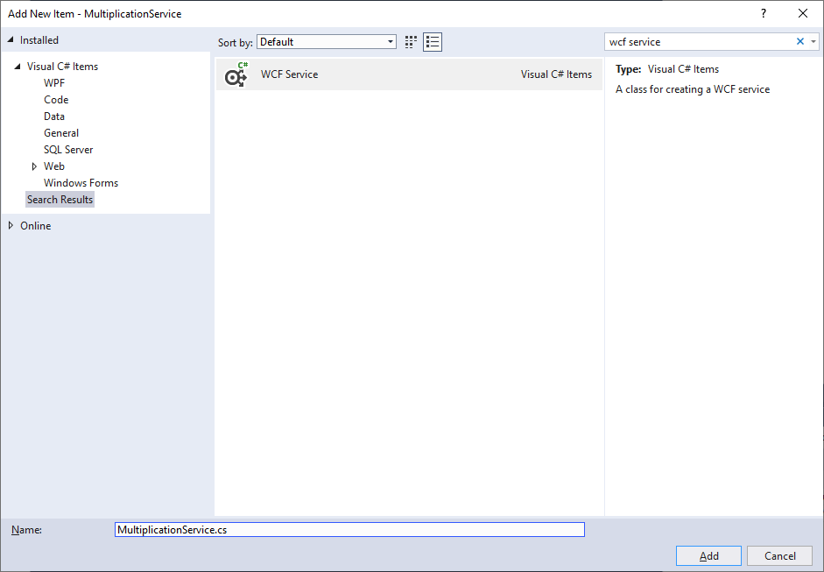
Fig. 1
In Visual Studio a new project needs to be created and a WCF Service needs to be added to that project. Fig. 1 shows the window that opens in Visual Studio that lets you select what to add to the project and what name to give it.

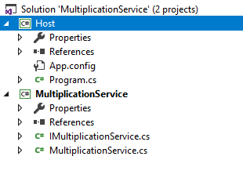
Fig. 2
Fig. 2 shows the solution explorer after the WCF service has been added and a Host project has been created. Fig. 3 shows the interface that was created with some code.

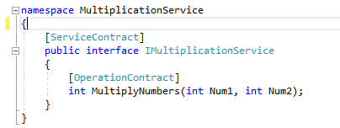
Fig. 3

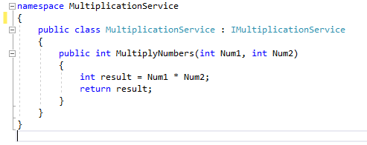
Fig. 4
Fig. 4 shows the implementation of the interface in the ‘MultiplicationService’ class.
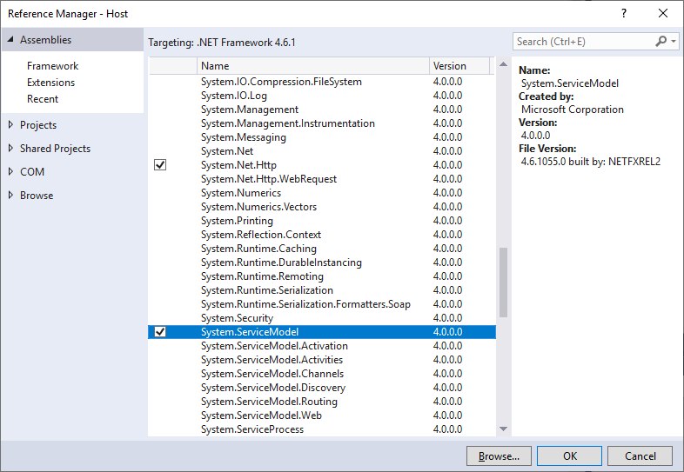
Fig. 5
The host requires a reference to the ‘System.ServiceModel’ assembly which is shown in Fig. 5.

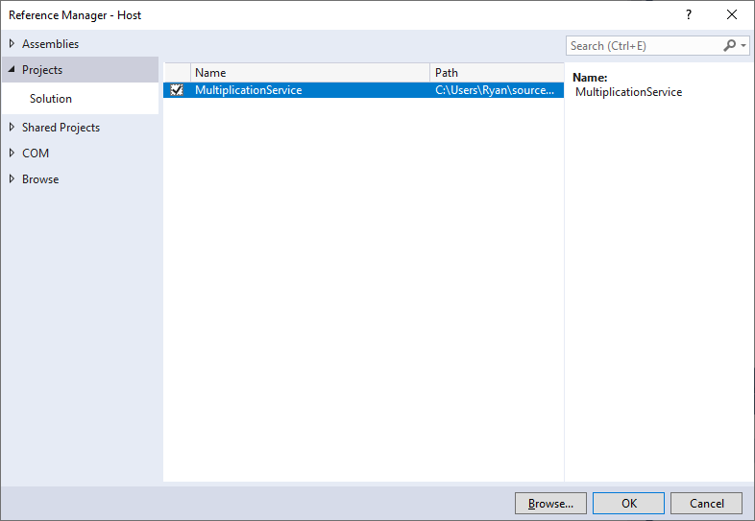
Fig. 6
A reference to the project with the WCF service needs to be adding which is shown in Fig. 6.
New versions of Visual Studio automatically create an App.config file. If there is not an application configuration file in project then one needs to be added.
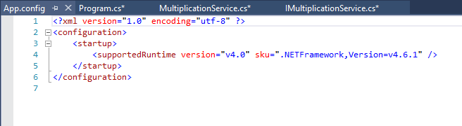
Fig. 7
Fig. 7 shows what the default App.config file looks like. The code we need for this file could be typed in manually, but Microsoft has created a WCF service configuration editor tool to simplify this process.
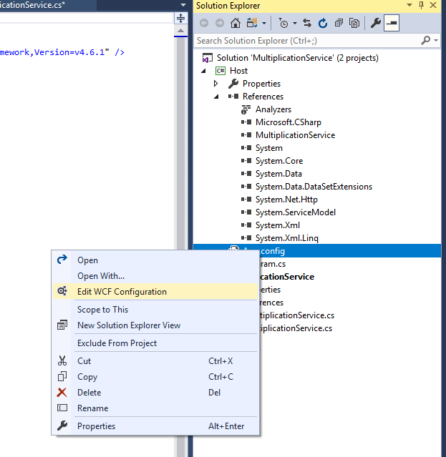
Fig. 8
Right clicking on the App.config file will give the option of editing the file with the configuration tool as shown in Fig. 8.
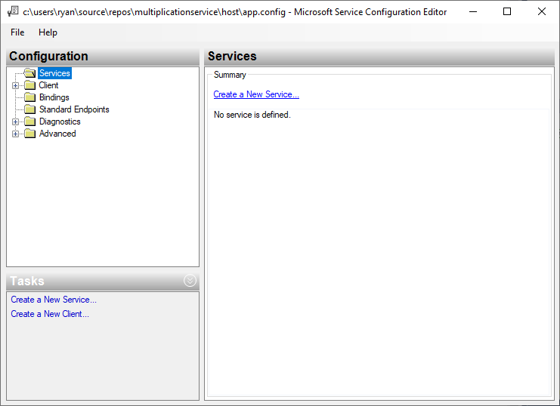
Fig. 9
We can run through the wizard shown in Fig. 9 to create a new service. We can select our created service to use and specific a service contract.
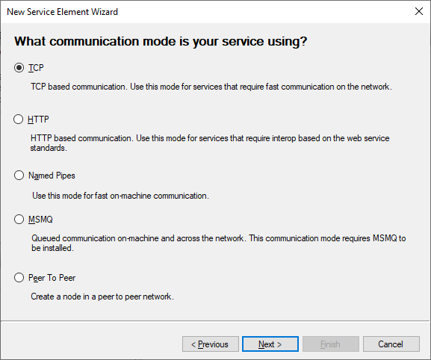
Fig. 10
There are different communication modes for the service that can be selected, shown in Fig. 10. A key advantage to using WCF is that it supports different communication modes, which earlier technologies did not. For this example TCP is being used.
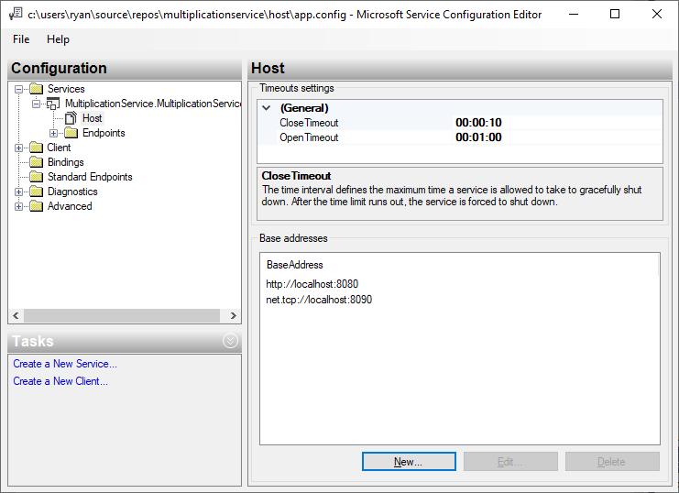
Fig. 11
There needs to be two base addresses, one for the service endpoint and one for the metadata to be available. In Fig.11 the base address for metadata exchange is ‘http://localhost:8080’. In this example the client and service are being ran on the same machine so the address is for the local machine. When creating a service that is useable over the internet between more than one computer i.e. a distributed application, a web address will need to be specified.

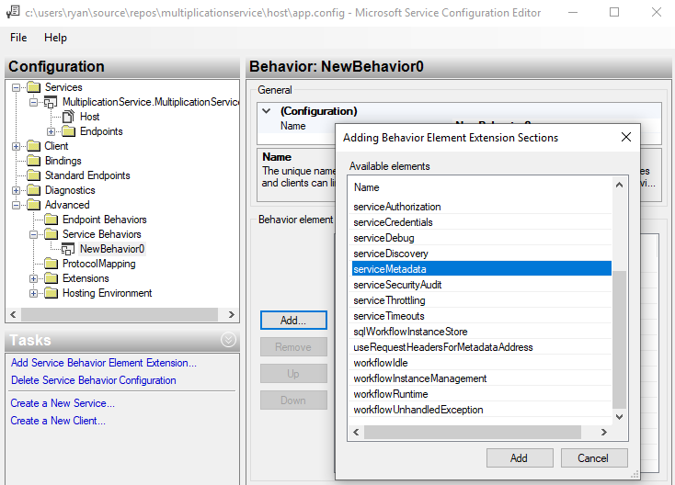
Fig. 12
A service has been created, but behaviours need to be enabled for it. Fig.12 shows adding service metadata as a behaviour of the service so metadata exchange can take place. Having metadata access the clients can generate proxy classes.
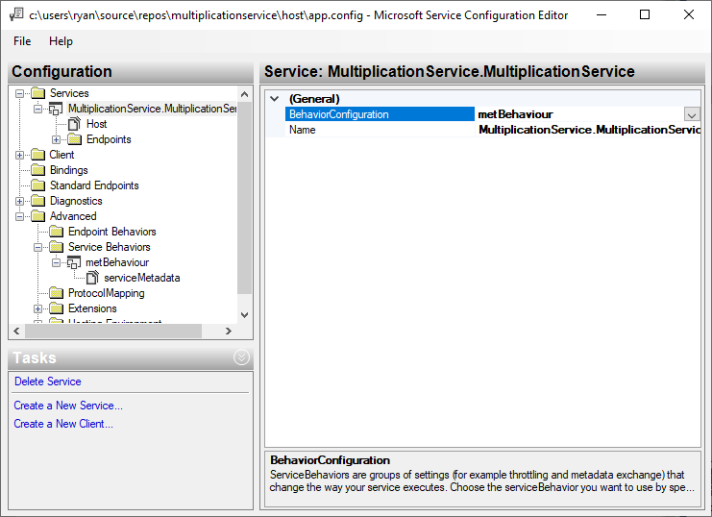
Fig. 13
In Fig. 13 the created behaviour is shown as an associated behaviour for the created service.

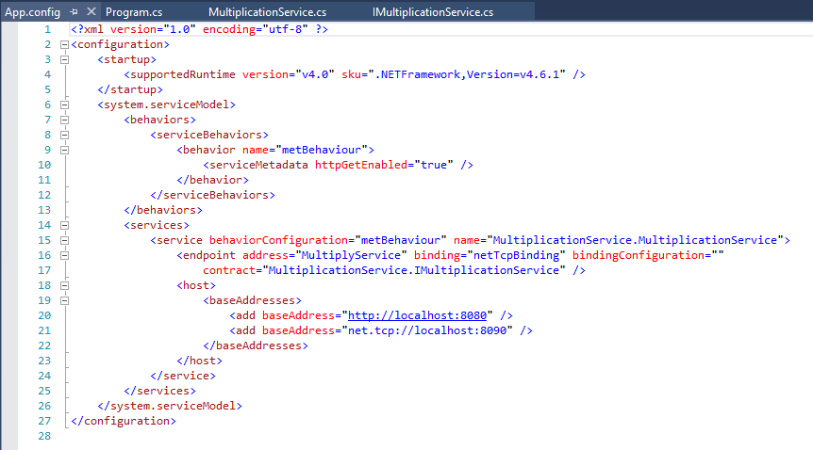
Fig. 14
In Fig. 14 we see the App.config file after the changes that were made in the editor. The configuration tool has entered all of this text for us. This files text is what makes the WCF service available for use by the client and function properly.
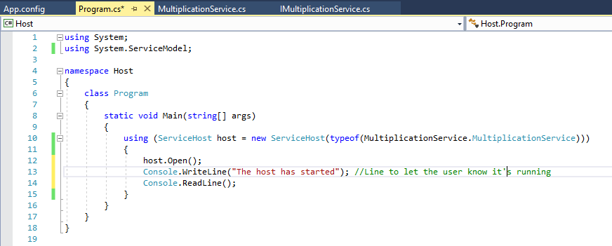
Fig. 15
Fig. 15 shows the code for the main program. This code will create an instance of the service that is being hosted and open it, making it available for clients to connect to.

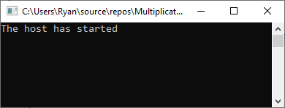
Fig. 16
In this example all of the steps for creating a WCF service have been completed. Running the example opens the program shown in Fig. 16. The communication channel is open for clients to connect to it.

The following shows an example of a client:
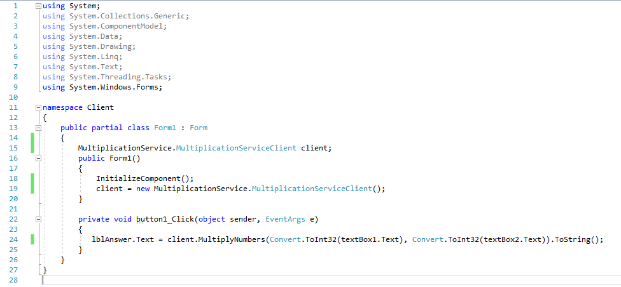
Fig. 17
Fig. 17 shows the code for a WinForms application that is referencing the WCF service. A new instance of the proxy class is used and the method from the service is invoked. Two integers are being passed from the client to the service which will then return a number to the client.
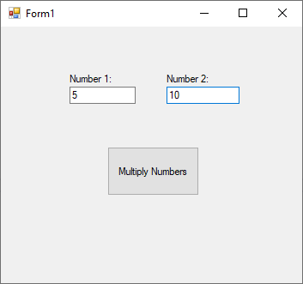
Fig. 18
Fig. 18 shows the client application running. Two integer values are entered to be passed to the WCF service.
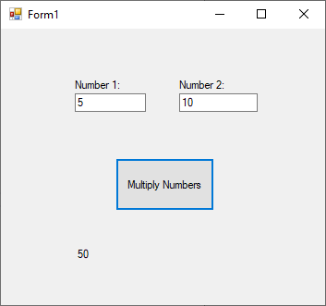
Fig. 19
Fig. 19 shows that after clicking the button in the client application the method from the service has successfully returned the correct number.

Advantages of self-hosting a WCF service:
- Easy to setup
- Easy to debug because a separate process that runs the WCF service does not need to be attached
- Supports all transport protocols
- The ‘Open’ and ‘Close’ methods make it easy to control when the services are running
Disadvantages of self-hosting a WCF service:
- The service host needs to be running for the clients to connect
- Making modifications to the code requires taking the service offline
- Limited features compared to other hosting methods

3.2 The Application Configuration File
In Fig. 14 the application configuration file is shown. We see the specified behaviours and what service they apply to, and that metadata exchange is enabled. We also see the ABCs of the WCF endpoint, these being: address; binding; and contract. All communication with the service occurs through the endpoints of the service. Endpoints provide clients access to the functionality that is being offered by the WCF service. All distributed systems require an endpoint for the client to connect to.
Every service in WCF is associated with a unique address. The address provides the location of the service. The address has a uniform resource identifier which represents the address of the service. The address tells the client where on the network messages should be sent. The same service can have different addresses for connecting clients using different technologies [9].
Bindings specify how the service is accessible. The binding defines the channel to be used to communicate with the endpoint. The transport protocol is specified, and whatever is specified is what must be used to connect to the endpoint. The encoding of the messages to be used is specified here. Any security requirements are also specified here.
Contracts outline what functionality the endpoint will expose to the client. In the created example the class that contains the method to multiply two integers is exposed to the client. Also specified is the type of processing or response message that the client will be receiving.

3.3 Principles and Process of Metadata Exchange in WCF
Metadata is data that reveals other data [10]. Metadata is used in WCF to describe how to interact with the service endpoint. The metadata in the example created in this report is accessible over HTTP and a browser can navigate to it. By default the metadata will not be published. What shows in the browser when the metadata HTTP address is entered can be seen in Fig. 20. It tells us that the service has been created.
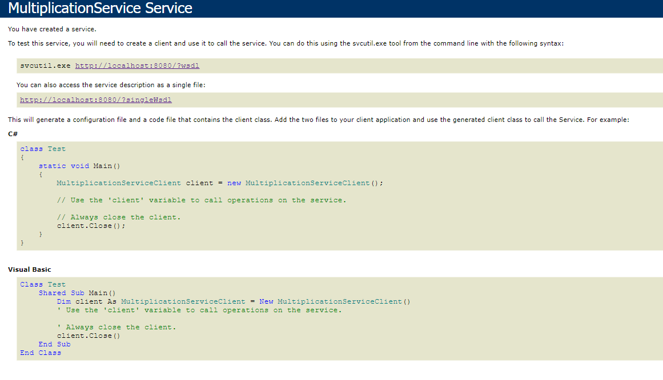
Fig. 20
Metadata can also be sent using the metadata exchange endpoint that is sometimes called MEX endpoint. The MEX endpoint can provide metadata that describes the contracts, operations, security, transactions, reliability, and faults.

4. Four major contract types

4.1 Service
This contract type describes the operations that are exposed by the service to the client. A service contract is defined in the interface of the WCF service and tells the client what the service can do.
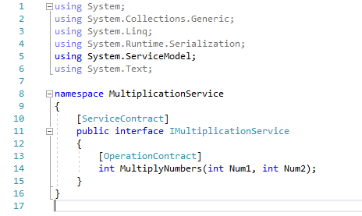
Fig. 21
The code shown in Fig. 21 shows the service contract. A client can connect to multiple services and use the interfaces from all of the connected service contracts.

4.2 Operation
An operation contract is part of the service contact, which is shown in Fig. 21. It contains the methods that are part of the WCF application and allows the client to use them.

4.3 Data
A data contract defines the data types of information being exchanged between the client and the service. A data contract is not required for a WCF service to function; the created example of a self-hosted WCF service does not contain one. Here is another example:
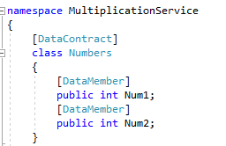
Fig. 22
Fig. 21 shows a modified version of the created WCF service with a data contract in place.

4.4 Fault
A fault contract will define errors raised by the service. The way errors are handled and affect the client will be in this contract. A fault contract allows errors in the service class to be displayed to the client. By default any unexpected exceptions that come up in the service will not tell the client, but with a fault contract we can set it up to throw up an exception.
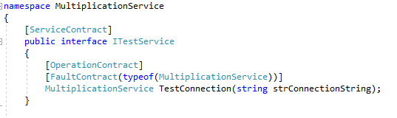
Fig. 23
A fault contract is shown in Fig. 23 for testing the connection to the service, error handling code can be implemented to show the client an error.

5. Exchange Patterns
In WCF the client and server communicate and exchange messages using a MEP (message exchange pattern). A MEP describes how messages are sent between applications [11]. There are different exchange patterns that are supported in WCF.

5.1 Request-response
The default MEP in WCF is request-response, sometimes called request-reply. This MEP sends a message and then a reply is received. In the example WCF service that was created in this report, this is the MEP that was used. The message being sent is the parameters for the method to multiple numbers and the response is the result of multiplying the numbers together. The data that the user wants to send is encapsulated in code that allows the WCF service to make sense of it.

5.2 One-way
In some scenarios we do not want a response back from the service. For example if we want to publish notifications to subscribers of a service. When the message that client sends reaches the service the client connection is released so that the client can continue with other work. The client will not be affected if a problem occurs with the service, since they won’t be notified of any exceptions that happen.

5.3 Duplex
Duplex MEP means that messages can travel both directions at the same time. Duplex is a bi-directional communication channel. Duplex allows for any side to send unrequested data to another side [12].

5.4 Asynchronous
The asynchronous MEP means that a service can get sent an asynchronous request message that is added to a queue, then the client can wait for a response and receive a response that appears synchronous, unaware that asynchronous messages were used.

5.5 Peer to peer
Peer-to-peer (P2P) computing is a distributed application architecture. P2P provides a secure and scalable MEP for developers. Tasks are split between peers that are treated equally in the application to complete the task without needing a server [13]. An example of P2P being used is in a chat application, where a group of people chat with one another using P2P without the need for servers.

6. How WCF Enables and Supports Interoperability
Interoperability is the ability of multiple systems to exchange information and to use the exchanged information [14]. With web services a common interoperability problem is how to map the inputs and outputs of the involved services [15]. WCF is designed to interoperate with Web services that follow the Web services specifications. WCF supports and implements many Web service protocols [16].
Without WCF if there are two different clients and a service needs to be implemented for them, but the clients use different technologies to then the developer needs to know different programming models. The first client wants a web service that uses HTTP protocol and XML message format to interact with a Java web application. The developer may create a Dot Net web service to satisfy the needs of this client. The second client is using a windows application built using .NET and needs TCP protocol to be used, with a binary message format. The developer will need to implement a Dot Net remoting service, because both client and server will need to be .NET to make them compatible. WCF solves this issue though by allowing clients with different technologies used in their applications to connect to the same service, but with different endpoints for the client to connect.
Clients will want to use different protocols and message formats, and this can mean implemented the same service twice using different technologies. WCF allows us to implement the service only once though. A single WCF service can have different exposed endpoints in its application configuration file. The service does not need any updating to its code to satisfy the protocol and messaging needs of a new client. Just adding a new endpoint that specifies the protocols and messaging requirements is enough in WCF services.

7. References

[1] | W. Zhang and J. Li, “Research and Application of WCF Extensibility,” in 2010 International Conference on Web Information Systems and Mining, Sanya, 2010.
[2] | L. B. Goel and R. Majumdar, “Handling mutual exclusion in a distributed application through Zookeeper,” in 2015 International Conference on Advances in Computer Engineering and Applications, Ghaziabad, 2015.
[3] | T. Fankhauser, Q. Wang, A. Gerlicher, C. Grecos and X. Wang, “Web Scaling Frameworks for Web Services in the Cloud,” IEEE Transactions on Services Computing, vol. 9, no. 5, pp. 728-741, 2015.
[4] | I. Košťál, “Benefits of the use of asynchronous methods in a WCF service and its client, synchronizing resource access between these methods,” in International Conference on Military Technologies (ICMT) 2015, Brno, 2015.
[5] | C.-s. Ran and N. Li, “Design and implementation of communication model based on Silverlight and WCF in EAM system,” in 2010 2nd IEEE International Conference on Information and Financial Engineering, Chongqing, 2010.
[6] | S. Resnick, R. Crane and C. Boewen, Essential Windows Communication Foundation (WCF): For .NET Framework 3.5, AddisonWesley Professional, 2008.
[7] | C. Tianhuang and H. Feifei, “Design patterns application in a distributed system,” in 2010 International Conference on E-Health Networking Digital Ecosystems and Technologies (EDT), Shenzhen, 2010.
[8] | A. W. Mohammed and A. M. Zeki, “Web services SOAP optimization techniques,” in 2017 4th IEEE International Conference on Engineering Technologies and Applied Sciences (ICETAS), Salmabad, 2017.
[9] | M. L. Bustamante, Learning WCF: A Hands-on Guide, O'Reilly Media, 2007.
[10] | S. L. Linfoot and T. Coughlin, “A cross-standard metadata formatting structure,” IEEE Transactions on Consumer Electronics, vol. 59, no. 3, pp. 550-555, 2013.
[11] | T. v. Lessen, J. Nitzsche and F. Leymann, “Formalising Message Exchange Patterns using BPEL Light,” in 2008 IEEE International Conference on Services Computing, Honolulu, 2008.
[12] | G. Yunhua and Y. Yonghua, “A Message Service System Based on WCF Duplex Communication,” in 2012 International Conference on Computer Science and Service System, Nanjing, 2012.
[13] | M. Zhang, Y. Xiong, Q. Zhang, L. Sun and S. Yang, “Optimizing the Throughput of Data-Driven Peer-to-Peer Streaming,” IEEE Transactions on Parallel and Distributed Systems, vol. 20, no. 1, pp. 97-110, 2008.
[14] | S. Pokraev, D. Quartel, M. W. A. Steen, M. Reichert, G. Doumeingts, J. Müller, G. Morel and B. Vallespir, “Semantic Service Modeling: Enabling System Interoperability,” Enterprise Interoperability, London, pp. 221-230, 2007.
[15] | M. Nagarajan, K. Verma, A. Sheth, J. Miller and J. Lathem, “Semantic Interoperability of Web Services - Challenges and Experiences,” in International Conference on Web Services (ICWS '06), 2006.
[16] | J. Smith, Inside Windows® Communication Foundation, Microsoft Press, 2007.

