BMIH6005 Organisational Consultancy

Name of the report: Consultancy Report
Name of Client: Thistle Hotels Ltd.

Student Name: Rukhsana Rehman
Student No:2012446
Tutor:Laurence Blake

Contents
Executive summary 1
Introduction 2
Scope and analysis 3
Description of Thistle Hotels Ltd. 3
PESTEL analysis of Thistle Hotels Ltd. 4
SWOT analysis of Thistle Hotels Ltd. 6
Main body 7
Issues in supply chain management of Thistle Hotels Ltd. 8
Issues with market growth of Thistle Hotels Ltd. 10
Issues in staff management of Thistle Hotels Ltd. 11
Findings and results 14
Action plan 16
Recommendations 18
Conclusion 19
Reference list 21

Executive summary
The aim of preparing this report is to provide insight into the operational issues in Thistle Hotels Ltd. along with their effects on the business. Thistle Hotels Ltd. is one of the numerous hotel chain companies that have been created to satisfy travellers' travel longings. Thistle Hotel’s 29% market share in the hospitality sector also validates the company's enormous market share. The report has identified three problems in the operations and management of Thistle Hotels Ltd. The firm is having trouble managing and procuring its supplies as a result of Brexit, which presents the company's supply chain with its first issue. The issue with Thistle Hotels Ltd's market expansion due to Brexit will be highlighted as the second issue. Finally, the research will examine Thistle Hotels Ltd.'s concern with personnel management. As internal and external factors also put impact the business operation and management, the report will use the PESTLE analysis model and SWOT analysis model to identify the capabilities and opportunities of Thistle Hotels Ltd. From the PESTLE analysis, it has been identified that the open market policy of the government for the companies that operate in the nation will aid the company to grow faster but country's tax rate is relatively high, which has a detrimental effect on both the running costs and the expansion of Thistle Hotels Ltd. company. The analysis shows that people in the UK have a tendency to travel, which means that their spending habits have a wonderful influence on Thistle Hotels Ltd.'s sales. However, the hotel's information system is weak, which results in a very poor percentage of client satisfaction. As Thistle Hotels Ltd. is a service-based business and does not produce carbon dioxide or other harmful gases, it is recognised as an environmentally responsible organisation, which improves its brand image. The Pestle analysis also highlighted that The Employment Act of 1996, the Health and Safety Act of 2010, and the Equal Remuneration Act of 1976 are all upheld by Thistle Hotels Ltd. which is supported by the legal environment of the UK and therefore have a positive impact on its operations (Noordzife, 2014). The SWOT analysis shows that Thistle Hotels Ltd. has a strong brand value in customers' minds which is one of its greatest strengths. The lack of staff management and supply chain issues is the recent weakness o the company. Another opportunity for the corporation is the UK's low corporate tax rate of 2.25% (Burnes, 2014). The main dangers to Thistle Hotels Ltd. include the high rate of inflation in the UK, the new threats brought on by the Brexit decision, and the constrained market expansion inside the UK. The report has employed a supply chain model to identify the problem in the supply chain of the company and found that the information system and the logistics function of Thistle Hotels Ltd are not in coordination. It has been identified that the information system in some branches of Thistle Hotels Ltd does not keep a proper record of the required supplies. Moreover, suppliers from other countries are now taking a higher lead time in delivering the supplies. This also creates disruption in the supply chain of Thistle Hotels Ltd. may make sure that the information system, forecasting, and logistics function operate concurrently by teaching the staff how to enter data into the information system correctly and sharing the impedance of information, matching system, and integrity among the functions. Additionally, the business may make sure that it has a mechanism for storing materials so that it can provide those supplies in the event of a sudden crisis in the supply chain. A study found that 45% of the hotels and tourism companies are facing a bottleneck in market growth within the UK due to Brexit (Whittington et al., 2020). Therefore, although the company is earning a lot in sales, it is facing market growth difficulties. As a solution, it is suggested that the business should focus on its worldwide presence by setting up branches in other nations like Asia, Australia, and so on. Opportunities in the global hospitality and tourist business will be made available to the market (Buttrick, 2009). The report also found that Thistle Hotels Ltd lacks in the performance stage of the talent management cycle which is leading to employee management issues. As a result, the organisation is unable to offer customized development training. The organization will be able to offer the most efficient training and development support to the employees based on their strengths and limitations by using an assessment system that can evaluate individual performance.

Introduction
Running a business requires operational efficiency and proper management. This fact is undeniably true in every industry of business (Jones, 2021). The hotel industry also has to bear this concept in operating its business. This report will highlight some of the operational problems faced by a hotel chain in the UK while critically analysing those problems. The purpose of preparing this report is to provide insight into the operational issues in Thistle Hotels Ltd. along with their effects on the business. While understanding these problems the clients would be able to take necessary measures to address them and refine the operational activities of the hotel.
The report will showcase three operational and management problems of Thistle Hotels Ltd in this report that can be addressed to improve the performance of the hotel. The first problem is in the supply chain department as the company is facing difficulties in managing and sourcing its supplies due to Brexit (O'Neill, 2022). The second problem that will be discussed is the problem facing the market growth of Thistle Hotels Ltd due to Brexit. Lastly, the report will analyse the problem in managing employees of Thistle Hotels Ltd.
The report will use the SWOT and PESTLE analysis models to analyse Thistle Hotels Ltd. Using these two models, it is possible to highlight the internal factors such as strengths and weaknesses and external factors such as opportunities and thirsts along with environmental forces (Jaya, Silva and Athauda, 2015). Apart from these two models, the report will employ a supply chain management model to identify the cause of the supply chain problem, a BGC matrix to highlight the market growth position of the company, and a talent management cycle in order to pinpoint the cause of issues in employee management in Thistle Hotels Ltd.

Scope and analysis

Description of Thistle Hotels Ltd.
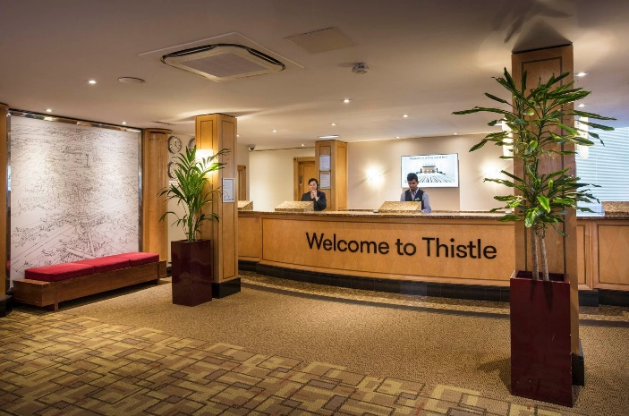
Figure 1: Thistle Hotels Ltd.
Source: (Thistle Hotels, 2022).
Since travelling is a part of British culture, individuals from that country have traditionally favoured it as a leisure activity. Thistle Hotels Ltd. is one of the numerous hotel chain companies that have been created to satisfy travellers' travel longings. The parental business of the hotel, Hong Leon Group, as it bought the hotel chain in 1990, which is presently the third-biggest hotel chain in the UK (Johnson, 2005). When it opened in 1965, the hotel's original founder was Scottish & Newcastle, a brewing company, and since then, it has been operating to satisfy the travel desire of the people. The proprietor of the hotel started it in order to take on Travelodge, the dominant hotel chain at the time, and it was one of the most cutting-edge hotels around. Later, in 1990, Hong Leon Group bought the whole stake in Thistle Hotels Ltd. and boost its overall business operations and customer service. With over 33 properties over 5000 rooms and 120 event spaces, The Thistle Hotels Ltd. is a sizable hotel network. Thistle Hotels Ltd. has over 17 sites across 3 countries and has its corporate headquarters in Uxbridge, England, UK. At the end of 2021, The Thistle Hotels Ltd. had a profit of £127 million and total revenue of £320 million. 68% of Hong Long Group’s overall profits are attributed to the hotel network (Thistle Hotels, 2022). Currently, 8,823 workers work at the Thistle Hotels Ltd. hotel, giving their all to provide the finest possible service to the patrons. 74% of Thistle Hotel’s 2541 clients responded to a survey conducted in 2022, which revealed that they are happy with the hotel's services. Thistle Hotel’s 29% market share in the hospitality sector also validates the company's enormous market share (O’Meara, 2021). In order to further enhance its service, the firm has integrated several technology advancements. The firm also has a brilliant brand reputation due to its reputation as an opulent wedding destination due to the presence of large wedding venues inside its hotels. Additionally, the variety of its offerings contributes to its good standing. The hotel's brand image has suffered as a result of its inability to maintain social distance during the COVID-19 epidemic.

PESTEL analysis of Thistle Hotels Ltd.
The external environment of a company refers to all external influences and elements that have a substantial effect on the operation and expansion of the firm. The PESTEL study is used to outline the external environment of Thistle Hotels Ltd. in this instance.
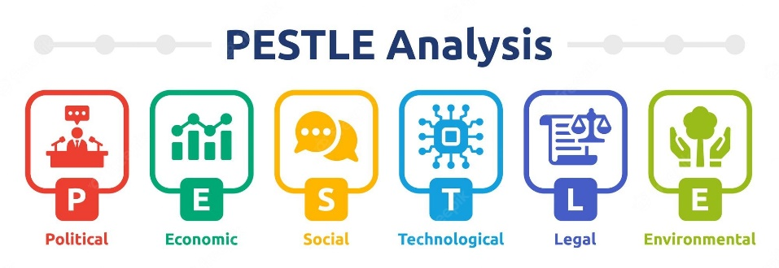
Figure 2: PESTEL analysis.
Source: (Hood, 2018).
Political: The UK government has an open market policy for the companies that operate in the nation, indicating that Thistle Hotels Ltd. receives certain advantages in building new hotels as well as in exporting and importing. Additionally, the UK is a member of the EU trading bloc, demonstrating the ability of Thistle Hotels Ltd. to draw in labourers and buy supplies from the trade group's associate countries. Given that both the hotel's client base and service quality improved, as a result, this is very successful for the hotel's long-term commercial development. But because of the large profit margin, the country's tax rate is relatively high, which has a detrimental effect on both the running costs and the expansion of Thistle Hotels Ltd. company.
Economic: The UK's GDP per capita as of 2021 is $31,708, this statistic reflects the country's residents' excellent standard of living. Given that individuals are more likely to travel and spend money on leisure when they have adequate cash on hand, this is good for Thistle Hotels Ltd.'s sales. Once again, the corporate interest rate is pretty reasonable in the UK, it is only 2.25% as of 2022, which shows that it has a beneficial effect on Thistle Hotels Ltd.'s revenue collection and secures the company's long-term success (Traynor, 2022). However, according to the most recent economic data, as of September 2022, the UK's inflation rate had risen to 10.1%, which had a detrimental impact on Thistle Hotels Ltd.'s revenue and operational expenses.
Social: People in the UK have a tendency to travel, which means that their spending habits have a wonderful influence on Thistle Hotels Ltd.'s sales. Additionally, service quality is among the highest in the nation, which positively influences the employee turnover rate, demonstrating that Thistle Hotels Ltd. can quickly build a big and devoted team. But with just 68.6 million people, the UK has a very tiny population, which has a detrimental effect on the hotel's ability to draw clients (Vidal, 2022).
Technological: Thistle Hotels Ltd. is highly advanced due to its usage of cutting-edge tools like robots, artificial intelligence, high-speed internet, and other technology that improves customer service and promotes long-term company success. However, the hotel's information system is weak, which results in a very poor percentage of client satisfaction.
Environmental: Because Thistle Hotels Ltd. is a service-based business and does not produce carbon dioxide or other harmful gases, it is recognised as an environmentally responsible organisation, which improves its brand image. A high running cost is indicated by the hotel's lack of waste management procedures and the utilisation of renewable energy.
Legal: The Employment Act of 1996, the Health and Safety Act of 2010, and the Equal Remuneration Act of 1976 are all upheld by Thistle Hotels Ltd., demonstrating the company's commitment to its workers (Campos and Marodin, 2019). This procedure gives the firm a competitive edge and aids in its legal operations. The hotel has not done a very good job of keeping a distance from society during the epidemic, which puts it in danger of lawsuits from guests and other legal problems. This has also prevented the hotel's long-term development as a company (Mansour, 2019).

SWOT analysis of Thistle Hotels Ltd.
Swot analysis helps to identify the strengths and weaknesses of the company which are related to internal factors and its capabilities. This analysis also helps to determine the opportunities and threats for the company. The SWOT analysis of Thistle Hotels Ltd. is drawn below.
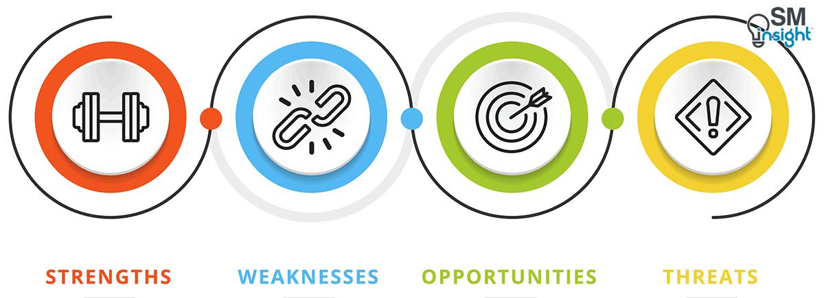
Figure 3: SWOT analysis.
Source: (Fisman and Sullivan, 2014).
Strengths | Weaknesses
- The company has a strong brand value.  - High-quality service.  - Strong financial capabilities. | - The company lacks staff management.  - Problems in supply chain management.  - Fewer hotels compared to other competitors (Price, 2021).
Opportunities | Threats
- Favourable governmental policies.  - High travel desire of the people.  - Low corporate tax (Hadi and Wood, 2019). | - High inflation rate.  - Emerging threats due to Brexit (Puspita and Yuliawan, 2019).  - Limited market growth opportunity.
The SWOT analysis shows that Thistle Hotels Ltd. has a strong brand value in customers' minds which is one of its greatest strengths. High-quality services and strong financial ability are also included in its strengths (Shen, 2018). High-quality services help the business to ensure customer satisfaction while the financial capability will help the business to survive in the economic crisis. The lack of staff management and supply chain issues is the recent weakness o the company. Due to this, the operational and, management sector of the company is facing many problems. Another weakness of the company is the fewer hotels compared to other competitors such as – Premier Inn (Gorman, 2020). As for the opportunities, the company enjoys favourable governmental decisions in the hotel industry. It also has the opportunity to increase its sales as the people of the UK have a high desire for travelling. Additionally, a low corporate tax which is 2.25% is also an opportunity for the company (Kefalas, 2021). The high inflation rate of the UK, emerging threats due to the Brexit decision, and limited market growth within the UK are the major threats to Thistle Hotels Ltd.

Main body
In order to improve the business pheromone, every organisation needs to identify the problems they are facing and should focus on solving them (Cunill and Forteza, 2021). Similar to other organisations, Thistle Hotels Ltd also aims to improve its operational efficiency. Although Thistle Hotels Ltd is focused on providing the best hospitality to its clients, the company is still facing some issues in its management and business operation due to internal as well as external factors. The problems that Thistle Hotels Ltd facing recently are –
- Thistle Hotels Ltd is facing problems in its supply chain management.
- Issues in the market growth due to Brexit are also a big problem for Thistle Hotels Ltd.
- Thistle Hotels Ltd is facing problems in its staff management throughout its branches.
In order to improve the operation of Thistle Hotels Ltd, the company needs to analyze these problems and identify suitable strategies that go along with the organizational capabilities of Thistle Hotels Ltd.

Issues in supply chain management of Thistle Hotels Ltd.
Supply chain refers to the well-structured network of organizations that supplies the required materials and resources for the company. Managing this network of the supply chain is known as supply chain management. It is basically a centralized system that ensures the flow of resources and materials. Kumar (2020) identified that managing the supply chain effectively can reduce excess costs of the supplies by 24%. The main objective of the supply chain is to ensure that there would not be any product or material shortage that can harm the organizational operations. However, Thistle Hotels Ltd. is currently facing supply chain problems in its operations. As one of the largest hotel chains in the UK, Thistle Hotels Ltd requires a large number of supplies in its daily operations. The main supplies required by Thistle Hotels Ltd are – mineral water supplies and water for showers, foods and beverages, bed sheets, mattresses, pillows, transportation service, furniture, tissues, and so on (Fernando, 2019). But it has been identified that many customers claim that the company is facing problems in its supply chain. The main problem in the supply chain for Thistle Hotels Ltd. occurred due to the government's decision to Brexit. According to Mihiotis and Georga (2021), 60% of the hotel supply chain has been affected due to Brexit. Previously the company could source its required materials and supplies from other nations in European Union with much efficiency. However, after Brexit, it becomes very complex and time-consuming to source supplies from outside of the UK. Additionally, it becomes difficult to maintain the supply flow with the major suppliers of Thistle Hotels Ltd. situated outside of the UK. This disruption in the flow of supplies has negatively affected the business image and resulted in customer dissatisfaction (Sari and Suslu, 2020).
Although this is resulting in a negative impact on Thistle Hotels Ltd., it is also providing an opportunity for the company to select the supplier for its products within the UK. This will help the company to improve its efficiency and reduce the lead time for receiving the supplies. As Thistle Hotels Ltd. will contract with domestic suppliers, the communication, as well as the opportunity of building a sustainable and strong supply chain, will also be upheld.
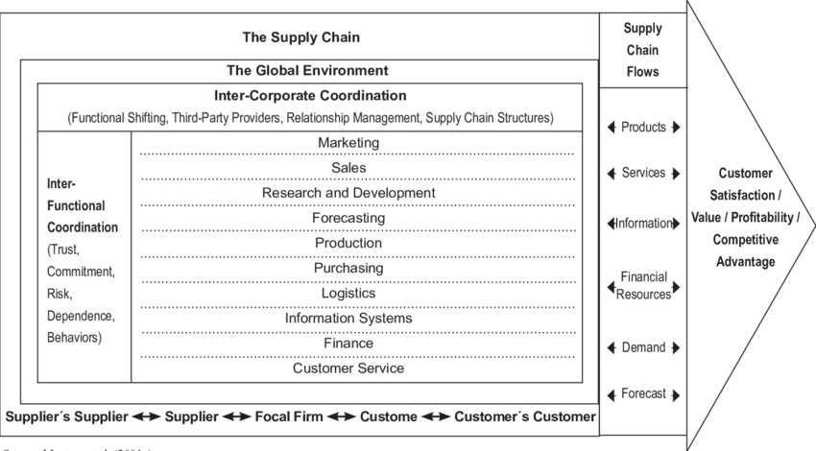
Figure 4: Model of supply chain management.
Source: (Rezaee, 2019).
Using the supply chain management model, the problem of Thistle Hotels Ltd. in its supply chain management can be identified. The model is focused on both internal as well external factors. The model suggests that Thistle Hotels Ltd should have inter-functional coordination among its various departments. In this, the marketing, sales, forecasting, production, purchasing, logistics, information system, finance, and customer service functions should have strong coordination (Tiawon and Supartha, 2021). However, the information system and the logistics function of Thistle Hotels Ltd are not in coordination. It has been identified that the information system in some branches of Thistle Hotels Ltd does not keep a proper record of the required supplies. As a result, the logics department does not know which branches need supplies or what amount of supplies are required. In addition to that, the forecasting of demand also get impacted as the branches do not properly provide data about the customer demand and required resource in the information system. A report shows that Thistle Hotels Ltd. has suffered supply chain problems equivalent to £500000 in 2021 (Siguaw and Enz, 2020). Although these internal functions lack coordination, the global environment also hampered the supply chain of Thistle Hotels Ltd. The Brexit policy of the UK government has impacted the supplies of Thistle Hotels Ltd. Suppliers from other countries are now taking a higher lead time in delivering the supplies. This also creates disruption in the supply chain of Thistle Hotels Ltd.

Issues with market growth of Thistle Hotels Ltd.
To analyse the market growth of a company, the BCG matrix can be applied. The BCG matrix can identify the position of an organisation and highlight market growth and market share (Ramanathan and Usha, 2019).
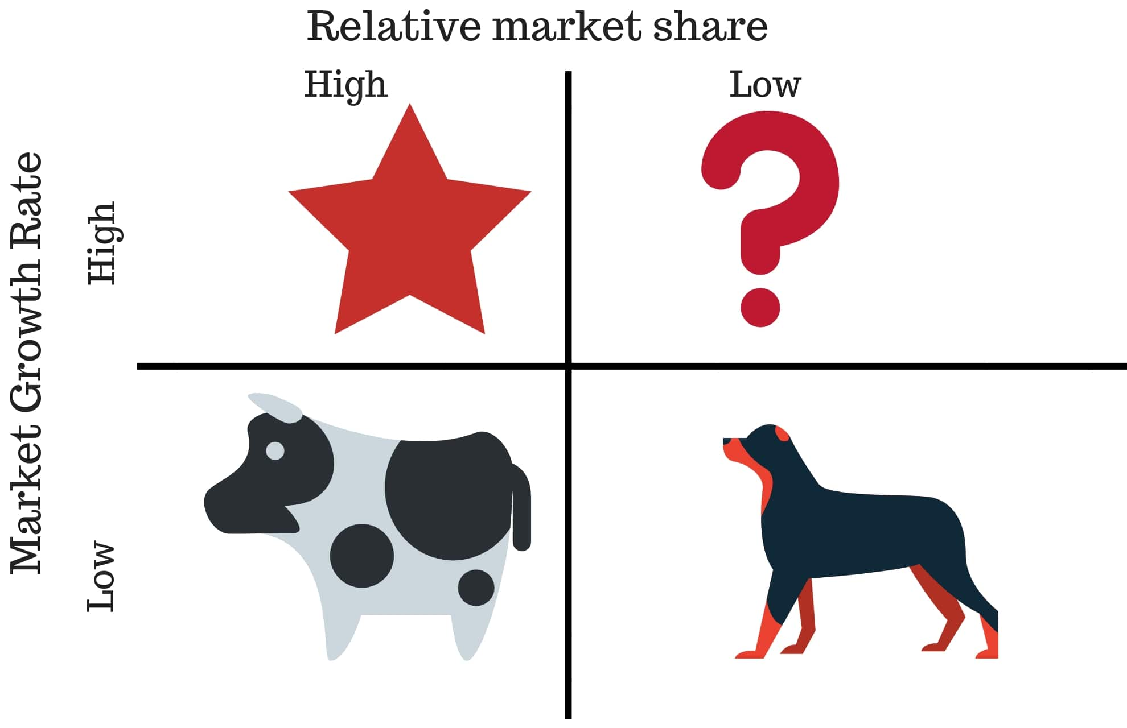
Figure 5: BCG matrix.
Source: (Proctor, 2020).
The BCG matrix has four stages based on the market share and market growth opportunity. These stages are - dogs, cash cows, stars, and question marks.
Dogs: Dog refers to a business that has a very low market share and also possesses low market growth opportunity. These kinds of businesses do not have good present or future prospects (Brierley, 2006).
Cash cow: A cash cow is a stage where the company has a large market share and earns a loss of sales revenue. However, in terms of market growth opportunity, the does not have bright prospects (Karatepe, 2019).
Stars: The companies that have a large market share and good market growth potential are known as the stars. Here, companies generate good revenue and have the potential to earn more in the future.
Question marks: The question marks stage represents the companies that have high, market growth potential but for some reason, presently the company lacks market share. In this stage, companies should focus on present development (Iqbal, 2021).
At present, Thistle Hotels is facing a lack of market growth opportunities within the UK. Even so, Thistle Hotels Ltd is having high sales in the domestic market. The company is performing various promotional activities such as price discounts, off-season sales, promotional codes, and so on. In their study, Le, Wu and Zhong (2020) pointed out that sales promotion has increased by 18% among domestic hotels in order to capture a higher market share.
Although these promotional activities are generating lost revenue, the company does not find any opportunity for further growth in its market. Additionally, Thistle Hotels Ltd. is also facing restrictions in opening its branches in other countries in Europe due to the governmental decision of Brexit. Taylor et al. (2020) have articulated in their study that, 45% of the hotels and tourism companies are facing a bottleneck in market growth within the UK due to Brexit. Therefore, with the high revenue and large market share with low potential for market growth in the UK, Thistle Hotels Ltd. is in the cash cow stage of the BCG matrix.

Issues in staff management of Thistle Hotels Ltd.
Employees are human resources that manage the task of the business. In order to improve business operations, a business requires good employees. As the hotel's services need many skilled employees that can provide satisfactory service to the clients, managing the employees is one of the most important functions of a hotel. According to Arifin, Ibrahim and Nur (2019), 74% of the customers claimed that they preferer hotels that can provide highly trained and satisfactory service-providing staff. This shows that, if a company wants to capture almost all of its customers and focus on its operational development, it should focus on the talent management of company. In order to manage the talent of an organisation, a company has to follow the talent management cycle.
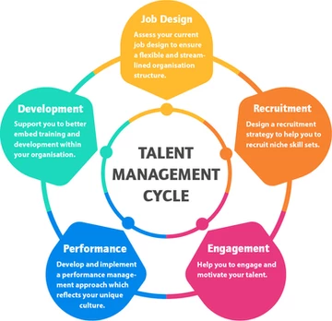
Figure 6: Talent management cycle.
Source: (Smith, 2019).
The talent management cycle has five stages. The stages of the talent management cycle are job design, recruitment, engagement, performance, and development.
Job design: Job desgn is te first atsge of takent amnagenrt. In this stage, the company has to design the respective responsibility of the particular employees (Chakravarti, 2017). A proper job design requires planning the tasks as well as the qualities that a person needs to have in order to fulfil the job responsibilities.
Recruitment: The second stage of talent management is to recruit suitable talent or employees. Here, the company has to announce the vacancy along with the responsibility that has been designed in the first stage (Fallon and Rutherford, 2017). The company should take a fair evaluation system in order to recruit employees.
Engagement: Engagement is the third stage of the talent management cycle. This stage focuses on the motivation of the employees and suggests that the company should take the necessary steps to engage its employees in work. According to Atanga (2021), high engagement of employees can increase the business performance of hotels by 15%.
Performance: Performance management is taste where the company will employ a performance monitoring and evaluation system. With this, the company would be able to identify which employees are good at which field and what the employees are lacking (Ellison, 2021). Through this stage, the company would also be able to design a culture that will help the employees to boost their performance.
Development: In the development stage the company will provide training and guideline in order to support the talents of the company. In this stage, the support and guidelines will be based on the skills and weaknesses of the employees (Batinic, 2020). The strengths and weaknesses that have been determined in the performance stage will be the focal point while designing the development programme for this stage.
With over 33 hotels all over the UK, the company has to manage a large number of employees. However, the company is facing pranks in its recent management. By applying the talent management cycle in Thistle Hotels Ltd., it has been identified that the company perform its jib design very effectively. The company highlights the required duties a particular employee has to perform (Ivanova, 2021). During the recruitment process, the company also provides the key job responsibilities and the qualifications for the vacancy. It helps the company to hire talented and capable employees for the company. As for the engagement stage, Thistle Hotels Ltd provides various types of compensation along with high commissions and incentives to its employees. Therefore, the employees of the company also get motivated towards their work.
However, Thistle Hotels Ltd lacks in the performance stage. The company does ensure a strong monitoring system for the performance of its employees. In 2021, the company has invested more than £150000 in its monitoring system for employee performance (Atilgan and McCullen, 2020). But the company do not possess any strong evaluation system for the employees. Therefore, the company can not track down the strength and weaknesses of employees individually. This lack of an evaluation system impacts the development stage of the talent management cycle. And due to this internal problem in performance management, Thistle Hotels Ltd provides development programmes such as training and guidelines in a general. Thus, many of the employees failed to cover up their individual lackings and that impacted the customer service of the company. Eventually, it leads to operational deficiency for Thistle Hotels Ltd. (Whittington and Molloy, 2005).

Findings and results
The finding and results of the analysis are drawn below.
The problem of Thistle Hotels Ltd. | Cause of the problem | Impact of the problem on Thistle Hotels Ltd. | The model used in the problem
Thistle Hotels Ltd. is having a problem with its supply chain. | The main reason for the problem in the supply chain manager of Thistle Hotels Ltd is the government's decision to Brexit (Brotherton and Shaw, 2020). Additionally, the branches of the company do not have coordination among functions such as – information system, logistics, and forecasting. | The issues in the supply chain have greatly damaged the flow of supplies in the company, as a result, the customers can not enjoy satisfactory service and thus impact the operations of the hotel (Capocchi, 2019). | To identify that the company is facing problems in its supply chain due to a lack of coordination among information systems, logistics, and forecasting, a supply chain management model was employed (Karatepe, 2020).
Problems in the market growth of Thistle Hotels Ltd. | The cause of the issues in the market growth of Thistle Hotels Ltd. is the high competition in the domestic market as well as the increased complexity of branches in other countries of Europe due to the Brexit policy. | The issues in the market growth opportunity of Thistle Hotels Ltd. have greatly impacted the future prospects of the company. Although the company is making money at present, with a lack of market growth opportunity, the company will have a hard time surviving in future. | To identify that the company is currently making money but has a low future prospect, the BCG matrix was employed.
Issues in staff management of Thistle Hotels Ltd. | The main cause of the staff management in Thistle Hotels Ltd. is due to the lack of a performance evaluation system in the hotel. As a result, the company can not determine the individual weakness and therefore can not provide an effective development programme (Dickens, 2019). | The issues in staff immanent result in employees with lack of professionalism and not superior services. As a result, the customers of the hotel become dissatisfied which leads to the operational deficiency of Thistle Hotels Ltd. | In order to pinpoint that Thistle Hotels Ltd. is facing its staff management problem due to a lack of a performance evaluation system, the Talent management cycle was employed while evaluating each stage of the cycle from the perspective of Thistle Hotels Ltd (Atkinson and Brown, 2021).
The finding and results of the data analysis show that Thistle Hotels Ltd. is facing problems in sourcing its materials and supplies. The company has been suffering from this issue ever since the Brexit policy of the UK government. An interview conducted by Wood (2022) highlights that Thistle Hotels Ltd. is facing the problem is supply chain mainly because it has become more complex to transport the materials and supplies from other countries of Europe as Brexit has placed a limitation on performing business with other countries in the EU. This results in the customers not getting the quality supplies, foods, and other materials that they used to enjoy before Brexit. This caused dissatisfaction among the customers which ultimately leads to the operational problem for Thistle Hotels Ltd. In another study, Sibanda and Pooe (2022) show that Thistle Hotels Ltd. has started to look for domestic supplies for the company, however, due to the quality issue of the supplies, the company suffers from 12% of its customer dissatisfaction. The supply chain model has also highlighted that, except for Brexit, and external issues, the company also suffers from a lack of coordination among the internal function such as – forecasting, information system, and logistics which also hamper having a proper supply chain (Basana et al., 2022).
The result also found that the company is suffering from market growth opportunities. Due to Brexit, the company faces various restrictions in opening its branches in other countries of the EU. As a result, the company is facing problems in its market growth opportunity, In addition to that, customers from other countries of the EU now have limited access to the UK. This also makes it hard to enjoy, market growth in other countries. The BCG matrix has highlighted that the company is now in the cash cow position as it is only earning money with no market growth opportunities. Warner (2020) also highlighted in his article that the UK hotel industry is facing a 45% market growth reduction after Brexit.
The analysis has highlighted that Thistle Hotels Ltd. has a big issue in managing its employees throughout all of its branches. The talent management cycle applied in the analysis has found that although Thistle Hotels Ltd. is performing every stage of the cycle effectively, the company lacks a proper performance evaluation system (Kerdpitak, 2020). As a result, Thistle Hotels Ltd. can not identify the individual weakness and strengths of the employees and provide training and development guidelines as a whole. This result that some employees remaining with their weaknesses and thus it results in an imbalance in the quality of the service. A survey conducted by Athiyaman (2022) on 4100 respondents shows that 73% of the customers determine their satisfaction level based on the quality of service provided by the hotel staff. As the imbalance of the quality among the employees results in customer dissatisfaction, it is impacting negatively the operations and management of Thistle Hotels Ltd.

Action plan
Number | Problem | Solution | Desired outcome | Time scale | Completion date | Planned budget
1 | Less coordination among information systems, forecasting and logistic functions resulting problems in the supply chain. | Thistle Hotels Ltd. needs to provide training to its employees to provide proper data about supplies in the information system that will help to forecast the logistics and supplies. Additionally, the company requires a warehouse to maintain the supply balance. | With the training programme, the employees have the skills and knowledge to properly provide data that will help to provide supplies in time. The warehousing system will help to transport the supplies to the branches in a much faster way which will improve the supply chain efficiency (Saunders, 2020). | 3 months | 10/02/2023 | £24,000
2 | Low market growth opportunity in domestic and other European countries due to Brexit. | Thistle Hotels Ltd. should try to focus on a global presence while considering other countries such s Asia and Australia in order to open branches there. | This will help the company to have a larger market growth potential. It will result in a customer base and market share in the international hotel market. | 1 year | 10/12/2023 | £120,000
3 | The problem is managing the staff throughout the branches as there is no individual performance evaluation system. | Thistle Hotels Ltd. should install a proper individual evaluation system for its employees to manage the talents of the company effectively. | The individual evaluation system will help to identify the weaknesses and potential of each employee as a result the company will be able to provide effective individual development training and guidance (Chung, 2020). | 8 months | 10/07/2023 | £18000

Recommendations
- The problem of supply chain management of Thistle Hotels Ltd. is mainly because of the lack of coordination among logistics, furcating and information systems. By providing training to the employees on how to input data in the information system properly and sharing the impedance of info, mating system, and integrity among the functions, Thistle Hotels Ltd. can ensure that the information system, forecasting, and, logistics function work simultaneously. Additionally, the company can ensure a warehousing system so that any sudden crisis in the supply chain can be mitigated by providing supplies from the warehouse. This solution will take 3 months to complete at the date of 10/02/23. The required budget for this solution is £24000.
- Thistle Hotels Ltd. also has a problem with market growth opportunities. Due to Brexit, the company is facing restrictions in opening its branches in many countries of the EU. And the domestic market already has strong competition with no market growth opportunities. As a solution, it is recommended that the company should be concerned with its global presence by opening its branches in other countries like – Asia, Australia, and so on (Baron and Armstrong, 2007). It will provide the market with opportunities in the international hotel and tourism market. The budget for this solution is approximately £120,000 as there need to be open branches in many countries. The time scale is 1 year which means the completion date will be 10/12/2023.
- The issues in managing the employees of Thistle Hotels Ltd. occurred as the company does not have any effective individual performance evaluation system. As a result, the organisation is unable to offer individual development training. The organisation will be able to offer the most efficient training and development support to the employees based on their strengths and limitations by using an assessment system that can evaluate individual performance (Matthias and Campbell, 2019). The budget for this project is £18000 and the time scale is 8 months. The completion date of this project is 10/07/2023.

Conclusion
The findings of this report indicate that Thistle Hotels Ltd. has suffered in its supply chain management due to a lack of coordination in information systems, forecasting, and logistics functions. The report recommends that the company should provide training in information systems and ensure the warehousing of its supplies in order to mitigate this problem. The report has highlighted that Thistle Hotels Ltd. having issues with its market growth in other EU countries due to Brexit. The recommended solution for this problem is that the company should focus on other countries outside Europe and try to have a global presence in the international hotel and tourism industry. This will provide a great market growth opportunity for Thistle Hotels Ltd. The report also found that Thistle Hotels Ltd. is facing difficulties in managing its employees effectively as it lacks an individual evaluation system. Therefore, the report suggests that the company should employ an individual training system to design a development programme based on individual capabilities and potentials.
Lastly, the consultant would like express thanks to Thistle Hotels Ltd. for choosing to investigate the operational and management issues. The consultant also hoped that Thistle Hotels Ltd. will hire the consultant again in the future if required.

Reference list
Arifin, M., Ibrahim, A. and Nur, M. (2019). Integration of supply chain management and tourism: An empirical study from the hotel industry of Indonesia. Management Science Letters, 1(1), pp.261–270.
Atanga, R.A. (2021). The Effect of Supply Chain Management Systems (SCMS) on Customer Satisfaction in The Hotel Industry In Ghana: The Case Of Selected Hotels In The Uk. RA Journal Of Applied Research, 04(11).
Athiyaman, A. (2022) “Strategic choices in the International Hospitality Industry,” International Hospitality Industry, pp. 142–160.
Atilgan, C. and McCullen, P. (2020). Improving supply chain performance through auditing: a change management perspective. Supply Chain Management: An International Journal, 16(1), pp.11–19.
Atkinson, H. and Brown, J. (2021). Rethinking performance measures: assessing progress in UK hotels. International Journal of Contemporary Hospitality Management, 13(3), pp.128–136.
Baron, A. and Armstrong, M. (2007) Human Capital Management. London: Kogan Page.
Basana, S.R., Suprapto, W., Andreani, F. and Tarigan, Z.J.H. (2022). The impact of supply chain practice on green hotel performance through internal, upstream, and downstream integration. Uncertain Supply Chain Management, 10(1), pp.169–180.
Batinic, I. (2020). Hotel management and quality of hotel services. Journal of Process Management. New Technologies, 4(1), pp.25–29.
Brierley, E. (2006) Talent on tap: getting the best from freelancers, interims and consultants. London: Chartered Institute of Personnel and Development.
British Journal of Management
Brotherton, B. and Shaw, J. (2020). Towards an identification and classification of critical success factors in UK hotels Plc. International Journal of Hospitality Management, 15(2), pp.113–135.
Burnes, B. (2014) 4th Edition, Managing Change, Great Britain, Prentice Hall.
Buttrick, R. (2009) The Project Workout, London: Prentice Hall
Campos, D.F. and Marodin, T.G. (2019). Perceptions Of Quality And Expectations Of Hotel Services. Journal of Operations and Supply Chain Management, 5(1), p.82.
Capocchi, A. (2019) “Revenue management from a business-economics perspective,” Economic Value and Revenue Management Systems, pp. 101–119.
Chakravarti, B.K. (2017). Hotel management. New Delhi: A.P.H. Pub. Corp.
Chung, K. (2020). Hotel management curriculum reform based on required competencies of hotel employees and career success in the hotel industry. Tourism Management, 21(5), pp.473–487.
Cunill, O.M. and Forteza, C.M. (2021). The Franchise Contract in Hotel Chains: A Study of Hotel Chain Growth and Market Concentrations. Tourism Economics, 16(3), pp.493–515.
Dickens, M. (2019). Productivity Performance in UK Hotels. Tourism and Hospitality Research, 1(2), pp.187–190.
Ellison, R. (2021). Brexit triggers uncertainty over the future of hotels in the UK. Prescriber, 27(7), pp.14–15.
Fallon, M.J. and Rutherford, D.G. (2017). Hotel management and operations. Hoboken, N.J.: Wiley.
Fernando, A.C. (2019) Business environment. Chennai, India: Pearson.
Fisman, R. & Sullivan, T. (2014) The Org: How the Office Really Works, Murray, London
Gorman, G. (2020) “The external environment of business,” Business Studies A Level, pp. 208–224.
Hadi, S. and Wood, L.C. (2019). Improving Hotel Performance Through Active Supply Chain Risk Management: A Preliminary Model. SSRN Electronic Journal, 1(1).
Hood, A. (2018) “The role of Pestel analysis,” Sustainable Management of Coal Preparation, pp. 415–419.
Human Resource Management Journal
Iqbal, U. (2021). Operational Performance in Daily Hotel and Business Management. Journal of Hotel & Business Management, 05(02).
Ivanova, M.G. (2021). Issues and challenges within Hotel Supply Chain. SSRN Electronic Journal, 1(1).
Jaya, A.A.K.K., Silva, S.D. and Athauda, A.M.T.P. (2015). A business strategy, market orientation and sales growth in the hotel industry. Tropical Agricultural Research, 24(3), p.228.
Johnson, M. (2005) The Independent Consultant’s Survival Guide, London, Chartered Institute of Personnel and Development.
Jones, S. (2021) “SWOT analysis,” Dictionary of Marketing Communications.
Karatepe, O.M. (2019). Perceptions of organizational politics and hotel employee outcomes. International Journal of Contemporary Hospitality Management, 25(1), pp.82–104.
Karatepe, O.M. (2020). High-performance work practices and hotel employee performance: The mediation of work engagement. International Journal of Hospitality Management, 32(1), pp.132–140.
Kefalas, A.G. (2021) “Toward a sustainable growth strategy,” Business Horizons, 22(2), pp. 34–40.
Kerdpitak, C. (2020). Effect Of Driver's Pressures On Supply Chain Management Performance Within The Hotel Industry. Polish Journal of Management Studies, 20(2), pp.290–299.
Kumar, T. (2020). Every Moment Matters: Study of Employee Engagement at Radisson Hotel Group, Nagpur. HELIX, 8(6), pp.4206–4209.
Le, S., Wu, J. and Zhong, J. (2020). Supply chain quality performance: The effect of supply chain integration in the hotel industry. Computational Intelligence, 1(1).
Mansour, K. (2019). Hotel Maintenance Management Practices. Journal of Hotel & Business Management, 5(1).
Matthias, O. and Campbell, J. (2019) “Consultancy in management education,” Management Consultancy Insights and Real Consultancy Projects, pp. 108–116.
Mihiotis, A. and Georga, A. (2021). Efficient Replenishment Techniques: Improving Supply Chain Operations. Supply Chain Forum: An International Journal, 2(1), pp.38–43.
Noordzife, G. (2014) Project Management of Hotel Opening Processes: Exploring Better Ways to Manage New Hotel Openings, CreateSpace
O’Meara, P. (2021) “Pestel and the Northern Society,” The Decembrist Pavel Pestel, pp. 114–123.
O'Neill, S. (2022) Thistle Hotels Ltd. sees upsides for itself with economic headwinds, Skift.
People and Strategy: Journal of the HR Planning Society
Price, L. (2021). The Limitations of the Law in Influencing Employment Practices in UK Hotels and Restaurants. Employee Relations, 15(2), pp.16–24.
Proctor, A. (2020) “Internal Business Environment,” Encyclopedia of the UN Sustainable Development Goals, pp. 408–408.
Puspita, N.M.D. and Yuliawan, A.K. (2019). Role Of Employee Engagement On Work Satisfaction Regarding Employee Services Quality At The Grand Santhi Hotel Denpasar. Review of Management and Entrepreneurship, 2(1), pp.1–16.
Ramanathan, U. and Usha, R. (2019). Guests’ perceptions on factors influencing customer loyalty. International Journal of Contemporary Hospitality Management, 23(1), pp.7–25.
Rezaee, Z. (2019). Relevance of Business Sustainability for Hotel Management. Journal of Business and Hotel Management, 02(01).
Sari, K. and Suslu, M. (2020). A modelling approach for evaluating the green performance of a hotel supply chain. Technological Forecasting and Social Change, 137(1), pp.53–60.
Saunders, K.T. (2020) “The interest rate swap: Theory and evidence,” Journal of Corporate Finance, 5(1), pp. 55–78.
Shen, H. (2018). Job Satisfaction of Female Migrant Workers in Hotel Industry. Journal of Hotel & Business Management, 5(1).
Sibanda, P. and Pooe, R.I.D. (2022). Enhancing supply chain performance through supply chain practices. Journal of Transport and Supply Chain Management, 12(1).
Siguaw, J. and Enz, C. (2020). Best practices in hotel operations. The Cornell Hotel and Restaurant Administration Quarterly, 40(6), pp.42–53.
Smith, W. (2019) “Business and the external environment,” Financial Services Management, pp. 130–145.
Taylor, S., Peacock, A., Banfill, P. and Shao, L. (2020). Reduction of greenhouse gas emissions from UK hotels in 2030. Building and Environment, [online] 45(6), pp.1389–1400.
Thistle Hotels (2022). Central London Hotels | Best Prices Guaranteed. [online] Thistle Hotels. Available at: https://www.thistle.com/ [Accessed 7 Nov. 2022].
Tiawon, H. and Supartha, I.W.G. (2021). Implementing a business strategy with supply chain management in a management system and management control to improve the performance of the hotel business. Uncertain Supply Chain Management, 9(3), pp.687–695.
Traynor, S. (2022) Edinburgh Thistle Hotels Ltd. evacuated as fire crews race to City Centre Hotel, Edinburgh live.
Vidal, M. (2022) “The management contradiction,” Management Divided, pp. 235–272.
Warner, S. (2020) “EU trade policy in practice,” Handbook on the EU and International Trade, pp. 169–170.
Whittington, R. and Molloy E. (2005) HR’s role in organisation: shaping change. Research report. London: Chartered Institute of Personnel and Development.
Whittington, R. et al (2020) Exploring Strategy. Harlow: Pearson Education Limited.
Wood, Z. (2022) Thistle Hotels Ltd took £226 from me even though there was no booking, The Guardian. Guardian News and Media.

