Assignment 1 Reflective Review of Learning Journey

Professional Career Development

Rasal Ahmed
Student number 1805728

Date: 07/03/2019

Contents
Introduction 1
1. SWOT analysis highlighting personal strengths, weakness and threats to turn into opportunities 1
2. Two learning styles questionnaire to professional career development 3
3. GO MAD framework for professional career development 200 4
4. Available learning and development options and interventions 5
5. Support mechanisms available for professional career development 6
6. Professional development plan (PDP) to achieve learning objectives 6
7. Ways to monitor self-development 7
Conclusion 7
References 8

Introduction
Skill and knowledge are required to perform job effectively and efficiently. These are the valuables capabilities of a person required to be successful in any type of profession and an employee interest to build his or her career in any area needs to achieve skills and gather knowledge. This report intends to focus on self-assessment regarding professional career development. The target profession considered here is management profession. The report will cover a SWOT analysis on self-professional development, two learning styles GO MAD framework, learning and development programs, supportive mechanisms, professional development plan and ways to monitor the professional career development.

1. SWOT analysis highlighting personal strengths, weakness and threats to turn into opportunities
Like an organisation, an employee can conduct SWOT analysis on himself or herself. SWOT means strengths, weakness, opportunities and threats. Knowing self-strengths and opportunities are advantageous to focus on these to perform on the job roles which enhances the possibility to be successful in employment (Mind Tools, 2019). Similarly, a person can improve his or her if weaknesses are visible enough and threats are identified clearly. Therefore, it is important that a personal know self-strengths, weaknesses, opportunities and threats before starting career in a particular sector because these factors are largely dominate on the performance, expectation and self-improvement plan of a potential employee (Rangkuti, 2015).

Strengths: Key strengths regarding my employment as a role in management are the unique skills, knowledge, and capabilities that make me different from other potential employees. I will have certification in professional management, a large network in social arena, graduation and post-graduation degree in management, managerial knowledge and other organisational knowledge. These are my strengths which are found to positively impact an efficiency and effectiveness of an employee at workplace (Mind Tools, 2019). Besides these, previous achievements, access to personal resources, others’ accreditment and compliance may be strengths of a personal which offer a niche place and comfort zone to perform better than others (Rangkuti, 2015).

Weaknesses: These are the negative factors related to employability. Identification of these factors help one to make plan for future how to turn the weaknesses into opportunities which needs to be conducted from both internal and external perspective (World Economic Forum, 2019). Sometimes, I have observed myself to avoid performing some tasks where I lack confidence and I think lack of confidence and ability to accept challenges are two of my great weaknesses at this point which hampers employability discouraging not to accept take risk and avoid risky activities which may result in betterment for both the organisation and the employees (Mind Tools, 2019). What people see in me as my weakness and lacking confidence in training, education and knowledge and personal traits not matching to the workplace or being able to apply them accurately are other sources of weakness here.

Opportunities: These are the positive issues which add value for a person in job performance. The on-going demand for understanding human psychology at workplace is becoming more and more important than before to understand the workforce and accordingly motivate, behave, guide, inspire and engage them within an organisation which is a great opportunity for me (Rangkuti, 2015). I have a large social network as identified my strength which will extends over the years after entering the workplace, each and every organisation require managers which implies the industry of professional managers increases. These are opportunities for me too.

Threats: These are negative factors for the employment and endanger the efficiency at workplace. There are few threats to be faced as a manager. The world is changing and so is the nature of job. Managerial job once highly required universal treatment for all which changes over the time where managers are expected to customise their functions, roles and motivational packages as well as mode of communication for each employee within a same organisation (Mind Tools, 2019). The rapid development in information and technology is another threat for managers who are not gathering and being introducing with newly coming tools and techniques at workplace. For example, managers who entered to the job before invention of widespread usage of computer get them threatened by innovation of computer (World Economic Forum, 2019). Social media presence at disseminating news and gathering and sharing information within a few seconds, is a big platform for both employers and employees which is nowadays is to hire is another threat which threatens managerial jobs also (Rangkuti, 2015).

2. Two learning styles questionnaire to professional career development
Learning is continuous and there should have a plan to learn but all of us are not following the same ways to learn and most importantly some prefer one to other method to learn new things and develop himself. There are many learning styles for professional career like visual, auditory and kinesthetics. Visual learners learn more through visual presentation of the information where auditory learns by hearing and kinesthetics learn by doing not be seeing or listening (Indeed, 2019). The style which will be preferable one for a learner should be assessed over the time by designing questionnaire. Two questionnaires are provided here to assess the learning style of a person who wants to build his career in teaching.
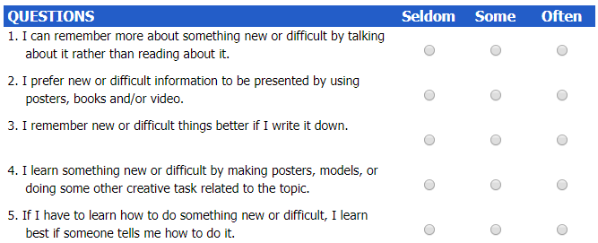
Figure 1: Learning style questionnaire Source: Learning Style, 2019
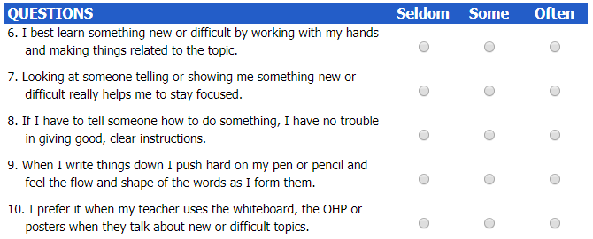
Figure 2: Learning style questionnaireSource: Learning Style, 2019

3. GO MAD framework for professional career development 200
GO MAD is a framework and a solution to improve productivity and enhance personal wisdom for career development in a systematic way. This framework was originally developed to increase productivity and increase results. A framework is given below.

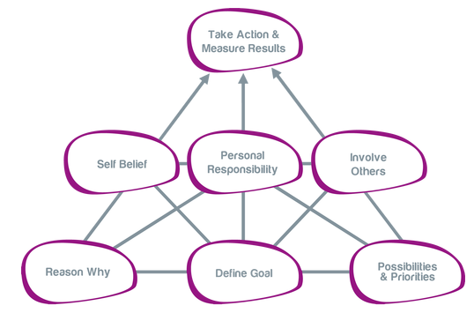
Figure 3: GO MAD Framework Source: Go MAD Thinking, 2019
This framework can be used to achieve expertise and build up one’s career development plan which ensures which priorities to set, enlist the challenges to face in doing so, and engaging people or materials who or what will be required to support the priorities at the right rime. A high-quality thinking in defining goal, set possibilities and priorities, and the reasons behind these are the lower stage of the framework and sell of belief or confidence, defining personal responsibilities and involving others are done in middle stage to facilitate the development plan and results come in and measured to take actions for the next period (Go MAD Thinking, 2019).

4. Available learning and development options and interventions
Learning and development are essential for career growth and development. This is a systematic process which starts with assessing the required skills, knowledge and capabilities required to perform a job or develop a career in a particular sector and then assessing existing skills, knowledge and capabilities available to identify the learning gap and considering the needs for learning and development so that proper actions can be taken to learn and develop oneself (CMTEDD, 2019).

There are a number of options by which one can learn and develop oneself. The easiest and effective one is participation in training where participants read and watch speak notes and PowerPoint, listen and talk with the trainer and sometimes participate on on-the-job training (CMTEDD, 2019). This is effective as participants get in direct touch with the trainer. Seating for exam or interview may be another option where participants are instructed to get prepared and then seat for face to face interview or written test and in this way, participant prepares himself or herself which is tested later (CMTEDD, 2019). Attending seminar on different issue can be another option where speaker discusses on a topic in details which enhances learning of listeners on that topic and thereby ensures development.

Most of the organisation nowadays arrange in-house training facilities by establishing training centre for own which ensures the organisation offers right training and learning scope to cope up with the organisation culture, environment and new changes occurred in the respective industry. This is also useful to learn and develop oneself being a fresher to join and being existing employee also. E-learning is getting popularity in these days where learners can learn on their own way at their flexible time just by browsing to internet, different learning-based sites and bogs.

5. Support mechanisms available for professional career development
There are many individual persons as well as institutions and organisations who work as supportive body to help people to plan for their learning and career development. In our personal life, family members are the first mechanisms who influence or who are taken as our supports for learning and development. This is most effective because family members are familiar and known from the earlier period which increases close interaction which is necessary for learning (Dessler and Varrkey, 2015). However, this option is universal as all the people around the world don’ have family members with required expertise and knowledge to guide towards learning and development. Early to my life I used to get my family members’ support for my development.

At some point, mentors also work for professional development where learners choose one mentor to whom he or she feels comfort and interest and the mentor guides, motivates, monitors and instructs towards the learning (Dessler and Varrkey, 2015). I have also a mentor whom I follow but he doesn’t direct me directly. Currently, I enrol in at the university which is another supporter for my learning and development in profession. For the time being, I am not engaged in any professional training which may require in future for further learning and development of my professional skills, knowledge, capabilities and expertise (Dessler and Varrkey, 2015).

6. Professional development plan (PDP) to achieve learning objectives
Personal or professional development plan is a very crucial one for learning and development in professional life. This plan starts with the selection of the sector or job where a person might be interested to build career (Doyle, 2019). I want to build my career in management and the required skills, knowledge and capabilities identification are the second stage of the plan where I need to outline all the requires issues like planning, organising, motivating, monitoring, inspecting and controlling knowledge as well as skills (Doyle, 2019). Then, plans are made how to acquire the required skills, knowledge and other issues within timelines. I have lack in confidence and motivational skill as I personal assess my weakness and these skills are highly required for a manager to get things done by the followers. These two skills are expected to achieve over the years, particularly at my employment period. My employer will be my support mechanism for this development (Doyle, 2019). After successful achievement of these skills, I think it would be useful for me to build career in all other areas.

7. Ways to monitor self-development
It is important that one monitor self-development in professional life to ensure whether existing ways are sufficient enough for career development or more rigorous strategies are needed to do so. Setting milestones at professional development plan with required skill achievement can be a better option to monitor self-development where a review is made at the end of each milestone to ensure the planned skill is achieved (Skills You Need, 2019). Deviation or variance analysis by measuring actual skill and comparing it with the planned skill level can be another better alternative for monitoring self-development. Modification may be required on the basis of such regular and irregular review which should be incorporated for the next stages of development.

Conclusion
Professional development is a continuous process to better suit and adapt oneself to the desire job to ensure productivity and employability. Here a personal SWOT analysis was conducted to facilitate my development on career. Then two learning styles questionnaires had been designed, GO MAD framework was introduced, learning and development options were explained. Finally, a support mechanism, professional development plan and ways to monitor self-development had been explained from my own career objective and learning as well as development.

References
- CMTEDD. (2019) ACTPS Performance Framework: Planning for Learning and Development. [online], Available at: https://www.cmtedd.act.gov.au/__data/assets/word_doc/0005/463604/plan_for_ld.doc/ [accessed 9 March]
- Dessler, G., &Varrkey, B. (2015). Human Resource Management, 15e. Pearson Education India.
- Doyle, A. (2019). How to Create a Professional Development Plan to Advance Your Career. [online] Available at: https://www.thebalancecareers.com/how-to-create-a-professional-development-plan-2059790 [Accessed 8 Mar. 2019].
- Go MAD Thinking. (2019). Go MAD Thinking. [online] Available at: https://www.gomadthinking.com/accelerating-results/coaching-facilitation/ [Accessed 8 Mar. 2019].
- Indeed. (2019). Learning Styles for Career Development | Indeed.com. [online] Available at: https://www.indeed.com/career-advice/career-development/learning-styles-for-career-development [Accessed 8 Mar. 2019].
- Learning Style. (2019). What Is My Learning Style - Learning Style Test 1. [online] Available at: http://www.whatismylearningstyle.com/learning-style-test-1.html [Accessed 8 Mar. 2019].
- Mind Tools (2019). Personal SWOT Analysis: Making the Most of Your Talents and Opportunities. [online] Available at: https://www.mindtools.com/pages/article/newTMC_05_1.htm [Accessed 8 Mar. 2019].
- Rangkuti, F. (2015). Personal SWOT analysis. GramediaPustaka Utama.
- Skills You Need. (2019). Reviewing and Revising Personal Development. Skills You Need. [online] Skillsyouneed.com. Available at: https://www.skillsyouneed.com/ps/reviewing-personal-development.html [Accessed 8 Mar. 2019].
- World Economic Forum. (2019). The impact of technology on employment. [online] Available at: https://www.weforum.org/agenda/2012/10/king-ludd-is-still-dead/ [Accessed 8 Mar. 2019].

