Road safety

Smart and connected devices II
Module code: ACDA6005
Module lecturer: Mabrouka Abuhmida

Contents
- 1.1 Abstract page 3
- 1.2 Introduction page 3
- 2.1 Road safety in the modern world page 4
- 2.2 Traffic lights page 4 -5
- 2.3 Cameras page 6 -7
- 3.1 Sat navigation page 8
- 4.1Parking sensors in car parks page 9
- 5.1 Cars page 10
- 6.1 Conclusion page 10
- 7.1 References page 11

1.1 Abstract

In the modern world technology is constantly evolving and improving. As well as being used in a variety of different areas such as hospitals , businesses , schools , homes and on the roads e.g. so technology has become a vital addition to the modern world in how the world operates, this is why it is important that when any new technology is produced it has specific use or is more efficient than the technology it is replacing. The focus within this assignment will be the internet of things which has a focus on devices with many features and being relevant to the modern world.

1.2 Introduction

As the main focus is on internet of things devices, this assignment will look at how IOT devices have been incorporated into the city’s roads. By having these devices utilised in the roads this assignment will look at how the devices can make the road safer for road users, pedestrians as well as aiding the law in catching road users who break the law by speeding.

2.1 Road safety in the modern world

The roads are a very difficult place to keep safe in the modern world. This is due to people being irresponsible behind the wheel as well as people crossing when they shouldn’t be. This danger is almost impossible to control as no technology is able to control when a person should cross or not and currently there is no technology that exists which will control the car when the driver is breaking the law.

2.2 Traffic lights

The only technology in place to notify a pedestrian to cross is traffic lights. Traffic lights can be seen almost everywhere. Traffic lights are a vital part of how the road works as they control the traffic flow of telling when cars to stop slow down and go as well as telling pedestrians when to cross and when not to cross. The first manually operated three colour traffic lights were first used in Piccadilly London in 1926, automatic traffic lights made their first experimental appearance in November 1927, after 3 years of experimentation it was considered a success and was made permanent in 1930 [1]. So, traffic lights have been effective for 89 years over these years they have helped improved road safety by controlling the traffic flow.

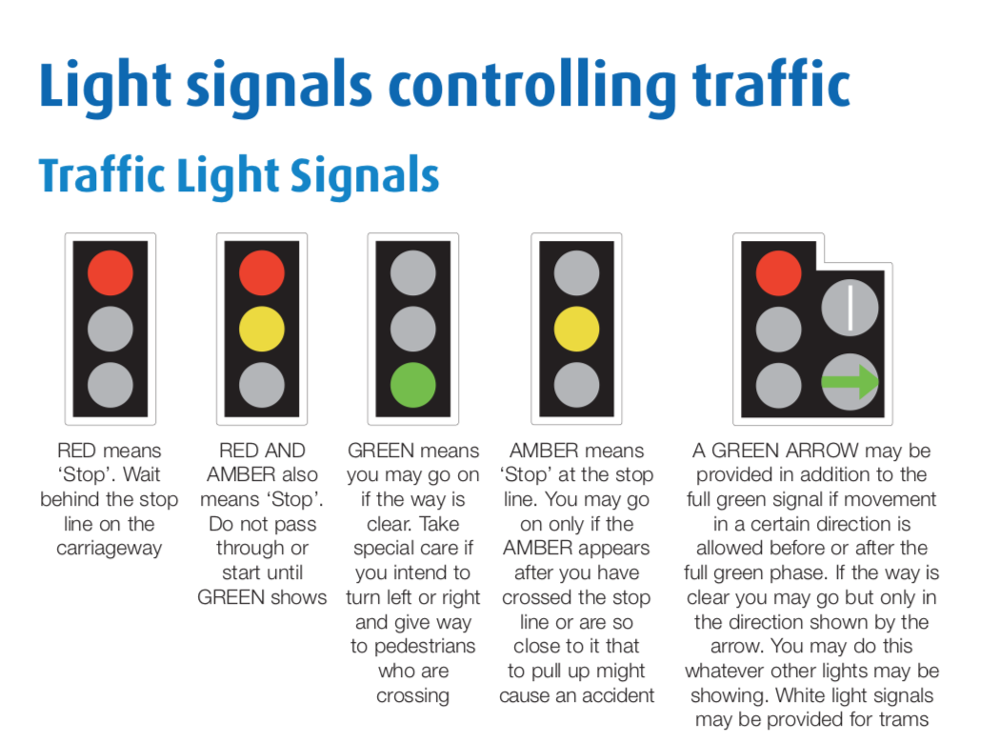

Figure 1 traffic light signals [2]

Traffic lights inductive loop

Traffic lights utilises a method called the inductive loop. The inductive loop will act as a metal detector, as it will detect different objects passing over the field which will then be measured. For example, once a vehicle has entered the area, the vehicle will then be detected within the field triggering the sensor [3]. Once the sensor has detected the presence of a vehicle the sensor can then operate. As a vehicle has been detected. This is why when cars pull up to a traffic light the traffic lights are able to detect the vehicle within the designated area it is down to the sensors.

Here is a display of how an inductive loop works. In figure 2 there is an electrical magnetic field covering the area. Once something passes into the electromagnetic field it will then be detected and sent to the system computer. As mentioned, the way an inductive loop works is the ability to detect a presence within the targeted area. By detecting a presence, the sensors will activate and will relay the information to the system computer.

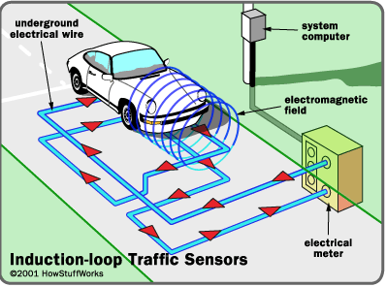
Figure 2 [4]

2.3 Cameras

Within cities there are different kinds of cameras which have different uses different uses. There are normal security cameras which will be seen in any buildings, shops, tourist areas e.g. as well as security cameras there is also speeding cameras which will be seen on roads, motorways. The speed cameras primary use is to capture and record the speed of passing by cars.

Security cameras

Security cameras is an essential in any kind of buildings. As well as watching key areas such as the street or inside buildings. Security cameras will be active 24/7 with a live feed [3]. This technology has made the roads more secure as they are constantly monitoring areas as they are switched on 24/7. By being active 24/7 this means that security cameras will capture any activity that happens within the cameras point of view. By capturing any activity within the camera view this will aid the police in keeping the streets safe and the roads secure by capturing footage of criminal activity or capturing key footage which could be key to their crime investigation. Another benefit the footage brings is that the police are able to go through the cameras feed from a previous time to review it for any key information they may need or have missed. Such as they want to identify a criminal or to follow the suspects footsteps, they are able to do so because of this technology. There is also the ability to pause the footage and save time stamps which may have a key moment.

Another advantage CCTV footage brings is that if footage was deleted it can be recovered if it was deleted as the footage will not be entirely removed immediately, whereas if the footage was overwritten before being deleted then the data may be lost. Although there are companies that can recover footage with overwritten, deleted and formatted footage [4]. This is a key part in keeping the roads safe as companies or the police will be able to recover lost footage if needed to aid in their investigation. As if the footage was permanently lost then it would be harder to catch a suspect or finding out the true outcome of the crime that is being investigated.

Having this technology in place monitoring the streets and roads greatly helps in monitoring crime or people who are making the roads a dangerous place. As if these people were caught on footage then the police will be able to identify them and stop the people from making roads a dangerous place by utilising security cameras.

Speed cameras

As mentioned, speed cameras primary use is to record and capture passing by cars. Speed cameras will be positioned in streets that have a set speed limit for example in a school area. This is key location for a speed camera to be placed as they will need to ensure motorists will slow down and abide by the speed law in that area, as kids, parents and grandparents will be crossing the road. With the use of speed cameras, they have a presence over a driver as the speed camera is the law of the road.

Speed cameras utilises name plate recognition as well as a speed recorder. Speed cameras will not only capture the speed of each passing car, but they will also capture the cars details from the cars number plates. For example, when a car approaches the speed camera will take a quick picture of the passing by car. With this captured image the speed camera is able to read the number plate and will call up the information on the car. Such as does the car have a MOT, the owners’ personal details (Address, name, car model). This information is all provided through the technology of picture capture and having the ability scan a key part of the image. As well as this the speed camera will also record the cars speed, this is where a speed camera will have the presence over the motorist as speeding is breaking the law. By having this technology in place, the speed camera is stopping motorists from speeding by recording their speed and data. Speed cameras have a presence as if a car is caught speeding by a speed camera then the law is able to get the owners details and punish them with a fine, removal of license, driving points e.g.

Another way that speed cameras will record the motorists speed will be having 2 in the same area with 100 yards between the 2 cameras. The first camera will capture the passing car then the 2nd camera which is further up the road will also capture the same passing cars. First camera will record the cars speed entering the speed limit zone. then the second camera will not only capture the speed of the car passing by, but it will also record how long it took the car to get from camera 1 to 2. This data will not only tell how long the car spent in this zone, but it will also record the cars approaching speed. The reason it will record the time is so that the camera can work out the cars speed based on how long it took the car to get from camera 1 to camera 2. This method will help to keep certain road zones safe from motorists who will speed through the zone then slow down as they approach the next camera.

All of the above-mentioned methods that speed cameras use is technology that has been utilised to help keep the roads safe from speeding motorists. As when a car is speeding it can be a hazard to other drivers and pedestrians. As the other drivers or pedestrians will not know the next action of this driver as this driver is unpredictable. Whereas when there are security measures in place, so this situation does not occur this removes this hazardous driver from the road and making the roads safer to use for everyone.
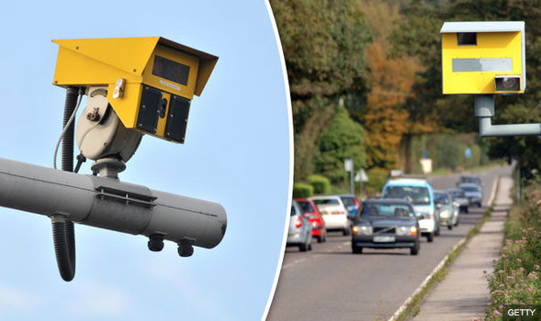Figure 3 [7]
3.1 Sat navigation
Satellite navigation has been a big addition to cars and car users. A car user has many uses of sat navigation. For example, planning the journey, live road updates. This has been beneficial to road safety as this technology provides vital live information to the driver.

Planning the journey

Sat navigation helps motorists to plan their journey via quickest route or longest route without traffic. This is beneficial to road safety as motorists will have their journeys planned and will likely take different routes based on their preferences. By having the journey planned this will result in less stress for the driver, as when driving the driver may become stressed or tired especially when driving for a long period of time.

Live road updates

Another feature the sat nav brings is live updates on the road. So, on the sat nav display feed the driver can see and will be notified of any road changes, obstacles on the road as well as notifying the driver where speed cameras are and the speed off the road. These features have helped made the road safer as the driver will be notified of all different kind of road changes.

Traffic updates

For example, if the driver had pre planned their journey then the driver can see if there is any heavy traffic up ahead so the driver could make a choice to choose a different route or to carry on.

Road changes
When on the road there maybe unexpected road or lane closures due to a crash or there is roadworks being carried out. This is information the driver will need to be wary off when travelling as taking different routes can lead to the driver feeling frustrated. As when driving it is important that focus is always on the road as there is so many unexpected possibilities that may occur.

Speed updates

The speed updates of the area are a very important feature. This feature is vital for when the driver is on the road as if the driver was caught going over the speed limit in any zone then there will be consequences. As well as leading to any injuries to other people as the driver will be speeding and will unlikely have time to break. For example, the speed limit in a school zone is 20 mph if the driver was going 30 mph then they are breaking the law as well as putting the pedestrians in danger as they will be 10 mph over the speed limit. This feature is vital in reducing people going over the speed limit. as any driver breaking the speed limit will always be putting others and their self in danger.

4.1Parking sensors in car parks

Parking sensors have been incorporated into car parks. They are commonly used in multi-story car parks for a mall. These sensors will be used to detect cars coming in and out of the building. As well as displaying a number the total number of spaces on each floor and displaying how many cars there are currently on each floor

In figure 4 below is an example of what a car park space would look like. This is a minor detail, but it can help to keep the roads safe from cluttered roads or cluttered parking areas. By having a cluttered car park, it would be very difficult to navigate through the car park as well as there being narrow gaps between each car. So, when navigating through a cluttered car park the driver needs to be constantly aware of any unexpected pedestrians. Such as kids running out on the road or people appearing from the narrow gaps. That is why having car park sensors can be beneficial for any car park as well as decreasing cluttered traffic and car parks

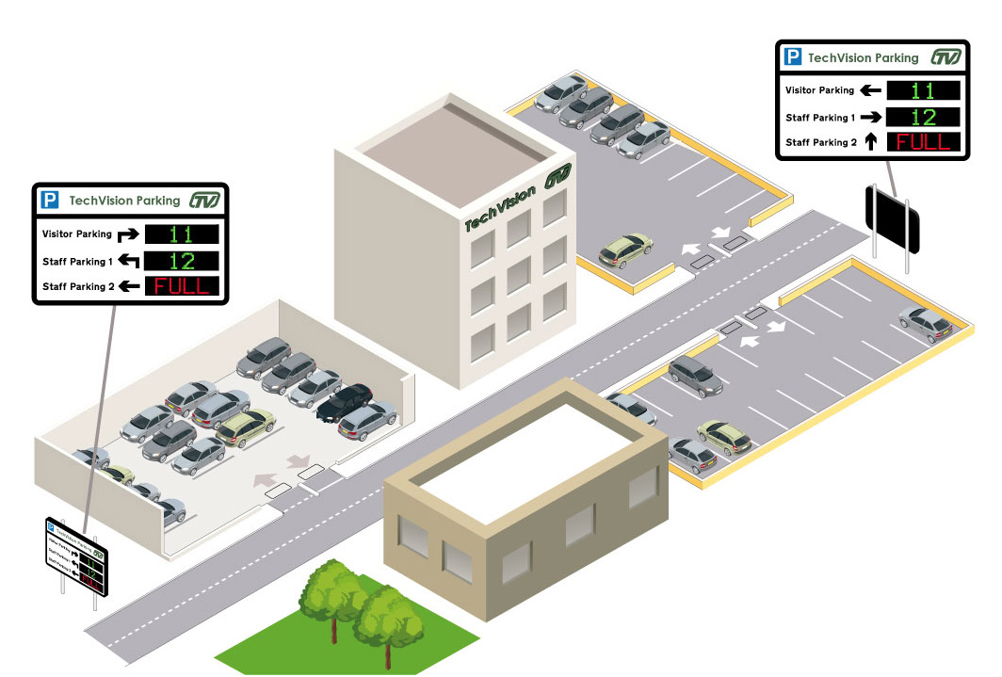

Figure 4 [7]

5.1 Cars

Selected cars have got a built-in rear-view camera with parking sensors.

Rear view camera

This camera has been created in order to help drivers park more safely with the ease of viewing the road behind them/ this technology has made parking easier and safer as well as aiding the driver with a view on heir blinis. As when parking the biggest danger will be what’s happening behind the car as it is very difficult for the driver to park and keep an eye on the road behind them. By having this camera, drivers will be able to park safely and making the road safer by parking appropriately while avoiding any pedestrians.

sensors

another feature that cars have is parking sensors. So, for example when a car is getting closer and closer to objects around the car. The sensor will trigger and will use a sound alarm to get louder the closer the driver gets to the obstacles ahead of them. This has made the road safer as driver will be able to detect any obstacles around the car when parking. As when a driver is parking the car there is a high chance of someone appearing behind the car or the driver hitting obstacles around the car.

6.1 Conclusion

In the modern world technology has been constantly added and been updated to carry out different tasks. In this case this assignment overlooked how technology has made the roads safer. By having technology on the road not only does it make the road safer, but it also helps when catching criminals as technology has become so advanced there is so many features on devices. Overtime technology has become more and more vital to road safety by having certain uses for different technology within the roads.

7.1 References

Bibliography

[1] | "when were the frist traffic lights installed," national motor musuem , [Online]. Available: https://nationalmotormuseum.org.uk/ufaqs/when-were-the-first-traffic-lights-installed/. [Accessed 28 11 2019].
[2] | "traffic light signla s," Uk government , [Online]. Available: https://assets.publishing.service.gov.uk/media/560aa3f9e5274a036900001c/the-highway-code-light-signals-controlling-traffic.pdf. [Accessed 28 11 2019].
[3] | "inductive loops," diamond traffic productions , [Online]. Available: http://diamondtraffic.com/technicaldescription/124. [Accessed 30 11 2019].
[4] | [Online]. Available: https://i.stack.imgur.com/bT2dY.gif. [Accessed 30 11 2019].
[5] | Yolanda, "how to choose a 24/7 camera (system)," Reo link, 18 October 2018. [Online]. Available: https://reolink.com/how-to-choose-24-7-security-camera-system/. [Accessed 29 11 2019].
[6] | F. Luo, "How to Delete CCTV Footage off SD Card, DVR, NVR & PC," Reo link , 2019 August 2019. [Online]. Available: https://reolink.com/how-to-delete-cctv-footage/. [Accessed 29 11 2019].
[7] | S. Wilkie, "Only this percentage of speed cameras working," Express, 4 November 2017. [Online]. Available: https://www.express.co.uk/news/uk/875306/Scotland-speed-cameras-not-working-AA-speeding-motorists. [Accessed 29 November 2019].
[8] | "parking space managemnt - multiple car parks," [Online]. Available: https://www.nortechcontrol.com/solutions/vehicle/parking-space-management-multiple-car-parks/. [Accessed 30 11 2019].

