p0rTfolio

LAURA KNIGHT
BMLC5010
GEORGINA ROYLANCE-SMITH
2400897

Contents
Task 1: Mind Map of Ideas 2
Task 2: Research Proposal 0
Task 3: Ethics Form 3
Task 4: Justification of the Chosen Research Method 19
Task 5: Draft Research Questions 20
Task 6: Evaluation of the Chosen Data Analysis Method 20
References 22

TASK 1: Mind Map of Ideas

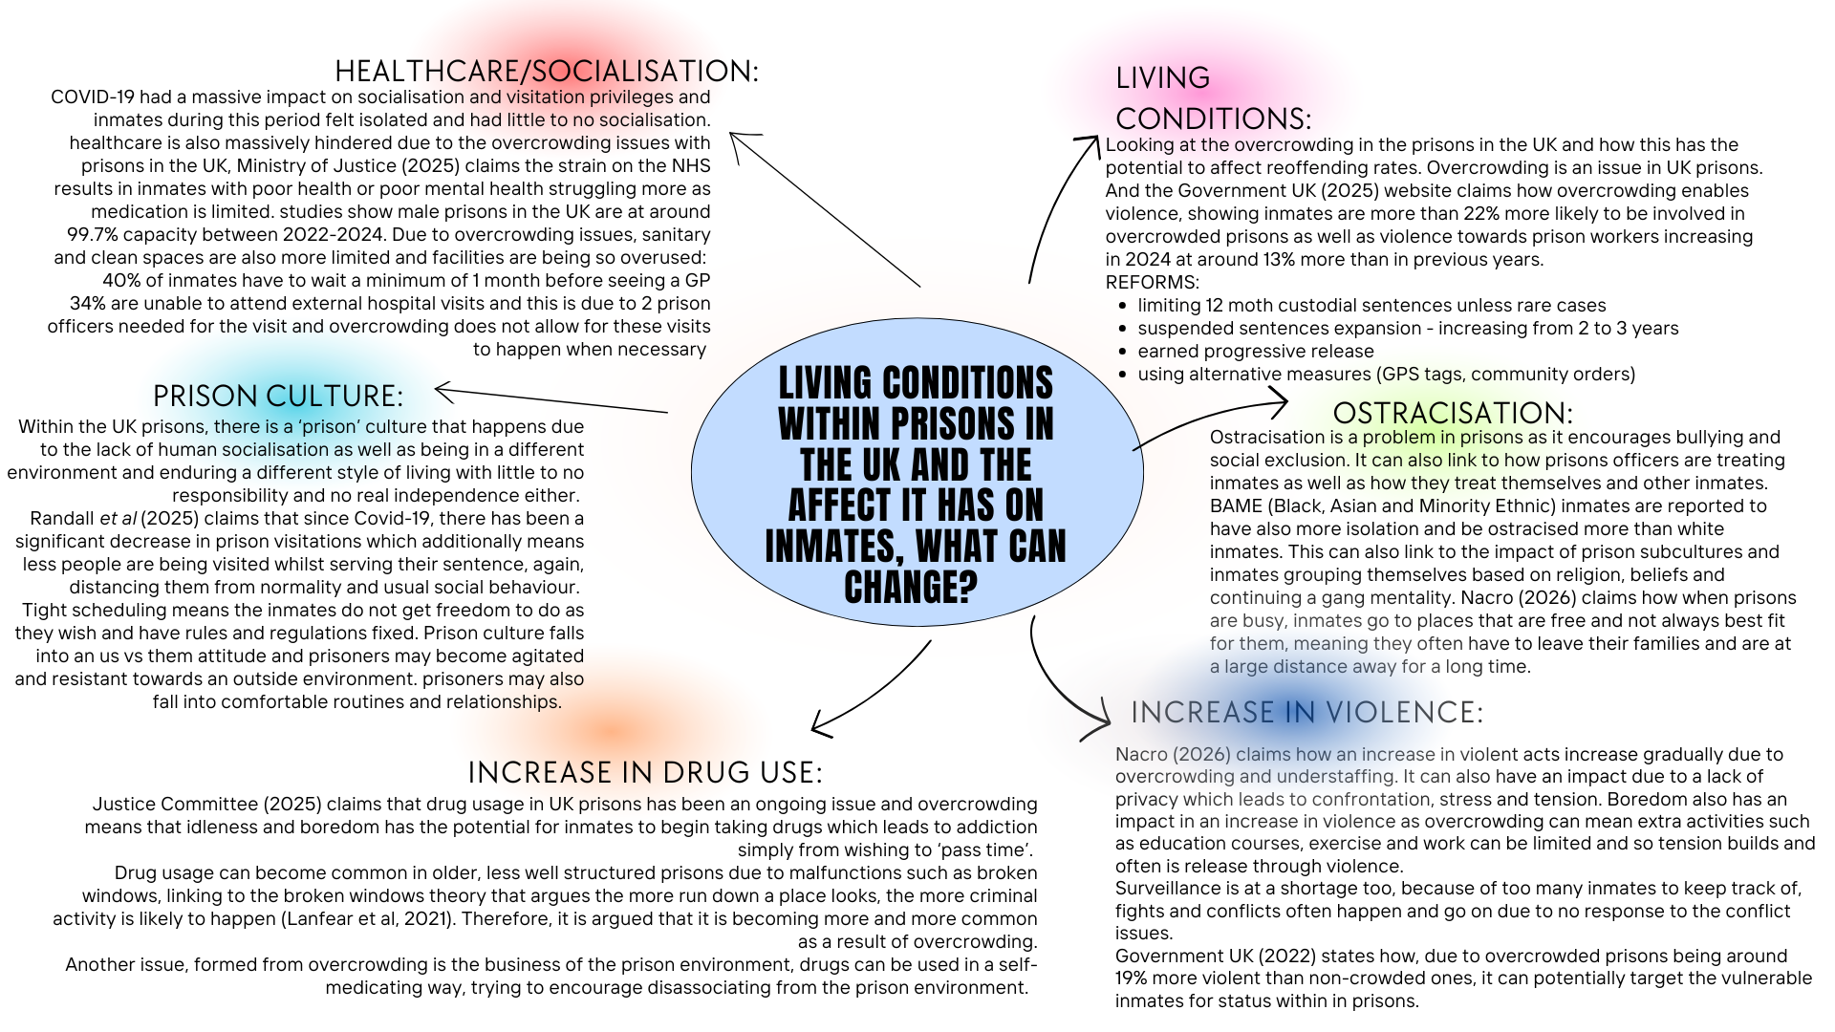

Task 2: Research Proposal



UNDERGRADUATE DISSERTATION
RESEARCH PROPOSAL FORM

NAME: Georgina Roylance-Smith | ID No: 2400897
DRAFT RESEARCH TITLE QUESTION:
Why this topic? Why is it worthy of consideration for an undergraduate dissertation?
To what extent do the living conditions and prison subcultures effect reoffending rates within prisons in England and Wales.
SUMMARY OF RESEARCH AIM & OBJECTIVES:
Here, you are required to clarify the information you want to collect on your research topic in the form of two, three or four key objectives:
1. Evaluate the contributing factors regarding an increase in violence and drug use in overcrowded prisons within the UK.
2. Examine the implications of decreasing standards of healthcare specifically regarding the context of overcrowding within Prisons in England and Wales.
3: Examine how prison culture might influence reoffending rates and how this might impact prisons.
4. Explore public perception surrounding prison culture and the treatment of inmates within prisons in England and Wales.
THEORETICAL CONTEXT:
Please clarify some of the key literature to be utilised as part of your research. Consider textbooks, journals, articles, government reports, organisational strategic plans. This need not be extensive but will give your supervisor a good point to start from.
This dissertation will look at the living conditions in the Prisons within in England and Wales and how conditions within the prisons can have an impact on the activity of drugs, violence and anti-social behaviour. It will also be linked to living conditions as result of overcrowding and the impact this has. It will also be analysing rehabilitation culture, looking into the success as well as the limitations (Mann, 2019)
Some of the key issues that will be discussed are the increase in violent behaviour, exploring whether violence is more common and reasons as to why this could be, as well as looking at the overall standard of healthcare within UK prisons and if this is improving or decreasing and if these factors are linked to the overcrowding issues.
Another issue that will be discussed is the impact of prison culture and what this means for the reoffending rates within UK prisons. The purpose of these topics being discussed is due to the impact it has on not only the inmates serving the sentence but also looking at in depth the impact these themes have in the reoffending rates and how they can potentially be prevented or improved. Another theme that will be discussed is the social effect on inmates and standard of living conditions. By doing primary research of an online survey, it will give a clear understanding as to whether the reality of prisons is accurately represented toward members of the public. The main point of discussion falls under the issues surrounding overcrowding, exploring whether this is a result of the increasing number of inmates or if it is the issues such as drugs and violent subcultures as spoken about previously.
This is relevant in contemporary society due to overcrowding and reoffending rates being at a high within Prisons in the UK. It is also being discussed in recent political conversations (UK Parliament, 2026) who claim that the prisons in England and Wales are at the ‘verge of a crisis’. UK Parliament (2026) claimed that the UK is currently in a Prison crisis and change needs to be made within the next year. There has also been a massive decrease with the overall standard of healthcare within prisons in England and Wales, so the reasons as to why this is, will also be explored in depth.
UK Government (2025) states how there has not only been a steady decrease in healthcare but also there has been a massive increase in drug use within prisons in England and Wales. This is shown from a study conducted by the UK Government, claiming that there was an increase in 2024 where there were 53,341 mandatory random drug tests carried out. Compared to 51,452 in 2019, there was a gradual increase. From the same study, from March 2024 to March 2025, there were over 26,000 drug finds within prisons in England and Wales. This is significant as it was a 25% increase from the previous year.
Similarly, there has been an increase in violence, Ministry of Justice (2025) study shows that from June 2024 to June 2025, there has been an increase of 401 deaths within prisons in England and Wales which was an increase of over 30% from the year previously. This suggests that there is an escalating statistic in both aggression and violence within prisons.
UK Government (2025) argues that this links directly to overcrowding for the following reasons:
- Heightened emotions and stress due to the small spaces being constantly full
- A lack of enough employees.

Legislation:
- Prison Reform Trust (2026) - The Sentencing Act 2026 – because of the issues of overcrowding and potential over sentencings
- Legislation.Gov.UK (2025) - Prison Rules 1999 – ensuring the safety, health and wellbeing of inmates, does this still get considered.

Living conditions within UK Prisons is an important topic according to Coyle (2018) due to the capacity issues where over 72% of UK prisons are at a 99% capacity. Capacity is defined as the ‘total amount that can be contained’ by the Cambridge Dictionary (2026). This effects not only the standard of living within prisons, but it also can potentially lead to health, drug and violence issues within prisons. Overcrowding leads to people being in smaller places with little to no alone time which in high stress situations, has the potential to also lead to issues such as aggression and poorer mental health.
Scandinavian Comparison: BIT (2025) claims how the Scandinavian approach within prisons compared to the UK is a lot more rehabilitative. Liberty (2024) describes their approach to be much more focusing on how to improve the inmates to reduce reoffending rates. In Norway, the 2 year-reoffending rates in 2025 was only 20% compared to the UK in 2025 where it was 53%. This could then be argued that living conditions and a more social rehabilitation focus can be more effective. However, due to the lack of research and taking a quite narrow approach, this dissertation will have some gaps regarding research sample sizes and also rely on secondary data too.
SUMMARY OF RESEARCH –SURVEY METHOD:
Summary of qualitative or quantitative methods, and survey techniques being considered.
Qualitative methods as well as quantitative techniques, doing an online survey. These surveys will also be using open and closed answer questions, open answer questions being the long, more descriptive style, gaining qualitative data. Then the closed answer questions will be focused on gaining the general gist, having quantitative data collected.
SUMMARY OF SAMPLING FRAMEWORK: Provide details of target sample. For example, who are you intending to ask to participate in your research, will you be seeking perspectives from experts who work in a given field, or will you be using a general questionnaire to gauge perspectives from members of the public?
The online survey will be aimed towards the public, asking them closed answer, multiple choice questions on the topics of drug usage in prisons, violence and the healthcare of those inmates.
The questions will ask their opinions on recent UK statistics based on the usage of drugs, contraband (phones) and other items.
Also looking at the statistics around healthcare and the accessibility and from this data, looking at how it shows the issues of overcrowding and other themes discussed.
It will be used to gauge the general public’s knowledge and understanding of the standards of prisons within the UK to see if the overcrowding problems is a progressing issue, not directing at any one sample of people.

INITIAL REFERENCE LIST:
Please follow the Harvard referencing system:
Mind Map references:
- Ministry of Justice (2025) ‘The Impact of Overcrowding on Assaults in Closed Adult Public Prisons’. Available at: https://www.gov.uk/government/publications/the-impact-of-overcrowding-on-assaults-in-adult-public-prisons/the-impact-of-overcrowding-on-assaults-in-closed-adult-public-prisons (Accessed 16th/2/26)

- NACRO (2026), ‘Overcrowding in Prisons within England and Wales. Available at: https://www.nacro.org.uk/nacro-services/our-work-in-criminal-justice/overcrowding-in-prisons/ (Accessed 16/2/26)

- UK Government, (2025), ‘The Impact of Overcrowding on Assaults in closed adult Public Prisons’. Available at: https://www.gov.uk/government/publications/the-impact-of-overcrowding-on-assaults-in-adult-public-prisons/the-impact-of-overcrowding-on-assaults-in-closed-adult-public-prisons (Accessed 16/2/26)

- Justice Committee (2025) ‘Tackling the drug crisis in our prisons’, House of Commons. Available at: https://committees.parliament.uk/publications/50009/documents/269349/default/

- Randall. E, Jones. J, Atherton. K, Netten. K, (2025) ‘Social Contact in Prison’s, Available at: https://assets.publishing.service.gov.uk/media/69381b465cc812f50aa41e47/Final_PDF_Social_Contact_in_Prison.pdf

- UK Government (2025) ‘The health of people in Prisons, on probation and in the scene of NHS estate in England’. Available at: https://www.gov.uk/government/publications/chief-medical-officers-annual-report-2025-infections/executive-summary-and-recommendations-accessible-version

- UK Parliament (2025) ‘Prison Crisis; As Justice System faces total Gridlock in 2026, PAC calls for rapid action’. Available at: https://committees.parliament.uk/committee/127/public-accounts-committee/news/205761/prisons-crisis-as-justice-system-faces-total-gridlock-in-2026-pac-calls-for-rapid-action/ (Accessed 22/2/26)

Task 3: Ethics Form

APPLICATION FOR ETHICAL APPROVAL
RESEARCH STUDENTS
This form is to be completed by the student within SIX months for full-time students and TWELVE months for part time students, after the commencement of the research degree or following progression to Part Two of your course.

Once complete, submit this form via the MyTSD Doctoral College Portal at (https://mytsd.uwtsd.ac.uk).

This document is also available in Welsh.

RESEARCH STAFF ONLY
All communications relating to this application during its processing must be in writing and emailed to pgresearch@uwtsd.ac.uk , with the title ‘Ethical Approval’ followed by your name.

STUDENTS ON UNDERGRADUATE OR TAUGHT MASTERS PROGRAMMES should submit this form (and receive the outcome) via systems explained to you by the supervisor/module leader.

In order for research to result in benefit and minimise risk of harm, it must be conducted ethically. A researcher may not be covered by the University’s insurance if ethical approval has not been obtained prior to commencement.
The University follows the OECD Frascati manual definition of research activity: “creative work undertaken on a systematic basis in order to increase the stock of knowledge, including knowledge of man, culture and society, and the use of this stock of knowledge to devise new applications”. As such this covers activities undertaken by members of staff, postgraduate research students, and both taught postgraduate and undergraduate students working on dissertations/projects.

The individual undertaking the research activity is known as the “principal researcher”.

Ethical approval is not required for routine audits, performance reviews, quality assurance studies, testing within normal educational requirements, and literary or artistic criticism.

Please read the notes for guidance before completing ALL sections of the form.

This form must be completed and approved prior to undertaking any research activity. Please see Checklist for details of process for different categories of application.
SECTION A: About You (Principal Researcher)
1 | Full Name: |  | Georgie Roylance-Smith
2 | Tick all boxes that apply: |  | Member of staff: | ☐ | Honorary research fellow: | ☐
 | Undergraduate Student | ☒ | Taught Postgraduate Student | ☐ | Postgraduate Research Student | ☐

3 | Institute/Academic Discipline/Centre: | Institute of Management and Health  Swansea Law School
4 | Campus: | Sa1 Waterfront
5 | E-mail address: | 2400897@student.uwtsd.ac.uk
6 | Contact Telephone Number: | 07895966296
 | For students:
7 | Student Number: | 2400897
8 | Programme of Study: | Criminology and Policing
9 | Director of Studies/Supervisor: | Laura Knight

SECTION B: Approval for Research Activity
1 | Has the research activity received approval in principle?  (please check the Guidance Notes as to the appropriate approval process for different levels of research by different categories of individual) |  | YES | ☐ | NO | ☒
 |  |  |  |  | Date
2 | If Yes, please indicate source of approval (and date where known): Approval in principle must be obtained from the relevant source prior to seeking ethical approval | Research Degrees Committee |  | ☐
2 |  | Institute Research Committee |  | ☐
2 |  | Other (write in) |  | ☐

SECTION C: Internal and External Ethical Guidance Materials
 | Please list the core ethical guidance documents that have been referred to during the completion of this form (including any discipline-specific codes of research ethics, location-specific codes of research ethics, and also any specific ethical guidance relating to the proposed methodology). Please tick to confirm that your research proposal adheres to these codes and guidelines. You may add rows to this table if needed.
1 | UWTSD Research Ethics & Integrity Code of Practice | ☒
2 | UWTSD Research Data Management Policy | ☒
3 | [List any other relevant documents here] | ☐

SECTION D: External Collaborative Research Activity
If there are external collaborators then you should gain consent from the contact persons to share their personal data with the university. If there are no external collaborators then leave this section blank and continue to section E.
1 | Institution | N/A
2 | Contact person name | N/A
3 | Contact person e-mail address | N/A
4 | Is your research externally funded? |  | YES | ☐ | NO |  | ☒
5 | Are you in receipt of a KESS scholarship? |  | YES | ☐ | NO |  | ☒
6 | Are you specifically employed to undertake this research in either a paid or voluntary capacity? | Voluntary | YES | ☐ | NO | ☒
7 |  | Employed | YES | ☐ | NO | ☒
8 | Is the research being undertaken within an existing UWTSD Athrofa Professional Learning Partnership (APLP)? | If YES then the permission question below does not need to be answered. | YES | ☐ | NO |  | ☒
9 | Has permission to undertake the research has been provided by the partner organisation? | (If YES attach copy)  If NO the application cannot continue | YES | ☐ | NO |  | ☒

Where research activity is carried out in collaboration with an external organisation
10 | Does this organisation have its own ethics approval system? | YES | ☐ | NO | ☒
 | If Yes, please attach a copy of any final approval (or interim approval) from the organisation (this may be a copy of an email if appropriate).

SECTION E: Details of Research Activity
1 | Indicative title: | ‘Evaluating the living conditions within prisons in the UK, as well as discussing the impact of prison culture and the subcultures regarding reoffending’.
2 | Proposed start date: | September 2026 | Proposed end date: | May 2027
Introduction to the Research (maximum 300 words per section)
Ensure that you write for a Non-Specialist Audience when outlining your response to the points below:

Demonstrate, briefly, how Existing Research has informed the proposed activity and explain

- What the research activity will add to the body of knowledge
- How it addresses an area of importance.

3 | Purpose of Research Activity.  Looking at the impact poor health and social standards within prisons in the UK can have and what this means for inmates in their subcultures and relationships between other inmates and their prison officers.  Similarly, there will be a discussion around the impact better standards can have on inmates and how it can more positively influence them and whether better socialisation, living conditions and a shift in prison culture would reduce reoffending rates. The purpose of this research is to explore the impact of themes such as drugs, violence, a lack of socialisation and how this relates to potential reoffending rates.  - 39% of inmates in England and Wales claim drugs are easy to access (House of Commons, 2025, page 3)  - From 2019-2023 within Prisons in the UK, there was a 750% increase in drug use because of drone smuggling them into the prisons, as well as an additional 43% increase in 2023-2024. This shows how large the issues of drugs are not made within prisons, but also the deliveries that inmates are able to get from the outside too (Prisoners Advice Service, 2026).  This is worth the research activity as it demonstrates clearly how factors such as socialisation, subcultures and the issues of drugs and violence, massively impact the reoffending rates for inmates and how drastic reoffending rates are if these variables are changed. This can be seen through positive reinforcement theory (UK Parliament, 2026), increase in mental health and stability (PACT, 2025) as well as effective management between officers and inmates (Vaze, 2021)
4 | Research Question  To what extent do the living conditions and prison subcultures effect reoffending rates within prisons in England and Wales.
5 | Aims of Research Activity  The aim of this research study will be to explore the living conditions within prisons, in England and Welsh prisons, and also discussing the impact that prison culture has on inmates and the subcultures surrounding prisons.  One aim of my research is to explore how the standards of living conditions relate to how much inmates tend to reoffend, and if this is a variable factor that can be changed effectively. Factors such as overcrowding within prisons lead to issues with inmates struggling with their mental health and so this increases the likelihood of recidivism (reoffending).  Not only discussing the issues of increasing reoffending rates as a potential result of poor living conditions in prisons, but also looking at how overcrowding leads to other major issues such as sentences mistakes, reduce in access to healthcare and proper socialisation with other inmates and family visitors. In 2025, most prisoners within the UK spent around 22 hours every day, seven days a week, locked in their cells, not only this, but they were also massively overcrowded and so hygiene and entertainment sources were very sparce. This links back to reoffending issues as a result of poor living conditions as well as the lack of normal socialisation and poor treatment from officers or other inmates within many UK prisons (House of Commons, 2026).
6 | Objectives of Research Activity  1. Evaluate the contributing factors regarding an increase in violence and drug use in overcrowded prisons within the UK.  2. Examine the implications of decreasing standards of healthcare specifically regarding the context of overcrowding within Prisons in England and Wales.  3: Examine how prison culture might influence reoffending rates and how this might impact prisons.  4. Explore public perception surrounding prison culture and the treatment of inmates within prisons England and Wales.
Proposed methods (maximum 600 words)
Provide a brief summary of all the methods that may be used in the research activity, making it clear what specific techniques may be used. If methods other than those listed in this section are deemed appropriate later, additional ethical approval for those methods will be needed. You do not need to justify the methods here but should instead describe how you intend to collect the data necessary for you to complete your project.
7 | Online survey will be the preferred method, asking questions around overcrowding issues, drug and violence issues, issues around a lack of socialisation and how this affects inmates and subcultures. Within the survey, there will be a variation of both short and long answer questions and so therefore, open and closed answered questions to gain more validity. Long, open answered questions will allow there to be qualitative data to be collected, and this is defined by Tenny et al (2026) as research that delves deeper into real issues in society and gives more richness in people’s opinions and much more description. And so, this is vital as numerical data cannot gain this quality of data in the same way. However, quantitative data is also very important to understand a different type of data collected. Here with there being two types of data, it gives a more reliable and valid accumulation for my research to branch off of.
Location of research activity
Identify all locations where research activity will take place.
8 | In the UK, online and in the University campus.
Research activity outside of the UK
If research activity will take place overseas, you are responsible for ensuring that local ethical considerations are complied with and that the relevant permissions are sought. Specify any local guidelines (e.g. from local professional associations/learned societies/universities) that exist and whether these involve any ethical stipulations beyond those usual in the UK (provide details of any licenses or permissions required). Also specify whether there are any specific ethical issues raised by the local context in which the research activity is taking place, for example, particular cultural and/or legal sensitivities or vulnerabilities of participants. If you live in the country where you will do the research, then please state this.
9 | Research will take place in the same place as where I live.

10 | Use of documentation not in the public domain: Are any documents NOT publicly available? | NO | ☒
10 |  | YES | ☐
11 | If yes, please provide details here of how you will gain access to specific documentation that is not in the public domain and that this is in accordance with the current data protection law of the country in question and that of England and Wales.  N/A

 | Does your research relate to one or more of the seven aims of the Well-being of Future Generations (Wales) Act 2015? | YES | NO
12 | A prosperous Wales | ☐ | ☐
13 | A resilient Wales | ☐ | ☒
14 | A healthier Wales | ☐ | ☒
15 | A more equal Wales | ☒ | ☐
16 | A Wales of cohesive communities | ☐ | ☒
17 | A Wales of vibrant culture and thriving Welsh language | ☐ | ☒
18 | A globally responsible Wales | ☒ | ☒
19 | If YES to any of the above, please give details:
If the standards of living conditions with Welsh prisons can be improved and work on, it can create a more equal divide between inmates and members of the public outside prison, potentially. Within this research, it may come to light the lack of education, socialisation and independence inmates have within the prisons and so this can potentially help give the inmates more equity and tools to gain experience and life skills so when they come out of prison, they can be more prepared for life after the sentence.
Potentially also linking to a globally responsible Wales, because it is improving the standard of prisons for all inmates.

SECTION F: Scope of Research Activity
 | Will the research activity include: | YES | NO
1 | Use of a questionnaire or similar research instrument? | ☒ | ☐
2 | Use of interviews? | ☐ | ☒
3 | Use of focus groups? | ☐ | ☒
4 | Use of participant diaries? | ☐ | ☒
5 | Use of video or audio recording? | ☐ | ☒
6 | Use of computer-generated log files? | ☐ | ☒
7 | Participant observation with their knowledge? | ☐ | ☒
8 | Participant observation without their knowledge? | ☐ | ☒
9 | Access to personal or confidential information without the participants’ specific consent? | ☐ | ☒
10 | Administration of any questions, test stimuli, presentation that may be experienced as physically, mentally or emotionally harmful / offensive? | ☐ | ☒
11 | Performance of any acts which may cause embarrassment or affect self-esteem? | ☐ | ☒
12 | Investigation of participants involved in illegal activities? | ☐ | ☒
13 | Use of procedures that involve deception? | ☐ | ☒
14 | Administration of any substance, agent or placebo? | ☐ | ☒
15 | Working with live vertebrate animals? | ☐ | ☒
16 | Procedures that may have a negative impact on the environment? | ☐ | ☒
17 | Other primary data collection methods. Please indicate the type of data collection method(s) below. | ☐ | ☒
 | Details of any other primary data collection method: | ☐ | ☒
If NO to every question, then the research activity is (ethically) low risk and may be exempt from some of the following sections (please refer to Guidance Notes).

If YES to any question, then no research activity should be undertaken until full ethical approval has been obtained.

SECTION G: Intended Participants
If there are no participants then do not complete this section, but go directly to section H.

 | Who are the intended participants: | YES | NO
1 | Students or staff at the University? | ☒ | ☐
2 | Adults (over the age of 18 and competent to give consent)? | ☒ | ☐
3 | Vulnerable adults? | ☐ | ☒
4 | Children and Young People under the age of 18? (Consent from Parent, Carer or Guardian will be required) | ☐ | ☒
5 | Prisoners? | ☐ | ☒
6 | Young offenders? | ☐ | ☒
7 | Those who could be considered to have a particularly dependent relationship with the investigator or a gatekeeper? | ☐ | ☒
8 | People engaged in illegal activities? | ☐ | ☒
9 | Others. Please indicate the participants below, and specifically any group who may be unable to give consent. | ☐ | ☒
 | Details of any other participant groups: N/A | ☐ | ☒

Participant numbers and source
Provide an estimate of the expected number of participants. How will you identify participants and how will they be recruited?
10 | How many participants are expected? | 100
11 | Who will the participants be? | Members of the public/family members/social media platform
12 | How will you identify the participants? | Social media link

 | Information for participants: | YES | NO | N/A
13 | Will you describe the main research procedures to participants in advance, so that they are informed about what to expect? | ☒ | ☐ | ☐
14 | Will you tell participants that their participation is voluntary? | ☒ | ☐ | ☐
15 | Will you obtain written consent for participation? | ☒ | ☐ | ☐
16 | Will you explain to participants that refusal to participate in the research will not affect their treatment or education (if relevant)? | ☐ | ☐ | ☒
17 | If the research is observational, will you ask participants for their consent to being observed? | ☐ | ☐ | ☒
18 | Will you tell participants that they may withdraw from the research at any time and for any reason? | ☒ | ☐ | ☐
19 | With questionnaires, will you give participants the option of omitting questions they do not want to answer? | ☒ | ☐ | ☐
20 | Will you tell participants that their data will be treated with full confidentiality and that, if published, it will not be identifiable as theirs? | ☒ | ☐ | ☐
21 | Will you debrief participants at the end of their participation, in a way appropriate to the type of research undertaken? | ☒ | ☐ | ☐
22 | If NO to any of above questions, please give an explanation

 | Information for participants: | YES | NO | N/A
24 | Will participants be paid? | ☐ | ☒ | ☐
25 | Is specialist electrical or other equipment to be used with participants? | ☐ | ☒ | ☐
26 | Are there any financial or other interests to the investigator or University arising from this study? | ☐ | ☒ | ☐
27 | Will the research activity involve deliberately misleading participants in any way, or the partial or full concealment of the specific study aims? | ☐ | ☒ | ☐
28 | If YES to any question, please provide full details

SECTION H: Anticipated Risks

Outline any anticipated risks that may adversely affect any of the participants, the researchers and/or the University, and the steps that will be taken to address them.

If you have completed a full risk assessment (for example as required by a laboratory, or external research collaborator) you may append that to this form.
1 | Full risk assessment completed and appended? |  | Yes | ☐
1 |  |  | No | ☒
2 | Risks to participants  For example: sector-specific health & safety, emotional distress, financial disclosure, physical harm, transfer of personal data, sensitive organisational information
 | Risk to participants:  Could indirectly offend some members of the public if they are more sensitive to questions surrounding prisons, drugs, violence or other issues spoken about. It can potentially bring up past trauma. | How you will mitigate the risk to participants:  Make it clear the questions do not need to be answered; it is confidential and anonymous too. They do not have to answer if they feel uncomfortable with it.
3 | If research activity may include sensitive, embarrassing or upsetting topics (e.g. sexual activity, drug use) or issues likely to disclose information requiring further action (e.g. criminal activity), give details of the procedures to deal with these issues, including any support/advice (e.g. helpline numbers) to be offered to participants. Note that where applicable, consent procedures should make it clear that if something potentially or actually illegal is discovered in the course of a project, it may need to be disclosed to the proper authorities
 | Ensure the questions are not misleading, insensitive or disrespectful, ensuring that they do not have to answer questions if they feel uncomfortable.
4 | Risks to the investigator  For example: personal health & safety, physical harm, emotional distress, risk of accusation of harm/impropriety, conflict of interest
 | Risk to the investigator:  Someone might disclose something that it not appropriate and so that might mean it causes an ethical issue. | How you will mitigate the risk to the investigator:  It would be mitigated by having additional support links, ensuring it is anonymous and ensuring the people completing the survey are aware of this at the beginning, before they even start.
5 | University/institutional risks  For example: adverse publicity, financial loss, data protection
 | Risk to the University:  If data get released, it may reflect the University poorly and so this could be a potential risk. | How you will mitigate the risk to the University:  Ensure confidentiality and report any breaches of data.
6 | Environmental risks  For example: accidental spillage of pollutants, damage to local ecosystems
 | Risk to the environment:  If the questionnaire is printed off or send physically to anyone then it defeats the purpose of it being an electronic questionnaire so may risk the environment that way. | How you will mitigate the risk to environment:  Do not print off the questionnaire.

 | Disclosure and Barring Service
 | If the research activity involves children or vulnerable adults, a Disclosure and Barring Service (DBS) certificate must be obtained before any contact with such participants. | YES | NO | N/A
7 | Does your research require you to hold a current DBS Certificate? | ☐ | ☒ | ☐
8 | If YES, please give the certificate number. If the certificate number is not available, please write “Pending”; in this case any ethical approval will be subject to providing the appropriate certificate number.

SECTION I: Feedback, Consent and Confidentiality

1 | Feedback  What de-briefing and feedback will be provided to participants, how will this be done and when?
 | To provide links to any relevant support organisations, linking to any of the more emotional questions or questions that would potentially trigger those affected by crime.
2 | Informed consent  Describe the arrangements to inform potential participants, before providing consent, of what is involved in participating. Describe the arrangements for participants to provide full consent before data collection begins. If gaining consent in this way is inappropriate, explain how consent will be obtained and recorded in accordance with prevailing data protection legislation.
Anyone willing to complete this survey, must be over the age of 18 and any responses will be anonymous and confidentially kept.
By completing this survey, it will be clearly shown that any given data to be collected and used for the research regarding this dissertation.
3 | Confidentiality / Anonymity  Set out how anonymity of participants and confidentiality will be ensured in any outputs. If anonymity is not being offered, explain why this is the case.
 | It must be set to anonymous and confidentiality, not showing any personal information to prevent ethical misconduct. Must have a consent form.

SECTION J: Data Protection and Storage

 | Does the research activity involve personal data (as defined by the General Data Protection Regulation 2016 “GDPR” and the Data Protection Act 2018 “DPA”)? | YES | NO
1 | “Personal data” means any information relating to an identified or identifiable natural person (‘data subject’). An identifiable natural person is one who can be identified, directly or indirectly, in particular by reference to an identifier such as a name, an identification number, location data, an online identifier or to one or more factors specific to the physical, physiological, genetic, mental, economic, cultural or social identity of that natural person. Any video or audio recordings of participants is considered to be personal data. | ☐ | X
 | If YES, provide a description of the data and explain why this data needs to be collected:
2
 | Does it involve special category data (as defined by the GDPR)? | YES | NO
3 | “Special category data” means sensitive personal data consisting of information as to the data subjects –  (a) racial or ethnic origin,  (b) political opinions,  (c ) religious beliefs or other beliefs of a similar nature,  (d) membership of a trade union (within the meaning of the Trade Union and Labour Relations (Consolidation) Act 1992),  (e) physical or mental health or condition,  (f) sexual life,  (g) genetics,  (h) biometric data (as used for ID purposes), | ☐ | X
 | If YES, provide a description of the special category data and explain why this data needs to be collected:
4 | It would be to see the ethnicity, age and gender of the people I am asking the questions too, as this will give a good indication as to who is aware of issues going on within prisons.

 | Will data from the research activity (collected data, drafts of the thesis, or materials for publication) be stored in any of the following ways? | YES | NO
5 | Manual files (i.e. in paper form)? | ☐ | ☒
6 | University computers? | ☒ | ☐
7 | Private company computers? | ☐ | ☒
8 | Home or other personal computers? | ☒ | ☐
9 | Laptop computers/ CDs/ Portable disk-drives/ memory sticks? | ☐ | ☒
10 | “Cloud” storage or websites? | ☐ | ☒
11 | Other – specify: | ☐ | ☒
12 | For all stored data, explain the measures in place to ensure the security of the data collected, data confidentiality, including details of backup procedures, password protection, encryption, anonymisation and pseudonymisation:

 | Data Protection
 | Will the research activity involve any of the following activities: | YES | NO
13 | Electronic transfer of data in any form? | ☐ | ☒
14 | Sharing of data with others at the University outside of the immediate research team? | ☐ | ☒
15 | Sharing of data with other organisations? | ☐ | ☒
16 | Export of data outside the UK or importing of data from outside the UK? | ☐ | ☒
17 | Use of personal addresses, postcodes, faxes, emails or telephone numbers? | ☐ | ☒
18 | Publication of data that might allow identification of individuals? | ☐ | ☒
19 | Use of data management system? | ☐ | ☒
20 | Data archiving? | ☐ | ☒
21 | If YES to any question, please provide full details, explaining how this will be conducted in accordance with the GDPR and Data Protection Act (2018) (and any international equivalents, where appropriate):
 | 2FA, Encrypted data base. Using Microsoft forms and all data collected is completely anonymous.
22 | List all who will have access to the data generated by the research activity:
 | Only the researcher (ME)
23 | List who will have control of, and act as custodian(s) for, data generated by the research activity:
 | N/A
24 | Give details of data storage arrangements, including security measures in place to protect the data, where data will be stored, how long for, and in what form. Will data be archived – if so how and if not why not.
 | Kept on One Drive and within an encrypted folder, it will also be deleted within six months after submission (November 2027).
25 | Please indicate if your data will be stored in the UWTSD Research Data Repository (see https://researchdata.uwtsd.ac.uk/ ). If so please explain. (Most relevant to academic staff)
 | N/A
26 | Confirm that you have read the UWTSD guidance on data management (see https://www.uwtsd.ac.uk/library/research-data-management/) | YES | ☒
27 | Confirm that you are aware that you need to keep all data until after your research has completed or the end of your funding | YES | ☒

SECTION K: Declaration
The information which I have provided is correct and complete to the best of my knowledge. I have attempted to identify any risks and issues related to the research activity and acknowledge my obligations and the rights of the participants.

In submitting this application I hereby confirm that I undertake to ensure that the above named research activity will meet the University’s Research Ethics and Integrity Code of Practice which is published on the website: https://www.uwtsd.ac.uk/research/research-ethics/
1 | Signature of applicant: | Georgina Roylance-Smith ‘GRS’ | Date:  24/04/2026

For STUDENT Submissions:
2 | Director of Studies/Supervisor: |  | Date:
3 | Signature: |  | Date:

For STAFF Submissions:
4 | Academic Director/ Assistant Dean: |  | Date:
5 | Signature: |  | Date:

Checklist: Please complete the checklist below to ensure that you have completed the form according to the guidelines and attached any required documentation:
☒ | I have read the guidance notes supplied before completing the form.
☒ | I have completed ALL RELEVANT sections of the form in full.
☒ | I confirm that the research activity has received approval in principle
☐ | I have attached a copy of final/interim approval from external organisation (where appropriate)
☐ | I have attached a full risk assessment (where appropriate) ONLY TICK IF YOU HAVE ATTACHED A FULL RISK ASSESSMENT
☒ | I understand that it is my responsibility to ensure that the above named research activity will meet the University’s Research Ethics and Integrity Code of Practice.
☒ | I understand that before commencing data collection all documents aimed at respondents (including information sheets, consent forms, questionnaires, interview schedules etc.) must be confirmed by the DoS/Supervisor, module tutor or Academic Director.

Task 4: Justification of the Chosen Research Method: 500 words
Online survey with open and closed answer question, why is this beneficial to my research. Looking at other research points that have used surveys and why this worked well and maybe encouraged this tool.
Abuhamda et al (2021) defines both quantitative and qualitative methods as useful and necessary methods that are used in all types of research. They claim how quantitative methods are used for pattern and trends within methods of research whereas qualitative methods are used for much more validity and in a more descriptive manner. During this part of research, there will be a demonstration of using both open and closed answered questions to ensure there is a variety of quantitative and qualitative data available while using an online survey as the chosen method. This is to ensure that throughout this dissertation there will be not only the overall trends of people’s answers but also data collected in order to gain individual personal perspectives. This will be very beneficial to the chosen specified research as it will give a clear portrayal of how people believe prisons and prison culture to be, versus the reality of this. This is key in this type of research as it will add both validity and an accurate representation of society’s knowledge and understanding.
Online surveys (questionnaires) are argued to be a very cost effective and accessible method in trying to collect data according to Regmi et al (2016) as they highlight how different methods such as interviews or postal surveys can be not only time consuming, but also much more expensive which is an additional strength of using online surveys as the chosen method. Online surveys are also a valid method to use in regard to be gaining larger data sizes due to their accessibility. With the development of technology and social media, online surveys are increasingly being used at a quite rapid speed as stated by Naumova (2025). However, the issues of online surveys are often overlooked as many people with either a disability or those of an older generation still cannot have as much access. Another limitation of using online surveys is the limited feedback often received back. Online surveys can sometimes have a bias undertone in leading questions and so feedback that is received might not be an accurate representation of people’s views and opinions (Andrade, 2020).
Microsoft forms will be the survey used with this dissertation. According to Microsoft Support (2026) it is considered an ethically trustworthy tool for online surveys and had secure safety standards. They use encrypted data security to ensure that all data is not only anonymous but also secured and not in danger of being compromised in anyway. The Microsoft forms are easily accessible and allow peoples opinions to be completely unbiased due to their anonymity.

Task 5: Draft Research Questions
Can be used on Microsoft forms, either add a screenshot or add the hyperlink
Please access my questions:
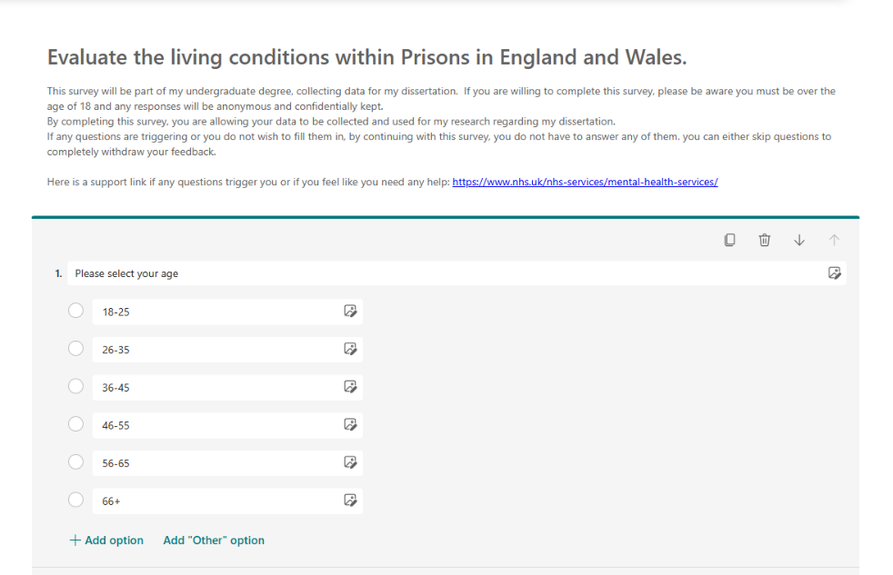
Here is a support link if any questions are triggering: https://www.nhs.uk/nhs-services/mental-health-services/

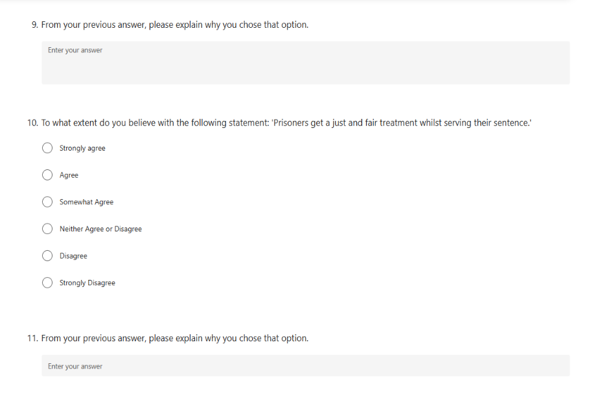
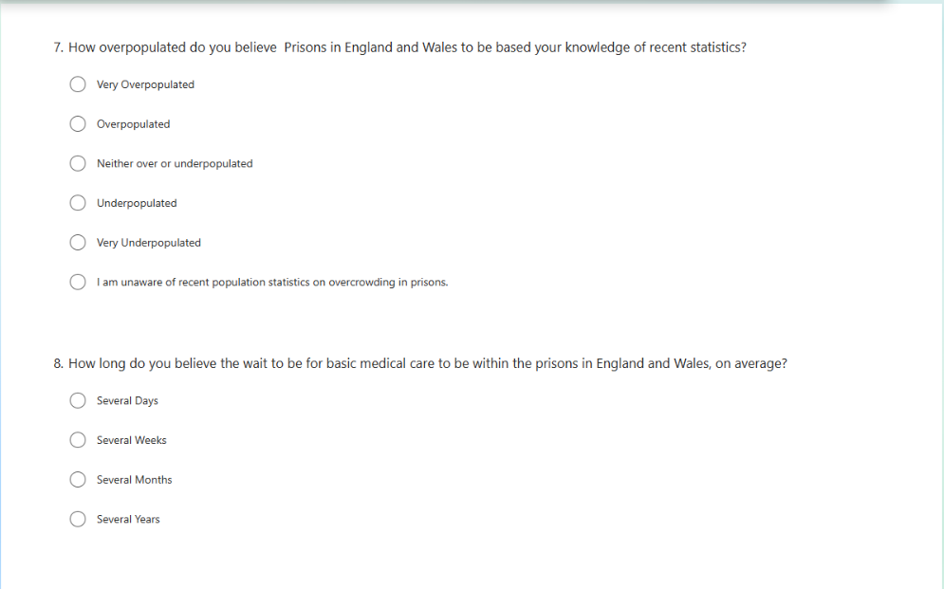
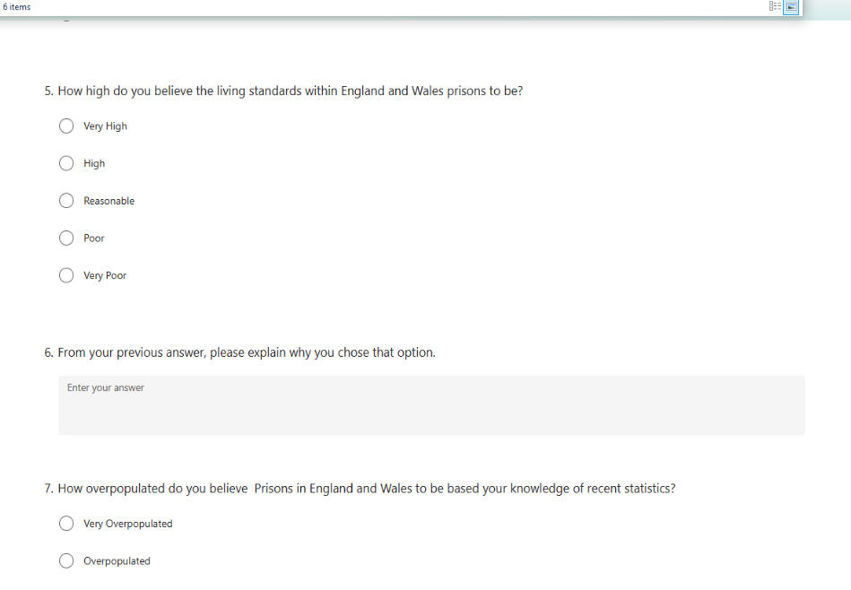
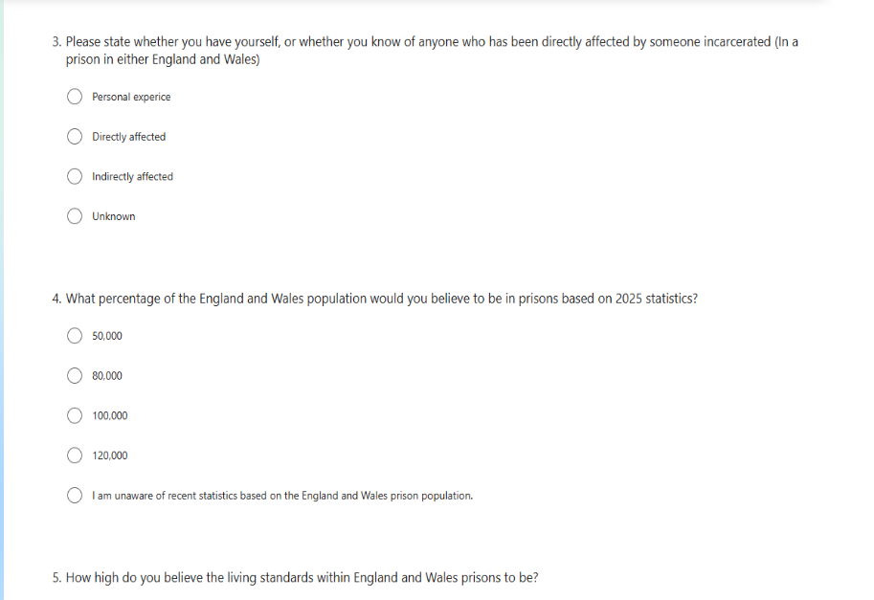
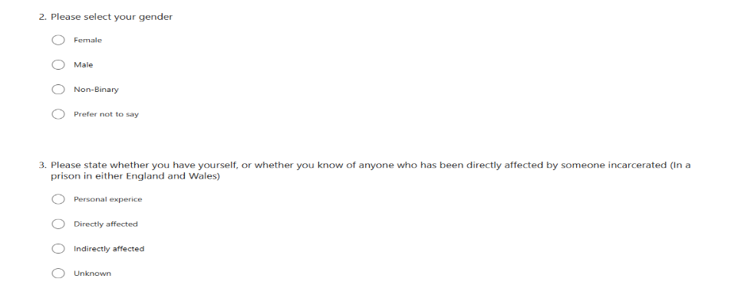

Task 6: Evaluation of the Chosen Data Analysis Method: 500 words

The chosen data analysis within this dissertation is both quantitative and qualitative data. This is to ensure there is valid data collected and not reduced to only one type of data, bringing more reliability and validity (Ahmed, 2024).
Slater and Hasson (2024) defines quantitative methodologies as the structured process that gains valid and reliable data throughout the analysis process. It is used purely for numerical data collection and it a useful tool in measuring measurements or statistical data. Quantitative methods are using though closed answer questions, or single choice question boxes. These are numerically based result, allowing the researchers to have an objective overall view of the data collected regarding a large or small number of data. Munther et al (2024) states how in order to gain more valid and reliable statistics from the data, it can be completed multiple times if the researcher needed more reliable data. This is also seen as a limitation for this specific research method.
For this dissertation, quantitative methods such as statistics, averages and closed answer questions, will be beneficial because it is an easy method to use to gain data. Vypr (2025) highlights how closed answer questions are usually much easier to understand, and so people give more valid and usable data. They also state how it is a flexible data method and so can be used in a multitude of ways, such as the methods stated before, closed answer questions and multiple choice. Once the data is collected, quantitative data is simpler to gain the results from, as they are presented in a pie chart or graph statistics.
Qualitative data is defined by Ugwu and Eze (2023) as being linked to emotions, feelings and deeper insights to the area being studied. Not using numerical data allows a more valid depth of understanding from the gathered research which can be used to translate the general view of data or multiple points of view. Qualitative methods such as open answered questions or interviews are a strong method to use in order to analyse the specific area as a descriptive tone can support the research. Thematic analysis is a method used based on qualitative methods and it is defined as a ‘structure yet flexible framework’ for identifying trends and patterns with qualitative data methods (Ahmad et al, 2025). Thematic analysis is a very widely used method regarding different themes and patterns from collected data.
Thematic analysis has a six-step framework, ensuring that all areas are covered and thoroughly explored. The steps include familiarisation, coding, generating themes, reviewing themes defining and naming themes and the finally writing up (Ahmad et al, 2025). The familiarisation of the data is the research gaining a basic understanding of any available patterns and themes showing from the collected data. Generating codes is the process of working through the data, collecting the data and processing it through a coding system. Generating the themes is based on the collected data and finding patterns from this. After this, reviewing the themes, this section of the process is profound as it links directly the themes back to the research questions and data from this. And once these steps have taken place, the researcher is able to complete the final step of writing up the data, presenting their findings. Caulfield (2022) explores how this will directly link to this research dissertation as it will present the opinions of the research and express opinions and experiences from the data survey. It will allow deep themes to be explored easier as well as looking at more broader themes. However, a limitation of this chosen method is argued by Javadi et al (2016) argues that thematic analysis can be considered to be limited to the bias of the researcher, due to it being purely based on the information fed to the people completed the survey. They may feel limited by the researchers bias and so might not feed the most accurate or reliable data, only the themes portrayed to them from the researcher.

References:

- Ahmed. A, Pereia. L and Jane. K (2024) ‘Mixed Methods Research’, Combining Both Qualitative and Quantitative Approaches. Available at: https://www.researchgate.net/publication/384402328_Mixed_Methods_Research_Combining_both_qualitative_and_quantitative_approaches#:~:text=Comprehensive%20Understanding:,Flexibility%20in%20Research%20Design
- Ahmed. S.K, Mohammed. R.A, Nashwan. A. J, Ibrahim. R. H, Abdalla. A. Q, Ameen. B. A, Khadir. R. M (2023) ‘Using Thematic Analysis in Qualitative Research. Available at: https://doi.org/10.1016/j.glmedi.2025.100198
- Andrade. C (2020) ‘Limitations of Online Surveys’. Available at: https://pmc.ncbi.nlm.nih.gov/articles/PMC7735245/#:~:text=Online%20surveys%20are%20growing%20in,generalized%20and%20may%20therefore%20mislead.
- Ayeisha Vaze (2021) ‘The Effects of Carceral space on the wellbeing of prisoners’, Architecture of Harm or Architecture of Hope? Available at: https://www.crimeandjustice.org.uk/sites/default/files/PSJ%20266%2C%20Architectures%20of%20harm.pdf#:~:text=prisoners'%20sketches%20demonstrated%20the%20importance%20of%20spaces,design%20which%20encouraged%20mobility%2C%20dignity%2C%20and%20a
- BIT (2025) ‘Reducing reoffending: lessons from Little Scandinavia’ available at: https://www.bi.team/events/reducing-reoffending-lessons-from-little-scandinavia/#:~:text=UK%20prisons%20have%20reached%20a,violations%20is%20down%20by%2050%25. (Accessed 27/4/26)
- Caulfield. J (2022) ‘How to do Thematic Analysis’, Guide and Examples. Available at: https://www.scribbr.co.uk/research-methods/thematic-analysis-explained/#:~:text=Thematic%20analysis%20is%20a%20good,your%20own%20choices%20and%20interpretations.
- Coyle. A (2018) ‘Prisons in Context’, An introduction to Penology, Routledge publishing, DOI: https://doi.org/10.4324/9781003073222
- Enas A. A. Abuhamda, Islam Asim Ismail, Tahani R. K. Bsharat (2021) ‘Understanding quantitative and qualitative research methods’: A theoretical perspective for young researchers, (February) Available at: https://www.researchgate.net/publication/349003480_Understanding_quantitative_and_qualitative_research_methods_A_theoretical_perspective_for_young_researchers
- Erin Randall, Jemma Jones, Katie Atherton, Kate Netten, (2025) Social Contact in Prisons, available at: https://assets.publishing.service.gov.uk/media/69381b465cc812f50aa41e47/Final_PDF_Social_Contact_in_Prison.pdf
- House of Commons (2025) ‘Justice Committee’, Tackling the Drug Crisis in our Prisons, Page 3. Available at: https://committees.parliament.uk/publications/50009/documents/269349/default/
- House of Commons (2026) ‘Justice Committee’, Ending the Cycle of Reoffending – Part One, Rehabilitation in Prisons, available at: https://committees.parliament.uk/publications/50209/documents/271003/default/
- Javadi. M and Zarea. K (2016) ‘Understanding Thematic Analysis and it’s Pitfall’, Journal of Client Care, p.38. Available at: https://www.researchgate.net/publication/307179806_Understanding_Thematic_Analysis_and_its_Pitfall
- Justice Committee (2025) Tackling the drug crisis in our prisons, House of Commons, Available at: https://committees.parliament.uk/publications/50009/documents/269349/default/
- Lanfear. C, Matsueda. R and Beach. L (2021), ‘Broken Windows, Informal Social Control, and Crime: Assessing Causality in Empirical Studies’. Available at: https://pmc.ncbi.nlm.nih.gov/articles/PMC8059646/
- Legislatgion.GOV.UK (2025) available at: https://www.legislation.gov.uk/uksi/1999/728/contents
- Liberty (2024) ‘Written Evidence from Liberty’, available at: https://committees.parliament.uk/writtenevidence/75450/pdf/#:~:text=3.,Scandinavian%20countries%20is%20around%2027%25.
- Liberty (2025) written evidence by Liberty. Available at: https://committees.parliament.uk/writtenevidence/75450/pdf/#:~:text=3.,the%20UK%2C%20at%2020%25.
- Mann. R (2019) ‘Rehabilitation Centre’. Available at: https://www.crimeandjustice.org.uk/sites/default/files/PSJ%20244%2C%20Rehabilitative%20culture.pdf
- Microsoft Security (2026) ‘Security and Privacy in Microsoft Forms’. Available at: https://support.microsoft.com/en-us/office/security-and-privacy-in-microsoft-forms-7e57f9ba-4aeb-4b1b-9e21-b75318532cd9#:~:text=HIPAA%20and%20BAA%20compliant.,the%20Microsoft%20Service%20Trust%20Portal. (Accessed 30/4/26)
- Munther. M and Tahani. R.K (2024) ‘Quantitative Research Methods’: Maximizing Benefits, Addressing Limitations, and Advancing Methodological Frontiers. Available at: https://www.researchgate.net/publication/379655878_Quantitative_Research_Methods_Maximizing_Benefits_Addressing_Limitations_and_Advancing_Methodological_Frontiers#:~:text=Quantitative%20methods%20have%20several%20advantages%2C%20including:%20*,and%20hypothesis%20testing**%20*%20**Automation%20and%20scalability**
- NACRO, Overcrowding in Prisons within England and Wales (2026), Available at: https://www.nacro.org.uk/nacro-services/our-work-in-criminal-justice/overcrowding-in-prisons/ (accessed 16/2/26)
- Naumova. E.N (2025) Challenges of Online Surveys and Synthetic Data in Achieving Reproducibility in Public Health Research: Echoes of the “Rise of the Machines”. Available at: https://link.springer.com/article/10.1057/s41271-025-00556-y#:~:text=The%20COVID%2D19%20pandemic%20further,example%2C%20Qualtrics%20and%20SurveyMonkey
- NHS (2026) ‘Mental Health Services’. Available at: https://www.nhs.uk/nhs-services/mental-health-services/ (Accessed 30/4/26)
- PACT (2025) ‘Why Support People in Prison?’ available at: https://www.prisonadvice.org.uk/about/why-support-people-in-prison/#:~:text=We%20believe%20supporting%20people%20in,%C2%A318%20billion%20a%20year (Accessed 30/4/26)
- Prison Reform Trust (2026) available at: https://prisonreformtrust.org.uk/adviceguide/the-sentencing-act/
- Prisoners Advice Service (2026) ‘The independent legal charity providing information's and representation to prisoners’, Prison and Health Services Struggling to Battle Changing Drug Threats’ Page 1. Available at: https://prisonersadvice.org.uk/wordpress/2026/02/16/prison-and-health-services-struggling-to-battle-changing-drug-threats/#:~:text=PRISON%20AND%20HEALTH%20SERVICES%20STRUGGLING,reduce%20drug%20harms%20in%20prisons
- Regmi. P, Waithaka. E, Paudyal. A, Simkhada. P, Teijlingen. E (2016) ‘Guide to the Design and the Application of Online Questionnaire Surveys’. Available at: https://pmc.ncbi.nlm.nih.gov/articles/PMC5506389/
- Slater. P and Hasson. F (2024) ‘Quantitative Data Quality Assurance, Analysis and Presentation’, available at: https://pmc.ncbi.nlm.nih.gov/articles/PMC12056448/
- Tenny. S, Brannan. J and Brannan. G (2025) ‘Qualitative Study’, Available at: https://www.ncbi.nlm.nih.gov/books/NBK470395/
- The Ministry of Justice (2025) ‘Safety in Custody Statistics, England and Wales’: Deaths in Prison Custody to June 2025 Self-harm and Assaults to March 2025. Available at: https://assets.publishing.service.gov.uk/media/6889fe34e1a850d72c4091f9/safety-in-custody-q1-2025.pdf (Accessed 30/4/26)
- UK Government (2025) HMPPS Annual Digest 2024 to 2025, available at: https://www.gov.uk/government/statistics/hmpps-annual-digest-april-2024-to-march-2025/hmpps-annual-digest-2024-to-2025--2#hmpps-annual-digest-202425 (Accessed 30/4/26)
- UK Government (2025) The health of people in Prisons, on probation and in the scene of NHS estate in England, available at: https://www.gov.uk/government/publications/chief-medical-officers-annual-report-2025-infections/executive-summary-and-recommendations-accessible-version
- UK Government, Ministry of Justice, (2025), Available at: https://www.gov.uk/government/publications/the-impact-of-overcrowding-on-assaults-in-adult-public-prisons/the-impact-of-overcrowding-on-assaults-in-closed-adult-public-prisons (Accessed 16th/2/26)
- UK Government, The Impact of Overcrowding on Assaults in closed adult Public Prisons, (2025), Available at: https://www.gov.uk/government/publications/the-impact-of-overcrowding-on-assaults-in-adult-public-prisons/the-impact-of-overcrowding-on-assaults-in-closed-adult-public-prisons (Accessed 16/2/26)
- UK Parliament (2025) Prison Crisis; As Justice System faces total Gridlock in 2026, PAC calls for rapid action, available at: https://committees.parliament.uk/committee/127/public-accounts-committee/news/205761/prisons-crisis-as-justice-system-faces-total-gridlock-in-2026-pac-calls-for-rapid-action/ (Accessed 22/2/26)
- UK Parliament (2026) ‘Better prisons, less crime’: Lords Justice and Home Affairs Committee report’ available at: https://lordslibrary.parliament.uk/better-prisons-less-crime-lords-justice-and-home-affairs-committee-report/#:~:text=An%20independent%20review%20on%20the,reform%20of%20sentencing%20is%20required.
- UK Parliament (2026) ‘Justice Committee’, Ending the Cycle of Reoffending, Available at: https://publications.parliament.uk/pa/cm5901/cmselect/cmjust/469/report.html#:~:text=Conclusions%20and%20recommendations-,Summary,%2C%20education%2C%20and%20family%20contact.
Uwgu. C.N and Eze. V.H.U (2023) ‘Qualitative Data,’ International Digital Organization for Scientific Research. Available at: https://www.researchgate.net/publication/367221023_Qualitative_Research#:~:text=It%20relies%20on%20the,and%20viewpoints%20%5B3%5D.
- Vypr (2025) ‘The Pros and Cons of Qualitative and Quantitative Research’. Available at: https://vyprclients.com/pros-and-cons-of-qualitative-and-quantitative-research/#:~:text=Larger%20sample%20sizes:%20By%20analysing,be%20gleaned%20in%20real%20time.

AI Acknowledgement:
I acknowledge the use of AI Tool. I used Canva (https://www.canva.com) on the 12^{th of} March to create a mind map for my dissertation plan.
I used the prompt(s):
1. Generate me a blue mind map with multiple bubbles for different points.

