
Approaches to Innovation and Organisational Change
ACMA5007: Management, Innovation and Sustainability

May 12, 2025
University of Wales Trinity Saint David

Executive Summary
The purpose of this report is to identify and evaluate approaches to innovation and organisational change. The change being discussed is a subcategory of Renishaw’s larger plan to implement the “Factory of the Future” initiative, a system known as AutoStore, which is a product management and storage solution.
Henri Fayol’s 14 principles of management were discussed to critically examine the management practises during the organisational change. Each principle was evaluated on its use during the change.
Lewin’s forcefield analysis model was used to derive the driving forces for change and resisting factors. They theorise that each force for change has an opposing resistive force. The model strives to negate these resisting factors by using the 3-step change model: unfreeze, change, refreeze.
Daniel Goleman’s model on emotional intelligence is used to evaluate the management recommendations. Goleman’s model can be summarised into two categories, personal and social competence. He theorises that both sections can only be met by the recognition and regulation of each competence.
Maslow’s Hierarchy of needs is used to evaluate the support offered to employees. The pyramidal structure details five levels of needs which must be met in order for the drive for personal goals can be achieved. In some circumstances the levels can progress in any order, but Maslow theories that it is unlikely for each level of need to be met without progressing from bottom to top.

Conclusion Summarised
The styles and skills of management and leaders differ between each individual they must be flexible in their approach as there is no model suitable for all and everyone responds differently. Managers must be mindful of emotional, intellectual and political quotients to extract the desired quality of work, which will differ from person to person. Managers are likely to adopt an authoritative or democratic management style, whereas leaders use their infectious enthusiasm to strive for organisational change. The AutoStore project was a successful and positive organisational change which aimed to implement modern practises. In conclusion, approaches to innovation and organisational changes are shaped by how the managers and leaders involved, recognise and respond to the social needs of employees throughout the process.
Table of Contents
Executive Summary 1
Conclusion Summarised 1
Index of Figures 2
Index of Tables 2
Introduction 3
Main Findings: Summary 4
Overview of Change 4
Assessment of the Effectiveness 4
Leadership & Management 4
Identifying the Innovation or Organisational Change 5
Critical Examination of Management Practise 7
Applying Lewin’s Forcefield Analysis Model 8
The Driving Forces for Change 8
Resisting Factors 8
Management Recommendations 9
Employee Support 10
Good Practice and Improvements 11
Conclusion 11
Bibliography 12

Index of Figures
Figure 1 (mynewsdesk.com, 2016) 3
Figure 2 (bonewsz.blogspot.com, 2021) 6
Figure 3 (Agarwal, 2025) 9
Figure 4 (Pichere, Cadiat, & Probert, 2025) 10

Index of Tables
Table 1 5
Table 2 8

Introduction
Approaches to Innovation and Organisational Change discusses an organisational change or innovation within the author’s current place of work. They were involved with the implementation of the change and will critically examine how the process was managed as well as its resulting effectiveness. Lewin’s Forcefield Analysis model is considered when delving into the driving forces for change and any resisting factors are highlighted in the report. An applicable change management model will be used to make recommendations on the rate of success of the change and consideration is given to the support offered to employees of the organisation where change was implemented, giving thought to subjects such as moral and motivation following change. The report will give weight to areas of good practice and highlight areas where improvement could be made to the process and how it was manged during implementation and aftercare. (Pitson, 2025).
The company being discussed in the report is Renishaw PLC, a global engineering technology group, focussed on creating high precision technology for metrology and healthcare applications, predominantly based in the UK (Renishaw PLC, 2025). The change being discussed is a subcategory of Renishaw’s larger plan to implement the “Factory of the Future” initiative, a system known as AutoStore, which is a product management and storage solution. This system maximises the efficiency of and automates the storage, pick and place aspects of product locations in the warehouse for both internal and external products. AutoStore is an automated order delivery system using robotics and advanced software to fulfil orders efficiently (AutoStore, 2025). This change of procedure required effective communication, direction from leadership, and the collaboration of multiple departments to implement successfully.
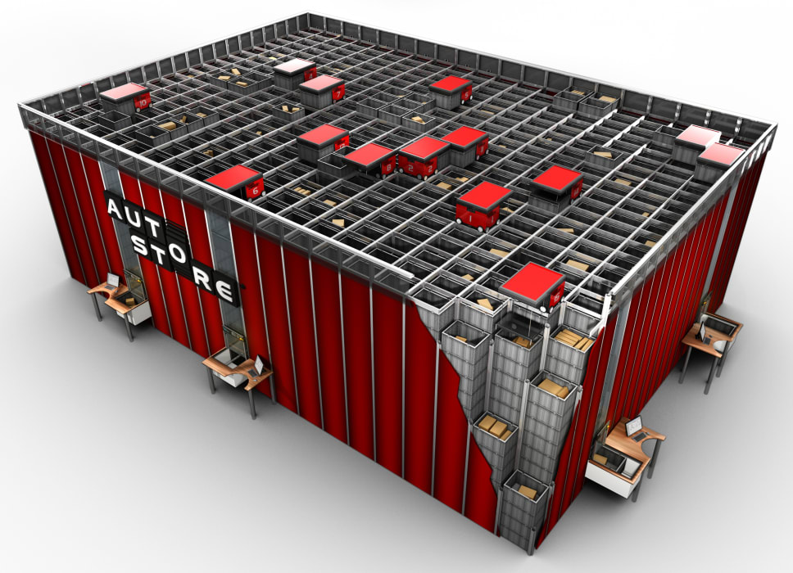
Figure 1 (mynewsdesk.com, 2016)

Main Findings: Summary

Overview of Change
The “Factory of the Future” initiative lead towards factory automation, this change began in the warehouse. An opportunity was identified when the Miskin site was under construction, the new halls could house an improved storage management solution. This opportunity has been successful, being perceived well, and provides a roadmap for the future.

Assessment of the Effectiveness
Kotter’s model for analysis promotes 8 sequential steps to overcome problems when change is introduced, they are: establish a sense of urgency so the change is necessary, form a collaborative group to lead it, create a vision, communicate the vision, empower others to act, plan and make short term wins for moral, assess changes and make appropriate adjustments, reinforce the new changes and reform behaviours, (Kotter, 1995). This organisational change was effective in creating a sense of urgency, collaboration, and vision creation and communication.

Leadership & Management
The Group Manufacturing Director managed the initial stages in an authoritative style and gave orders to team leaders. The project leadership was given to the Assembly Systems Group team lead, whose role was largely centred around people and moral management. “The leadership relationship is a social process dependent upon the type of power and influence exercised over other people” (Christy & Mullins, 2013).

Identifying the Innovation or Organisational Change
At Renishaw’s Miskin site, the company has begun the journey towards its “Factory of the Future” initiative. This initiative involves a roadmap that works towards the future of warehouse automation which includes the implementation of 4 key features, they are:
- The AutoStore: a modular storage system
- Robot Piece Picking: aiming to reduce manual handling
- AMR (Automated Mobile Robot) / CMR (Collaborative Mobile Robot):
automated transportation of product
- Semi-Automated Dispatch: resulting in a more streamlined dispatch operation
The project timeline for the implementation of the AutoStore has been a 3-year process which is nearing completion. See Table 1 below for the AutoStore project timeline. Currently, the status of the project is “Hardware Installed” and 11,300 storage bins have been successfully inserted into the system by the warehouse and apprentice teams. The AutoStore is currently in a period of validation after which the system is on track to “Go Live” in quarter 2 of 2025.
Table 1
START | Q2 2023  Initial Research |  | Q1 2024  Supplier Chosen
Q2 2025  Go Live |  | Q1 2025  Hardware Installed |  | Q3 2024  Installation Begins

The Miskin site now houses Wales’s first AutoStore system which has allowed the warehouse to increase its usable volume of storage from 190m³ to 1125m³. This increase of efficiency is due to the use of vertical storage as well as eliminating the need for wasted space, which is inevitable in shelving units, such as walkways and ununiform product heights. The AutoStore has 4 transaction ports, where product can be placed into or requested from storage, and is able to present 235 bins to the ports per hour. This results in a 50% reduction in product picking and storage when compared to the original manual process of picking orders performed by warehouse staff. The AutoStore has 8 robots which sit on gridded rails above the storage unit, 4 for the Y axis and 4 for the X axis, as once on the rails the robots cannot turn around, only being able to move in the X or Y axis with no rotational capabilities. This means that due to their design, there will always be one row of the grid the robot will not be able to access as it will be covering the access to the storage locations underneath it, hence the need for robots positioned in both axis.
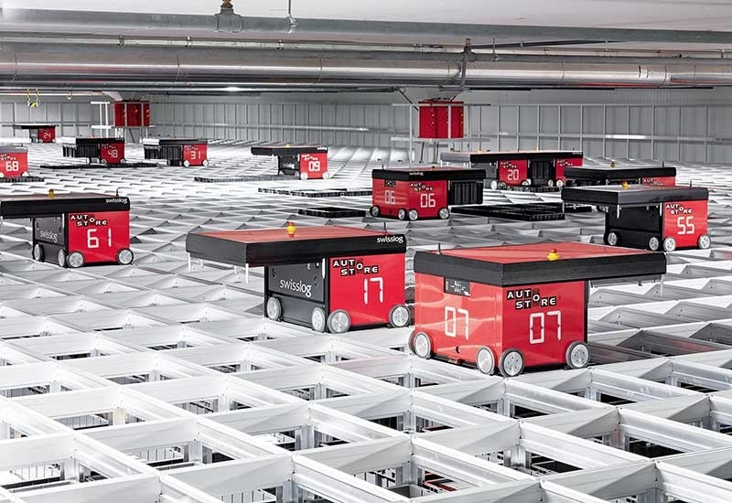
Figure 2 (bonewsz.blogspot.com, 2021)
The Group Manufacturing Director had a firm but fair management style and championed the change. The project had been approved before the key stakeholders were involved in implementing the process. This top-down autocratic management approach promoted collaboration in the early stages of the project and consequently made teamwork easier as there was a common goal. “Autocratic Leadership is a management style characterized by individual control over all decisions and little input from group members” (Practical Psychology, 2024).
During the preliminary stage, regular “Steering Groups” were held by management including the Group Manufacturing Director and Assembly Managers. These meetings initially focussed on feasibility and costs but became weekly workshops with all levels of management. These workshops were collaborative sessions where key stakeholders aimed to identify and mitigate risks. The key stakeholders were the Assembly Systems Group (ASG), Warehouse Operations Management and IT & Security. Consideration was given to the current processes and the desired outcome of the change. An initial problem was the warehouse was not allowed to be disrupted.
Previously, process knowledge was verbal and warehouse staff were expected to learn on the job, going forward we wanted this documented. The warehouse team did not have an engineering team to oversee this transition, so ASG filled that role and adopted a democratic management style. “Democratic leaders welcome and value others’ input, rely heavily on team participation, and facilitate discussions that enable multiple members of their group to weigh in on decisions” (NSLS, 2022).
Team communication was key when running through scenarios for the Process Failure Mode Effective Analysis (PFMEA). The failure analysis would be considered against process flow charts to identify and rectify any issues, as well as indicating how and in which areas the new system is improving the previous process. The PFMEA measured factors such as occurrence, detection and severity, then gave each step in the process flow an overall risk factor.

Critical Examination of Management Practise
The management of the organisational change is examined below using Henri Fayol’s 14 principles of management (Peek, 2025), they are:
- Division of Work
  - Appropriate to the team skills and increased the efficiency of the project.
- Authority and Responsibility
  - Each team reported to a single leader which was effective because it facilitated accountability, resulting in less delays.
- Discipline
  - No reprimand actions were in place as the effective incentive was recognition for good work.
- Unity of Command
  - A single leader would report to higher management, which avoided hierarchal confusion.
- Unity of Direction
  - The authoritarian approach from the group manufacturing director was effective in creating a unified goal.
- Subordination of Individual Interest
  - Everyone was unified in working towards the interests of the company.
- Remuneration
  - The employees have a salary.
- Centralisation
  - The division of power and authority given to those in charge of the implementation resulted in the responsibility being shared.
- Scalar Chain
  - The scalar chain in the project was clear with a top-down hierarchal approach.
- Order
  - Everyone knew their responsibility which removed the fear of the unknown.
- Equity
  - All employees were treated equally creating a positive working environment.
- Stability
  - Providing stability for the employees was important as it gave them job security.
- Initiative
  - Employees are encouraged to follow their initiative when completing the tasks.
- Esprit de Corps
  - Regular progress meetings were held, and problems could be discussed openly, which allowed support to be offered and was effective in building trust within the team.

Applying Lewin’s Forcefield Analysis Model
Lewin’s forcefield analysis model is a 3-step change process where the organisation is put through states of “unfreezing, movement, and refreezing” (Hussain, et al., 2018). The model allows organisations to identify and evaluate “diverse factors influencing the success or failure of a change via a systematic approach” (Six Sigma, 2024). The forcefield analysis proposes that each force advocating for change will be met with an equal resistive force, see Table 2.
Table 2
The Driving Forces for Change | Resisting Factors
Automation | Job Security
Storage Flexibility | Familiarity
Future Proofing | Change Anxiety

Automation: The automated process is faster than its manual counterpart, does not need a salary and could enable the company to hire less employees.
Storage Flexibility: The storage system is modular and supports future expansion.
Futureproofing: The company wants to stay competitive with its lead times, wants to be seen as modern and keeping up with technology to attract a competent workforce, the money saved on efficient storage could be given back to the employees in the form of increased salary or bonus’.
Job Security: Employees may worry that they are replaceable.
Familiarity: Employees understand the current processes and may not look to the future but instead have a mindset of “if it isn’t broken, don’t fix it”.
Change Anxiety: People fear the unknown and may be afraid that the new system will not perform as well as the current.

Management Recommendations
Managers must have an appropriate understanding of the Intellectual (IQ), Political (PQ) and Emotional Quotients (EQ), good managers know how to balance them and tailor their responses to individuals. Daniel Goleman’s model on emotional intelligence explores the following 5 areas: The Emotional Brain, The Nature of Emotional Intelligence, Emotional Intelligence Applied, Windows of Opportunity, and Emotional Literacy (Goleman, Emotional Intelligence : 25th Anniversary Edition, 1996). Those areas can be further segmented into 4, they are: Self-Awareness, Empathy, Self-Management and Social Skills, which can be further reduced to personal and social competence, see Figure 3 (Agarwal, 2025) (Agarwal, 2025). Personal competency covers the awareness and management of an individual, whereas social competence covers the awareness and management of an individual in group settings.
An area where management could have improved during the organisational change would be social awareness. Once an issue was announced, management were good at conflict resolution, but they were not always proactive in identifying potential disagreements in the group initially. A more empathic approach to employees would reduce the need for conflict resolutions.
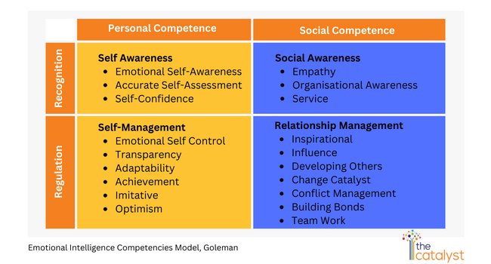
Figure 3 (Agarwal, 2025)

Employee Support
Employees will have an emotional shift throughout the change process. Their transition can be guided and supported by consulting the principles outlined in a motivational model such as Maslow’s Hierarchy of Needs (Pichere, Cadiat, & Probert, 2025). The model, see Figure 4 (Pichere, Cadiat, & Probert, 2025) below, allows the employer to acknowledge the employees’ needs during the period of change and put measures in place to reassure and motivate them. The model can be more fluid than the pyramid structure suggests but the lower sections are generally more important and will promote a drive to reach the next level.
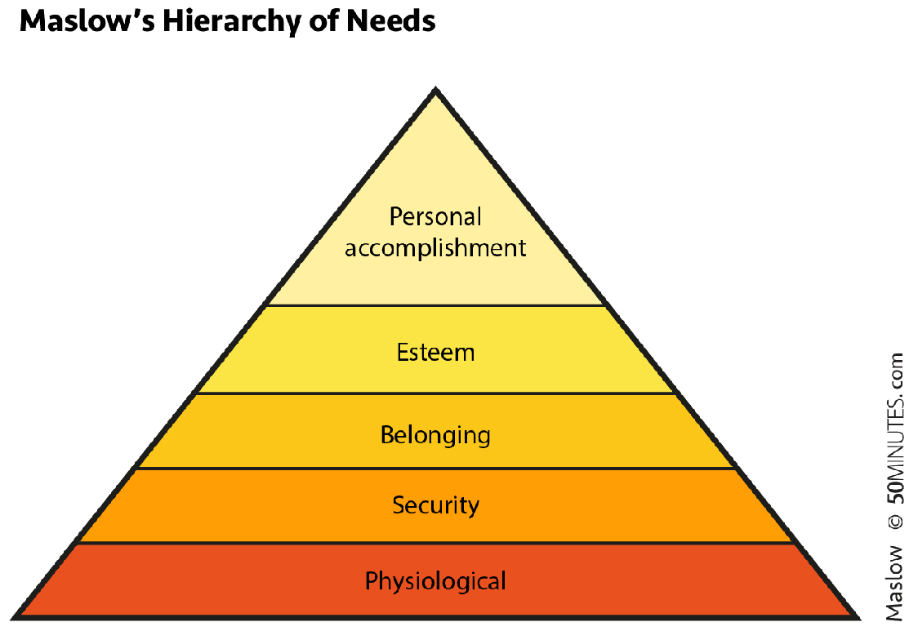
Figure 4 (Pichere, Cadiat, & Probert, 2025)
Physiological needs are a person’s basic needs; employees will otherwise look elsewhere for work, for example, bathrooms and minimum wage. Employees were not moved into their new area until the infrastructure was completed as moving them before completion would have had a negative impact on their moral.
Security needs are a person’s perception of safety, such as an adequate level of Health & Safety and job security, pension and sick pay schemes are provided examples.
Belonging needs can be described as a person’s social requirements. The personal and professional areas in this section are closely linked. Social activities in the workplace allow team members to bond and develop trust. Regular communications on project updates were held, motivating employees to trust in the organisation of their team leader.
Esteem needs become available once a person’s physiological, security and belonging needs have been met. In the workplace, this can be desire for recognition. Employees received regular feedback and praise for good work. Any feedback from higher management was fed down appropriately which motivated employees and sparked their drive for personal accomplishment.
Personal Accomplishment needs are individual and based on personality and desires, rather than how they might be perceived by others. Personal accomplishment needs can be met by using an appraisal system. Team leaders developed their leadership and interpersonal skills and were enthusiastic and supportive of ideas which gave the team confidence in their vision.

Good Practice and Improvements
An area where the project could be improved is the addition of short-term wins because the project was 2 years long, celebrating the completion of each milestone would’ve improved moral.
Areas of good practise would be the effective communication of the vision set out by the group manufacturing director in the initial stages, as well as the overall collaboration by the teams.

Conclusion
Management styles and leadership skills differ between individuals. Managers must be flexible in their approach as everyone responds differently and there is no model suitable for all. Some people thrive under an authoritarian style of management, whereas others may prefer a more democratic approach. Managers must be mindful of emotional, intellectual and political quotients when dealing with employees, to extract the best quality of work from them. For example, some may prefer structured tasks, whereas others may thrive on using their initiative.
Leaders strive for organisational change and use their infectious enthusiasm much like a salesperson. They aim to motivate and promote positivity which can generally persuade individuals into likeminded thinking. They must be careful to balance the type of task with the group members and any preexisting authority levels within it, as well as predicting and eliminating any social conflicts within the group.
The AutoStore project has been a positive change to the organisation which aims to modernise its processes. It will set an example of how automation can improve the current system and provide futureproofing. The success of this project will promote positivity towards similar organisational changes and innovations. Every change will be met with resistance but proactively planning for those factors and implementing mitigations in the initial stages, will enable managers and leaders to be more effective in their approaches with regards to employees relations.
In conclusion, approaches to innovation and organisational changes are shaped by the managers and leaders involved with it. How they recognise and respond to the social needs of their employees, will determine the type of working environment, overall moral within the team and thus success or failure of the change.

Bibliography
Adam-Smith, D., & Peacock 1922, A. (1994). Cases in Organisational Behaviour. Pitman.
(Accesssed: 2025).
Adam-Smith, D., & Rayner, C. (2009). Managing and Leading People. Chartered Institute of Personnel and Development.
(Accesssed: 2025).
Agarwal, P. (2025). Why Emotional Intelligence Is An Indispensable Skill For Sales Leaders? Retrieved May 6, 2025, from The Catalyst: https://www.thecatalyst.co.in/blogs/emotional-intelligence-skill-in-sales-leaders/
(Accesssed: 2025).
AutoStore. (2025, 04 23). The AutoStore DNA. Retrieved 2025, from AutoStore System: World's Fastest AS/RS | 4x Space and 99.7% Uptime | AutoStore
(Accesssed: 2025).
Baron, R. A., & Greenberg, J. (1997). Behaviour in Organizations: Understanding and Managing the Human Side of Work. Prentice Hall.
(Accesssed: 2025).
Bhatti, N., Maitlo, G. M., Shaikh, N., Hashmi, M. A., & Shaikh, F. M. (2012, February 1). The Impact of Autocratic and Democratic Leadership Style on Job Satisfaction. International Business Research, 5(2). Toronto, Ontario, Canada: Canadian Center of Science and Education. doi:10.5539/ibr.v5n2p192
(Accesssed: 2025).
bonewsz.blogspot.com. (2021). AutoStore Grid. Retrieved May 10, 2025, from https://bonewsz.blogspot.com/2021/04/autostore-grid-how-to-uninstall.html
(Accesssed: 2025).
Bridger, E. (2018). Employee Engagement: A Practical Introduction. Kogan Page Limited.
(Accesssed: 2025).
Brown 1960, D., & Armstrong 1928, M. (2019). Armstrong's Handbook of Reward Management Practice: Improving Performance Through Reward (6 ed.). Kogan Page.
(Accesssed: 2025).
Christy, G., & Mullins, L. J. (2013). Management and Organisational Behaviour (10 ed.). Pearson. doi:ISBN : 9780273792642
(Accesssed: 2025).
Echavarria, M. (2016). Enabling Collaboration: Achieving Success Through Strategic Alliances and Partnerships. LID.
(Accesssed: 2025).
Goleman, D. (1996). Emotional Intelligence : 25th Anniversary Edition. London: Bloomsbury Publishing. doi:ISBN 9781526634344
(Accesssed: 2025).
Goleman, D., & Cherniss, C. (2024, May 6). OPTIMAL LEADERSHIP AND EMOTIONAL INTELLIGENCE. Leader to Leader, 2024(113), 7-12. Retrieved May 1, 2025, from https://doi.org/10.1002/ltl.20813
(Accesssed: 2025).
Gowler, D., Legge, K., & Clegg, C. W. (1993). Case Studies in Organizational Behaviour and Human Resource Management. Paul Chapman Publishing.
(Accesssed: 2025).
Hussain, S. T., Lei, S., Akram, T., Haider, M. J., Hussain, S. H., & Ali, M. (2018, July 24). Kurt Lewin's change model: A critical review of the role of leadership and employee involvement in organisational change. Journal of Innovation & Knowledge, 3(3), 123-127. Retrieved May 1, 2025, from https://www.sciencedirect.com/science/article/pii/S2444569X16300087
(Accesssed: 2025).
Judge, G., Gennard, J., & Chartered Institute of Personnel and Development. (2005). Employee Relations (4 ed.). Chartered Institute of Personnel and Development.
(Accesssed: 2025).
Juneja, H. (2025, April 3). Henri Fayols 14 Principles of Management. Retrieved May 1, 2025, from Management Study Guide: https://www.managementstudyguide.com/management_principles.htm
(Accesssed: 2025).
Kotter, J. P. (1995, Summer). Leading Change: Why Transformations Fail. National Productivity Review, 14(3), pp. 148-149. Retrieved from https://www.proquest.com/docview/215023787?accountid=130472&parentSessionId=0y4ULrax8NTjpN74xsCGB%2B1WA3OHbBQWF3LAPGK6MDg%3D&pq-origsite=primo&sourcetype=Trade%20Journals
(Accesssed: 2025).
Lee 1974, J. (2014). Building Your Business the Right-Brain Way: Sustainable Success for the Creative Entrepreneur. New World Library.
(Accesssed: 2025).
Manchester, J. e. (2014). Facilitating Lewin’s change model with collaborative evaluation in promoting evidence based practices of health professionals. Evaluation and program planning, 47, 82–90. Retrieved May 1, 2025, from https://doi.org/10.1016/j.evalprogp
(Accesssed: 2025).
mynewsdesk.com. (2016). The AutoStore System - EET Group A/S. Retrieved May 10, 2025, from https://th.bing.com/th/id/R.9a8c0edfadba8a30728ba5c4c6f56784?rik=VHWgH7UxZxUtvQ&riu=http%3a%2f%2fresources.mynewsdesk.com%2fimage%2fupload%2fc_limit%2cdpr_auto%2cf_auto%2ch_700%2cq_auto%2cw_auto%2fa6ry1iohheqdctalfkkw.jpg&ehk=Psr1VsNi7cfj8Y5GfpvZN5xGEMmbG
(Accesssed: 2025).
NSLS. (2022, June 15). Key Characteristics of Democratic Leadership. Retrieved 2025, from The National Society of Leadership and Success: https://www.nsls.org/blog/key-characteristics-of-democratic-leadership
(Accesssed: 2025).
Ohno, T., Toyota Production System, Kaizen, & Ono 1912-1990, T. (2013). Taiichi Ohno's Workplace Management: with new Commentary from Global Quality Visionaries. McGraw-Hill.
(Accesssed: 2025).
Peek, S. (2025, January 16). The Management Theory of Henri Fayol. (C. Brooks, Editor) Retrieved 2025, from Business.com: https://www.business.com/articles/management-theory-of-henri-fayol/
(Accesssed: 2025).
Pichere, P., Cadiat, A.-C., & Probert, C. (2025). Maslow's Hierarchy of Needs. Lemaitre Publishing. doi:ISBN : 9782806265876 / ISBN : 2806265878
(Accesssed: 2025).
Pitson, M. (2025, 04 23). ACMA5007: Management, Innovation & Sustainability. Retrieved 2025
(Accesssed: 2025).
Practical Psychology. (2024, February). What is Autocratic Leadership (Definition + 9 Examples). Retrieved 2025, from Practical Psychology: https://practicalpie.com/what-is-autocratic-leadership/
(Accesssed: 2025).
Rees, G., & Smith, P. (2014). Strategic Human Resource Management: An International Perspective (7th ed.). SAGE. doi:ISBN : 9781446255865
(Accesssed: 2025).
Rees, G., & Smith, P. (2014). Strategic Human Resource Management: An International Perspective. SAGE. doi:ISBN : 9781446255865
(Accesssed: 2025).
Renishaw PLC. (2025, 04 23). About Renishaw. Retrieved 2025, from About Renishaw: https://www.renishaw.com/en/About-renishaw--6432
(Accesssed: 2025).
Riggio, R. E. (2024, August 30). Why Are People So Resistant to Change? Retrieved May 1, 2025, from Psychology Today: https://www.psychologytoday.com/us/blog/cutting-edge-leadership/202408/why-are-people-so-resistant-to-change?msockid=02b6c339cdbf6f541e31d1b3cc746e5b
(Accesssed: 2025).
Six Sigma. (2024, April 2). Lewin's Force Field Analysis in Change Management. What, Why and How. Retrieved May 1, 2025, from Six Sigma: https://www.6sigma.us/six-sigma-in-focus/lewin-force-field-analysis-in-change-management/#:~:text=Lewin%E2%80%99s%20Force%20Field%20Analysis%20is%20a%20powerful%20framework,failure%20of%20a%20change%20via%20a%20systematic%20approach.
(Accesssed: 2025).
Timms, P. (2020). The Energized Workplace: Designing Organizations Where People Flourish. Kogan Page Inc.
(Accesssed: 2025).
Williams, A. D., & Tapscott, D. (2008). Wikinomics: How Mass Collaboration Changes Everything. Atlantic.
(Accesssed: 2025).

