Connex – ToFD & PAUT Weld Scanner
Benjamin Andrew Woodhead – P151944
UWTSD – School of Engineering - BEng Mechanical & Manufacturing Engineering
Spring 2020

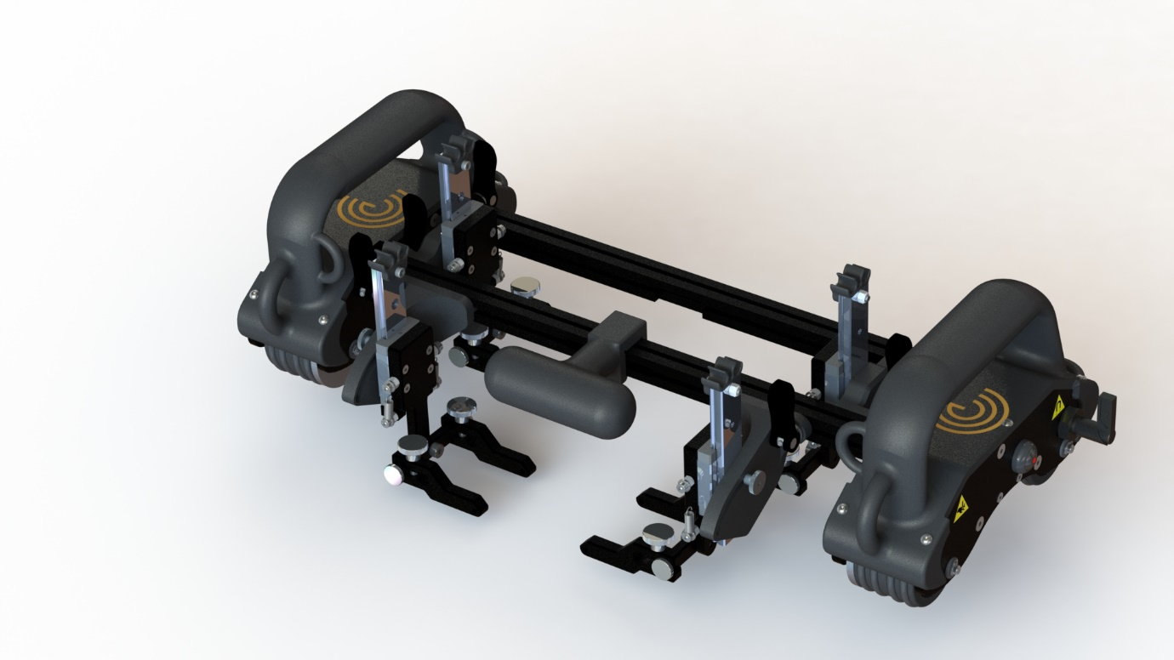

Declaration of Conformity
This thesis is the product of the author’s own research and has not been submitted for consideration in a degree classification by any previous student.

Acknowledgements
This project would not have been possible without the support, financial backing and guidance of several individuals, so a great deal of thanks is due to the following:
- Eddyfi Technologies, employer – provided funding, resources and technical experience in the development of the project.
- Stuart Kenny, GM – the driving force behind this project from the beginning, his field experience in NDT was invaluable in the design stages. Some questionable opinions on the England rugby team though.
- Gareth Mugford, Product Manager for UT – also provided great insight for the design stages from his time as an applications engineer, while also providing vital testing feedback from the prototyping stages.
- Dan Williams, Head of R&D – Dan always keeps the design teams focused during development, his input was key for keeping me pointed in the right direction.
- Ralph Lieb, Electronics Designer – responsible for the electronic subassemblies in almost all my scanners, if it wasn’t for him my designs would be pretty but ultimately useless.
- Matthew Everett, Production Engineer – key to things actually getting ordered and built, also has the unenviable job of ensuring our designs can work on a large scale.
- Huw Lewis, NDT Applications Engineer at CAN Offshore – provided on-site testing for this project and always made the feedback sound positive, even when it wasn’t.
- Annys Leech, fiancé - has listened to more than one flaming rant in the completion of this project. Much love.
- Alison Woodhead, My Mum – has always provided great balance and support in my life, I could not have achieved any of it without her.
- Wayne Woodhead, My Dad – the real reason I know anything about engineering, he gave me my shot in the world of NDT as well as all the encouragement you could need along the way. He also pushed me to do this degree though, so he comes last on this list..

Abstract
This dissertation details the development of a new manually-operated ToFD and PAUT-capable scanner by the author as part of the Eddyfi UK development team. Details of the general principles of these ultrasonic techniques and potential competitors are followed by a discussion of the required product specifications and how they related to the subsequent design work. The design followed the company-standard Concept, Alpha and Beta prototype stages, with each stage subject to testing and approval of each of the appropriate subsystems. Cost analysis is also performed at the Alpha and Beta stages, comparing the Connex system with the identified competitor products, with details of future upgrades and accessories detailed afterwards. All mechanical design work is the product of the author, with electrical design courtesy of Ralph Lieb of the Eddyfi Research & Development team.
Contents
Declaration of Conformity 1
Acknowledgements 1
Abstract 2
Table of Figures 4
Table of Tables 5
List of Abbreviations/Terminology 5
Introduction 7
Literature Review/Market Analysis 9
Technique Analysis 9
Time of Flight Diffraction (ToFD) 10
Phased Array Ultrasonic Testing (PAUT) 12
Competitor Analysis 14
Jireh STIX 16
AUT Solutions WeldScan 18
Phoenix ISL Swift 19
Product Specifications 21
Operating Requirements 21
Mechanical Requirements 21
Probe Requirements 22
Electrical Requirements 22
Umbilical Requirements 23
Accessory/Transit Case Requirements 23
Cost 23
Timing Plan 24
Design and Testing 26
Feasibility Study & Initial Concept 26
Design 26
Feedback 33
Prototype Alpha 34
Design 34
Cost Analysis 35
Testing & Feedback 36
Prototype Beta 39
Design 39
Cost Analysis 45
Testing & Feedback 45
Transit Case Design 48
Business Impact 50
Production Publishing 52
Future Work – Product Drops 52
Drop 1 – Longitudinal Scanning 53
Drop 2 - Chain Scanner 54
Drop 3 – Corrosion Mapping Configuration 55
Conclusion 57
Appendices 58
Works Cited 58

Table of Figures
Figure 1 – Simplified UT Test Setup (Jamil, et al., 2019) 9
Figure 2 – Basic ToFD Setup (Olympus IMS, 2014) 11
Figure 3 – Multi-Probe ToFD Setup (Olympus IMS, 2014) 11
Figure 4 – Linear Array Probe Cross-Section (Oceaneering International, 2018) 12
Figure 5 – Wave Interference Patterns (Oceaneering International, 2018) 13
Figure 6 - PAUT Sectorial Scan (Olympus IMS, 2020) 14
Figure 7 – Jireh STIX (Jireh , 2020) 16
Figure 8 – AUT Solution WeldScan (AUT Solutions, 2020) 18
Figure 9 – Phoenix ISL Swift (Phoenix ISL, 2020) 19
Figure 10 – Original Timing Plan (Larger version available in Appendix 1) 24
Figure 11 - Connex Initial Concept Model 26
Figure 12 – Wheel Concept Design (Exploded View) 27
Figure 13 - Tractor Concept Design (Exploded View) 29
Figure 14 - Brake Lever Mechanism (Exploded View) 29
Figure 15 – Toolpost Assembly Concept Design 30
Figure 16 - Probe Holder Concept Design 31
Figure 17 - Handle Concept Design 31
Figure 18 - Elbow Scanning Attachment Concept Design 32
Figure 19 - Elbow Scanning Configuration Concept Design 32
Figure 20 - Prototype Alpha Design 34
Figure 21 - Prototype Beta Design 39
Figure 22 - Beta Design Toolpost Probe Arms with Olympus-compatible Pivot Pins 40
Figure 23 - Beta Prototype Main Toolpost Assembly 41
Figure 24 - Beta Prototype External Toolpost Assembly 41
Figure 25 - Beta Prototype Wheel Assembly 42
Figure 26 - Beta Prototype Tether Points 43
Figure 27 - Beta Prototype Snap-On Handle 44
Figure 28 - Beta Prototype Quick-Release Bridge (colour altered for clarity) 44
Figure 29 - Wheel Slip Test 46
Figure 30 - Surface Separation Test 47
Figure 31 - Transit Case Design (Exploded) 48
Figure 32 - Packed Connex System 50
Figure 33 - Longitudinal Concept 53
Figure 34 - Longitudinal Scanning Prototype 54
Figure 35 - Chain Scanner Concept 55
Figure 36 - Corrosion Mapping Concept 56
Figure 37 - Corrosion Mapping Probe Holder 56

Table of Tables
Table 1 – Recommended ToFD Setups 11
Table 2 - Connex Cost Benefit Projections 51
Table 3 - Mantis Cost Benefit Projections 51

List of Abbreviations/Terminology
NDT – Non-Destructive Testing, utilising non-destructive methods to test the integrity of assets
UT – Ultrasonic Testing, the use of sound waves to detect flaws in materials
ToFD – Time of Flight Diffraction, a specific type of UT that utilises a pitch-catch pair of UT probes
PCS – Probe Centre Separation, the distance between a pair of ToFD probes
PAUT – Phased Array Ultrasonic Testing, a specific type of UT that utilises a linear array of UT probes
Prove-up – the NDT industry term for verifying results with a complementary technique
CAD – Computer Aided Design, a software package used to create 3D models; this project utilised Solidworks from D’Assault Systemes
MRD – Market Research Document, a report that details the market requirements for a given project
PRD – Product Requirement Document, a report that details the specifications of a product
MPL – Manufacturing Plan, a report that details how a new product will be handled by the Production team
LPL – Launch Plan, a report that details how a new product will be marketed
BU – Business Unit, an independent subsidiary of Eddyfi Technologies
O/D – Outer Diameter of a pipe section
I/D – Inner Diameter of a pipe section
Intrados – the internal radius of a pipe elbow section
Extrados – the external radius of a pipe elbow section
Tractor – the wheeled assemblies of a weld scanner that provide the contact reference for the scanner
Toolpost – the subassembly that contains the probe mounting parts of a weld scanner
Bridge – the rails that connect the tractors and the toolposts mount to
Dead zone – the area which cannot be scanned by a system due to distance from probe to outer limit of the scanner
Pole piece – a piece of ferrous material, typically mild steel, used to direct magnetic flux from a permanent magnet. Typically used to extend the ‘range’ of a wheel magnet without having to expose a brittle magnet to excessive impacts or loads.
Purchased parts – these are all parts that are used off-the-shelf, with no additional work required. These are given the part number prefix ‘SW-‘.
Machined parts – these are custom parts produced by some sort of manufacturing technique. These are typically steel or aluminium parts produced by conventional machining methods, or polymer parts produced via additive manufacturing. These are all given the part number prefix ‘S00-‘.

Introduction
Almost every action in daily life requires some sort of stressed system to operate correctly. Whether this be the drive shaft on a car, the support beams on a staircase or thousands of kilometres of industrial pipeline designed to carry hundreds of thousands of barrels of crude oil each day, the ability to deal with the associated stresses is key. Non-Destructive Testing (NDT) is the field of testing these systems for potential areas of stress failure using techniques that do not require the destruction of the inspected asset. This could be using such simple techniques as visual inspection, or by using advanced imaging techniques that can inspect the internal structure of a material. NDT often focuses on the integrity of the material sections that make up an asset, but equally important are the welds that join these sections together. Defects may appear in a weld “which constitute an interruption of the basic structure and properties of the weld” (Roca Barcelo, Jaén del Hierro, Ribes Llario, & Real Herráiz, 2018); it is these defects from which stress cracks can propagate and failure is caused. These defects could be superficial, such as weld spatter or undercutting, or internal such as inclusions, porosity, fusion failure or cracking. It is these internal defects that are the focus of equipment produced by Eddyfi Technologies.
Eddyfi Technologies is a global umbrella company that produces equipment for NDT market through its independent subsidiary companies. Each of the subsidiaries is specialised in certain complementary fields of NDT, and as a project backed by Eddyfi UK this thesis details a design project focused on Ultrasonic Testing (UT), one of Eddyfi UK’s specialist areas. UT is the technique of using sound waves to detect and size internal defects within a material that could potentially cause the asset to fail. UT itself contains multiple variations that can be used in different scenarios to create a complete picture of an asset’s integrity, with each of these variations typically specialising in a certain type of data set or asset geometry.
The purpose of this project was to design a Time of Flight Diffraction (ToFD) and Phased Array Ultrasonic Testing (PAUT) capable scanner, for the purpose of manual weld inspection primarily on pipelines. This project was named the Connex. The product was developed, and will be produced, by Eddyfi UK (formally Silverwing NDT) and will be used in conjunction with instruments produced by separate Eddyfi Technologies Business Unit (BU) M2M. The combination of scanner system and instrument will be marketed as a complete package allowing the end user to perform a full multi-technique integrity inspection of weld lines, typically in the petrochemical industry.
The design process loosely followed the PR100 process as defined by the Eddyfi Technologies guidelines (Desmarais, 2016). This can be broken into the following stages, which will also act as the subsection headers for this design section of this thesis:
- Initial idea – identifying a market space or product area in which the company are not currently active and could potentially be a profitable area.
- Feasibility study – a basic first investigation into the design, this stage was used by the designer to produce a basic concept model to approximate how the unit would function to achieve its core goal.
- Market research – assess potential competitors to proposed product, determine areas of weakness and compare to market requirements. This should result in the production of the Market Research Document (MRD).
- Product requirements – this section uses the details of the MRD to produce a list of specifications and targets that the designer must aim for. These product details are finalised in the Product Requirement Document (PRD).
- Initial concept model – produce a basic concept of the new product, either in CAD or a basic prototype. This is reviewed internally by the design team, the product manager and the BU director.
- Prototype Alpha – based on feedback from the initial concept, produce a functional prototype for testing. This prototype is solely for in-house testing of the base functionality of the product, so does not need to consider aesthetics or final part materials unless necessary for testing.
- Prototype Beta – a full production-spec prototype based on feedback from Prototype Alpha, intended for field trials by selected Beta testers. This should be produced with final part materials and be representative of the final product, as by this stage there should only be minimal changes to implement from feedback.
- Transfer to Production – once final testing has completed and the design is approved, the necessary documentation must be produced to hand over the project to the manufacturing team. This involves producing and publishing all required part manufacturing drawings, General Assembly (GA) drawings and Work Instructions.
- Future Drops – design work begins on added functionality projects planned for future releases of the product. This helps to extend the lifespan and capability of the product, helping to keep sales strong throughout the life of the product.

Literature Review/Market Analysis

Technique Analysis
Conventional single-crystal UT uses a pulse-echo technique, creating a narrow beam of ultrasound from a piezo-electric transducer fired into the inspection material and measuring the time taken for the beam to be reflected back from the back wall of the material or an internal defect. The width of the beam is dictated by the size of the transducer crystal element. The resultant echoes are displayed on a flaw detector, a type of oscilloscope, which displays the rectified waveform using a time-base which starts with the initial pulse and is calibrated against the known acoustic velocity of the material (Charlesworth & Temple, 2001). Should the received signal deviate from the return time expected from the nominal material thickness and acoustic velocity, an internal defect is likely responsible.
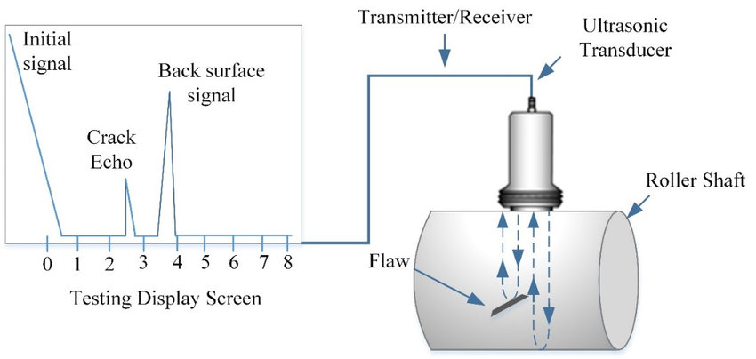
Figure 1 – Simplified UT Test Setup (Jamil, et al., 2019)
The instrument is set up with a calibration block containing a known internal defect, by setting the signal from the known defect to a certain screen height on the instrument by adjusting the amplifier gain. This sets the ‘reporting level’, above which all signals are recorded as flaws and below which signals are ignored (Charlesworth & Temple, 2001). Typically some sort of couplant medium is used to transfer the UT signal from the probe to the inspection surface, as air has a low acoustic velocity and causes impedance of the signal. This couplant medium could take the form of a gel or oil, applied between the probe and the inspection surface – in the case of this project, it is applied to the base of the probe mounting wedge.
While this single-crystal technique is reliable at detecting defects, it also requires a large amount of operator skill due or system setup to be confident in the results. This is because keeping the probe perpendicular to the surface is vital for accurate readings, as a poorly angled probe could lead to artificially increased path length or a complete loss of signal. This means that the geometry of a weld is not conducive to normalised single-crystal inspection, as the undulating surface of a weld makes vertically normalising a probe extremely difficult (Kenny, The Basics of ToFD Inspection, 2019). This is compounded by the fact that weld root erosion is typically found directly below the weld cap, so direct inspection using vertical UT is impossible without removing the weld cap (Eddyfi Technologies, 2018). This is where angled techniques such as ToFD and PAUT are useful, as they can inspect the integrity of a weld whilst riding on the smooth surface adjacent to the weld.

Time of Flight Diffraction (ToFD)
A ToFD inspection relies on using a pair of UT transducers mounted in angled wedges, in a pitch-catch configuration – this means one transducer is responsible for firing the ultrasonic beam, while the other detects the refracted signal. The beam has a natural spread, defined by the limits of the ‘lateral wave’ and the ‘back-wall echo’ (BWE); the lateral wave is the shortest distance between the probes, typically along the surface of the material, while the BWE is the signal refracted from the far surface of the material. This gives a useful delimited zone within which to detect defects (Charlesworth & Temple, 2001).
During the inspection, the probes are placed either side of the weld and exploit the beam spread to cover as much of the weld height as possible. Should a defect be present, the beam will come in to contact with it and diffracted energy will be scattered – measuring the time of flight of these diffracted beams allows the defect to be accurately sized and located (Olympus IMS, 2014). The operator must set the probes at a certain distance apart, known as the Probe Centre Separation (PCS) to balance area coverage with signal degradation. This PCS and the overall scan setup are dictated by various factors, including but not limited to (Ginzel, 2013):
- The material to be tested
- The geometry of the asset
- The instrumentation available (single or multi-channel)
- Probe availability (size, frequency, wedge angle)
- Detection requirements (the minimum reporting level)
- Sizing requirements
- Inspection speed and accuracy
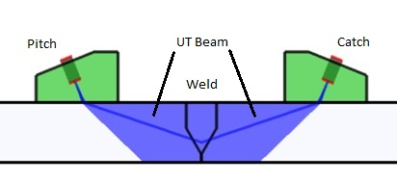
Figure 2 – Basic ToFD Setup (Olympus IMS, 2014)
Where possible, a single pair of transducers will be utilised to reduce setup time and signal processing complication. However, when inspecting a thicker surface (>~50mm), one pair of probes cannot be relied upon to accurately cover the entire height of the weld. Should this be the case, multiple pairs can be used at different spacings in order to focus on different sections of the weld from root to cap.
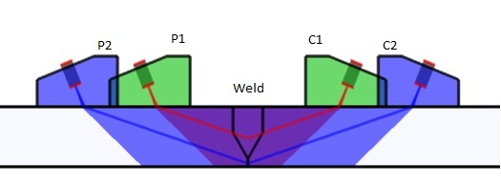
Figure 3 – Multi-Probe ToFD Setup (Olympus IMS, 2014)
As with conventional UT, the probe frequency and element size required are also dictated by material properties and thickness, as well as the angle of the mounting wedge used. While there are no perfect rules to cover all inspection scenarios, there are general settings that can be used as a base setup. An example of a recommended setup guide can be seen in the table below (Ginzel, 2013):

Table 1 – Recommended ToFD Setups
Material Thickness (mm) | No. Probe Pairs | Probe Frequency (MHz) | Wedge Angle (degrees) | Element Size (mm)
6-10 | 1 | 15 | 70 | 2-3
10-15 | 1 | 15-10 | 70 | 2-3
15-35 | 1 | 10-5 | 70-60 | 2-6
35-50 | 1 | 5-3 | 70-60 | 3-6
50-100 | 2 | 5-3 | 70-45 | 3-12
100-200 | 3 | 5-3 | 70-45 | 3-20
200-300 | 4 | 3-1 | 70-40 | 3-20

The ability to hold multiple pairs of ToFD probes is a key advantage to any UT weld scanner, as doing so increases the range of assets that can be effectively scanned. This requirement led to the specification of a minimum probe capacity of 2 pairs for the scanner project.

Phased Array Ultrasonic Testing (PAUT)
Phased Array Ultrasonic Testing works on similar principles to that of standard UT; a sonic pulse is fired in to the target material, and by measuring the time taken for the sound wave to reflect back to the transducer the thickness of the material – or any internal defects – can be found. However, PAUT relies on using a number of single-point UT probes (‘elements’) banded together in to a linear array and firing these probes at different time intervals to create an interfering wave pattern. Typically a PAUT probe has between 16 and 128 elements, with some having as many as 256 (Oceaneering International, 2018).
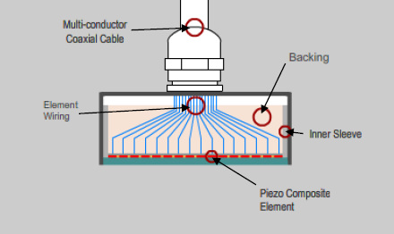
Figure 4 – Linear Array Probe Cross-Section (Oceaneering International, 2018)
The science of this can be traced back to physicist Edward Young, with his 1801 Double-Slit Experiment, in which he demonstrated that waves that combine in phase reinforce each other, while waves that interfere out of phase will cancel each other out (Oceaneering International, 2018).
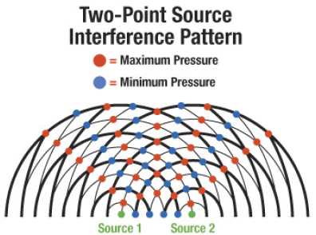
Figure 5 – Wave Interference Patterns (Oceaneering International, 2018)
By controlling the firing order of these waves (‘phase shifting’), the waves can be bent, steered or focused. A linear array uses this to create a single wave front that is pulsed in to the material, and the reflection of this wave can be detected by all the probe elements and combined in to a single visual representation (Oceaneering International, 2018). This allows for uninterrupted coverage of an area, rather than relying on single-point inspection from traditional UT probes. In terms weld inspection the wave is pulsed into the weld, reflected from the internal wave geometry and detected by the array. This means that unlike ToFD probes, a single PAUT probe can be used to inspect a weld should the conditions limit the ability to use two in a pair – the operator would then simply place the scanner on the other side of the weld and repeat the scan to inspect the other side of the weld (Lewis, 2020). Additionally, because the wave front can be steered by phase shifting (known as ‘sectorial scanning’), PAUT can be used to scan the weld from multiple angles whilst using the same probe and angle wedge setup (Oceaneering International, 2018); Figure 6 below shows the linear scan on the left, and the combined sectorial scan on the right – note the 49° angle of beam achievable with a steered wave front.
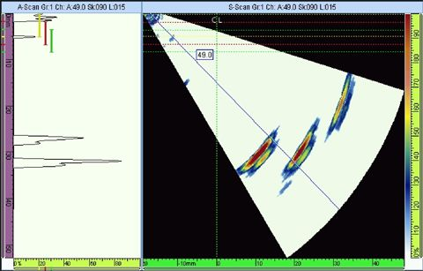
Figure 6 - PAUT Sectorial Scan (Olympus IMS, 2020)

Competitor Analysis
One of the reasons for this project stemmed from Eddyfi Technologies’ acquisition of instrument manufacturer M2M. M2M produce a line of instruments capable of processing ToFD inspection data, and as such were reselling ToFD-capable scanners from other manufacturers – as a manufacturer of scanning systems, this was obviously not welcomed by the Eddyfi group. This section contains the critical analysis of the most popular scanners currently on the marketed, and which aspects of them would look to be improved by the Connex project. The following criteria are what were deemed to be the most important in the success of a new system:
- Cost – an obvious consideration, but any product must be able to justify its price tag. There are existing systems in a wide price range so the Connex did not have a specific price target, but any increases over competitor pricing must come with significant functionality improvements.
- Maximum number of mountable probes – this is the number of probes that can be mounted simultaneously during a single scan. The ability to mount multiple probes is key for larger welds as a single ToFD pair cannot necessarily cover the weld from root to cap.
- Probe compatibility – many inspection teams use both ToFD and PAUT during a weld inspection as the differing techniques provide validation for each other’s results. Being able to mount both types of probe provides a functionality improvement for the scanner.
- Encoder – an encoded scan allows the operator to set a datum on the inspection surface, perform a scan and then have a record of the location of any discovered defects. This data can be used by the operator to go back and prove-up the results with a complementary technique or given to repair teams in order to be able to know the areas requiring patch repair.
- Elbow scanning capability – almost every pipeline has bend sections, and these sections also require weld inspection. However, with a scanner that has tractors fixed at both ends these sections are very hard to scan as the intrados and extrados shift the point of reference for the toolposts, potentially lifting the probe from the surface. To negate this problem, scanners can be figured for what is known as ‘cantilever scanning’, where the tractors are placed at one end of the bridge while the toolposts are placed at the other. This allows the scanner to use the straight pipe section as the surface reference for stable movement, while the probe pair is placed either side of the weld.
- Pipe diameter range – this is the size of pipeline that can be inspected by a scanner. All dimensions given in this section refer to the circumferential scanning ability, as longitudinal scanning will not be considered until a later drop for the Connex system.
- Magnetic adhesion – the scanner is primarily intended for use on ferrous materials, so magnets will be used to adhere the system to the surface. These magnets should be strong enough to safely support the weight of the scanner and associated cabling, but not so strong as to pose risk when deploying or removing the system.
- Stable tracking – as both ToFD and PAUT both rely on a probe system a set distance from the target weld, the ability to track straight as the system moves around the pipe is key. Any deviation from poor stability has the chance to distort data capture.
- Braking system – denotes whether or not the system has the ability to hold itself in position on an inspection surface. This has been deemed key as it greatly aids the operator in setup if they can make probe adjustments on the inspection surface without having to support the scanner. Additionally, it is a benefit to any operator using rope access to inspect a surface, as they can fix the scanner in position while adjusting their rope harness.
The following sections asses the advantages and disadvantages of each scanner, as well as which aspects were used as influences for the Connex scanner design. All specifications were collected from Mugford & Kenny in the MRD (Mugford & Kenny, 2020), and opinions on performance from inspection engineer Lewis in a system review interview (Lewis, 2020).

Jireh STIX
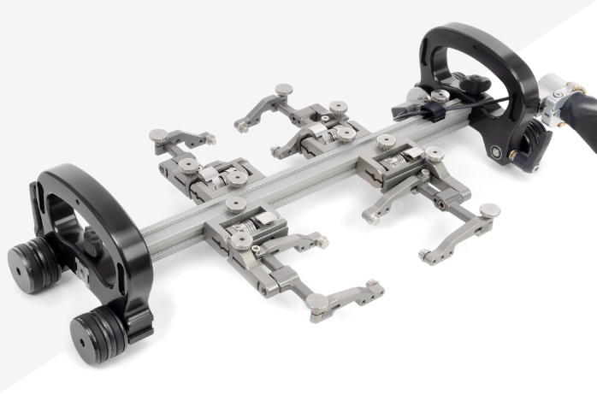
Figure 7 – Jireh STIX (Jireh , 2020)

Key points:
- Cost – 5392 EU
- Max no. probes – 4
- Probe compatibility – ToFD and PAUT
- Encoder – external clip-on
- Elbow scanning capability – yes
- Pipe diameter range – 4” to flat
- Braking system – yes, lever actuated, both tractors
The Jireh system is the primary competitor to the Connex system as it was the top seller from M2M prior to the start of the Connex project. It is regarded as the current benchmark for manual weld inspection scanners; because of this, the specifications for the system had to either be met or surpassed in the Connex design.

Advantages:
- Quick release toolposts – the ability to swiftly attach, remove and adjust toolposts is a benefit in the field when switching between pipes or techniques. Spare toolposts can be purchased and set up with different probes to reduce time spent switching setups during an inspection.
- Stackable magnet wheels – if magnetism needs to be increased or reduced due to material thickness or coating then additional wheels can be stacked on to the existing units.
- Universal probe arms – the adjustable width allows different size wedges to be used without having to provide custom arm sets. Switchable mounting lugs allows for use with wedges from multiple manufacturers.
- Lightweight package – the simplicity of the system allows for a lightweight overall package.
- Easily replaceable encoder – encoders are prone to failure in the field, so having an easily switchable unit allows inspection teams to carry a spare should issues arise in the field.

Disadvantages:
- Single bridge – while the single bridge beam reduces weight and complexity, it reduces the torsional stiffness of the system. Due to the hazardous operational environments and general lack of care from operators, system robustness is key to the longevity and reputation of the system.
- Short wheelbase – the reduced distance between wheel centres means that when deployed on larger diameter pipes (>12”) the system has a tendency to skew on the scan path.
- Small wheels – on extruded pipe this has no real impact, however on seam-welded pipes the system has a reduced ability to ride over larger weld caps.
- External encoder – an easily replaceable encoder is a benefit due to the fragile nature of encoders, however having the encoder mounted externally increases the chance of damage due to impact, snagging etc.
- Lack of ergonomics – while the handles are useful, they are rather small and made from aluminium. This means they can be hard to use with gloved hands, and uncomfortable in very hot, cold or wet environments.
- Limited probe mounting – by only having a single bridge piece, a maximum of 4 probes can be mounted at once. While this is enough for basic ToFD inspection, on larger welds it is not possible to run a twin-pair ToFD setup simultaneously with a PAUT probe pair.

Design Influences for Connex:
- Gimballed probe holders – by having self-normalising probe holders, the setup time for the operator is reduced. This also reduces the risk of a failed scan should an obstacle be hit during the run.
- Quick-release probe holders – this allows for easier setup, as toolposts can be configured when detached from the main scanner and then easily reattached when needed.
- Twin brake system – by being able to apply brakes to both tractors, the risk of one side slipping and pulling the scanner from the surface is reduced.
- Cantilever scanning ability – being able to position the probe holders outside the tractors, greater access to pipe elbows is achieved.

AUT Solutions WeldScan
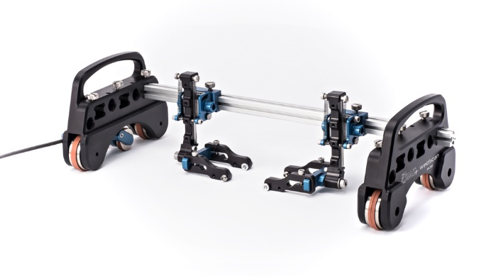
Figure 8 – AUT Solution WeldScan (AUT Solutions, 2020)

Key points:
- Cost – ~5000 EU (exact cost unknown as AUT declined to quote to Eddyfi)
- Max no. probes – 4
- Probe compatibility – ToFD and PAUT
- Encoder – external clip-on
- Elbow scanning capability – yes
- Pipe diameter range – 6” to flat
- Braking system – no
Recently released on to the market, the WeldScan is very similar to the Jireh unit but with some key changes to improve functionality.

Advantages:
- Quick release toolposts – as with the Jireh system, the ability to easily remove and attach toolposts provides benefit to operators.
- Universal probe mounting arms – the ability to mount probes from an array of manufacturers increases the potential customer base, as many inspection teams will already have ToFD and PAUT probe sets.
- Easily replaceable encoder – with encoders prone to damage, it is always useful to be able to replace them quickly in the field if needed.
- Larger wheelbase compared to Jireh systems – this increased wheelbase provides more stability on pipe surfaces and decreases scanner drift during scans.
- Adjustable bridge locations – the bridge section can be removed and replaced in different positions on the tractor. This allows for a reduction in dead zone if scanning up to an obstacle, as the probes can be positioned to be the furthest forward point of the system.
- Interchangeable bridges – multiple types of bridge are offered, allowing the system to be configured for multiple applications such as longitudinal scanning.

Disadvantages:
- Single bridge – as with the Jireh system, the single bridge results in a lack of torsional stiffness for the system. This is compounded when using the system configured with the bridge at either the front or rear, as the moment created by the handles is increased.
- External encoder – similar to the Jireh system, an external encoder is more likely to be damaged as a result of impact.
- Limited probe mounting – the system is limited to a 4 probe setup maximum, reducing the scan efficiency on larger welds.

Design Influences for Connex:
- Configurable bridges – by having removable bridges the application variety of the system is increased. This will help future drops of the Connex scanner as different bridge configurations could be supplied to customers, expanding the system scope without the customer having to pay for expensive replacement tractors or electronics.
- Reduced dead zone – for pipe racks with little distance between pipes, this reduced dead zone configuration allows the user to scan a greater section of the pipe before hitting an obstacle.

Phoenix ISL Swift
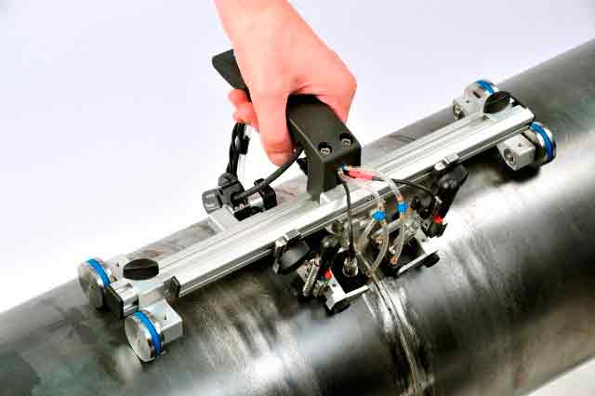
Figure 9 – Phoenix ISL Swift (Phoenix ISL, 2020)

Key points:
- Cost – £2800+VAT
- Max no. probes – 2
- Probe compatibility – ToFD and PAUT
- Encoder – external clip-on
- Elbow scanning capability – yes
- Pipe diameter range – 3” to flat
- Braking system – yes, thumb lock, single side
Marketed as a compact, low-profile scanner, the focus of the Swift is low-diameter pipes and simple single-pair inspection in limited-access areas.

Advantages:
- Pipe diameter range – by being to be deployed on pipes down to 3” O/D, the Swift has a greater diameter range than any of the competitors.
- Scanner height – by keeping the overall height of the system low, it is able to scan pipes housed in tight pipe racking.
- Ergonomic handle – the simple plastic handle provides a comfortable interaction point for the user.

Disadvantages:
- Lack of stability – by having a wheelbase and wheel size able to reach 3” pipes, the stability of the system during scans is compromised. The system has a tendency to drift off-line on pipes with smoother surfaces or coatings.
- Lack of magnetism – the small wheel design results in low-power magnets housed inside. When coupled with the off-centre handle, the system is prone to being lifted off the surface by the operator during scanning.
- Single-pair probe mounting – by only being able to mount a single pair of probes at once, the operator is forced to perform multiple replicas of scans with the probes set to different widths in order to scan the entire height of a large weld.

Design Influences for Connex:
- Polymer handle – by using polymer for the handle a more ergonomic shape is achievable, whilst reducing operator discomfort in extreme hot and cold environments.
By analysing the advantages and disadvantages of competitor systems, a product specification list could be generated that would result in a more versatile, stable and operator-friendly final product.

Product Specifications
From the market research completed and input from experienced inspection engineers a list of product requirements was assembled. This list would be used to dictate and review the design work of the Connex scanner and is a combination of requirements taken from the company PRD and the designer’s own personal ideas. It should be noted however, that some of these requirements were not discovered or added until after the initial prototype had been tested – these will be denoted as such:

Operating Requirements
- Scanning capability – the system must be able to perform a circumferential scan on pipes ranging from 4” O/D to flat.
- Temperature – scanner must be able to operate in environments ranging from -20°C to +60°C ambient.
- Weather resistance – system must be IP64 rated minimum, with special consideration for saltwater resistance due to marine applications.
- Ability to cope with seam welds – scanner will be regularly deployed on seam-welded pipe, so must be able to ride over a weld caps up to a maximum height of 5mm.
- Ability to scan elbows – scanner must be able to perform cantilever scans on pipe elbows from 4” Short Radius up.

Mechanical Requirements
- Maximum weight – scanner should target a maximum weight of 4Kg, with a total packed system weight of 10Kg.
- Minimum radial clearance – this is the height from the inspection surface to the furthest extent of the scanner when placed on a 4” pipe. It should not exceed 10.5cm.
- Swappable bridges – the bridge assembly must be able to be removed and replaced in the field with minimal tools. This requirement did not apply until after the Alpha Prototype.
- Braking – system must be able to support its own weight while at the 3 o’clock position on a pipe with 2mm of non-ferrous coating.
- Ergonomic handles – polymer handles must be present to allow for comfortable scanner operation and carrying.
- Tether points – some form of tethering loop must be present in order to secure system to operator or tie-off point. This requirement did not apply until after the Alpha Prototype.

Probe Requirements
- Maximum capacity – the Connex must be able to mount 6 probes simultaneously, of any type. This requirement did not apply until after the Alpha Prototype.
- Wedge compatibility – system must be able to mount the following wedges:
  - ToFD:
    - Phoenix standard ToFD wedge series
    - EkoScan standard ToFD wedge series
    - Olympus standard ToFD wedge series
  - PAUT:
    - Phoenix/EkoScan:
      - EKPIPE 55Deg
    - Olympus:
      - SA1-N60S A1
      - SA2-N55S A2
      - SA10-N55S A10
      - SA12-N55S A12
      - SA32-N55S A32
      - SPWZ1-N55S
      - SPWZ3-N55S
- Quick release – all probes must be able to be removed or attached without the use of tools.
- Pivot buttons – interchangeable pivot buttons must be provided to allow for mounting of different manufacturer’s wedges. This requirement did not apply until after the Alpha Prototype.
- Max probe separation – system must be able to achieve a maximum probe separation of 200mm for ToFD wedges and 120mm for largest PAUT wedges. This requirement did not apply until after the Alpha Prototype – the original specification was for 60mm of separation on one set of ToFD probes.

Electrical Requirements
- Multifunction button – button must be present in order to operate start/stop function. Will be used in further drops as indexing button for corrosion mapping configuration.
- Encoder – utilise 1024Pulse Per Revolution, IP64-rated encoder. This pulse rate was chosen as with a 50mm diameter wheel it allows for a signal every 0.15mm.
- Electronic output – use standard Fischer push/pull connector as output for button and encoder.

Umbilical Requirements
- Removable sleeving – sleeving must be provided that can be removed and reattached by user depending on required configuration.
- Contents – umbilical must be able to house the following:
  - Encoder cable
  - Irrigation hose – 8mm O/D PVC hose for irrigated probe wedge water supply
  - Up to 6x standard UT cable
  - Up to 6x standard PAUT cable
- Strain relief – some form of strain relief must be present to allow sleeving to attach to scanner, reducing tension on internal components/connectors.

Accessory/Transit Case Requirements
- Case – use Nanuk case to keep in line with existing product line.
- Keep plate – case must contain mild steel keep plate in order to pass magnetic shipping regulations. No magnetic field must be able to be detected once system is fully packed.
- Foam lining – custom foam lining as provided by Nanuk. Must display the scanner in a professional manner and be able to house the following:
  - Connex Scanner
  - System-specific documentation
  - Umbilical cable – 5m as standard, capable of 15m
  - Tool posts – 4 as standard, with capacity for 6
  - Pneumatic fittings – a range of fittings will be supplied in order to link umbilical hose to customer irrigation hoses.

Cost
- Selling price should aim for approximately £5000 to keep in line with competitors – this is not fixed, but any increases over competition should come with significant functionality increases to offset the additional cost.
- Standard Eddyfi product margins aim to be approximately 60% - this means in order to sell for £5000, the maximum total system build cost should not exceed £2000. As previously stated however, this price could be permitted to rise if additional functionality results.

Timing Plan
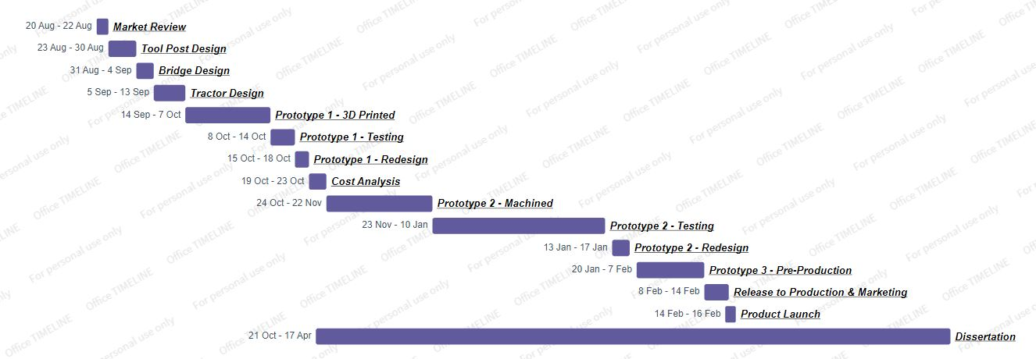
Figure 10 – Original Timing Plan (Larger version available in Appendix 1)
The project timing plan is broken into the following segments, with time estimations based on previous project experience and fabrication lead times:
- Market Review; 20/08/19 – 22/08/19; this is the investigation into existing products that our product would be competing against. This includes analysing the cost and capability of the main competitors and finding the improvements that would most increase value to the end user.
- Tool Post Design; 23/08/19 – 30/08/19; the first phase of development is to design the assembly that will hold the ToFD probes. Because we will not be supplying the probes or angle wedges ourselves, the tool post has to be compatible with customers’ existing probes – the most commonly used among our existing customer base are those produced by Phoenix ISL, so these are the models that will be designed for.
- Bridge Design; 31/08/19 – 04/09/19; design time to develop the bridge system that the tool posts will mount to. This will allow the tool posts to be positioned at different points along the bridge to add positioning freedom for the operator.
- Tractor Design; 05/09/19 – 13/09/19; design of the wheeled tractors that will carry the bridge and tool posts. Must include magnetic wheels to allow the scanner to adhere itself to an inspection surface, and a mechanism that allows for ‘offset’ scanning to accommodate pipe bend section weld scanning. Must also include some form of encoder mechanism to allow for corrosion mapping.
- Prototype 1 – 3D Printed; 14/09/19 – 07/10/19; using in-house 3D printing to produce a space model that can be used to confirm assembly fitments and ergonomic design.
- Prototype 1 – Testing; 08/10/19 – 14/10/19; testing of the initial printed prototype. This will focus on wheel magnet strength testing, deployment on lower limit diameter pipes, probe mounting and potentially capturing signal data.
- Prototype 1 – Redesign; 15/10/19 – 18/10/19; making any required changes from the testing of Prototype 1.
- Cost Analysis; 19/10/19 – 23/10/19; gathering supplier quotes for machined parts and prices for purchased components to produce a cost analysis spreadsheet. This should provide price estimates for both further prototypes and final production builds and comparing these to the budget restraints.
- Prototype 2 – Machined; 24/10/19 – 22/11/19; time allocated to ordering and receiving machined parts. 4 weeks lead time is planned for as this is standard for low-volume machined parts based upon previous supplier experience.
- Prototype 2 – Testing; 23/11/19 – 10/01/20; beta testing phase. Machined fits and tolerances to be tested for proper function, as well as aesthetic review. Three units to be produced, one allocated to Development for in-house testing and two to external beta testers for field testing.
- Prototype 2 – Redesign; 13/01/20 – 17/01/20; Making any design changes based upon beta tester feedback.
- Prototype 3 – Pre-production; 20/01/20 – 07/02/20; Production and assembly of final pre-production prototype. This is used to prep the Production team for the product, including assembly tutorials, fabricating any necessary jigs and finalising the General Assembly Drawing Packs for transfer.
- Release to Production and Marketing; 08/02/20 – 14/02/20; transferring all necessary files to Production, and working with marketing to produce final marketing pack, press release and advertising images.
- Product Launch; 14/02/20; product now available to the public and Sales teams able to take orders with confirmed lead times.
Generally, the timing plan laid out at the start of the project was well adhered to. The final prototype stage ran slightly longer than expected however, and this caused the end of design cycle to be heavily impacted by the Covid-19 crisis. While design work could continue through remote-access means, any physical testing for the product had to be put on hold while social-distancing was enforced and the Eddyfi UK premises was shut down to all non-essential activities. Additionally, manufacturing subcontractors were unable to provide some parts necessary for a complete final prototype. As a result, final testing, the release to Production and the final launch have been postponed until government restrictions are lifted. With such a significant number of changes from the Alpha prototype, it was deemed too large a risk by Eddyfi management to move forwards with the planned production release without extensive field testing, so the product release date was also pushed to a minimum of Q3 2020. However, the global crisis has impacted the sales of all competitor products equally due to test sites restricting all access to visitors, including NDT testing teams – while this is obviously a negative for Eddyfi as a company, it does mean that Eddyfi are not losing market share for ToFD/PAUT-capable manual scanners in this period, so work can continue on future accessories and improvements to bolster the capabilities of the system once a full system release is feasible.

Design and Testing

Feasibility Study & Initial Concept

Design
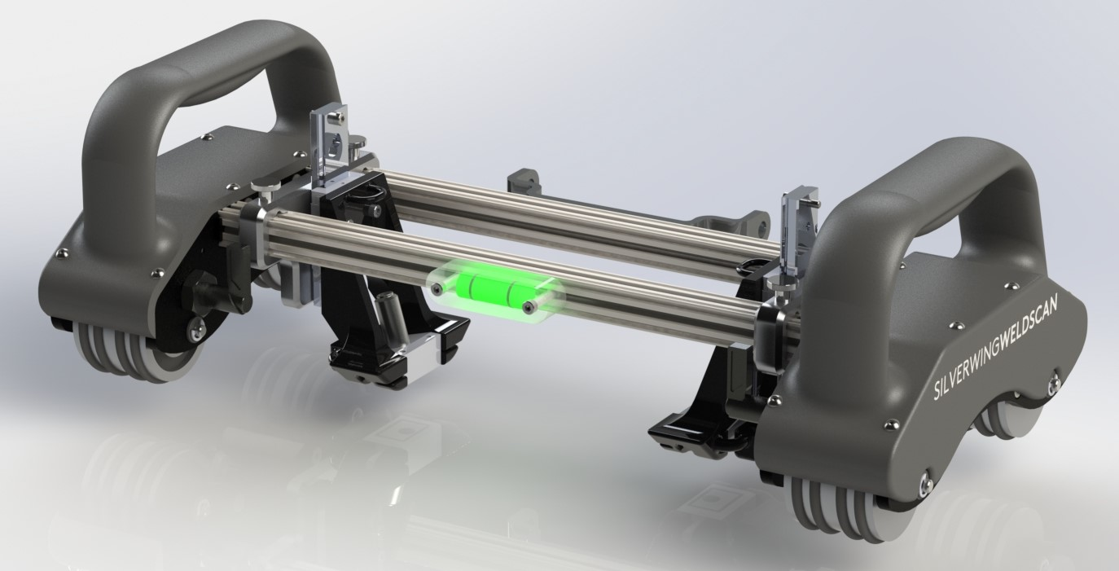
Figure 11 - Connex Initial Concept Model
This stage of the design occurred prior to any market research and product requirement definition, and so was based solely around the core idea of producing an encoded ToFD scanner for 4”+ ferrous pipework. At this stage very little physical prototyping occurred, as the purpose of the task was to produce a CAD model that could be reviewed by the applications specialist before any monetary investment occurred. This stage was used to identify the key subassemblies of the product that would be required, and they were broken down as the following:
- Wheel assembly – the primary surface contact point of the scanner, the wheels were designed around a type of neodymium ring magnet currently stocked by Eddyfi UK. These magnets were known to provide a good strength to weight ratio as they had been used on a previous manual scanner, and by using magnets already stocked the manufacturing cost could be reduced over purchasing a new magnet. The team were also keen to reduce any side-to-side slip during operation, so a nitrile O-ring was chosen for the tyre as it would provide good grip when under compression and was easily available for minimal cost compared to a custom overmould. Nitrile also has good resistance to oils and solvents, which would be a benefit when operating in the hazardous environments intended for the scanner. A 2-piece aluminium hub would hold both the magnets and O-rings together and provide a complete casing to protect the magnets from rust damage. This hub was designed to house up to 5 ring magnets at a time, as from prior experience it was known that dialling in the required number of magnets for a system is incredibly difficult without real-world testing, so this extra space would be prudent to design in from the start. The two halves would then be pinned together through simple dowel pins to act as a single unit when rotating.
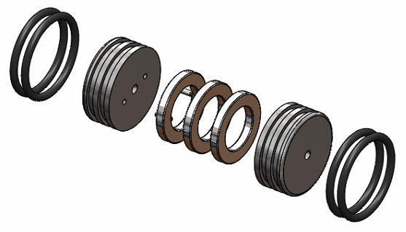
Figure 12 – Wheel Concept Design (Exploded View)
- Bridge – after an initial look at similar existing scanners, it was decided that a single-bridge design would not offer the ruggedness that Eddyfi UK strive for in design. Additionally, by situating the probes between two rails and directly down the centreline of the tractor wheelbase the probes would not need to be gimballed as they would be permanently perpendicular to the inspection surface. This would remove complexity from the toolposts, saving cost and increasing durability. It just so happened that shortly prior to the inception of this project that the company had been sent a sample kit of extruded bridge pieces from MakerBeam, and being impressed with the quality and finish of these parts it was decided they would be used for the bridge assembly on the Connex. For the initial concept 300mm bridge sections were chosen, as these were the longest available in the kit and could offer up to 65mm of probe separation when the toolposts were mounted.
- Encoder – as only a simple 1-axis encoder was required, the basic encoder assembly used on a number of existing products was used to save on purchasing costs. This assembly consists of a 5-24V, 1024 pulse-per-revolution encoder, a single push-button for start/stop functionality and a Fischer push-pull output connector. This would be mounted to a simple bent steel plate, and the encoder would be directly driven from one of the wheels – while this drive system has the potential for damaging the encoder through impact to the wheel, the relatively low magnet strength of these wheels meant that this was deemed a low risk, and a fixed direct drive has been found to be more reliable than a spring-loaded encoder on previous scanners due to the lack of slip between the scanner wheel and the encoder wheel.
- Tractors – these would be the subassemblies that would house the magnet wheels and encoder, as well as link the bridge section. Because the deployment specification was already known (4”+ pipe), the wheelbase could be designed to allow for this to provide suitable clearance for the scanner bridge. The side plates would be machined from aluminium for strength and the ability to place mounting threads, while a simple 3D-printed plastic cover was added to the lower portion to hide the internal electronics. Press-fit dry bearings where chosen to mount the wheel axles as they do not have the potential for rust or seizure compared to deep-groove ball bearings, and due to the low speeds involved and the fact the wheels were not fixed to the axles, the higher speed rating of ball bearings was deemed unnecessary. The whole assembly was then held together with 4 simple threaded steel pins, chosen for their strength and low cost. The final requirement was for a braking mechanism, and this was achieved by mounting lever-operated spring plungers to the front end of the inner side plates of each tractor. When engaged, a steel pin extends from the housing and slots into receiver cuts in the wheel hub, preventing the wheel from turning and so holding the system in place. The lever can then be rotated 180° to withdraw the pin and the system will travel as normal. The reason that lever-throw plungers were chosen is that they are easily operable with gloved hands, provide a positive lock in either position and can be operated while the user has their hands on the handles – this allows the brakes to be engaged or disengaged whilst the operator properly supports the weight of the system, reducing the likelihood of dropping the system whilst operating the brakes.
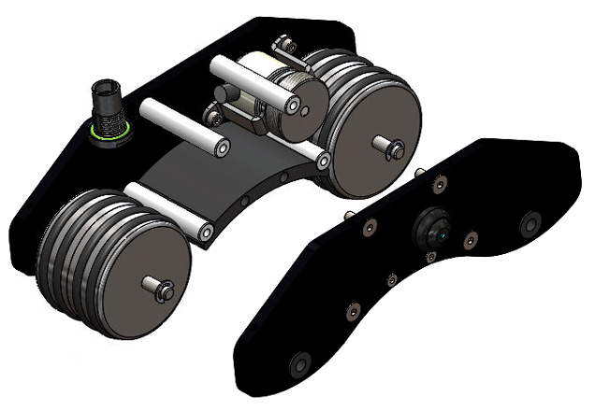
Dry Bearings
Support Pins
Figure 13 - Tractor Concept Design (Exploded View)
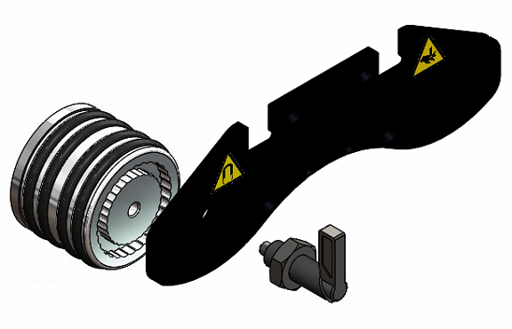
180°-throw Brake Lever
Figure 14 - Brake Lever Mechanism (Exploded View)
- Toolposts – at the time of initial design, only one type of ToFD probe and wedge was considered for the unit. This meant that a single-piece probe holder could be designed, with a tool-less snap-in feature that would allow for simple insertion and removal of the probe assembly. By producing this part in a fibreglass-reinforced nylon via 3D printing, the part could be designed to have enough flex to allow for the tool-less operation, whilst remaining stiff enough to be stable during operation. A magnet carrier was also built into the probe holder, as this would allow the probe to be kept secured to the surface without the need for unsightly springs. A modified version of an existing linear rail and carriage was used to give the probe holder linear movement, which was an advantage as while offering very smooth motion, these parts are relatively expensive and buying in bulk with another system would reduce purchasing costs. The required length of travel for the probe holder to sit on both 4” pipe and flat plate was 21mm, so the existing rails could be cut to length and used. All of this would then be bolted to a 2-part aluminium T-piece that would provide mounting to the twin rails of the bridge. By having this part as a 2-piece design the toolposts could be easily removed from the bridge without having to remove one of the tractors and sliding the whole assembly off the end of the rails. Position locking along the bridge would be achieved by a simple thumbscrew clamping mechanism on the top section of the two-part aluminium frame.
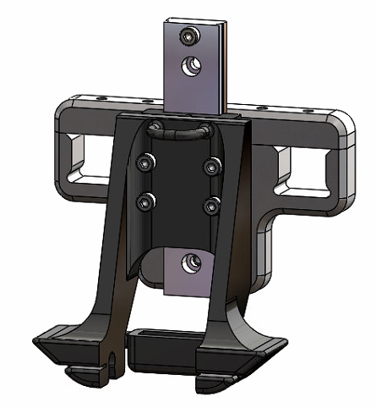
Magnet Holder
Probe Holder
Linear Rail
Figure 15 – Toolpost Assembly Concept Design
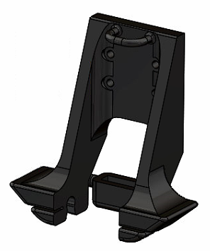
Figure 16 - Probe Holder Concept Design
- Handle – as a manually operated scanner, the handles would play a large role in an operator’s satisfaction with the system. An uncomfortable, unergonomic system would be resented by an operator having to use it for extended periods no matter the scan quality, so ensuring a quality handle design was paramount. Due to these factors it was decided that a polymer material would be best, as this could be produced in a comfortable shape by either moulding or additive manufacturing. Additionally, the material would not be uncomfortable to use in either very hot or very cold climates. The handle must be able to be comfortably gripped using a gloved hand, so this dictated the overall size of the handle section, while the base must cover the top of the tractor. The left hand handle would require an outlet for the encoder assembly connector, meaning that each handle would have to be a distinct part, but additional setup costs could be avoided if additive manufacturing was utilised.
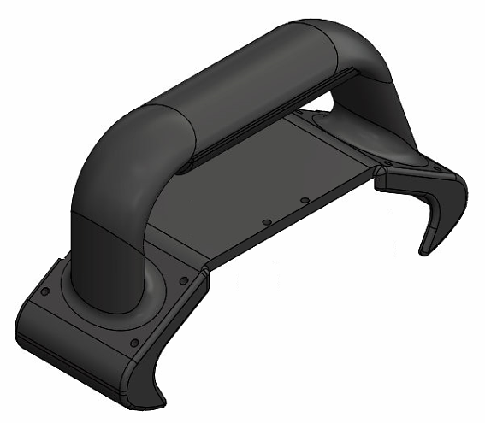
Figure 17 - Handle Concept Design
- Elbow scanner – in the initial design the cantilever elbow-scanning capability was provided by a separate assembly, consisting of a simplified replica of the main bridge that attached to the side of the right hand tractor. This assembly would come with its own pair of toolposts, so the main scanner would not have to be disassembled in order to perform an elbow inspection. Attachment would be performed via a quick-release system consisting of a set of shoulder bolts acting as locating lugs and a captive thumbscrew to lock the subassembly in place.
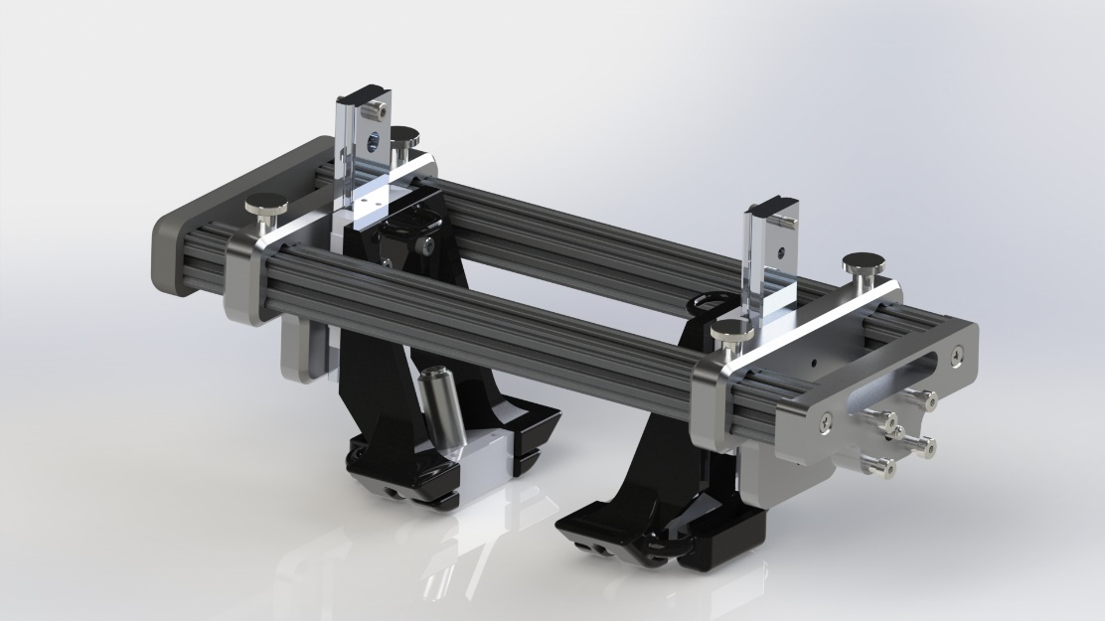
Figure 18 - Elbow Scanning Attachment Concept Design
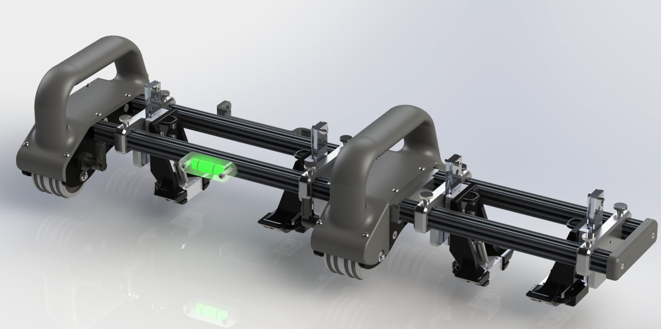
Figure 19 - Elbow Scanning Configuration Concept Design

Feedback
This concept design was presented to the General Manager of Eddyfi UK, Stuart Kenny. As the GM of the company he takes a direct interest in all product design, but he also has a wealth of experience in the operation of ToFD scanning systems from his time as an NDT Technician at Oceaneering International, so his input was invaluable.
Generally, the feedback was positive; the polymer handles, tool-less probe insertion, twin-beam bridge and general tractor design were well received, while the separate secondary elbow scanning bridge assembly was not. This additional assembly was deemed too bulky and inefficient, and this feedback led to the positional tractor system in future designs. The toolpost locking thumbscrews were deemed too awkward to operate when wearing gloves, so in future designs these would be substituted for lever-action cam locks.

Prototype Alpha

Design
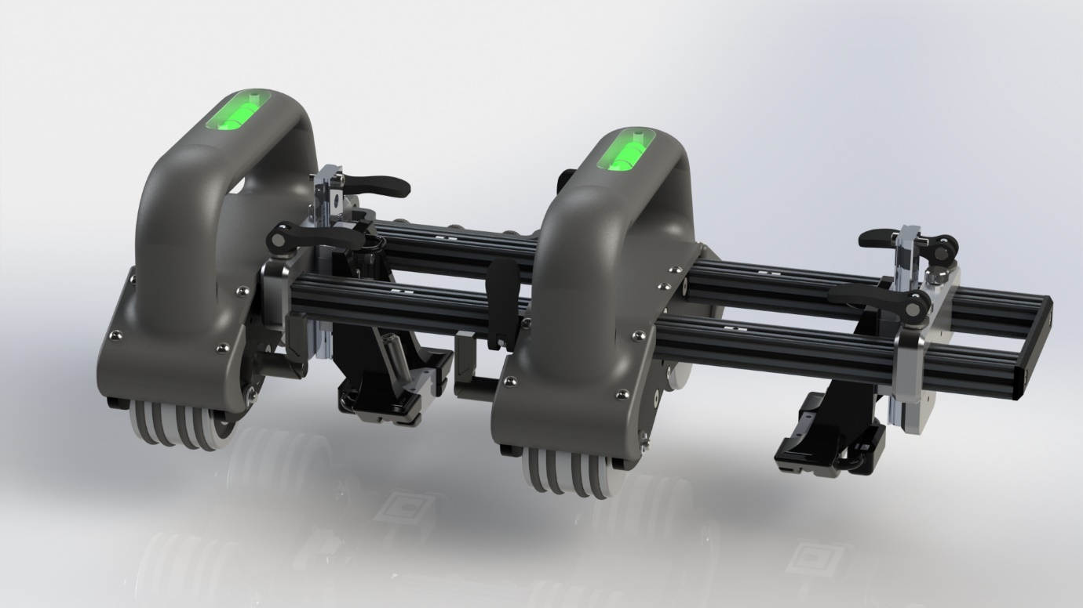
Figure 20 - Prototype Alpha Design
The design that was taken to first stage physical prototyping featured a number of key changes from the initial concept model:
- Pass-through tractor design – after the separate cantilever elbow scanning assembly was rejected, a new mechanism was required. It was replaced by making the non-electronics tractor capable of being repositioned along the main bridge assembly and locked in place using a pair of cam locks. The toolposts could now be positioned as required for elbow scanning, whilst reducing the number of total required parts for both the manufacturer and operator.
- Increased bridge length – with the changes to the cantilever scanning design, 52mm of the original bridge length was lost inside the tractor when in conventional setup. Fortunately, a 360mm extrusion was readily available from Makerbeam so the 300mm version was substituted for minimal cost increase and no additional work required to gain correct length bridge pieces.
- Toolpost position locking mechanism – as previously stated, the thumbscrews used for locking the toolposts at a position along the bridge were deemed to be too awkward to properly operate during operation. These were subsequently replaced with lever-operated cam locks, as they provide equally secure clamping force with a simpler operation.
- Integrated spirit levels – added to the handles as a simple aid to the operator, these spirit levels were included to help in positioning the scanner on vertical pipework. As keeping the weld cap to be inspected precisely between the probes is key for ToFD scanning, scanner misalignment and the resulting ‘drift’ during movement is a serious problem. This can be reduced by the spirit levels, as the operator can then more accurately position the scanner parallel to the weld on these vertical pipes.
Once this design had been reviewed and approved, it was then signed off for Alpha Prototyping – this would involve producing a single complete system in the materials intended for the final product.

Cost Analysis
In order to produce the Alpha prototype, quotes from machining subcontractors would have to be requested – this then is also an appropriate time to request quotes for Production-size batches and perform a predicted cost analysis for the final product.
All aluminium parts were sent to five separate suppliers for cost comparison, and these costs were then weighed against the designers previous experience with the supplier – for example, a company may have the cheapest costs, but if they have been known to miss delivery dates or not produce parts correctly to drawings on previous orders then the monetary saving may not be worth it. It is worth noting that each of the five companies generally produce quality work, but the designer definitely has his preferences.
For the polymer handle parts, only one supplier could be quoted from as they are the only supplier that offer the required process in Eddyfi UK supplier list. This process is known as Multi Jet Fusion (MJF) printing, and offers the best combination of uniformity, surface finish, mechanical properties and price for customer interaction parts such as handles. While filament-based techniques can offer improved strengths, the tendency for this technique to have non-uniform areas of visible layering on curved sections of a part reduce the aesthetic and interactive appeal. MJF works by sintering a powder together to produce the desired parts, so while the surface finish is not as smooth as the smooth areas of filament methods, it is completely uniform around curved areas of a part. This means a more professional look overall, and the slightly textured surface finish actually aids grip in parts such as handles.
For the probe holder parts of the toolposts, these would be printed in-house. This was because the production department of Eddyfi UK has 3D printer capable of producing parts in a chopped-carbon filled PA12 nylon, suitable for non-interactive production parts. Part costs for these were easy to attain, as the printing software used to generate the print files also gives the part cost based on material usage.
From Appendix 2 it can be seen that there was a large variation in total order costs from the five companies. The supplier chosen was Cwm Engineering, for a number of reasons; first and foremost, they are supremely reliable with a history of delivering quality parts by the initial delivery date given. In a company that holds minimal stock, being able to plan production schedules accurately is key, and reliable lead times are vital to that. Secondly, their quote was not significantly more per system than the cheapest received and given their history of quality this slight increase is easily accepted by management. Lastly, they are happy to co-ordinate any additional finishing work required for parts prior to final delivery – this is a significant benefit, as any part that has to be received from one supplier and sent out for additional work has to be listed on the Enterprise Resource Planning (ERP) system as multiple separate parts for each stage of manufacturing, while multiple jobs must be set up for each stage. This additional complexity in the ordering process is never appreciated by the Production team, so wherever possible the design teams try to choose suppliers that will minimise this.
The analysis in Appendix 1 also allowed for an estimation of the final sales price. Eddyfi UK typically aims for a 60% profit margin on their key products, and by pricing the system at £4995 this can be achieved with a margin of 60.95%. Most importantly however, this means the system can be priced competitively with the Jireh and AUT equivalents, and should the system be able to deliver on its advantages over these competitor systems it will present a very appealing package to customers.

Testing & Feedback
In order to properly assess the capabilities of the scanner, a testing plan was created to cover the key areas. These key areas were as follows:
- Data capture capability – the simple ability for the scanner to provide quality data during an inspection. This would hinge on the scanner’s ability to keep the probes in the correct and stable position throughout a scan; excess vibration, bending of the toolposts or probe separation from the surface would all contribute to a loss of probe signal.
- Magnetic adhesion – the ability for the scanner to support its own weight in a stable position when on a surface. The specification for this surface was a minimum of 6mm steel plate. This area would test both the magnet wheel strength and the capability of the braking system.
- General appeal/ease of use – how comfortable and intuitive, or not, the system is to use for the operator.
These aspects of the system would be assessed by a team of individuals, consisting of the designer, the Product Manager, the General Manager and a current NDT technician. The results were generally favourable, with some failures noted and either rectified or added to the modifications list for the next prototype;
- Data capture capability – when operating on a correctly prepared and lubricated surface, the toolposts worked well. However, when run on a poor-quality surface or without sufficient probe couplant, the increased friction caused excessive vibration to the probe holders that had a negative impact on the signal quality, as can be seen in Appendix 3. However, this had been anticipated and was quickly rectified through the addition of fibreglass support layers into the 3D printed parts – this resulted in an increase to the part cost, hence the trial without the support layers, but it did resolve the issue by adding additional stiffness to the arms of the probe holder. The toolpost bodies held themselves in position well, and the available distance between the probes allowed for a large range of welds to be inspected – up to 25mm in width. This is important as weld cap width typically increases with material thickness, but also allows for the inspection of rough welds that have not been ground back once in place.
- Magnetic adhesion – with the initial configuration of the magnetic the initial tests were a failure; the system would support itself on surfaces from 8mm thick, but at the minimum 6mm specification the system would slide down the surface when the brakes were applied. It was noted that while still a test fail, the braking performance was increased when the brakes were operating on the rear wheels rather than the front – this is because the mass of the system was then adding to the force between the braked wheel and the surface, increasing the total friction. This led to the decision to move the brakes to the rear wheels for future designs. Additionally, when travelling around a vertical pipe the scanner had a tendency to drift downwards under its own weight, so a decision was made to further increase the magnetic strength through the use of a pole piece in future designs.
- General appeal/ease of use – easily the most successful category, the look and feel of the system was very well received. The stability of the twin-bridge system was much preferred by those experienced with the competitor systems, the brakes were easy to operate and worked well on surfaces where sufficient magnetic force could be achieved, and the switch to the cantilever scanning configuration was simple and effective. A number of potential improvements were noted, such as the addition of tether points and a removable central handle. The tether points would come in useful for operators using rope access, as they could tether the system to themselves in order to free hands for manipulating the access ropes, and prevent damage resulting from potential droppages. The central handle would be useful when scanning pipes to which only one side is accessible, as the scanner could be pushed around to the opposite side, and then pulled back without potentially pulling the scanner off course by using one of the main handles.
Overall, the testing was successful, with some relatively minor modifications required but nothing that would require a fundamental redesign. However, it was at this stage in the project that it was decided that the system should be compatible with Phased Array probe setups and able to operate a minimum of two probe pairs simultaneously – this would require some severe changes to the design.

Prototype Beta

Design
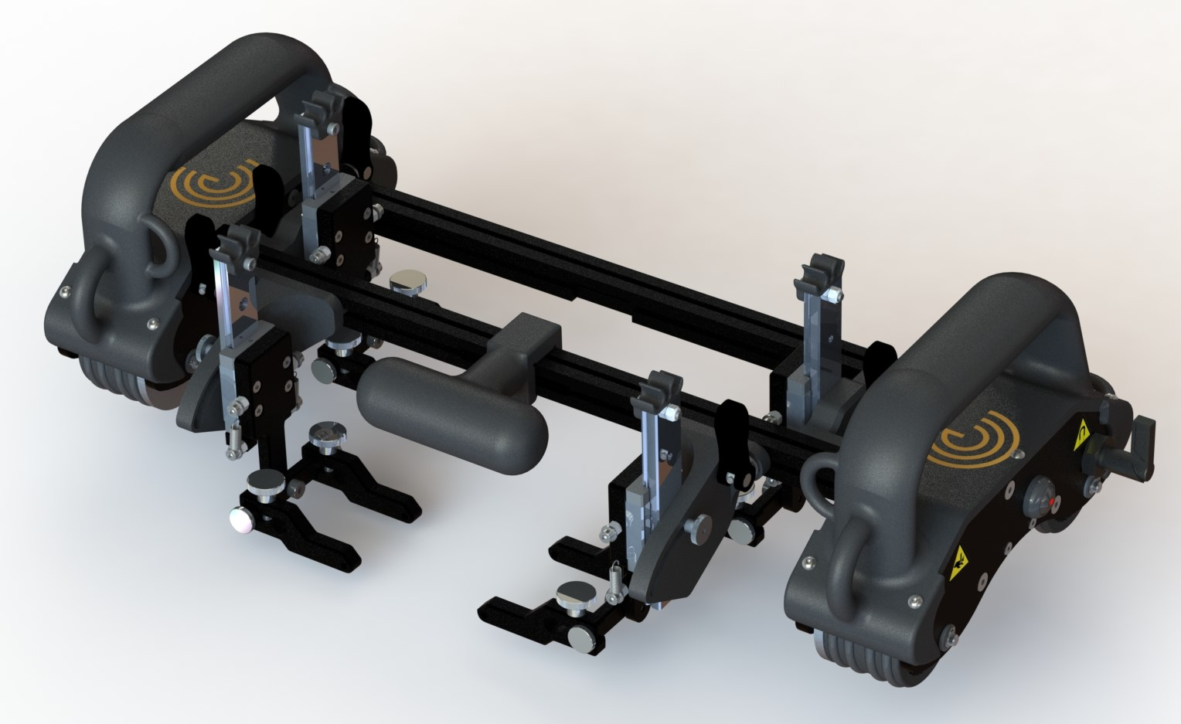
Figure 21 - Prototype Beta Design
With the introduction of the additional post-Alpha product requirements - denoted in the Product Specifications section - came a considerable number of design changes. These compounded with the test findings from the Alpha prototype to produce a design that maintained the overall aesthetics of the original design, but with significant mechanical revisions:
- Universally compatible toolposts – now that the product requirements called for compatibility with a wide range of both ToFD and PAUT probe wedges, a new design had to be created. These wedges would vary in width, height and depth, resulting in a probe holder design that could be adjusted to suit the needs of any of the designated wedges. The dimensions of the probe arms were chosen to be able to fit the largest of these wedges, while the clamping thumbscrew could be loosened to adjust the distance between them depending on the width of the required wedge. This also meant the loss of the snap-in functionality that was present in the original 3D-printed design, as each probe wedge from each manufacture had a slightly different mounting method; a series of removeable ‘pivot pins’ were created that could be added to the probe mounting arms, allowing them to securely clamp the chosen wedge via its particular mounting bore.
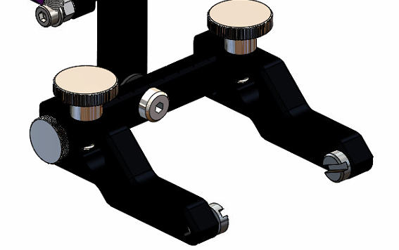
Clamping Screw
Pivot Pins
Probe Arms
Figure 22 - Beta Design Toolpost Probe Arms with Olympus-compatible Pivot Pins
The requirement to mount up to six toolposts simultaneously also lead to design changes for the toolpost mounting body; because each of the six toolposts would have to able to be positioned at any point along the bridge rail, the bridge-encompassing clamp method would no longer be suitable due to the potential for clashes. This led to the modification of the mounting body to use the T-slots of the rail extrusions as the primary point of mounting, with corresponding T-bosses on the mounting body – see Figure 23. The external toolposts would use similar T-bosses for mounting, and slots cut into the front and rear faces of the rail extrusions allowed for simple attachment or removal of these extra toolposts as required. The external toolpost mounting bodies would differ from the primary ones with the inclusion of a rotation system for the linear rail – because the probes rely on the spring force applied to the linear carriage to keep them pressed to the surface, this rotation allows the rail to be positioned perpendicular to a pipe surface, and thus maintain the correct spring force to the probe – see Figure 24. This position can then be locked with a rear-mounted thumbscrew to maintain this pressure throughout a scan. In both cases, the toolpost assembly would feature a lever-operated cam lock that can be engaged to apply pressure between the toolpost body and the bridge rail to fix them in position.
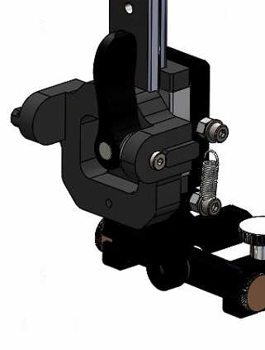
Cam-Lever Lock
T-Boss
Figure 23 - Beta Prototype Main Toolpost Assembly
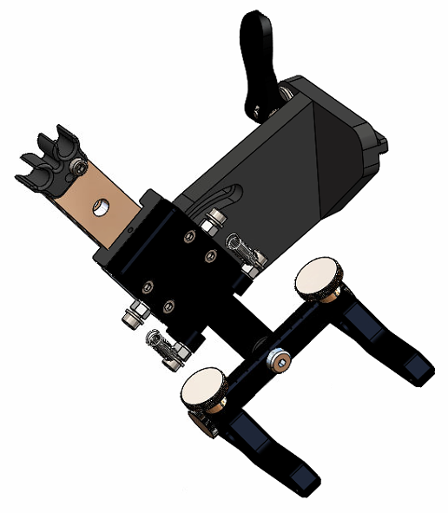
Figure 24 - Beta Prototype External Toolpost Assembly
- Improved magnet wheels – after the poor performance of the Alpha magnet wheels during testing, it was decided to add a mild steel pole piece to the design. 1018 mild steel was chosen due to the high magnetic permeability from its high iron content (98.81-99.26%, (Matweb, 2020)) and availability, while the lack of corrosion resistance could be countered by a simple nickel coating. These pole pieces work by being able to sit closer to the ferrous inspection surface than the magnets themselves as they are externally mounted to the sides of the wheel body, then help to direct the magnetic flux into the ferrous material. The width of these pole pieces can then be controlled to refine the resultant magnet strength, so these were designed in both 4mm and 8mm thick variants to provide options during testing. The braking levers were moved to the rear in order to improve braking performance as found by the Alpha build, as well as to the outer side of the tractors so as not to clash with the new external toolposts. While this increased the overall width of the system, it was deemed a positive trade-off given the additional functionality the external toolposts provide.

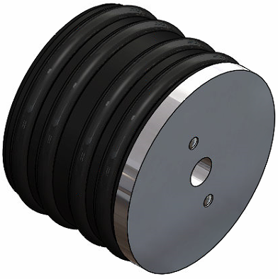
Mild Steel Pole Piece
Figure 25 - Beta Prototype Wheel Assembly
- Tether points – in order to comply with rope-access safety guidelines, all equipment must be able to be secured to the top of the work area in case of dropping. This called for the inclusion of tether points to the handle section that would allow for securing lines to be clipped to the system. These were added to the polymer handle sections as the material has been seen to perform well in this role during tests on existing systems (chiefly the R-Scan Array), as well as reducing the need for additional parts in the total system build.

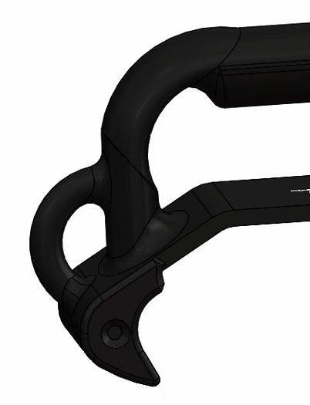
Tether Point
Figure 26 - Beta Prototype Tether Points
- Central handle accessory – it was found during alpha prototype testing that when moving the scanner around a pipe, the operator had a tendency to grip the centre of the leading bridge rail to pull the scanner around from the far side of the pipe. While this was effective and had no real negative effects, it was deemed somewhat unprofessional and something that could be rectified with the inclusion of a central handle. However, because in certain situations the toolposts – or even the tractors – could be required to sit centrally on the rail, this handle could not be a permanent fixture. This led to the development of the polymer snap-on central handle – the polymer chosen was the same MJF PA12 nylon as the main handle bodies, as this would provide both an aesthetic match and the necessary strength. As the handle was not designed for transporting or supporting the scanner, only moving it around a pipe surface, the aesthetic properties were deemed more important than the potential strength benefits of moving to an FDM fibre-reinforced polymer, so the matching MJF nylon was chosen. The handle is a simple body that provides a comfortable grip for the user that can be deployed and removed as necessary – by designing the mounting clip as seen in Figure 27, the handle provides a positive lock when pulled tangentially to the pipe surface, but easily snaps free when pulled directly upwards.

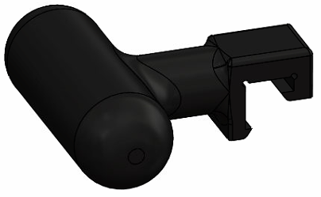
Figure 27 - Beta Prototype Snap-On Handle
- Quick-release bridges – with the updated product requirements now including PAUT probes, the required length of the bridge must also be altered in order to accommodate the PCS requirements of these probes. However, rather than try to accomplish a one-size-fits-all approach with a single extended bridge that would provide far too much available length for most applications, it was decided to move to a quick-release bridge system. This way a second longer bridge assembly could be provided as part of the system package, and the operator could easily switch between bridges in the field depending on the specific requirements of each particular job. This was accomplished by adding 3 shoulder screws to the exterior of the internal electronics tractor face, and 3 corresponding mating slots into an interface plate that would form the cap of the bridge assembly. This would allow for a simple sliding mate that would provide a strong, multi-plane lock between the tractor and the bridge, that would be then locked in place by two simple captive thumbscrews.
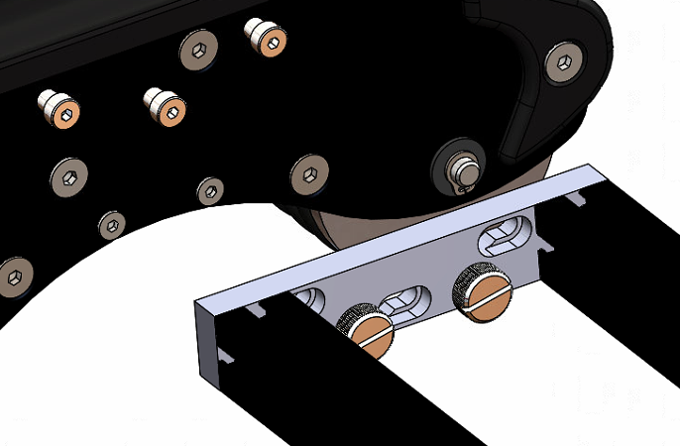
Figure 28 - Beta Prototype Quick-Release Bridge (colour altered for clarity)
Typically for a Beta prototype in Eddyfi Technologies, 5 units are produced which are then split between in-house test teams and selected customers for field trials. However, in the case of the Connex system, because so much had changed between Alpha and Beta due to added product requirements, it was deemed prudent to build a single unit for in-house trials before the additional customer-trial units were built.

Cost Analysis
The costing for the Beta prototype build was somewhat easier than that of the Alpha, as the supplier for machined parts had already been chosen. This meant updating the costing sheet was simply a case of sending all new machined parts for quotation, finding the costs of all new purchased parts and collating with the existing costs into a new spreadsheet – see Appendix 5. Once completed, the total scanner cost could be calculated as £1801.11; while this is a significant increase of ~£300 over the Alpha design, the system now had significant functionality increases to match the cost increase. This potential price increase for the end user is also reasonably justified, as this added functionality will increase their inspection efficiency as both the initial scan and the complementary technique prove-up can be performed in the same action. This reduces overall scan time, saving the inspection company cost per job, as well as potentially allowing them to complete more jobs in the same time frame.

Testing & Feedback
The testing procedure was similarly applied to the Beta prototype as it was to the Alpha, covering the key areas of data capture, magnetic adhesion and general appeal/ease of use:
- Data capture – due to the radical design changes of the toolpost assembly from the Alpha prototype, data capture was a significant focus during the initial testing. Fortunately, the move to aluminium parts for the body of the probe holder maintained the probe stability despite the geometry changes and captured data was deemed both adequate and reliable. The T-slot bodies on the toolpost mounts worked well also, providing both a stable platform for the probe holder and easy lockable positioning along the bridge rails with the cam-lock levers. As can be in Appendix 9, the system operated well on an inspection surface and reliably collected data as intended.
- Magnetic Adhesion – the addition of the magnetic pole pieces was a great success. Once added, the system could comfortably support its own weight on a 6mm thick inspection surface, the brakes performed as intended on a similar surface and the overall grip was improved. The system also no longer suffered from ‘rolling drop’ when mounted on a vertical pipe, where the previous design would slowly fall as it was moved across a vertical surface. The results can be seen in the video of Appendix 4 (note that the build for this test was not a complete Beta prototype but the pole pieces mounted to the previous Alpha build). Further testing was completed to ascertain the required force to cause the scanner to slip when the brakes were engaged, as well as the force required to detach the scanner from the surface completely. This testing was performed on the minimum requirement of 6mm thick plate, as this would provide the least magnetic adhesion due to the magnetic flux dissipating further from the scanner, thus not being available to directly oppose the pull-off force. This testing was broken down into three stages:
  - 3 o’clock pipe position wheel slip – the pipe was positioned on the horizontal axis of the pipe with the brake engaged and loaded with weights until the scanner began to slip downwards. This breaking mass was found to be 2.75kg.
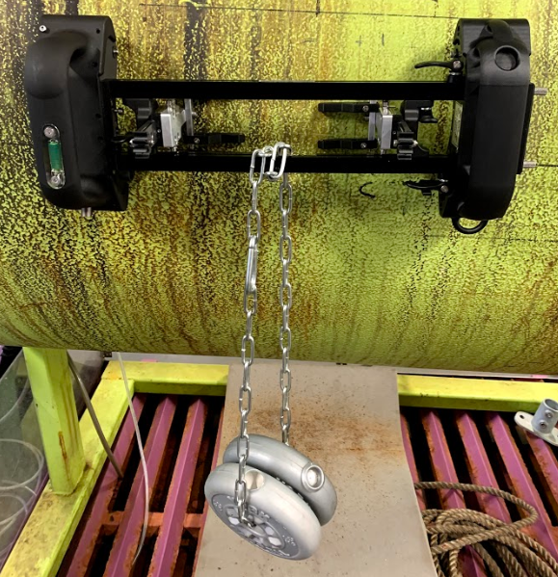
Figure 29 - Wheel Slip Test
  - 6 o’clock pipe position surface separation – the scanner was positioned at the lowest point of the pipe and loaded with weights until the scanner detached from the surface. The scanner was loaded with the maximum available 8.75kg yet no separation was seen.
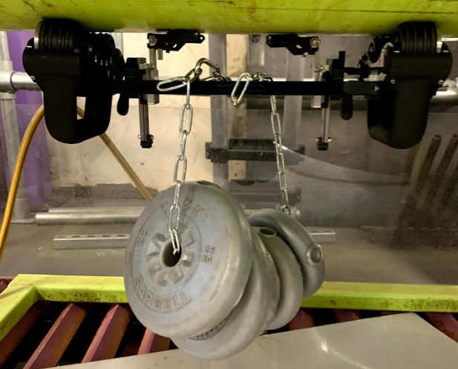
Figure 30 - Surface Separation Test
  - Level plate surface separation – as the previous test was deemed incomplete due to unavailability of more mountable weights, the scanner was positioned on flat plate and pulled from the surface, using a newton meter with a kilogram reading to measure the required force. This was performed with multiple thickness shims to simulate potential surface coating thicknesses:
    - 6mm plate, 0mm coating – an average of 25kg required for separation
    - 6mm plate, 1mm coating – an average of 15kg required for separation
    - 6mm plate, 2mm coating (worst case scenario as stipulated by PRD) – an average of 10kg required for separation
These tests were deemed an overall success, as the pull-off forces recorded were considerably greater than the weight of the umbilical that the scanner will be required to support, estimated at 5kg by the electrical design team. While the wheel slip test result was not ideal, the fact that this potential slip is highly unlikely to result in a dangerous separation and fall from the surface means that the available magnet force was deemed adequate by the Project Manager.

Transit Case Design
As with any scanner system, a transit case was needed as part of the final system package. Eddyfi stipulate the use of Nanuk casing systems so as to maintain a common aesthetic throughout the company product line, as well as Nanuk’s proven track record of supplying rugged, waterproof products. Nanuk also offer the option of customised foam interiors, which are key when designing a professional-looking product of for non-standard items – these custom interiors are designed by Eddyfi, produced by Nanuk and supplied with the case shell as a single assembly. The complete case requirements can be found in the Product Specification section of this report, but the key aspects of the design were as follows:
- A clean display of the scanner upon opening of the case – this meant a main layer featuring only the scanner, with any peripherals or accessories stored in other areas of the case.
- Magnetic keep plates – in order to comply with shipping regulations, no magnetic field can be able to be detected on the exterior of the case. This results in the use of mild-steel keep plates to absorb magnetic flux from the scanner wheels.
- A maximum packed weight of ~15kg – because inspection sites are often remote, large and hard to access, the total system mass must be able to be transported with relative ease by a single operator. While there is no longer a fixed mass dictated by the HSE for safe manual handling, 15kg is commonly used within Eddyfi as the maximum safe lifting weight.
- Peripheral/accessory storage – the entire system was required to be housed within a single transit case for ease of transportation, so all additional parts such as the umbilical cable, tools and documentation must be able to be housed within the case.
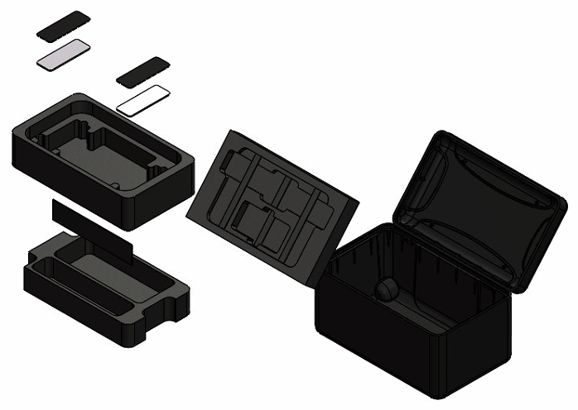
Lid Section
Upper Section
Keep Plates
Lower Section
Figure 31 - Transit Case Design (Exploded)
The case chosen for the design was the Nanuk 938 outer with custom foam layer internals designed by the author, as this was the smallest possible case that could house all of the required contents. Additionally, the case is supplied with wheels and a transport handle built in, so transportation would be easier than a carry-only option on suitable ground. The custom foam interior was designed based upon the given specification, and featured 3 primary sections:
- Main display area – the first layer visible when opening the case, this section features a form-fitting profile cut for the Connex scanner and the required keep plates. In order to further improve the aesthetic appeal of this layer, the keep plates were covered by simple pieces of black acrylic – these had the added benefit of reducing the magnetic pull between the scanner and the keep plate, as mounting directly to the plates made removing the scanner somewhat awkward due to the strong magnet pull. The profiled cuts surrounding the tractors prevent the scanner from moving during transport, while the oversized cut for the bridge section allows the scanner to be transported with all 6 toolposts attached.
- Lower storage area – in this lower section an umbilical cable up to 10m in length can be stored. The standard system is issued with a 5m cable, but with almost all previous scanning systems there have been requests for longer cables so the capability to house a 10m version from the start seemed prudent. This section also contains a general storage area, allowing operators to transport items such as spare probes or wedges, couplant bottles or a UT pre-amp.
- Lid section & accessory storage – when speaking to applications engineers, it was requested that accessory items such as tools should be as easy to access as possible. This led to the main tool kit and extended bridge assembly being housed in the lid as the operator would not have to remove the main display layer to access them. The toolkit is a simple waterproof hard case and can be used to store items such as UT cables, pneumatic fittings for irrigation hoses and the hex key required to change the scanner encoder. Both the tool kit and bridge assembly are recessed behind the document storage area, with all 3 being retained by simple elasticated strapping. This document storage area is designed for an A4 document wallet, which will contain the system certification documentation as well as providing quick access for documents such as work orders, site passes and safety certificates.
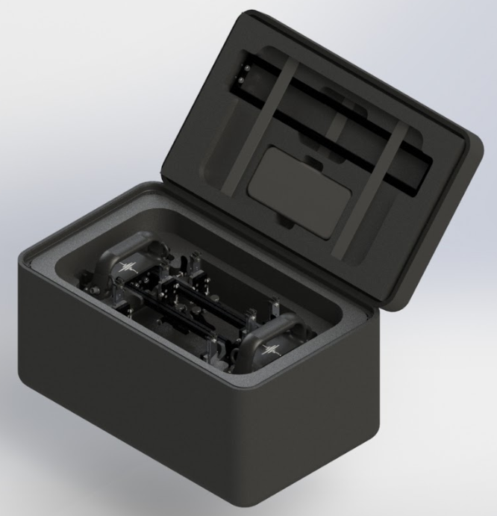
Figure 32 - Packed Connex System

Business Impact
In order to justify the investment in the design and production of the Connex scanner, the costs must be balanced against the benefits of adding the system to the Eddyfi product line. This was performed by the applying the previous cost analysis information to the Market Research Team’s projected sales figures across the lifespan of the product, as can be seen in the table below – the original estimations can be seen in Appendix 6, while the following table has been adjusted to use the updated product build cost from the Beta Prototype cost analysis and converted to Sterling.
Table 2 - Connex Cost Benefit Projections
From these projections it can be seen that the Connex scanning system could potentially be worth over £1.5m in profit to Eddyfi UK over its lifespan, even based on conservative estimates of an average 20 units sold per year. Additionally, this does not take into account potential revenue from future accessories, upgrades and servicing for which there is currently no cost analysis data. Perhaps most importantly, another consideration is the impact to Eddyfi Technologies as a global group – as stated previously, the Connex system is designed to be compatible with the M2M Mantis line of instruments and sold as a complete inspection package system, so the total system value to the Eddyfi group could be substantially greater: on the assumption that 90% of customers purchase the system as a complete package (10% is allowed for existing Mantis customers or second scanner purchases), this could represent 391 extra Mantis units sold for the Eddyfi Technologies group across the lifespan of the Connex. The following table applies this 90% assumption to Table 2, with the costs and prices adjusted to those of the base Mantis unit:
Table 3 - Mantis Cost Benefit Projections
By combining values from Tables 2 and 3, the projected profits for the complete Connex/Mantis system are calculated to be £1,345,167.50 over the first 5 years and £5,845,999.30 over the product lifespan. However, this is a conservative estimate based on the entry-level Mantis system so it could potentially increase further should customers purchase the more advanced versions. Additionally, the differences between the specifications of the Mantis system are solely software-based, so no hardware cost increase is seen by the group in the production of these advanced versions - any extra revenue from their sale is purely profit.
A final consideration for the impact of the Connex scanning system is not fiscal in nature; the ultimate goal of any piece of inspection equipment is to improve the safety of the industry in which it is applied. If the Connex system can improve the efficiency with which safety inspections are performed, this would naturally lead to an increase in the number of inspections that can be performed. By performing extra inspections, the risk of potentially environmentally damaging incidents occurring is reduced – this is especially beneficial in industries such as petrochemical and oil manufacture and transportation, as the effects of chemical and oil spills from asset failure are particularly hazardous.

Production Publishing
Production publishing involves the creation and approval of all required machining and General Assembly (GA) drawings, before handing these over to the Production team for manufacturing to begin. From the GA’s the Bills of Manufacturing are produced, which are imported into the company ERP system to control the required ordering and stock management of each part and subassembly. Unfortunately, with the delays to testing and release these drawings are not able to be submitted for approval, however a sample pack of pre-approval drawings has been provided in Appendix 8.

Future Work – Product Drops
For each new product release, Eddyfi Technologies typically has planned functionality boosters known as ‘drops’ to be strategically released over the first 1-2 years of a product’s life. This tactic has multiple benefits, as it reduces initial core product pricing, adds functionality to a product over its lifespan and eases the pressure on design and testing teams to deliver all planned functionality at the initial launch. The future drops for the Connex system are as follows:
- Drop 1 – Longitudinal Scanning Configuration; this drop focuses on converting the Connex scanner from a solely-circumferential weld scanner into a system that can be used to scan seam welds running the length of larger 20” in diameter and above. This figure was chosen as typically below this diameter pipe sections are extruded rather than rolled and welded, so seam welds are less prevalent.
- Drop 2 – Chain Scanner Attachment; this sub-project aims to provide an upgrade that converts the Connex into a chain scanner system that can be deployed on non-ferrous pipework. By using a locking system that wraps around the pipe, the wheel magnets no longer provide the required adhesion mechanism, so the system can be deployed on specialist stainless steel pipework.
- Drop 3 – Corrosion Mapping Configuration; this drop aims to combine the reliable manual pipe scanning of the Connex with the Aqualock irrigated PAUT probe system. This would convert the Connex from a weld-inspection tool into a full corrosion-mapping tool for the sections of pipework between the welds, effectively allowing the Connex to detect any and all corrosion at any point of a pipeline. The Aqualock and internal PAUT probe work similarly to that of the PAUT weld inspection probes, but instead of being mounted to an angled wedge the probe sits perpendicular to the inspection surface above a column of liquid couplant. This allows for the detection and mapping of corrosion across surfaces.
Because of the inability to carry out planned Beta testing due to Covid-19, the time that would have been spent on testing could now be used to begin work on the design of these future drops. While testing on these concepts is obviously also very limited during the Covid-19 restrictions, the initial concepts could be developed for trials once development returns to normal; these initial concepts are detailed below:

Drop 1 – Longitudinal Scanning
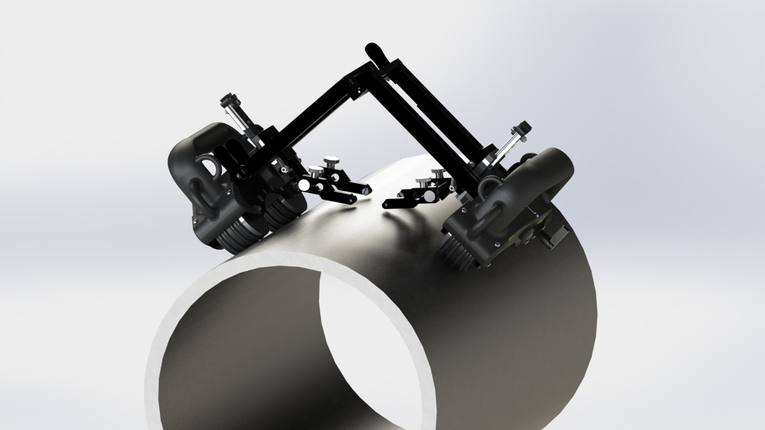
Figure 33 - Longitudinal Concept
With the inclusion of the quick-release bridge option into the main Connex design, the capacity for longitudinal scanning was greatly increased. By adding a simple locking hinge mechanism to the centre of the bridge, the tractors could now be positioned along the longitudinal axis of the pipe while maintaining full wheel contact. A problem occurred however, in that the probe arms of the toolposts ran parallel to the bridge rails causing them to be elevated from the surface when the hinge was at its fully opened position. This was rectified by adding an extra mounting position to the probe arms at 45° to the base cut, allowing the operator to remove the arms, rotate them to this greater angled position and reinstall them. As can be seen in Figure 33, this allows the arms to maintain probe contact with the surface at pipe diameters as low as 12” – this more than bested the given requirement of 20”. A simple prototype for this design was able to be constructed using 3D printed parts and rail sections already in stock, as can be seen in Figure 34 – the scanner moved smoothly and maintained a correct probe position throughout the length of the simulated scan, so the design was approved for further testing once field trials are again available.
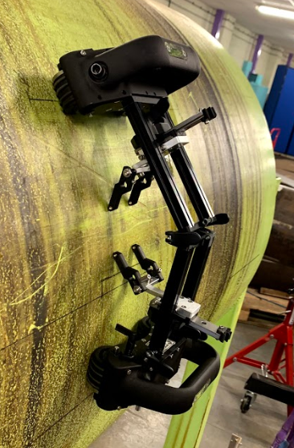
Figure 34 - Longitudinal Scanning Prototype

Drop 2 - Chain Scanner
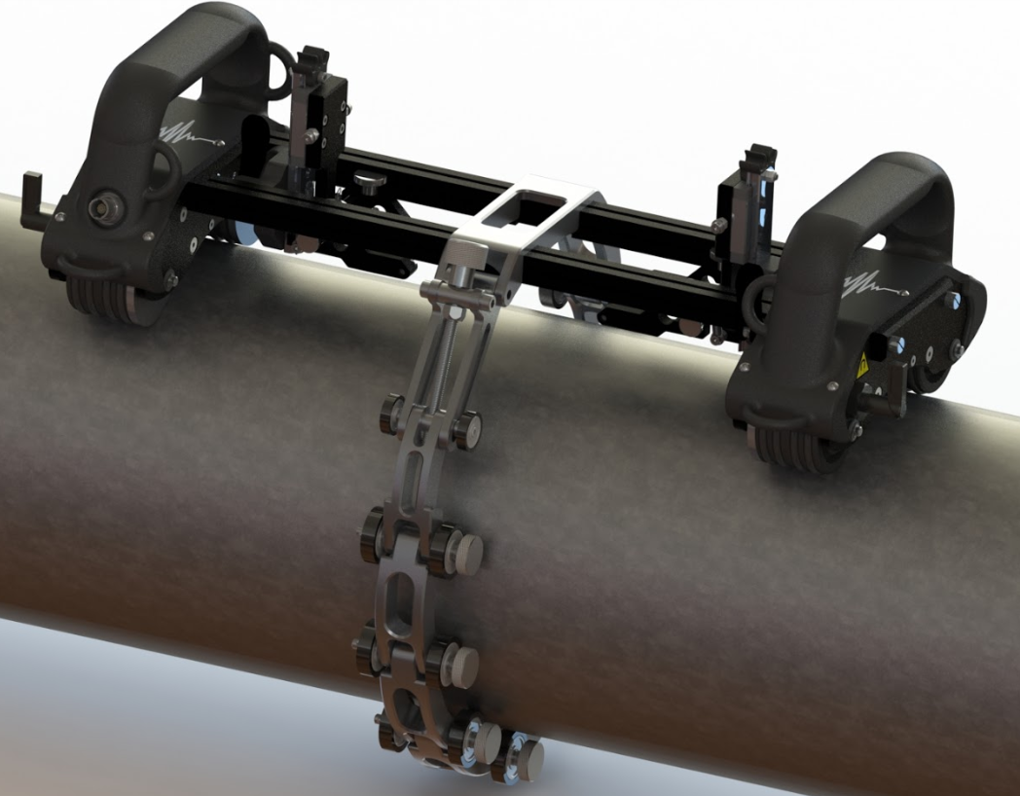
Figure 35 - Chain Scanner Concept
The chain scanner accessory is relatively simple in its idea, acting as a wheeled ratchet strap in principle. The design consists of 3 core subassemblies – the main links, the adjuster link and the attachment link. The operator can connect the chain accessory to the main scanner bridge with the attachment link, wrap the main body around the pipe, attach the hooked final link to the adjuster and then tighten the thumbscrew to secure the system in place. The operator can then manoeuvre the scanner around the non-ferrous pipe as they would normally with no fear of the scanner detaching. Motion is kept smooth with the use of urethane-coated bearings attached to each of the links, and the use of a lead screw to adjust the chain tension ensures that the chain does not become loose during movement. Importantly, the chain does not intrude into the path of the main toolposts at all, allowing for the full PCS range of the system to still be utilised. This design is still currently in the concept phase at time of writing, but initial feedback from internal applications specialists has been good enough to be approved for prototyping. The intended diameter range for this system was 4-36”, so the system will be supplied with 10 links as standard allowing the system to be deployed on pipes up to 12”, with additional packs of 10 links available depending on the customer’s requirements.

Drop 3 – Corrosion Mapping Configuration
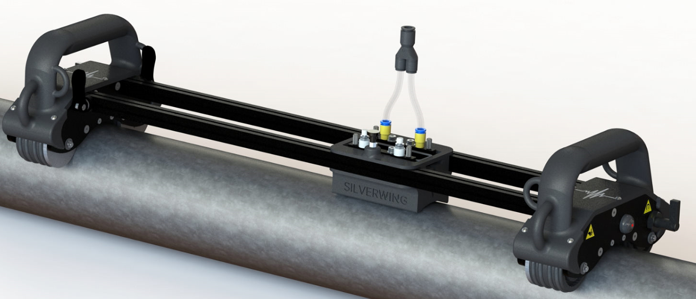
Figure 36 - Corrosion Mapping Concept
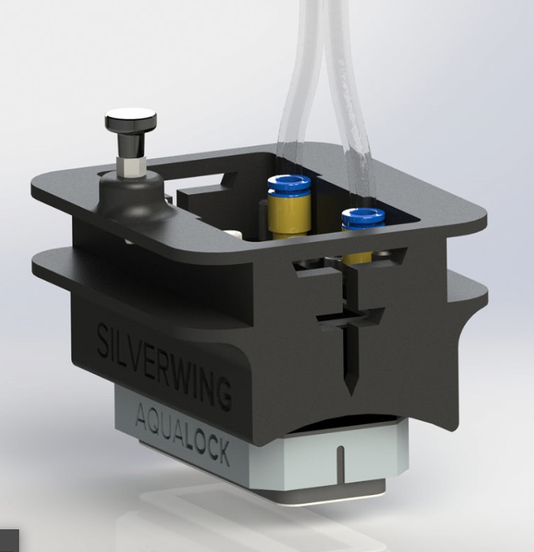
Figure 37 - Corrosion Mapping Probe Holder
Similarly to the longitudinal bridge, the corrosion mapping concept makes use of the easily switchable bridge sections. For the corrosion mapping configuration, a complete bridge assembly would be supplied, including the probe holder seen in Figure 33. Typically, when used with an M2M Mantis or Gekko capture instrument as recommended with the Aqualock, the user will perform scans of 500mm in width to balance scan efficiency with data size. This is why the corrosion mapping bridge assembly uses much longer rails than that of the standard Connex setup. The probe holder houses the Aqualock PAUT probe system and is inserted between the bridge rails during assembly. The Aqualock works by scanning one path forwards, moving 50mm to the side to line up with the next path and scanning backwards; this is then repeated to cover the entire intended area, known as raster scanning. In order complete this without the operator having to judge the 50mm themselves, an indexing spring plunger is attached to the top face of the probe holder with the locating pin dropping into receiver holes placed in 50mm steps across the top of the new bridge rails. This removes the potential for operator error and ensures that the entire target area is covered during the scan. This design is also awaiting physical testing, but feedback on the concept models has been positive from applications engineers and the management team.

Conclusion
Other than the unforeseen complications due to the global Covid-19 outbreak, the project was a success. While the requirements for the product shifted and grew midway through the project, this is not an uncommon experience during a product’s development cycle so posed only minor design problems. These problems also arose following the testing of the Alpha prototype, a point at which significant design changes would be expected in any project as testing reveals problems and improvements, so this shift added little to the overall timeline. While field trials on the Beta prototype have been unable to be completed due to movement restrictions, in-house testing has shown very promising results and a new scanning system able to complete the remit of providing a competitive manually operated ToFD and PAUT weld scanning system. With the global economic downturn following Covid-19, the Connex system could also prove to be a key selling item for Eddyfi UK, as customers are likely going to be wary of purchasing high-cost flagship items while recovering from the downturn; the relatively low cost of the Connex means that it would not necessarily be counted as a capital outlay by an inspection company and the purchase could be approved by the inspection teams themselves. This easily-approved cost coupled with the high functionality of the system could make it a prime purchase opportunity in the 12-18 months after the pandemic, helping Eddyfi to recover from the downturn itself. However, even the problems resulting from the Covid-19 pandemic have been used to the system’s advantage, with the initial design work of future developments able to be completed – this will allow for extended testing on these subsystems once restrictions have been lifted and these upgrades will further help push sales of the system. These upgrades will also further distinguish the Connex system from the competitors, transforming the Connex from a simple multi-technique weld scanning instrument into a multi-role tool for the complete corrosion analysis of pipework systems.

Appendices
All appendices can be accessed from Google Drive at the following link:
https://drive.google.com/open?id=1nU8kQc8BX9MgvJVJCTKGu2k4dbsQPCov
Appendix 1 – Original Timing Plan – the Gantt chart created at the beginning of the project to outline the timings of each development stage.
Appendix 2 – RMSTF00001 Cost & Ordering Alpha Prototype – Excel spreadsheet detailing the costs, lead times, suppliers and order status for the building of the initial prototype. Also contains estimated Production batch cost and profit estimates based on order quantities for 25 systems.
Appendix 3 - Prototype Alpha - Data Capture Test 1 – video demonstrating probe holder vibration during prototype Alpha
Appendix 4 - Prototype Alpha-2 - Stability Test – video demonstrating improved scanner grip and probe holder stability
Appendix 5 – Connex Beta Build Costings – excel document detailing the part costs for the Connex beta build
Appendix 6 – Market Requirements Document – initial market analysis document produced by Eddyfi Market Research team
Appendix 7 – Product Requirements Document – detailed product requirements as stipulated by Product and Project Managers, based upon MRD.
Appendix 8 – Sample drawing pack – PDF copies of machining drawings and GA’s.
Appendix 9 - System Operation Video – a short video showing the operation and data capture of the Connex system

Works Cited
American Welding Society. (2009). Guide for the Nondestructive Examination of Welds, 4th Edition. Miami: American Welding Society.
AUT Solutions. (2020). WeldScan. Retrieved from AUT Solutions: https://autsolutions.net/ndt-products/ndt-scanners/manual-ndt-ut-scanners/weldscan/
Burch, S. F., & Collet, N. J. (2009). Recommended Practice for the Non-destructive Inspection of Weld Corrosion. Warrington: ESR Technology.
Charlesworth, J., & Temple, J. (2001). Engineering Applications of Ultrasonic Time-of-Flight Diffraction, Second Edition. Philadelphia, PA: Research Studies Press Ltd.
Desmarais, F. (2016). PR100 - Type 4 Product Development. Quebec, QC: Eddyfi Technologies.
Drury, J. (2004). Ultrasonic Flaw Detection for Technicians, Third Edition. Swansea: Silverwing Ltd.
Eddyfi Technologies. (2018). Non-Intrusive Inspection - Vessels, Pressure Systems and Associated Pipework. Quebec, QC: Eddyfi Technologies.
Ginzel, E. (2013). Ultrasonic Time of Flight Diffraction. Ontario: Eclipse Scientific .
Habibpour-Ledari, A., & Honarvar, F. (2018). Three Dimensional Characterization of Defects by Ultrasonic Time-of-Flight Diffraction (ToFD) Technique. Journal of Nondestructive Evaluation.
Health and Safety Executive. (2019). ALARP "At A Glance". Retrieved from HSE.gov: http://www.hse.gov.uk/risk/theory/alarpglance.htm
Jamil, M., Niazi, A., Hegab, H., Sarfraz, S., Sharma, N., Mia, M., . . . Pruncu, C. (2019). Internal Cracks and Non-Metallic Inclusions as Root Causes of Casting Failure in Sugar Mill Roller Shafts. Materials, 12, 24-74.
Jireh . (2020). STIX - 4 Probe Weld Scanner. Retrieved from Jireh: https://www.jireh.com/products/stix-4-probe-weld-scanner/
Kenny, S. (2019, August 17). Initial Scanner Proposal & Outline. (B. Woodhead, Interviewer)
Kenny, S. (2019, August 23). The Basics of ToFD Inspection. (B. Woodhead, Interviewer)
Kenny, S., & Mugford, G. (2019, August 21). Weld Scanner Competitor Review. (B. Woodhead, Interviewer)
Lewis, H. (2020, January 23). Prototype Alpha Analysis & Competitor Review. (B. Woodhead, Interviewer)
Matweb. (2020). AISI 1018 Mild Steel, Cold Drawn. Retrieved from Matweb: http://www.matweb.com/search/DataSheet.aspx?MatGUID=3a9cc570fbb24d119f08db22a53e2421
Mugford, G., & Kenny, S. (2020). Marketing Requirements Document - Connex (PO 29352). Swansea: Eddyfi Technologies.
Nanuk . (2020). Nanuk 938. Retrieved from Nanuk.com: https://www.nanuk.com/nanuk-938.php?lang=lang-en
Oceaneering International. (2018). PAUT Course Notes. Swansea: Oceaneering International.
Olympus IMS. (2014). Introduction to Time-of-Flight Diffraction (TOFD) for Weld Inspection. Retrieved from Olympus IMS: https://www.olympus-ims.com/en/applications/introduction-to-time-of-flight-diffraction-for-weld-inspection/
Olympus IMS. (2020). An Introduction to Ultrasonic Phased Array Technology. Retrieved from Olympus-IMS: https://www.olympus-ims.com/en/ultrasonics/intro-to-pa/
Phoenix ISL. (2020). MagMan. Retrieved from Phoenix ISL: https://www.phoenixisl.com/product/magman/
Phoenix ISL. (2020). Swift. Retrieved from Phoenix ISL: https://www.phoenixisl.com/product/swift/
Roca Barcelo, F., Jaén del Hierro, P., Ribes Llario, F., & Real Herráiz, J. (2018). Development of an ultrasonic weld inspection system based on image processing and neural networks. Nondestructive Testing & Evaluation, 33(2), 229-236.
Williams, D. (2020). Product Requirements Document - Connex (PO 29352). Swansea: Eddyfi Technologies.

