Building a Sustainable Marketing Relationship
Mst. Shalma Pervin
Sainsbury’s
Date: Nov 18, 2022

Executive summary
Companies that really care about their clientele and make an effort to develop meaningful connections with their clients see considerably more rapid growth than their rivals. This is because the market frequently provides continued support to established companies. Instead of actively seeking out new connections, firms that practice "relationship marketing" put their attention on strengthening and broadening the ties that already exist inside their organisation. When it comes to relationship marketing, you should give priority to returning clients who are already acquainted with your brand. Because of these relationships, there is a possibility that prospective new consumers will be drawn in, and that current customers will spread the word. Sainsburys focuses on maintaining good customer relation through their customer satisfaction strategies including its segmentation, pricing and differentiation strategies.

Table of Contents
1. Introduction 4
2. Brief profile of Sainsbury’s 4
2.1. Historical development 4
2.1.1. Current market share- is it in growth or decline? 5
2.1.2. Profit or loss status 6
2.1.3. The mission statement for the organization 7
2.1.4. Sainsbury's 'Marketing Relationship' strategy 7
2.2. Data collection/analysis/evaluation can impact a 'Marketing Relationship' and help it to become 'sustainable.' 8
2.3. Segmentation 9
2.4. Pricing strategy 10
2.5. Differentiation 11
2.5.1. Porter’s generic model 11
2.6. Ethics and Sustainability 12
2.6.1. Ethics 12
2.6.2. Customer centrality 13
2.6.3. Sustainability 13
3. Conclusion 14
6. Appendix I 18
7. Appendix II 18

Introduction
The report was requested by Management, in start of November, the report is based on the customer relationship strategy of Sainsbury’s. Green marketing, also known as sustainable marketing, seeks to have as few negative effects as possible on the natural environment. Some people frequently criticise companies for what they perceive to be wasteful spending, high prices, and deceptive marketing practices. This research investigates the qualitative aspects of Sainsbury's, such as market share, profit loss, customer centrality, and marketing ties. This paper underpins b the market segmentation, pricing and differentiation of Sainsbury’s along with the integration of sustainability and ethics. The research is secondary as all the data is taken from books and articles. The research was compiled using articles from Science Direct, Emerald, and Academic Search Complete. In addition, the websites of Sainsbury's and the government have provided useful information for the investigation.

Brief profile of Sainsbury’s

Historical development
According to Berrow et al., Sainsbury's has become the biggest supermarket chain in the United Kingdom since launching its first food shop in London in 1869. John James, a local citizen, bought the structure at 12 Kingsland High Street in 1903 and transformed it into Dalston's first grocery shop. Every retailer now provides in-store delivery due to the persistent shortage of wheelchair-accessible cars. Even though a convenience shop was nearby, event organisers selected a place in the midst of the march. Customers would have more time to examine items throughout the summer if businesses lacked air conditioning. By the time its creator, John James Sainsbury, passed away in 1928, the network had more than a hundred locations. John Benjamin Sainsbury, the eldest son, partnered with his father in business in 1915 and eventually became the company's chief executive officer.
In the 1930s and 1940s, after the acquisition of the Thorough good chain in the Midlands the previous year, the firm made substantial expenditures to enhance shop layout, customer service, and retail cleanliness. This grocery company has been around for a long, which is a positive, but its 15 percent market share is what actually distinguishes it. In the United Kingdom, the corporation owns or operates more than 800 convenience shops and smaller supermarkets. Before moving into other areas like as fashion and communications technology, the firm established its mark in the food industry. With the September 2016 acquisition of Home Retail Group for 1.10 billion British Pounds, the firm entered the nonfood retail industry. The Home Retail Group consists of businesses such as Habitat and Argos and is well-known for its vast product variety, which includes gadgets.

Current market share- is it in growth or decline?
With their "Aldi Price Match" collection, Sainsbury's, the second-largest of the "big four," has successfully competed with Aldi. As a result, Sainsbury's share of the grocery market may have fallen by 0.6% that year. The company's losses are far lower than those of its competitors as a result of customers' emphasis on sustainability, improved quality, and affordable costs. By 2022, it is estimated that they would control 15% of the food retail market in the United Kingdom (Beckers et al., 2021).
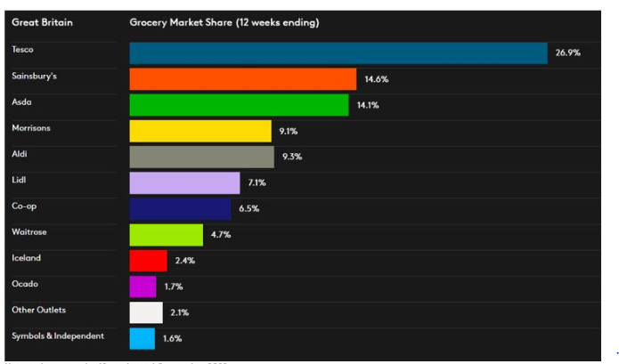
Figure 1 Sainsbury’s market share
(Sourced: Sourcera)

Profit or loss status
For the fiscal year ended March 6, 2022, Sainsbury's earned 854 million pounds before taxes. Sainsbury's obtained the data independently (2019). The company's earnings in 2018 was 677,000,000 GBP. The company's financial health has dramatically improved since last year. Due to write-downs and operational expenses, Sainsbury's expects a loss for the 2020/21 fiscal year. In the last year, the company's financial condition has dramatically improved.
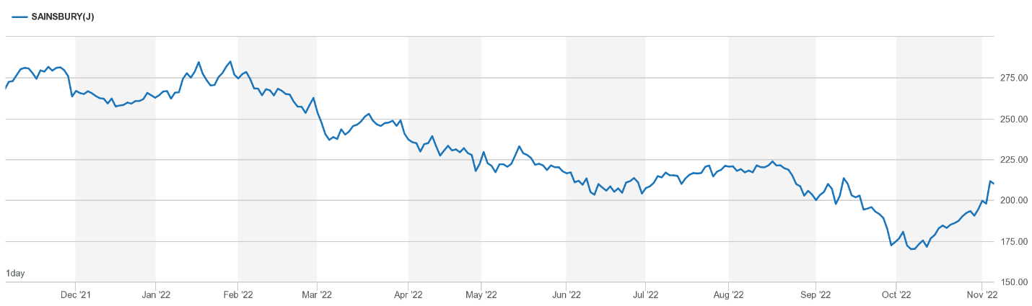
Figure 2 Market share price Sainsbury’s
(Sourced: Sainsbury’s)
Sainsbury's revenue for the six months ending September 18 increased by 5.3% year-over-year to £15.7 billion. Despite intense competition from the prior year, when lockdowns and restrictions caused a surge in store sales, the grocery store's income increased by 0.8%. However, Sainsbury's market share has been steadily declining for several years. During this time period, the company opened fewer new retail locations (Corfe, 2018).
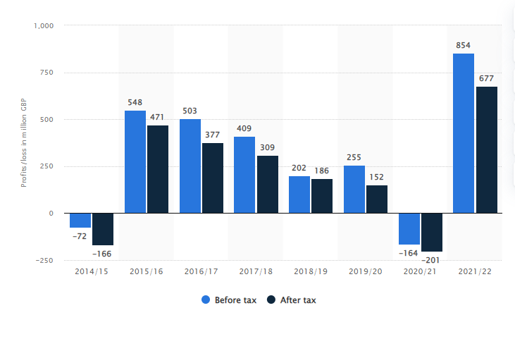
Figure 3 Sainsbury’s profit loss since 2014 (Sourced: Statistica)

The mission statement for the organization
The company's goal is to become the go-to option for food industry customers, and it plans to do this by making its operations "faster, simpler, and more unified" (Jung et al., 2019).
To succeed, Sainsbury recognises the need of maintaining open lines of communication and gaining a thorough grasp of its consumers' wants and requirements. To effectively assist customers, supermarket personnel should be able to begin conversations and interpret body language.

Sainsbury's 'Marketing Relationship' strategy
According to Burgess (2017), the majority of businesses utilise CRM initiatives to gain a deeper understanding of their clientele and the characteristics that make them loyal customers. The company's global reputation is highly dependent on customer loyalty and satisfaction.
Businesses that care about their customers and cultivate close relationships with them flourish much more quickly than their competitors. This is because the market frequently provides continued support to established companies. With "relationship marketing," businesses focus on building and expanding their existing network, as opposed to aggressively pursuing new connections. Prioritize returning customers who are familiar with your brand in relationship marketing.

Data collection/analysis/evaluation can impact a 'Marketing Relationship' and help it to become 'sustainable.'
By doing research on successful advertising strategies, we are able to understand how and why these strategies were successful. Utilize marketing analytics to maximise your return on investment (ROI), improve your strategy, and target the appropriate audience. It's possible that putting marketing analytics to use may be beneficial for companies and the customers they serve. This study will help marketers maximise their return on investment by determining the most successful techniques for improving conversions, brand recognition, or both. This research will aid marketers in maximising their return on investment (ROI). In addition, analytics ensure that clients see advertising that are more relevant to their areas of interest, as opposed to the intrusive commercials that are standard (Habeh et al., 2020).
Quarterly, the company's managers and leaders conduct surveys and market research to gauge customer satisfaction with the company's products and services. This helps them gauge the success of their supply chain and corporate strategy, both of which are designed to increase the company's bottom line and ensure its continued viability. Sainsbury's supply chain management has improved the two-way flow of information between the company's workers and its consumers, two key metrics for gauging customer happiness and, ultimately, brand loyalty. When a company's overall strategy is well-aligned with its supply chain management, it is able to reliably meet the needs of its customers by delivering high-quality goods and services to its designated market (Murmura et al, 2017). Sainsbury's corporate social responsibility practices, as reflected in the company's workplace culture, have a positive impact on customer satisfaction levels, as measured by a quarterly market survey, by influencing customer satisfaction levels by 38 points. The impression made on a consumer before, during, and after a transaction will be what determines whether or not that customer will return for further business in the future. Touchpoints are defined as each time a customer engages in activity with a company, such as making a purchase. Sainsbury’s use many places at which a client interacts with the brand are known as "customer touchpoints."
They require individual information as opposed to depending on broad demographic categories in order to develop adverts that appeal to the particular tastes of each user. Without it, there is no way to avoid failing. Advertising agencies are required to produce timely and contextual adverts across all relevant channels in order to advance prospective customers farther down the sales funnel. Sustainable marketing is essential to the success of your company and the pleasure of your stakeholders because of the emphasis your firm takes on concerns such as the preservation of the environment, human health, resource security, fair trade, and social equality. Because there is a lot of advertising on the market that is focused on "taking down" competitors, this method will make the company's adverts stand out more. If a customer believes that a brand cares about them as people and meets their requirements, they are more likely to remain loyal to that brand and to recommend it to others. Additionally, in the present competitive business climate, maintaining strong relationships with existing customers is critical to a company's overall success (Mesa and Holt, 2021).

Segmentation
Sainsbury has shown that by segmenting its consumer base, it can more precisely target certain groups. Several market categories may be handled more effectively if tailored to their unique needs and interests. The advertising efforts of Sainsbury's target specific demographics. The practice of dividing a market into subgroups of consumers with comparable desires and needs is known as market segmentation. By dividing a market into smaller, more manageable submarkets whose consumers share similar characteristics, a company may increase its chances of success in that market. A market may be segmented using several criteria, including population size, age distribution, education level, income level, and customer preferences (Knox, 2017).Sainsbury's promotes various age groups, from youngsters to senior citizens. Since it is a handy one-stop shop for all their shopping requirements, this age group has depended on that supermarket chain for decades. In contrast, the company's bread-and-butter customers are families, namely Mom. Multiple television advertisements for Sainsbury's target this demographic. Sainsbury's has become an industry leader with a 16.0% share of the United Kingdom's intermediate and premium grocery sector. Sainsbury's has an outstanding reputation among customers of the middle and upper classes. This allows the corporation to charge above-average pricing for various items.
Richeld’s research apply to Sainsburys as according to this theory, businesses with a higher employee retention rate will perform better in the long run. High client retention rates are seen as definitive evidence of the quality of the products and services provided by these businesses. they do not use hubby's scoring model (Fatricia, 2016).A Sainsbury's contact centre employee who claimed she would not have been fired if she were "white and Scottish" was unsuccessful in her accusations of discrimination and wrongful termination. As part of her position at Sainsbury's, a huge grocery chain, she was responsible for receiving customer phone calls. The following year, reports arose that she abruptly hung up on customers, prompting an investigation. After having its worst Christmas season performance in a decade, Sainsbury is increasing the amount of effort it is putting into advertising. The transition is from a "high/low" pricing strategy to a "medium/low" price approach. Even though the business has increased, the high employee turnover rate has remained the same (Xiao, Chen and Yu, 2021).

Pricing strategy
In light of what is provided, the prices do not seem exorbitant. The prices at Sainsbury's are similar to those of other large UK supermarkets, such as Tesco and Asda. They were able to save money due to price awareness activities that made them aware of offers and new products. boosting awareness via extensive media coverage Hermansyah, Sainsbury, and Krass all agree that Sainsbury's principal objective is to improve the shopping experience of its customers (2017). This might lead to an oversupply of retail establishments in high-traffic areas and on major thoroughfares. As part of a bigger campaign to educate shoppers about the store's options, Sainsbury's has published a new commercial emphasising the importance of healthy eating.
Maintaining consistently lower costs than competitors is essential to this strategy, which may only be sustainable for a limited time. Due to a product placement-based criteria for price discrimination, Sainsbury's is permitted to routinely charge higher prices for particular products. Sainsbury's has a competitive advantage over its rivals owing to its distinguished reputation. Sainsbury's offers an extensive assortment of infant and toddler items at competitive pricing. Much study has been conducted on Sainsbury's pricing strategy and its connection with the other components of the marketing mix. The company's expected annual revenue is around $25 billion (Morelli, 2017).

Differentiation
Sainsbury's success may be ascribed to the store's consistent product quality, reasonable price, immaculate stores, and nice, informed employees (Hotchkiss, 2018). Sainsbury's uses the Quality Attribute System (QAS) to assess its suppliers, guaranteeing that the items sold in its shops are of the highest quality possible (Cronshaw, Davis and Kay, 2015). It is available at a range of prices, making it affordable to a large number of people. Due of the increased quality of its items, Sainsbury's is able to demand a higher price (Rohwer and Topi, 2018). Many of the shop's essentials are competitively priced, which will appeal to consumers on a budget. High at Sainsbury's is equivalent to the norm everywhere. Sainsbury's has lately implemented basket tills, self-checkout lanes, and cutting-edge scan and pack equipment to reduce the amount of time shoppers spend in line to pay for their purchases.
Additionally, Sainsbury offers next-day delivery for orders placed before midnight. Sainsbury is successful because it offers a variety of tasty, high-quality, and nutritional food alternatives to its clients (Makopoulou and Neville, 2016). Sainsbury's environmental sensitivity is reflected in the store's eco-friendly packaging. The wait is bearable, and assistance arrives soon. Internet buying at Sainsbury's gives an added advantage (Newall, 2018).

Porter’s generic model
Due to these practices, our products and services will be more adaptable and imaginative than those of our rivals.
This shrewd tactic will help Sainsbury to distinguish itself from its rivals.
These components are crucial to Sainsbury's success:
Excellent growth, expansion, and development.
Thus, it is possible to offer high-quality products.
It seems that advertising and money are on the increase.
Sainsbury might separate itself from its competitors by charging greater costs for its better-quality items. To sustain our current market share, we must consistently generate new items and services.

Ethics and Sustainability
Sainsbury's recognises that certain of its suppliers may need assistance in order to shift to more sustainable practices, despite the fact that the retailer maintains stringent requirements for its suppliers. It is feasible that by working closely with farmers, producers, and processors, it may be possible to construct sustainable supply chains that will allow the company to address its social and environmental concerns. Our customers like how we streamline our responses to their complex requirements. By the year 2020, we predict that our vendors will have made significant improvements to their businesses. Here is merely one illustration: Take, for example: (Riley et al., 2018). The long-term success of the business is directly correlated to the degree to which management is dedicated to upholding ethical principles. Sanctions have been imposed on suppliers by Sainsbury for breaking the Ethical Trading Initiative (ETI) Base Code for Responsible Sourcing of Products (Hermansyah, Sainsbury and Krass, 2018). In order to do this, we shall conduct ourselves in accordance with the 12 guiding principles that are defined in our Code. These values include maintaining a secure working environment and compensating our staff members fairly (Karcher et al., 2022). Sainsbury will only do business with those suppliers that comply with its Code of Conduct for Ethical Trade and make strides to improve working conditions. It is necessary to have both a code of ethics and the resources linked to it (such as standards and guidelines) in order to avoid unethical business practices (Boylan et al., 2019).

Ethics
Service providers are required to keep records of the results of their work and report any irregularities to Sainsbury's in accordance with the retail giant's code of conduct. Our firm is dedicated to the advancement of ethical business practises, and the Ethical Trade Policy and the Sainsbury's Code of Conduct serve as the pillars upon which this commitment is built. Each of our vendors is given a ranking based on the degree of danger that they may potentially provide to our company; the top two suppliers on this list are routinely audited to ensure that they are doing business in an ethical manner. Sainsburys follows both descriptive and normative ethics as it aims to provide fresh and healthy eating’s thus is fair in its business and follows normative ethics. Similarly it have no discrimination for any race or creed thus follows descriptive ethics Immediately. addressing issues discovered during an audit is required (Boylan et al., 2019). By working together with other companies to teach its suppliers about fair trade practices and giving those suppliers the chance to put those practices into action, Sainsbury is having a positive influence on the lives of its employees (Harris et al., 2018).

Customer centrality
The primary concept of the management philosophy known as "customer-centricity" is that the demands and wishes of the organization's clients should take second place to those of the organisation itself. For a marketing plan to be effective, the wants and aspirations of customers must take priority over those of the firm. Sainsbury has proved that a corporation may have a major influence on customers by responding to customer comments and inquiries on social media with promptness and courtesy. According to the findings of a recent inquiry (Grimmer, 2019). Customers with a louder voice have a better possibility of having their thoughts considered and adopted by companies. Sainsbury’s use up of conducting and evaluating customer satisfaction feedbacks after each quarter of year. To enhance customer service, Sainsbury has implemented a communication strategy. This strategy directs all of the company's marketing materials and offers different communication channels for customers. Sainsbury's gives their personnel with thorough training on how to communicate politely and persuasively with customers. Sainsbury's use customer guides to promote upcoming events and discounts. Customers appreciate shopping at Sainsbury's because the store's layout makes it simpler for customers to locate the products they want amid the company's huge range (Harrison and Easton, 2019).

Sustainability
All industries will suffer the effects of climate change and resource depletion. Our company's future prosperity is in jeopardy if we fail to act responsibly as stewards of the Earth's resources and do all in our power to prevent climate change. Because we care about the environment and want to provide our clients with long-term solutions, we give environmental responsibility top attention. Sainsbury's decreases its carbon footprint and increases its energy efficiency by using cutting-edge technologies. We want to minimise the amount of edible food that is wasted by increasing the number of organisations to whom we donate food and by educating our customers on how to do the same.

Conclusion
In the same way as many other businesses, Sainsbury promotes and markets the things it sells via the use of discounts and special offers. It is quite feasible for promotional codes and campaigns to boost income while simultaneously strengthening consumer loyalty. On the other hand, the value of these certificates may reach tens of millions of pounds. There are some types of companies for whom market segmentation is not only necessary but also potentially expensive. It is possible for marketers to adjust their plans so that they better satisfy the requirements of their target customers (Paull, 2020). Obtaining the support of baby boomers requires taking a different strategy than is necessary to engage millennials. Sainsbury's annual discount sale is very successful despite the fact that it costs the company millions of dollars. As a result of the present state of the company's finances, Sainsbury is unable to give away any free items at this moment. There was widespread consensus that Sainsbury's has the widest selection overall. The company's food sector is an industry leader when it comes to persuading consumers to embrace more healthful eating behaviours. The well-known chef was brought on board to help improve both the reputation of the firm and the overall quality of its offerings. The signals that are sent to children by the eating habits of their mothers have a substantial influence on the sales of food products sold by a firm. Innovations in technology set a product apart from those made by other manufacturers. Nonetheless, in order to increase profits, investment in these businesses is necessary.

- References
Beckers, J., Birkin, M., Clarke, G., Hood, N., Newing, A. and Urquhart, R. (2021). Incorporating E‐commerce into Retail Location Models. Geographical Analysis. doi:10.1111/gean.12285.
Boylan, S., Sainsbury, E., Thow, A.-M., Degeling, C., Craven, L., Stellmach, D., Gill, T.P. and Zhang, Y. (2019). A healthy, sustainable and safe food system: examining the perceptions and role of the Australian policy actor using a Delphi survey. Public Health Nutrition, 22(16), pp.2921–2930. doi:10.1017/s136898001900185x.
Corfe, S. (2018). What are the barriers to eating healthily in the UK? [online] Available at: http://www.smf.co.uk/wp-content/uploads/2018/10/What-are-the-barriers-to-eating-healthy-in-the-UK.pdf.
Dangelico, R.M. and Vocalelli, D. (2017). ‘Green Marketing’: an Analysis of definitions, Strategy steps, and Tools through a Systematic Review of the Literature. Journal of Cleaner Production, [online] 165(0959-6526), pp.1263–1279. doi:10.1016/j.jclepro.2017.07.184.
Fatricia, R.S. (2016). SWOT ANALYSIS OF SAINSBURY’S SUPERMARKET. Jurnal Manajemen Terapan dan Keuangan, [online] 5(1), pp.19–35. doi:10.22437/jmk.v5i1.3232.
Grimmer, E.L. (2019). The power of private labels drives Coles’ deal with Sainsbury’s: Interview with Isabelle Lane. ecite.utas.edu.au. [online] Available at: http://ecite.utas.edu.au/135739/1/135739 [Accessed November 5 2022].
Guo, L. and Wang, Z. (2019). Ratio Analysis of J Sainsbury plc Financial Performance between 2015 and 2018 in Comparison with Tesco and Morrisons. American Journal of Industrial and Business Management, 09(02), pp.325–341. doi:10.4236/ajibm.2019.92022.
Habeh, O., Thekrallah, F., Salloum, S.A. and Shaalan, K. (2020). Knowledge Sharing Challenges and Solutions Within Software Development Team: A Systematic Review. Studies in Systems, Decision and Control, pp.121–141. doi:10.1007/978-3-030-47411-9_7.
Harris, P., Riley, E., Sainsbury, P., Kent, J. and Baum, F. (2018). Including health in environmental impact assessments of three mega transport projects in Sydney, Australia: A critical, institutional, analysis. Environmental Impact Assessment Review, 68, pp.109–116. doi:10.1016/j.eiar.2017.09.002.
Harrison, D. and Easton, G. (2019). Patterns of actor response to environmental change. Journal of Business Research, 55(7), pp.545–552. doi:10.1016/s0148-2963(00)00194-6.
Hermansyah, A., Sainsbury, E. and Krass, I. (2017). Investigating influences on current community pharmacy practice at micro, meso, and macro levels. Research in Social and Administrative Pharmacy, 13(4), pp.727–737. doi:10.1016/j.sapharm.2016.06.007.
Hermansyah, A., Sainsbury, E. and Krass, I. (2018). Multiple policy approaches in improving community pharmacy practice: the case in Indonesia. BMC Health Services Research, 18(1). doi:10.1186/s12913-018-3258-8.
Hotchkiss, J. (2018). Polar Opposites: Judgments and Counterfactuals in Sainsburys V. Mastercard and Asda V. Mastercard. World Competition, [online] 41(3). Available at: https://kluwerlawonline.com/journalarticle/World+Competition/41.3/WOCO2018023 [Accessed November 5 2022].
Jung, B., Sainsbury, S., Grum, R.M., Wilkins, S. and Tryssenaar, J. (2019). Collaborative Fieldwork Education with Student Occupational Therapists and Student Occupational Therapist Assistants. Canadian Journal of Occupational Therapy, 69(2), pp.95–103. doi:10.1177/000841740206900205.
Karcher, D.B., Cvitanovic, C., van Putten, I.E., Colvin, R.M., Armitage, D., Aswani, S., Ballesteros, M., Ban, N.C., Barragán-Paladines, M.J., Bednarek, A., Bell, J.D., Brooks, C.M., Daw, T.M., de la Cruz-Modino, R., Francis, T.B., Fulton, E.A., Hobday, A.J., Holcer, D., Hudson, C. and Jennerjahn, T.C. (2022). Lessons from bright-spots for advancing knowledge exchange at the interface of marine science and policy. Journal of Environmental Management, [online] 314, p.114994. doi:10.1016/j.jenvman.2022.114994.
Knox, S. (2017). Loyalty-based segmentation and the customer development process. European Management Journal, 16(6), pp.729–737. doi:10.1016/s0263-2373(98)00049-8.
Littlechild, S. (2021). Exploring customer satisfaction in Great Britain’s retail energy sector part II: The increasing Use of Trustpilot online reviews. Utilities Policy, 73, p.101297. doi:10.1016/j.jup.2021.101297.
Makopoulou, K. and Neville, R. (2016). Sainsbury’s Active Kids for All Inclusive PE Training Programme - Final Report (December 2016). [online] epapers.bham.ac.uk. Available at: http://epapers.bham.ac.uk/3172/ [Accessed November 5 2022].
Marsden, T. (2017). New rural territories: Regulating the differentiated rural spaces. Journal of Rural Studies, 14(1), pp.107–117. doi:10.1016/s0743-0167(97)00041-7.
McGreevy, M., Harris, P., Delany-Crowe, T., Fisher, M., Sainsbury, P. and Baum, F. (2019). Can health and health equity be advanced by urban planning strategies designed to advance global competitiveness? Lessons from two Australian case studies. Social Science & Medicine, 242, p.112594. doi:10.1016/j.socscimed.2019.112594.
Mesa, W. and Holt, A. (2021). Identifying Trends and Opportunities in Small Business Research: A Review of Articles in the Small Business Institute Journal, 2008-2019. Small Business Institute Journal. doi:10.53703/001c.28161.
Morelli, C. (2017). Constructing a Balance between Price and Non-Price Competition in British Multiple Food Retailing 1954–64. Business History, 40(2), pp.45–61. doi:10.1080/00076799800000168.
Newall, H. (2018). Commemoration: Sacred Differentiation of Time and Space in Three World War I Projects. Staging Loss, pp.59–76. doi:10.1007/978-3-319-97970-0_4.
Paull, B. (2020). Interchange fee win for Sainsbury’s and others in the Supreme Court. [online] Burness Paull. Available at: https://www.burnesspaull.com/insights-and-events/news/interchange-fee-win-for-sainsburys-and-others-in-the-supreme-court [Accessed November 5 2022].
Riley, E., Harris, P., Kent, J., Sainsbury, P., Lane, A. and Baum, F. (2018). Including Health in Environmental Assessments of Major Transport Infrastructure Projects: A Documentary Analysis. International Journal of Health Policy and Management, 7(2), pp.144–153. doi:10.15171/ijhpm.2017.55.
Rohwer, L. and Topić, M. (2018). The communication of Corporate–NGO Partnerships: analysis of Sainsbury’s collaboration with Comic Relief. Journal of Brand Management, 26(1), pp.35–48. doi:10.1057/s41262-018-0111-7.
Sainsbury, S.L. (2019). EcoCost : an ecological evaluation system for building materials. [online] eprints.utas.edu.au. Available at: https://eprints.utas.edu.au/21474/ [Accessed November 5 2022].
Shackleton, R. (2017). Exploring Corporate Culture and Strategy: Sainsbury at Home and Abroad during the Early to Mid 1990s. Environment and Planning A: Economy and Space, [online] 30(5), pp.921–940. doi:10.1068/a300921.
Xiao, B., Chen, Q. and Yu, Z. (2021). Research on the Investment Value of Sainsbury’s. Proceedings of the 2021 6th International Conference on Social Sciences and Economic Development (ICSSED 2021). doi:10.2991/assehr.k.210407.022.
Xu, J., You, X., Li, Y. and Lu, J. (2022). Channel and Pricing Strategy of Competing Retailers in a Two-Stage Supply Chain. IEEE Transactions on Engineering Management, [online] 69(6), pp.2882–2896. doi:10.1109/TEM.2020.3020566.

6. Appendix I
Sainsbury’s values
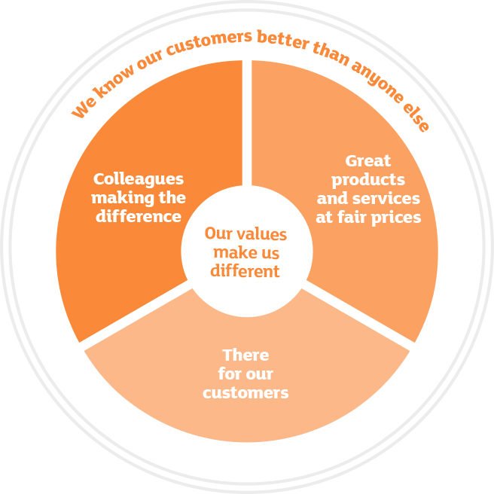

7. Appendix II
Customer perception of siansburys

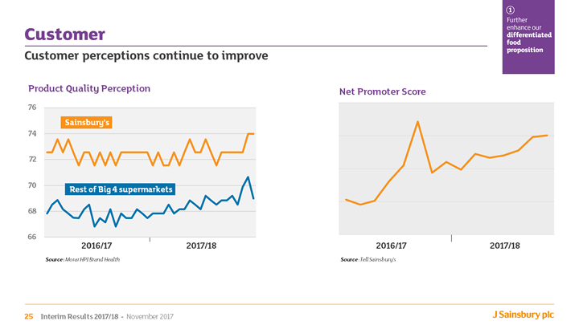

8. Appendix III
Market growth of Sainsbury’s


