Luke Cripps (P149407)
Turbo charger analysis
Powertrain Design and Efficiency

Table of Contents
Introduction 2
Background Research 2
Methodology 3
Results And Analysis 4
Conclusion 9

Introduction

The aim of this investigation is to choose an appropriate compressor from ones available for a turbocharged engine through calculations knowing the characteristics of the engine. As well as this, the anatomy of the turbocharger is looked at through the dismantling of turbocharger in a workshop environment.

Background Research

The first patent for a turbocharging system was applied for in 1896 by Swiss engineer Alfred Buchi, but the main use for turbochargers in the early 20th century was in the aviation industry. This is due to the turbocharger being able to provide boost to the engine as the air is less dense above sea level, where a normally aspirated engine would struggle. By the mid 1920s, turbochargers started being used in ships and trains. During the second world war, turbochargers leaped forward in its design and manufacturing aspects. When turbochargers started being brought into the automotive industry in the 1960s, they were unreliable and vehicles using this systems were recalled and sales of them were stopped. Moving forward a decade, the time of the first oil crisis, the advancement of the turbo technology meant the they could be used in commercial diesel vehicles. This also saw the start of turbochargers being used within motorsport, most notably formula 1. The future of turbocharged vehicles is not in danger for the time being, due to the credibility issues faced by hybrid and electric cars, and improved environmental impacts that turbo-diesel cards provide (Turbosmart, 2011).

A turbocharger is an air pump that takes air at atmospheric pressure, and compresses the air to a higher pressure, and then takes the compressed air to the engine via the intake valves on the intake manifold. The exhaust gases escaping from the exhaust manifold collide with turbine exhaust, which in turn makes the turbine on the compressor side turn via the connecting shaft. The air on the compressor side of the turbocharger hits the turbine, spinning at up 150000 rpm, where the air is fed through various pipes to the intercooler, where the air is cooled, increasing in density, where the air is then fed into the intake manifold to complete the combustion process. The diagram appendix 1 illustrates the process (Turbo Dynamics, 2018). Once the exhaust gases have served their purpose, they are vented out to the catalytic converter, and then out of the tailpipe to the atmosphere.

There are three important sections to a turbocharger; the turbine; the compressor; and the bearing system (Miller, 2008). The turbine component is comprised of two major parts; the turbine wheel and turbine housing. The turbine is the component that transfers the energy from the exhaust gases into mechanical energy via the rotation of the turbine wheel. For this reason, the design of the turbine is crucial to the efficiency and the effectiveness of the turbocharger.

The compressor component also has two major parts; the compressor wheel and compressor cover. The compressor has two functions. The first function is to raise the pressure in the intake, so that the combustion chamber would fill up more with air. The other function is to increase the density of the air. The increase in air density and the increase in intake pressure means that the engine can produce more power (IMechE, 2016).

The bearing system, supports the turbine shaft that links the turbine to the compressor. The design of the bearing is crucial to the operation of the turbocharger. The bearing system has a tough job, as it needs to support the turbine wheel and compressor wheel when spinning at 100000rpm or more, while surviving gyrations produced by the engine, which vary due to power output and engine speed. The bearing is located in the bearing housing, where there are other design features that are crucial to the performance of the turbocharger (Chris Hadfield, 2017).

Methodology

A turbocharger unit is straight forward machine to dismantle, but it is necessary to strip the turbocharger using the right method. To properly dismantle the turbocharger unit, the following steps need to be used, working with the correct equipment; ratchet; socket set and anal keys:

- Firstly take the exhaust manifold off the turbo actuator as it’s the bulkiest component and the easiest part of the turbo that can be separated from the entire unit.
- The next step is to remove the bracket that keeps the waste gate attached to the turbo housing.
- Now the v clamp that keeps the turbo housing and the actuator needs to undone and removed.
- After the clamp has been removed, the housing and actuator can be properly separated by undoing the bolts that hold the two parts together.
- The impela shaft can now be taken out of the turbo housing.
- The recirculate value, and the oil feed and return on the turbo housing can now be taken off by unscrewing the bolts using the anal keys.

The parts of the turbocharger mentioned above can be seen through appendix 2 to appendix 11.

Results And Analysis

To work out the correct compressor to use for the engine, there is some basic information that needs to be knows about the v8 engine:

Bore | 95mm
Stroke | 80mm
Engine Speed | 9500rpm
Volumetric Efficiency | 85%
Boost | 12psi
Table 1 - Basic information of the engine

First the volumetric flow rate for the normally aspirated engine needs to be calculated using the following equation:

$$V= \frac{v x η_{v} x N}{2 x 60}$$

V = Volumetric Flow Rate
v = Total Engine Displacement
$η_{v}$ = Volumetric Efficiency
N = Engine Speed

To work out the total engine displacement, the following equation needs to be used:

$$v= π x \frac{b^{2}}{4} x s x n^{'}c$$

b = Bore
s = Stroke
n’c = Number of Cylinders

Doing these calculations gives the total engine displacement as 4.536x10-3. Plugging this number into the first equation gives the volumetric flow rate of the normally aspirated engine of 0.305m3/s. To convert this value into cubic feet per minute, it needs to be multiplied by 2119. This then provides a value of 646.295cfm. This value then needs to be multiplied by the pressure ratio to get the volumetric flow rate for the turbo charged engine. The pressure ratio is calculated using the following equation:

$$PR= \frac{14.7+Boost}{14.7}$$

The calculated pressure ratio is 1.816326531. Now the volumetric flow rate for the turbocharged engine can be calculated by multiplying the normally aspirated volumetric flow rate by the pressure ratio just calculated. The value for this is 1173.883cfm. This value then needs to be converted to lbs/min as for the four compressor, this is the unit used on all the compressor graphs. This is done by multiplying the flow rate by 0.07, giving the flow rate of 82.172lbs/min. This value is then used on the compressor graphs so that the most appropriate one can be chosen.

To decide which compressor is the most appropriate to use for the turbocharger, on each one of the graphs, the value for the flow rate and the point at which it crosses with the pressure ratio needs to be marked. Then a line parallel with the x axis needs to be drawn until the value for half the flow rate has been reached. From there a diagonal line from that point to 20% of the flow rate going down to a pressure ratio of 1 needs to be drawn.

Looking at the brief, the T048 H-3 compressor and the T3 Super 60 compressor cannot be considered. This is due to both compressors not being able to withstand a volumetric flow rate of 82lbs/min, as the x axis for both graphs does not reached the desired flow rate. The following graphs illustrate the method mentioned above:

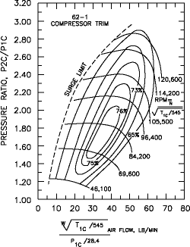
Figure 1 - The compressor map for 62-1 compressor

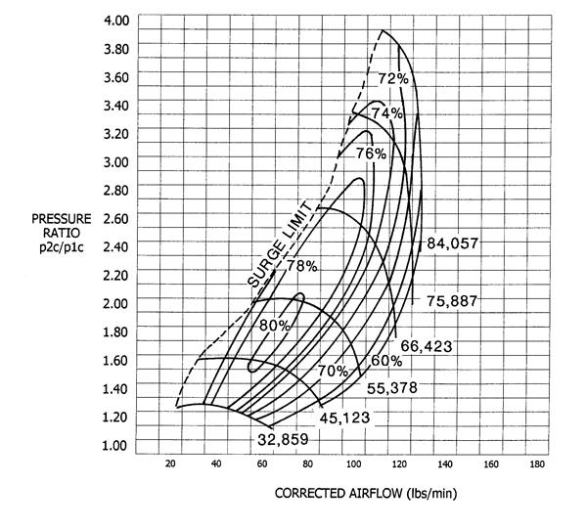

Figure 2 - The compressor map for the second compressor

From looking at these compressor maps, the 62-1 compressor in figure 1 provides a good efficiency for the midrange engine speed of the vehicle, however it does not provide any additionally effect to the output of the engine at the higher rpm range. This is due to the flow rate needed for the turbocharged engine being higher than the compressor can handle. Whereas the second compressor in figure 2 is able to handle the flow rate at the rev limit of 9500rpm, while still being able provide a good efficiency at the mid-range of the engine speed.

Now, actual temperature rise can be calculated using the given compressor efficiency taken from the compressor map in figure 2. To do this calculation, the following equation needs to be used:

$$ATR= \frac{{PR}^{0.28} x T_{in}- T_{IN}}{η_{c}}$$

ATR = Actual Temperature Rise
PR = Pressure Ratio
Tin = Inlet Temperature
$η_{c}$ = Compressor Efficiency
The compressor efficiency used is 78%, with the inlet temperature being the same as ambient temperature, 27’C (300 kelvin), with the pressure ratio being the same calculated earlier. The calculated temperature rise for the turbocharged engine is 69.955 Kelvin.

The temperature of the inlet of the intercooler can also be calculated using the following equation:

$$η_{i}= \frac{T_{co}- T_{io}}{T_{co}- T_{a}}$$

$η_{i}$ = Intercooler efficiency
$T_{co}$ = Temperature at the outlet of the compressor
$T_{io}$ = Temperature at the outlet of the intercooler
$T_{a}$ = Ambient temperature

Firstly, the temperature at the outlet of the of the compressor needs to calculated using the following equation:

$$T_{out}= {PR}^{0.28} x T_{in}$$

$T_{out}$ = Outlet temperature
$T_{in}$ = Inlet temperature

The pressure ratio is the same as calculated earlier, with the inlet temperature being the same as ambient temperature (300K). This gives the outlet temperature as 354.565K. This value is then used in the equation above, but the equation needs to be rearranged to get Tio as the subject:

$$T_{io}= T_{co}- η_{i} ( T_{co}- T_{a} )$$

This then gives a temperature for the outlet of the intercooler of 321.826K.

Attention then turns to estimating the internal area of the intercooler needed for the turbocharged engine to provide assistance in the cooling of the air entering the intake manifold. To aid in the estimation of the internal area needed, the following graph is used:

Figure 3 - A graph showing the relationship between volumetric flow rate and internal area for the intercooler

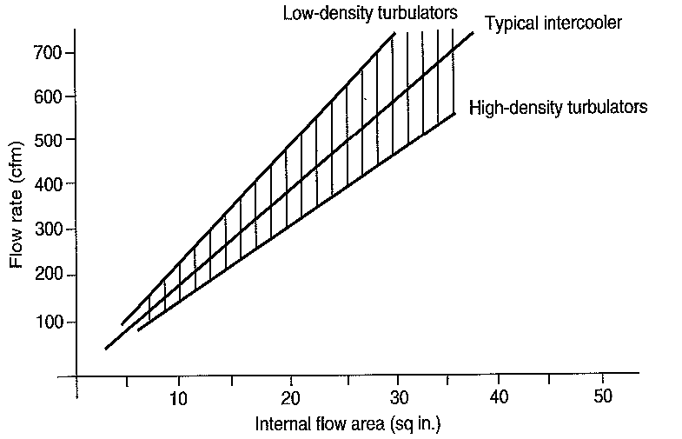
To work out the internal flow area needed for the intercooler, firstly, the gradient for the graph above needs to be worked out. To do this, two points on the graph need to be taken, so that the change in the y axis and the change in the x axis can be calculated which represents the gradient. After doing this, the calculated gradient is 19.355. From this, the volumetric flow rate for the turbocharged engine can be used with the gradient to estimate the required size of the internal area of the intercooler. Doing this gives the estimated internal area of the intercooler as 60.604 sqin. The working for all the methods mentioned above can be seen in appendix 12 and appendix 13.

In order to convert this naturally aspirated engine to a turbocharged engine, there are many components inside the engine that would need to be changed, to deal with the increased power output. The conrods would have to be changed to deal with the increased load applied to them, as well as the pistons and other major components that help with the complete combustion of the fuel and air mixture in the engine. Additionally, the ecu for the vehicle would have to be changed or reprogrammed so that the emissions, fuelling and injection of the car can be monitored and then the occupant of the vehicle can be alerted to a problem if it arises.

Conclusion

Looking at all the available information mentioned above, the most appropriate compressor to use with the turbocharged v8 engine is the compressor seen in figure 2. This compressor provides a good compressor efficiency at the engine’s rev limit, but still provides a similar standard for efficiency lower down the rev range. The other three compressors that could have been chosen did not have the appropriate compressor efficiency needed for the engine at the higher engine speeds. However, as the engine in question is a v8, a twin turbo systwm could be used instead of a single turbo. This would mean that the other compressors that were not considered in the results and analysis section could be looked at to see if they would operate better than the one chosen for the single turbocharger system.

Bibliography

Asif Faiz, C. S. (1996). Air Pollution from Motor Vehicles: Standards and Technologies for Controlling Emissions. World Bank Publications.

Chris Hadfield, R. N. (2017). Today's Technician: Automotive Engine Repair & Rebuilding, Classroom Manual and Shop Manual. Cengage Learning.

Filipi Z, W. Y. (2001). Effect of Variable Geometry Turbine on Diesel Engine and Vehicle System Transient Response. SAE International.

Frigo S, P. G. (2014). Numerical Evaluation of an Electric Turbo Compound For SI Engines. SAE International.

IMechE. (2016). 8th Interntaional Conference On Turbochargers and Turbocharging. Elsevier.

Miller, J. K. (2008). Turbo: Real World High-Performance Turbocharger Systems. CarTech Inc.

Mutta S, S. N. (2016). Thermodyanic Study of Turbocharger Matching and Combustion Optimization for Better Low End Torque and High Speed Power. SAE International.

P, F. (1979). Turbocharging Four-Cycle Diesel Engines. SAE International.

Tennant D, W. B. (1989). The Turbocompound Diesel Engine. SAE International.

Turbo Dynamics. (2018). How Does A Turbocharger Work. Retrieved from https://www.turbodynamics.co.uk/technical/understanding-turbochargers/

Turbosmart. (2011, September 19). History of Turbocharging. Retrieved from www.turbosmart.com/news/history-of-tubrocharging

Appendix
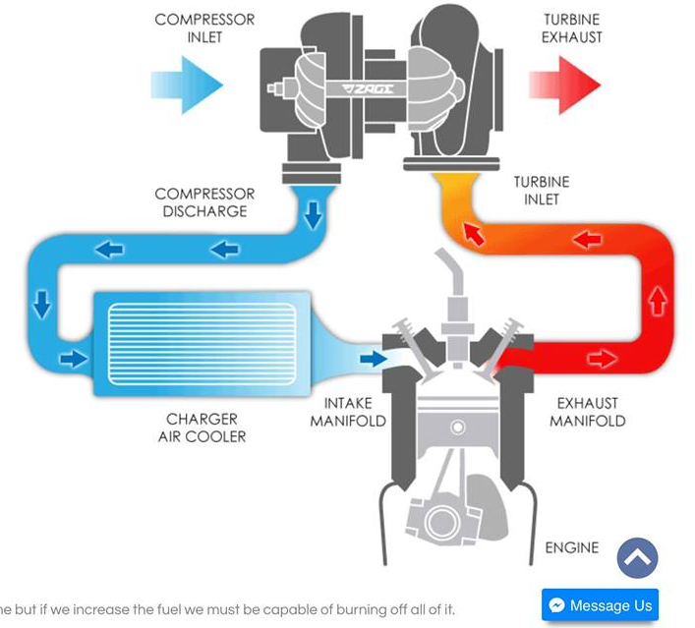
Appendix 1 - The airflow for a turbocharged engine

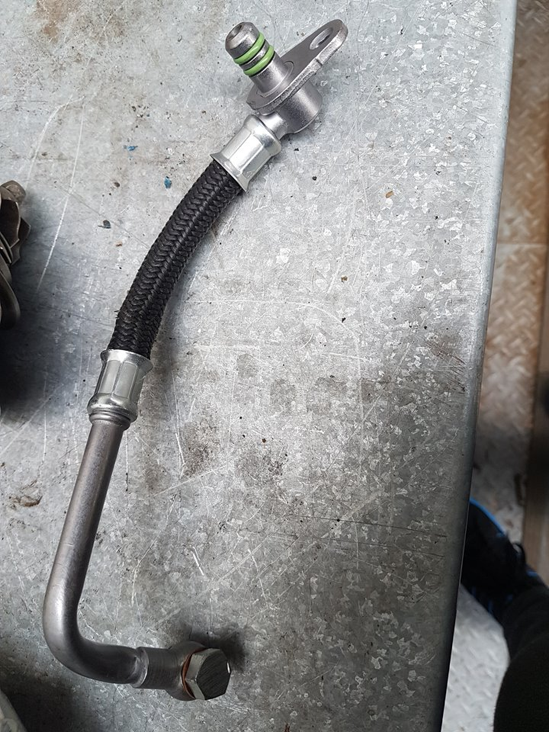
Appendix 2 - The oil return for the turbocharger
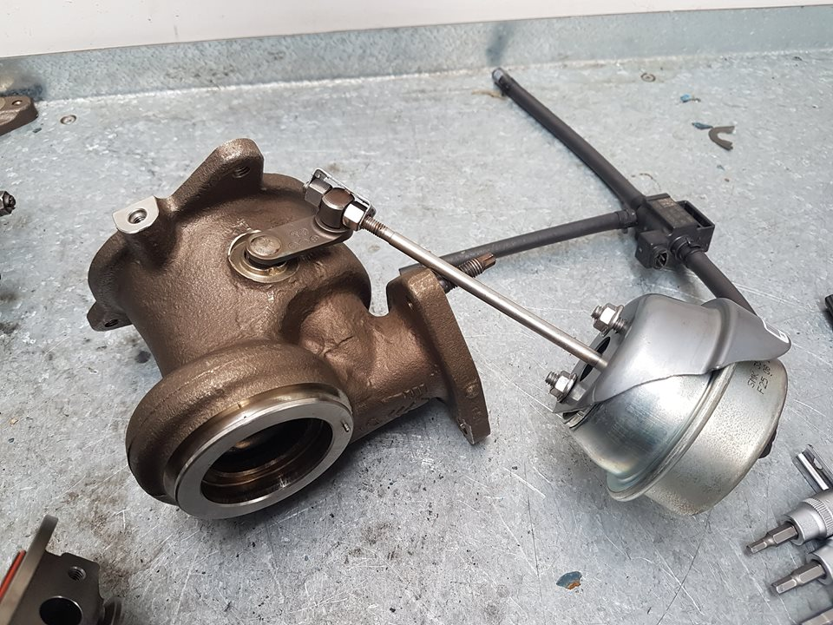
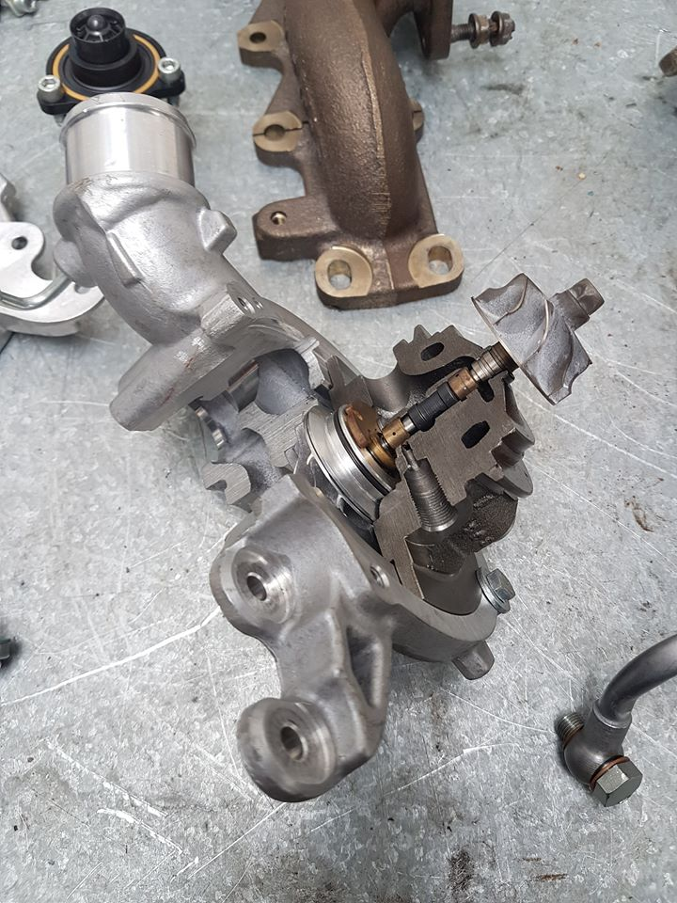
Appendix 3 - The turbo actuator and waste gate
Appendix 4 - The location of the compressor inside the turbocharger

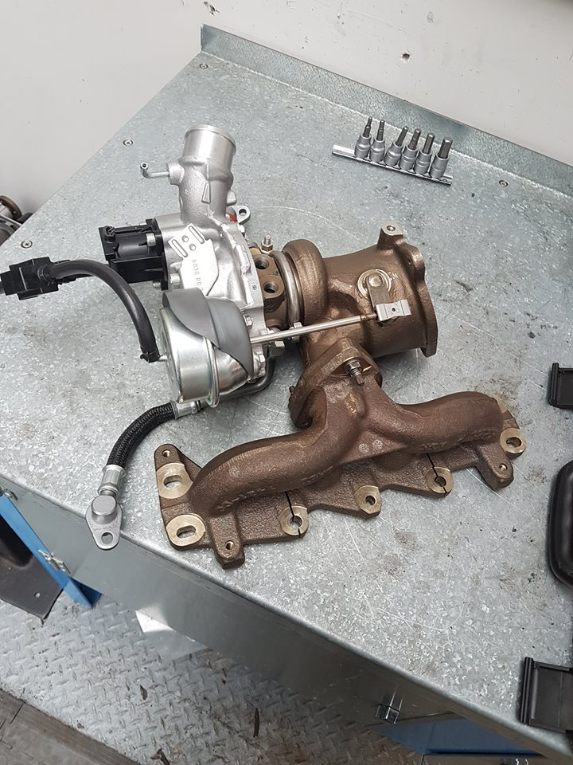
Appendix 5 - The assembled turbocharger
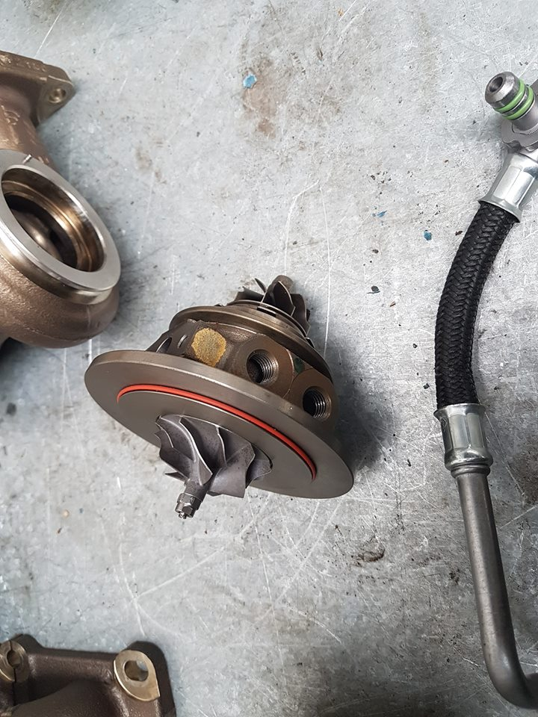
Appendix 6 - The impela shaft of the turbocharger
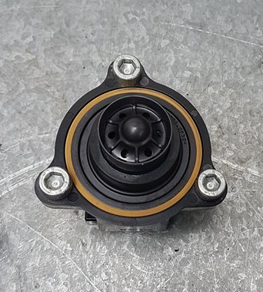
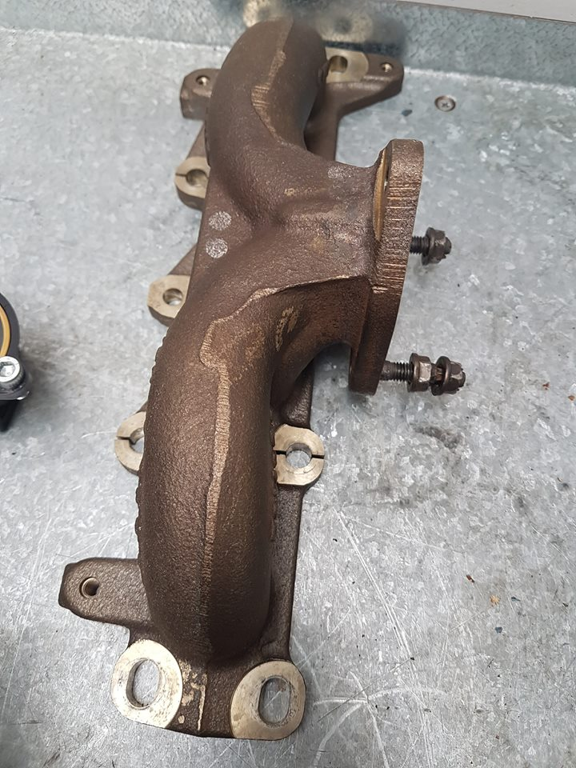
Appendix 8 - A recirculate valve
Appendix 7 - The exhaust manifold
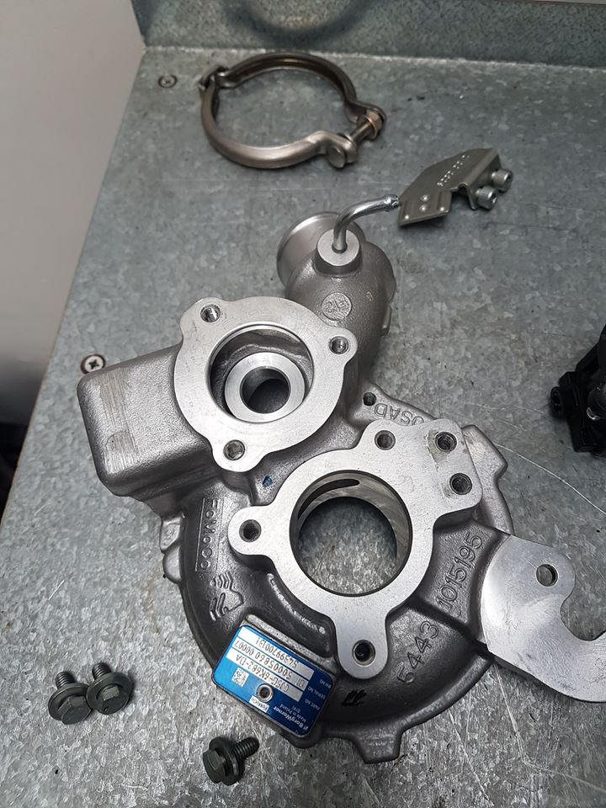

Appendix 10 - The turbo housing
Appendix 7 - The V clamp that holds the actuator and turbo housing together

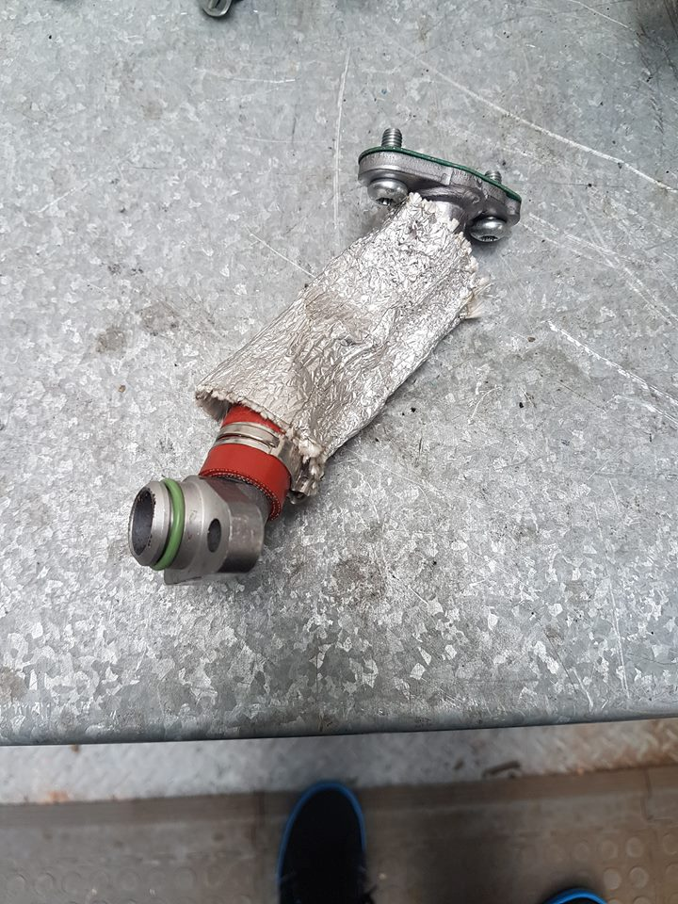
Appendix 11 - The oil feed

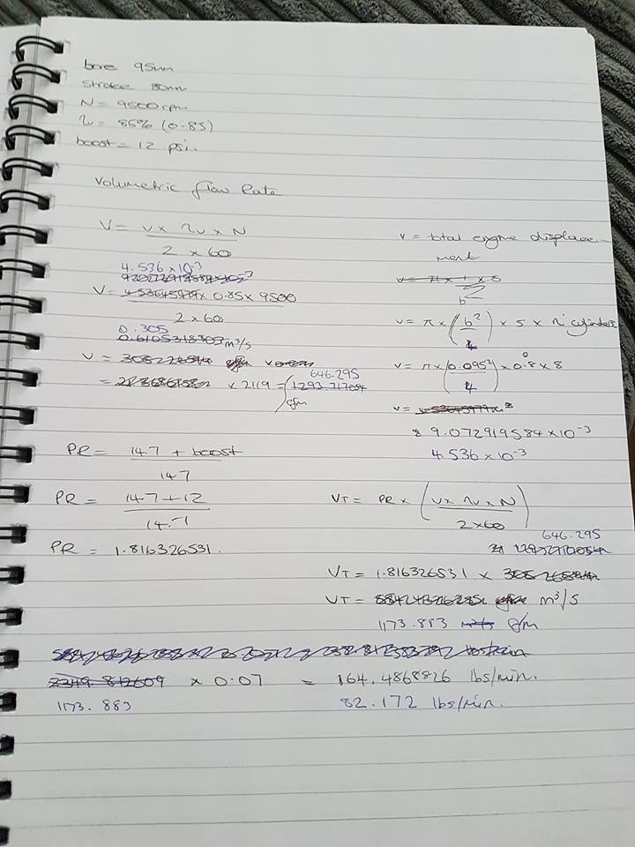
Appendix 12 - Calculations for the results and analysis section

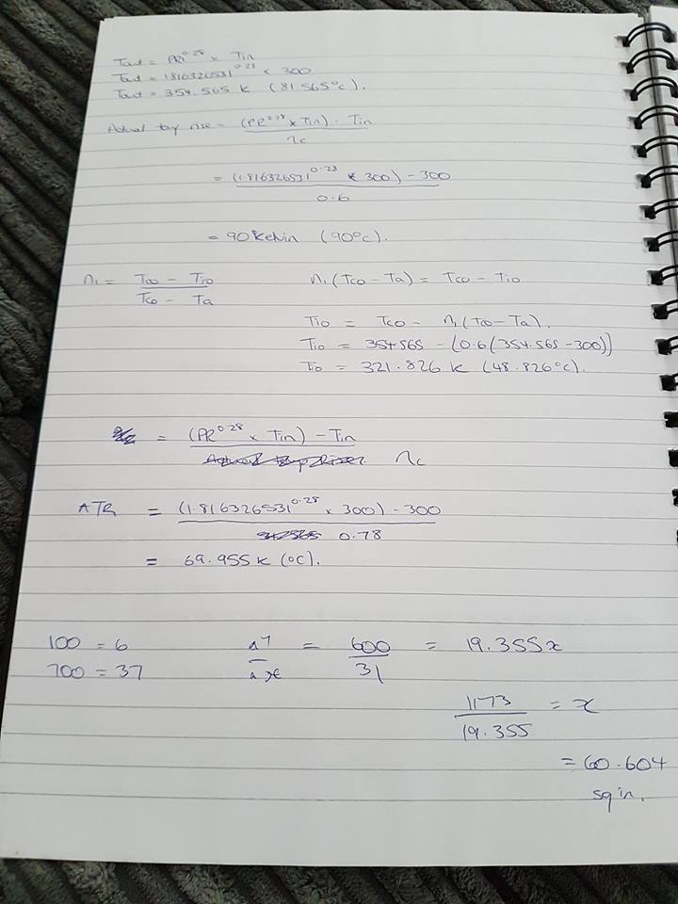
Appendix 13 - Calculations for the results and analysis section

