UWTSD
WISA


Engineering Technical Report
Workshop and Practise
ACHA4011

Callum Francis-Beck
2312005
1/12/24

Table of Contents
1 Introduction 2
2 Chapter 2 Health and Safety 3
3 Chapter 3 - Engineers’ Role in Society 4
4 Chapter 4 - Problem Solving 5
5 Chapter 5 - Team Structure 7
6 Chapter 6 Personal Development Plan 9
7 Conclusion 10&11
8 References 12

No table of figures entries found.

Introduction
The purpose of this paper is to give an overview of health and safety, sustainability, and problem-solving issues that engineers face every day. From wearing specific PPE in workshops and looking at risk assessments and determining what is high and low risk, to discussing how we deal with sustainability and environmental issues that surround the end product they are trying to create and how engineers use certain skills and processes to help with development, market and supplier issues.

Chapter 2 Health and Safety
While in the workshops at the university, many PPE items are required to enter and work in each room. Each room has different requirements; some require only steel-toe cap boots while others require goggles or overalls. The machine workshop requires PPE such as steel toe cap boots, goggles, and clothing covering arms and legs. These must be worn at all times due to fine pieces of hot metal that might come from the machines such as the lathe and the mills. According to the HSE (2004) the most common accidents that occur while using a mill/lathe come from the user not wearing goggles while operating the machines and while clearing away the swarf. Another common cause of injury mentioned is entanglement while working near the machine while it is operating (HSE, 2004).
Usually, the work carried out in workshops are generally covered by the Provision and Use of Work Equipment Regulations 1998 (PUWER), these regulations make sure that equipment used for working purposes is suitable for the task set, it also mentions that protective devices should be in place such as guards, emergency stop switches and other forms of energy isolation so that the machine can be shut off in the event of emergency.
Also, under PUWER it states that the person operating the machinery should be responsible for ensuring the work equipment is all in working order that it is maintained correctly, and that any damage or misuse is reported immediately to avoid injury. (HSE, 2024)
Below is an example of a health and safety matrix that was taken directly from the manufacturing workshop. This would be used while creating a risk assessment. Green, Yellow, and Red boxes represent the level of risk associated with each task, it also shows the severity level of the task and the impact the risk could have, and using that determines the risk level colour in the box.
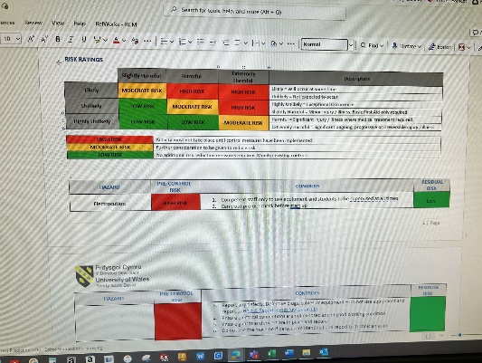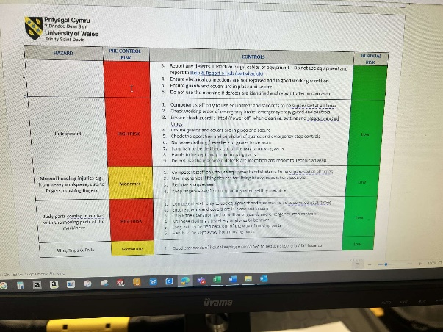
As is shown by the second image, control measures have been put in place to bring the severity level of the task down to as low as possible to minimize risks in the workshop. Things like reporting defects in equipment, good housekeeping to keep areas clean and free from anything that might cause slips, trips, and fall hazard as well as not wearing loose clothing, jewelry, or gloves to avoid entrapment in the machines. These are just three examples out of the many listed in a risk assessment.

Chapter 3 - Engineers’ Role in Society
An engineer has a very important role in society due to the power they have to create new ways to become sustainable in their field of work, The Engineering Council states in their code of conduct, engineers should know that the impact of their work will not only be local and immediately effective to them but could effect the entire planet and may last for a long time and might surpass several supply chains, engineers must also understand the full effects of sustainability across the life span of products and processes. During the design stage engineers can reduce the material usage using specific processes (Engineering Council, 2023).
World Federation of engineering organizations (WFEO) has published their own in-depth code of conduct for engineers, in the article they highlight many options for sustainability such as being able to continuously improve your knowledge surrounding the environmental stewardship and related issues in your area of expertise as well as working with experts to assess areas where you could be lacking knowledge for environmental and sustainability matters. (WFEO, 2013)
Both codes of conduct are quite vague and cover a wide range of engineering issues, but you can relate them back to motorsport for example bringing in experts to help reduce the carbon footprint of motorsport.

Chapter 4 - Problem Solving
Engineers face many problems when developing new vehicles or parts, there are many examples of this while going through the material selection process, engineers must make sure the materials selected are suitable for the job, this means they have to be sustainable and environmentally friendly if possible or they should only use what they need to ensure there is no unnecessary waste.
While still in the development process engineers must think of the risks associated with the product they are developing as safety and reliability is key to the sale of the product. (Spires, 2024)
Once the product is on the market engineers continue to research and develop improvements to the current product or start the development process again with new iterations of the existing product.
One example of dealing with a product while on the market is carrying out recalls on vehicles that are being sold. Sometimes, due to safety concerns engineers have found, cars will be called back into the factory to be improved like Toyota had to do in 2022 over concerns that their BZ4X electric vehicles curtain airbags and wheel hub bolts (Birch, Griffiths, 2023).
When producing a product engineers may face a problem along the supply chain which can cause delays and issues getting the product ready for market, solve this requires good communication with suppliers, phone calls and meetings will help the understanding of the supply issues, if the time schedule is tight then other options can be explored like finding another company to deliver the product or even find a different supplier altogether. (Amrepinspect, 2024)
The flow chart below shows the process that may be taken to solve certain issues.

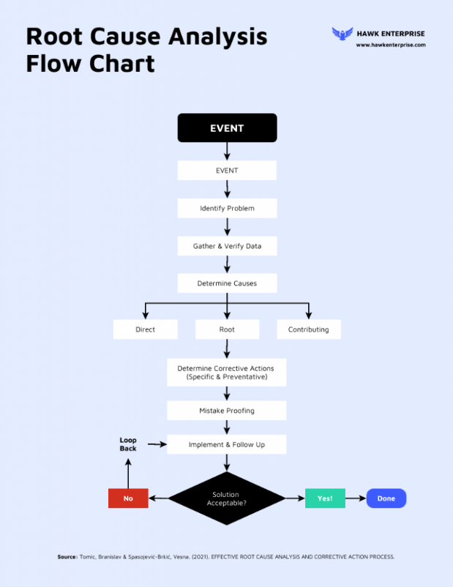

(Venngage, 2024)

Chapter 5 - Team Structure
During my time in my previous job as an electrician before starting university, most of the jobs we had were very teamwork orientated. One time while working at Rolls Royce, in Bristol, we were tasked with installing a very large power supply cable across the factory floor. This took a lot of organization and teamwork to complete. We worked to a “hierarchical structure” to get the job done, so in the leadership role was the supervisor, who organized the route the cable was going, the time of day that best fit the workers of the factory and the way the teams were set out. In total we had 3 teams, team 1 was pulling the cable off the reel and feeding it up to Team 2 who were the main communicators and were controlling the flow of the job, and then Team 3 was on the other end receiving the cable. This proved to be very effective and efficient as the job was done quicker and better than expected, some improvements could have been made as the communication broke down over long distances as the cable was pulled further. We could have solved those issues with the use of a two-way radio to communicate over the distance.

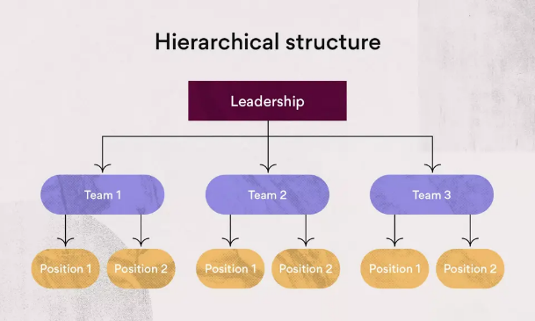

(Asana, 2024)
Upon carrying out research I cannot find another structure that would be useful for the same job, however from an engineer’s perspective I find the “matrix structure” would work well for a team environment as it has multiple leaders for each department, team members can report to either the team leader or the head of the department, this could improve efficiency and communication as team members have the option to talk to either the team leader or the head of the department to discuss any issues that arise (Asana, 2024).
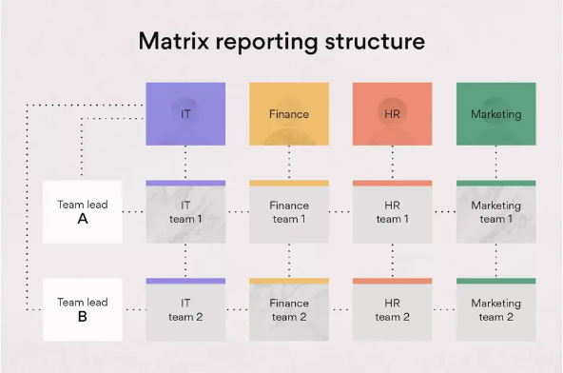

(Asana, 2024)
A negative example of teamwork that could have benefitted from a good team structure is the foundation year project on designing a soapbox. There was no leadership to keep tabs on what our progress was looking like. We decided between ourselves who was doing what task and our team progress was slow and unsteady. If we followed the hierarchal structure, progress would have been more efficient as the team leader would be able to check on each team individually and would have been able to place us in our teams according to what strengths we have. For example, my main strength is not illustrations, but I was tasked with sketching our designs for the CAD team to use to create a CAD model.

Chapter 6 Personal Development Plan

Name – Callum Francis-Beck
Degree – Motorsport Engineering HND
Previous Qualifications – City & guilds Electrical installation, grade C in maths, science and English, merit in creative media, B in computer science
Previous Experience – No previous motorsport experience, Electrician 7 Years
Long Term Goals (5 to 10 years)
Work my dream job as a motorsport engineer.
Short Term Goals (0 to 5 years)
Complete my degree with the highest possible grade.

Goal | Objective | Resources Required | Measurement | Target Date
Pass maths resit in January. | Gain above 40%in exam. | Revision | Practice tests to see progress | January 2025
Gain more knowledge and understanding of how a motorsport team works. | Spend more time around the MCR team | Access to workshops and competent people | Document what I've learned each day | ASAP
Improve media skills to help the MCR. | Take more photos at race weekends. | Personal camera equipment | Engagement from social media | ASAP

Conclusion
Throughout this paper, many points have been raised around subjects such as what an engineer does in society for sustainability and environmental awareness. Also including common health and safety legislation and risk assessments regarding working in a machine-heavy environment. Team structure methods such as the matrix style and the hierarchy style along with problem-solving methods surrounding development, market and supplier issues were discussed. Also included is an example of a personal development plan which is helpful to understand goals and how to achieve them whilst helping to comprehend the importance of time scales that have been set.

References
Amrepinspect. (2024) troubleshooting tips: dealing with unreliable or inconsistent suppliers [online] Available at: https://medium.com/@amrepinspect5/troubleshooting-tips-dealing-with-unreliable-or-inconsistent-suppliers-cb98947149f4 [Accessed 29th November 2024]
Asana, Inc (2024) Team structure:10 effective ways to organize your team [online] Available at: https://asana.com/resources/team-structure [Accessed 25th November 2024]
Asana, Inc. (2024) What is a matrix structure, and how does it work? [online] Available at: https://asana.com/resources/matrix-organization [Accessed 25th November 2024]
Health and Safety Executive (HSE). (2004) Health and safety in engineering workshops HSG129 [online] Available at: https://www.hse.gov.uk/pubns/priced/hsg129.pdf [Accessed 25th November 2024]
Health and Safety Executive (HSE). (2024) Provision And Use Of Work Equipment Regulations 1998 (PUWER)- Overview [Online] Available at: https://www.hse.gov.uk/work-equipment-machinery/puwer-overview.htm [Accessed 25th November 2024]
Birch, R., Griffiths, H. (2023) Car recalls explained: what should you do if you get one? [online] Available at: https://www.autoexpress.co.uk/car-news/105055/car-recalls-explained-what-should-you-do-if-you-get-one [Accessed 28TH November 2024]
Venngage. (2024) Root cause analysis flow chart template [online] [image] Available at: https://venngage.com/templates/diagrams/root-cause-analysis-flow-chart-3305b690-f43f-4989-9b02-bc9e88719a1b [ Accessed 28th November 2024]
WFEO. (2013) WFEO Model Code of Practice for Sustainable Development and Environmental Stewardship [online] Available at: https://www.wfeo.org/wp-content/uploads/code-of-practice/WFEOModelCodePractice_SusDevEnvStewardship_One_Page_Publication_Draft_en_oct_2013-3.pdf [Accessed 26th November 2024]

