Data Analysis and Visualisation
Assessment 2 t-Test June 2021 Term 1 and Term 2

Student: Gabor Gulyas (20299954)
Class: BSc Cloud Computing June 2020/2021
Lecture: Koushik Modak
Date 02/09/2021

Table of Contents

Cover 0
Table of Contents 1
Introduction 1
Description of the dataset 2
Visualisation of the dataset 6
Analysis 6
Outliers in the dataset 8
Results 9
Conclusion 9
References 10

Introduction
A t-test is a measurable test that is utilized to analyse the method for two gatherings. It is normal utilized in theory testing to decide if an interaction or treatment affects the number of inhabitants in interest, or regardless of whether two gatherings are not quite the same as each other.

Description of the dataset

A Data set is a set or assortment of information. This set is typically introduced in a plain example. Each section depicts a specific variable. What's more, each column compares to a given individual from the informational collection, according to the given inquiry. This is a piece of information for the executives.
Informational indexes depict values for every factor for obscure amounts like tallness, weight, temperature, volume, and so forth of an item or upsides of irregular numbers. The qualities in this set are known as a datum. The informational index comprises information of at least one individual relating to each line.

Dataset Meaning
An informational index is an arranged assortment of information. While dealing with the information, the informational index can be a lot of tables, blueprints and different articles. The information is coordinated to a specific model that assists with preparing the required data. The arrangement of information is any for all time saved assortment of data that normally contains either case-level, accumulated information, or factual direction level information.

Types of Data Sets
In Statistics, we have different types of data sets available for different types of information. They are:
- Numerical data sets
The mathematical informational collection is an informational collection, where the information is communicated in numbers instead of regular language. The mathematical information is in some cases called quantitative information. The arrangement of the multitude of quantitative information/mathematical information is known as the mathematical informational index. The mathematical information is consistently in the structure of the number, with the end goal that we can perform a number-crunching procedure on it.
- Bivariate data sets
An informational index that has two factors is known as a Bivariate informational index. It manages the connection between the two factors. Bivariate dataset typically contains two sorts of related information.
- Multivariate data sets
The dataset with various factors. When the dataset contains at least three than three information types (factors), then, at that point the informational index is known as a multivariate dataset. As such, the multivariate dataset comprises individual estimations that are gained as a component of at least three than three factors.
- Categorical data sets
Absolute informational collections address elements or attributes of an individual or an article. The all-out dataset comprises of an all-out factor likewise called the subjective variable, that can take precisely two qualities. Subsequently, it is named as a dichotomous variable. Unmitigated

information/factors with multiple potential qualities are called polytomous factors. The subjective/unmitigated factors are regularly thought to be polytomous variables except if in any case indicated.
- Correlation data sets
The arrangement of qualities that exhibit some relationship with one another demonstrates correlation informational collections. Here the qualities are observed to be subject to one another. For the most part, a connection is characterized as a factual connection between two substances/factors. In certain situations, you may need to anticipate the relationship between things. It is fundamental to see how connection functions. The correlation is grouped into three sorts. They are:
- Positive correlation – Two factors move a similar way (Either both are up or both or down)

- Negative correlation – Two factors move in inverse ways. (One variable is up and another variable is down as well as the other way around)

- No or zero correlation – No connection between two factors.

Mean, Median, Mode and Range of Data-Sets
The mean, median and mode alongside range are the significant themes in Statistics. Allow us to get past informational collections here.
Mean of a data set collection is the normal of the multitude of perceptions present in the table. It is the proportion of the number of perceptions to the all-out number of components present in the informational index. The equation of mean is given by;
Mean = Sum of Observations/Total Number of Elements in Data Set
Median of an informational index is the centre worth of the assortment of information when organized in climbing requests and dropping requests.
Mode of a data-set is the variable or number or worth that is rehashed the greatest number of times in the set.
Range of a data set is the distinction between the greatest worth and least worth.
Range = Maximum Value – Minimum Value

- Median of a data-set: 43,5
- Mode of a data-set: 50
- Range of a data-set: 87

- Identify Independent sample/paired sample
Sample 1 white people, sample 2 BAME. No relationship between, different values, randomly we can select values and in this case, we need to use an independent (two)sample.

- Write your Null and Alternative Hypotheses. The concept of the hypothesis, developing null and alternative hypothesis:

Null Hypothesis: BBC news, it has been identified that the infection rate of Covid-19 is the same ratio between white and BAME in the UK
Alternative Hypothesis: BBC news, it has been identified that the infection rate of Covid-19 is varied between white and BAME in the UK

- Calculate the degree of freedom Df=(N-2=n1+n2-2=50+50-2=98) Df=98

- Calculate t-obt value:

First, we need to collect all details that we have and we need to count the mean:

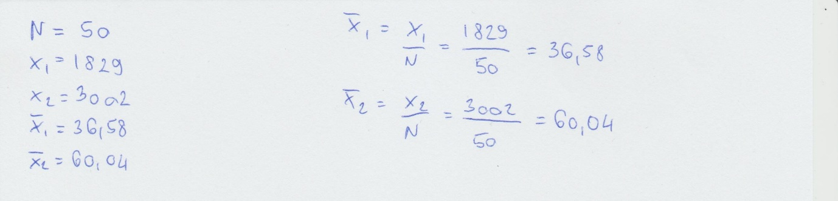
After when we know both of the means, we need to go and make both variance Standard Deviations:
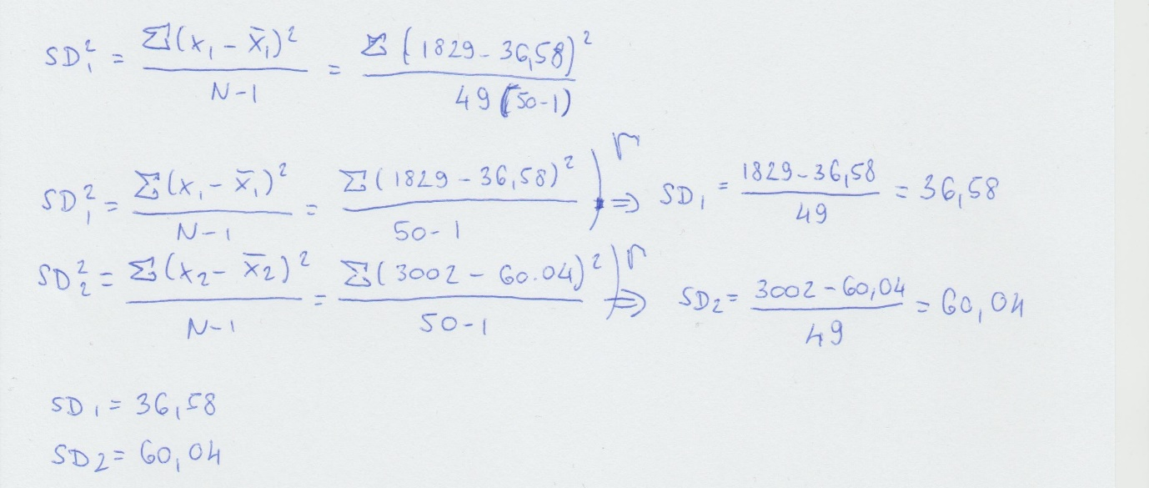

So now we know Standard Deviations1=36.58 and Standard Deviations2=60.04 we can now can do t-obt formulas:

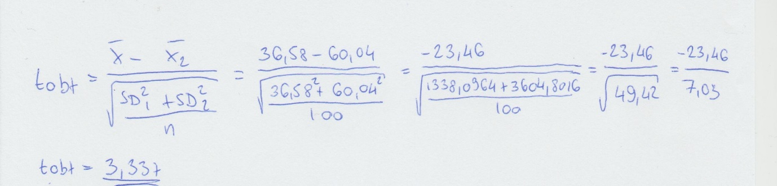

T-test mean:
The t-test is a hypothesis test used by the researcher to compare the population average of a variable, which is divided into two categories depending on the interval less. More specifically, a t-test is used to examine how the devices taken from the two independent samples differ from each other. The T-test follows the t-distribution, which is appropriate when the sample size is small and the standard deviation of the population is unknown. The shape of the t-distribution is greatly influenced by the degree of freedom. The degree of freedom includes the number of independent observations in a given series of observations.

Have a looking this situation:

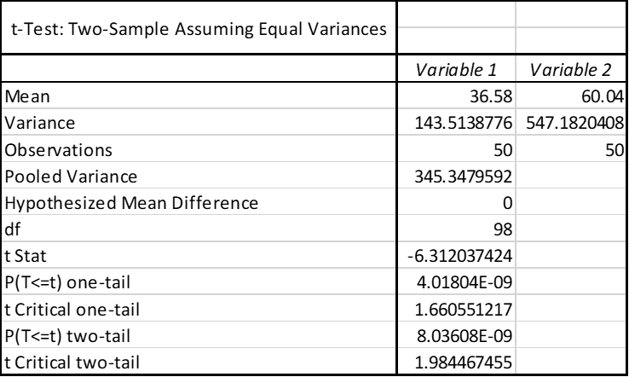

The age of the theory is the start of a logical cycle. It alludes to speculation, in light of thinking and proof. The specialist looks at it through perceptions and tests, which then, at that point gives realities and figure potential results. The theory can be inductive or deductive, straightforward or perplexing, invalid or option. While the invalid theory is the speculation, which is to be tried, though elective speculation gives an option in contrast to the invalid theory.
Invalid theory infers an explanation that anticipates no distinction or impact. In actuality, an elective theory anticipates some distinction or impact. Invalid theory This article extracts shed light on the principal contrasts among invalid and elective speculation.

Visualisation of the dataset
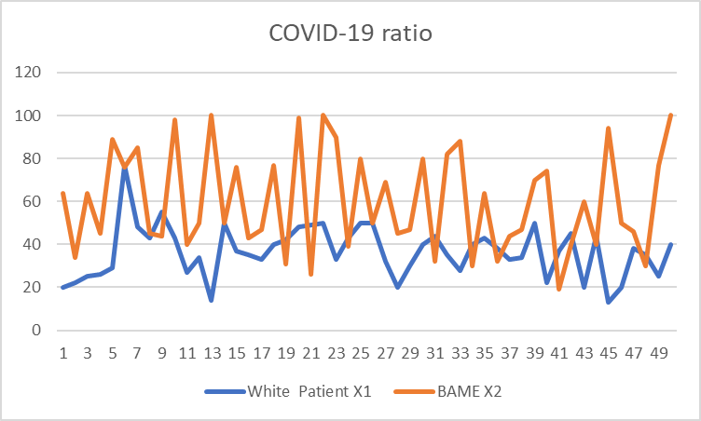

In these two graphics is easy to show you, how much difference between the two types of patient. BAME people are got infected normally age between 40 and 80, the white patient is been infected mostly between 30 and 50 and is got some young patient value what you can see in the second diagram line

a patient there under 20 what makes confuse because the task description writes: „All the patient age is between 20 and 100 years.

Analysis

After we have been done the t-Test even different values of the t-Test we need to make a hypothesis again.

Null Hypothesis: BBC news, it has been identified that the infection rate of Covid-19 is the same ratio between white and BAME in the UK this one we need to reject because t critical what is 1.988 is lower like t-obt what is values is 3.337

Alternative Hypothesis: BBC news, it has been identified that the infection rate of Covid-19 is varied between white and BAME in the UK, so this is Alternative Hypothesis.

We need to still test in different p values situations to where is the t-obt is still=3.337

In this situation, the Null Hypothesis needs to reject too because still lower the value of the t Critical(1.660551) like the t-obt(3.337) but we can call still Alternativ Hypothesis.

In this situation, we can call Null Hypothesis because the higher the value of the t Critical(3.392588) like the t-obt(3.337) and the Alternativ Hypothesis is opt-out.

This is about the same as the first two, not enough high the t Critical level to stand like a Null Hypothesis and this way this is another Alternative Hypothesis.

Outliers in the dataset

Outliers mean:
An anomaly is a perception that lies an unusual separation from different qualities in an irregular example from a populace. One might say, this definition surrenders it to the expert (or an agreement cycle) to choose what will be considered unusual. Before unusual perceptions can be singled out, it is important to describe ordinary perceptions.
Approaches to depict information: Two exercises are fundamental for describing a bunch of information:
- Assessment of the general state of the diagramed information for significant provisions, including balance and takeoffs from suspicions. The part on Exploratory Data Analysis (EDA) examines suppositions and synopsis of information exhaustively.

- Assessment of the information for strange perceptions that are far taken out from the mass of information. These focuses are regularly alluded to as anomalies. Two graphical strategies for distinguishing exceptions, disperse plots and box plots, alongside a scientific system for identifying anomalies when the conveyance is ordinary (Grubbs' Test), are additionally talked about exhaustively in the EDA section.

lower inner fence: White patient 27.75 BAME 42.25
upper inner fence: White patient 44 BAME 80

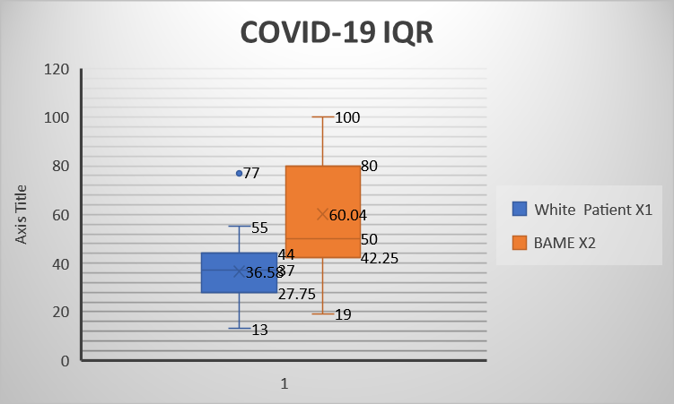

Results

Coronavirus contamination rate for the particular race of the populace that is white and BAME. The dataset has a similar example size which has made a solid base for the examination. In the wake of directing theory testing, one can say that there is no reliance on the number of inhabitants in a specific race among one another for the spread of contamination. The thought of exceptions has characterized the skewness among the information which is bigger for BAME. Then again, the change distinction is very huge among the two sets which additionally dismisses the invalid theory.
This additionally demonstrates that each set of races has their unmistakable disease pace of Coronavirus which relies upon inner elements and no outer components. These interior components can be their way of life, cleanliness, and absence of precautionary measures.

Conclusion

The given task depended on utilizing one such device of information examination for the Coronavirus related information that is speculations trying. The given dataset has been investigated utilizing enlightening measurements, speculation testing, and anomalies. The task gives the point-by-point part of speculations examination of the dataset in a most extreme exploratory way. The thought of Coronavirus contaminations steers clears the race of individuals, except for the way that shows their cleanliness and way of life.

References

- Mezei Istvan, Farago Istvan, Simon Peter- Bevezetes az analizisbe
- Dr. Gaspar Csaba – Analízis (2004)
- Gonda Istvan, Dr. Nemeth Jozsef – Bevezetes az Analizisbe (2011)

