BEng Motorsport Technology
Engine Performance Characteristics

Joe Howard
2100922

University of Wales Trinity Saint David
School of Engineering

Motorsport Engineering BEng (HONS)
20/03/2023
Contents

Introduction – 3

Equipment – 4

Methodology – 6

Spreadsheet data – 7

Graph Analysis – 8

Test Conclusions – 10

Performance and Test Evaluation – 11

References - 12

Introduction

The aim of the test was to get an in depth understanding of how an engine performs on a dyno. This includes how changing the throttle input has an impact on fuel consumption, overall efficiency and on power. The aim was to understand how to calculate important factors relating to performance from basic engine data such as RPM, fuel flow and power output. The dyno session is also important as it will educate the team about the dangers of engines, fuels, and harmful gasses. Using an engine dyno can be very dangerous so precaution must be taken. The last aim was to understand how this specific dyno records engine power. Another goal was to understand how an engine dyno differs from a rolling road setup for cars.

Equipment

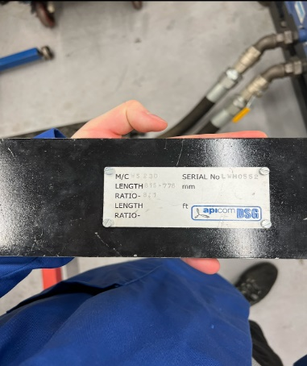

Figure 1 shows the load arms from the dyno. They have a specific length and weight which are used in calculations for power and torque. They sit above the load cells and help record the twisting force produced by the engine.

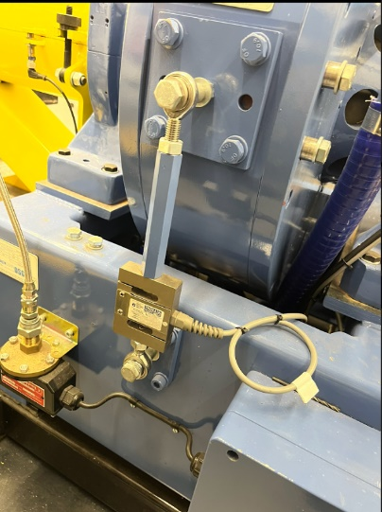
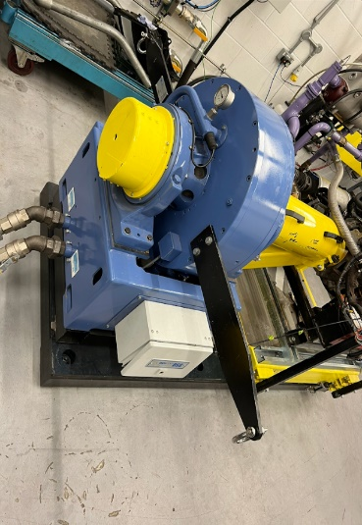
Figure 3
In figure 2 it is possible to see the two load arms on the dyno. The yellow shaft on the dyno is what is connected to the crankshaft of the engine. The dyno has several coolant pipes entering from the left.
Figure 2
Figure 1
Figure 3 shows the load cells on either side of the dyno. The load cells are responsible for recording the twisting force that the engine produces. It does this by using sensors which detect the sensors either compressing or extending. This measurement is then converted into Kilowatts.
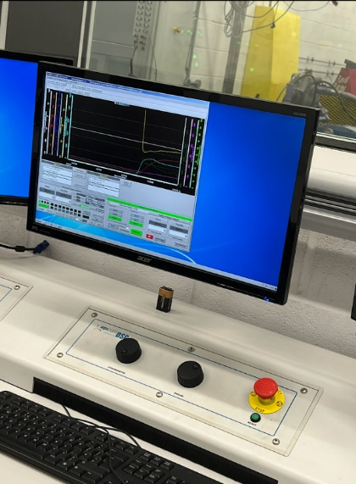

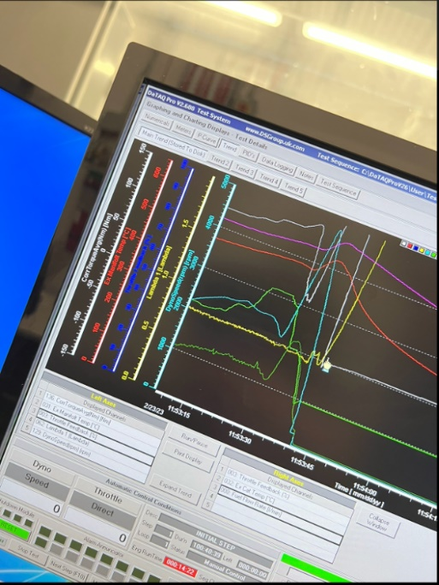
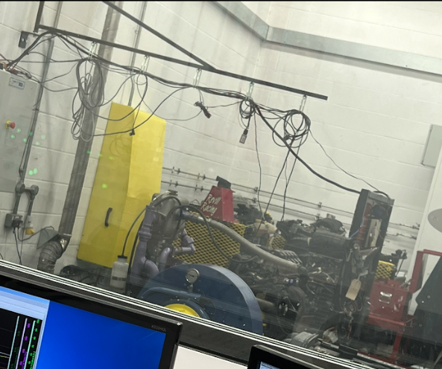
Figure 6
Figure 5
Figure 4
Figure 6 gives a close up of the data collected from the dyno. The data can be exported to excel, and it can be used to calculate values such as efficiency and SFC. The light blue line is engine speed, the yellow line is the lambda reading, The dark blue line is Throttle feedback, the red line is exhaust manifold temperature and the white line is Torque. It is possible to adjust the fuel flow and timing and see how the graph lines change.
This figure shows the engine hooked up to the dyno. The overhead wires are the ancillaries for the engine such as spark plugs and various sensors. The right panel contains the ecu and ignition system for the car.
Figure 4 shows the controls for the dyno. The panel has dials to change engine rpm and dyno resistance. These are used to observe how much load the engine can produce before stalling. There is an emergency stop button next to it which will cut fuel and stop the dyno safely.
Methodology

- Preparing the dyno – Check over the engine to ensure that all the ancillaries are plugged in, and that the engine has enough oil. Then check to ensure the engine and dyno have no loose bolts, and that no wires will be tangled in the rotating elements of the engine. Turn the key to stage 2 on the ignition to check for any warning lights. If everything is clear the engine is ready to be started.
- Starting the engine – Sit at the control panel in the dyno safety room. Ensure the extraction is turned on and shut the door behind you. This will help keep harmful gasses out from the control room. Click the engine start button on the software. Ensuring the rpm dial is set to minimum. The engine must be warm before revving it and doing dyno runs. If the engine is cold, it could have poor oil circulation which might wear some components out faster. Ensure the engine idles for five minutes before commencing a dyno run.
- Initial measurement – Commence a few powers runs on the dyno with no added load. Raise the RPM dial in a smooth and linear motion. Observe the data on the software.
- Dyno run with load – Raise the engine RPMs from idle, and at the same time slowly increase the load the dyno puts on the engine. When the engine revs drop below 2000, raise them to around 4000, then add some more load on the other dial. Do this until the engine cannot take anymore force, causing a stall. This will give you a torque output for the engine under load.
- Export the data collected to excel and analyse it. The data can be used to optimise the efficiency and performance of the engine by adjusting the ignition timing, varying the cam duration, and adjusting fuel load.

Spreadsheet data

Below are images of the spreadsheet data collected in excel. The given values for the engine were fuel, load, dyno speed and lambda.

(Figure 7, Engine dyno Calculations)

Graph Analysis

(Figure 8, SFC vs engine speed)

The figure above shows the graph of Specific Fuel Consumption vs Engine speed. SFC can be defined by “The specific fuel consumption of an engine is the rate of fuel burnt to produce a unit of thrust.” (Specific Fuel Consumption Definition and Meaning | Collins English Dictionary, 2023). The graph shows a high initial SFC at idle, when the engine is not running efficiently. Engines do not produce peak power or efficiency at very low RPMs. This is supported by the following quote “In fact, letting the engine idle damages it more because fuel is not burnt effectively, leaving residues. This happens because the engine is not running at its optimum temperature. This will result in the car returning lower fuel economy due to these fuel residues” (Specific Fuel Consumption Definition and Meaning | Collins English Dictionary, 2023) As RPM increases, so does the fuel consumption of the engine, resulting in a positive gradient.

(Figure 9, Torque vs Engine speed)
The figure above is the graph of Torque vs engine speed. As engine speed increases to between 2000 and 4000 rpm it is producing the peak torque output that is available. The torque band of an engine is typically in the middle and does not span from idle to redline. As higher RPMS typically result in more torque. Towards 5000 rpm, the engine is not operating in the efficient torque band, so the torque drops off. When driving a car, this could be solved by changing gear to lower the rpms to get into the torque and power bands again.

(Figure 10, Brake power vs Engine speed)
The figure above shows the graph of Brake power vs engine speed. Brake power is defined as “the net power available at the shaft” (Workbook, 2023) With that in mind, as the engine speed increases, so does the available power at the output shaft. The higher the engine revs, the more power it makes. The curve drops off at the top as the engine has reached redline. It is typical for an engine to have a slight power drop off at redline. This can be caused by excess engine heat reducing power, or the fuel injectors reaching their maximum operating capacity.

Test conclusions

Overall, the test results look accurate and logical. It is clear to see that varying engine speed as a direct impact on fuel consumption, torque, and available power at the output shaft. This is because the engine is spinning faster and using more fuel. Which also results in an increase of torque and power. The graph of torque vs engine speed might be slightly incorrect. As expected, the torque increased with engine speed, however the curve looks rather flat. And the graph shows lots of torque being produced at idle. This was quite unexpected. The below figure was found after researching for a similar dyno experiment online. The data below is for a 2001 1.6 Honda civic. The torque curve looks similar, but the figure below shows 25nm of torque at idle. This seems more correct. So, some results for the torque calculations must be incorrect.
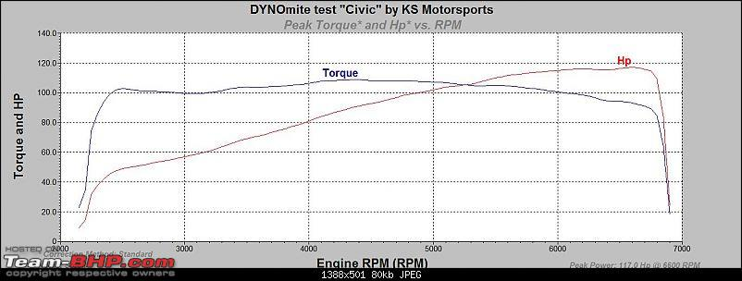

(Figure 11, Honda Civic dyno run, 2010)

Performance and Test Evaluation
I think I performed well with the tasks. I asked the lecturer many questions to help build my understanding. I also took good pictures for evidence to help with the assignment. When I operated the dyno, I managed to produce the highest power and torque values for my group. This was due to my understanding of slowly building up load on the engine. I also checked over the engine before the dyno runs which I was pleased by. I was happy with my understanding of health and safety and ensuring no fluids leak during the runs. My performance could have been improved by asking what typical torque and power values are from idle to redline. This would help me with the assignment as I could check my calculations for errors. This would have stopped the confusion with my torque graph. The investigation could have bene improved by changing fuels and air filters to see if performance fuels and parts make a difference in power and fuel consumption. I also think that it could have been improved by unplugging one coil pack to induce a misfire. I would be very interested to compare the torque, power, efficiency, and lambda reading with the engine running on three and four cylinders.

References

Specific fuel consumption definition and meaning | Collins English Dictionary. (2023, March 25). Collins Dictionaries. https://www.collinsdictionary.com/us/dictionary/english/specific-fuel-consumption

Specific fuel consumption definition and meaning | Collins English Dictionary. (2023, March 25). Collins Dictionaries. https://www.collinsdictionary.com/us/dictionary/english/specific-fuel-consumption

Workbook, E. (2023, February 27). What is Brake Power in IC Engine? Definition, Formula & Unit (Rope Brake & Prony Brake Dynamometer) - ElectricalWorkbook. ElectricalWorkbook. https://electricalworkbook.com/brake-power/#:~:text=Brake%20Power%20is%20defined%20as%20the%20net%20power,used%20for%20measuring%20the%20B.P%20are%20as%20follows.

G. (2010, October 17). Honda Civic Dyno Run no.1 - Stock. Team-BHP.com. https://www.team-bhp.com/forum/modifications-accessories/90676-honda-civic-dyno-run-no-1-stock.html
Equations – Given by lecturer
Data value references – Given by lecturer

Honda CRX workshop manual – Given by lecturer

