BMIH5004
Management & Organisational Behaviour

Hilton Hotels & Resorts: A Case Study Analysis



Student name: Mircea Nicolae Tilica
Student ID: 2246572
Lecturer name: Antoinette Milne, Ben Chong and Daniel Payne
Wordcount:2000
Date of submission: January 2025

I confirm that I have not used any AI tools in the research and creation of this
assignment. I confirm that I have not presented any AI generated materials as my own
work. I confirm I have copies of my drafts, notes, and other resources I used, which I
may be asked to provide in evidence.

EXECUTIVE SUMMARY

This report critically evaluates Hilton Hotels & Resorts, focusing on its organizational structure, corporate culture, goals, and strategic initiatives. Hilton balances centralized decision-making with local autonomy, creating challenges in maintaining consistency across global operations. Its culture promotes hospitality, teamwork, and employee empowerment, though variations exist across locations. Hilton’s key goals include global expansion, technological advancements, and achieving carbon neutrality by 2030. Recent change initiatives include the ‘Travel with Purpose’ sustainability strategy, expansion into India, and embracing sleep tourism trends. While these initiatives enhance Hilton’s market position, they also present challenges such as high implementation costs, regulatory compliance, and competitive pressures. Recommendations focus on refining strategic execution, maintaining service consistency, and strengthening local market adaptability.

TABLE OF CONTENTS

1) Introduction 4
2) Organisation Structure, Culture, and Goals 5
❖ Organisation Structure 5
❖ Organisational Culture 5
❖ Organisational goal 6
3) Recent Change Initiatives 6
❖ Travel with Purpose’ Enhanced Sustainability Targets 6
❖ Expansion into the Indian Market 6
❖ Embracing Sleep Tourism Trends 8
4) Strategic Direction 9
✵ Hybrid Organizational Design 9
✵ Digital Innovation for Enhanced Experience 9
✵ Sustainability and Workforce Empowerment 10
5) Conclusion 10
6) Recommendations 11

Introduction
Hilton Hotels & Resorts is one of the world’s most recognized names in global hospitality with more than 7,000 properties over 120 countries. Hilton was established in 1919 and has equipped itself with the strong reputation for luxury, customer service, and innovation (Jones, 2024). Hilton Hotels & Resorts, this report is going to assess, analyse, and critically evaluate in both the corporate and individual hotel levels. Hilton’s organisational structure, corporate culture, goals, recent change initiatives and strategic direction will be addressed. The theories of management and organisational behavior will be taken into account in order to evidence base an evaluation. Then, recommendations for improving the market position of Hilton will be given.

Organisation Structure, Culture, and Goals

Organisation Structure
A critical examination of Hilton’s organizational design reveals a deliberate balance between centralized control and decentralized autonomy each with its own strengths and challenges. At the corporate level, Hilton employs a hierarchical structure that centralizes decision-making to ensure a consistent brand identity and uniform strategic direction worldwide. This centralization fosters strong quality control and clear policy implementation. However, such a system can also inhibit rapid responsiveness and innovation, as rigid structures may delay the incorporation of localized insights or emergent market trends (Reidhead, 2020).
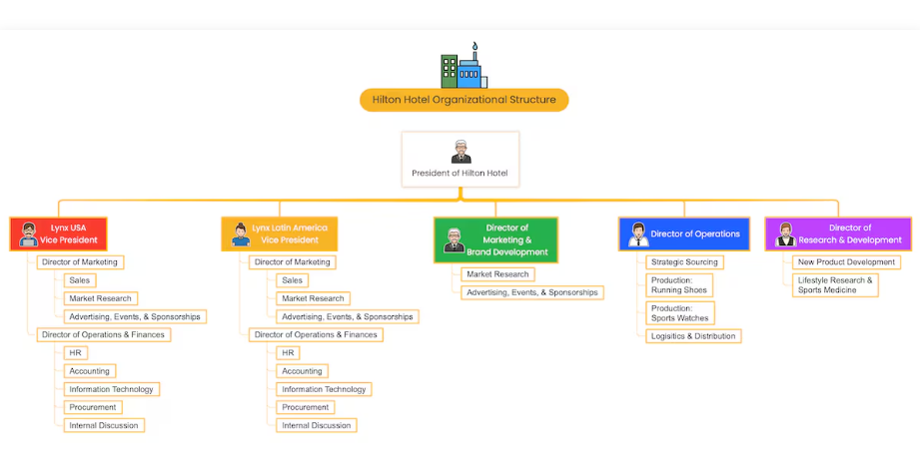
Figure 1: Hilton’s Organisational structure

On the other hand, Hilton’s decentralization at the individual hotel level gives local managers freedom to make decisions based on conditions in a given regional market. In this regard, it is important because it allows for catering to various customer demands and cultural imperatives (Aggarwal & Mittal, 2024). But the decentralized model offers inherent variability on service standards without a well-designed corporate system to integrate brand promise if not deployed well. The larger problem lies in finding a balance between the need for a coherent global identity that can somehow be influenced by local adaptability (Langer, 2022).
This balance is further complicated where Hilton has adopted matrix structure which when coupled with corporate leadership and franchise owners create a dual reporting system. This design is meant to bring about clarity on who can allocate resources, but there is also ambiguity in who has the authority to do so. Such sophistication necessitates strong network channels of communication and conflict resolution, as to maintain an alignment between corporate and local interests (Browning, 2015).

Organisational Culture
Hilton's corporate culture, which is founded on its mission to "fill the earth with the light and warmth of hospitality," aids in bridging various organisational levels (Hantuli, 2016). By using Hofstede’s Cultural Dimensions Theory, it appears that the company’s emphasis on customer satisfaction, teamwork, and employee empowerment is indeed rooted in this sense but also provokes questions regarding the consistency of these values in relation to the scope of the company’s market (Jan et al., 2024). Furthermore, incorporation of McGregor’s Theory Y that promotes self-motivation and responsibility of employee puts Hilton on the path of creating an environment that supports idea generation. Yet, differences within these ideals could be practical between the corporate headquarters and every hotel affecting overall performance (Okechukwu & Nwosu, 2020).

Organisational goal
From a strategic perspective, Hilton’s beforehand ambitious goals such as the aggressive expansion and technological improvements, and the 'Travel with Purpose' program aiming to reach carbon neutrality by 2030 are a glaring indication of a forward-looking strategic intent of the firm (Hilton, 2024b). However, these objectives need to be critically evaluated regarding the operational challenges of its complicated organizational structure and cultural integration that might slow down the implementation process.

Recent Change Initiatives

Travel with Purpose’ Enhanced Sustainability Targets
Hilton also in 2022 reinforced its environmental, social and governance (ESG) strategy, 'Travel with Purpose', which had targeted goals to overcome climate change and drive social impact. By 2030, 56% in franchised hotels and managed hotels as well as the amount of greenhouse gas emissions intensity in managed hotels and franchised properties needs to be dropped (Hilton, 2023). In addition to that, Hilton wants to reach 5 million learning, and career growth opportunities for 20 million community members by 2030 (Harrison et al., 2022). It places Hilton as the forerunner of sustainable hospitality, a role that reinforces the company’s promotion of a reputation for sustainability among greener customers, investors and regulatory bodies. Hilton attracts clientele by tying itself in with the global tide towards sustainability, meaning the clientele is willing to pay handsomely to associate with a company with corporate responsibility and eco-friendly business practices (Walters, 2024). It also strengthens Hilton’s corporate social responsibility (CSR) efforts that make McDonald happy and will make stakeholders trust and stand by that brand. In addition, the career growth programs and community engagement programs ensures a long-term workforce stability and talent retention (Vacations, 2024).
However, these sustainability targets represent challenges in their implementation. In order to achieve the substantial reduction of emissions, there will be the need to invest into energy efficient infrastructure, renewable energy sources and sustainable supply chains at the expense of increased operational costs (Machado, 2023). Furthermore, Hilton has to make sure that franchise network is in line and if not, it is in compliance with its franchise network across a range of commitment as well as financial capabilities. Hilton’s Sustainability approach is consistent with the Stakeholders Theory, which positions that there must be a balance to the interests of the various stakeholders in Organization including people who patronize, the employees, investors and in general, communities referred to as stakeholders (Awa et al., 2024). Hilton’s commitment to measurable and credible sustainability objectives is reflected in its setting science-based targets verified by the Science Based Targets initiative (SBTi). It reflects proactive change management based on anticipating the trends of regulatory developments and the consumer expectations (CDP, 2022).

Expansion into the Indian Market
Hilton has acknowledged the growth of leisure and business travel in the country and planned the growth of its presence in India by a large amount in 2024 (Hudson, 2025). The strategy includes 150 hotels under the Spark brand through a licensing agreement with Embassy Group and plans to have 4 times its rooms over the next five years. It is also part of Hilton’s overall growth strategy that aims to diversify its global portfolio and revenue streams. Also, there is a lot of capital pushing in to India, boasting a huge middle class, rising disposable incomes and a government initiative to promote tourism that makes it a lucrative market. Hilton takes advantage of these factors to boost its brand presence and competition in Asia-Pacific (Limone, 2024).
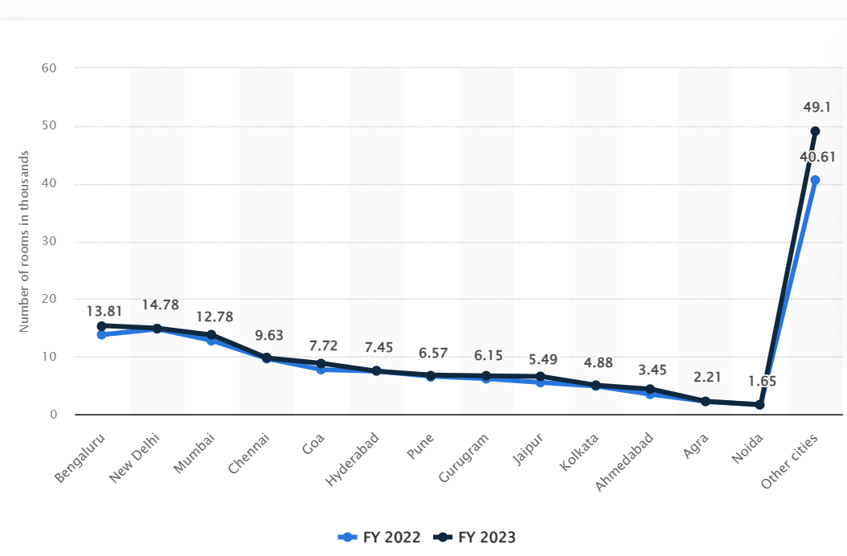

Figure 2: Existing supply of hotel rooms across Indian cities from financial year 2022 to 2023 (Keelery, 2024)

The graph leans towards the rising hotel rooms supply across Indian cities from FY2022 to FY2023 hinting at an increasing competition in the hospitality sector. Hilton has large competitors such as Taj, Marriott and Oberoi in key markets like Bengaluru, New Delhi and Mumbai, they are already dominating the room count there. To succeed, Hilton needs to price itself, provide the service excellence and have strategic partnerships to compete while navigating the competitive landscape in expansionary cities with rapid supply growth.
Moreover, the market entry strategies for different cultural and regulatory aspects need to be careful. None of these expansions will succeed if companies cannot adapt to the local behavior of consumers, limitations in the infrastructure and economic fluctuations (Hamdi, 2023). Hilton’s expansion strategy combines with Ansoff’s Matrix which means that it is a market development strategy because the company is entering a new geographical market with the same services. The licensing agreement with Embassy Group at the same time results in ambushed capital expenditure that is akin to their asset light business model in the hospitality industry (Gurcaylilar-Yenidogan & Aksoy, 2018).
Kotter’s 8-Step Change Model is relevant in evaluating how well this expansion is managed (Laig & Abocejo, 2021). Hilton has shown how to create a sense of urgency (India’s growing travel sector), develop a vision (to increase presence through partnerships) and generate short term wins (launch first batch of hotels to see market response). But, to achieve long term success needs sustained engagement with local stakeholders, a high-risk management capacity and updating of services evergreens with the changing consumption trends.

Embracing Sleep Tourism Trends
Hilton has risen to the opportunity of wellness tourism, whether that means “sleep tourism” travelers seeking restorative sleep or offering sleep packages. At Conrad Hotel in Bali for instance, Hilton has brought in premium mattresses, a pillow menu, soundproofing technology and wellness packages such as ‘Sway Sleep Therapy’ and at Castle Hot Springs in Arizona, Hilton introduced ‘Soak & Slumber’ (Hilton, 2024a).
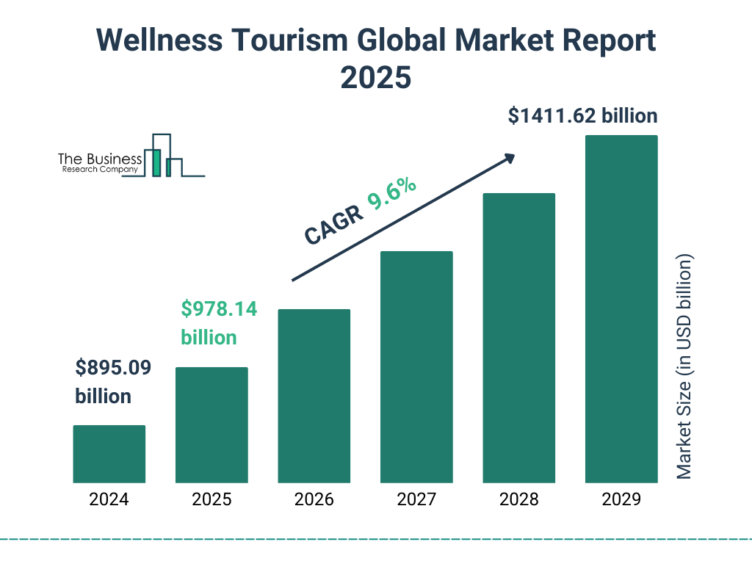
Figure 3: Wellness tourism global market report (company, 2025)

The graph highlights wellness tourism's growth, aligning with Hilton's sleep tourism initiatives, catering to rising demand for restorative sleep experiences. Hilton has the ability of this initiative to differentiate its offerings and to attract a niche market focused on health and well-being. Sleep tourism is part of broader wellness trends and is aimed at those who are willing to pay premium for experiences promoting physical and mental well-being. Hilton positions itself as an innovator of luxury travel by implementing sleep solutions drawn from the science (Matteucci, 2020).
Though, sleep tourism is a specialized niche and therefore does not cater for a broader audience. Since wellness conscience consumers are open to accept these offerings, budget or travelling on short project period basis for business purposes might not see much added value. However, this operational challenge still exists despite that consistency in delivering high quality sleep across all properties is also required (S. f. Hilton, 2024). Kotter’s Change Model suggests that sleep tourism fits with Hilton’s sleep tourism initiative and is also a short-term win by bringing up novel services and solutions in response to the needs of emerging consumers. Hilton’s agility in adapting to market demands is demonstrated by responding to evolving trends in wellness trends (Priya et al., 2024).
As seen from the angle of Blue Ocean Strategy, Hilton commits to develop sleep tourism, which means doing something not seen by anyone else and providing services that are superior from the value point of view. Hilton’s differentiation arms it away from the harsh price competition by focusing on experience-driven consumers (Yunus & Sijabat, 2021). However, whether sleep tourism can sustain long-term viability does depend on the company’s ability to start and change its service portfolio seamlessly to take into account these offerings.

Strategic Direction

Hybrid Organizational Design
In terms of centralization versus decentralization of organizational design, Hilton’s has a hybrid organizational design; while centralized for the brand management portion of the firm it has high degrees of autonomy for all operations (Lamo, 2019). At the corporate level decisions are made which promote core brand values and quality standards on all properties. Also, local managers are given the autonomy to adapt operational practices to fit regional market demands. The dual structure mirrors the core belief of Contingency Theory that organizations should have designs that are adaptable to the environmental conditions. Such a system is conducive to adaptability and responsiveness, but it also requires concerns about consistency in maintaining brand ‘integrity’ on the global level against local innovation is the perpetual managerial question (McAdam et al., 2019).

Digital Innovation for Enhanced Experience
To arise to the evolving consumer expectations, Hilton has placed digital transformation at the top of its strategic levers (Fachada, 2023). As an example of advanced data analytics, efforts to digitalize check ins and the adoption of keyless room access are investments in mobile technology that help to personalize guest experience and improve service delivery processes (Abdalla, 2024). This is consistent with Porter’s Value Chain framework with technology as a critical supporting activity that aids in overall service quality and operational efficiency (Kumar & Rajeev, 2016). Still, digital strategies provide Hilton with an edge in the competition through differentiation and at the same time, there are risks including technological obsolescence and cybersecurity threats. Therefore, continuous innovation and strong its governance qualities that are necessary and on high need to sustain these digital advancements.

Sustainability and Workforce Empowerment
Sustainability and commitment to corporate social responsibility are also long-term strategic objectives of Hilton (Jones et al., 2014). The company leverages sustainability as a strategic asset by developing through comprehensive environmental programs to achieve reduction in energy consumption, waste and water usage using the Resource Based View. The eco-centric approach helps in reducing the operational costs by the time and it also attracts travelers who are conscious of their environmental impact. Simultaneously, Hilton also spends heavily in workforce development and talent empowerment and has a motivated and skilled workforce that play an integral part in service excellence. Structured training and reward systems back by employee centric culture make the company capable of continuously innovating from within (Pereira, 2023). However today, it is a challenge to integrate these sustainable practices effectively with continuous business needs and the end result of dual focus on climate action and talent development must translate into long term competitive advantage.

Conclusion
In conclusion, Hilton’s integrated approach to organizational design, culture, and strategic direction exemplifies a sophisticated balance between global consistency and local responsiveness. The company’s hybrid model combines centralized decision-making with decentralized operations, ensuring brand uniformity while empowering regional managers. Digital innovation initiatives enhance guest experience, while sustainability efforts and workforce empowerment drive long-term value creation. Ambitious programs such as “Travel with Purpose,” market expansion in India, and niche offerings like sleep tourism underscore Hilton’s proactive adaptation to evolving industry trends. Ultimately, Hilton’s success depends on continuously aligning these diverse strategies to navigate operational challenges and sustain competitive advantage in practice.

Recommendations
- Corporate leaders and local managers use virtual meeting platforms every month to exchange localized insights from all properties and preserve uniform quality standards.
- IT staff at every hotel needs six months to implement digital check-in and keyless room access to improve guest satisfaction and simplify operations.
- The company should begin eco-friendly programs now through hotel renovations and power upgrades at main hotels under sustainability officer leadership to reach green goals and draw responsible tourists.
- Hilton will organize employee training every three months through HR to make sure staff support business values and deliver high service standards worldwide.

References

Abdalla, H. (2024). The Impact of Digitalization in Improving Customer Experience at Hotel AX, Helsinki.
Aggarwal, S., & Mittal, A. (2024). Futuristic hospitality conceptualized: DASH-Decentralized Autonomous and Smart Hotel system. Journal of open innovation: technology, market, and complexity, 10(1), 100223.
Awa, H. O., Etim, W., & Ogbonda, E. (2024). Stakeholders, stakeholder theory and corporate social responsibility (CSR). International Journal of Corporate Social Responsibility, 9(1), 11.
Browning, T. R. (2015). Design structure matrix extensions and innovations: a survey and new opportunities. IEEE Transactions on Engineering Management, 63(1), 27-52.
CDP, D. I. A. (2022). Hilton Worldwide, Inc. - Climate Change 2022.
company, T. b. r. (2025). Wellness Tourism Market Size 2025 And Growth Rate. https://www.thebusinessresearchcompany.com/
Fachada, B. C. (2023). Business Adaptive Strategies in Crisis: The case of Hilton Hotels Worldwide Universidade Catolica Portuguesa (Portugal)].
Gurcaylilar-Yenidogan, T., & Aksoy, S. (2018). Applying Ansoff’s growth strategy matrix to innovation classification. International Journal of Innovation Management, 22(04), 1850039.
Hamdi, R. (2023). Chains are wild about India – but it’s not an easy catch. https://ik.imgkit.net/3vlqs5axxjf/HIT/uploadedImages/Site_Management/HIT_Logo_White_forweb.svg?n=4850&tr=h-65%2Cfo-auto
Hantuli, L. (2016). An Analysis of Hotel Loyalty Programs: A Case Study of the Hilton HHonors Loyalty Program.
Harrison, J. S., Kelso, A., Reilly, P., & Sadler, W. (2022). Hilton Worldwide Holdings Inc.
Hilton. (2023). ENVIRONMENTAL, SOCIAL AND GOVERNANCE
Hilton. (2024a). In Search of Sleep: Hilton Caters to Rising Number of Sleep Tourists with Debut of Hilton Sleep Retreats. https://stories.hilton.com/
Hilton. (2024b). INTEGRATION OF ESG ACROSS OUR BUSINESS. https://esg.hilton.com/
Hilton, S. f. (2024). Hilton Shares Key Insights on Sleep Tourism. https://stories.hilton.com/emea
Hudson, S. (2025). Hospitality Management: International Introduction. Taylor & Francis.
Jan, J., Alshare, K. A., & Lane, P. L. (2024). Hofstede’s cultural dimensions in technology acceptance models: a meta-analysis. Universal Access in the Information Society, 23(2), 717-741.
Jones, P. (2024). Wellness in the Global Hospitality and Tourism Industry. Athens Journal of Tourism, 11(3), 225-238.
Jones, P., Hillier, D., & Comfort, D. (2014). Sustainability in the global hotel industry. International Journal of Contemporary Hospitality Management, 26(1), 5-17.
Keelery, S. (2024). Existing supply of hotel rooms across Indian cities from financial year 2022 to 2023. https://www.statista.com/
Kumar, D., & Rajeev, P. (2016). Value chain: a conceptual framework. International Journal of Engineering and Management Sciences, 7(1), 74-77.
Laig, R. B. D., & Abocejo, F. T. (2021). Change management process in a mining company: Kotter’s 8-step change model. Journal of Management, Economics, and Industrial Organization, 5(3), 31-50.
Lamo, E. G. (2019). The Center of Success: A Case Study on Hilton's Company Culture.
Langer, A. (2022). The hotel on the hill: Hilton Hotel’s unofficial embassy in Rome. Diplomatic History, 46(2), 375-396.
Limone, J. (2024). Hilton reaches licensing deal for Spark hotels in India. Travel Weekly https://www.travelweekly.com/
Machado, R. (2023). Sustainability for Hotels – The Impact on Profitability. https://blog.guestcentric.com/?utm_source=chatgpt.com&utm_source=chatgpt.com
Matteucci, V. (2020). How can the hospitality industry increase corporate value aligned with sustainable development goals? Case examples from Hilton, Meliá and Sun. Worldwide Hospitality and Tourism Themes, 12(5), 509-523.
McAdam, R., Miller, K., & McSorley, C. (2019). Towards a contingency theory perspective of quality management in enabling strategic alignment. International journal of production economics, 207, 195-209.
Okechukwu, N., & Nwosu, P. D. M. F. O. (2020). The Role of Leadership in The Empowerment of Nigerian Employees. Education, 4(1), 1-23.
Pereira, M. I. M. (2023). The Importance of Training & Development Practices to Retain Talent in the Hospitality Industry Universidade NOVA de Lisboa (Portugal)].
Priya, N., Satpathy, I., Patnaik, B., & Thaichon, P. (2024). Transforming Workplace Wellness in the Next-Generation Hospitality Industry by Leveraging Transformational Digital Technologies and Tools. In Technology and Luxury Hospitality (pp. 295-313). Routledge.
Reidhead, C. (2020). Impact of organizational culture on employee satisfaction: A case of Hilton hotel, United Kingdom. Journal of Economics and Business, 3(1).
Vacations, H. G. (2024). Corporate Social Responsibility. https://corporate.hgv.com/
Walters, D. (2024). PEOPLE's 100 Companies That Care in 2024: Employers Putting Their Communities First. https://people.com/
Yunus, M., & Sijabat, F. N. (2021). A review on blue ocean strategy effect on competitive advantage and firm performance. Academy of Strategic Management Journal, 20(1), 1-10.

