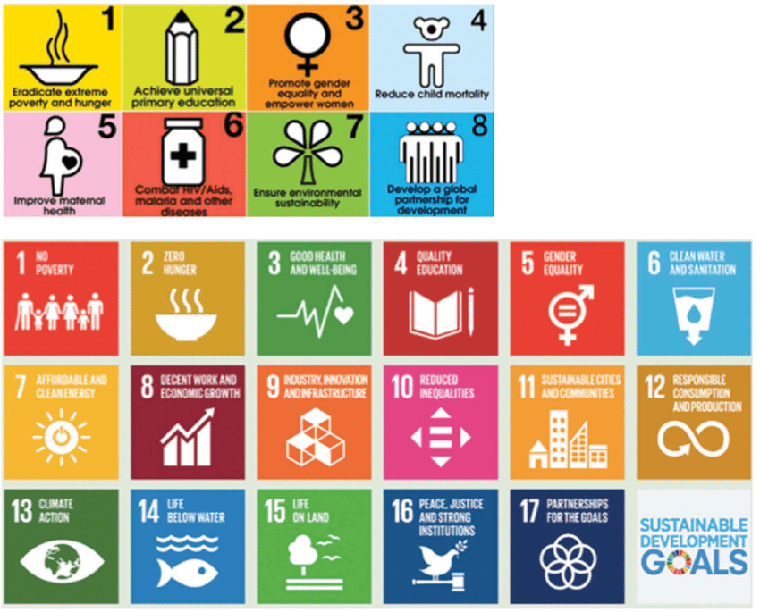
This handout shows the logos for the United Nations’ 8 Millennium Development Goals (MDGs, 2000-2015)
and the 17 Sustainable Development Goals (SDGs, 2015-2030) and is a prompt for a class discussion,
during the class on Mega-cities, showing SDG No. 11 (Sustainable Cities) in the context of the MDGs and SDGs
as a whole.

