

LOCATION: Swansea | LLEOLIAD: abertawe
LEVEL 4 | LEFEL 4
EXAMINATION PERIOD | CYFNOD ARHOLIADAU
January 2024 | IONAWR 2024
MODULE CODE: ACDA4004
Micros Peripherals & Interfaces
TIME: 2 HOURS
answer all questions

Equipment or materials required. Please select from the following:
Adnoddau neu ddefnyddiau sydd eu hangen.

Cyfrifiannell/Calculator
X
Llyfr Agored/Open Book

Arall/Other Nodwch/Please Note ……………………….

ANSWER ALL QUESTIONS

- The following comprise a number of mnemonics from the PIC16F84 microprocessor instruction set. Give the meaning of what each mnemonic stands for and explain what the instruction actually does.

  - MOVLW
[2 Marks]
  - DECFSZ
[2 Marks]
  - CLRF
[2 Marks]
  - SUBWF
[2 Marks]
  - DECF
[2 Marks]
  - ANDLW
[2 Marks]

- For the successive approximation ADC shown in Fig Q2, explain the general principle of operation for the circuit.
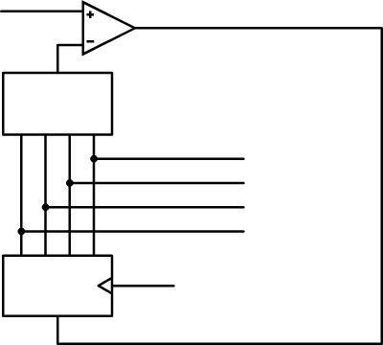
DAC
SAR
Clock
Reset
Output
V_{in}
Q0
Qn
Digital Output

Fig Q2.
[10 Marks]

- Draw the logic symbol for an XOR gate and provide the truth table for it.
[4 Marks]

- Write the Boolean equation and truth table for the circuit shown in Fig Q4
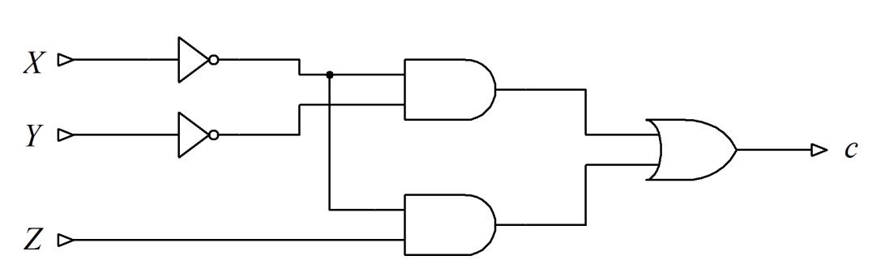
Fig Q4
[6 Marks]

- Compare and contrast the Harvard and Von Neumann processor architectures and state common applications for each. You may wish to use diagrams to support your answer.
[10 Marks]

- Using De Morgan’s Theorem, show how you can implement a NAND function using only NOR logic.
[8 Marks]

Diwedd/End

