Name: Ashia Aslam
Student ID: 2324496
Module: Employability and Career Development
Module Code: LCLM4005
Lecture Name: Olu Adegbite
CV-
Personal contact details-
Ashia Aslam
Ashiaaslam786@hotmail.co.uk
07792446994
31 Druids Lane, Maypole, B14 5SL

Personal statement-
I am a highly motivated and successful individual who is expected to get a in Business Studies at the University of Wales Trinity Saint David. I have strong leadership skills and an excellent understanding of core business principles and a passion for learning.

Education & Qualifications-
Swanshurst School 1996-2001
University of Wales Trinity Saint David- Business Studies (Expected graduation: July 2026)
- Mathematics (2001)- D
- English (2001)- C
- Science (2001)-D
- History (2001)- C
- French (2001)- D
- Design Technology (2001)- D
Employment history-
Debenhams (2004-2021)
- Progressed from Christmas Temporary Sales Assistant to Senior Sales during a 16-year career
- Demonstrated commitment, reliability, excellent leadership skills and consistent high performance
Christmas Temporary Sales Assistant -> Permanent Sales Assistant (2004-2008)
- Began as a Christmas temporary sales assistant and earned a permanent position through strong performance
- Provided excellent customer service during peak trading periods
- Assisted with stock replenishment and maintaining shop floor standards
- Supported sales activities and ensured customers had positive shopping experiences
Sales Assistant (2008-2015)
- Assisted customers with purchases and provided them with product recommendations
- Maintained attractive and well stocked sales displays
- Processed transactions accurately and handled cash responsibly
- Contributed to department sales
Senior Sales Assistant (2015-2021)
- Exceptional customer service and achieved sales targets
- Supported management with the daily store operations
- Assisted with visual merchandising, stock control and promotional events
- Handled customer queries and complaints professionally

Hobbies & Interests-
I am a mom of 3 children, and I am also a university student at the University of Wales Trinity Saint David. I like to host events for my family and friends, do puzzles such as jigsaws and wordsearches in my spare time and go for walks.

Ashia Aslam
07792446994
ashiaaslam786@hotmail.co.uk
18/06/2026
Hiring Manager
Deichmann
63 High Street
Birmingham
B4 7TA

Dear Hiring Manager,
I am writing to apply for the Retail Supervisor (20 hours) position at Deichmann in Birmingham.
I am a hardworking, reliable and friendly person with over 16 years of retail experience including progressing from Sales Assistant to Senior Sales Assistant at Debenhams. I provide excellent customer service, and I am confident working in a busy environment and can stay calm under pressure.
I believe I could become a valuable member of your team as I have good leadership & organisational skills, responsible and willing to learn. I am particularly interested to this job opportunity because it combines my passion for customer service with leadership responsibilities. The duties outlined in the job listing closely match my previous experience.
In addition to my retail background, I am currently studying Business at the University of Wales Trinity Saint David. My business studies have helped me enhance my understanding of leadership, business operations which I think would really help me at Deichmann.
I am excited about the opportunity to potentially work for Deichmann and would welcome the chance to discuss my application further.
Thank you for your time and consideration. I look forward to hearing from you.
Yours sincerely,
Ashia Aslam
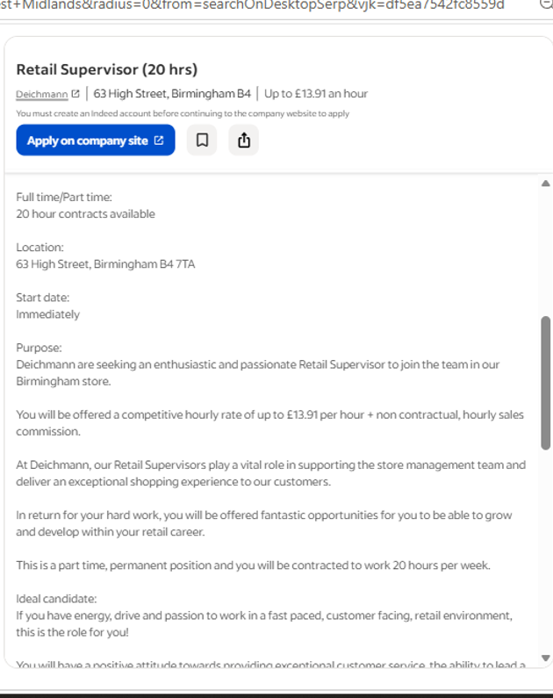
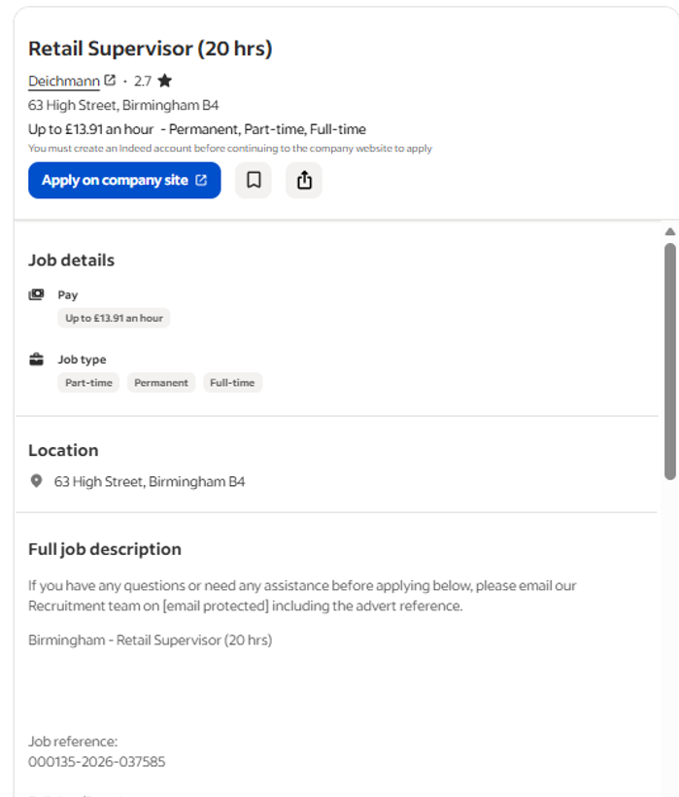

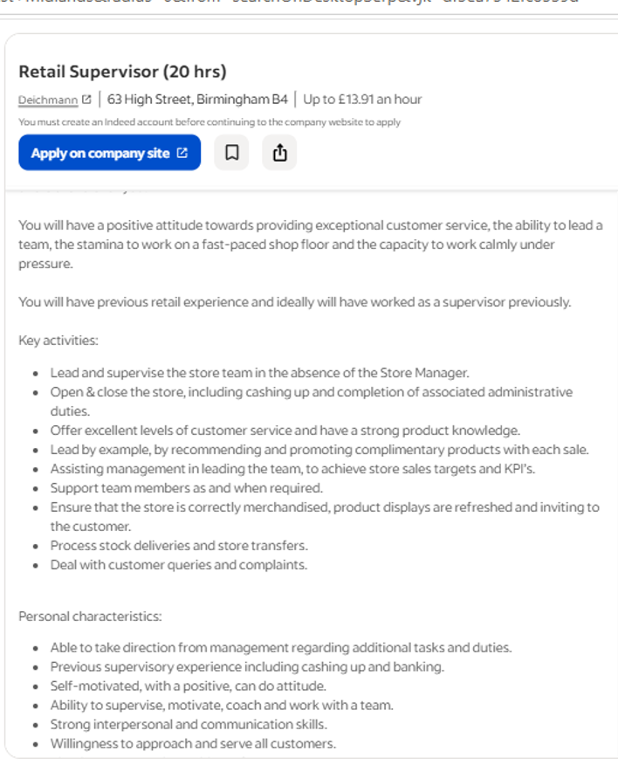
https://uk.indeed.com/viewjob?jk=df5ea7542fc8559d&from=shareddesktop_copy

